CONDUCTORLESS BUS TICKETING SYSTEM USING RFID AND GSM

AuthorAffiliations

**Abhishek G,** Scholar**,** Electronics and Communication Engineering, National Engineering College, Kovilpatti, Tamilnadu, India.

**Arun N,** Scholar**,** Electronics and Communication Engineering, National Engineering College, Kovilpatti, Tamilnadu,India.

**Karmegam S,** Scholar**,** Electronics and Communication Engineering, National Engineering College, Kovilpatti, Tamilnadu,India.

**Karthikeyan V,** Scholar**,** Electronics and Communication Engineering, National Engineering College, Kovilpatti, Tamilnadu,India.

**Vishnu K,** Scholar**,** Electronics and Communication Engineering, National Engineering College, Kovilpatti, Tamilnadu,India.

**Dr. N Arumugam,** Associate Professor**,** Electronics and Communication Engineering, National Engineering College, Kovilpatti, Tamilnadu,India.

**ABSTRACT**

Buses are the essential mode of open transportation in our country. It can be exceedingly troublesome to both issue and get tickets amid crest hours. How to utilize alter to supply the voyager a sense of steadiness is the basic issue as well. The likelihood of untrue ticket bargains to boot tall. Furthermore, until they arrive at their goal, the voyagers must keep their ticket in a secure put. The programmed ticket issuance strategy is said to be able to unravel these sorts of issues. The labels are examined utilizing the radio- recurrence recognizable proof (RFID) per user utilized in this article. Recharging the RFID tag is conceivable. Exterior the transport entrance could be a settled hardware called an RFID per user framework. When a traveler sheets a transport, they must check their shrewd card in an RFID per user. In case the RFID per user distinguishes a savvy card with adequate adjust for their travel, the traveler is considered an approved person and is allowed to continue to their destination. The gadget will identify anybody who enters the transport without checking the RFID tag. The SMS notice is at that point sent to the checking person through GSM modem**..**

1. **INTRODUCTION**

Populace and contamination are both expanding. The lion's share of individuals have private vehicles, coming about in expanding activity clog and fuel utilize. Taking open transport can assist you avoid this. Buses are more proficient than trains in terms of open transportation since they can reach each alcove and crevice of the city. In common, all buses, open or private, have conductors who collect tickets. After boarding the transport, the conductor will estimate tickets

The conductor must reestablish the proper remaining adjust to the travelers, which more often than not causes commotion. Another impediment is the squander of paper. Many transport conductors directly utilize flexible ticketing machines to issue tickets. Isolated Amid crest hours, ticket checkers are relegated to avoid ticket extortion. Within the case of RFID-only frameworks, the goal must be entered to begin with, or particular labels are doled out to particular courses. Another elective is to buy a ticket earlier to the begin of the travel, in spite of the fact that usually as it were open on end-to-end buses. On the off chance that it was facilitated, the affirmation is subsequently deducted from their account; something else, they must have their RFID card with them to pay the affirmation. An imaginative arrange to utilize GPS and shrewd cards to computerize the open transport admission collection framework, limiting transport passage calculation and laborer control. RFID and GPS technology are commonly utilized to supply shrewd ticketing frameworks in buses. RFID labels can give imperative data almost the traveler and the adjust. An RFID per user is utilized to examined the labels. To approve the labels, microcontrollers are utilized. The data is shown to the travelers through an LCD show. The accelerometer is utilized to identify an mishap within the occasion of one. The area of the mishap is decided employing a GPS module and a GSM framework, and the data is sent to a neighborhood clinic. There are continuously concerns with buses in our nation that are related to ticketing technique. The conductor may give tickets to people who area unit all movement inside the transport. The conductor can issue tickets to travelers agreeing on the tally and amount given to him/her. This will incorporate a parcel of paper for printing the tickets, and the utilize of a hand-held hardware will moreover cause a part of issues. The voyager must too carry the fitting sum with him/her at all times. When a traveler does not have the proper amount, the conductor ought to have the right alteration. A few conductors don't always allow travelers the right alter. For case, when we travel from Dissolve to Coimbatore, the ticket expense is as it were 59 rupees, but the conductor gets 60 rupees. The conductor must then hand over one rupee to the voyager. A few conductors provide the fitting rectification to the voyager unit of, measurement whereas others don't . The current strategy overcomes these troubles by using an RFID with a console into which the voyager must sort the assignment all over he/she goes to encourage down. The RFID scanner can examine different data from the RFID tag around the traveler. The different sums are charged from the voyager as a result of this.

1. **METHODOLOGY**

**Fig2.1. Block diagram of the proposed system**

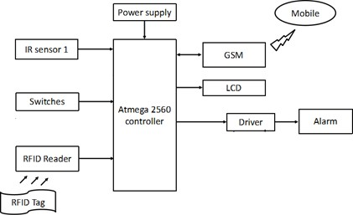An Atmega2560 controller, IR sensors, RFID, a keypad, switches, GSM, a driver, a engine, and an LCD show are all portion of this extend. To number the number of people entering and leaving the transport, two infrared sensors are utilized, as well as

passage and exit entryways. RFID is utilized to recognize people and calculate transport passages. The RFID per user is arranged within the passage entryway; on the off chance that the scanner peruses the tag and gives the goal, the situate is relegated utilizing the keypad. Each situate encompasses a constrain control connected. It decides whether or not the relegated situate is possessed. On the off chance that a situate is saved, this innovation will open the section door (Engine) by means of the driver unit. On the off chance that somebody enters the transport without a reservation, this instrument sends a notice to the control room through GSM. The controller is utilized to control the transport engine, entryway engine, and alert through the driver unit. It is utilized to control engines through a hand-off. Our project's current status is shown on an LCD.

* 1. **HARDWARE DETAILS: -**

1. **RFID: -**

RFID is the remote utilize of electromagnetic areas to communicate information for the reason of consequently distinguishing and following labels joined to products. The labels incorporate electronically put away information. A few labels are fueled by electromagnetic acceptance from attractive areas created close the peruser. A few sorts collect vitality from examining radio waves and serve as inactive transponders. Other sorts depend on a neighborhood control source, such as a battery, and can work hundreds of meters far off from the per user.

# IR SENSOR: -

Infrared radiation may be a parcel of the electromagnetic range having wavelengths that are longer than unmistakable light wavelengths but

shorter than microwave wavelengths, i.e., a run of 0.75m to 1000m. Infrared wavelengths are undetectable to human vision. Close infrared wavelengths change from 0.75m to 3m, mid infrared wavelengths extend from 3m to 6m, and distant infrared wavelengths surpass 6m. (The divisions are not correct; numerous individuals characterize ranges in an unexpected way).

# MODEM: -

A GSM modem may be a sort of modem that, like a portable phone, acknowledges a SIM card and works through a versatile administrator membership. To a portable administrator, a GSM modem looks precisely like a portable phone. When a GSM modem is associated to a computer, the computer can communicate over the portable organize. Whereas most of these GSM modems are utilized to put through to versatile web, a few of them can moreover send and get SMS and MMS messages. GSM modems can be standalone modems with serial, USB or Bluetooth interfaces, or feature phones with GSM modem capabilities.

# RELAY: -

Transfers are electronic exchanging gadgets. Mechanical electronic frameworks are fueled by exchanging gadgets. Contacts are shaped or broken when a transfer is invigorated or actuated. They are utilized to control substituting current or coordinate current power. They are utilized to oversee the grouping of occasions that happen amid the working of a framework such as an electronic radiator, counter, welding circuits, X-ray hardware, measuring frameworks, caution frameworks, and communication. Electromagnetic transfers are

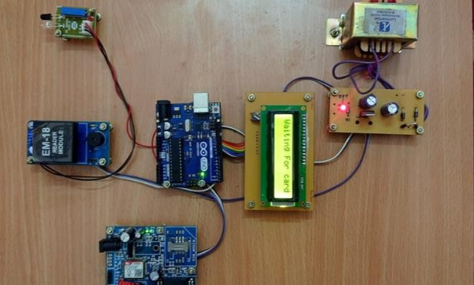electromagnets with a attractive impact delivered by the coil current. It pulls or pushes level delicate press armatures or hand-off contact strips.

# DC MOTOR: -

The coordinate current engine is the engine that turns coordinate current into mechanical work. It works on the Lorentz guideline, which states that "a current carrying conductor put in a attractive and electric field encounters a drive."

1. **MODELING AND ANALYSIS**

The demonstrate proposed is isolated into two components. The ticketing strategy will be mechanized with remote keeping money within the to begin with module. RFID cards and perusers are utilized to empower remote keeping money. The voyager will be given a card that will store the essential data around the traveler in memory. When the traveler brings the card close the peruser at the boarding and goal focuses, the data on the card is broadcast by means of radio recurrence. The information is gotten by the peruser and sent to the microcontroller unit for encourage preparing. The boarding and goal areas will be recovered utilizing the GPS module, coming about within the era of travel admission and the transmission of travel points of interest to the traveler.

**Fig1. Waiting For The Card**

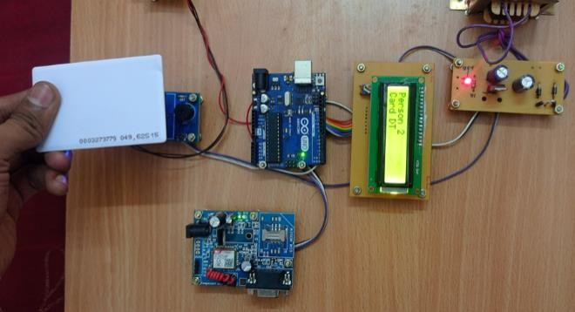

**Fig2. Card Recognized through RFID peruser**

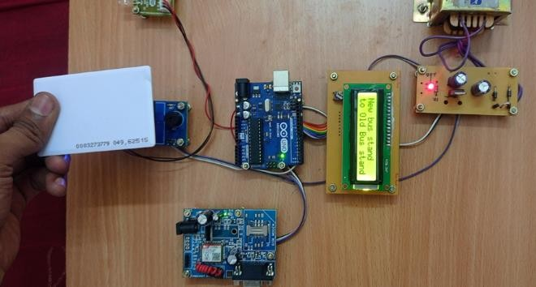

**Fig3. Destination is displayed**

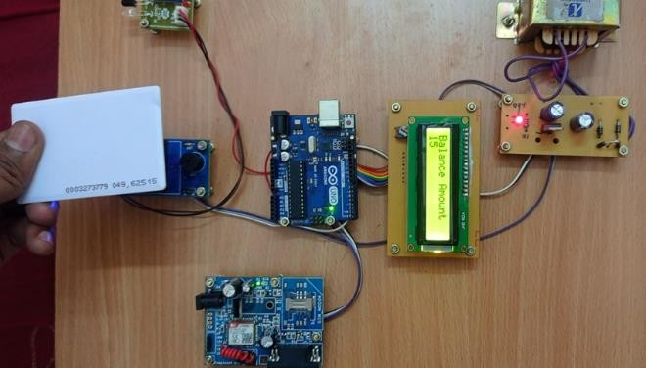

**Fig4. Balance Amount**

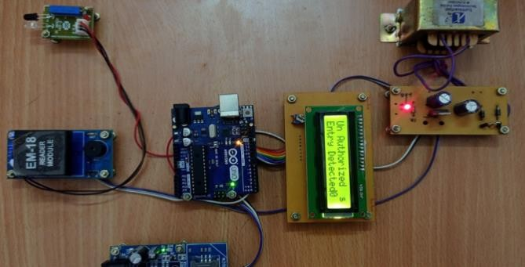

**Fig5. Sum is Charged from card**

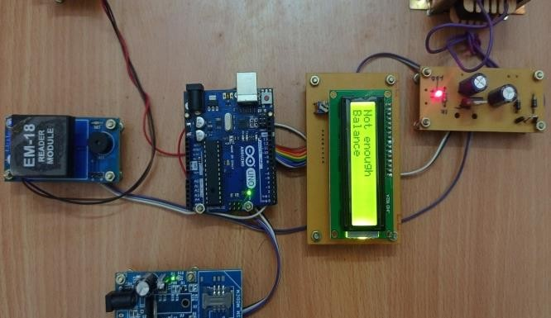

**Fig6. Not Enough Balance Message Notification**

**Fig7. Amount zero**

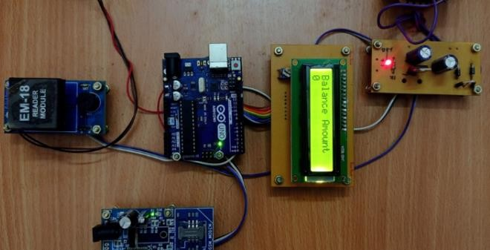

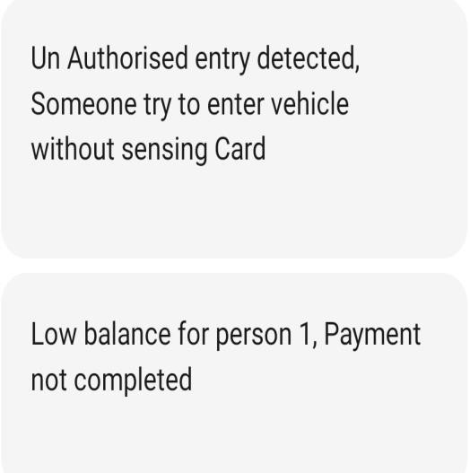

1. **RESULTS AND DISCUSSIONS**

This proposition is based on the RFID technology- based transport ticketing framework. The major objective of this venture is to create broad utilize of impeded innovation. Diminish the sum of paper squandered. Whereas numerous may contend that exchanging to paperless will be more costly in terms of program and equipment needs than the past paper-based framework, a Shrewd Ticketing framework has its focal points. The framework ought to be completely computerized, reliable, straightforward, and user-friendly. With minor or no alterations, the complete framework can be utilized in interstate vehicles, toll installment frameworks, and railroad ticketing frameworks. Since the cards are reusable, they are distant more helpful than paper based ticketing framework.

1. **CONCLUSION**

This framework overcomes the challenges of the travelers. This framework is more secure since it sends the area of the transport amid the time of mischance to the adjacent clinic. Ticket extortion can be dodged. This framework can be assist created by supplanting charge card within the put of a RFID tag.

1. **REFERENCES**
   1. Md. FoisalMahedi Hasan, Golam Tangim, Md. KafulIslam, Md. Rezwanul Haque Khandokar, ArifUlAlam “RFID-

based Ticketing for Public Transport

System: Perspective Megacity Dhaka”,

IEEE05564067, 2010 IEEE

* 1. Sana Said Al-Ghawi, Dr.S. Asif Hussain, Muna Abdullah Al Rahbi, S.Zahid Hussain, “AUTOMATIC TOLL E- TICKETING SYSTEMFOR TRANSPORTATION SYSTEMS”,

IEEE07460382, 2016 IEEE.

* 1. Kaushal M. A., Harshil M. G., Priyank J. S, “Automatic Ticket Vending via

Messaging Service ATVMS”, In: International Journal of Computer Applications, Volume 42, No.17, March 2012.

* 1. PT.Manikandan, G. Kalaiyarasi, PK. Priyadharshini, R. Priyanga, “Conductor

less Transport ticketing Framework Utilizing RFID and Mischance Data through GPS and GSM", IJISET, Vol. 2 Issue 9, September 2015 .

* 1. Piyush C., Rakesh K. K., Prakhar S, “RFID-based ticketing for open transport

framework: point of view megacity”, In: Universal Diary of Progress Investigate in Computer Science and Administration Considers, Volume 2, Issue 5, May 2014.