IMAGE PROCESSING USING DATA AUGUMENTATION

Nandhini D

*Master of Engineering,Computer Science and Engineering,*

*Adithya Institute of Technology,Coimbatore,*

*(of affiliation)*

*Anna University,Chennai,*

*Tamilnadu,India.*

Mail:nandhudeva12@gmail.com

# ABSTRACT

*— The system is Image Processing Using Data Augmentation in the domain of Machine Learning. Machine learning is a method of data analysis that automates analytical model building. It is a branch of artificial intelligence based on the idea that systems can learn from data, identify patterns and make decisions with minimal human intervention. The algorithm used for the system is DATA AUGMENTATION. Data augmentation is a strategy that enables practitioners to significantly increase the diversity of data available for training models, without actually collecting new data. Data augmentation techniques such as cropping, padding, and horizontal flipping are commonly used to train large neural networks. There are several techniques used by this Algorithm to predict the image. One of the most common data augmentation techniques used for images is Position augmentation. Scaling, Cropping, Flipping, Padding, Rotation, Translation, Affine transformation, Color augmentation,*

*Brightness, Contrast,Saturation are some of the techniques of Data Augmentation. In these techniques, the system uses the Flip, Zoom, and Rotate technique to predict the image what it is and also to find the image with the reduction in the code size and with great accuracy and less in the loss rate of the image.And when compare the result of processed image and Data Augmentation processed image, the proceeded image of Data Augmentation will provide the better accuracy and provide result with code reduction and speed*.

# INTRODUCTION

*The Image Processing along with Data Augmentation technique able to detect, predict and obtain what kind of image it is. For example, a image is taken and uploaded in the system means the system will give the proper result of image that what is uploaded to it. First it will create the data sets which refers to images that uploaded in the machine and here the system uses the images of the flower with five different kind of classes. And then the system is configure the datasets that it should identify the images that it belongs to which class and what*

*image. After that have to standardize the data sets to predict the image. Then have created the model of the images as discussed the earliest, it have five different classes and have to model that five different types of the flowers. And then have to compile the model to find the image to which class it belongs to. Then it visualize the resultant image of the image processing. And also, have to calculate its performance. This will give a better accuracy to find the image. To get more accuracy here the system uses the Data Augmentation technique in Machine Learning.*

# METHODOLOGY

***TensorFlow****is an open source library created for Python by the Google Brain team. TensorFlow compiles many different algorithms and models together, enabling the user to implement deep neural networks for use in tasks like image recognition/classification and*[*natural language processing*](https://stackabuse.com/what-is-natural-language-processing/)*. TensorFlow is a powerful framework that functions by implementing a series of processing nodes, each node representing a mathematical operation, with the entire series of nodes being called a "graph".*

*In terms of****Keras****, it is a high-level*API*(application programming interface) that can use TensorFlow's functions underneath (as well as other ML libraries like Theano). Keras was designed with user-friendliness and modularity as its guiding principles. In practical terms, Keras makes implementing the many powerful but often complex functions of TensorFlow as simple as possible, and it's configured to work with Python without any major modifications or configuration.* [*Image recognition*](https://www.mathworks.com/discovery/image-recognition.html)*refers to the task of inputting an image into a neural network and having it output some kind of label for that image. The label that the network outputs will correspond to a pre-defined class. There can be multiple classes that the image can be labeled as, or just one. If there is a single class, the term "recognition" is often applied, whereas a multi-class recognition task is often called "classification".A subset of image classification is object detection, where specific instances of*

*objects are identified as belonging to a certain class like animals, cars, or people. Here in this project the Data augmentation techniques is used to predict the images.*

# OUTPUT

Here in this project, it provides two output one output is without using the data augmentation technique and other with using data augmentation technique.

Without the usage of data augmentation technique the accuracy and loss rate will be like as the following figure:

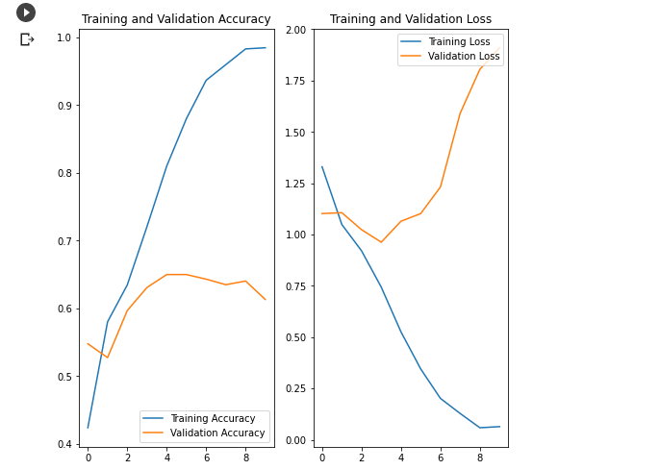

With the usage of the data augmentation technique the accuracy rate will get increased and the loss rate will be getting decreased that is shown in the following figure of one of the analysis.

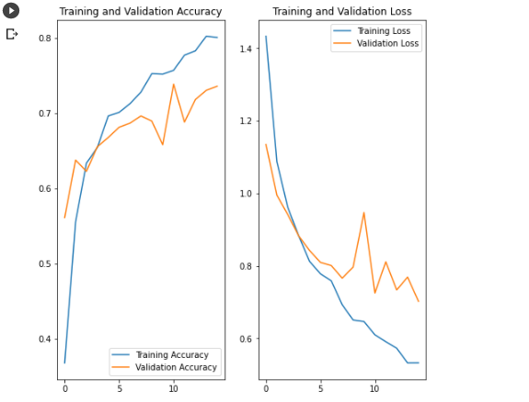

Then the final result after using data augmentation will be displayed with the accuracy rate of the image that is uploaded.

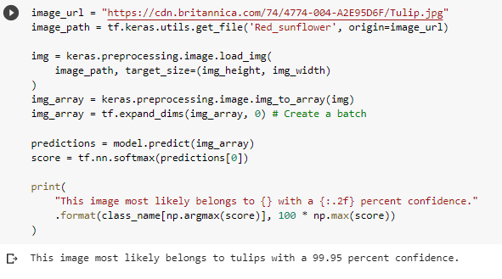

***RESULT***

The Image Processing along with Data Augmentation technique is able to detect, predict and obtain what kind of image it is. And will provide the result with great accuracy and with less loss rate. From this project we can able to predict what the image is with more accuracy.

# CONCLUSION:

*This project IMAGE PROCESSING USING DATA AUGMENTATION is used the image like what it is with great accuracy and with less loss and along with the reduction of the code. This will be will execute the result with the name of the image and along with the accuracy rate. So, this will be helpful in finding most wanted criminal list in the police station with great accuracy.*

# REFERENCES

# [1] Connor Shorten and Taghi Khoshgoftaar (2019) from Florida Atlantic University. A survey on Image Data Augmentation for Deep Learning

# [2] Alex Hern´andez-Garc´ıa(2020), from Institute of Cognitive Science. Data Augmentation and Image Understanding

# [3] Nurya Aghnia Farda(2020), Department of Computer Science and Information Engineering, National Central University, Jhongli Country, Taiwan. Sanders classification of calcaneal fractures in CT images with deep learning and differential data augmentation technique

# [4] Hao Wang(2019). Data Augmentation for Object Detection via Progressive and Selective Instance-Switching

# [5] Amit Chaudary from (2020), Research and Engineering. A Visual Survey of Data Augmentation in NLP

*[6]Changhee H, Hideaki H, Leonardo R, Ryosuke A, Wataru S, Shinichi M, Yujiro F, Giancarlo M, Hideki N. GAN-based synthetic brain mr image generation. In: 2018 IEEE 15th International Symposium on biomedical imaging (ISBI 2018). IEEE, 2011. P. 734–800*

*[7] A Antoniou, A Strokey, H Edwards(2018). Augmenting image clarifiers using Data Augmentation generate adversarial networks – ICANN 2018 pp 594- 603.*

*[8] C.Zhang and P. Zhou[2015]. A convolutional neutral network for leaves recognization using Data Augmentation – ICANN 2015 pp 332-336.*

[*9]* A Krizhevsky, I Sutskever and G E. Hinton, "Image net classification with deep convolutional neural networks", Advances in Neural Information Processing Systems, 2012..