**A STUDY ON CUSTOMER PERCEPTION TOWARDS OPENING AND BANK ACCOUNT**

**VERONICA A* MUTHUMANI S\*\***

MBA student Jerusalem College of Engineering, Chennai.

Professor and Head MBA, Jerusalem College of Engineering, Chennai.

**ABSTRACT**

**Banking sector** acts as the backbone of modern business. Development of any country mainly depends upon the banking system. A bank is a financial institution which deals with deposits and advances and other related services. It receives money from those who want to save in the form of deposits and it lends money to those who need it. The banking is one of the most essential and important parts of human life. Customer Relationship Management in Banking Sector is a number of strategies and technology that are used to build stranger relationship between banks and their customers. A bank will store information that is related to their customers, and they will spend time analyzing it so that is can be used for their purpose. The study reveals the importance of the role played by the banking sector in economic development.

**INTRODUCTON**

**Banking** is an industry that handles cash, credit, and other financial transactions. Banks provide a Safe place to Store extra cash and credit. They offer savings accounts, Certificates of Deposit, and checking accounts. Banks use these deposits to make loans. These loans include home mortgages, business loans, and car loans.

A Bank is a financial institution licensed to receive deposits and make loans. Two of the most common types of banks are commercial/retail and investment banks. Depending on type, a bank may also provide various financial services ranging from providing safe deposit boxes and currency exchange to retirement and wealth management.

The banking system in India is significantly different from that of other Asian nations because of the country’s unique geographic, social, and economic characteristics. India has a large population and land size, a diverse culture, and extreme disparities in income, which are marked among its regions. There are high levels of illiteracy among a large percentage of its population but, at the same time, the country has a large reservoir of managerial and technologically advanced talents. Between about 30 and 35 percent of the population resides in metro and urban cities and the rest is spread in several semi-urban and rural centers. The country’s economic policy framework combines socialistic and capitalistic features with a heavy bias towards public sector investment. India has followed the path of growth-led exports rather than the “export led growth” of other Asian economies, with emphasis on self-reliance through import substitution.

**REVIEW OF LITERATURE**

Sharad Kumar in his article "Banking changing the gear" (February 2010) has reviewed that Indian banking is transforming itself into a customer centric, commercial position by providing the better and qualitative services in addition to primary services with the help of superior technology and effective innovation which is producing customer delight. India has always been a high potential of savings and deposits and its customers were by and large conservative in nature. He also explained that today's customer is wise one. They are clear in their mind about their needs, desire, wants and the capabilities that they posses in converting their desire into demand. The relationship between the desire and demand is one which generates all the activities of the economy.

He also reviewed that shift in consumer expectations also been taken place. Today's customer is wise, rational, choosey and intelligent one. In this situation question is how to satisfy banking customers? It is crucial one that has kept the flame of innovation ignited in the Indian banking landscape. With the technological development and revolutions customer awareness immensely increased. He has been considered 2 types of bank customers. In 1st category, client who believes in offering the best value for money by offering quick and efficient services like fast remittance, wealth management, advisory transactions banking, private equity syndication, merger and acquisition etc., apart offering normal banking services. While 2nd type of customers who expects the personal banking services like Mutual Fund, Bancansurance, Demat Services, Tax Payments. It is natural that customers look for convenience when they do banking. There is no doubt that the banks are not only banks but they are the financial supermarket. The banking industry would never have thought of such range of products being sold from the counter as well as beyond the counters at the door step of the customers.

He also explained the term 'BANKING' as follows :

B = Banking of efforts for nation economic prosperity.

A= Advancement of working capital, loans.

N = Nutrition food, it helps the weak farmers, land less laborers to purse milk animals.

K= Keeps your money safe and grow at fastest rate.

I = Industrial development takes place.

N= Numerous deposits schemes to suit your expectations and packet and purpose.

G= Getting a prompt courteous and efficient services.

In addition to above he gave more stress on bank marketing, various types of services provided by the bank and last but not least the role of bank employee towards the service quality.

**METHODOLOGY**

In this study based on both primary and secondary data. The primary data were collected from public sector and private sector bank customers using well-defined and well-framed questionnaire. Convenience sampling method was used for selecting sample respondents. one hundred respondents were selected for the present study. The secondary data were collected from various books, journals, research articles, magazines, and websites. Primary Objectives to study the customer perception towards opening an bank account. Secondary objectives to find the reason on what basis banks must be considered. To study the convenience in using a bank account. To study the effect of service provided and satisfaction level of customer. Need of study The banking industry plays an important role in the country’s economy. Here I wanted to analyze whether opening a bank account could impact the growth of the banks. Scope of study is to focuses on the impact on opening a bank account, as well as the level of customer satisfaction with these services. It also allows everyone to see how many new banking services are used by consumers. Limitation of study the size of the sample was relatively small-100 participants. A larger sample would likely upgrade the reliability of the research. The lack of resources led to convenience sampling therefore the data is slightly based. In some cases, participants refused to fill the questionnaire.

**ANALYSIS**

1. **PERCENTAGE ANALYSIS:**
2. **AGE OF THE RESPONDENTS:**

|  |  |  |  |  |  |
| --- | --- | --- | --- | --- | --- |
| **Age** | | | | | |
|  | | Frequency | Percent | Valid Percent | Cumulative Percent |
| Valid | 21-30 | 100 | 96.2 | 100.0 | 100.0 |
| Missing | System | 4 | 3.8 |  |  |
| Total | | 104 | 100.0 |  |  |

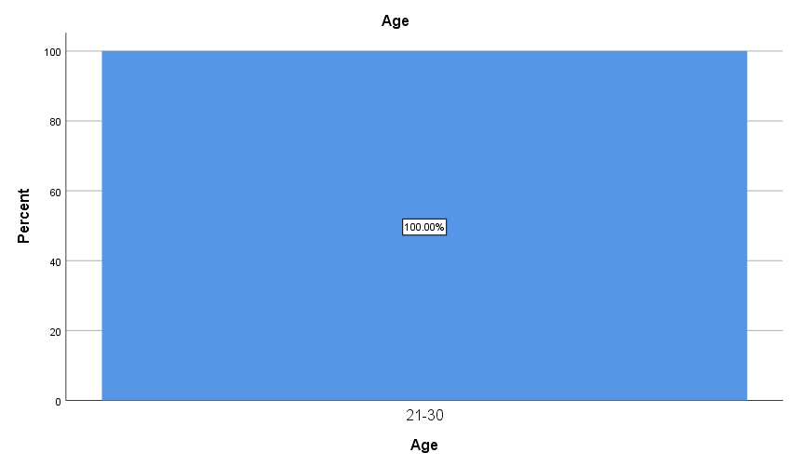

**FIGURE: 1**

**INTERPRETATION:**

From the above table it shows that one of 100 respondents, 100% are between 21 – 30years.

1. **GENDER OF THE RESPONDENTS**

|  |  |  |  |  |  |
| --- | --- | --- | --- | --- | --- |
| 1. Valid | Male | 51 | 49.0 | 51.0 | 51.0 |
| Female | 49 | 47.1 | 49.0 | 100.0 |
| Total | 100 | 96.2 | 100.0 |  |
| Missing | System | 4 | 3.8 |  |  |
| Total | | 104 | 100.0 |  |  |

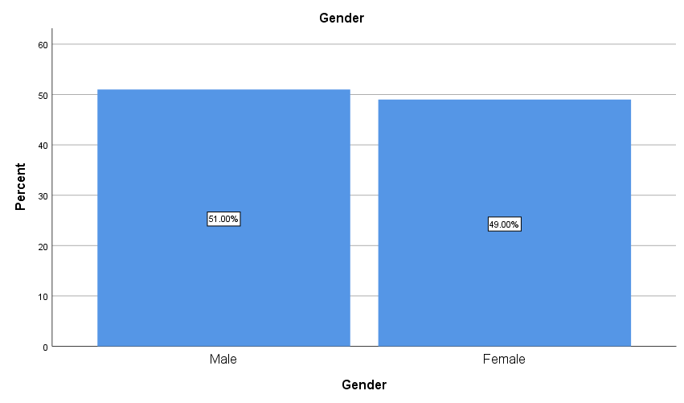

**FIGURE: 2**

**INTERPRETATION**: From the above table it is interpreted that 49% are male and 51% of respondents are female. Majority (51%) are female.

1. **PROFESSIONAL STATUS:**

|  |  |  |  |  |  |
| --- | --- | --- | --- | --- | --- |
| **Profession** | | | | | |
|  | | Frequency | Percent | Valid Percent | Cumulative Percent |
| Valid | student | 86 | 82.7 | 86.0 | 86.0 |
| Government employee | 4 | 3.8 | 4.0 | 90.0 |
| Private employee | 8 | 7.7 | 8.0 | 98.0 |
| others | 2 | 1.9 | 2.0 | 100.0 |
| Total | 100 | 96.2 | 100.0 |  |
| Missing | System | 4 | 3.8 |  |  |
| Total | | 104 | 100.0 |  |  |

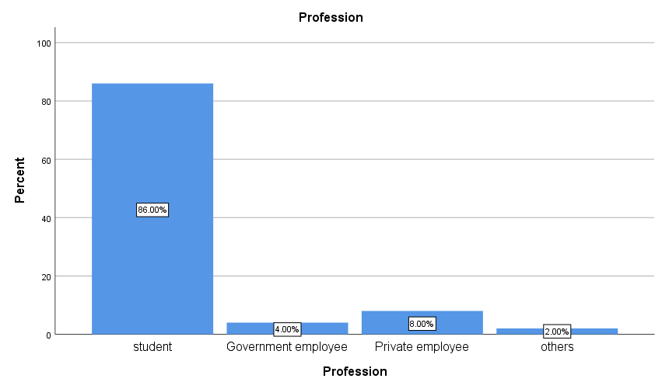

**FIGURE: 3**

**INTERPRETATION**: From the above table it is interpreted that 82.7% are Student, 3.8% are Government Employees,8% are Private Employees, 2% Other. Majority (82.7%) Students.

1. **MONTHLY INCOME:**

|  |  |  |  |  |  |
| --- | --- | --- | --- | --- | --- |
| **Monthly income** | | | | | |
|  | | Frequency | Percent | Valid Percent | Cumulative Percent |
| Valid | below 20000 | 96 | 92.3 | 97.0 | 97.0 |
| 21000-30000 | 3 | 2.9 | 3.0 | 100.0 |
| Total | 99 | 95.2 | 100.0 |  |
| Missing | System | 5 | 4.8 |  |  |
| Total | | 104 | 100.0 |  |  |

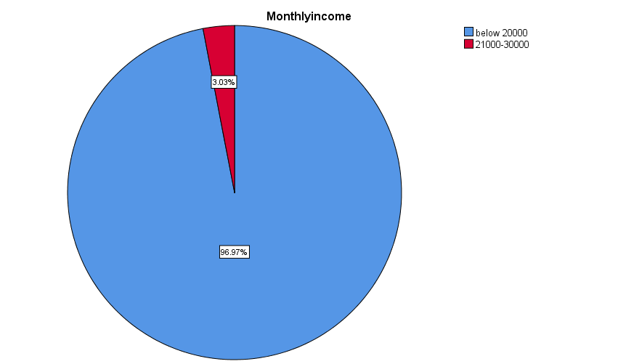

**FIGURE: 4**

**INTERPRETATION:** From the above table it is interpreted that 92.3% are Below Rs20000, 2.9% are Rs21000-30000

1. **ONEWAY-ANOVA**

To find relationship difference between convenience and satisfaction level of using bank account.

**NULL HYPOTHESIS (H0):** There is a significance difference between convenience and satisfaction level of using bank account.

**ALTERNATIVE HYPOTHESIS (H1**): There is no significance difference between convenience and satisfaction level of using bank account.

**Table 5**

|  |  |  |  |  |  |
| --- | --- | --- | --- | --- | --- |
| **ANOVA** | | | | | |
| Monthly income | | | | | |
|  | Sum of Squares | df | Mean Square | F | Sig. |
| Between Groups | .199 | 3 | .066 | 2.330 | .079 |
| Within Groups | 2.710 | 95 | .029 |  |  |
| Total | 2.909 | 98 |  |  |  |

INFERENCE

The significant value 0.079 is less than the table significant value (0.079>0.05). H0 is accepted and H1 is rejected.

Therefore, there is significance difference between convenience and satisfaction level of using bank account.

1. **CHI-SQUARE**

To find the relationship between quality services and customer satisfaction.

**NULL HYPOTHESIS (H0**): There is no significance difference between quality services and customer satisfaction.

**ALTERNATIVE HYPOTHESIS (H1):** There is significance difference between quality services and customer satisfaction.

**TABLE 6**

|  |  |
| --- | --- |
| **Test Statistics** | |
|  | Did the banks are satisfy your needs |
| Chi-Square | 10.240a |
| df | 1 |
| Asymp. Sig. | .001 |
| a. 0 cells (0.0%) have expected frequencies less than 5. The minimum expected cell frequency is 50.0. | |

**INFERENCE**

The significant value 0.001 is less than the table significant value (0.001<0.05).

H0 is rejected and H1 is accepted.

Therefore, there is significance difference between quality services and customer satisfaction.

1. **CORRELATION**

To find the effect of service provided and satisfaction level of the customer.

NULL HYPOTHESIS(H0): There is no significant difference between service provided and the level of the customer.

ALTERNATIVE HYPOTHESIS(H1): There is a significant difference between service provided and the level of the customer.

**TABLE 7**

|  |  |  |  |
| --- | --- | --- | --- |
| **Correlations** | | | |
|  | | Do you think of it as something you need or don’t need | What be the top things you would generally consider |
| Do you think of it as something you need or don’t need | Pearson Correlation | 1 | .031 |
| Sig. (2-tailed) |  | .759 |
| N | 100 | 100 |
| What be the top things you would generally consider | Pearson Correlation | .031 | 1 |
| Sig. (2-tailed) | .759 |  |
| N | 100 | 100 |

INFERENCE

The significant value 0.759 is less than the table significant value (0.759>0.05).

H0 is rejected and H1 is accepted.

**FINDINGS**

According to the study, one of 100 respondents, 100% are between 21 – 30years. According to the study, it is interpreted that 49% are male and 51% of respondents are female. Majority (51%) are female. According to the study, interpreted that 82.7% are Student, 3.8% are Government Employees,8% are Private Employees, 2% Other. Majority (82.7%) Students. According to the study, table it is interpreted that 92.3% are Below Rs20000, 2.9% are Rs21000-30000.

**SUGGESTIONS**

A bank account can be convenient if you need a place to deposit paychecks or a way to pay bills and cover everyday spending. But not everyone has a bank account.  households are either underbanked, meaning they rely on nontraditional banking options, or unbanked, meaning they have no bank account at all.

Opening a bank account has its benefits, and the process isn’t as complicated as it may seem. Opening a bank account is generally a fast process that can take anywhere from a few minutes to a few days, depending on the financial institution and the type of account. Most banks can open accounts on the same day when you apply in person.

Opening a bank account online can take minutes, but you’ll have to wait five to seven business days for a physical debit card if you plan to use the account for purchases at retailers that don’t support digital wallets.

**REFERENCE**

* <https://www.bing.com/ck/a?!&&p=9af21e26ac5c61f7JmltdHM9MTY5NDA0NDgwMCZpZ3VpZD0yOTdlOTVlZi1kNDgxLTYyZDMtMTQ1ZS04NmZlZDUyYzYzMzYmaW5zaWQ9NTMzMw&ptn=3&hsh=3&fclid=297e95ef-d481-62d3-145e-86fed52c6336&psq=reference+for+opening+an+bank+account&u=a1aHR0cHM6Ly93d3cuYmFua29mYmFyb2RhLmluL3BlcnNvbmFsLWJhbmtpbmcvYWNjb3VudHM&ntb=1>
* Khan, D. H. (2017). E-Banking: Benefits and Issues. American Research Journal of Business and Management, 1-7.
* Dr. Jagdeep Singh, M. J. (2018). The Impact of E-banking on Service Quality: (A Case Study of Selected Cities of Punjab). International Journal of Management Studies, 114-127.