Implementation of Hybrid Serial communication protocol

¹Vivek Kumar, ²Deepak Sharma
¹M.tech Scholar, ²Assistant Professor
^{1, 2}Dept. of ECE, LNCT (Bhopal) Indore Campus, Indore (M.P)

Abstract— UART (Universal Asynchronous Transceiver) is a serial communication protocol mainly used for short-distance, low-speed, and low-cost data exchange. We don't need all the functions of UART, we just integrate its core. The UART consists of three main modules of baud rate generator, receiver, and transmitter. UART implemented in VHDL language can be integrated into FPGA to realize compact, stable, and reliable data transmission. This is very important for the design of the SOC. Simulation results with Quartos II are fully compatible with the UART protocol.
Keywords— UART, asynchronous serial communication, VHDL, Quartus II, simulation.

Introduction
Data transmission refers to the process of transferring data between two or more digital devices. Data is transmitted from one device to another in analog or digital format. Basically, data transmission enables devices or components within devices to speak to each other.
Data is transferred in the form of bits between two or more digital devices. There are two methods used to transmit data between digital devices: serial transmission and parallel transmission. Serial data transmission sends data bits one after another over a single channel. Parallel data transmission sends multiple data bits at the same time over multiple channels.
Serial communication is a way of transmitting data between two devices one bit at a time over a single communication line. It is commonly used in microcontrollers, embedded systems, and other electronic devices.
Serial communication can be either synchronous or asynchronous. In synchronous communication, the transmitter and receiver are synchronized using a clock signal, while in asynchronous communication, no clock signal is used. Instead, the data is transmitted as a series of bits, with each byte being preceded by a start bit and followed by one or more stop bits.
There are several types of serial communication protocols, including UART (Universal Asynchronous Receiver-Transmitter): As described earlier, UART is a type of asynchronous communication that is commonly used in microcontrollers and other embedded systems.
- SPI (Serial Peripheral Interface.
- I2C (Inter-Integrated Circuit.
- CAN (Controller Area Network).
- USB (Universal Serial Bus).
- UART (Universal Asynchronous Receiver-Transmitter).
UART is widely used in embedded systems due to its simplicity, low cost, and low power consumption. It is often used for communication between a microcontroller and other peripherals such as sensors, displays, and other microcontrollers.

Data bits

 |  | 1 | 2 | 3 | 4 | 5 | 6 | 7 | 8

Idle bit Start bit Parity bit Stop bit

Fig. 1. UART Frame Format.

LITERATURE REVIEW
This paper [9] tries to make a design demonstrated into VHDL which means testing UART communication protocols’ ability to be demonstrated and stable. The paper delivers an overview of the use of the protocol.
In the meantime, this paper [10] makes efforts to design and synthesize a UART block protocol communication. The research in this paper applies the Baud Rate Generator, Transmitter, and Receiver Modules.
In the paper [11], the investigation makes a design that can run SPI communication protocol in FPGA. The paper also defines how Clock Polarity and Phase which is a mode that can be used for synchronization between master and slave. The paper describes the port description used both on SPI Master and SPI Slave.
In the paper "SPI Execution on FPGA" [12], the study also tried to implement SPI communication protocol on FPGA. In the projected architectural design, the project uses registers on SPI Master and SPI Slave. Also in this architectural design is the use of Clock Generator.

UART1 UART2

TX RX
Baud Baud
rate rate
RX TX

Fig. 2 Architecture UART.

Fig. 3 Timing diagram UART

III. METHODOLOGY AND SYSTEM DESIGN

Methodology
UART communication Protocol has the following components.
- Baud rate: Baud rate defines the speed of communication. The unit of Baud rate is bits/s. The Baud rate of the sender and receiver must be the same.
- Data Bits: It is also important to define the size of the frame. That is known as data bits. After the completion of one frame sender has to send either a start bit or stop bit so that the receiver knows the data transfer is completed.
- Parity: This is used to detect an error in communication. It may be odd parity or even parity. This protocol is not mandatory it depends on the developer, whether they want to use it or not. It can be selected as none.
- Stop Bit: Polarity defines the Start bit or Stop bit. That menace Start bit maybe 0 or 1 same as stop bit maybe 0 or 1. If the start bit is 0 then the stop bit is 1 and vice versa.

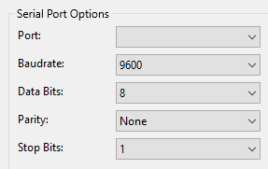

Fig. 4 UART Protocol.

Proposed Methodology.
- Issue in existing design:
In the existing design, it is compulsory to send the fixed frame length whether it’s an important bit or not.
Ex- 1: I have to send “A”.
ASCII value of A is 0x41 in
0 | 1 | 0 | 0 | 0 | 0 | 0 | 1
MSB LSB
The last MSB bit is not an important bit if we consider the hex value of “A”.
So it is not important to send. It means that the frame length is not fixed during communication. It is decided at run time.
Ex- 2: I have to send “Hello World”.
In the above string “Hello World” the char l repeats. So no need to send it again. And I can save here the 8-bit data sending time.
- My design:
In my design, I connect an extra clock line that indicates the start and end of the frame due to which it is not important to fix the frame length of each byte and I can save the time consumption that is used in sending unwanted bits.
Also, the clock line can indicate to the receiver that to repeat the last sent byte, and therefore no need to send the repeated word hence it increases the speed of communication.
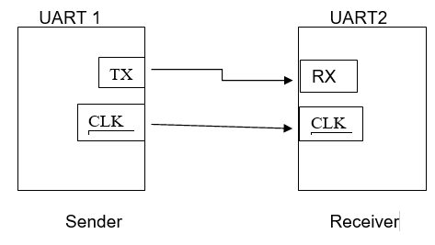
Fig. 5 Hybrid UART.

Working:
CLK line always keeps at a HIGH state. When Transmitter has to start the communication it pulls the CLK line LOW. The transmitter keeps CLK at a LOW state until sends all usable bits using the TX line at a fixed Baudrate.
Data line Toggle HIGH and LOW according to set Baudrate until all usable data send.

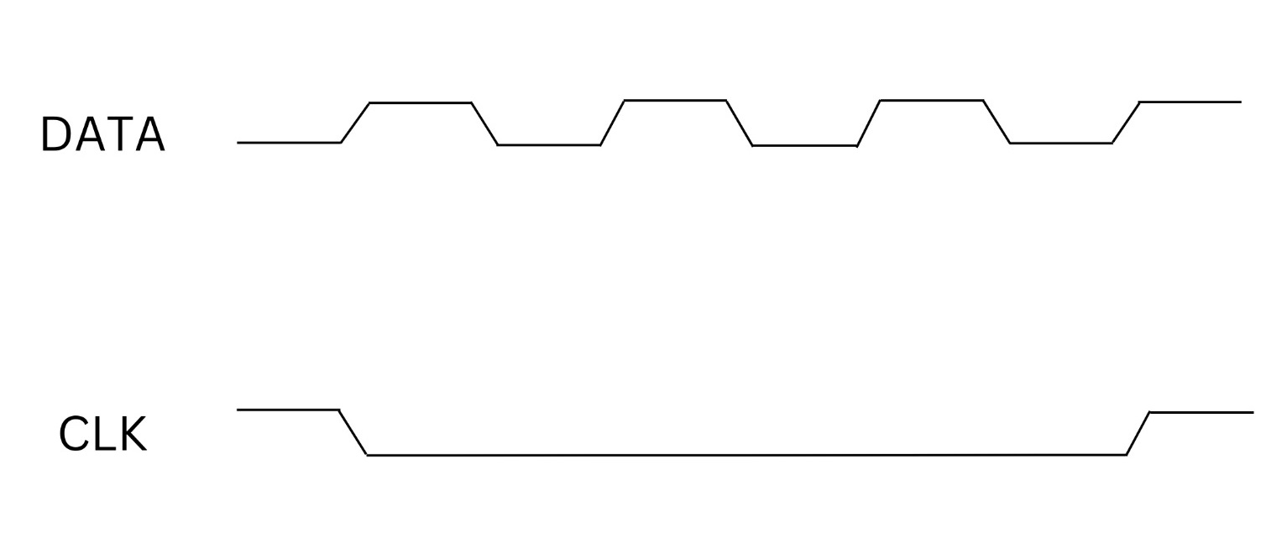

Fig. 6 Clock Diagram.

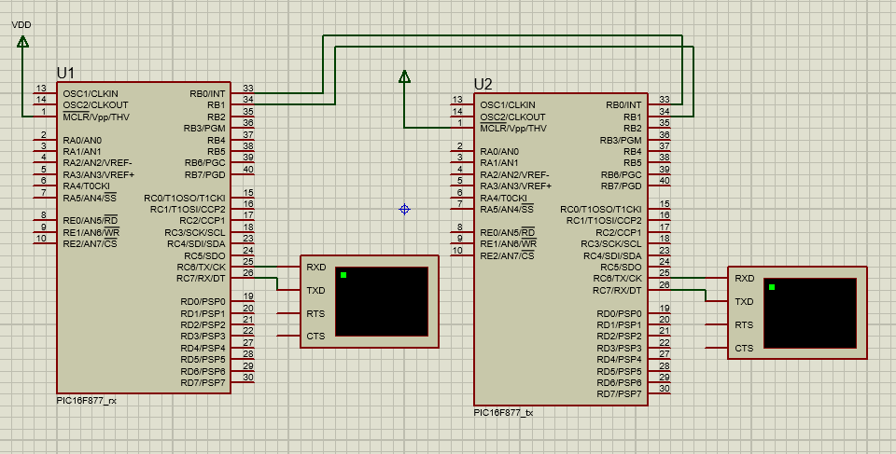

Fig. 7 Implementation.

The receiver controller waits until the CLK line is HIGH. When the CLK line becomes LOW receiver starts reading the DATA line and according to the baud rate it receives bits. The remaining bit from MSB is 0 and it becomes a char of 8 bits.
In the case of the last send char being the same as the present sending character then only CLK becomes LOW and only 1 bit later it comes HIGH. The receiver understands that it has to repeat the last received byte.

To implement the above Hybrid UART communication Protocol we need controllers. I can take the GPIO of the controller as TX, RX, and clock line. I can define timer interrupts for Baudrate bit sampling and Hardware interrupts for frame end detection. The rest bit is automatically filed with 0 so there is no chance of error in communication.
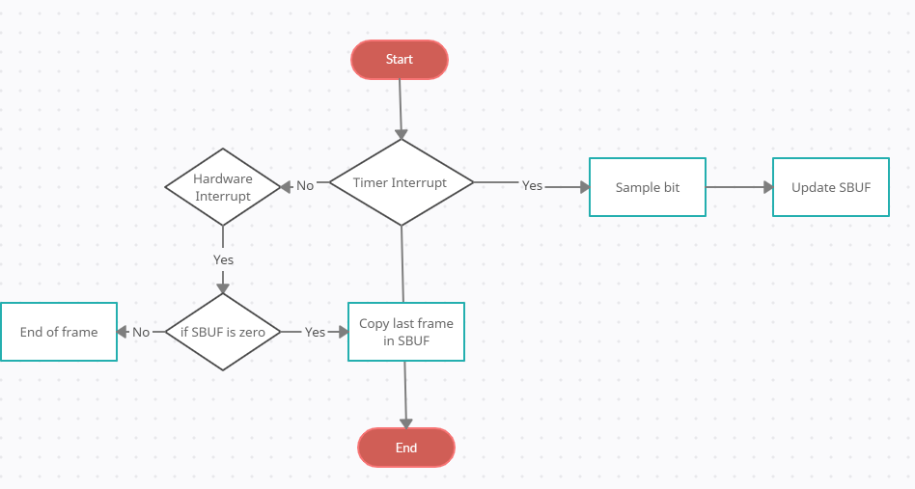
Fig. 8 Implementation of Receiver.

On the transmitter side we need a bit counter that counts the valid bits in a frame to send and also checks the last send byte and upcoming byte is the same. So that without sending the bits transmitter simply sends the end-of-frame signal and the receiver copies the last char from SBUF.
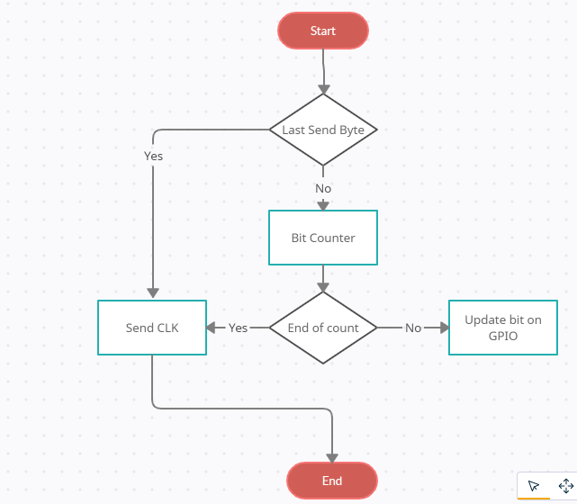
Fig. 9 Implementation of Transmitter.

Result.
In the proposed Hybrid method of UART communication Protocol, the Total time to send a particular word depends on many factors.
Now let’s take an example to calculate the increased speed with the same Baudrate.
We have to send the string “Hello World”.
Let the Baudrate of communication is 9600.
The total character in the given string is 11.
So no of bits that have to send is 11*(8+1).
8 = Frame length.
1 = Start bit.
So total time = 11*9 / 9600 = 0.0103125 S.

Now sending the same string using Hybrid UART.
The valid bits in each char are 7.
And the continuous repetition of char is 1.
So the total no of chars is 10.
CLK required = 11
So total time = (10*7+11)/9600 = 0.0084375 S.
I.e. the Hybrid UART is 1.22 Times faster than the old UART.
IV. CONCLUSION AND FUTURE SCOPE
Conclusion.
UART communication protocol plays a vital role in the field of serial communication. Because of its simple design and less wiring. It is also very famous because it is very easy to implement in any hardware either via software or hardware.
It’s also very easy for programmers to implement because of its simple design protocol. In the available UART protocol, the suggested implementation will increase the communication speed and make UART for fast communication with available resources. The speed can be increased min of 1.22 times of available speed. That reduces the use of SPI which is a complex communication protocol as well as requires 4- wire to communicate.
Future Scope.
Serial communication is the backbone of a communication system because of its less no of required hardware and long-distance communication protocol.
Since serial communication sends the data in series it requires only a single line which reduces the cost of hardware. It also reduces the maintenance cost.
In serial communication, it is very easy to find errors in transmission lines because of less no wiring.
The Suggested Hybrid UART will increase the speed of UART communication protocol and increase the usability of UART.
In the Future speed of data, transmission is very important. So it is very essential to increase the speed of available serial communication protocol.

References

- Zou,Jie Yang,Jianning。Design and Realization of UART Controller Bas ed on FPGA.
- Liakot Ali ， Roslina Sidek ， Ishak Aris ， Alauddin Mohd. Ali ， Bambang Sunaryo Suparjo. Design of a micro - UART for SoC application [J].In: Computers and Electrical Engineering 30 (2004) 257– 268.
- HU Hua, BAI Feng-e. Design and Simulation of UART Serial Communication Module Based on Verilog -HDL[J]. J ISUANJ I YU XIANDA IHUA 2008 Vol. 8.
- Frank Durda Serial and UART Tutorial. uhclem@FreeBSD.org.
- statista, “Internet of things (iot): number of connected devices worldwide from 2012 to 2020 (in billions),” https://www.statista.com/statistics/471264/iot-number-of-connecteddevices-worldwide/, 2017, accessed : 2017-02-11.
- R. Buyya and A. V. Dastjerdi, Internet of Things: Principles and paradigms. Melbourne, Australia: Elsevier, 2016.
- M. Abdurohman, A. Sasongko, and R. Rawung, “Mobile tracking system based on event driven method,” in Applied Mechanics and Materials, vol. 321-324. Trans Tech Publ, 2013, pp. 536–540.
- V. Suryani, A. Rizal, A. Herutomo, M. Abdurohman, T. Magedanz, and A. Elmangoush, “Electrocardiagram monitoring on openmtc platform,” in 38th Annual IEEE Conference on Local Computer Networks - Workshops. Sydney, NSW: IEEE, 2013, pp. 843–847.
- M. Abdurohman, A. Herutomo, V. Suryani, A. Elmangoush, and T. Magedanz, “Mobile tracking system using openmtc platform based on event driven method,” in 38th Annual IEEE Conference on Local Computer Networks - Workshops. Sydney, NSW: IEEE, 2013, pp. 856–860.
- M. Abdurohman, A. G. Putrada, S. Prabowo, C. W. Wijiutomo, and A. Elmangoush, “M2m device connectivity framework,” International Journal on Electrical Engineering and Informatics, vol. 9, no. 3, pp. 441–454, 2017.
- W. Dargie and C. Poellabauer, Fundamentals of wireless sensor networks: theory and practice. Chichester, United kingdom: John Wiley & Sons, 2010.
- M. Abdurohman, Perancangan Embedded System Berbasis FPGA. Yogyakarta: Graha Ilmu, 2014.
- Y.-y. Fang and X.-j. Chen, “Design and simulation of uart serial communication module based on vhdl,” in Intelligent Systems and Applications (ISA), 2011 3rd International Workshop on. IEEE, 2011, pp. 1–4.
- G. B. Wakhle, I. Aggarwal, and S. Gaba, “Synthesis and implementation of uart using vhdl codes,” in Computer, Consumer and Control (IS3C), 2012 International Symposium on. IEEE, 2012, pp. 1–3.
- V. D. Veda Patil, “Implementation of spi protocol in fpga,” International Journal of Computational Engineering Research (IJCER), vol. 3, no. 2, pp. 142–147, 2013.
- T. D. Shingare and R. Patil, “Spi implementation on fpga,” International Journal of Innovative Technology and Exploring Engineering (IJITEE), vol. 2, no. 2, pp. 7–9, 2013.
- A. K. Oudjida, M. L. Berrandjia, R. Tiar, A. Liacha, and K. Tahraoui, “Fpga implementation of i 2 c & spi protocols: A comparative study,” in Electronics, Circuits, and Systems, 2009. ICECS 2009. 16th IEEE International Conference on. IEEE, 2009, pp. 507–510.
- T. P. Blessington, B. B. Murthy, G. Ganesh, and T. Prasad, “Optimal implementation of uart-spi interface in soc,” in Devices, Circuits and Systems (ICDCS), 2012 International Conference on. IEEE, 2012, pp. 673–677.

