Power Generation using PizeoElectricity

Dr. N.Sambasiva Rao
Professor and Head of the Department of Electrical and Electronics Engineering(EEE).NRI Institute of Technology(Autonomous),
Vijayawada,India,
nsraohodeee@gmail.com
G.Rajeswari
Department of Electrical and Electronics Engineering(EEE).NRI Institute of Technology(Autonomous),
Vijayawada,India,
gurramrajeswari219@gmail.com
Mrs. S.Bhavani
Associate Professor of the Department of Electrical and Electronics Engineering(EEE).NRI Institute of Technology(Autonomous),
Vijayawada,India,
sampara.bhavani@gmail.com

Ch. Harika
Department of Electrical and Electronics Engineering(EEE).NRI Institute of Technology(Autonomous),
Vijayawada,India,
chenumoluharika23@gmail.com
T.Krishna Priya
Department of Electrical and Electronics Engineering(EEE).NRI Institute of Technology(Autonomous),
Vijayawada,India,
tkrishnapriya2003@gmail.com

R V S Sai Charan
Department of Electrical and Electronics Engineering(EEE).NRI Institute of Technology(Autonomous),
Vijayawada,India,
rvsscharan2@gmail.com

Abstract:—At the moment, the rate at which energy demand is increasing is concerning, because there aren't enough energy supplies to support sustainable development. To address the increasing demand, it is critically important to develop accessible, clean-burning energy sources that are never exhausted. Since walking is the most common daily activity, every time someone walks, they waste energy by putting it to use on the ground. This concept is affordable and easy to implement. The procedure's outcomes are then looked through and assessed. This project offers advantages including energy savings and zero emissions, both of which are advantageous for growth.

Keywords—piezoelectric sensor, pic microcontroller,streer light
- INTRODUCTION
One of the most important topics in the world today is energy, particularly in countries where the energy crisis is a significant problem. We all know that natural resources would eventually deplete. Because of this, researchers are seeking for renewable energy sources. That couldn't be bad for the environment, can it? Humans have already employed energy-harvesting technology including windmills, geothermal heat, solar energy, and piezoelectric materials. Since they derive from replenishable natural resources, they are referred to as renewable energy. These macro energy harvesting devices, commonly referred to as renewable energy collection plants, generate MW-level power. These organic resources, also known as micro energy harvesting plants, have the capacity to generate micro energy. The underlying principle of this tiny energy collection.The materials that may generate electric energy when mechanical stress is applied are known as piezoelectric materials or piezoelectrics. Quartz is a well- known piezoelectric substances. Certain materials, including quartz, topaz, etc., exhibit the piezoelectric effect, which causes them to generate an electric charge proportional to the mechanical stress placed upon them. .A material's ability to produce an AC (alternating current) voltage in response to mechanical stress or vibration, or to vibrate in response to an AC voltage, or both, is known as the piezoelectric effect or piezoelectricity. Quartz is the most typical piezoelectric substance. Due to the great efficiency of power generation, PZT material has been used in numerous commercial goods. One of the primary ways to boost the power generation is to raise the applied stress or strain on the piezoelectric material, which produces more mechanical energyThe transfer of electrical and mechanical energy within a material is described by the piezoelectric effect. More specifically, it is the linear relationship between a material's electrical polarisation and its stress state.
Important Goals:
Long-term objectives for researchers studying piezoelectronics academically and practically include increasing the output of piezoelectricity, enhancing the sensitivity of piezoelectric-based sensors, and expanding its application range.

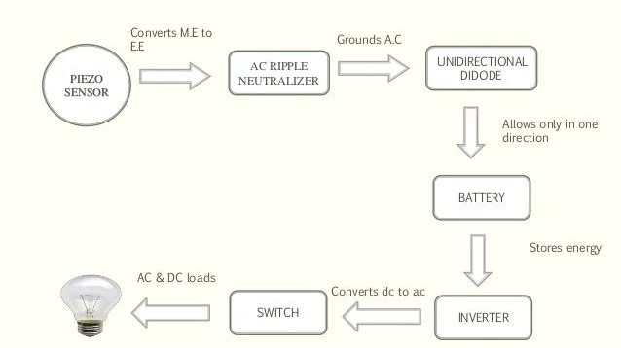
BLOCK DIAGRAM

Fig:1 Block diagram of piezoelectricity
The piezoelectric material in the block diagram is where the mechanical pressure is delivered from an outside source, and the associated vibrations are then transferred to the piezo material. "PIEZO ELECTRICITY" is the term used to describe a material's capacity to produce and tolerate an electrical potential. This piezoelectric substance produces an alternating voltage. It is necessary to rectify the generated alternating power using an AC to DC converter. Using a boost up converter, a form of DC to DC converter, this rectified DC voltage should be increased. The generated DC voltage is kept in a battery-based storage element.
PIZEOSENSOR
A piezoelectric sensor is a device that converts changes in pressure, acceleration, temperature, strain, or force into an electrical charge via the piezoelectric effect. The Greek word for "press" or "squeeze" is piezo-. Piezoelectric sensors are adaptable instruments for measuring a variety of processes.
A piezoelectric sensor has a 5V/ strain sensitivity. Quartz is the most preferred material for a piezoelectric sensor due to its great degree of flexibility. Let's take a look at a straightforward Arduino use of a piezoelectric sensor as we must first understand what it is. Here, we're attempting to turn on and off an LED when the pressure sensor senses sufficient
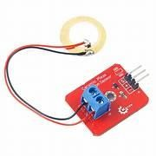

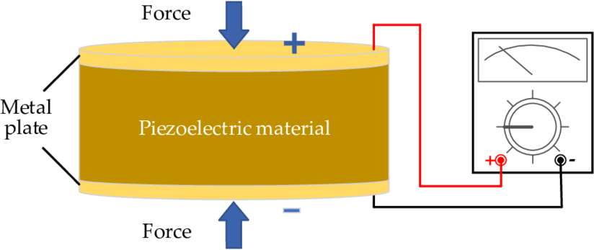

Fig:-2 Pizeo electric sensor

AC RIPPLE NEUTRALIZER SYSTEM

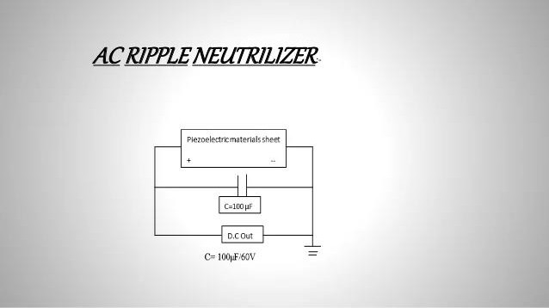
Fig :-3 Ac Neutralizer system
The ripple effect A periodic non-sinusoidal waveform called ripple current is derived from an AC power source and is characterised by pulses of high amplitude and limited bandwidth. An accompanying sinusoidal voltage waveform's peak or close to peak amplitude and the pulses' peak amplitude coincide.
With the aid of a pic16f877A pic microcontroller, an AC ripple neutralizer regulates voltage fluctuations and a unidirectional current controller regulates battery charging current. Lead acid batteries are used to store the voltage produced by a series of sensors. Both DC and AC loads can be driven by this voltage.
The ac ripple current and the dc, or average value, of the inductor current make up this signal. The current-sense amplifier Gi's output is added to an external ramp called VSLOPE to create VRAMP, which is then sent into the comparator's inverting input. The effective VRAMP in Figure 2 is 1 V. The modulator voltage gain Km is equal to 10 when VIN = 10 V.
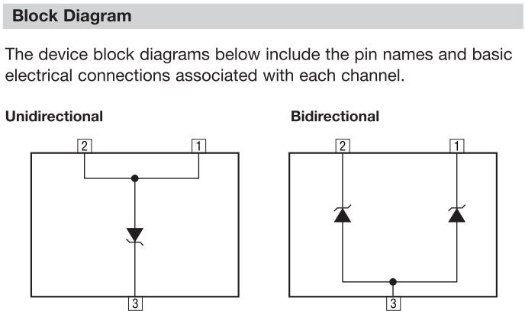
UNIDIRECTIONAL DIODE

Fig:-4 Block diagram of unidirectional diode
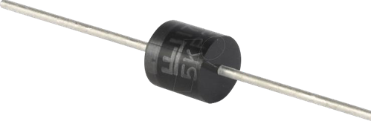
Fig :-5 shows the unidirectional diode
A unidirectional network (sometimes called a unidirectional gateway or data diode) is a network appliance or device that only allows data to flow in one direction. Data diodes are most typically seen connecting two or more networks with varying degrees of security in high security environments, such as defence.Unidirectional gateways frequently enable one-way data transfers from a network with high security to a network with lower security. Using that connection, data can be exchanged while the
By applying an electric charge to a piezoelectric material, which causes it to deform (compress or expand), this phenomena can be produced. It is electrical energy. thus This phenomenon can be created by delivering an electric charge to a piezoelectric material, which causes it to deform (compress or expand). Electrical energy is it.
LEAD ACID BATTERY
Electrons in the external circuit travel, and current-carrying ions flow through the electrolyte to create electric current. The same chemical potential exists between the two electrodes, hence a disposable battery will continue to produce electricity until its reactants are all used up.
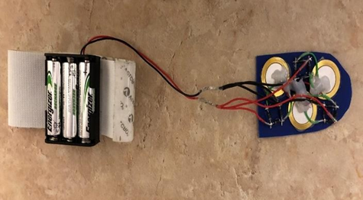
Fig:-6 Battery arrangement in pizeoelctric material

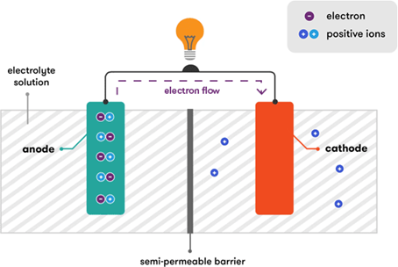
Fig :- 7 working of battery in piezoelectricity
In raise the voltage of the battery in order to use it to power a piezo device. The amplification process begins with an oscillator that generates smaller sine waves. The sine waves are then amplified by a piezo amplifier. Simply said, all battery cells are built upon this fundamental concept. Each will be covered individually. As was already mentioned, Alessandro Volta invented the first battery cell, also known as the simple voltaic cell. Making this kind of cell is remarkably easy. The electrolyte in one container is dilute sulfuric acid. One copper rod and one zinc rod are currently submerged in the fluid, and their exterior electrical connections have been made.a cathode that produces a charge
INVERTER

A power electronic device or circuitry that converts direct current (DC) to alternating current (AC) is known as a power inverter, inverter, or invertor. The exact gadget used determines the produced AC frequency. Rectifiers, which were initially substantial electromechanical machines converting AC to DC, accomplish the opposite with inverters.

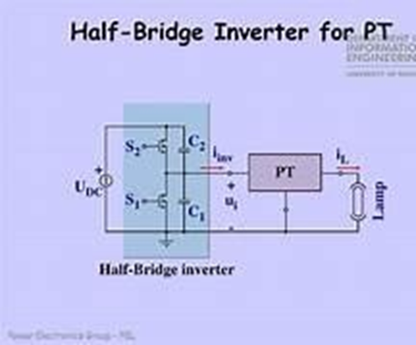

Single-phase half bridge inverters are one type of single-phase bridge inverter. A voltage source inverter, that is. An inverter that uses a DC voltage as its input source is called a voltage source inverter. In general, bridge inverters fall into one of two categories: single-phase half bridge inverters or single-phase full bridge inverters.
COMPLETE SET UP

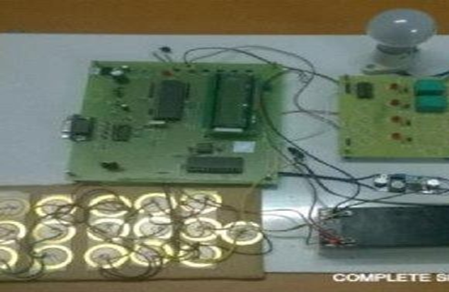
Fig :-8 circuit and connections for power generation

Inducing an electric field into a piezoelectric material will generate strain within the material, and mechanical strain on a piezoelectric material will result in polarity in the material. Mechanical strain and electric fields acting on a material cause piezoelectricity. Net polarisation and the formation of a dipole when pressure is applied to a piezoelectric material in the direction of the applied tension.

ARDUINO
The diagram above, fig.-9 displays the hardware connections for the Arduino interface for the piezoelectric sensor. Piezoelectric sensors have two output pins, one at positive potential and the other at negative potential, or ground. Positive potential pin is connected to the Arduino's pin 3 analogue channel, and negative potential pin is connected to ground.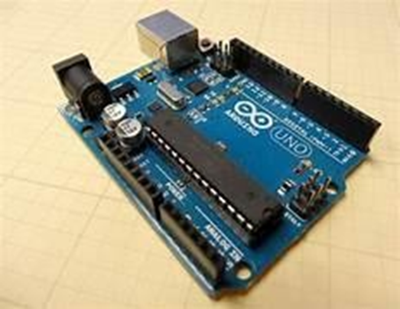
Fig :-9 It shows Arduino set up

ARDUINO SPECIFICATIONS
- PARAMETERS VALUE
- Input voltage 7-12V
- Temperature range
- Input voltage limits 6-20V
- Analog i/p pins 6 (A0-A5)
- DC current on I/O pins 40mA
- DC current on 3.3V pin 50mA
- Operating Voltage Range (V) 5v
- Digital I/O Pin Count 14(Out of which 6 provide PWM o/p)
- Flash memory 32 KB
- Data EEPROM (bytes) 1 KB
- SRAM Bytes 2 KB
- Frequency (clock speed) 16 MHz

FEATURES OF ARDUINO
- The operating voltage is 5V.
- The recommended input voltage will range from 7v to 12V.
- The input voltage ranges from 6v to 20V.
- Digital input/output pins are 14.
- Analog i/p pins are 6.
- DC Current for each input/output pin is 40 mA.
- DC Current for 3.3V Pin is 50 mA.
- Flash Memory is 32 KB.

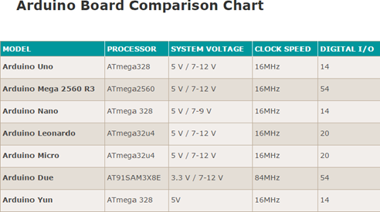

CONCLUSION

The major objective of this design is to minimise the electricity crisis by implementing dependable and environmentally pleasant renewable energy sources through foot power generation. For example, piezoelectric micro-electro-mechanical (MEM) system, piezoelectric road signs, self- powered piezoelectric power generation shoes, passive safety-belt detecting device, and wireless sensor network are some examples of recent research papers that focus on piezoelectric power generation in the fields of mechanical, material, microelectronic science, and certain limited and special application areas. The appropriate use of piezoelectric energy generation in the sphere of electricity production is also presented in this research. Since they can hold a lot of tension, flexible piezoelectric materials are appealing for power production applications. Vibrational energy can be transformed into electrical energy using piezoelectric materials. This electrical energy can be utilised after conversion.

Acknowledgment
It is highly acknowledged that the Department of Electrical and Electronics Engineering(EEE) at NRI Institute of Technology,Agiripalli has provided assistance.

References
- G. Eason, B. Noble, and I. N. Sneddon, “On certain integrals of Lipschitz-Hankel type involving products of Bessel functions,” Phil. Trans. Roy. Soc. London, vol. A247, pp. 529–551, April 1955. (references)
- J. Clerk Maxwell, A Treatise on Electricity and Magnetism, 3rd ed., vol. 2. Oxford: Clarendon, 1892, pp.68–73.
- I. S. Jacobs and C. P. Bean, “Fine particles, thin films and exchange anisotropy,” in Magnetism, vol. III, G. T. Rado and H. Suhl, Eds. New York: Academic, 1963, pp. 271–350.
- R. Nicole, “Title of paper with only first word capitalized,” J. Name Stand. Abbrev., in press.
- Y. Yorozu, M. Hirano, K. Oka, and Y. Tagawa, “Electron spectroscopy studies on magneto-optical media and plastic substrate interface,” IEEE Transl. J. Magn. Japan, vol. 2, pp. 740–741, August 1987 [Digests 9th Annual Conf. Magnetics Japan, p. 301, 1982].
- M. Young, The Technical Writer’s Handbook. Mill Valley, CA: University Science, 1989.

