IMPACT ON EFFECTIVENESS OF USER PERCEPTION ON USING CHATGPT

1AJITH N AND 2MUTHUMANI S

1MBA STUDENT JERUSALEM COLLEGE OF ENGINEERING, CHENNAI

2PROFESSOR AND HEAD MBA, JERUSALEM COLLEGE OF ENGINEERING, CHENNAI

ABSTRACT:

The advent of AI technologies like ChatGPT has ushered in a new era of human-computer communication. This paper delves into a critical aspect of this interaction the impact of user perception on the effectiveness of ChatGPT. While the technical prowess of ChatGPT is evident, its success hinges on how users perceive its responses, abilities, and limitations. The abstract explores the intricate relationship between user perception and the system's performance, discussing how accurate responses, contextual understanding, transparency, and ethical considerations play pivotal roles. The study emphasizes the significance of user satisfaction, trust, and acceptance, while also acknowledging the challenges posed by system limitations and potential misunderstandings. By examining the correlation between user perception and ChatGPT's effectiveness, this abstract provides valuable insights into optimizing human-AI interactions for enhanced user experiences.

Keywords:- ChatGPT; Chatbot; AI; RLHF; Natural Language; NLP; Open AI; Bard; SFT Model; RM Model; PPO.

Introduction

In the rapidly evolving landscape of artificial intelligence, ChatGPT has emerged as a prominent example of natural language processing technology. Designed to engage in human-like conversations, ChatGPT has the potential to revolutionize the way we interact with machines. However, its effectiveness hinges not only on its technical capabilities but also on how users perceive and interpret its responses. The user's perception of influences their satisfaction, trust, and willingness to engage with the system. This interplay between user perception and system performance ChatGPT's performance, reliability, and alignment with their needs directly underscores the importance of understanding the impact that user perception can have on the utilization and acceptance of ChatGPT.

Reviwe of literature

Conversational AI systems that use large language models like ChatGPT have become increasingly popular in recent years. These systems are capable of generating human-like responses to user queries and interactions, but there are concerns about the privacy and security of user data in these systems, particularly given the complexity of the algorithms and machine learning techniques used to generate responses. A survey of 500 users conducted by the consulting firm Capgemini found that 56% of respondents were comfortable interacting with virtual assistants that use large language models, but users also had concerns about the accuracy and transparency of these systems, as well as about the collection and use of their personal data (Capgemini, 2019). A study by researchers at the University of California, Berkeley found that some chatbots using large language models could be exploited by attackers to extract sensitive information from users. The study also identified issues with the transparency and explain ability of these systems, which could make it difficult for users to understand how their data is being used (Li et al., 2020). There are also ethical considerations involved in the use of ChatGPT in conversational AI systems. For example, there are concerns about the potential for these systems to perpetuate biases and stereotypes, particularly if they are trained on datasets that contain biased or incomplete information. There are also concerns about the accountability of these systems, particularly in cases where they make decisions that have real-world consequences (Holstein & Schultz, 2019).

Methodology

This study used a descriptive statisticsmethod to investigate user perceptions and attitudes towards conversational AI systems that use ChatGPT. A survey was administered through google form to a sample of 101 users to gather the data.The quantitative data collected in this study was analyzed using descriptive statistics, such as frequencies and percentages, to summarize the characteristics of the sample and identify patterns in user attitudes towards the use of ChatGPT

Impact on effectiveness of user perception on using chatgpt

To know the impact of using chatgpt

To know the awarness of chatgpt among public

To identify the factors affecting using chatgpt

ANALYSIS

1. PERCENTAGE ANALYSIS

TABLE 1

|  |  |  |  |  |  |
| --- | --- | --- | --- | --- | --- |
| **Gender** | | | | | |
|  | | Frequency | Percent | Valid Percent | Cumulative Percent |
| Valid | Male | 59 | 59.0 | 59.0 | 59.0 |
| Female | 41 | 41.0 | 41.0 | 100.0 |
| Total | 100 | 100.0 | 100.0 |  |

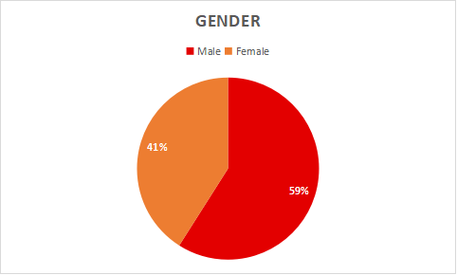

Figure: 1

Interpretation: Form the above table it is interpreted that 59% are male and 41%of respondents are female majority(59)are male

1. AGE FOR RESPONDENTS

TABLE 2

|  |  |  |  |  |  |
| --- | --- | --- | --- | --- | --- |
| **Age** | | | | | |
|  | | Frequency | Percent | Valid Percent | Cumulative Percent |
| Valid | 18-24 | 77 | 77.0 | 77.0 | 77.0 |
| 24-34 | 9 | 9.0 | 9.0 | 86.0 |
| 35-40 | 5 | 5.0 | 5.0 | 91.0 |
| Above40 | 9 | 9.0 | 9.0 | 100.0 |
| Total | 100 | 100.0 | 100.0 |  |

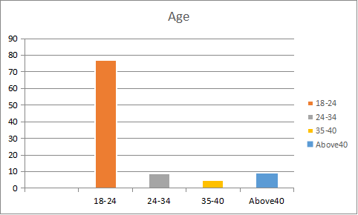

FIGURE: 2

INTERPRETATION: From the above table it is interpreted that 77 are 18-24

years, 9 are 24-34 years, 5 are 35-40 years and 9 are above 40 and above. Majority

(77) are 18-24 years.

3. EDUCATIONAL QUALIFICATION

TABLE 3

|  |  |  |  |  |  |
| --- | --- | --- | --- | --- | --- |
| **Education background** | | | | | |
|  | | Frequency | Percent | Valid Percent | Cumulative Percent |
| Valid | High school | 14 | 14.0 | 14.0 | 14.0 |
| Bachelor's degree | 24 | 24.0 | 24.0 | 38.0 |
| Master's degree | 53 | 53.0 | 53.0 | 91.0 |
| Professional course | 9 | 9.0 | 9.0 | 100.0 |
| Total | 100 | 100.0 | 100.0 |  |

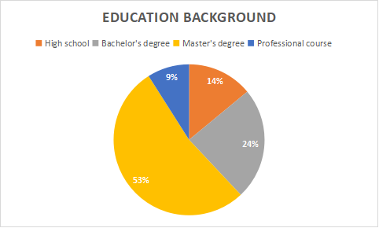

FIGURE:3

INTERPRETATION:

From the above table it is interpreted that 9 high school are 24 Bachelor’s degree, 14 are Master’s degree, 53 are Professional degree, majority (53) master’s degree

4 EMPLOYMENT STATUSES

TABLE 4

|  |  |  |  |  |  |
| --- | --- | --- | --- | --- | --- |
| **Occupation** | | | | | |
|  | | Frequency | Percent | Valid Percent | Cumulative Percent |
| Valid | Student | 68 | 68.0 | 68.0 | 68.0 |
| Empolyee | 20 | 20.0 | 20.0 | 88.0 |
| Umempolyee | 3 | 3.0 | 3.0 | 91.0 |
| Retried | 3 | 3.0 | 3.0 | 94.0 |
| Homemaker | 6 | 6.0 | 6.0 | 100.0 |
| Total | 100 | 100.0 | 100.0 |  |

FIGURE:4

INTERPRETATION: From the above table it is interpreted that 68,student, 20, empolyee, 3, unemployed, 3, retried, 6homemaker and ,majority(68) student

*5.* ANNUAL INCOMETABLE 5

|  |  |  |  |  |  |
| --- | --- | --- | --- | --- | --- |
| **Income (per month)** | | | | | |
|  | | Frequency | Percent | Valid Percent | Cumulative Percent |
| Valid | Below 10000 | 50 | 50.0 | 50.0 | 50.0 |
| 10000-30000 | 38 | 38.0 | 38.0 | 88.0 |
| 30000-50000 | 9 | 9.0 | 9.0 | 97.0 |
| Above 50000 | 3 | 3.0 | 3.0 | 100.0 |
| Total | 100 | 100.0 | 100.0 |  |

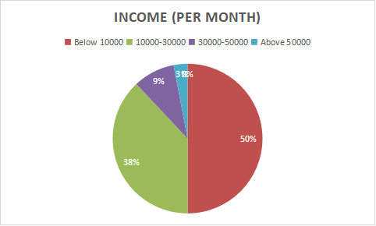

FIGURE:5

INTERPRETATION: From the above table it is interpreted that Below 100000,

Are 50 Rs100000-300000,38 are Rs 300000-500000 are 9 and 500000 Above are .3

Majority (50) are below10000

ONEWAY ANOVA

TABLE 6

One-Way Analysis of Variance (ANOVA) is a statistical technique used to compare means across multiple groups. It's commonly used when you have one independent variable (also known as a factor) with more than two levels, and you want to determine if there are any significant differences in the means of a dependent variable among those levels.

Inference

To find out the difference between the frequency of using chat gpt and how respondents came to know about chat gpt

NULL HYPOTHESIS

Ho: There is no difference between the frequency of using chat gpt and how respondents came to know about chat gpt

**ALTERNATIVE HYPOTHESIS**

H1: There is difference between the frequency of using chat gpt and how respondents came to know about chat gpt

|  |  |  |  |  |  |
| --- | --- | --- | --- | --- | --- |
| **ANOVA** | | | | | |
| How did you come to know about chatgpt | | | | | |
|  | Sum of Squares | df | Mean Square | F | Sig. |
| Between Groups | 7.376 | 4 | 1.844 | 1.976 | .104 |
| Within Groups | 88.664 | 95 | .933 |  |  |
| Total | 96.040 | 99 |  |  |  |

**Chi-Square Tests**

TABLE 7

The Chi-Square test is a statistical method used to determine if there is a significant association or relationship between categorical variables. It's commonly used to analyse data in the form of frequency counts or proportions in contingency tables. The Chi-Square test assesses whether the observed frequencies in the table differ significantly from the expected frequencies, assuming that there is no association between the variables

Inference

To find out the association between the satisfaction level of the respondent and recommnent of chat Gpt

NULL HYPOTHESIS

H0: there is no the satisfaction level of the respondent and recommnent of chat Gpt

ALTERNATIVE HYPOTHESIS

H1: there is the satisfaction level of the respondent and recommnent of chat Gpt

|  |  |  |  |
| --- | --- | --- | --- |
| **Chi-Square Tests** | | | |
|  | Value | df | Asymptotic Significance (2-sided) |
| Pearson Chi-Square | 4.698a | 3 | .195 |
| Likelihood Ratio | 5.014 | 3 | .171 |
| Linear-by-Linear Association | 1.514 | 1 | .219 |
| N of Valid Cases | 100 |  |  |
| a. 2 cells (25.0%) have expected count less than 5. The minimum expected count is .64. | | | |

FINDINGS

According to the study, 59% are male and 41%of respondents are female. Majority(59) are male.According to the study, 77are 18-24years, 9 are 24-34years, 5are 35-40 years and 9 are 40 above. Majority (77) are 18-24 years According to the study, 9 high school are 24 Bachelor’s degree, 14 are Master’s degree, 53are Professional degree, majority (53) master’s degree According to the study, 68,Student, 20, Empolyee, 3, Umempolyee, 3, Retried, 6 Homemaker and ,majority(68)Below 100000, 38are50 Rs100000-300000, 9 are Rs 300000-500000 and 3 are 500000 Above.Majority (50) are below10000

SUGGESTIONS

Chat GPT is al that was a use an under the age group of 18-24 with a percentage of 77.0% from this we can must use the age group of between 18 and 24 can look for Chat GPT and mainly user on Chat GPT and 59% are male and 41% of female use on Chat GPT use and student 68% that was must and more use on chat gpt and this is user free Chat bot The advent of AI technologies

Reference

Beldad, A., Hegner, S., &Finne, Å. (2020). Factors affecting consumer trust and distrust in artificial intelligence advice in decision-making. Journal of Business Research, 108, 63-75.

Bernal, D. D., Castaño-Monsalve, J. F., & Sierra, G. M. (2021). Conversational agents and data privacy: A systematic review. Expert Systems with Applications, 167, 114193.

Galarneau, C., & Hall, R. (2019). Chatbots and the new world of HCI. In Proceedings of the 24th International Conference on Intelligent User Interfaces (pp. 505-506).

Li, Y., Ott, M., Cardie, C., &Hovy, E. (2020). Towards making the black box more transparent: Investigating feedback mechanisms in natural language generation. In Proceedings of the 58th Annual Meeting of the Association for Computational Linguistics (pp. 2381-2396).

Holstein, K., & Schultz, J. (2019). Neural networks and the need for explainability. In Proceedings of the IEEE/ACM International Conference on Advances in Social Networks Analysis and Mining (ASONAM) (pp. 982-989).]