Accident Alert System Using Gps and Gsm

|  |  |  |  |  |  |  |  |
| --- | --- | --- | --- | --- | --- | --- | --- |
|  | Dr. N.Sambasiva Rao | |  | L. Prasanna Kumar |  | Komaravalli Abhilash | |
|  | Professor and Head of the | |  | Department of Electrical and |  | Department of Electrical and | |
|  | Department of Electrical and | |  | Electronics Engineering (EEE). NRI |  | Electronics Engineering (EEE). NRI | |
| Electronics Engineering(EEE) | | |  | Institute of Technology (Autonomous) |  | Institute of Technology(Autonomous) | |
| NRI Institute of Technology(Autonomous), | | | | Vijayawada, India, |  | Vijayawada, India, | |
|  | Vijayawada, India, | | [prasannakumar122315@gmail.com](mailto:prasannakumar122315@gmail.com) | |  | abhilashkomaravalli5222@gmail.com | |
|  | nsraohodeee@gmail.com |  |  |  |  |  |  |
|  | Loya Gowtham Chand | |  | M Naga Bhagya Lakshmi | Shaik Asia, Thindi Ravindra Reddy | | |
|  | Department of Electrical and | |  | Department of Electrical and |  | Department of Electrical and | |
| Electronic Engineering (EEE). NRI | | |  | Electronic Engineering (EEE). NRI | Electronic Engineering (EEE). NRI | | |
| Institute of Technology (Autonomous) | | |  | Institute of Technology(Autonomous) | Institute of Technology(Autonomous) | | |
|  | Vijayawada, India | |  | Vijayawada, India |  | Vijayawada, India | |
| [gowthamloya@gmail.com](mailto:gowthamloya@gmail.com) | | |  | [3010luckylakshmi@gmail.com](mailto:3010luckylakshmi@gmail.com) |  | [ravindra160402@gmail.com](mailto:ravindra160402@gmail.com) | |

safety and accident management, these solutions can assure faster

***Abstract*—The accident alert system using GPS and GSM is a cutting-edge safety solution designed to give greater value to straight away help needed move in the event of road accident. The system is got mixed together into vehicles and got ready with GPS parts of a greater unit to constantly computer viewing output the vehicle's position and rate of motion. When accident takes place, the system's built-in sensors 3 discover the force of meeting blow and apparatus to start in motion a ready. The GPS part of a greater unit then takes the right in details placing of the accident. upon sensing the accident, the system uses the GSM part of a greater unit to send a short time Distress 4 sign put out to the nearest straight away help needed support inside middle. The ready has in it full of force news given, such as the error placing, vehicle details, and the seriousness of the force of meeting blow.**

**Keywords—GPS, GSM, Accident, Vehicle, Sensors, Response Position.**

I. INTRODUCTION

Accident alert systems are technologically advanced safety mechanisms created to instantly warn the appropriate authorities or emergency services when an accident happens. The system is often incorporated into automobiles, mobile devices, or infrastructure to speed up reaction times and increase the likelihood of giving individuals hurt in accidents urgent aid. An accident warning system's main goal is to automatically recognize and report situations, including vehicle accidents or other crises, without relying exclusively on human interaction. The technology may alert emergency services instantly when an accident is detected, providing vital details including the incident's location, time, and severity. GPS, sensors, accelerometers and communication networks are just a few of the technology used in these systems.

Together, these elements properly pinpoint the moment of an accident, communicate the vital information to first responders, shorten response times, and perhaps save lives. Accident alarm systems could greatly increase the efficiency and decrease the response time of emergency services, particularly in rural or sparsely populated locations where accidents might not be quickly seen by onlookers. In addition to improving overall traffic

Aid and medical care by automating the reporting procedure. Road Accidents continue to be a significant cause of fatalities and injurie Worldwide, more than 1.3 million people die annually due to road Traffic accidents, with many more sustaining severe injuries.

The timely response of emergency services can be critical in reducing the severity of injuries and increasing the chances of survival for accident victims. Vehicles with accident alert systems are outfitted with a variety of sensors, including GPS modules, accelerometers, and gyroscopes. These sensors keep a constant eye on the direction, speed, and motion of the vehicle’s sophisticated algorithms are used to process and analyze the sensor data in real-time. The algorithm is able to distinguish between typical driving habits and patterns that indicate accidents. In the case of an accident, the system's algorithms identify unexpected changes in vehicle behavior, such as sudden deceleration, direction changes, or rollover occurrences. The accident detection system may also be activated by the deployment of an airbag. The accident alarm system is linked to a communication network, like a cellular or satellite network. When an accident is discovered the system. Even if no one inside the vehicle can make a distress call, the system ensures help is summoned without relying on bystander intervention. The accident alert system represents a transformative advancement in road safety technology

II.BLOCK DIAGRAM

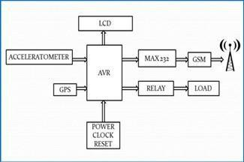

Fig.1.Blockdiagram of accident alert system

The designed model's block outline is shown in Fig1.

Thus, accident detection system using GPS and GSM has gained attention. This system automatically informs accident to the preprogrammed numbers. In this system Accelerometer and GPS tracking system are used for accident detection. When accident occurs, this system sends short message to mobile number via GSM modem. Message will give longitude and latitude values. From these values location of accident can be determined. And also, AVR controller will enable airbag to blow and message with Accident location will send to preprogrammed numbers such as a Ambulance, police station.

III.LIST OF ELEMENTS AND OVERVIEW The list of elements that are required to develop accident

Alert system as shown in the below table[I]. some of the main components are Accelerometer, Gps, Gsm, Avr, Microcontroller. TABLEI.LIST OF ELEMENTS THAT ARE REQUIRED

|  |  |
| --- | --- |
| Component | Quantity |
| Accelerometer | 1 |
|  |  |
| Gps module | 1 |
|  |  |
| Gsm module | 1 |
|  |  |
| MAX232 | 1 |
|  |  |
| Avr controller | 1 |
|  |  |
| Relay | 1 |
|  |  |
| Lcd | 1 |
|  |  |

We will discuss briefly about the each and every component that is listed in the above table[I].

1.Accelerometer:

A Micro-Electro Mechanical System (MEMS) sensor known as an accelerometer monitors static (earth gravity) or dynamic acceleration in all three axes. It is commonly used in various electronic devices and systems to detect motion, orientation, and tilt. Accelerometers are fundamental components in modern technology and are found in smartphones, fitness trackers, gaming controllers, automotive systems, aircraft, robotics, and many other applications.

It monitors the level of acceleration in the area where it is mounted, allowing us to measure the acceleration or deceleration of objects like cars, the tilt of a platform with relation to the axis of the earth, or machine vibration. Accelerometers use the unit "g" to measure acceleration (gravity's acceleration is 9.81 m/s2). An accelerometer produces electricity from mechanical motion. The diagram of an accelerometer is depicted in the figure below.

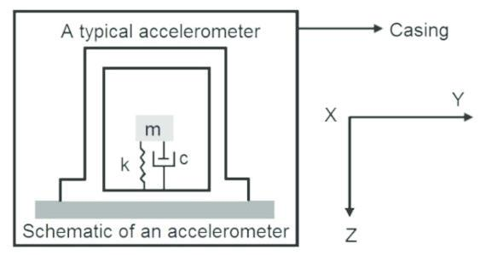

Fig2: Accelerometer diagram

2.Gps Module (Global Position System):

A navigational tool from the space age, the System (GPS Global Positioning), can locate you anywhere on the planet, typically to within a few yards or meters. 24 satellites in a precise orbit 12,000 miles above the earth make up the GPS constellation. High frequency radio waves are used by the satellites to convey data

back to Earth. GPS triangulates your position by using satellite ranges. In other words, the GPS device simply calculates the distance to each satellite it is sampling by multiplying the transit time of the signals received from the satellites by the speed of light. Distance equals speed multiplied by time

After locking onto a signal from at least three separate satellites, GPS can determine a location and track movement. The receiver can determine the user's latitude, longitude, and altitude when four or more satellites are visible.

The GPS receiver serves as the location detecting sensor. The system needs a GPS signal obtaining equipment that is extremely sensitive and precise. Its 20 parallel channels, 4000 search bins, and quick setup time—8 seconds for a hot start and 40 seconds for a cold start—enable quick satellite signal gathering. Even in cities, tracking sensitivity of 159 dBm delivers good navigation performance

NMEA-0183 is the protocol used by GPS receivers, according to the National Marine Electronics Association (NMEA).

It produces the following output messages. We so receive 7-8 distinct messages.

GGA: Fixed data from the global positioning system.

Geographic position, or latitude and longitude, is GLL.

Message ID, UTC position, latitude, longitude, north-south, and east-west are all included in GGA.

The message ID, $GPGGA, is referred to as the protocol header. [ All of these data were retrieved into the microcontroller software. Then, via the GSM system, this date (location) is sent to a predetermined number.

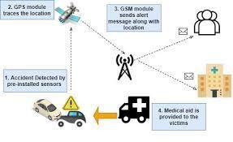

Fig3: Gps based accident detection system

3.Gsm Module (Global System for Mobile Communication):

A GSM modem is a mobile phone substitute without the screen, keypad, and speakers. This uses a SIM card and is powered by a mobile provider subscription. A GSM modem can function just like a mobile phone and take SIM cards from any GSM network operator. GSM services are offered by more than 690 mobile networks in 213 countries, and 82.4% of all mobile connections worldwide use GSM. It provides short message services (SMS) and general packet radio services (GPRS) in addition to voice communication for the movement of data. GSM converts data to an electronic form, compresses it, and delivers it along with two other streams of user data, each in its own time slot, down a channel. It uses the 900 MHz or 1800 MHz frequency bands for operation’s is the modulation method employed. There are two additional frequency bands, however those indicated above are the most used. GSM transmits data at a speed of 270 kbps. The GSM modem sent the accident's position across the GSM network. The microcontroller has control over the modem. The Hayes AT-Command set serves as the foundation for the setup and control

protocol used by GSM modems. The letter AT stands for attention. Extension commands are GSM AT commands. Extended instructions include things like +CMGS, +CMGL and +CMGR. The main goal of this application is to send a message and the location of the car, which can be accessible using GPS, to a pre-programmed number whenever an accident occurs.

GSM Air Interference specification:

|  |  |
| --- | --- |
| parameters | specifications |
| Reverse channel | 819-915MHz |
| frequency |  |
| Tx/Tx frequency | 45MHz |
| slotting |  |
| Forward channel | 935-960MHz |
| frequency |  |
|  |  |
| Tx/Rx time slots | 3 Time slots |
| spacing |  |
| User per frame | 8 |
| Frame period | 4.615ms |
| Time slot period | 569.5us |
| Bit period | 3.692us |

4.AVR Controller (Advance Virtual RISC):

AVR microcontrollers are a family of microcontrollers developed by Atmel Corporation (now part of Microchip Technology Inc.) and are widely used in various embedded systems and electronic applications. AVR stands for "Alf and Vegard's RISC" (Reduced Instruction Set Computer). In this setup, an ATmega16 microcontroller is employed. An 8-bit, low-power CMOS microcontroller called the ATmega16 is based on the AVR improved RISC architecture. It completes instructions in one clock cycle, resulting in throughputs that are close to 1 MIPS per MHz32 general purpose working registers and an instruction set are combined in the AVR core. Since each of the 32 registers is directly connected to the arithmetic logic unit, it is possible to access two separate registers with a single instruction that is completed in a single cycle. In comparison to traditional CISC microcontrollers, the resulting design is more code efficient and achieves throughputs that are up to ten times quicker.

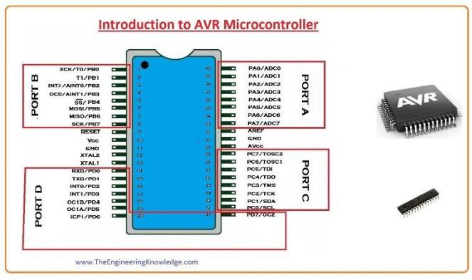

Fig4: AVR Microcontroller

PIN1: I/O, T0 (Timer0 External Counter Input), XCK: USART External Clock I/O

PIN2: I/O, T1 (Timer1 External Counter Input)

PIN3: I/O, AIN0: Analog Comparator Positive Input, INT2:

External Interrupt 2 Input

PIN4: I/O, AIN1: Analog Comparator Negative Input, OC0:

Timer0 Output Compare Match Output

PIN5: I/O, SS: SPI Slave Select Input. This pin is low when controller acts as slave.

PIN6: MOSI (Master Output Slave Input). When controller acts as slave, the data is received by this pin.

[Serial Peripheral Interface (SPI) for programming]

PIN7: MISO (Master Input Slave Output). When controller acts as slave, the data is sent to master through this pin.

[Serial Peripheral Interface (SPI) for programming]

PIN8: SCK (SPI Bus Serial Clock). This is the clock shared between this controller and other system for accurate data transfer. PIN9: Reset Pin, Active Low Reset

PIN10: VCC=+5V

PIN11: Ground

Every voltage is evaluated in relation to this terminal.

PIN12: XTAL2 Output for external crystal oscillator or clock source

PIN13: XTAL1 Input for external crystal oscillator or clock source

PIN14: (RXD), I/O PIN 0, USART Serial Communication Interface

PIN15: (TXD), I/O Pin 1, USART Serial Communication Interface

PIN16: (INT0), I/O Pin 2, External Interrupt INT0

Pin 18: External Interrupt 0 input. It can trigger an interrupt on a rising or falling edge.

Pin 17: External Interrupt 1 input. It can trigger an interrupt on a rising or falling edge.

PIN19: (OC1A), I/O Pin 5, PWM Channel Outputs

PIN20: (ICP), I/O Pin 6, Timer/Counter1 Input Capture Pin

PIN21: (OC2), I/O Pin 7, Timer/Counter2 Output Compare Match Output

PIN22: (SCL), I/O Pin 0, TWI Interface

PIN23: (SDA), I/O Pin 1, TWI Interface

PIN24-27: JTAG INTERFACE

PIN28: (TOSC1), I/O Pin 6, Timer Oscillator Pin 1

PIN29: (TOSC2), I/O Pin 7, Timer Oscillator Pin 2

PIN30: AVCC (for ADC)

PIN31: GND (for ADC)

PIN32: Analog Reference Pin for ADC

PIN33: (PA7) ADC7 PAx: I/O, ADCx (Where x is 7 – 0)

PIN34: (PA6) ADC6 Analog to Digital Converter

PIN35: (PA5) ADC5 Analog to Digital Converter

PIN36: (PA4) ADC4 Analog to Digital Converter

PIN37: (PA3) ADC3 Analog to Digital Converter

PIN38: (PA2) ADC2 Analog to Digital Converter

PIN39: (PA1) ADC1 Analog to Digital Converter

PIN40: (PA0) ADC0 Analog to Digital Converter

5.MAX232:

A well-liked integrated circuit (IC) for serial communication, the MAX232 converts signals between TTL (Transistor-Transistor Logic) voltage levels and RS-232 voltage levels. It was created by Maxim Integrated Products and has been extensively used in numerous electrical applications for many years.

The MAX232's primary function is to make it easier for devices that operate at various voltage levels to communicate with one another. TTL employs logic levels (0V for logic low and generally 5V for logic high), whereas RS-232 uses positive and negative voltage levels to represent data in serial communications.

To convert the signals, the MAX232 IC has a charge pump, capacitors, and drivers. Here is a list of its essential parts and features.

Here is a list of its essential parts and features:

Charge Pump Circuit: The MAX232 has an inbuilt charge pump circuit that converts a single power supply voltage (often +5V) into greater positive and negative voltages. This is required because RS-232 signals operate at voltage levels that are greater than those used by TTL.

Capacitors:External capacitors must be attached to the MAX232 in order to stabilize and regulate the positive and negative voltages that are created.

Drivers: The IC features two sets of drivers: RXD1, RXD2, and RXD3 convert RS-232-level signals to TTL-level signals, and TXD1, TXD2, and TXD3 convert RS-232-level signals to TTL-level signals.

Voltage Levels for RS-232: The normal RS-232 voltage levels are +3V to +15V for logic low (space) and -3V to -15V for logic high (mark). RS-232 is excellent for industrial and communication applications since these voltage levels allow for long-distance communication and noise immunity.

TTL Voltage Levels: The standard TTL voltage levels for logic low and high are 0V and about 5V, respectively. TTL is frequently used in digital logic circuits, microprocessors, and microcontrollers.

When connecting a microcontroller or other TTL-level devices to a computer or any RS-232 compatible device, the MAX232 serves as an interface in between. It converts the TTL-level signals from the microcontroller to RS-232-level signals that the computer can understand and vice versa.

Fig5: MAX232 Diagram

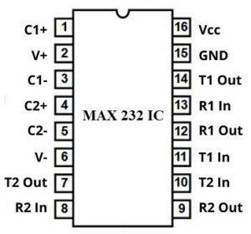

Pin-1(C1+): The positive terminal of a capacitor is connected to this pin

Pin-2(Vs+): The capacitor’s positive leg is connected to it by grounding the negative leg.

Pin-3(C1-): The negative pin of the capacitor is connected to this pin and the positive pin is connected to pin1

Pin-4(C2+): The positive terminal of a capacitor is connected to this pin

Pin-5(C2-): The negative terminal of a capacitor is connected where the positive terminal is connected to Pin4.

Pin-6(Vs-): The negative terminal of a capacitor is connected to this pin & 5 volts is provided to the positive terminal of the capacitor.

Pin-7(T2OUT): It provides the converted TTL signal in the form of RS-232. Here TTL signal can be obtained by T2IN Pin from the microcontroller and this pin is connected to Pin2 of DB-9 port of your computer like Rxd.

Pin-8(R2IN): This Pin gets the signal of RS-232 like an input & provides the changed signal in the form of TTL on the R2OUT pin. This pin is connected to DB9 Port’s Txd pin, which is Pin3.

Pin-9(R2OUT): It provides the signal changed within TTL form. The signal is received from Pc at R1In Pin. Connect this pin to your module (TTL) Rxd pin which receives the signal.

Pin-10(T2IN): This pin gets transmitted signal from microcontroller & gives the changed RS-232 signal over T2OUT pin. Here, the signal can be transmitted from the microcontroller serial port’s txd pin. This pin can be connected to your Txd pin of the module.

Pin-11(T1IN): This pin works like a T2IN.

Pin-12(R1OUT): This pin works like an R2OUT.

Pin-13(R1IN): This pin works like an R2IN.

Pin-14(T1OUT): This pin works like aT2OUT.

Pin-15(GND): This pin is a GND pin.

Pin-16(VCC): This pin is a voltage supply pin where 5V is provided to this pin.

6.Relay:

A relay is an electrically operated switch. It consists of a set of input terminals for a single or multiple control signals, and a set of operating contact terminals. The switch may have any number of contacts in multiple contact forms, such as make contacts, break contacts, or combinations thereof. It is an essential component in many safety-critical systems, providing a fail-safe mechanism to control various functions in response to accident detection.

Here's how a relay can be incorporated in accident detection:

1.Collision Detection:

The accident detection system, which may include sensors like accelerometers or collision sensors, monitors the vehicle's movement and detects sudden changes in acceleration or collisions.

2.Microcontroller Processing:

The sensor data is sent to a microcontroller (e.g., an AVR microcontroller) that processes the information and determines if an accident has occurred.

3.Relay Activation:

Upon confirming an accident, the microcontroller activates the relay by energizing its coil through a suitable circuit. The relay's coil operates using a lower current that the microcontroller can handle.

4.Switching Action:

When the relay coil is energized, it creates a magnetic field that pulls its contacts together. This mechanical action closes or opens the relay's electrical contacts.

5.Emergency Alert:

The relay can be connected to a GSM module to send an emergency alert via SMS or call to predefined contacts.

6.Airbag Deployment:

In automotive applications, the relay can be part of the airbag deployment system, triggering the airbag inflation upon collision detection.

7.Power Cutoff:

The relay can cut off power to specific vehicle systems to prevent further damage or accidents.

8.Warning Alarms:

It can activate warning alarms or hazard lights to alert other nearby vehicles.

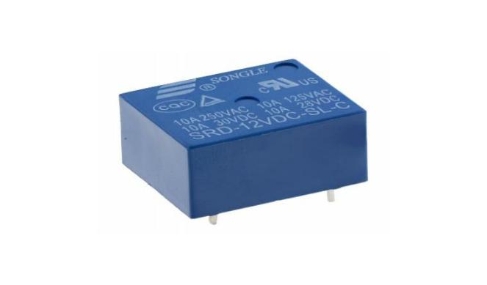

Fig6:Relay

7.LCD (Liquid Crystal Display):

Liquid Crystal Display, or LCD, is a flat-panel display technology that is frequently used in electronic devices like smartphones, laptops, computer displays, digital cameras, calculators, and more. LCD is an acronym for Liquid Crystal Display. Due to their small size, low power consumption, and enhanced image clarity, LCDs have largely supplanted previous display technologies like cathode ray tube (CRT) screens.

Collision Detection: To identify unexpected changes in acceleration or collisions, the system continuously analyzes the movement of the vehicle using sensors like accelerometers or collision sensors.

Microcontroller Processing: After the sensor data is transmitted, it is processed by a microcontroller or a special accident detection module to see if an accident has taken place.

IV.System operation:

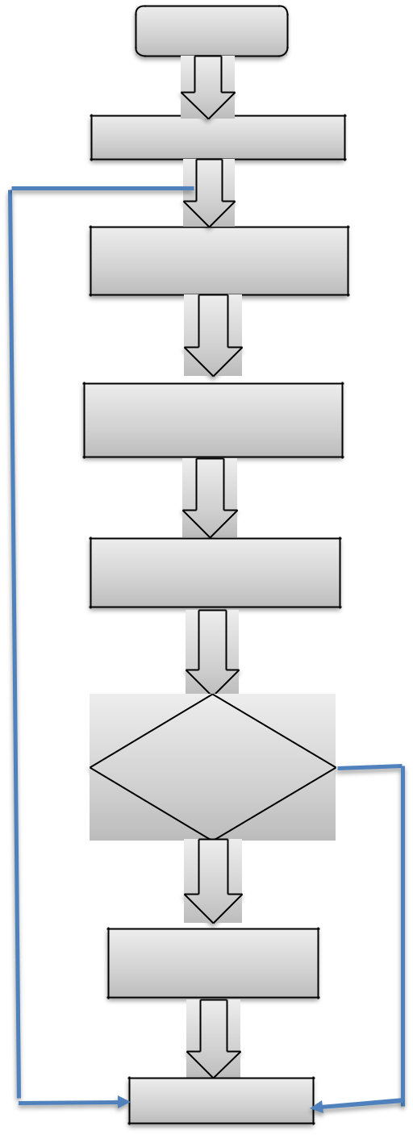

Start

Initialize LCD

Read the status of the

center

Read the data from the

Gps

Display the data from

LCD

Sensor is

triggered

Sending SMS

using Gsm

END

V.Future Scope:

In order to identify which node would be easier to access from the accident scene, we can add certain modules to the device to tell it of information about the traffic.

This system ought to be connected to the airbag system in the car so that accidents may be rapidly discovered

VI.Result and Conclusion:

Automatic accident detection and reporting system is designed in this paper. When accident occurs, itis sensed by Accelerometer. Short message including location of accident obtained using GPS, is sent via GSM network. It provides more than 70% safety for four wheelers. It is the fact that implementation of system will increase cost of vehicle but it is better to have some percent safety rather than having no percent of safety. The emergency services team receives timely information from this proposed model concerning the accident site.

Accident location may be accurately and automatically located, saving time spent looking for the accident scene. The system pinpoints the precise latitude and longitude of the accident scene and transmits the data to the nearby hospital or police station as well as the people who need to know. This suggested model does not require several crash sensors, saving money, and it is also easier to interface. The collision must occur before the crash sensor activates. Finding the accident site with the right equipment, however, is difficult and requires a lot of investigation.

VII.ACKNOWLEDGMENT

It is highly acknowledged that the Department of Electrical and Electronics Engineering (EEE) at NRI Institute of Technology, Agiripalli has provided assistance.

REFERENCES

1. World Health Organization Road Traffic Injuries Fact Sheet

No 358, March 2013. Available from: http://www.who.int/mediacentre/factsheets/fs358/en/ [Last accessed on 2013 Jul 15].

1. GPS [http://www8.garmin.com/aboutGPS/](mailto:http://www8.garmin.com/aboutGPS/?subject=http://www8.garmin.com/aboutGPS/)
2. GPS

<http://gpsd.berlios.de/vendor-docs/sirf/SiRF2-Leadtek.pdf>

1. GSM modem Wireless Communication by THEODORE RAPPAPORT
2. GSMmodem <http://www.developershome.com/sms/atCommandsIntro.asp>
3. Accelerometer <http://www.engineersgarage.com/articles/acceleromete>
4. Malik, A.S., Boyko, O., Atkar, N. and Young, W.F. (2001) A Comparative Study of MR Imaging Profile of Titanium Pedicle Screws. Acta Radiologica, 42, 291-293. <http://dx.doi.org/10.1080/028418501127346846>
5. Khan, A.M. and Tehreem, A. (2012) Causes of Road Accidents in Pakistan. Journal of Asian Development

Studies, 1.

1. Thompson, C., Whit, J., Doughenty, B., Abnight, A. and Schmidt, D.C. (2010) Using Smart Phone to Detect Car Accidents and Provide Situational Awareness Emergency Responses. The 3rd International ICT Conference on Mobile

Wireless Middleware Operating Systems and Applications