INDOLENCE ESPIAL AND VIGILANT SYSTEM

|  |  |  |
| --- | --- | --- |
| Dr. N. Sambasiva Rao | Mr. B. Eedukondalu | Perna. Swathi |
| Professor &Head of EEE | Assistant professor of EEE | Department of Electrical & Electronics |
| NRI Institute of Technology | NRI Institute of Technology | Engineering |
| Pothavarappadu,Agiripalli | Pothavarappadu, Agiripalli | NRI Institute of Technology |
| [nsraohodeee@gmail.com](mailto:nsraohodeee@gmail.com) | [eedukondalu@nriit.edu.in](mailto:eedukondalu@nriit.edu.in) | Pothavarappadu,Agiripalli |
|  |  | [swathip0212@gmail.com](mailto:swathip0212@gmail.com) |

|  |  |  |
| --- | --- | --- |
| Yeddu. Syam Swaroop | Gade. Dimple Sai Chandra Sekhar | Dasari. Srinivasarao,B.Raviteja |
| Department of Electrical &Electronics | Department of Electrical & Electronics | Department of Electrical & Electronics |
| Engineering | Engineering | Engineering |
| NRI Institute of Technology | NRI Institute of Technology | NRI Institute of Technology |
| Pothavarappadu, Agiripalli | Pothavarappadu, Agiripalli | Pothavarappadu,Agiripalli |
| [syamswaroop10152@gmail.com](mailto:syamswaroop10152@gmail.com) | [dimplesaichandrashekar@gamil.com](mailto:dimplesaichandrashekar@gamil.com) | [srinudasari4512@gmail.com](mailto:srinudasari4512@gmail.com) |
|  |  | [ravitejabolla213@gmail.com](mailto:ravitejabolla213@gmail.com) |

ABSTRACT

Sluggishness and Exhaustion of drivers are among the critical reasons for street mishaps. Consistently, they increment the measures of passing and fatalities wounds worldwide.

In this paper, a module for cutting edge Driver Assistance Framework (ADAS) is introduced to lesson the number of mishaps because of driver exhaustion and thus increase the transportation security; this framework manages programmed driver sluggishness identification in view of visual data and Man-made brainpower.

We propose a calculation to find, track, and breakdown both the drivers face and eyes to gauge PERCOLS, an experimentally upheld proportion of tiredness associated with slow eye conclusion.

Catchphrases-Sleepiness identification, ADAS, Face Detection and following Eye location and following, Eye state, PERCLOS.

**Keywords — Sleepiness discovery, ADAS, Face Detection and Following, Eyes Recognition and Following, Eye**

***state, PERCLOS.***

1. INTRODUCTION

At present, transport frameworks are a fundamental piece of human exercises. We as a whole can be survivor of tiredness while driving, essentially after too brief night rest, altered state of being or during long excursions. The impression of rest decreases the driver's degree of vigilance creating perilous circumstances and builds the likelihood of an event of mishaps. Driver drowsiness and weakness are among the significant reasons for street mishaps.

Consistently, they increment the quantity of passing and fatalities wounds internationally. In this specific

circumstance, it means quite a bit to utilize new technologies to plan and fabricate frameworks that can monitor and to quantify their degree of consideration during the whole course of driving.

In this paper, a module for ADAS (Progressed driver help Framework) is presented in order to reduce the number of mishaps caused by driver exhaustion and thus improved road safety. This framework treats the automatic discovery of driver sleepiness in light of visual data and man-made reasoning.

We propose a calculation to find, track and analyze both the driver face and eyes to quantify PERCLOS (level of eye conclusion).

1. LITERATURE SURVEY

A few endeavors have been accounted for in the writing on the advancement of the not-meddling observing drowsiness frameworks in view of the vision.

* Vitabile et al. [1] carry out a framework to distinguish side effects of driver sleepiness in light of an infrared camera. By taking advantage of the peculiarity of brilliant pupils, a calculation for distinguishing and following the driver's eyes has been created. At the point when

tiredness is recognized, the framework cautions the driver with an alert message.

* Bhowmick et Kumar [2] utilize the Otsu thresholding [3] to remove face locale. The restriction of the eye is done by finding facial tourist spots like eyebrow and conceivable face

XXX-X-XXXX-XXXX-X/XX/$XX.00 ©20XX IEEE

place. Morphological activity and Kmeans is utilized for exact eye division.

* Malla et al. [4] foster a light-unfeeling framework. They utilized the Haar calculation to distinguish objects [5] and face classifier carried out by [6] in OpenCV [7] libraries. Eye districts are gotten from the facial locale with anthropometric variables. Then, they identify the eyelid to gauge the degree of eye conclusion.

1. BLOCK DIAGRAM AND FLOWCHART Under the radiance of what has been referenced

previously, the distinguishing proof of the driver sleepy state given by the PERCLOS is for the most part passed by the accompanying stages:

1. Face detection,
2. Eye location,
3. Eye state recognition

# Face detection:

The evenness is one of the main facial highlights. We displayed the evenness in a computerized picture by a one- layered signal (gatherer vector) with a size equivalent the width of the picture, which gives us the esteem relating to the place of the upward pivot of evenness of articles is in the each for two white pixels which are on similar line we increment the worth in the medium between these two pixels is the gatherer vector. (The algorithm is applied on image we called a white pixel.

We present enhancements for the computation algorithm of evenness into a picture to adjust it to the recognition of face by applying a bunch of rules to give a superior computation of evenness of the face.

## Block Diagram

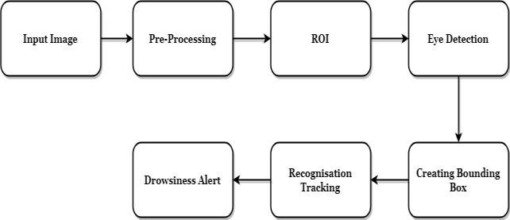

Fig.1(a)

## Flowchart

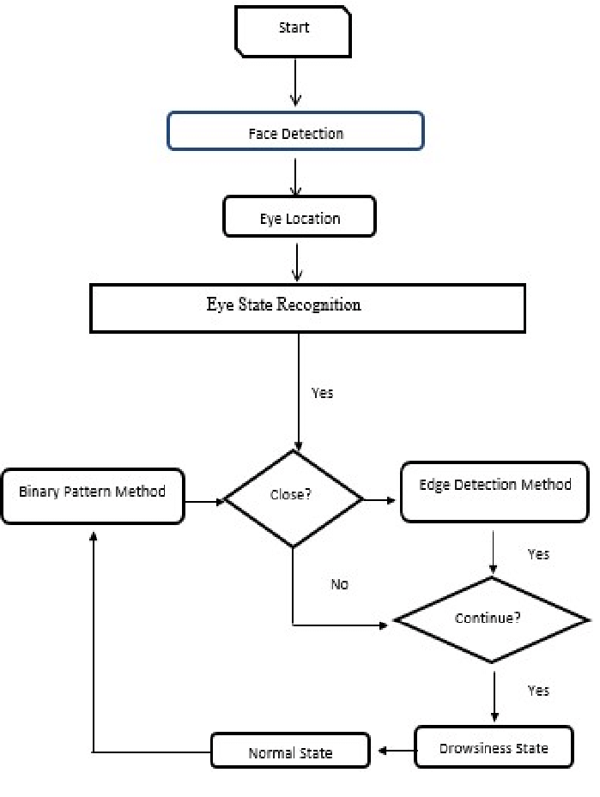

1. Eye location: Fig.1(b)

Since the eyes are in a characterized region face (facial anthropometric properties), we limit our research nearby between the temple and the mouth (Eye District of Interest 'eROI') (Figure 2.a). We benefit from the balanced attribute of the eyes to distinguish them in the face.

In the first place, we clear upward the eROI by a rectangular cover with an expected level of level of the eye what’s more, a width equivalent to the width of the face, and we workout the evenness.

The eye region compares to the position which has a high estimation of balance. Then, at that point, in this obtained locale, we ascertain the evenness again in both left and right sides. The most noteworthy worth compares to the focal point of the eye. The outcome is displayed in (Figure 2.b).

# Eye state recognition:

The improved on strategy for estimating the PERCLOUS worth of the driver was to workout the ratio of eyes being open and shut with the complete number of frames for a given period. Results: If the eyes were shut more than the set threshold in the all out number of edges, the framework would caution the driver.

The integral image computation can be performed in the equation given below:

(x,y) =∑ i(x’,y’)

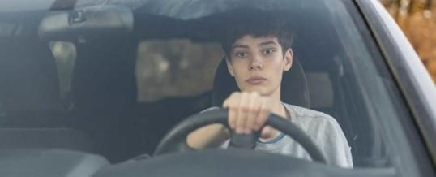

Fig. 2(a)

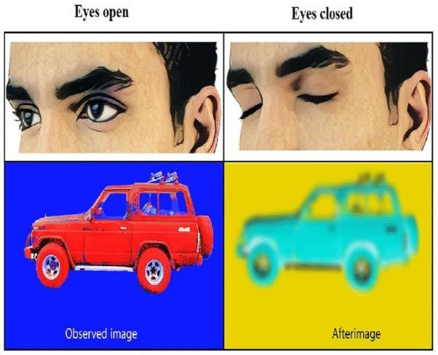

Fig .2(b)

FN indicates that an estimate is negative.

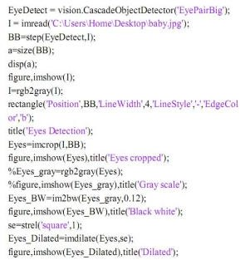(MATLAB Code)

1. COMPONENTS DESCRIPTION

## How the Algorithm Functions

Fig.3

The proposed system is made up of the following primary components.

* 1. 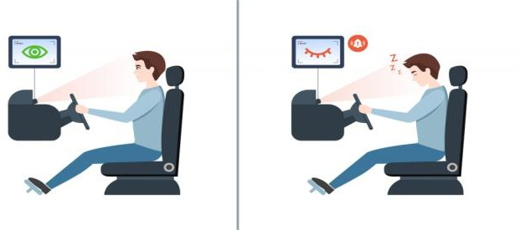Pi Camera Module V2:

This Raspberry Pi Camera module v2 can be utilized rather than the first camera module, to catch superior quality video with still picture with the assistance of Sony IMX219 8-megapixel sensor [33, 34]. It works with 1080p30, 720p60, and VGA90 video modes which associate with a

Our framework begins with the introduction stage,

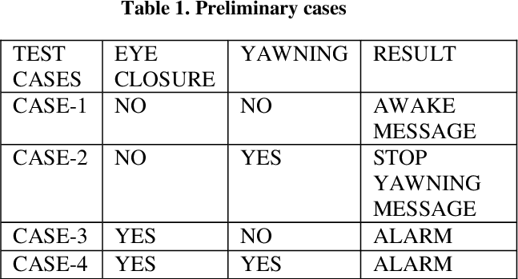which is face and eyes identification to remove both face what’s more, eyes areas and accept them as layouts to follow them in the accompanying casings. For each following we test assuming that following is fortunate or unfortunate? Assuming that the following is terrible we get back to the introduction step, else we pass to the following advances which are: eyes states identification and driver state.

CSI port through a 15 cm lace link on the Raspberry Pi module that is portrayed as in Figure 4

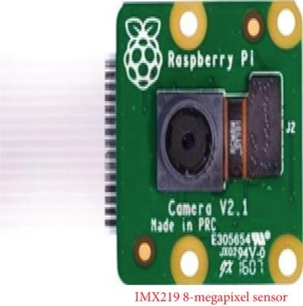

Fig.4

* 1. 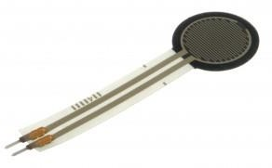Crash Sensor:

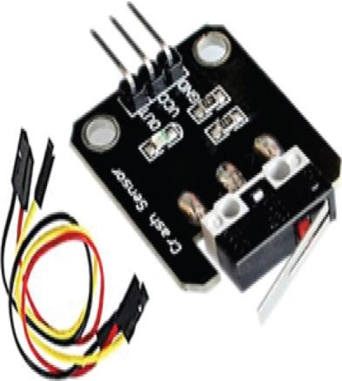Fig.7

4. GPS Module:

Fig.5

An electronic gear gives security and distinguishes an effect through vibrations. Because of tiredness, any kind of crash might occur; then, it identifies the effect of impact as displayed in Figur*e 5*

*Speaker module:*

*Speaker moduleAn electronic gear gives security and distinguishes an effect through vibrations. Because of tiredness, any kind of crash might occur; then, it identifies the effect of impact as displayed in figure* 6. It integrates an adjustable volume potentiometer, a speaker,a 2W audio amplifier chip and a 3-pin header interface. It can easily amplify small audio, signals by provinding a maximum 8.5 times amplification, and play the amplified signal through speaker

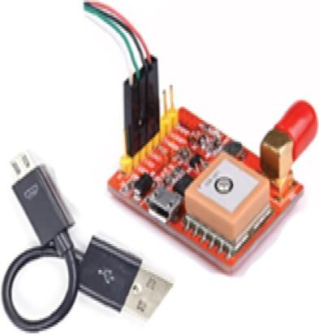Fig.6

* 1. Force Delicate Resistor Sensor (FSR):

Extraordinary kinds of resistor known as power delicate resistor, whose obstruction might vary, as indicated by tension or power on it. Thus, it is made by a thick polymer sheet which is worked in various conditions. Because of good stunning obstruction, it is coordinated in this framework as portrayed in Figure 7.

This module is utilized to follow the vehicle's area, on the off chance that any serious impact happens with a sluggish driver. It is the fundamental part to recognize the scope and longitude of any region on the Earth with date and time from satellite. In this framework, the setback area is effortlessly followed and the area is sent utilizing GPS as depicted in figure 8

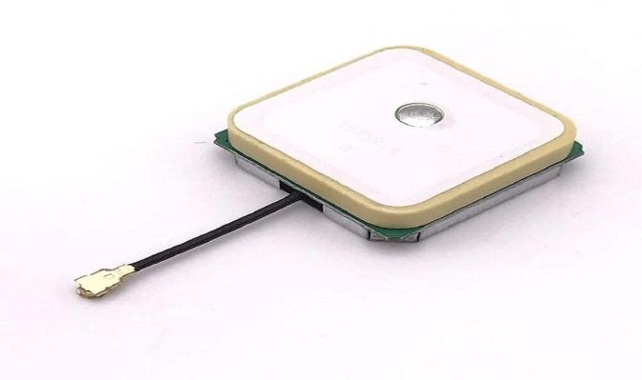

*Fig.8*

1. EXPERIMENTAL RESULT

Huge measure of convenience testing and trial and error was finished on the model under various conditions. We accomplished a general precision of 80.55%. In situations where the driver was not sleepy, we recorded 62.5% accuracy. In situations where the driver was really feeling sleepy, we recorded 85.71% accuracy. The model, toward the finish of every preliminary attempt, had the option to add temperature sensor information to the handling unit, read photoplesythm-based beat oximeter information into the handling unit, with a baud pace of 115200, recognize and process flickers, identify and handle yawn and pinpoint area and recommend close by bistros. We utilized an Apple MacBook Expert, furnished with an Intel Center i7 processor, 16GB of Smash and the incorporated FaceTime camera to peruse values from the sensors and perform ongoing video examination. The presentation of the frame- work was good with the caution being sounded in the span of a second, when the framework recognized sluggishness. Sleepiness location was too almost momentary as the framework was good with the caution being sounded in the span of a second, when the framework recognized sluggishness. Sleepiness location was too almost momentary as the framework returned a positive sign as soon the squint length surpassed the edge esteem set during the learning phase.

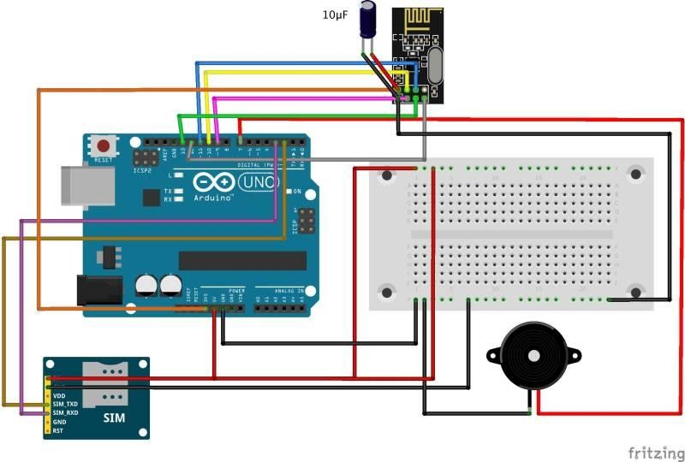

Fig.9(a)

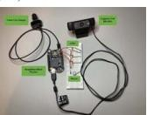

Fig.9(b)

1. CONCLUSION AND POINTS OF VIEW

In this paper, we introduced the origination and implementation of a framework for distinguishing driver drowsiness in view of vision that means to caution the driver if he is in sluggish state. This framework can decide the driver state under genuine constantly conditions utilizing IR camera. Face and eyes recognition are executed in light of balance. Hough Change for Circles is utilized for the choice of the eyes states. The outcomes are acceptable with a chance for improvement in face recognition utilizing different strategies concerning the computation of evenness. Besides, we will carry out our algorithm on a DSP (Digital Signal Processor) to ) to make an autonomous framework working progressively.

A future heading for working on the proposed driver tiredness location and cautioning framework would be the execution of different boundaries that show the sleepiness condition of the driver, for example, head slant or forward slant of the body, which could be observed for example through an inertial estimation unit. Other suitable choices incorporate controlling conduct, which could be observed through a controlling wheel point sensors, controlling wheel

hold force, or physiological signs like ECG, EEG, EOG, or GSR. Despite the fact that the physiological boundaries would altogether support up the execution of the framework they are by and large a for the most part stayed away from, owing to their degree of intrusiveness and the distress made to the driver.

# ACKNOWLEDGMENT

The creators might want to thank every one of the drivers on whom theframework was tried on as well as the doctors counseled duringthe concentrate on the three phases of sleep. Picture handling accomplishes exceptionally exact and solid location of sleepiness.Pictures handling offers a painless way to deal with recognizing tiredness without the inconvenince and impedence. A sleepiness discovery framework created around the standards of picture handling passes judgement on the drivers readiness level based on nonstop eye terminations with 80% accuracy.

1. REFERENCES
2. S. Vitabile, A. Paola and F. Sorbello, “Brilliant Understudy Recognition in an Implanted, Constant Tiredness Checking Framework” , in 24th Global Meeting on Cutting edge Data Systems administration also, Appilications, 2010.
3. B. Bhowmick and C. Kumar, “Identification and Arrangement of Eye State in IR Camera for Sleepiness Recognizable proof”, in Continuing of the IEEE Worldwide Gathering on Signal what’s more, Picture Handling Applications, 2009.
4. N. Otsu, "A Limit Determination Technique from Dim Level Histograms", IEEE Exchanges on systems Man and Cybernatics, pp. 62-66, 1979.
5. A. Malla, P. Davidson, P. Bones, R. Green and R. Jones, “Computerized Video-based Estimation of eye Conclusion for Recognizing Conduct Microsleep”, in 32nd Yearly Worldwide Meeting of the IEEE,

Buenos Aires, Argentina, 2010.

1. P. Viola and M. Jones, "Quick Article Recognition utilizing a Helped Outpouring of Basic Highlights", in Procedures of the IEEE PC Society Meeting.
2. R. Lienhart and J. Maydt, "A Drawn out Set of Haar-like Elements for Fast Item Recognition", in Procedures of the IEEE Global Gathering

on Picture Handling, 2002.

1. OpenCV. Open Source PC Vision Library Instructional booklet, 2001.

.