Smart Energy Meter and Monitoring System using IOT

Dr. N.Sambasiva Rao
Professor and Head of the Department of Electrical and Electronics Engineering(EEE).NRI Institute of Technology(Autonomous),
Vijayawada,India,
nsraohodeee@gmail.com
G.Vijaya Durga
Department of Electrical and Electronics Engineering(EEE).NRI Institute of Technology(Autonomous),
Vijayawada,India,
vijaydurgagunduboina@gmail.com
S.Bhavani Associate Professor of Electrical and Electronics Engineering(EEE).NRI Institute of Technology(Autonomous),
Vijayawada,India,
sampara.bhavani@gmail.com

R.Likhitha Department of Electrical and Electronics Engineering(EEE).NRI Institute of Technology(Autonomous),
Vijayawada,India,
Raavilikhitha6@gmail.com
Ch.Hemanth Reddy
Department of Electrical and Electronics Engineering(EEE).NRI Institute of Technology(Autonomous),
Vijayawada,India,
chhemanth567@gmail.com

D.Gnaesh,M.Sardar Hussain
Department of Electrical and Electronics Engineering(EEE).NRI Institute of Technology(Autonomous),
ganeshdasari202@gmail.com
sardaar0505@gmail.com

Abstract— The effort of collecting electricity utility meter reading. Internet of Things (IoT) present an efficient and co- effective to transfer the information of energy consumer wirelessly as well as it provides to detect the usage of the electricity the main intention of this project is measure electricity consumption in home appliances and generate it's bill automatically using IoT. The energy grid needs to be implemented in a distributed topology that can dynamically absorb different energy sources. IoT can be utilized for various applications of the smart grid with distributed energy plant meter, energy generation and energy consumption meter smart meter, energy demand side management and various area of energy production.

Keywords— Smart Grid, Energy Meter, Internet of Things.
- INTRODUCTION
The energy consumption can be monitored by using an electric device called energy meter. The cost and the regular usage of Power consumption are informed to the user to overcome high bill usage. The Energy meter shows the amount of units consumed and transfers the data to both the customer and to the electrical board so this helps in reducing man-power. The user can check their Power usage from anywhere and at any time interval. The IoT is used to Turn on/off the household appliances using relay and Arduino interfacing. The objective of this system is to monitor the amount of electricity consumed. The distributer and the consumer both will be benefitted by eventually reducing the total Power consumption.
- LITERATURE SURVEY
Anitha et al., [1] proposed “Smart energy meter surveillance using IoT” about IoT, internet of things as an emerging field and IoT based devices have created a revolution in electronics and IT. The foremost objective of this project is to create awareness about energy consumption and. efficient use of home appliances for energy savings. Due to manual work, existing electricity billing system has major drawbacks. This system will give the information on meter reading, power cut when power consumption exceeds beyond the specified limit using

IoT. The Arduino esp8266 micro controller is programmed toper form the objectives with the help of GSM module. It is proposed to overcome all the disadvantages in the already existing energy meter. All the details are sent to the consumer’s mobile through the IoT and the GSM module and it is also displayed in the LCD. It is a time savings and it helps to eliminate the human interference using IoT.
Devadhanishini et al., [2] “Smart Power Monitoring Using IoT” that energy Consumption is the very important and challenging issue. Automatic Electrical Energy meter is used in large electric energy distribution system. The integration of the Arduino WIFI and SMS provides the system as Smart Power Monitoring system. Smart energy meter provides data for optimization and lessthe power consumption. This system also includes a motion sensor such that if there is no human in house or house it will automatically turn off the power supply.
Mohammed Hosseiu et al., [3] presented a paper titled “Design and implementation of smart meter using IoT” describing the growth of IoT and digital technology. The future energy grid needs to be implemented in a distributed topology that can dynamically absorb different energy sources. IoT can be utilized for various applications of the smart grid consisting power consumption, smart meter, electric power demand side management and various area of energy production. In this paper, the Smart Energy Metering(SEM) is explained as the main purpose of SEM is necessary for collecting information on energy consumption of household appliances and monitor the environmental parameters and provide the required services to home users.
Himanshu K Patel et al., [4] demonstrated “Arduino based smart energy meter” that removes human intervention in meter readings and bill generation thereby reducing the error that usually causes in India. The system consists the provision of sending an SMS to user for update on energy consumption along with final bill generation along with the freedom of reload via SMS. The disconnection of power supply on demand or due
to pending dues was implemented using a relay. The system employs GSM for bidirectional communication.
Bibek Kanti Barman, et al., [5] proposed “smart meter using IoT” on efficient energy utilization plays a very vital role for the development of smart grid in power system. Hence proper monitoring and controlling of power consumption is a main priority of the smart grid. The energy meter has many problems associated to it and one of the key problems is there is no full duplex communication to solve this problem, a smart energy meter is proposed based on Internet of Things. The smart energy meter controls and calculate the consumption of energy using ESP 8266 12E, a Wi-Fi module and send it to the cloud from where the consumer or customer can observe the reading.
Therefore, energy examine has been
by the consumer becomes much easier and controllable. This system also helps in detecting energy loss. Thus, this smart meter helps in home automation using IoT.
Garrab et al., [6] proposed AMR approach for energy saving in Smart Grids using Smart Meter and partial Power Line Communication” on the raising demand of energy. Smart meters are one of the proposed solutions for the Smart Grid. In this article, an AMR solution which gives detailed end-to-end application. It is based on an energy meter with low-power microcontrollerMSP430FE423A and the Power Line Communication standards. The microcontroller includes an energy metering module ESP430CEl.
Landi et al., [7] presented "ARM-based Energy management system using smart meter and Web server about a low-cost real-time ARM-based energy management system. An integrated Web Server helps to collect the statistics of energy consumptions, power quality and is to interface devices for load displacement. The device is used to access the information. In this way it is possible to manage the power consumption of the power system leading to a consumption of power.
Koay et al., [8] explained "Design and implementation of Bluetooth energy meter" described around the year 2004, digital meter has started to replace the electromechanical meters in Singapore. A wireless digital power meter would offer greater convenience to the meter reading task. Bluetooth technology is a possible wireless solution to this issue. The power reader can collect the power consumption reading from the energy meter wirelessly based on Bluetooth. Two methods that can retrieve the meter reading with little human intervention, are added and implemented in the targeted applications, they are Automatic meter reading(AMR) and the Automatic polling mechanism(APM). Some commercial applications are applied for the Bluetooth-enabled energy meter.
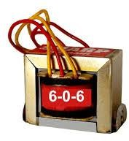
- PROPOSED METHODOLOGY
The smart energy meter monitoring system is shown in figure 1. The block diagram consists of Arduino, energy meter, WIFI module and IoT, Relay and transformer.

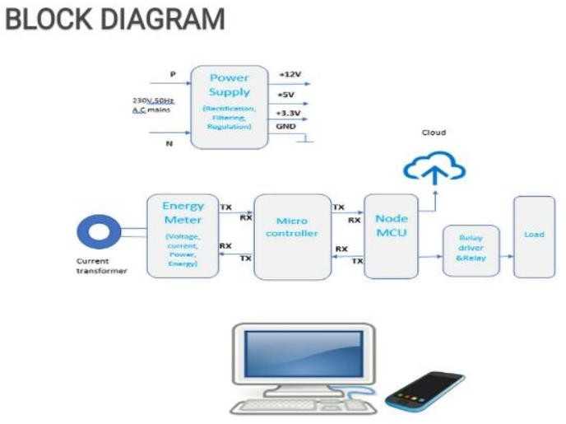
Fig.1 Smart energy meter

Energy meter used here is clamp energy meter .230V AC mains is the input given to the transformer and AC mains is converted to low voltage.
Energy meter measures the live current, voltage and power in terms of KW-h. Microcontroller reads these parameters and send it to the cloud. NodeMCU is a Wi-Fi device which has a microcontroller in it. This connects the local router through IoT. The status of these parameters can be obtained through mobile or laptop.
WIFI is used for data communication. WIFI is configured with Arduino.
The Data from the Energy meter is sent to Arduino and to WIFI module and it reaches the users mobile phone. In this system the user can switch on/off the mains or home appliances from their Android smart phone app. The WIFI module trans and receives the data from cloud and sends to Arduino and the Arduino controls the relay to switch on and off the circuit of the home [8-9].
- Transformer
Selecting a suitable transformer is of great importance. The current rating and the secondary voltage of transformer is a key factor. The current rating of the Transformer depends on the current needed for the load to be driven. The input voltage to the 7805 IC should be at least 2 volt greater than the required 2 volt output; therefore it requires an input voltage at least close to 7V. So, a 6-0-6V transformer with current rating of 500mA is use.

Fig.2 Transformers
- Relay
Relay is the three terminal high voltage (NC, C and NO) devices which connect to control. Relay also has three pins with low voltage (ground Vcc and signal) which connect to the Arduino. Relay is a 120-240 switches are connected inside to an electro magnet

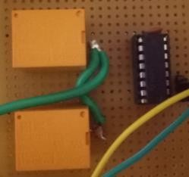

Fig.3RelayModules

- Energy Meter
Energy meter is the meter which is used for measuring the energy utilized by electric load. The energy is the total power consumed and utilized by the load at a particular interval of time.

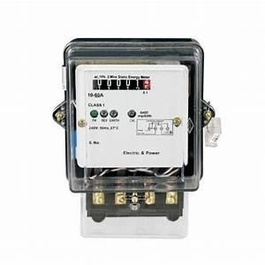

Fig.4 Energy Meter Module

- Wi-Fi Module
Wi-Fi module delivers highly integrated WI-FI solution to meet users for continuous demand of efficient power usage.
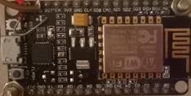

Fig.5 Wi-Fi Module

- Internet of Things
Internet of Things (IoT) links anything from anywhere in the universe. It communicates with almost everything around the world. The communication can be a control signal or identified data from this world. It is a common internet data communication and is communicated in different ways. The Internet of Things (IoT) collects the data of automated objects and helps the machine learn where it needs. The data is stored in cloud and sends to the energy meter to switch on/off objects.

- Final Hardware

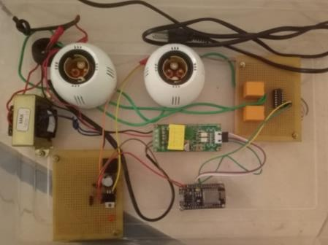

Fig.6. project model

The PIR sensor used in this hardware setup senses the
human motion and Arduino information. It sends signal
to relay and relay will cut of the power.

IV.RESULTS AND DISCUSSIONS

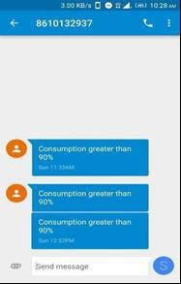
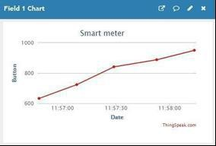

Fig.6ExpectedResults

Here the graph is plotted between time and power units. It shows the energy consumption for a user at a time. Power consumed by the user reaches 90% then alert message will sent to the user [12].
V.CONCLUSIONS
Smart energy monitoring system includes Arduino, WI-FI, energy meter. The system automatically reads the energy meter energy meter and provides home automation through an app developed and power management done through this application. The proposed system consumes less energy and it will reduce manual work.
We can receive monthly energy consumption from a remote location directly to centralize office. In this way we reduce human effort needed to record the meter reading which are till now recorded by visiting the home individually

VI.ACKNOWLEDGMENT
It is highly acknowledged that the Department of Electrical and Electronics Engineering(EEE) at NRI Institute of Technology,Agiripalli has provided assistance
REFERENCES
- Anitha.k ,prathik, “Smart Energy Meter surveillance Using IoT”
,Institute of Electrical and Electronics Engineers(IEEE), 2019.
- Devadhanishini, et.al” “Smart Power Monitoring Using IoT”5th International Conference on Advanced Computing & Communication Systems (ICACCS) 2019.
- Mohammad Hossein Yaghmaee Design and Implementation of an Internet of Things Based Smart Energy Metering” 6th IEEE International Conference on Smart Energy Grid Engineering 2018.
- Himanshu kpatel “arduino based smart energy meter” 2nd Int'l Conf. on Electrical Engineering and Information &Communication Technology (ICEEICT) 2018.
- “Bibek Kanti Barman, et.al” proposed paper “smart meter using IoT” department of international electronics and electrical engineering (IEEE) 2017.
Garrab.A, Bouallegue.A, Ben Abdullah, A new AMR approach for energy savings in Smart Grids using Smart meter and partial power line communication”, IEEE First International Conference on ICICS,vol 3, pp. March 2012.
- Landi,c.: Dipt. Di Ing.dell”Inf, SecondaUniv di Napoli,Aversa,Italy; Merola p.”ARM-based energy management system using smart meter and Web server”,IEEE instrumentation and measurement technology conference binjing, pp.1-5 may 2011.
- [8] B. S. Koay, S. S. Cheah, Y. H. Sng, P. H. Chong, P. Shum, Y. C. Tong, X. Y. Wang, Y. X. Zuo and H. W. Kuek, "Design and implementation of Bluetooth energy meter", IEEE Proceedings of the 4th International Joint Conference of the ICICS, vol. 3, pp. 1474-1477, Dec,2003.
- N. Fathima, A. Ahammed, R. Banu, B.D. Parameshachari, and N.M. Naik, “Optimized neighbor discovery in Internet of Things (IoT),” In Proc. of International Conference on Electrical, Electronics, Communication, Computer, and Optimization Techniques (ICEECCOT), pp. 1-5, 2017.

