RECOGNIZABLE PROOF OF TRANSPORT FOR BLIND PEOPLE

Dr. N. SAMBASIVA RAO

Professor & Head of Electrical & Electronics Engineering

NRI Institute of Technology Vijayawada, India, ([nsraohodeee@gmail.com](mailto:nsraohodeee@gmail.com))

CH.VENKATA MANI DURGA PRAVEESH

(20KN1A0213)

Department of Electrical &Electronics Engineering NRI Institute Of Technology Vijayawada, India, ([praveeshchukka@gmail.com](mailto:praveeshchukka@gmail.com))

Mrs. S. RAMYAKA

Assistant Professor of Electrical &Electronics Engineering NRI Institute of Technology

Vijayawada, India, ([ramyaka.sammangi@gmail.com](mailto:ramyaka.sammangi@gmail.com))

D.LAKSHMANA KUMAR (21KN5A0204)

Department of Electrical &Electronics Engineering NRI Institute Of Technology Vijayawada, India,

[(lakshmanakumar991@gmail.com](mailto:lakshmanakumar991@gmail.com))

K.SUDHARANI (20KN1A0224)

Department of Electrical &Electronics Engineering NRI Institute Of Technology Vijayawada, India,

([komminenisudharani725@gmail.com](mailto:komminenisudharani725@gmail.com))

T.LOHIT KUMAR (20KN1A0249)

Department of Electrical &Electronics Engineering NRI Institute Of Technology Vijayawada, India,

([lohitkumarthotakura@gmail.com](mailto:lohitkumarthotakura@gmail.com))

G VIJAY KUMAR (20KN1A0217)

Department of Electrical & Electronics Engineering NRI Institute Of Technology Vijayawada, India,

([vijaylumar4102002@gmail.com](mailto:vijaylumar4102002@gmail.com))

***Abstract :***

#### In general, traveling by bus is safe and comfortable, but owing to the growth in the number of buses and passengers, it will be more challenging now and will be even harder for those who are blind to travel by bus. This research offers a simple, low-cost technology that blind persons can use to determine which bus is approaching the bus stop. The major goal is to give blind individuals a bus detection system by using Radio Frequency Identification (RFID) technology to assign various tags to various buses. Arduino, RFID readers and tags, a Bluetooth speech announcement module, and a mobile phone running the Serial Monitor App are all employed in the experiment setup.

***Keywords—Bus Identification Device, Blind people, RFID, Bus, Bus Station, Voice Message.***

**INTRODUCTION**

In our busy environment, public transit plays a crucial role in facilitating connections between people and in facilitating travel. In contrast to the majority of people, folks with physical disabilities frequently find seeking transportation options to be a difficult and intimidating experience. People typically

become more worried and dependent on others when there are no obvious cues, which restricts their liberty and generally hurts their personality.

The "Advanced Bus Identification System" developed with Arduino is one innovative solution to this issue and the empowerment of those with visual impairments. This cutting- edge device aims to close the accessibility gap and make public transportation more accessible to everyone by giving blind people a reliable and autonomous way to detect buses and converse with them at bus stops. The microcontroller platform used by our system, Arduino, is adaptable and enables the integration of a variety of sensors and communication modules. We have created a practical, portable, and cost-efficient solution.

Transport ID: The framework continues to identify the course number and aim of transport even after it has been distinguished. Our sophisticated system scans RFID tags installed in the bus's interior or deciphers the information shown on the electronic display board.

# PROJECT SPECIFICATION

The ARDUNIO, an ultrasonic sensor, an RF module, an encoder-decoder, and a Bluetooth module make up the transport acknowledgment framework. An RF module with

XXX-X-XXXX-XXXX-X/XX/$XX.00 ©20XX IEEE

a transmitter and a receiver is used to communicate with and receive signs from a visually impaired person. gadget to the device used by truck drivers and vice versa. The encoder and decoder are contacted separately by these transmitters and collectors. Above importantly, the ultrasonic sensor will be able to tell if there is a conveyance nearby for a person who is impaired. When the blind person is alerted to the arrival of the transport by a bell, he activates the flip switch on his module, and his information is then relayed to the transport driver. As soon as the transport driver notices the visually impaired person's presence, he will be able to identify him thanks to a mobile application that connects remotely through Bluetooth to the client's module.

# PROPOSED METHOD

This framework employs RFID technology for ID chores and is made to help with voice order signals by providing data to dazzle. Each car next to the driver has an RFID reader that is Bluetooth-connected to an Arduino Uno. Each bus stop is now equipped with voice-assistance technology, like a plain speaker. Similar to this, voice commands are delivered using a cell phone and the Chronic Screen program.

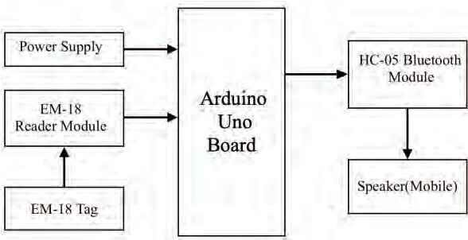

Figure 1. Reco using Arduino

The key steps of this implementation are

* Placing the RFID tag in front of the RFID reader RFID reader provides a signal to Arduino Uno about the detection of RFID tag which contains information about the bus.
* Then, Arduino Uno sends a signal to the Bluetooth module

which is connected to a mobile(here) with Bluetooth.

* The application will produce a voice message.

## Working

.

An impressive RFID tag is worn by the delivery drivers. When transport is moving toward a bus stop, the driver should place the RFID label they were provided next to the RFID editor. The editor uses an exceptionally identifiable proof code to access the data of the transport. This editor also recognizes RFID labels, which include information about the

transportation such as the transport number and locations. The RFID editor functions as a transmitter and communicates with Arduino using the transport's unique proof code and an unloaded version of the software.

The Arduino will send signals to the Bluetooth module using an extremely identifiable proof code. Right now, Arduino serves as the beneficiary and sends the signals to the Bluetooth module. The data is now handled by the voice-based playback framework and supplied via the speaker.

# Hardware resources

The main hardware resource in this implementation is an Arduino board, Bluetooth module, RFID reader, and tags.

**ARDUINO UNO:**

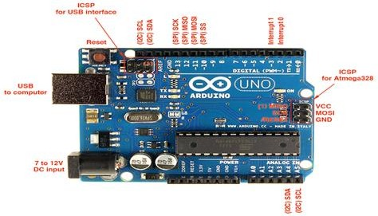

#### Fig-1 Arduino Uno

The Arduino UNO bus identification system is accessible to blind people. Many other applications,

such as IoT (Internet of Things) and sensor-based systems projects, use a popular microcontroller board called the Arduino UNO. It is well-liked and straightforward to utilize. A Bus Identification System can be constructed with an Arduino UNO to assist those with visual impairments. Using a USB connection or an external power supply, the Arduino Uno can be powered. On an external supply ranging from 6 to 20 volts, the board can function. Nevertheless, the 5Vpin may not produce exactly five volts when supplied with less than 7V, and the board may be faulty. Injurious overheating of the voltage regulator is a possibility.

# Bluetooth module:

* It uses the HC-05 module, a Bluetooth Serial Port Protocol-SPP module. It is designed for establishing a remote transparent serial connection. It can be utilized in a master-slave configuration. The salient features of this module-
* Bluetooth V2.0+EDR.
* • 3 Mbps Modulation using the complete 2.4 GHz CSR Blue Center 04-External single-chip Bluetooth architecture with AFH (Adaptive Frequency Hopping) and CMOS technology.
* As a matter of course, the module is utilized as a slave. Using only AT instructions, the module's role—Master or Slave—can be planned out. The HC-05 is a cool module that can be used with full-duplex remotes. It very well may be utilized between two Arduinos to speak with one another. It is designed to use a cable connection. It has 6 pins but we generally care about 4 of them namely RX, TX, VCC(5V), AND GND.

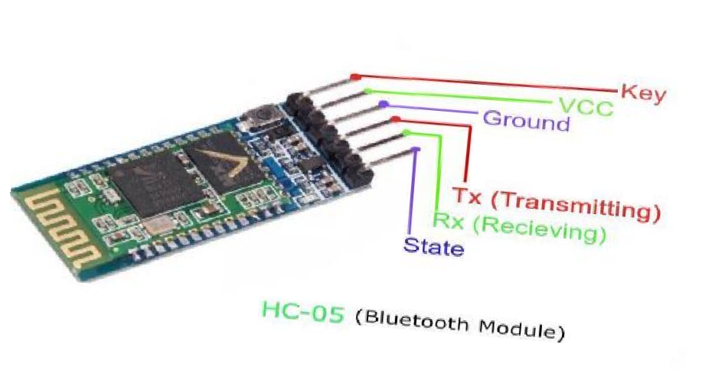

**Fig-2 Diagram of Bluetooth module**

# Ultrasonic sensor (HC SR-04) :

Based on delivering and receiving ultrasonic signals, it calculates distances. These tools are trustworthy and cost-effective for wireless applications.

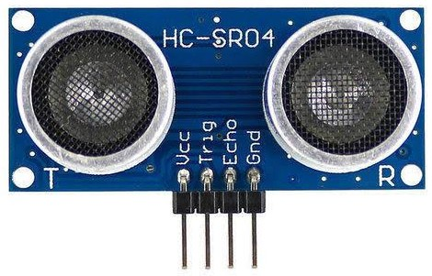

# Fig-3 ultrasonic sensor LV Maxsona:

The LV Max Sonar EZ is a series of ultrasonic distance sensors developed by Max Botix Inc. These sensors are designed to provide accurate and reliable distance measurements using ultrasonic technology. The LV Max Sonar EZ sensors are widely used in various applications, including robotics, automation, industrial equipment, and environmental monitoring.

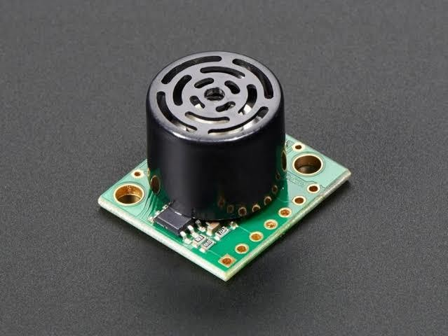

**Fig-4 LV Max sona**

# Voice Box Shield:

Arduino shields are add-on modules that can be easily attached to an Arduino board to extend its capabilities or add specific functionalities. A "Voice Box Shield" could potentially be a shield designed to enable voice-related features with an Arduino.

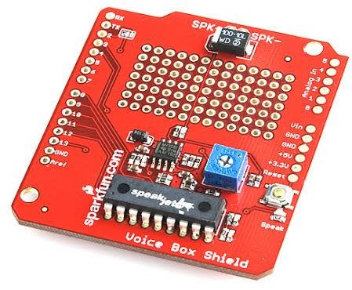

**Fig-5 Voice box shield**

# DC motor:

Electrical energy is converted into mechanical energy by an electromechanical device known as a DC (Direct Current) motor. It consists of two parts: the stationary stator and the rotor, which revolves. A DC motor must typically be connected to a power source to operate (such as a battery or a motor driver run by a microcontroller). The polarity and voltage of the motor can be changed to change the direction and rate of rotation.

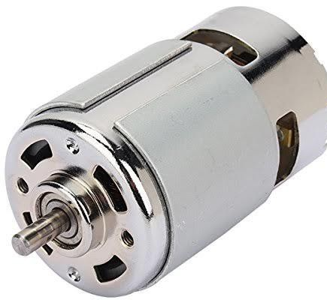

***Fig-6 DC motor***

***RFID Reader:***

A wireless system made up of two parts, readers and tags, is referred to as radio frequency identification (RFID). A reader is a machine equipped with one or more antennas that transmit radio waves and receive signals from RFID tags.

Tags can be passive or active. They convey their identity and other information to adjacent readers using radio waves. The reader provides power to passive RFID tags, which do not have batteries. Batteries power the active RFID tags.

One serial number or multiple pages of data can be stored on RFID tags. Readers can be portable so they can be carried by hand, fixed on a post, or suspended from the ceiling. Also possible are reader systems.

**Implementation and design evolution:**

The bus driver will broadcast "a" through his smartphone, and the buzzer will beep to welcome the blind passenger. The signal is taken in by the Bluetooth module and sent to the microcontroller.

When the user sends the letter "b" through his smartphone, the buzzer will stop beeping. The signal is taken in by the Bluetooth module and sent to the microcontroller.

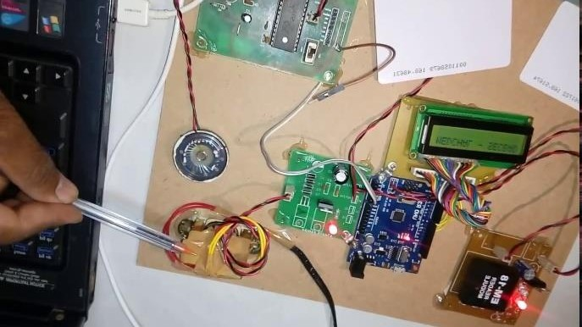

***Fig-7 implementation***

***Arduino programming:***

### For Bluetooth modules that can be utilized by the transport driver utilizing an application:

#include<avr/io.h> #characterize F_CPU a million

#include<avr/usart.h> void fundamental()

{

PORTB=output if(input_value==a)

{ B0=1;

}

if (input_value==b)

{ B0=0;

}

}

**For the ultrasonic sensor to identify the item**: #include<avr/io.h>

#characterize F_CPU a million #include<avr/usart.h>

void fundamental ()

{

PORTB=output

If (distance < 30cm)

{ B0=1;

Delay = 3sec;

B0 =1;

}

Most of the time, blind people find it difficult to go outside of their comfort zones. These visually impaired individuals can now navigate and cross lanes

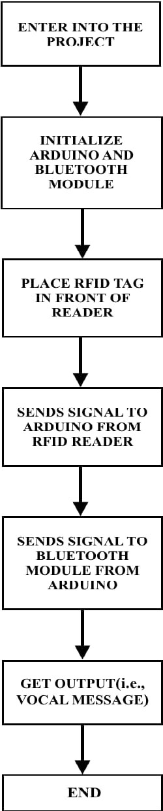with the help of a variety of equipment. These new inventions, such as canes and walking sticks, are intended to make it simpler for these people to walk and cross the street. The technological tools needed to use public transit were unavailable to them.

Because of this, there was a need for an ongoing solution, and after reading an article in a journal on the problem, this idea was born. We thus investigated developing a bus identification system that would allow blind individuals to utilize an ultrasonic sensor to detect the presence of a bus and navigate a public transportation system on their own.

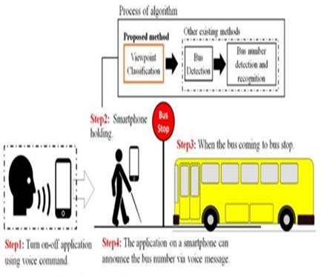

**Fig-8 Overview of system design, other existing methods, and the proposed method**

# Testing, Analysis, and Evaluation:

### Importance

Our project is relevant up to the point at which the desired results will be obtained. It may very well be used for a particular group of people in our society— specifically, people who are physically disabled—but after some improvements, it may also be used for other sections of the general public.

### Viability

Our project makes use of an ultrasonic sensor, which is used to detect any object within its given range or in the immediate vicinity. In our project, we used an ultrasonic sensor with a 30m range. If the ultrasonic sensor's range had been increased, it might have been able to identify or detect each check that was within its range. We have used a low reach in this way to make it easier to place the conveyance.

### Productivity

Our undertaking is productive inside a specific short reach where fewer checks can be distinguished. It tends to be made more proficient by fostering a portable based application furthermore, taking care of the picture of transports by utilizing uses of picture handling, and acquainting a braille console with the client's module with the goal that the client can take care of the ideal transport number to board the specific transport.

# Problems, faults, bugs, and challenges:

### problems

As a subsequent choice, we might have involved ZigBee setup of RF module yet since its expense is a lot higher so we selected for RF module and a Bluetooth module which give better results for nearly minimal price.

### faults

At first, we utilized two RF modules which caused undesirable obstruction i.e., the data sent by the transmitter of the principal RF module couldn't come to the collector of the subsequent module. Fairly,

because of impedance it was gotten by the collector of the principal module in this way impeding the resultant result.

### Bugs

We have taken care of the programming to control the miniature regulators and the Bluetooth gadget to set up a correspondence between the client gadget and the transport module utilizing remote correspondence by ARDUINO UNO. We have dealt with certain issues connected with the mistakes while executing the projects and redressed the bugs and run-time mistakes.

### Challenges

The greatest test looked at by us was to control the impedance caused because of the presence of two RF modules. We conquered the test by utilizing one RF module and a Bluetooth module thereby leading to the desired result.

# CONCLUSION

Outwardly disabled people find it difficult to adjust to their local environmental factors in the current serious world where everyone needs to move as quickly as is realistically expected. So to help them take baby steps in the direction of improvement, we came up with a concept where the physically impaired person can easily identify the vehicle they need to load up and shorten the time taken by them in such exercises so they can complete other important exercises with more than enough time and precision.

This idea helped us to understand the lives of those who are physically challenged people as well as how difficult it might be at different points in time to obtain the necessities of life.

# REFERENCES

* 1. Simon Knight's Arduino for Beginners: A Step-by-Step Guide (Arduino Hardware & Software).

"Bus detection device for the blind using RFID application," 2009 5th International Colloquium on Signal Processing & Its Applications, Kuala Lumpur, 2009, pp. 247-249. Mohd Zikrul Hakim Noor, I. Ismail, and M. F. Saaid.

* 1. Ramyadevi, K., Preetha, M., and Elavarasi (2017). a sophisticated digital system for VIPs (visually impaired people). International
  2. Burkhause, R. V., Daly, M. C., McVicar, D., & Wilkins, R. (2014). Disability benefit growth and disability reform in the US: lessons from other OECD nations. *IZA Journal of Labor Policy*, *3*(1), 4.
  3. Abdullah, S., Noor, N. M., & Ghazali, M. Z. (2014). Mobility recognition system for the visually impaired. 2014 IEEE 2nd International Symposium on Telecommunication Technologies (ISTT).