**Analysis of the distributed solar generation's fault characteristics**

Sunil Patel, Prof. Vishal Rathore

**1.M.Tech. Student, EX Departement, BITS COLLEGE OF ENGINEERING, BHOPAL,M.P.**

**2.Faculty, EX Departement, BITS COLLEGE OF ENGINEERING, BHOPAL, M.P.**

**Abstract -** This paper presents power analysis and simulations of Inverter Based Distributed Energy Sources (DER) is an inverter based distributed energy meter with low fault current negative negative series current and zero series current. In the inspection and protection of relays needs to understand the DER fault. This chapter deals with the example of Dominion Energy failure. Stopper's error analysis showed that the actual response to DER errors may differ from the previous.The current relay lock is replaced by the car door lock, all of which provide the relay current until the upper limit is exceeded three times. The current relays are no longer switched off due to delay, but only for minor change faults. For different situations, check the display by setting the DER (PVA) to reverse with the relay's counter. Use the best simulation platform to simulate an integrated MATLAB configuration for this analysis. However, more research is needed to model and carefully evaluate hypotheses developed using real-world networks to validate the effectiveness of participation.

**Index Terms-** DER System, Sequence component,protection system,MATLAB, Simulink Solar Power Generation Fault..

# INTRODUCTION

With the increased demands of the electrical power systems and events of electricity shortages, power quality issues, rolling blackouts and spikes in electricity price have led to research of alternate sources of energy. This led to the development of Distributed Energy Resources (DER) that is a small-scale power generation source located close to where electricity is used and primarily acts as an alternative to or an enhancement of the existing electric power grid[1].

With consideration to the construction of large, central power plants and high-voltage transmission lines, DER is a faster and less expensive option. It offers higher reliability, increased power quality, high energy efficiency and energy independence. The utilization of renewable distributed energy generation methods and green power like wind, biomass photovoltaic, geothermal or hydroelectric power provides a noteworthy environmental benefit.

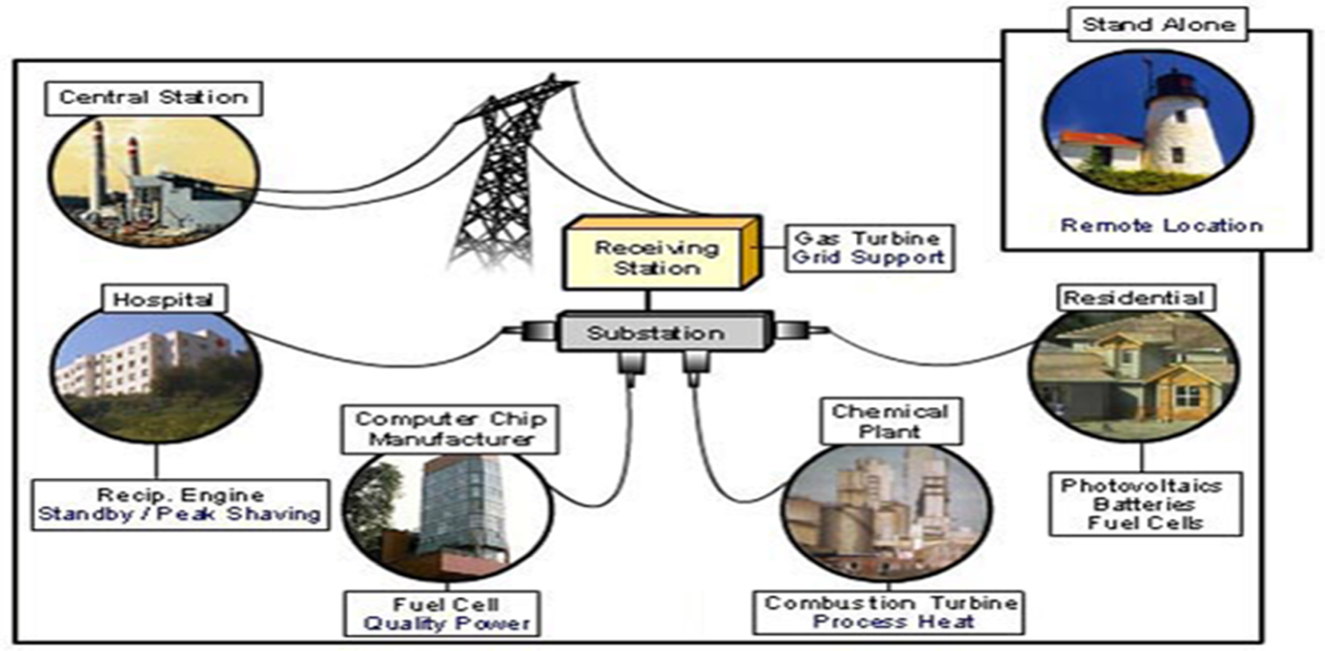

**Fig. 1 Types of distributed energy resources and technologies**

**II.** **COMPONENTS OF DER TECHNOLOGIES**

A DER technology mainly consists of energy generation and storage systems placed at or near the point of use which usually includes fuel cells, reciprocating engines, micro turbines, load reduction and energy management techniques.

DER also engages power electronic interfaces, communications and control devices so as to obtain higher efficiency and for the operation of single generating units, multiple system packages and collective power blocks[3].

**CHARACTERISTICS AND APPLICATION OF DER**

The primary application of DER includes:

* Premium power: lesser frequency variations, voltage transients and other disruptions
* Back-up power: used as a back-up in the event of an outage
* Peak shaving: used when electric use and demand charges are high
* Low-cost energy: locally available and economical primary power source
* Combined heat and power (cogeneration): increase the efficiency during power generation by using the waste heat for existing thermal process

Basically, the DER provides better reliability, helps to reduce overloaded transmission lines, adequate power quality, manage price fluctuations, build up energy security and provides superior stability to electric grid.

**SOLAR ENERGY POWER GENERATION**

The conversion of sun's radiation into electricity via the use of solar photovoltaic cells is termed as solar power generation. Photovoltaic effect is the basic principle of this power conversion[5].

A minimum number of steps are included in the power generation as compared to conventional generation methods which paves way for wide range of applications. Converting sunlight into electricity can be mainly done in two ways. First method is where solar energy is used as a source of heat which is further used to produce the steam that drives the steam turbine.

This method of power generation is termed as solar thermal power generation. Second method makes use of silicon PV cells to directly convert solar energy into electricity and is termed as solar power generation.

**Major factor for choosing the solar power generation are:**

* free availability
* lesser time is needed for installation of solar power plants
* clean energy production
* economical as only one-time initial investment is needed

# PV CELLS

# A PV cell also termed as solar cell is a semiconductor device which converts the sunlight energy falling on it into electricity without carrying out much energy conversion steps. This conversion takes place by photovoltaic effect and thereby they are called Photovoltaic (PV) cells. It generates voltage and current at its terminals when sunlight is incident on it [4].

# 

# Fig. 2 PV CELLS

# 

# POWER SYSTEM PROTECTION

# The main objective of power system protection is to isolate a faulty section of electrical power system from rest of the healthy system so that this portion can function suitably without any serve damage because of fault currents.

# The circuit breaker isolates the faulty system from rest of the live system as they automatically open during fault condition because of its trip signal which comes from the protection relay.

# The system cannot be fully prevented from fault currents but we can prevent the continuation of flow of fault current by quickly disconnecting the short circuit path from the system for which the protection relays should have following functional requirements[4].

# Reliability: Relays remain inoperative for a long time before a fault occurs; but it must respond instantly and accurately during fault occurrence.

# Selectivity: The relay must be operated only in those conditions for which relays are custom-made in electrical power system i.e. at some fault point it should not be operated or must be operated at some definite time.

# Sensitivity: The relaying equipment must be sufficiently sensitive to operate precisely when level of fault condition just crosses the predefined limit.

# Speed: The protective relays must operate at the required speed i.e. it should neither be too slow which may result in damage to the equipment nor it should be too fast which may result in undesired operation[6].

# Inverter-based distributed energy resources (DERs) are characterized with low fault current and negligible amount of negative and zero sequence currents.

# Understanding DER’s fault characteristics is critical for fault analysis and protective relay setting. Despite the abundant work on DER modelling, few research studies have been done to analyse DER’s fault behaviours during actual fault events.

# This thesis explores recorded fault events collected by Dominion Energy. Fault magnitude, angle, and sequence components are analysed to show that actual DER fault response may differ from previous understandings.

# The general reclosure over current relay is replaced with counter set reclosure over current relay which completely triggers off when the restricting number crosses 3 times. So, the over current relay only closes to short transient faults but not long-time faults.

# The analysis with respect to different conditions is checked using a DER (PVA) connected to this counter set reclosure over current relay.

**Objective of the work**

The following are the objectives of this thesis

1. To develop a distributed solar energy with circuit breaker but without relay.
2. To develop a distributed solar energy with circuit breaker and over current relay.
3. To develop a distributed solar energy with circuit breaker and Counter Set reclosure over current relay.

# 

# Fig. 3 Proposed system of Fault Characteristic of DER System

# III.SIMULATION RESULTS

**Simulation Parameter of Proposed system**

|  |  |
| --- | --- |
| Name | Unit and Value |
| Supply Voltage | 132KV |
| Power | 2500MVA |
| Step-up down Transformer | 132KV/34.5KV |
| Power rating of step-up transformer | 47MVA |
| Frequency | 50Hz |
| Phase to phase voltage | 34.5KV |
| Active Power | 100KW |
| Reactive Power | 50KVAR |
| Circuit Breaker Resistance | 0.01 Ohm |
| Solar irradiation | 1000 W/m2 |
| Temperature | 35 Degree |
| Duty Cycle | 0.5 |
| Capacitor | 1000 Micro Farad |
| Resistance | 0.005 Ohm |
| Inductor | 5Mh |

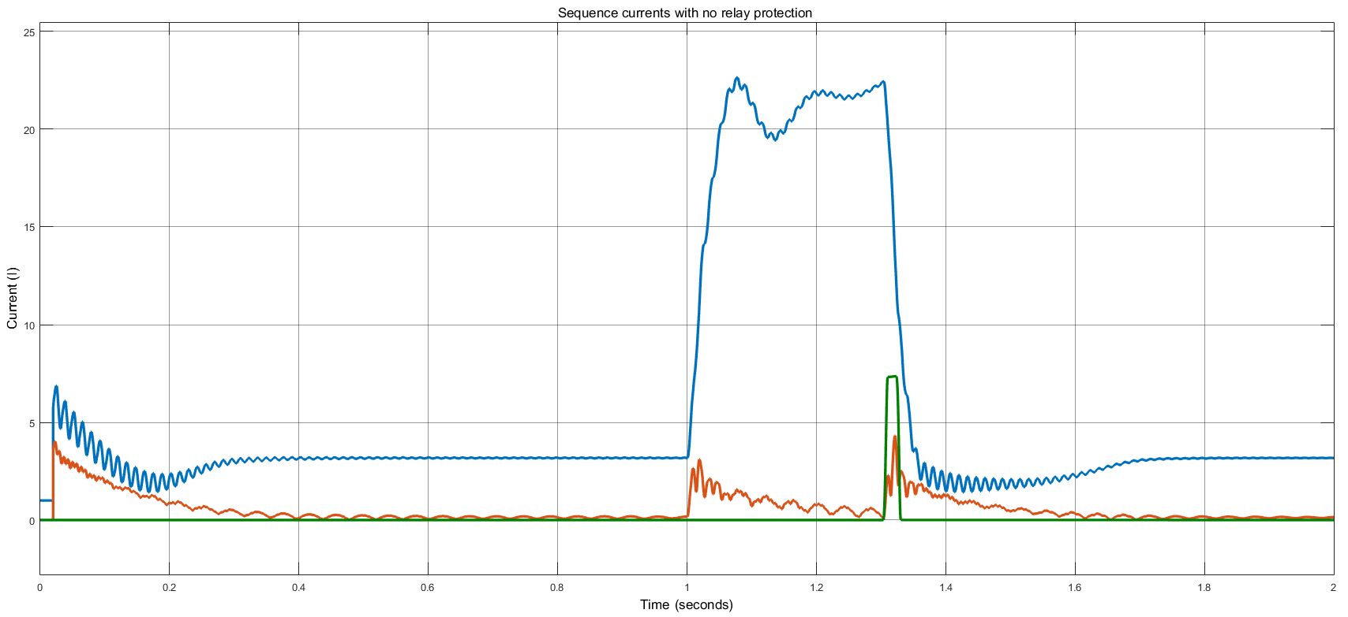

Fig.4 Sequence currents with no relay protection with fault from 1 to 1.3sec

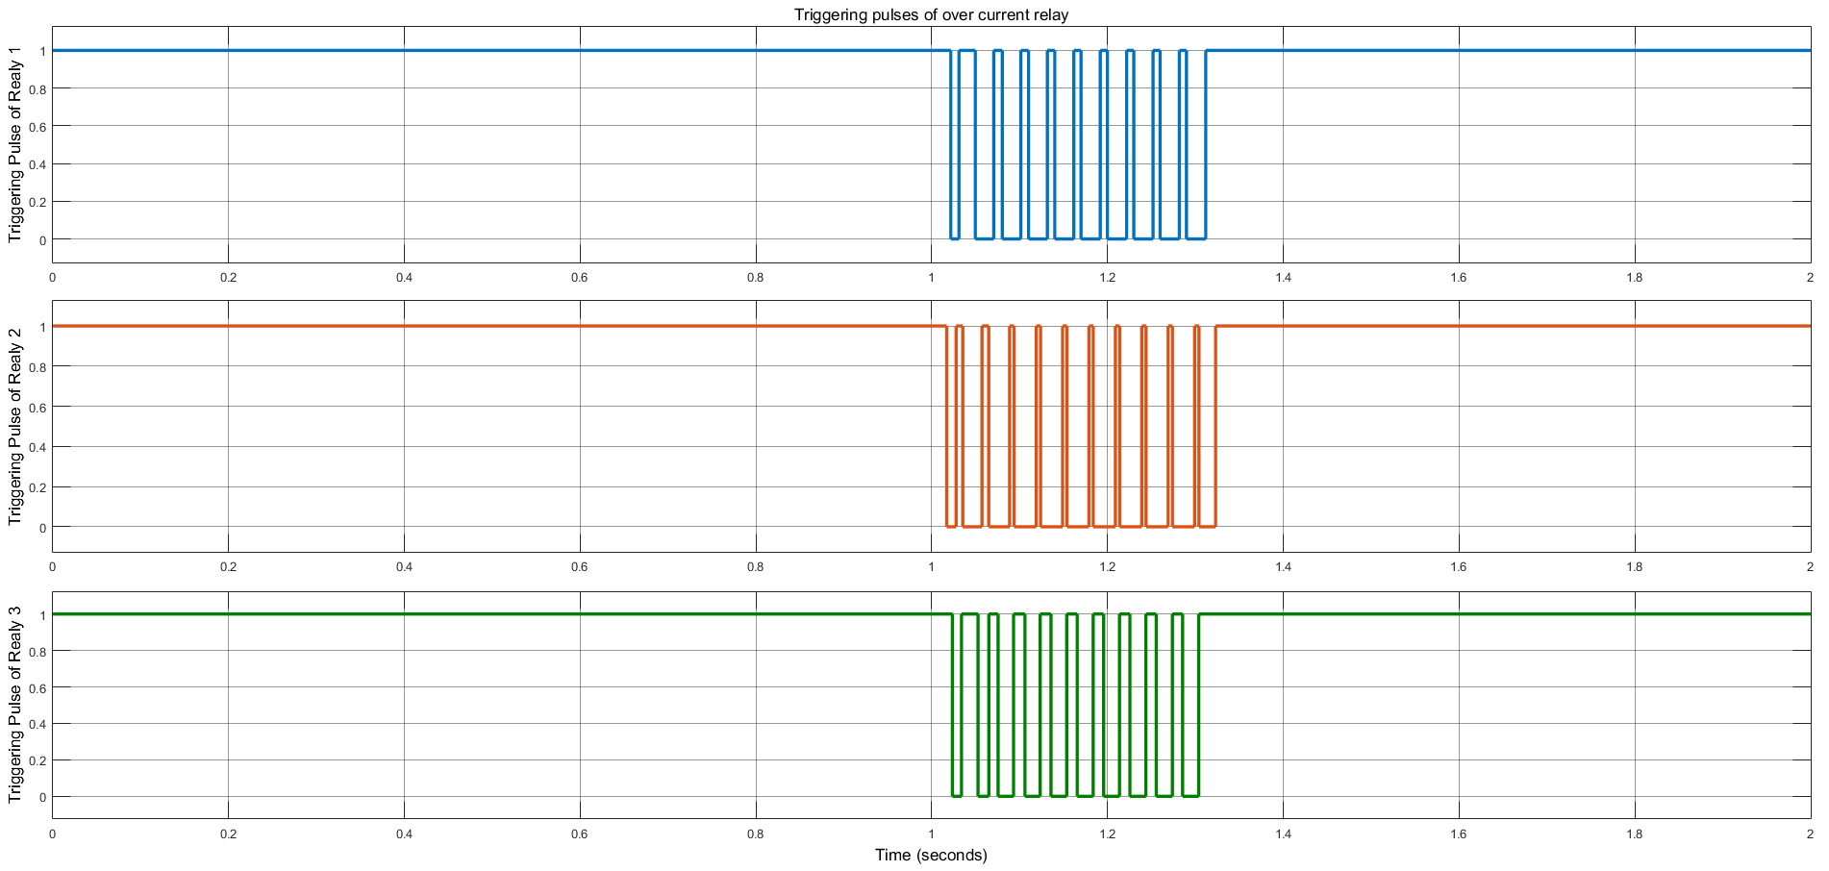

Fig. 5 Triggering pulses of over current relay

# IV.CONCLUSION

In the given comparison the reclosure over current relay has less fault current converging at the fault location as compared to over current relay and no relay models. However, the no relay model is a completely failed model as the fault remains in the line and the modules are damaged. The overcurrent relay continuously triggers ON and OFF during the fault and damages the modules connected to the test system. The reclosure over current relay helps the breaker to shut OFF completely after some restrickings and the test system is protected from the fault and the modules remain intact.

Any numerical models, i.e. mathematical simulation models have limitations. A mathematical simulation model will provide correct simulation results to the type of phenomena to be observed or examined by including appropriate individual model component (such as protections, controls and capabilities). Thus, the proper selection of the mathematical simulation model needs to be performed by power system engineers in academia as well as in industry. However, the proper selection of the mathematical simulation model is not an easy task. Distributed generation is expected to play a greater role in power generation over the coming decades, especially close to the end-use low voltage consumer side. There is a growing interest on the part of power consumers for installing their own generating capacity in order to take advantage of flexible DG technologies to produce power during favorable times, enhance power reliability and quality, or supply heating/cooling needs. The range of DG technologies and the variability in their size, performance, and suitable applications suggest that DG could provide power supply solutions in many different industrial, commercial, and residential settings. In this way, DG is contributing to improving the security of electricity supply. If DG does take a large share of the generation market, the role of distribution utilities will become vastly more important than currently. There will be a need to reform distribution system design requirements to accommodate DG. Undertaking further studies to identify the technical capabilities, the operating strategies, and the skill requirements of distribution network operators would help prepare electricity markets for a more decentralized electricity system.

**Future Scope**

In the given proposed system, the model can be updated with other renewable source like wind farm or fuel cell and can be protected with the proposed relay protection from faults. The relays can also be updated with directional over current relay or time inverse over current relay for better protection.

**REFERENCES**

[1] G. Kou, L. Chen, P. VanSant, F. Velez-Cedeno and Y. Liu, "Fault Characteristics of Distributed Solar Generation," in IEEE Transactions on Power Delivery, vol. 35, no. 2, pp. 1062-1064, April 2020, doi: 10.1109/TPWRD.2019.2907462.

[2] Mohamed-M-H Adam “Fault analysis for renewable energy power system in micro-grid distributed generation” Indonesian Journal of Electrical Engineering and Computer Science 13(3):1117-1123 March 2019.

[3] D. Kim and N. Cho, "Power Flow Based Fault Analysis Method for Distribution Grid with Inverter-Based DER," 2017 Ninth Annual IEEE Green Technologies Conference (Greentech)*,* Denver, CO, 2017, pp. 14-19, doi: 10.1109/GreenTech.2017.8.

[4] Namhun Cho “shunt fault analysis methodology of power distribution networks with inverter-based distributed energy sources of the Korea Electric power corporation” Renewable and Sustainable Energy Reviews 2020-08-02, *DOI:*10.1016/j.rser.2020.110140.

[5] Alsafasfeh, “Fault Detection and Analysis for Large PV Systems using Drones and Machine Vision. Energies 2018,11, 2252.

[6] H. Guan, G. Hao, and H. Yu, “Study of fault location algorithm for distribution network with distributed generation based on IGA-RBF neural network,” International Journal of Grid and Distributed Computing, vol. 9, no. 7, pp. 33–42, 2016.

[7] H. Hooshyar and M. E. Baran, "Fault Analysis on Distribution Feeders with High Penetration of PV Systems," IEEE Transactions on Power Systems, vol. 28, no. 3, pp. 2890-2896, 2013.

[8] R. Teodorescu, M. Liserre and P. Rodriguez, in Grid Converters for Photovoltaic and Wind Power Systems, John Wiley & Sons Ltd, 2010.

[9] C. S. Syamdev and A. A. Kurian, “HVDC fault tolerant converter for renewable energy source grid,” 2014 Int. Conf. Adv. Green Energy, ICAGE 2014, pp. 184–190, 2014.

[10] Lucian loan Dulau. “Effect of distributed generation in power system” s. Published by Elsevier Ltd. Selection and peer-review under responsibility of the Petru Maior University of Tirgu Mures. doi: 10.1016/j.protcy.2013.12.549.

[11] Madeleine and han slootweg “strategic bidding of distributed energy resources in coupled local and central markets” sustainable Energy Grids and networks 2020-09-24**,***DOI:*10.1016/j.segan.2020.100390.

[12] Dong-Eok Kimand Namhun Cho “Fault Analysis Method for Power Distribution Grid with PCS-based Distributed Energy Resource” Journal of Electrical Engineering and Technology · March 2017 DOI: 10.5370/JEET.2017.12.2.522

[13] Mesut E. Baran and EI- Markaby “Fault Analysis on Distribution Feeders with Distributed Generators” IEEE TRANSACTIONS ON POWER SYSTEMS, VOL. 20, NO. 4, NOVEMBER 2005.

[14] Haizhu Yang “Fault Location of Active Distribution Networks Based on the Golden Section Method” Hindawi Mathematical Problems in Engineering Volume 2020 08 Feb 2020.

[15] J. C. Gomez, J. Vaschetti, C. Coyos, and C. Ibarlucea, “Distributed generation: impact on protections and power quality,” IEEE Latin America Transactions, vol. 11, no. 1, pp. 460–465, 2013.

[16] K. Sun, Q. Chen, and Z. Gao, “An automatic faulted line section location method for electric power distribution systems based on multisource information,” IEEE Transactions on Power Delivery, vol. 31, no. 4, pp. 1542–1551, 2016.

[17] L. De Andrade and M. Teresa Ponce de Leao, “fault location for transmission lines using wavelet,” IEEE Latin America Transactions, vol. 12, no. 6, pp. 1043–1048, 2014.

[18] S. G. Ferhatbegovic, A. Marusic, and I. Pavic, “Single phase fault distance estimation in medium voltage distribution network based on traveling waves,” International Review of Electrical Engineering—IREE, vol. 7, no. 1, pp. 3532–3541, 2012.

[19] R. J. Hamidi and H. Livani, “A recursive method for travelingwave arrival-time detection in power systems,” IEEE Transactions on Power Delivery, vol. 34, no. 2, pp. 710–719, 2019.

[20] S. Azizi, M. Sanaye-Pasand, M. Abedini, and A. Hassani, “A traveling-wave-based methodology for wide-area fault locationin multiterminal DC systems,” IEEE Transactions on Power Delivery, vol. 29, no. 6, pp. 2552–2560, 2014.

[21] E. G. Carrano, F. G. Guimaraes, R. H. C. Takahashi, O. M. Neto, and F. Campelo, “Electric distribution network expansion under load-evolution uncertainty using an immune system inspired algorithm,” IEEE Transactions on Power Systems, vol. 22, no. 2, pp. 851–861, 2007.

[22] C. J. Fan, K. K. Li, W. L. Chan et al., “Application of wavelet fuzzy neural network in locating single line to ground fault (SLG) in distribution lines,” International Journal of Electrical Power & Energy Systems, vol. 29, no. 6, pp. 497–503, 2007. [14] S. M. Brahm, “Fault location in power distribution system with penetration of distributed generation,” EEE Transactions on Power Delivery, vol. 26, no. 3, pp. 1545–1553, 2011