**A STUDY ON EMPLOYEE MOTIVATION IN IT SECTOR**

1M. Sai Shravan and 2Sivakanni

1MBA student Jerusalem College of Engineering, Chennai

2Assistant Professor MBA, Jerusalem College of Engineering, Chennai

# ABSTRACT:

Employee motivation is a critical factor in the success of organizations, especially in the fast-paced and competitive Information Technology (IT) sector. This study investigates the key drivers of motivation among IT professionals, considering both intrinsic and extrinsic factors. Through a comprehensive analysis of survey data and interviews with IT employees, this research identifies the most influential motivators and explores how they impact job satisfaction, productivity, and employee retention in IT organizations. The findings shed light on the unique motivational dynamics within the IT sector and offer valuable insights for HR professionals and managers aiming to enhance employee motivation and engagement in this industry.

# INTRODUCTION

The project work entitled a STUDY ON EMPLOYEE MOTIVATION with special

Reference to Bridget solutions is mainly conducted to identify the factors which will

motivate the employees and the organizational functions in Bridget solutions

Chennai.

Management's basic job is the effective utilization of human resources for achievements

of organizational objectives. The personnel management is concerned with organizing human

Resources in such a way to get maximise output to the enterprise and to develop the talent of

people at work to the fullest satisfaction. Motivation implies that one person, in organization

context a manager, includes another, say an employee, to engage in action by ensuring that a

channel to satisfy those needs and aspirations becomes available to the person. In addition to this, the strong needs in a direction that is satisfying to the latent needs in employees and harness them in a manner that would be functional for the organization.

Employee motivation is one of the major issues faced by every organization. It is the

major task of every manager to motivate his subordinates or to create the 'will to work' among the subordinates. It should also be remembered that a worker may be immensely capable of doing some work: nothing can be achieved if he is not willing to work. A manager has to make appropriate use of motivation to enthuse the employees to follow them. Hence this studies also focusing on the employee motivation among the employees of Hyderabad Industries Ltd.

The data needed for the study has been collected from the employees through

questionnaires and through direct interviews. Analysis and interpretation have been done by using the statistical tools and data are presented through tables and charts.

The secondary data, on the other hand are those which have already been collected by

someone else and which have already been passed through the statistical process. The researcher has collected the secondary data from the company's records, pamphlets, websites, and also from the previous annual reports.

TECHNIQUES USED FOR ANALYSIS

The techniques used for analysis are

a) correlation Method

b) chi square Method

# REVIEW OF LITERATURE

A Literature Review has been done to know about the various aspects of job design in Order to identify those motivation factors that affect job performance. **Matthew Abioro (2017)**: This research study empirically evaluates the effect of employee motivation on organizational performance. Within the present study, the questionnaire was used because the main data collection tool. For a transparent analysis, the study focuses on two general variables; the variable which is that the organizational performance and therefore the experimental variable which is that the motivation of the workers. Three different hypotheses were formulated and tested using descriptive statistics and coefficient of correlation techniques respectively, so as to determine whether there's a relationship between employee motivation, pay, work environment and organizational performance. Research findings indicate that employee motivation features a positive effect on organizational performance. Therefore, it's recommended that the organization take the difficulty of employee motivation seriously to facilitate effective work.

**Ovidiu- iliuta Dobre (2014)**: Most organizations compete to survive in this volatile and ferocious market. Ambient. Employee motivation and performance are key tools for any success long-term organization. On the one hand, measuring performance is essential for the organization management, as it highlights the evolution and results of the organization. On the other hand, there is a file positive relationship between employee motivation and organizational effectiveness, reflected in many Educations. This article aims to analyse the factors that drive employee motivation towards high levels of performance. Addicted Dissatisfaction with monotonous jobs and customer pressure could weaken the organization. Performance. Therefore, absenteeism rates can increase and employees can leave the organization joint competitors offering better working conditions and greater incentives. Not all people are the same, therefore everyone must be motivated using different strategies. For example, an employee may be motivated by higher commission, while another may be motivated by job satisfaction or a better work environment.

**Aguinis et al. (2013)** stated that monetary rewards can be a very powerful determinant of employee motivation and achievement which, in turn, can advance to important returns in **Vuori and Okkonen (2014)** stated that motivation helps to share knowledge through an intra-organizational social media platform which can help the organization to reach its goals and objectives.

# RESEARCH METHODOLOGY

**DEFINITION**

Research is defined as the systemized effort to gain knowledge". Research method is

a way to systematically solve the problem. Business research is an organized, database, systematic, critical, objective, scientific inquiry or investigation in to a specific problem under taken with the purpose of finding answers or solutions to it. Research study plays a vital role in all kinds of business activities.

**In this study,** Descriptive research design is used which is most appropriate that enables a researcher to explore new areas of investigation. The sample unit was taken from the employees of- "Bridget solutions at Chennai". The size of the respondents covered for the study was 100 employees of Bridget solutions, Chennai.

**SOURCES OF INFORMATION**

Two types of data namely primary data and secondary data are collected. Primary data is

the data explicitly gathered for this research work, and the secondary data which was obtained from various sources like organizations records, books and also from the websites.

In this study. primary data collection is adopted through a well-structured questionnaire. The forms of questions contained in the questionnaire are:

a) Multiple choice questions

b) Dichotomous scale questions

c) Ranking scale form questions

# ANALYSIS

**Percentage analysis**

|  |  |  |  |  |  |
| --- | --- | --- | --- | --- | --- |
| **Are you satisfied with your job by the current motivation system in the organization?** | | | | | |
|  | | Frequency | Percent | Valid Percent | Cumulative Percent |
| Valid | Yes | 100 | 61.7 | 61.7 | 61.7 |
| No | 62 | 38.3 | 38.3 | 100.0 |
| Total | 162 | 100.0 | 100.0 |  |

Table 1

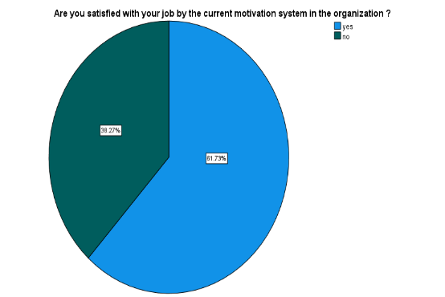

**Inference: As the table shows 61.73% of respondents are satisfied with current motivation system in their company.**

|  |  |  |  |  |  |
| --- | --- | --- | --- | --- | --- |
| **How you are satisfied with the safety measures adopted in your organization?** | | | | | |
|  | | Frequency | Percent | Valid Percent | Cumulative Percent |
| Valid | 1 | 10 | 6.2 | 6.2 | 6.2 |
| 2 | 12 | 7.4 | 7.4 | 13.6 |
| 3 | 20 | 12.3 | 12.3 | 25.9 |
| 4 | 71 | 43.8 | 43.8 | 69.8 |
| 5 | 49 | 30.2 | 30.2 | 100.0 |
| Total | 162 | 100.0 | 100.0 |  |

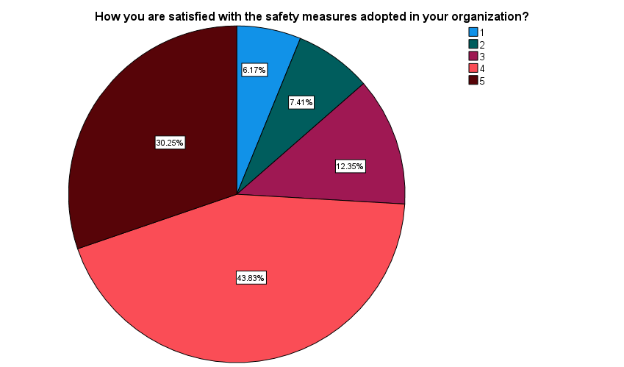Table 2

**Inference: As the table shows 43.83% of respondents rated 4 for the satisfaction levels of the safety measures adopted in the organization.**

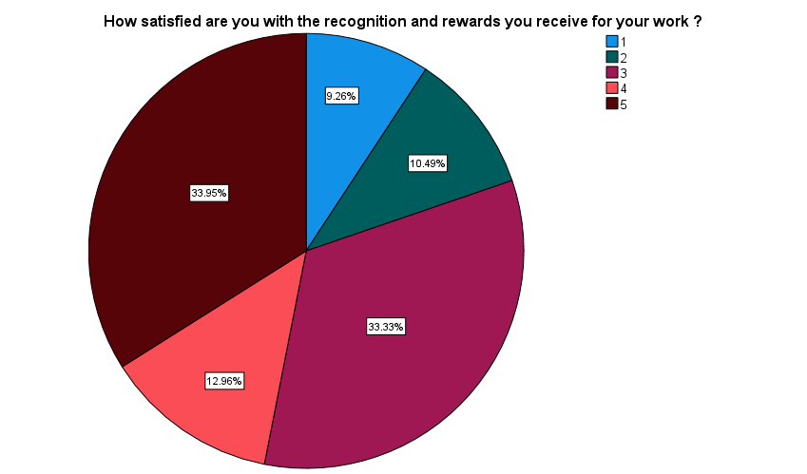Table 3

|  |  |  |  |  |  |
| --- | --- | --- | --- | --- | --- |
| **How satisfied are you with the recognition and rewards you receive for your work?** | | | | | |
|  | | Frequency | Percent | Valid Percent | Cumulative Percent |
| Valid | 1 | 15 | 9.3 | 9.3 | 9.3 |
| 2 | 17 | 10.5 | 10.5 | 19.8 |
| 3 | 54 | 33.3 | 33.3 | 53.1 |
| 4 | 21 | 13.0 | 13.0 | 66.0 |
| 5 | 55 | 34.0 | 34.0 | 100.0 |
| Total | 162 | 100.0 | 100.0 |  |

**Inference: As the table shows 33.95% of respondents feel satisfied for the recognition and rewards, they receive at work.**

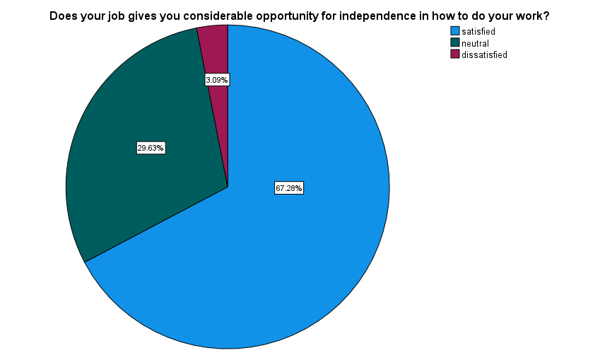Table 4

|  |  |  |  |  |  |
| --- | --- | --- | --- | --- | --- |
| **Does your job give you considerable opportunity for independence in how to do your work?** | | | | | |
|  | | Frequency | Percent | Valid Percent | Cumulative Percent |
| Valid | satisfied | 109 | 67.3 | 67.3 | 67.3 |
| neutral | 48 | 29.6 | 29.6 | 96.9 |
| dissatisfied | 5 | 3.1 | 3.1 | 100.0 |
| Total | 162 | 100.0 | 100.0 |  |

**Inference:**

**As the table shows 67.28% of respondents are satisfied that they have independence in doing their work.**

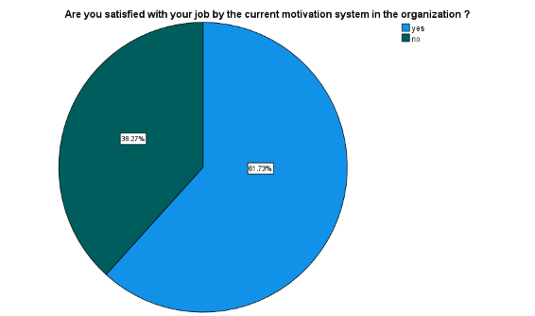Table 5

|  |  |  |  |  |  |
| --- | --- | --- | --- | --- | --- |
| **Are you satisfied with your job by the current motivation system in the organization?** | | | | | |
|  | | Frequency | Percent | Valid Percent | Cumulative Percent |
| Valid | Yes | 100 | 61.7 | 61.7 | 61.7 |
| no | 62 | 38.3 | 38.3 | 100.0 |
| Total | 162 | 100.0 | 100.0 |  |

**Inference:**

**As the table shows 61.73% of respondents are satisfied with current motivation system in their company.**

**CORRELATION:**

Correlation coefficients provide a numerical summary of the direction and strength of the linear relationship between two variables.

**Aim:** To find out how motivation leads to good human relationship.

**Null hypothesis(H0):** There is no significant relationship between employees and motivation

**Alternative hypothesis(H1):** There is significant relationship between employees and motivation

|  |  |  |  |
| --- | --- | --- | --- |
| **Correlations** | | | |
|  | | Management is really interested to motivating employees? | Rate your professional relationship with your co-workers? |
| Management is really interested to motivating employees? | Pearson Correlation | 1 | .260** |
| Sig. (2-tailed) |  | .001 |
| N | 162 | 162 |
| Rate your professional relationship with your co-workers? | Pearson Correlation | .260** | 1 |
| Sig. (2-tailed) | .001 |  |
| N | 162 | 162 |
| **. Correlation is significant at the 0.01 level (2-tailed). | | | |

**INFERENCE:** From the above table, we find that significant value is .001 which is lesser than the table value 0.005, so the null hypothesis is rejected and alternative hypothesis is accepted.

Therefore, the motivation leads to good human relationship.

**CHI SQUARE:**

A chi-square test is a statistical test used to compare observed results with expected results. The purpose of this test is to determine if a difference between observed data and expected data is due to chance, or if it is due to a relationship between the variables you are studying.

**Aim:** To find the effect of monetary and non-monetary benefits provided by the organisation

**Null hypothesis(H0):** There is no significant difference between monetary and non-monetary benefits provided by organisation

**Alternative hypothesis(H1):** There is significant difference between monetary and non-monetary benefits by organisation

|  |  |  |
| --- | --- | --- |
| **Test Statistics** | | |
|  | Do you think that the incentives and other benefits will influence your performance? | Which Type Of Incentives Motivates You More? |
| Chi-Square | 133.593a | 62.111a |
| df | 2 | 2 |
| Asymp. Sig. | .000 | .000 |
|  | | |
| a. 0 cells (0.0%) have expected frequencies less than 5. The minimum expected cell frequency is 54.0. | | |

**INFERENCE:** From the above table, we find that significant value is .000 which is lesser than the table value 0.05, so the null hypothesis is rejected and alternative hypothesis is accepted.

Therefore, there is significant difference between monetary and non-monetary benefits by organisation

**CHI SQUARE:**

A chi-square test is a statistical test used to compare observed results with expected results. The purpose of this test is to determine if a difference between observed data and expected data is due to chance, or if it is due to a relationship between the variables you are studying.

**Aim:** to analyse how motivational factors leads to job satisfaction among employees.

**Null hypothesis(H0):** There is no influence ofmotivational factors on job satisfaction among employees.

**Alternative hypothesis(H1):** There is influence ofmotivational factors on job satisfaction among employees.

|  |  |  |
| --- | --- | --- |
| **Test Statistics** | | |
|  | What is your opinion on job security existing in the company? | Does the management involve you in decision making which are connected to your department? |
| Chi-Square | 130.815a | 114.111a |
| df | 2 | 2 |
| Asymp. Sig. | .000 | .000 |
| a. 0 cells (0.0%) have expected frequencies less than 5. The minimum expected cell frequency is 54.0. | | |

**INFERENCE:**

From the above table, we find that significant value is .000 which is lesser than the table value 0.05, so the null hypothesis is rejected and alternative hypothesis is accepted.

Therefore, motivational factors will lead to job satisfaction.

**FINDINGS:**

The data reveals that as the 61.73% of respondents are satisfied with current motivation system in their company. The Furter study reveals that 43.83% of respondents rated 4 for the satisfaction levels of the safety measures adopted in the organization.33.95% of respondents feel satisfied for the recognition and rewards, they receive at work. And 67.28% of respondents are satisfied that they have independence in doing their work.

**SUGGESTIONS:**

1. Enhance the Motivation System:

While a majority of respondents (61.73%) are satisfied with the current motivation system, there is room for improvement. Consider conducting surveys or focus groups to gather feedback on what aspects of the motivation system are working well and where enhancements are needed.

2. Safety Measures:

It's positive that 43.83% of respondents rated safety measures at 4 out of 5, indicating moderate satisfaction. To improve this, organizations can Invest in continuous safety training and awareness programs.

Encourage employees to actively participate in safety initiatives. Regularly assess and update safety protocols based on employee feedback and industry best practices.

3. Recognition and Rewards:

While 33.95% of respondents feel satisfied with recognition and rewards, there is potential to boost this satisfaction level. We suggest implementing a more formalized recognition program that highlights employee achievements. Offering a variety of rewards, both monetary and non-monetary, to cater to different employee preferences. Organisations must also ensure that recognition is timely, specific, and tied to performance.

4. Independence in Work:

A substantial majority (67.28%) of respondents are satisfied with their independence at work, which is a positive sign. However, sustaining this satisfaction is essential. It’s a must to continue promoting a culture of trust and autonomy, where employees have the freedom to make decisions within their roles.

# CONCLUSION:

# Employee motivation plays a pivotal role in the prosperity of organizations, particularly within the dynamic and fiercely competitive Information Technology (IT) sector. This research delves into the primary sources of motivation for IT experts, encompassing both internal and external factors. By thoroughly examining survey responses and conducting interviews with IT staff, this study pinpoints the most potent motivators and examines their effects on job contentment, efficiency, and staff retention within IT enterprises. The discoveries illuminate the distinctive motivational forces at play within the IT domain, offering valuable guidance to HR specialists and managers striving to boost employee motivation and commitment in this field.

# Reference:

1.Mitch, M. (2017). 15 Tips to Increase Motivation in the Workplace. Retrieved, July 14, 2017, from Motivating your

<http://businesstips.ph/tips-to-increase-motivation-in-the-workplace/>

2. pis, G. (2013). 5 Ways Leaders Keep Hope Alive in Difficult Times. Forbes.com. Retrieved, July 14, 2017, from

<https://www.forbes.com/sites/glennllopis/2013/08/19/5-ways-leaders-keep-hope-alive-in-difficult-times/>

3. Erb, M. (2017). Seven Ways to Boost Employee Morale. Entrepreneur Media, Inc. Retrieved, July 14, 2017, from

<https://www.entrepreneur.com/article/220000/>

4. Hyland, M. E. Motivation and placebos: do different mechanisms occur in different contexts?

Philosophical Transactions of the Royal Society B. Biological Science. Retrieved, May,

14, 2017, from

<https://www.ncbi.nlm.nih.gov/pmc/articles/PMC3130400/>