**AUTOMATIC IRRIGATION SYSTEM USING ARDUINO UNO**

**DR.N. Sambasivarao1, Venkata Lokesh Peketi2, Mounika Bai Pathangi3,** **Jaya Sai Nimmala4, Naga Vasantha Jutru5, Vamsi Krishna Bodavula6.**

1Professor and Head of the Department, Electrical and Electronics Engineering, NRI Institute of Technology, Vijayawada, India

2UG Student, Electrical and Electronics Engineering, NRI Institute of Technology, Vijayawada, India

3 UG Student, Electrical and Electronics Engineering, NRI Institute of Technology, Vijayawada, India

4 UG Student, Electrical and Electronics Engineering, NRI Institute of Technology, Vijayawada, India

5 UG Student, Electrical and Electronics Engineering, NRI Institute of Technology, Vijayawada, India

6 UG Student, Electrical and Electronics Engineering, NRI Institute of Technology, Vijayawada, India

**ABSTRACT**

This paper introduces an innovative approach to automated irrigation by presenting the design and implementation of an efficient and user-friendly automatic irrigation system using the Arduino Uno microcontroller. The system utilizes a soil moisture sensor to continuously monitor the moisture level in the soil. Once the moisture level falls below a pre-defined threshold, the sensor triggers the Arduino Uno to activate a water pump, ensuring timely and precise irrigation for plants or crops. The proposed system offers a straightforward and accessible solution for individuals with limited experience in electronics, making it feasible for a wide range of users. Its adaptability allows users to tailor the system to suit their specific irrigation requirements, providing flexibility and ease of integration with different setups. The core functionality of the automatic irrigation system is based on the synergy between the Arduino Uno and the soil moisture sensor. The Arduino serves as the intelligent control unit, effectively interpreting sensor data and initiating the water pump when necessary. As a result, this autonomous irrigation system optimizes water usage, prevents water wastage, and facilitates plant growth by maintaining an ideal soil moisture level. Overall, this paper's contribution lies in the demonstration of an accessible, yet highly efficient automated irrigation system that can benefit both amateur gardeners and agricultural professionals. With the Arduino Uno as its backbone, this system promotes sustainable and responsible water management, fostering healthy and thriving plant ecosystems.

**Keywords:** Automatic Irrigation, Arduino UNO, Soil moisture sensor, Relay module, Automation.

1. **INTRODUCTION**

Agriculture stands as one of the cornerstones of human civilization, providing sustenance and indispensable products to communities worldwide. Nevertheless, this vital sector faces a critical challenge due to its substantial dependence on water resources. With water scarcity becoming an increasingly prevalent issue across various regions, the quest for sustainable water management in agriculture has grown more urgent than ever before. Automatic irrigation systems are becoming increasingly popular as a way to conserve water and improve crop yields. These systems use sensors to monitor soil moisture levels and weather conditions, and they can automatically turn on or off irrigation water supplies as needed. This can help to ensure that crops receive the right amount of water at the right time, which can lead to increased productivity and profitability[1]. In this context, the implementation of an automatic irrigation system emerges as a promising solution to address the pressing concerns of water conservation and labor optimization in agriculture. By adopting such innovative technology, farmers can revolutionize their irrigation practices, significantly improving water efficiency and crop yield. The focal point of this research presentation revolves around an automatic irrigation system utilizing the Arduino Uno microcontroller—a cutting-edge development in the realm of agricultural automation. By harnessing the capabilities of the Arduino Uno, this system showcases a proficient means to monitor and manage crop hydration with precision and intelligence. The overarching goal of this study is to explore how the automatic irrigation system, based on the Arduino Uno, can facilitate resource-efficient farming practices. By integrating technology into agriculture, the system aims to curtail water consumption while simultaneously reducing the labor-intensive efforts traditionally associated with manual irrigation. Through this presentation, we delve into the multifaceted benefits of embracing an automatic irrigation system in modern agriculture. As we uncover the potential advantages of water savings, labor optimization, and sustainable farming, we emphasize the transformative impact that this technology can have on the agriculture sector, paving the way towards a more resilient and ecologically responsible future.

1. **LITERATURE REVIEW**

Smart irrigation systems are the latest trend in irrigation technology. These systems use sensors and other technologies to monitor soil moisture levels, weather conditions, and other factors, and they can automatically adjust the watering schedule accordingly[6]. The use of Arduino Uno for automatic irrigation systems has been gaining popularity in recent years. This is due to the fact that Arduino Uno is a relatively inexpensive and easy-to use microcontroller that can be programmed to control a variety of components, including soil moisture sensors, water pumps, and valves. One of the most popular applications of Arduino Uno for automatic irrigation systems is in agriculture. In agriculture, automatic irrigation systems can be used to water crops at the optimal time and frequency, which can help to improve crop yields and reduce water waste. The Internet of Things is updating the way we interact with the world around us. This technology is also being used to develop smart irrigation systems that can automatically control the watering of crops based on soil moisture levels, weather conditions, and other factors[2]. In this project, an Arduino soil moisture sensor is used to automate farm irrigation and soil moisture control. When the electricity is on, this automatic irrigation system detects the amount of moisture in the soil and automatically turns the pump on. An irrigation system must be used properly because the main source of water shortages is a lack of rain, which causes sporadic water consumption that wastes enormous amounts of water. For this reason, we utilize a system for automatically watering plants and checking the moisture level of the soil. This system works well in all types of weather[8].

1. **SYSTEM COMPONENTS**

**3.1 Arduino Uno Microcontroller**

Arduino is an open-source electronics platform based on easy-to-use hardware and software[3]. The Arduino Uno microcontroller plays a pivotal role as the intelligent control unit in the automatic irrigation system. With its user-friendly interface, even individuals with limited electronics experience can effortlessly program and operate the Arduino Uno. Its versatility allows it to execute a wide range of tasks, making it a perfect fit for the automation of irrigation processes. Additionally, its robust design ensures reliable and long-term operation, making it a dependable choice for agricultural applications.

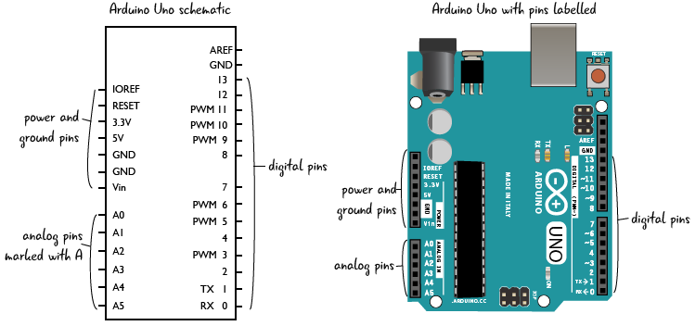

**Figure 1:** Pin diagram of Arduino uno.

**3.2 Soil Moisture Sensor**

Irrigation system is very important for agriculture. The soil moisture regulation is a big issue of growing plants. This is because inappropriate soil moisture affects to root water potential and leave water potential as well. Functionally, plant root transports water including nutrient via xylem to leave for photosynthesis activity. Consequently, the relationship of photosynthesis and soil moisture need to be considered as the key success for agriculture as well[4]. The soil moisture sensor is a crucial component in the automatic irrigation system, enabling precise measurement of soil moisture levels. By providing real-time data on soil hydration, the sensor empowers the Arduino Uno to make informed decisions regarding irrigation. This simple yet effective device is readily available and cost-effective, making it accessible to farmers of all scales. The accuracy of moisture measurements can be affected by a number of factors, including the type of sensor, the material being measured, and the environmental conditions.

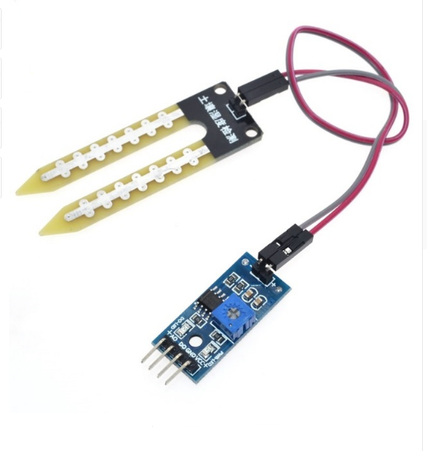

**Figure 2:** Soil moisture sensor

**3.3 Water Pump**

The water pump serves as the heart of the automatic irrigation system, responsible for delivering water to the plants when required. Whether utilizing a 12V DC pump or a battery powered alternative, the water pump's seamless integration with the Arduino Uno ensures timely and efficient irrigation. Its role in maintaining the ideal moisture level in the soil leads to improved crop health and higher yields.

**3.4 12V Power Supply**

The 12V power supply is the energy source that drives the entire automatic irrigation system. Supplying power to the Arduino Uno, soil moisture sensor, and water pump, the 12V power supply can be conveniently obtained from various sources, including wall adapters or batteries. Its stable and consistent power delivery ensures uninterrupted system operation, contributing to the system's overall effectiveness.

**3.5 Relay Module**

One of the most common uses for relay modules is to control high-power devices from a low-power microcontroller. For example, you could use a relay module to control a light bulb from an Arduino. The relay module would take the low-power signal from the Arduino and use it to switch on or off a high-power circuit that controls the light bulb[7]. The relay module acts as a crucial safety feature, separating the low-voltage Arduino Uno from the higher voltage requirements of the water pump. By functioning as a control interface, the relay module enables the Arduino Uno to safely manage the water pump's activation and deactivation. This isolation ensures that the microcontroller remains protected and extends its lifespan while effectively controlling the water pump.

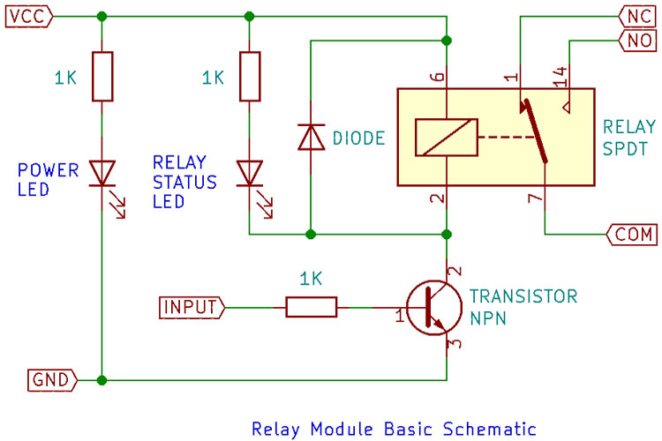

**Figure 3:** Relay module Circuit diagram.

**3.6 Jumper Wires**

Jumper wires play a fundamental role in connecting the components of the automatic irrigation system. These versatile and cost-effective wires offer a straightforward and efficient means of establishing electrical connections between different elements. Their ease of use facilitates swift prototyping and adjustments, making them an indispensable component during system development.

**3.7 Breadboard**

The breadboard provides a convenient platform for prototyping and assembling the automatic irrigation system. It simplifies the process of connecting electronic components, allowing for swift experimentation and modification. Its cost effectiveness and reusability make it an invaluable tool for farmers and hobbyists alike in testing and refining their irrigation setups.

1. **SYSTEM CONSTRUCTION**

To construct the automatic irrigation system, meticulous assembly of each component is crucial to ensure its flawless functionality and smooth operation. The following step by step instructions provide guidance for the successful integration of the system. To begin, establish a connection between the soil moisture sensor and the Arduino Uno. The soil moisture sensor is equipped with three pins: VCC, GND, and OUT. First, connect the VCC pin of the soil moisture sensor to the 5V pin on the Arduino Uno. Then, securely attach the GND pin of the sensor to the GND pin on the Arduino Uno. Lastly, establish communication by connecting the OUT pin of the soil moisture sensor to any available analog input pin on the Arduino Uno. This connection facilitates vital data exchange between the sensor and the microcontroller. Next, proceed to connect the water pump to the Arduino Uno through the relay module. The water pump has two wires: positive and negative. For a successful connection, connect the positive wire of the water pump to the common (COM) pin of the relay module. Simultaneously, ensure the negative wire of the pump is connected to the ground (GND) pin on the Arduino Uno, completing the electrical circuit and enabling the pump to function effectively. Additionally, connect the normally open (NO) pin of the relay module to any available digital output pin on the Arduino Uno (e.g., D10). This connection allows the Arduino Uno to control the water pump's activation through the relay module. Now, establish the connection between the 12V power supply and the Arduino Uno. The power supply is equipped with two wires: positive and negative. To ensure proper functionality, connect the positive wire of the 12V power supply to the VIN (Voltage In) pin on the Arduino Uno, thereby supplying the required voltage to the board. Additionally, connect the negative wire of the power supply to the GND pin on the Arduino Uno, establishing a robust ground connection and completing the power supply circuit. With the individual components now connected to the Arduino Uno, proceed to link the jumper wires to the breadboard. Jumper wires play a pivotal role in creating seamless connections between various components on the breadboard. Connect the VCC and GND rails on the breadboard to the 5V and GND pins on the Arduino Uno, respectively. Additionally, ensure the soil moisture sensor and relay module are appropriately connected to the designated pins on the Arduino Uno, facilitating effective data transfer and control. The final step involves uploading the Arduino code to the Arduino Uno. The code serves as the control mechanism for the automatic irrigation system, dictating its operation. The Arduino code can be readily obtained online or crafted from scratch to cater to the specific requirements of the irrigation system. Once the code is successfully uploaded, the automatic irrigation system is ready for action, efficiently managing water distribution and ensuring optimal plant growth based on real-time soil moisture data.

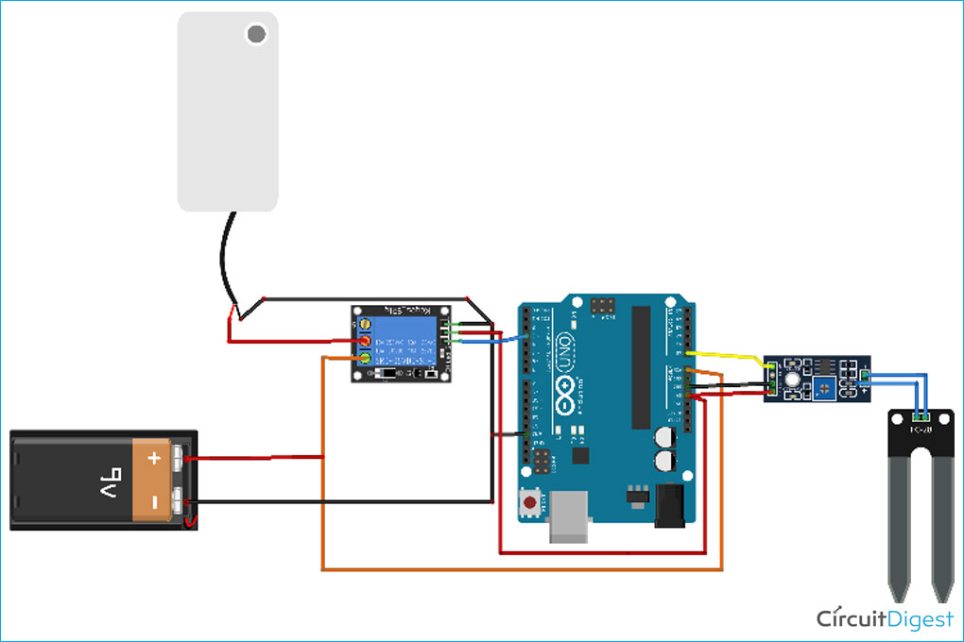

**Figure 4:** Connection of the Automatic Watering System.

1. **WORKING**

The automatic irrigation system using Arduino Uno represents a significant advancement in agricultural practices, particularly concerning water management and sustainability. The system's functionality initiates with the moisture sensor, which diligently measures the soil's moisture level. This sensor continuously provides real-time data to the Arduino Uno, the central control unit of the system. Leveraging its versatile programming capabilities, the Arduino Uno processes the moisture data and compares it to a pre-set threshold value that can be customized to suit various plant species and environmental conditions. Upon detecting that the soil's moisture level has fallen below the threshold, signaling the need for irrigation, the Arduino Uno promptly takes action. It activates the water pump connected through a relay module, enabling water to flow to the plants. The water pump ensures the plants receive the optimal hydration required for healthy growth. The intelligent irrigation process continues until the soil moisture level reaches the desired threshold, prompting the Arduino Uno to deactivate the water pump. This water-saving mechanism efficiently conserves water resources, prevents over-irrigation, and reduces unnecessary water consumption. The automatic irrigation system's brilliance lies in its continuous loop operation, tirelessly monitoring the soil's moisture level to deliver the appropriate amount of water to the plants based on their immediate needs. This iterative cycle optimizes water usage, minimizes irrigation costs, and fosters resource-efficient agriculture. The system's user-friendly assembly and maintenance further enhance its appeal, making it a practical and accessible solution for farmers and gardeners alike. By embracing the automatic irrigation system with Arduino Uno, agriculture takes a significant stride towards sustainability. Its ability to enhance crop yields, improve soil health, and conserve water resources underscores its indispensable value in modern farming practices. This innovative technology empowers farmers to adopt responsible water management practices, safeguard the environment, and pave the way for a more resilient and prosperous agricultural future. The complete work flow of the system is represented in the fig (5). The process starts with giving the supply to the system. When the system gets started then the soil moisture sensor checks the moisture content in the soil. If the moisture level of the soil is less than the required level then the water pump gets into the on state. Once the moisture level is achieved the required level then the water pump turns off and the process ends. If the soil moisture level is not less than the required level then the water pump remains off and the process ends.



**Figure 5:** Flow Chat of Irrigation System

1. **CONCLUSION**

In conclusion, the implementation of an automatic irrigation system using Arduino Uno proves to be a simple yet highly effective method to ensure optimal plant hydration. By employing a moisture sensor to monitor soil moisture levels, this system intelligently activates the water pump only when necessary, minimizing water wastage and promoting sustainable irrigation practices. The ease of building and adapting the system makes it suitable for a wide range of applications, from small-scale gardens to expansive farms and greenhouses. Its efficiency in delivering water precisely to plants when needed not only conserves water but also reduces the overall cost of irrigation, benefiting farmers and gardeners alike. The automatic irrigation system using Arduino Uno emerges as a valuable tool in agriculture, yielding a multitude of advantages. Firstly, it contributes to increased crop yields by providing plants with the necessary water at crucial growth stages. Secondly, the system promotes responsible water usage, mitigating environmental impacts and conserving water resources. Additionally, its consistent moisture supply aids in improving soil health, minimizing the risk of erosion, and enhancing soil fertility. Beyond these benefits, the system also proves to be economically advantageous, as it reduces labor costs by automating the irrigation process. This allows farmers to allocate their time and resources more efficiently, focusing on other essential farming tasks. Incorporating automatic irrigation systems into agriculture presents an innovative approach that fosters sustainable practices and resource-efficient farming. By enhancing crop yields, conserving water, improving soil health, and optimizing labor, the automatic irrigation system using Arduino Uno stands as a crucial tool in the quest for sustainable and productive agricultural practices. As farmers and gardeners embrace this technology, they not only ensure the well-being of their crops but also play an essential role in safeguarding the planet's precious water resources and promoting a more resilient and thriving agricultural ecosystem. Therefore, the adoption of automatic irrigation systems represents a significant step towards a greener and more food-secure future.

1. **REFERENCES**
2. Ashish Upadhyay, Prem Kumar, and Ravikant Yadav, “Automatic Irrigation Systems with SCADA: A Future Prospective”, LAP LAMBERT Academic Publishing, October, 2015.
3. Sampa Das,Puja Bose, Sanjugh Guha Thakurata, “Smart Irrigation System Using IOT”, February, 2023.
4. Don Wilcer, “Arduino for Beginners: Essential Skills Every Maker Needs”, QUE, December, 2016.
5. Supachai Puengsungwan, “IoT based Soil Moisture Sensor for Smart Farming”, International Conference on Power, Energy and Innovations, pp. 221- 224, 2020.
6. Vijay P. Singh and Qiong Su,“Irrigation Engineering”, Cambridge University Pres, October, 2022.
7. “What is Relay Module?”, <https://www.elprocus.com/5v-relaymodule/>.
8. Abhishek Kumar, Magesh.S, “Automated irrigation system based on soil moisture using arduino”, International Journal of Pure and Applied Mathematics, Volume 116 No. 21, pp. 319-323, 2017.