A STUDY ON JOB SATISFACTION OF TEACHERS IN PRIVATE SCHOOL

Buvaneshwari K and Praveen S V

MBA student Jerusalem College of Engineering, Chennai

Assistant Professor and Head MBA, Jerusalem College of Engineering, Chennai

**ABSTRACT**

This research study aims to explore and analyse the factors influencing job satisfaction among teachers in private schools. Job satisfaction is a critical aspect of the education sector as it directly impacts teaching quality, student outcomes, and the overall functioning of educational institutions. Private schools play a significant role in the educational landscape, and understanding the factors that contribute to the job satisfaction of their teachers can have implications for the recruitment, retention, and professional development of educators. A structured questionnaire will be administered to a representative sample of teachers from various private schools, collecting quantitative data on their demographics, teaching experience, workload, compensation, administrative support, professional development opportunities, and overall job satisfaction. Additionally, semi-structured interviews will be conducted with a subset of teachers to gain deeper insights into their experiences, perceptions, and emotions related to job satisfaction**.** To undertake this investigation, data was gathered from a diverse sample of 100 respondents representing various segments of society, including employees, private sector workers, students, business professionals, and homemakers. These respondents were invited to provide their assessments on a range of statements. The data amassed was meticulously organized, coded, and subsequently subjected to thorough analysis using statistical tools like chi-square tests, one-way ANOVA, correlation assessments, and frequency tabulations, all facilitated by SPSS software.

**Key words:** demographics, teaching experience, workload, compensation, administrative support.

**INTRODUCTION**

The teaching profession is known for its challenges and rewards. Private schools, in particular, often have unique characteristics that can impact teachers' job satisfaction. These schools might offer smaller class sizes, specialized curricula, and more autonomy in teaching methods. However, they might also have their own set of challenges, including higher expectations from parents, different administrative structures, and potentially varying compensation models.

On the other hand, dissatisfied teachers might experience burnout, reduced performance, and even turnover, negatively affecting the overall quality of education provided by the school.

**REVIEW OF LITERATURE**

In their study Mehboob, F., Sarwar, M. A. and Bhutto, N. A. (2012) have found that female faculty members were normally less satisfied with their job than male faculty members. All the “Job Hygiene” and “Job motivator” attributes were practically or noticeably related to job contentment. The factors “Policy” and “Working condition” were the least satisfying characteristics while “work itself” was the most satisfying factor found in the job in this study correspondingly. The management of “SALU” need to pay attention to those factors which creates displeasure among faculty members’ mostly the intellectual strategy execution; they should also arrange certain training and development sessions with a view to not only enhance the knowledge, skills and Abilities of faculty members but also to link the up between contentment and discontent. There were also several other factors which creates contentment and discontentment was the “Working Condition” of the organization. The management should attempt to advance organizations working conditions by performing more research and development services to faculty members and also do necessary changes in recovering the classroom environment in the organizations. In their study on job satisfaction among academic staff: a comparative analysis between public and private sector universities of Punjab, Pakistan Khalid, S., Irshad, M. Z., & Mahmood, B. (2012) have found that salary disparity does exist between public universities and private universities in Pakistan and Educators in public sector universities were found less contented with (1) job security and (2) Co-worker’s behaviour, on the other hand private sector universities educators were

more contented with their (1) supervision(2) Salary and (3) Promotional opportunities than the educators of public university. level of overall job contentment that they derived from various variables like Relationship with co-workers, Salary, behaviour, promotional opportunity, Job

security and Supervision. It also covers many states of the alliance as a way of result a permanent result to faculty member’s harmful outlook toward occupation and job discontent. A different perspective regarding job contentment and discontent and their motivational variables needs to be taken into thought the exclusive character of the parameters used in this research but their environmental and cultural beginning is therefore extremely suggested.

**METHODOLOGY**

The primary objective of this study is a study on job satisfaction of teachers in private school To measure the level of job satisfaction of the private school teachers ,To identify the major problems faced by the private teachers and To find the remuneration and appraisal. This study has been conducted The chosen methodology aims to provide a detailed understanding of the factors influencing job satisfaction and to draw meaningful conclusions for the benefit of both educators and educational institutions. The research will adopt a mixed-methods approach, incorporating both quantitative and qualitative techniques to capture a well-rounded perspective. The limitations of the study is respondents are reluctant to response in all cases and since small size of 100 respondents are taken so it is difficult of draw inferences about the population from this sample size. Primary data is collected by providing questionnaire to friends, relatives & colleagues, through emails, WhatsApp, etc. Secondary data is collected by analyzing through websites, vlogs, etc.

**ANALYSIS**

1. **PERCENTAGE ANALYSIS FOR AGE VARIABLE**

**TABLE 1 CHART 1**

|  |  |  |
| --- | --- | --- |
| **PARTICULARS** | **FREQUENCY** | **PERCENTAGE** |
| 21-25 | 21 | 44.4% |
| 26-30 | 28 | 24.3% |
| 31-35 | 17 | 14.8% |
| 36-40 | 15 | 13.0% |
| ABOVE 40 | 4 | 3.5% |
| TOTAL | 115 | 100% |

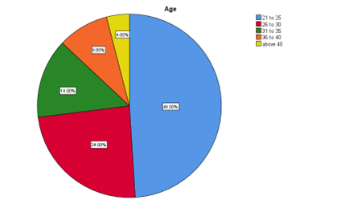

**INFERENCE**

From the above result it is observed that out of 115 respondents 49% are 21-25, 24% are 26-30, 14% are 31-35, 9% are 36-40 and 14% are above 40.

1. **PERCENTAGE ANALYSIS FOR GENDER VARIABLE**

**TABLE 2 CHART 2**

|  |  |  |
| --- | --- | --- |
| **PARTICULARS** | **FREQUENCY** | **PERCENTAGE** |
| MALE | 42 | 36.5% |
| FEMALE | 73 | 63.5% |
| TOTAL | 115 | 100% |

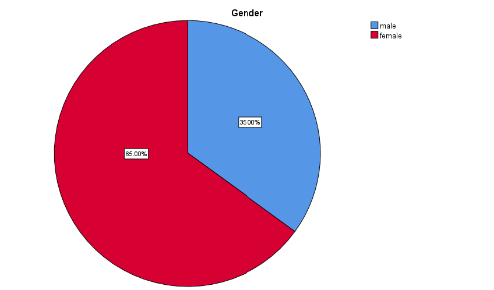

**INFERENCE**

From the above data it is found that out of 115 respondents 35% are male and 65& are females.

1. **PERCENTAGER ANALYSIS FOR INCOME VARIABLE**

**TABLES 3 CHAPTER 3**

|  |  |  |
| --- | --- | --- |
| **PARTICULARS** | **FREQUENCY** | **PERCENTAGE** |
| BELOW 10000 | 30 | 26.1% |
| 10001-15000 | 36 | 31.3% |
| 15001-20000 | 24 | 20.9% |
| 20001-25000 | 16 | 13.9% |
| ABOVE 25000 | 9 | 7.8% |
| TOTAL | 100 | 100% |

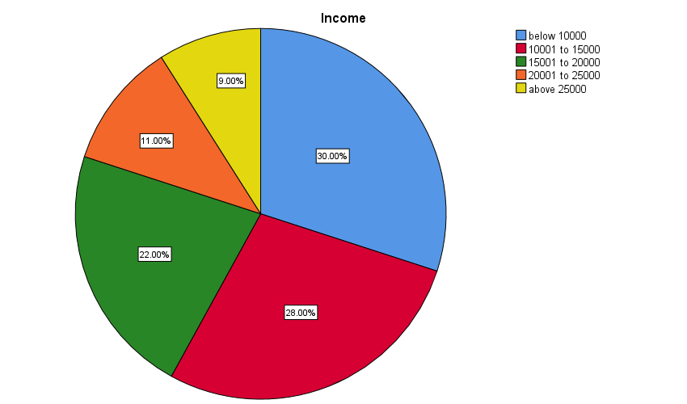

**INFERENCE**

From the above result it is found that out of 100 respondents 26.1% earn below 10000, 24.3% earn 10001-15000, 9.6% earn 15001-20000, 7.8% earn 46000-55000 and 4% earn above 56000.

1. **PERCENTAGER ANALYSIS FOR WERE YOU SASTISFIED WITH THE APPRAISAL GIVEN TO YOU**

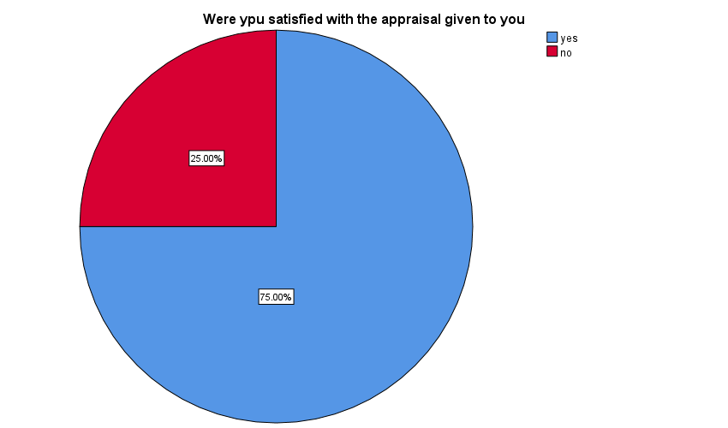 **TABLE 4 CHART 4**

|  |  |  |
| --- | --- | --- |
| **PARTICULARS** | **FREQUENCY** | **PERCENTAGE** |
| YES | 82 | 71.3% |
| NO | 33 | 28.7% |
| TOTAL | 100 | 100% |

**INFERENCE**

From the above table and chart it is analysed that out of 100 respondents have with were you satisfied with the appraisal percentage 62.2% are YES& 21.7% of NO.

1. **PERCENTAGE ANALYSIS FOR THE SCHOOLING STAFF VOLUNTARILY PUTS EFFORTS FOR STUDENTS WITH DISABILITES**

**TABLES 5 CHARTS 5**

|  |  |  |  |
| --- | --- | --- | --- |
| **The schooling staff voluntarily puts efforts for students with disabilities** | | | |
|  | | Frequency | Percent |
| strongly disagree | 7 | 6.1 | 6.1 |
| disagree | 13 | 11.3 | 11.3 |
| neutral | 29 | 25.2 | 25.2 |
| agree | 49 | 42.6 | 42.6 |
| strongly agree | 17 | 14.8 | 14.8 |
| Total | 100 | 87 | 100 |

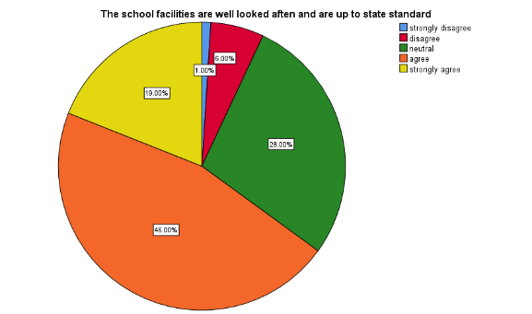

**INFERENCE**

From this above data it is found that out of 100 respondents 4% are strongly disagree, 11% are disagree, 14% are neutral and 23% are agree with their staff efforts.

1. **CHI- SQUARE ANALYSIS**

To find the relationship between gender and satisfied with the appraisal and remuneration given and received to the teachers.

**NULL HYPOTHESIS:**

**H0:** There is no relationship between gender and satisfied with the appraisal and remuneration given and received to the teachers.

**ALTERNATIVE HYPOTHESIS:**

**H1:** There is a relationship between gender and satisfied with the appraisal and remuneration given and received to the teachers.

|  |  |  |  |
| --- | --- | --- | --- |
|  | Gender | Were ypu satisfied with the appraisal given to you | Are you satisfied with the remuneration you received as a teachers |
| Chi-Square | 8.357a | 25.878 a | 17.609a |
| df | 1 | 1 | 1 |
| Asymp. Sig. | 0.04 | 0.01 | 0.01 |

**TABLE 6**

1. 0 cells (0.0%) have expected frequencies less than 5. The minimum expected cell frequency is 50.0.

**INFERENCE**

From the above result it is found that the significance have expected frequencies less than5.

The minimum expected cell frequency is 50.0.

**7. ONE-WAY ANOVA TEST**

To find out the difference between the staff is all task related to the school ,the school facilities are well looked aften and are up to state standard & How pleased are you with the number of holidays you receive in a year

**NULL HYPOTHESIS:**

**H0:** There is no significant difference between the staff is all task related to the school ,the school facilities are well looked aften and are up to state standard & How pleased are you with the number of holidays you receive in a year

**ALTERNATIVE HYPOTHESIS:**

**H1:** There is a significant difference between the staff is all task related to the school ,the school facilities are well looked aften and are up to state standard & How pleased are you with the number of holidays you receive in a year

**TABLE 7**

|  |  |  |  |  |  |  |
| --- | --- | --- | --- | --- | --- | --- |
|  | | Sum of Squares | df | Mean Square | F | Sig. |
| The staff is unbiased in all tasks related to the school | Between Groups | 8.582 | 4 | 2.146 | 2.283 | 0.65 |
| Within Groups | 103.383 | 110 | .940 |  |  |
| Total | 111.965 | 114 |  |  |  |
| How pleased are you with the number of holidays you receive in a year | Between Groups | 1.616 | 4 | .404 | 0.388 | 0.817 |
| Within Groups | 114.557 | 110 | 1.041 |  |  |
| Total | 116.174 | 114 |  |  |  |
| The school facilities are well looked aften and are up to state standard | Between Groups | 4.543 | 4 | 1.136 | 1.270 | .286 |
| Within Groups | 98.378 | 110 | .894 |  |  |
| Total | 102.922 | 114 |  |  |  |

**INFERENCE**

From the one-way ANOVA test it is found that the significant value of 0.286is more than the table value of 0.5, the null hypothesis is accepted. That is, there is no significant difference between the school ,the school facilities are well looked aften and are up to state standard & How pleased are you with the number of holidays you receive in a year.

**FINDINGS**

According to the study that out of 115 respondents 49% are 21-25, 24% are 26-30, 14% are 31-35, 9% are 36-40 and 14% are above 40.According to the respondents 35% are male and 65& are females. study According to the study26.1% earn below 10000, 24.3% earn 10001-15000, 9.6% earn 15001-20000, 7.8% earn 46000-55000 and 4% earn above 56000. According to the study, chart it is analysed that out of 100 respondents have with were you satisfied with the appraisal percentage 62.2% are YES& 21.7% of NO. According to the study, from the test it is found that the significance value is 0.243 which is higher than the table value 0.5, the Null hypothesis was accepted. That is There is relationship between between the staff is all task related to the school ,the school facilities are well looked aften and are up to state standard & How pleased are you with the number of holidays you receive in a year. According to the study, from the above result it is found that the significance value (0.004) is less than the table value (0.5). Therefore, the null hypothesis was rejected. That is, there is an association between. According to the study, from the one-way ANOVA test it is found that the significant value of 0.237 is more than the table value of 0.5, the null hypothesis is accepted. That is, there is no significant difference between the gender and the satisfaction level of current smartphone.

**SUGGESTIONS**

Job satisfaction among teachers in private schools is a vital aspect that significantly influences the overall quality of education and the learning environment. Creating an environment where teachers feel valued, supported, and content is crucial for fostering effective teaching practices and ensuring positive student outcomes. To enhance job satisfaction in private schools, several strategies can be considered. Firstly, fostering a culture of appreciation and recognition can go a long way in boosting teacher morale. Regularly acknowledging teachers' efforts and achievements, both within the school community and through formal recognition programs, can help them feel valued and motivated.

Secondly, providing professional development opportunities is essential. Private schools should invest in continuous training and workshops that enable teachers to enhance their skills, stay updated with the latest teaching methods, and foster a sense of growth and career progression. Moreover, involving teachers in decision-making processes can empower them and make them feel more connected to the school's mission and vision. Encouraging open communication and seeking their input on matters related to curriculum, classroom management, and school policies can create a sense of ownership and involvement.Competitive compensation and benefits packages are also crucial for job satisfaction. Ensuring that teachers receive fair and competitive salaries, along with benefits like healthcare, retirement plans, and other incentives, demonstrates that the school values their contributions and is invested in their well-being.Reducing administrative burdens and paperwork can also contribute to job satisfaction. When teachers can focus more on actual teaching and less on bureaucratic tasks, their overall job satisfaction tends to improve. Lastly, promoting work-life balance is essential. Private school teachers often invest a significant amount of time and energy into their work. Encouraging reasonable work hours, providing adequate planning time, and supporting flexible scheduling can help prevent burnout and promote a healthier work-life balance.In conclusion, prioritizing job satisfaction among teachers in private schools is pivotal for creating a positive educational environment. By cultivatinga culture of appreciation, offering professional development, involving teachers in decision-making, providing competitive compensation, reducing administrative burdens, and promoting work-life balance, private schools can ensure that their teaching staff remains motivated, dedicated, and committed to delivering quality education.

**REFERENCE**

1. Suki, N. M., & Suki, N. M. (2011). Job satisfaction and organizational commitment: The effect of gender. International journal of psychology research, 6(5), 1-15. [11]Liu, Z. (2010, August).

2. The Comparison of HR Practice and Job Satisfaction: A Case Study of a Domestic and a Foreign Company in China. In Management and Service Science (MASS), 2010 International Conference on (pp. 1-4).

3. Zheng, Y., Zhao, N., & Wang, E. P. (2010, October). The impact of life stress on job satisfaction: A multilevel study. In Future Information Technology and Management Engineering (FITME), 2010 International Conference on (Vol. 1, pp. 397-400).

4.Zilli, A. S., & Zahoor, Z. (2012). Organizational Commitment among Male and Female Higher Education Teachers. Indian Journal of Psychology and Education, 2(1), 55-60. [13]Teh, P. L., & Laosirihongthong, T. (2011, September). Job involvement, job satisfaction, and organizational commitment: Predicting propensity to leave a job among skilled employee. In Quality and Reliability (ICQR), 2011 IEEE International Conference on (pp. 1-5).

5.Calisir, F., & Gumussoy, C. A. (2007, December). Determinants of job satisfaction in the it industry. In Industrial Engineering and Engineering Management, 2007 IEEE International Conference on (pp. 1960-1964).

6.Kassim, E. S., Ali, S. A. M., Jalaini, S. F. A. K., Said, N. A., Ab Latiff, D. S., & Salleh, (2013, June). Work life balance and job satisfaction:How relevant are they?. In Technology, Informatics, Management, Engineering, and Environment (TIME-E), 2013 International Conference on (pp. 62-66).