**A STUDY ON CUSTOMER SATISFACTION TOWARDS E-BANKING SERVICES IN CHENNAI**

Bhuvaneshwari B* and S V Praveen**

*MBA student Jerusalem College of Engineering, Chennai

**Assistant Professor MBA, Jerusalem College of Engineering, Chennai

**ABSTRACT**

This study examines customer satisfaction and experience regarding e-banking services through an analysis of various demographic and usage-related factors. Utilizing quantitative data collected from a diverse sample of respondents, the study provides insights into customer preferences, challenges, and levels of satisfaction associated with e-banking services. Electronic banking (e-banking) is defined as the automated delivery of new and traditional banking products and services directly to customers through electronic, interactive communication channels. E-Banking is also called Internet banking, on-line banking or PC banking. E-banking includes ATMs, wire transfers, telephone banking, electronic funds transfers and mobile transfer using various banking apps and credit cards. Nowadays, internet banking sites process customer service inquiries, allow transactions from one account to another, take loan applications, open new accounts etc. The research not only identifies the key determinants of customer satisfaction but also offers insights into areas requiring improvement. Financial institutions can utilize these findings to refine their e-banking platforms, enhance user experiences, and strengthen customer relationships. As the financial industry continues to evolve with technological advancements, prioritizing customer satisfaction in e-banking services remains crucial for sustained success and competitiveness.

Keywords: Customer satisfaction and perception, E-Banking

**INTRODUCTION**

**CUSTOMER SATISFACTION**

Customer satisfaction refers to the contentment and fulfillment customers experience with a product, service, or experience. It directly impacts brand loyalty, repeat business, and positive word-of-mouth. Monitoring and meeting customer expectations through quality, convenience, and effective support are pivotal to ensuring high levels of satisfaction. Feedback loops and data analysis help businesses continually enhance offerings for a loyal and satisfied customer base. Ultimately, customer satisfaction is a cornerstone of sustainable business success.

**E-BANKING**

E-banking in India has rapidly evolved, enabling customers to conduct financial transactions electronically through digital platforms. The government's push for digitalization, increasing smartphone penetration, and improved internet connectivity have fueled its growth. Major banks offer a range of services, including fund transfers, bill payments, and investment management, making banking more accessible and convenient. While adoption is rising, challenges like digital literacy and cybersecurity need continued attention to ensure safe and inclusive e-banking for all segments of the population.

**REVIEW OF LITERATURE**

**Rajasulochana, D. S. M. (2022),** in this study e-banking is defined as electronic delivery of banking services, highlighting the need for banks to understand changing customer expectations. The research investigates the influence of internet banking service quality on customer satisfaction in Indian Overseas Bank, Canara Bank, Punjab National Bank, ICICI, and HDFC Bank. An exploratory survey in Karnataka Region with 192 internet banking customers reveals significant impact of service quality dimensions—efficiency, system availability, fulfillment, privacy, contact, and responsiveness—contributing a combined 71% to overall customer satisfaction in both Public and Private banks.

**Amin (2016),** investigates internet banking service quality's impact on e-customer satisfaction and loyalty. Among 1,000 distributed questionnaires to internet banking customers, 520 were returned, revealing significant positive relationships between service quality dimensions (personal need, site organization, user-friendliness, efficiency) and e-customer satisfaction. Higher service quality leads to greater e-customer satisfaction, loyalty, and reduced intention to leave, suggesting a vital role for efficient banking website design in driving positive e-banking experiences.

**Nupur J. M. (2010),** in this study the impact of e-banking on customer satisfaction in Bangladesh is examined. The research finds that e-banking services contribute to speedier and reliable banking experiences, leading to increased customer satisfaction. Five key service quality dimensions are identified: reliability, responsiveness, assurance, empathy, and tangibles. The study, conducted from 2006 to November 2009, involves 250 customers and reveals that reliability, responsiveness, and assurance play a significant role in satisfying e-banking customers in Bangladesh.

**RESEARCH METHODOLOGY**

The study is intended to analysis the customer satisfaction towards e-banking services in Chennai. Hence, analytical study has been adopted. The survey approach is used during the research. Separate structured questionnaire was used for achieving the object of the study. Sample of 108 respondents were chosen for the study. This study was carried out in Chennai. The task of data collection begins after a research problem have been defined and research design has been found out. The data is collected through Primary data and Secondary data. In this study a questionnaire comprising 25 questions with multiple choices was framed for the purpose of the study. The questionnaire was distributed among the people. The objective of the study is to know about the level of customer satisfaction towards e-banking services.

**OBJECTIVES OF THE STUDY**

* To study the awareness of e-banking services among peoples
* To study the problem faced by people while using e-banking services
* To identify the factors influencing the customer satisfaction

**DATA ANALYSIS**

**PERCENTAGE ANALYSIS**

|  |  |  |
| --- | --- | --- |
| PARTICULARS | FREQUENCY | PERCENTAGE |
| Lack of trust in online security | 41 | 38% |
| Lack of knowledge or understanding | 11 | 10.2% |
| Prefer traditional banking methods | 17 | 15.7% |
| Concerns about technical issues and complications | 19 | 17.6% |
| Lack of access to internet and technology | 9 | 8.3% |
| others | 11 | 10.2% |

**Percentage analysis for What are the main reasons you haven't used e-banking services?**

**Table no. 1 Chart no. 1**

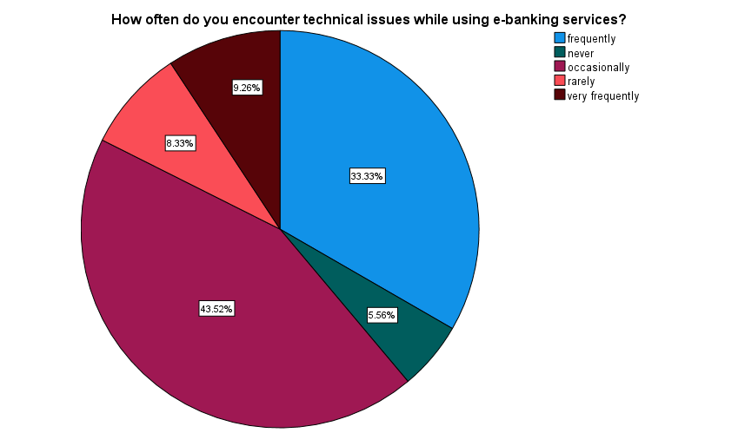

Inference

As the table shows that majority (38%) of the respondent’s main reason for not using E-Banking services was lack of trust in online security, 18% of the respondent’s main reason for not using E-Banking services was concern about technical issues and complications and only 8% of the respondent’s main reason for not using E-Banking services was lack of access to internet and technology.

**Percentage analysis for How often do you encounter technical issues while using e-banking services?**

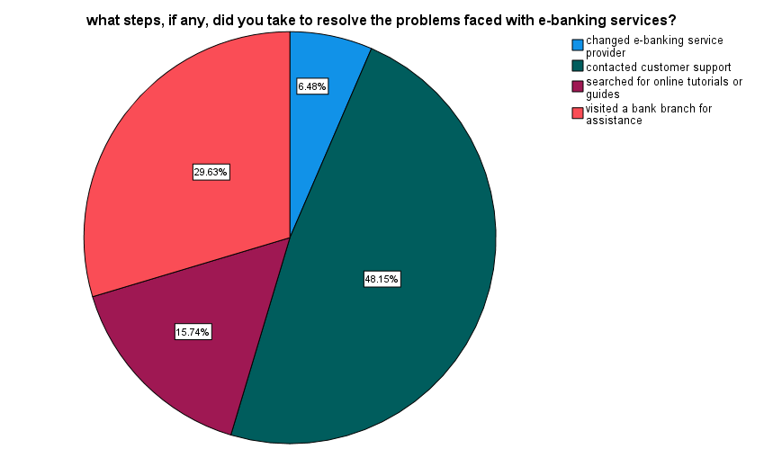**Table no.2 Chart no.2**

|  |  |  |
| --- | --- | --- |
| PARTICULARS | FREQUENCY | PERCENTAGE |
| Very frequently | 10 | 9.3% |
| Frequently | 36 | 33.3% |
| Occasionally | 47 | 43.5% |
| Rarely | 9 | 8.3% |
| never | 6 | 5.6% |

Inference

As the table shows that majority (44%) of the respondent have occasionally encountered technical issues while using E-Banking services and only 5 % of the respondent have never encountered technical issues while using E-Banking services.

**Percentage analysis for what steps, if any, did you take to resolve the problems faced with e-banking services?**

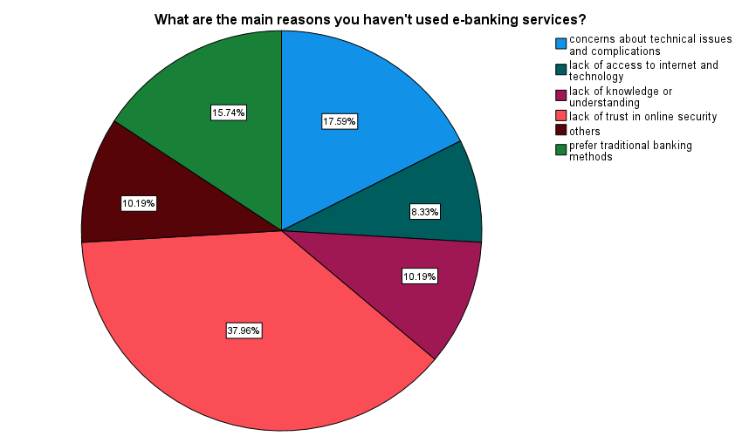**Table no.3 Chart no. 3**

|  |  |  |
| --- | --- | --- |
| PARTICULARS | FREQUENCY | PERCENTAGE |
| Contacted customer support | 52 | 48.1% |
| Visited a bank branch for assistance | 32 | 29.6% |
| Searched for online tutorials or guides | 17 | 15.7% |
| Changed e-banking service provider | 7 | 6.5% |

Inference

As the table shows that majority (48%) of the respondent have contracted customer support to resolve the problems faced with E-Banking services and 16% of the respondent have searched for online tutorials or guides to resolve the problems faced with E-Banking services.

**Percentage analysis for How would you rate the convenience of accessing e-banking services?**

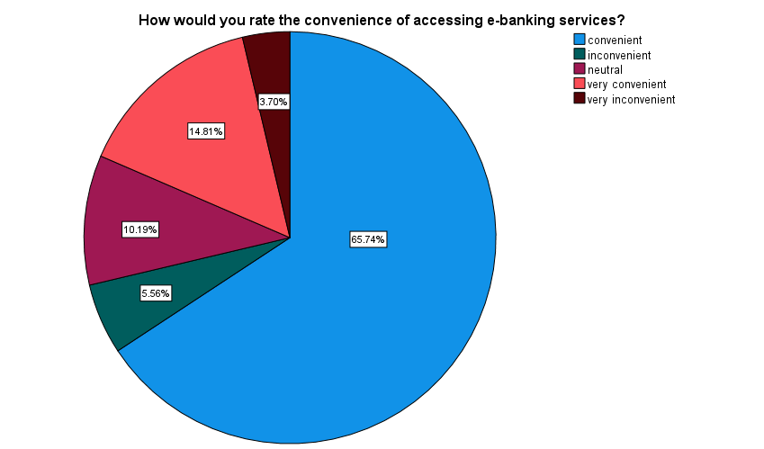**Table no. 4 Chart no. 4**

|  |  |  |
| --- | --- | --- |
| PARTICULARS | FREQUENCY | PERCENTAGE |
| Very convenient | 16 | 14.8% |
| convenient | 71 | 65.7% |
| neutral | 11 | 10.2% |
| inconvenient | 6 | 5.6% |
| Very inconvenient | 4 | 3.7% |

Inference

As the table shows that majority (65%) of the respondent were convenient of accessing e-banking services.

**Percentage analysis for How likely are you recommend e-banking services to others?**

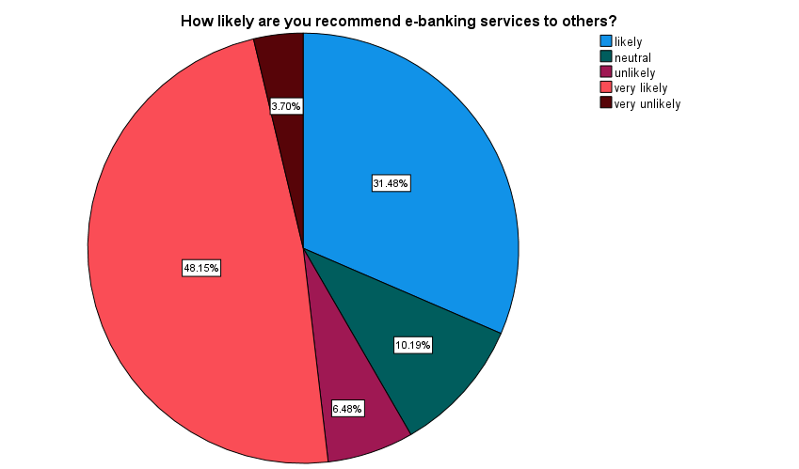**Table no. 5 chart no.5**

|  |  |  |
| --- | --- | --- |
| PARTICULARS | FREQUENCY | PERCENTAGE |
| Very likely | 52 | 48% |
| Likely | 34 | 31.5% |
| Neutral | 11 | 10.2% |
| Unlikely | 7 | 6.5% |
| Very unlikely | 4 | 3.7% |

Inference

As the table shows that majority (48%) of the respondent were very likely to recommend e-banking services to others.

**CHI-SQUARE TEST**

The chi-square test is used to determine if there is a significant association or difference between categorical variables. Chi-Square Analysis is done between the awareness of E-Banking and using of any E-Banking services

**Null hypothesis:** There is no significant association between the awareness of E-Banking and used any E-Banking services.

**Alternative hypothesis:** There is a significant association between the awareness of E-Banking and used any E-Banking services.

|  |  |  |
| --- | --- | --- |
| Table No.6. Inferential Analysis for the awareness of E-Banking and used any E-Banking services  . | | |
|  | Are you aware of e-banking services? | Have you ever used any e-banking services? |
| Chi-Square | 88.926a | 88.926a |
| df | 1 | 1 |
| Asymp. Sig. | .000 | .000 |
| a. 0 cells (0.0%) have expected frequencies less than 5. The minimum expected cell frequency is 54.0. | | |

Inference

From the above table, we find that the significant value is 0.000, which is less than table value 0.05, so the null hypothesis is rejected and alternative hypothesis is accepted.

Therefore, there is a significance association between the awareness of E-Banking and usage of any E-Banking services.

CORRELATION ANALYSIS:

A correlation hypothesis typically predicts the direction and strength of the relationship

between the variables. Here Correlation is used here to give relation between technical issues while using e-banking services and likeness to consider using e-banking services in the future.

**Null hypothesis:** There is no significance relation between technical issues while using e-banking services and likeness to consider using e-banking services in the future.

**Alternative hypothesis:** There is a significance relation between technical issues while using e-banking services and likeness to consider using e-banking services in the future.

|  |  |  |  |
| --- | --- | --- | --- |
| TABLE NO. 7 Inferential Analysis for technical issues while using e-banking services and likeness to consider using e-banking services in the future. | | | |
|  | | How often do you encounter technical issues while using e-banking services? | On a scale of 1 to 5, with 1 being "very likely" and 5 being "not at all likely", how likely are you to consider using e-banking services in the future? |
| How often do you encounter technical issues while using e-banking services? | Pearson Correlation | 1 | .200* |
| Sig. (2-tailed) |  | .038 |
| N | 108 | 108 |
| On a scale of 1 to 5, with 1 being "very likely" and 5 being "not at all likely", how likely are you to consider using e-banking services in the future? | Pearson Correlation | .200* | 1 |
| Sig. (2-tailed) | .038 |  |
| N | 108 | 108 |
| *. Correlation is significant at the 0.05 level (2-tailed). | | | |

Inference:

From the above table, we find that the significant value is 0.038, which is smaller than table value 0.05, so the null hypothesis is rejected and alternative hypothesis is accepted.

Therefore, there is a significance relation between technical issues while using e-banking services and likeness to consider using e-banking services in the future.

**Weighted average**

A weighted average is a calculation that takes into account the varying degrees of importance of the numbers in a data set. In calculating a weighted average, each number in the data set is multiplied by a predetermined weight before the final calculation is made. A weighted average can be more accurate than a simple average in which all numbers in a data set are assigned an identical weight.

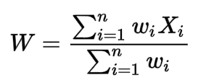

Based on your experience, please rate your satisfaction level with each of the factors mentioned below

|  |  |  |  |  |  |  |  |  |
| --- | --- | --- | --- | --- | --- | --- | --- | --- |
| **PARTICULARS** | **5** | **4** | **3** | **2** | **1** | **TOTAL** | **AVERAGE SCORE** | **RANK** |
| **User interface and ease of navigation** | 130 | 184 | 60 | 22 | 5 | 401 | 26.73 | 1 |
| **Security measures** | 95 | 180 | 72 | 26 | 7 | 380 | 25.33 | 5 |
| **Speed and responsiveness of the platform** | 105 | 172 | 87 | 20 | 5 | 389 | 25.93 | 3 |
| **Range and availability of services** | 120 | 176 | 78 | 12 | 6 | 392 | 26.13 | 2 |
| **Customer support and assistance** | 125 | 148 | 81 | 24 | 7 | 385 | 25.67 | 4 |

Inference

From the above table, it was found that User interface and ease of navigation hence it is ranked 1, followed by moderately are Range and availability of services hence it is ranked 2 and Speed and responsiveness of the platform is ranked 3 and Customer support and assistance is ranked 4 and finally Security measures is ranked 5.

**FINDINGS**

* As the table shows that majority (38%) of the respondent’s main reason for not using E-Banking services was lack of trust in online security.
* As the table shows that majority (44%) of the respondent have technical glitches or system errors while using E-Banking services.
* As the table shows that majority (48%) of the respondent have contracted customer support to resolve the problems faced with E-Banking services.
* As the table shows that majority (65%) of the respondent were convenient of accessing e-banking services.
* As the table shows that majority (48%) of the respondent were very likely to recommend e-banking services to others.

**SUGGESTIONS**

* Since a notable percentage (38%) of respondents cite a lack of trust in online security as their main reason for not using e-banking services, consider addressing this concern through enhanced security measures, clear communication about security protocols, and educating customers about the safety of e-banking.
* The high percentage (44%) of respondents encountering technical glitches or system errors suggests the need for improving the technical stability of the e-banking platform. Regular maintenance, testing, and prompt resolution of technical issues can enhance user experience.
* The fact that 48% of respondents reached out to customer support to resolve issues highlights the importance of having efficient and responsive customer support services. Ensure that customer support channels are easily accessible and capable of addressing user concerns effectively.
* Acknowledge the positive sentiment (65%) regarding the convenience of accessing e-banking services. Continue to prioritize ease of use and accessibility, keeping the user journey streamlined and hassle-free.
* Leveraging the high percentage (48%) of respondents willing to recommend e-banking services to others, consider implementing referral programs or incentives that can encourage satisfied customers to spread the word.

**REFERNCE**

1. Rajasulochana, D. S. M. (2022). E-Banking and Customers' Satisfaction in Public and Private Sector Banks in Karnataka: An Empirical Analysis. Journal of Positive School Psychology, 6(8), 8270-8279.
2. Amin, M. (2016). Internet banking service quality and its implication on e-customer satisfaction and e-customer loyalty. International journal of bank marketing, 34(3), 280-306.
3. Nupur, J. M. (2010). E-banking and customers’ satisfaction in Bangladesh: An analysis. International review of business research papers, 6(4), 145-156