**A STUDY ON STUDENTS PERCEPTION TOWARDS E-LEARNING**

Jacob martin. A and Surendher R

MBA student Jerusalem College of Engineering, Chennai

Professor and Head MBA, Jerusalem College of Engineering, Chennai

**ABSTRACT**

E-learning refers to the use of electronic technologies to facilitate learning and education. It involves the use of various digital media, such as videos, audios, and interactive simulations, to deliver educational content. E-learning has gained immense popularity in recent years due to its flexibility, convenience, and cost-effectiveness. It allows learners to access educational materials anytime, anywhere, and at their own pace. E-learning has also been found to improve learner engagement and retention rates. However, there are also challenges associated with e-learning, such as the need for reliable internet connectivity and the potential for social isolation.

**1.1 INTRODUCTION**

E-Learning is an alternative to a traditional classroom learning experience and is often referred to as “online learning,” “remote learning,” “virtual learning,” “mobile learning,” “digital learning,” or “distance education.” eLearning development is the process of creating technology-based education. The term was originally used to define automated learning systems that allowed students to learn on their own time at their own speed via a computer.

E-Learning is a form of education that utilizes electronic media and technology to deliver learning content and facilitate communication between learners and instructors. It allows learners to access educational materials and interact with instructors from anywhere in the world, at any time. E-Learning is a form of education that utilizes electronic media and technology to deliver learning content and facilitate communication between learners and instructors. It allows learners to access educational materials and interact with instructors from anywhere in the world, at any time. E-Learning can take many forms, including online courses, virtual classrooms, webinars, and multimedia presentations. It provides a flexible and convenient way for learners to acquire new skills and knowledge, and it is becoming increasingly popular in both academic and corporate settings. E-Learning has many benefits, including cost-effectiveness, accessibility, and the ability to personalize learning experiences to suit individual needs and preferences.  Although eLearning is based on formalized learning, it is provided through electronic devices such as computers, tablets and even cellular phones that are connected to the internet.

**1.2 OBJECTIVES OF THE STUDY**

**PRIMARY OBJECTIVE:**

* To analyse the efficiency and effectiveness of e-learning in students perception.

**SECONDARY OBJECTIVES:**

* To find the effectiveness of e-learning over traditional classes.
* To study the impacts and purposes of electronic learning.
* To asses the satisfaction level of students learning through online mode.

**1.3 NEED FOR STUDY:**

* E –learning helps create a larger pool of teachers and trainers in developing regions.
* Online learning stimulates students to develop their critical thinking skills and accommodate to the virtual environment in a way they may not have practiced in the classroom, in person.
* E- learning allows learners to quickly and more easily complete their training, resulting in improved performance and greater productivity.

**1.4 SCOPE OF THE STUDY:**

* E- learning provide students access to wider range of educational resources and instructors. With e- learning, students can access a variety of course offerings and gain diverse perspectives.
* It allows students to build independent study habits. It also helps students to recognizes the importance their personal responsibility.

**1.5 LIMITATION OF THE STUDY:**

* While, I doing my report somebody gives their negative feedback about e- learning and a research report is usually not used because of mismatch analyses result.
* Sometimes, technical issue and no responds from the public.

2. REVIEW OF LITERATURE:

* Firstly, this chapter shall focus on discussing what is meant by e-learning, and how the definition of e learning has been developed up until the present day. Secondly, it shall discuss opportunities and limitations related to e-learning; e-learning in Higher Education and how we can benefit from it.
* This chapter also relates two of the most common models that might be applied to the adoption of technological innovation and investigates the stages through which technological innovation can happen. It is argued that the power of societies is highly affected by its stock of knowledge and how effectively they can use this knowledge in order to create new knowledge (Bennett, et al., 2008).
* The aim of this review is to become knowledgeable with the guidelines and paths of where and how to explore e-learning development.
* **1. According to IBM**, students in online learning courses incorporating multimedia content learn five times more material than students in traditional face-to-face classes. Because online courses provide students with full control over their studies, they can work at their own pace.**14-Feb-2022.**
* **2. C.-H. P. Muhammad Ali, Syed Ali Raza, Wasim Qazi**, “Assessing e-learning system in higher education institutes : evidence from structural equation modelling,” Interact. Technol. Smart Education, 2017.
* **3.** **M. Alawamleh and L. M. Al-twait,** “The effect of online learning on communication between instructors and students during Covid-19 pandemic,” **Asian Educ. Dev. Stud, 2020.**
* **4.** **G. Chopra, P. Madan, P. Jai singh and P. Bhaskar** “Effectiveness of e-learning portal from students’ perspective: A structural equation model (SEM) approach,” **Interact. Technol. Smart Educ., vol. 16, no. 2, pp. 94–116, 2019.**

**3.RESEARCH METHODOLOGY:**

This chapter discusses the methodology used to conduct the fieldwork of this research to propose identify the research’s problems and present the structure to how solve these problems in stages; each stage depend on rules and directions. According to Adam & Healy (2000), research methodology is the total approach used to investigate the issue of concern, and within that, the specific research methods and tools used to meet the declared research objectives. Adam & Healy (2000) consider methodology to be the procedures used for collecting and analysing the required data. In order to select an appropriate research methodology and decide on data collection techniques, a clear and explicit statement   
of the research aim and objectives is necessary. Research is the process of systematic and in-depth study or search for any particular topic, subjects or area of investigation, backed by collection, compilation, presentation and interpretation of relevant details or data.

4.DATA ANALYSIS:

4.1.1 CLASSIFICATION BASED ON THE AGE OF THE RESPONDENTS

TABLE CHART

|  |  |  |  |  |  |
| --- | --- | --- | --- | --- | --- |
| **AGE** | | | | | |
|  | | Frequency | Percent | Valid Percent | Cumulative Percent |
| Valid | 16-18 | 12 | 11.2 | 11.2 | 11.2 |
| 19-21 | 80 | 74.8 | 74.8 | 86.0 |
| ABOVE 21 | 15 | 14.0 | 14.0 | 100.0 |
| Total | 107 | 100.0 | 100.0 |  |

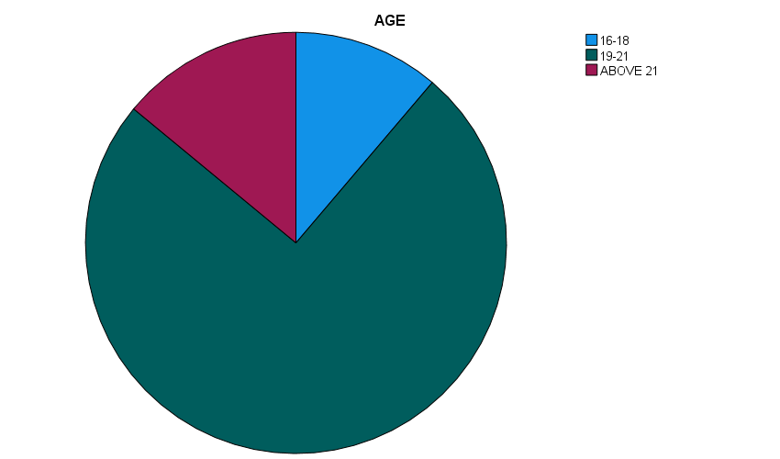**INTERPRETATION:**

As the table shows the majority of the respondent are the age between 19-21years.

4.1.2 CLASSIFICATION BASED ON THE RESPONDENT GENDER .

|  |  |  |  |  |  |
| --- | --- | --- | --- | --- | --- |
|  | | Frequency | Percent | Valid Percent | Cumulative Percent |
| Valid | MALE | 103 | 96.3 | 96.3 | 96.3 |
| FEMALE | 4 | 3.7 | 3.7 | 100.0 |
| Total | 107 | 100.0 | 100.0 |  |

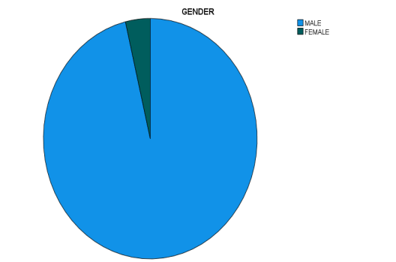

**INTERPRETATION:**

As the table shows that most of respondents are male with percentage of 96% as shown in the pie chart.

4.1.3 CLASSIFICATION BASED ON THE EDUCATIONAL QUALIFICATION OF THE RESPONDENTS

TABLE

|  |  |  |  |  |  |
| --- | --- | --- | --- | --- | --- |
| **EDUCATION QUALIFICATION** | | | | | |
|  | | Frequency | Percent | Valid Percent | Cumulative Percent |
| Valid | SCHOOL PUPIL | 14 | 13.1 | 13.1 | 13.1 |
| UG | 64 | 59.8 | 59.8 | 72.9 |
| PG | 19 | 17.8 | 17.8 | 90.7 |
| OTHERS | 10 | 9.3 | 9.3 | 100.0 |
| Total | 107 | 100.0 | 100.0 |  |

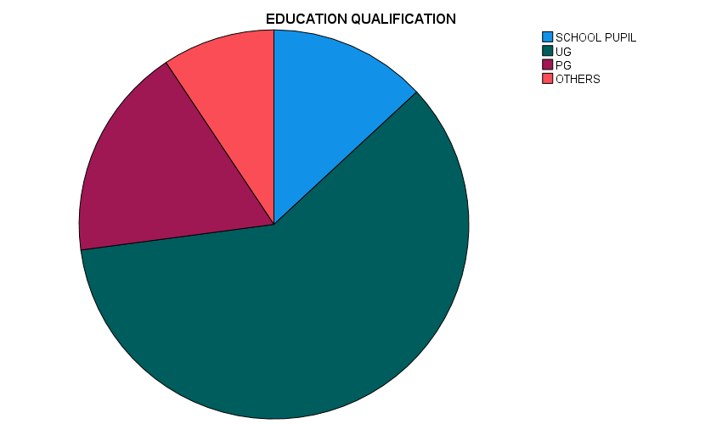

**INTERPRETATION:**

As the table shows that 59% respondent has an educational background as UG degree.

**CHI- SQUARE TEST**

To find out the significant association in the e- learning classes compared to traditional classes.

**NULL HYPOTHESIS (H0):**

There is no significance association in e- learning classes compared to traditional classes.

**ALTERNATIVE HYPOTHESIS (H1):**

There is significance association in e- learning classes compared to traditional classes.

|  |  |  |  |  |
| --- | --- | --- | --- | --- |
| **TO FIND THE EFFECTIVE E- LEARNING OVER TRADITIONAL CLASSES**  **Crosstabulation** | | | | |
| Count **TO FIND THE EFFECTIVE E- LEARNING OVER TRADITIONAL CLASSES** | | | | |
|  | |  | | Total |
| YES | NO |
| DO YOU THINK E-LEARNING WILL BECOME MORE EFFECTIVE IN THE FUTURE? | YES | 68 | 19 | 87 |
| NO | 15 | 5 | 20 |
| Total | | 83 | 24 | 107 |

|  |  |  |  |  |  |
| --- | --- | --- | --- | --- | --- |
| **Chi-Square Tests** | | | | | |
|  | Value | df | Asymptotic Significance (2-sided) | Exact Sig. (2-sided) | Exact Sig. (1-sided) |
| Pearson Chi-Square | .093a | 1 | .760 |  |  |
| Continuity Correctionb | .000 | 1 | .993 |  |  |
| Likelihood Ratio | .092 | 1 | .762 |  |  |
| Fisher's Exact Test |  |  |  | .770 | .483 |
| Linear-by-Linear Association | .093 | 1 | .761 |  |  |
| N of Valid Cases | 107 |  |  |  |  |
| a. 1 cells (25.0%) have expected count less than 5. The minimum expected count is 4.49. | | | | | |
| b. Computed only for a 2x2 table | | | | | |

**INFERENCE:**

The significance value is 0.05 is lesser than the table value of 0.761 (0.05<0.761). hence H1 is accepted and H0 is rejected.

Therefore, there is a significant association in e- learning classes compared to traditional classes.

**CORRELATION:**

TO FIND OUT THE RELATIONSHIP BETWEEN EDUCATIONAL QUALIFICATION AND PREFERED E- LEARNING

**NULL HYPOTHESIS:**

There is no relationship between educational qualification and preferred e- learning.

**ALTERNATIVE HYPOTHESIS:**

There is relationship between educational qualification and preferred e- learning.

|  |  |  |  |
| --- | --- | --- | --- |
| **Correlations** | | | |
|  | | WHICH E-LEARNING DO YOU PERFER? | EDUCATION QUALIFICATION |
| WHICH E-LEARNING DO YOU PERFER? | Pearson Correlation | 1 | .092 |
| Sig. (2-tailed) |  | .348 |
| N | 107 | 107 |
| EDUCATION QUALIFICATION | Pearson Correlation | .092 | 1 |
| Sig. (2-tailed) | .348 |  |
| N | 107 | 107 |

**INFERENCE:**

The significance value is 0.05 is lesser than the table value of 0.348 (0.05>0.348). Hence H0 is accepted and H1 is rejected.

Therefore, there is no relationship educational qualification and preferred e- learning.

**ANOVA**

To find the online streaming classes provides better experience and the rating on the perception towards e- learning clasess.

**NULL HYPOTHESIS (H0):**

There is no significant difference between the online streaming classes provides better experience and the rating on the perception towards e- learning classes.

**ALTERNATIVE HYPOTHESIS (H1):**

There is a significant difference between the online streaming classes provide better experience and the rating on the perception towards e- learning classes.

|  |  |  |  |  |  |
| --- | --- | --- | --- | --- | --- |
| **ANOVA** | | | | | |
| DO YOU THINK ONLINE STREAMING CLASSES PROVIDES A BETTER EXPERIENCE? | | | | | |
|  | Sum of Squares | df | Mean Square | F | Sig. |
| Between Groups | 2.033 | 4 | .508 | 2.937 | .024 |
| Within Groups | 17.650 | 102 | .173 |  |  |
| Total | 19.682 | 106 |  |  |  |

INFERENCE:

The significance value is 0.05 is lesser than the table value of 0.024 (0.05>0.024). Hence H0 is accepted and H1 is rejected.

Therefore, there is a significant difference between the online streaming classes provides better experience and the rating on the perception towards e- learning classes.

**5.FINDINGS**

According to the survey, there are 107 respondents, from that 11% are 16-18 years old, 74% are 19-21 years old and 10% are above 21 years old. According to the survey, there are 107 respondents, from that 96% are male and 4% are female. According to the survey, there are 107 respondents, from the 13% are school pupil, 59% are UG, 17% are PG and 9% are others. According to the survey, there are 107 respondents, from that 75% are yes and 25% are no said. According to the survey, there are 107 respondents, from that 44% are YOUTUBE , 5% are BYJUS, 37% are GOOGLE MEET and 12% are OTHERS said. According to the survey, there are 107 respondents, from that 72% are network issues, 10% are costly, 5% are no convenient and 12% are others. According to the survey, there are 107 respondents, from that 70% are 1-5 hours, 18% are 5-10 hours, 7% are 10-15 hours and 3% are more than 15 hours are their spending. According to the survey, there are 107 respondents, from that 81% are yes and 19% are no said. According to the survey, there are 107 respondents, from that 77% are yes and 23% are no said. According to the survey, there are 107 respondents, from that 32% are flexible learning, 28% are conducting more tests, 39% are suitable languages. According to the survey, there are 107 respondents, from that 29% are excellent, 40% are good, 20% are moderate, 1% are dislike and 8% are mostly dislike. According to the survey, there are 1076 respondents, from that 33% are yes and 67% are no said.

**6. SUGGESTION:**

Students may need additional support or resources to help them succeed in their e- learning environment. Collaboration with peers can help students learn from each other and develop important social skills. Clear instructions can help students understand what they need to do it. Multimedia content such as videos, image and audio can help students learn and retain information letter. Feedback is essential for students to understand their progress and identify areas where they need to improve. The scope and nature of data required moving a theoretical assumption and concept into a particular methodology; also, the resource constraints such as the time and cost required undertaking the study; and the researcher’s personal experience, knowledge and skills. Therefore, the research choices involve using quantitative and qualitative data analysis in this research project, after considering the research design, the nature of the sample of questionnaires and the collection data.

**6. CONCLUSION:**

As the results from this chapter suggest, there are many strategic approaches that a researcher may adopt in the researching field of social science. The research strategy is a way of going about one’s research, embodying a particular style and employing different research methods.

A number of issues have been considered in determining the optimum research strategy to satisfy the aim and objectives of this study.

the scope and nature of data ,required moving a theoretical assumption and concept into a particular methodology; also, the resource constraints such as the time and cost required undertaking the study; and the researcher’s personal experience, knowledge and skills. Therefore, the research choices involve using quantitative and qualitative data analysis in this research project, after considering the research design, the nature of the sample of questionnaires and the collection data.

**7. REFERENCE:**

Akyol, Z., & Garrison, D. R. (2011). Understanding cognitive presence in an online and blended community of inquiry: Assessing outcomes and processes for deep approaches to learning. British Journal of Educational Technology, 42(2), 233-250.

Bates, A. W. & Poole, G. (2003). Effective teaching with technology in higher education: Foundations for success.  Indianapolis, IN: Jossey-Bass.

Bonk, C. J. & Graham, C. R. (Eds.). (2005). Handbook of blended learning: Global Perspectives, local designs. San  Francisco, CA: Pfeiffer Publishing.

Conceição, S. C. O., & Lehman, R. M. (2011). Managing online instructor workload: Strategies for finding balance and success. San Francisco, CA: Jossey-Bass.

Palloff, Rena M., Pratt, Keith. (2007) Building online learning communities: Effective strategies for the virtual classroom San Francisco, CA: Jossey-Bass,

Picciano, A. G., & Dziuban, C. D. (Eds.).  (2007). Blended Learning Research Perspectives, United States:  The Sloan Consortium.

Picciano, A., Dziuban, C., & Graham, C. (Eds.) (2014). Blended learning: Research perspectives (Vol. 2). New York: Routledge.

Roblyer, M.D. (2006). Integrating educational technology into teaching. (4th ed.). Upper Saddle River, NJ: Pearson Education, Merrill.