**A STUDY ON CONSUMER BUYING BEHAVIOUR TOWARD MINERAL WATER**

1SEENUVASAN R and 2SIVAKANNI S

1MBA student Jerusalem College of Engineering, Chennai

2Assistant Professor, Department of MBA, Jerusalem College of Engineering, Chennai

**ABSTRACT**

Consumer Behaviour refers to the buying behavior of the ultimate consumer. Many factors, specificities, and characteristics influence the individual in what he is and the consumer in his decision-making process, shopping habits, purchasing behavior, the brands he buys, or the retailers he goes to. By identifying and understanding the factors that influence their consumers, brands have the opportunity to develop a strategy, a marketing message, and advertising campaigns more efficiently and more in line with the needs and ways of thinking of their target consumers, a real asset to better meet the needs of its consumers and increase sales. The study further delves into consumer preferences concerning various qualities of mineral water which play a major role in shaping purchasing behavior. To undertake this investigation, data was gathered from a diverse sample of 100 respondents representing various segments of society, including employees, private sector workers, students, business professionals, and homemakers. These respondents were invited to provide their assessments on a range of statements. These statements pertained to factors such as their current brand usage, pricing considerations, available features, brand expectations, satisfaction levels, and acquired benefits. The data collected was meticulously organized, coded, and subsequently subjected to thorough analysis using statistical tools like chi-square tests, one-way ANOVA, correlation assessments, and percentage analysis, all facilitated by SPSS software.

KEYWORDS: Consumer, strategy, and marketing message.

**INTRODUCTION**

Mineral water is water from a [mineral spring](https://en.wikipedia.org/wiki/Mineral_spring) that contains various [minerals](https://en.wikipedia.org/wiki/Mineral), such as [salts](https://en.wikipedia.org/wiki/Salt_(chemistry)) and [sulfur compounds](https://en.wikipedia.org/wiki/Sulfur). Mineral water may usually be still or [sparkling](https://en.wikipedia.org/wiki/Carbonated_water) (carbonated/effervescent) according to the presence or absence of added [gases](https://en.wikipedia.org/wiki/Gas). Traditionally, mineral waters were used or consumed at their spring sources, often referred to as "taking the waters" or "taking the cure", at places such as [spas](https://en.wikipedia.org/wiki/Spa), [baths](https://en.wikipedia.org/wiki/Public_bathing), or [wells](https://en.wikipedia.org/wiki/Well). The term *spa* was used for a place where the water was consumed and bathed in; a bath where the water was used primarily for bathing, therapeutics, or recreation; and a well where the water was to be consumed. Today, it is far more common for mineral water to be [bottled](https://en.wikipedia.org/wiki/Bottled_water) at the source for distributed consumption. Travelling to the mineral water site for direct access to the water is now uncommon, and in many cases not possible because of exclusive commercial ownership rights. There are more than 4,000 brands of mineral water commercially available worldwide.

This article examines the influence of water on public health through history. Farming and the development of settlements led to the beginning of the problem faced by mankind today – how to get drinkable water for humans and cattle and how to manage the waste we produce. The availability of water in large quantities has been policies are discussed. Early Systems and Innovations: considered an essential part of civilization throughout the different periods: Roman baths needed a lot of water, as do the water closets and showers used in current Western civilization. The importance of good quality drinking water has been established for years. However, the importance of proper sanitation was not understood until the 19th century. This article outlines the importance of water throughout history.

**REVIEW OF LITERATURE:**

Maeena Naman Shafiee(2018) The objective of the study is to identify the methods used for quality determination by consumers. Focusing on better bottle design which is easy to carry. The consumer awareness survey revealed that bottle designs that are easy to carry are more preferred by consumers. Since they are easy to carry. The findings are that packaging and bottle designs that are easy to carry are preferred the most by consumers. M. Sangeetha & Dr. K. Brindha (2017). The objective of the study is to analyze the factors that influence consumers in the purchase of bottled drinking water. Bottled drinking water is a product, which people buy not only when they undertake traveling or stay out of their place but also during their stay in their places. The reason is that people are becoming health conscious in the present-day environment. The finding is that there is a variance in satisfaction with different aspects of bottled drinking water when compared with the brand used and education level.

Thilagavathi P. and Ramya S. (2015) The main aim of the study was to know the factors influencing the choice of buyers while purchasing water bottles. To measure the satisfaction level of the consumer and determine the factors influencing satisfaction, to know the problems faced by the consumers of water bottles. The research was based on sampling techniques, independent variables, and dependent variables. The statistical data is analyzed. From the study, it is concluded majority of the consumers have a locality for their brand and to meet the changing environment the firm has to be constantly innovative and understand the consumer’s needs and wants. Nilima Das (2013) The main aim was to find customer awareness regarding the use of packed water bottles. The research was based on primary data and secondary data. Samples are randomly selected. The analyzed data was presented using descriptive statistics. They found during the purchasing of water bottles most consumers prefer health and safety to price. From the study, they have concluded that they provide valuable information related to consumer behavior. Linden, 2013) Consumers are more inclined to buy a large quantity of bottled water believing that bottled water is not the replacement, and water consumption requires a substantial change in lifestyle either quality water or their health. Next, buying a substantial small amount of bottled water is inconclusive to be hoping that the difference in taste between water and bottled water is pale or small, and hopes that they cannot produce a negative impact on the high intake that decreases consumption.

Wright, (2012) reveals that in low and middle-income countries, public perceptions of drinking water safety are relevant to the promotion of household water treatment and to household choices over drinking water sources. However, most studies on this topic have been cross-sectional and have not considered temporal variation in drinking water safety perceptions. The objective of this study is to explore trends in perceived drinking water safety in South Africa and its association with disease outbreaks, water supply, and household characteristics. The results suggest that perceived drinking water safety has remained relatively stable over time in South Africa, once the expansion of improved supplies is controlled for. The stability over time in public perception of drinking water safety is particularly surprising, given the large cholera outbreak that took place at the start of this period.

**METHODOLOGY:**

The objective of the research is to know the customer perception of buying mineral water and To know the reason for switching to mineral water and also to find out influencing factor to buy or not to buy mineral water

Primary data are collected by providing a questionnaire to friends, relatives & and colleagues, through emails, WhatsApp, etc. Secondary data are collected by analyzing through websites, vlogs, etc. Probability sampling is a technique in which the researcher chooses samples from a larger population using a method based on probability theory. For a participant to be considered as a probability sample, he/she must be selected using a random selection. Probability sampling uses statistical theory to randomly select a small group of people (sample) from an existing large population and then predict that all their responses will match the overall population. Target respondents are users, Populations are infinity, and Sample size is 100. The data is collected by the survey method. The survey was done through a questionnaire via Google Forms. The sources of secondary data refer to the information gathered by the researcher that already exists through articles, research papers, online sites, and websites. both descriptive statistics and inferential statistics methods were used in the study for analysis purposes.

**ANALYSIS**

1. **PERCENTAGE ANALYSIS FOR AGE VARIABLE**

**Table 1 chart 1**

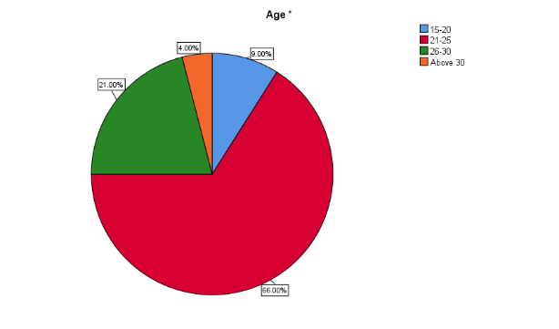

|  |  |  |  |
| --- | --- | --- | --- |
|  | | Frequency | Percent |
| Valid | 15-20 | 9 | 9.0 |
| 21-25 | 66 | 66.0 |
| 26-30 | 21 | 21.0 |
| Above 30 | 4 | 4.0 |
| Total | 100 | 100.0 |

**INFERENCE:**

From the above data, it is found that out of 100 respondents, 9% are in the age group of 15-20, 66% are in the age group of 21-25, 21% are in the age group of 26-30, and 4% are above age 30.

1. **Percentage analysis for factors influencing to purchase of mineral water**

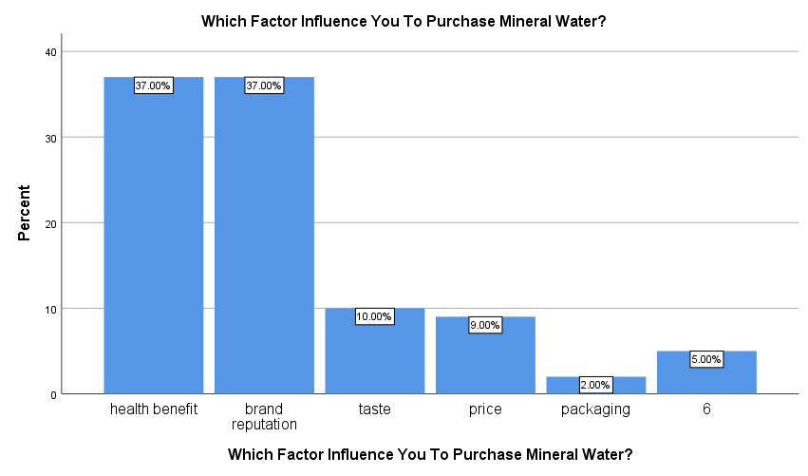 **table 2 chart 2**

|  |  |  |  |
| --- | --- | --- | --- |
|  | | Frequency | Percent |
| Valid | health benefit | 37 | 37.0 |
| brand reputation | 37 | 37.0 |
| Taste | 10 | 10.0 |
| Price | 9 | 9.0 |
| packaging | 2 | 2.0 |
| 6 | 5 | 5.0 |
| Total | 100 | 100.0 |

**INFERENCE**

From the above data, it is found that out of 100 respondents, 37 % are health benefits,

37% are brand reputation, 10% are taste, 9% are price, 2% are packaging.

1. **Percentage analysis for where consumers buy the mineral water usually**

**Table 3 chart 3**

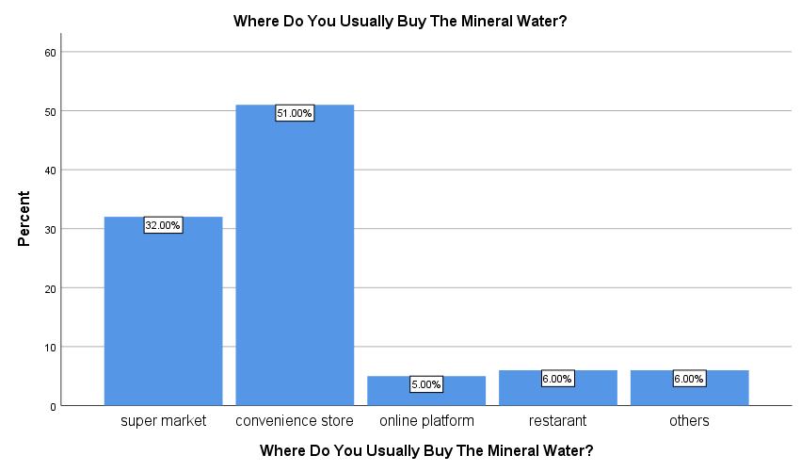

|  |  |  |  |
| --- | --- | --- | --- |
|  | | Frequency | Percent |
| Valid | supermarket | 32 | 32.0 |
| convenience store | 51 | 51.0 |
| online platform | 5 | 5.0 |
| restaurant | 6 | 6.0 |
| Others | 6 | 6.0 |
| Total | 100 | 100.0 |

**INFERENCE**

From the above data, it is found that out of 100 respondents, 32% are supermarkets, 51% are convenience stores, 5% are online platforms, 6% are restaurants and 6% are others.

1. **CHI-SQUARE TEST**

To find the relationship between the purchase of mineral water and the source of mineral water

**NULL HYPOTHESIS:**

**H0:** There is no relationship between the source of mineral water and the need to purchase it.

**ALTERNATIVE HYPOTHESIS:**

**H1**: There is a relationship between the source of mineral water and the need to purchase it.

**Table 4**

|  |  |  |  |
| --- | --- | --- | --- |
|  | Value | Df | Asymptotic Significance (2-sided) |
| Pearson Chi-Square | 20.212a | 10 | .027 |
| Likelihood Ratio | 16.487 | 10 | .087 |
| Linear-by-Linear Association | 6.657 | 1 | .010 |
| N of Valid Cases | 100 |  |  |
| a. 12 cells (66.7%) have an expected count of less than 5. The minimum expected count is .04. | | | |

**INFERENCE**

From the test, it is found that the significance value is .027 which is lower than the Table value of 0.05, the Null hypothesis was rejected. Hence there is a relationship between the source of mineral water influences the purchasing

**5. ANOVA**

To find the difference between the purchase and usually buy the mineral water

**NULL HYPOTHESIS:**

**H0:** There is no association between the frequency of buying mineral water and the place of buying.

**ALTERNATIVE HYPOTHESIS:**

**H1:** There is an association between the frequency of buying mineral water and the place of buying.

**Table 5**

|  |  |  |  |  |  |
| --- | --- | --- | --- | --- | --- |
|  | Sum of Squares | Df | Mean Square | F | Sig. |
| Between Groups | 22.795 | 4 | 5.699 | 4.861 | .001 |
| Within Groups | 111.365 | 95 | 1.172 |  |  |
| Total | 134.160 | 99 |  |  |  |

**INFERENCE:**

From the above test, it is found that the significant value is .001 which is less than the table value of 0.5. Therefore, the Null hypothesis was rejected. Therefore, there is an association between the frequency of buying mineral water and the place of buying.

**6. CORRELATION**

To find the difference between the plastic bottles and the stopped using mineral water.

**NULL HYPOTHESIS:**

**H0:** There is no significant relationship between the usage of plastic bottles and not drinking mineral water

**ALTERNATIVE HYPOTHESIS**

**H1:** There is a significant relationship between the usage of plastic bottles and not drinking mineral water

**Table 6**

|  |  |  |  |
| --- | --- | --- | --- |
|  | | | |
|  | | the use of plastic bottles can be a reason for you 2t to prefer mineral water. | Have You Ever Stopped Using Mineral Water For The Following Reasons? |
| the use of plastic bottles can be a reason for you 2t to prefer mineral water. | Pearson Correlation | 1 | .058 |
| Sig. (2-tailed) |  | .571 |
| N | 100 | 99 |
| Have You Ever Stopped Using Mineral Water For The Following Reasons? | Pearson Correlation | .058 | 1 |
| Sig. (2-tailed) | .571 |  |
| N | 99 | 99 |

**INFERENCE**

From the above table, it is found that the significant value is .058 which is less than the table value of 0.5. Therefore, the null hypothesis was rejected. Therefore, there is a significant relationship between the usage of plastic bottles and not drinking mineral water

**FINDING:**

* From the above data it is found that out of 100 respondents, 9% are 15-20, 66% are 21-25, 21% are 26-30, and 4% are above 30.
* From the above data it is found that out of 100 respondents, 47% are male and 53% are female
* From the above data it is found that out of 100 respondents, 5% are school,33% are UG, 57% are PG and 5% are professional course
* From the above data it is found that out of 100 respondents, 39% are students, 44% are employees, 14% are a businessman and 3% are freelancers.
* From the above data it is found of 100 respondents 43% are below 25000, 33% are 26000-35000, 19% are 36000-45000 and 5% are above 45000.
* From the above data it is found that out of 100 respondents, 28% are daily, 40% 2-3 times a week, 13% are once a week, 14% are rarely and 5% are occasionally.
* From the above data it is found that out of 100 respondents, 41% are yes always, 44% are sometimes and 15 5 are never.
* From the above data it is found that out of 100 respondents, 63% are very important % are somewhat likely, 4% are not likely
* From the above data it is found that out of 100 respondents, 58% are yes always,

40 % are sometimes, and 2% are never.

* From the above data it is found that out of 100 respondents, 63% are very important % are somewhat likely, and 4% are not likely.
* From the above data it is found that out of 100 respondents, 58% are yes always,

40 % are sometimes, and 2% are never.

* From the above data it is found that out of 100 respondents, 37 % are health benefits,

37% are brand reputation, 10% are taste, 9% are price, 2% are packaging.

* From the above data it is found that out of 100 respondents, 32% are supermarkets, 51% are convenience stores, 5% are online platforms, 6% are restaurants and 6% are others.
* From the above data it is found that out of 100 respondents, 67% are yes always, 30% are sometimes, and 3% are never.
* From the above data it is found that out of 100 respondents, 46% are yes, 36% are no, and 18% are may be.
* From the above data it is found that out of 100 respondents, 23% are 15-20rs,

34% are 20-25rs, 30% are 35-30rs, 12% are 30-35rs.

* From the above data it is found that out of 100 respondents, 59% are yes, 28% are no, and 13% are maybe.
* From the above data it is found that out of 100 respondents, 33% are word of mouth, 54% are advertisements, 10 % are Internet, and 3% are others.
* From the above data it is found out of 100 respondents 54% are yes, 32% are no, and 14% are may be.
* From the above data it is found that out of 100 respondents, 43% are YES, 57% are NO.
* From the above data it is found that out of 100 respondents, 80 % are YES, 13% are NO 7% are MAYBE.
* From the test it is found that the significance value is .027 which is lower than the Table value of 0.05, the Null hypothesis was rejected. That is relationship between the source of mineral water influences the purchasing
* From the above test it is found that the significant value is .001 which is less than the table value of 0.5. Therefore, the Null hypothesis was rejected.
* From the above table it is found that the significant value is .058 which is less than the table value of 0.5. Therefore, the null hypothesis was rejected.

**SUGGESTIONS:**

Health and Hydration: Highlight the health benefits of drinking mineral water. Emphasize that it can help with hydration, improve skin health, and provide essential minerals. Brand Reputation: Consumers often trust well-established brands. Build a strong brand reputation by consistently delivering high-quality mineral water and ensuring transparency in sourcing and production. Packaging: Attractive and eco-friendly packaging can attract consumers. Consider using recyclable materials and promoting sustainability. Pricing: Offer a range of price points to cater to different consumer segments. Premium brands can focus on quality, while budget-friendly options should still meet safety and taste standards. Taste and Purity: Ensure that your mineral water tastes clean and fresh. Conduct regular quality tests to maintain purity. Labeling: Clearly label the mineral content of your water. Some consumers seek specific minerals, such as calcium or magnesium, for health reasons. Convenience: Make your mineral water readily available in various sizes, from single-serving bottles to larger containers. Ensure it's accessible in grocery stores, online, and in vending machines. Marketing and Advertising: Utilize digital marketing and social media to reach a wider audience. Highlight the benefits of mineral water, such as its role in a healthy lifestyle. Customer Reviews and Testimonials: Encourage satisfied customers to leave reviews and testimonials. Positive feedback can build trust and influence buying decisions.

**CONCLUSION:**

Factors contributing to perceptions of drinking water quality are diverse. Water managers and policymakers must consider these variables to predict potential issues and optimize the effectiveness of projects or regulations. While largely related to aesthetics, sensory characteristics significantly influence these perceptions and require cautious handling. When making alterations to the supply system and formulating quality standards, past experiences should be taken into account. Thoughtfully crafted communication strategies are essential for interactions with consumers, especially when introducing supply changes or during disruptive events. Utilizing surveys and qualitative approaches can offer insights to shape specific policies and enhance services. It is crucial to prioritize freshwater education from an early age, focusing on locally pertinent subjects like tap water applications and water sources. Despite advancements in this field, there remain gaps in knowledge and areas that necessitate further research.

**REFERENCE:**

1. Mr. Avinashgupta. A consumer preference analysis of soft drinks in the city of Coimbatore, M. Phil., dissertation submitted to Bharathiar University, 1991.

2. Mr. Prithiv Raj S. A study on perception of consumers towards soft drinks, dissertation submitted to Bharathiar University, 1997.

3. Dr. Sampathkumar R. Submitted the research report entitled Brand Preference. A study on soft drinks market” Indian Journal of marketing, 2003.

4. Zhai, X.: ‘Practices and theories: How can machine learning assist in innovative assessment practices in science education’, Journal of Science Education and Technology, 2021, 30, (2), pp. 1-11.

5. OECD: ‘AI and the Future of Skills’, (Eds.): ‘Book AI and the Future of Skills’ (2021, ed.).

6. Zhai, X., Haudek, K.C., Shi, L., Nehm, R., and Urban-Lurain, M.: ‘From substitution to redefinition: A framework of machine learning-based science assessment’, Journal of Research in Science Teaching, 2020, 57, (9), pp. 1430-1459.

7. Li, Y., Choi, D., Chung, J., Kushman, N., Schrittwieser, J., Leblond, R., Eccles, T., Keeling, J., Gimeno, F., and Dal Lago, A.: ‘Competition level code generation with alpha code’, Science, 2022, 378, (6624), pp. 1092-1097.