**A Study on the consumer perception towards**

**Online Grocery buying**

1Sai Sudharshan R and 2Sivakanni S

1 PG Student department of MBA Jerusalem College of Engineering Chennai

2Assistant professor Department of MBA, Jerusalem College of Engineering, Chennai

# ABSTRACT

The advent of digital technology has ushered in a new era of shopping, revolutionizing traditional retail industries including the grocery sector. This study aims to explore and analyze consumer perceptions towards online grocery buying, focusing on the factors influencing their preferences, challenges faced, and overall satisfaction with the online grocery shopping experience. The research employs a mixed-methods approach, combining quantitative survey data with qualitative insights gathered through interviews and focus group discussions. A structured questionnaire was distributed to a diverse sample of consumers who have engaged in online grocery shopping. The survey encompassed aspects such as demographic information, frequency of online grocery purchases, reasons for choosing online platforms, perceived benefits and drawbacks, concerns related to product quality and freshness, delivery efficiency, and user interface experience. The findings reveal that convenience, time-saving, and a wider product selection are the primary motivators for consumers to opt for online grocery shopping. Moreover, factors such as perceived product quality, delivery reliability, and user-friendly interfaces emerge as crucial determinants of consumer satisfaction. However, concerns related to product freshness, accurate order fulfillment, and potential privacy and security issues still loom as barriers to widespread adoption. Through qualitative analysis, this study delves deeper into the nuanced consumer perceptions, providing valuable insights into the emotional and psychological aspects underlying online grocery buying decisions. Focus group discussions shed light on emerging trends, such as the impact of sustainability considerations and the role of social influence on consumer choices.

# INTRODUCTION

The term “perception” can be defined as the ability to derive meaning. Derived from the word “perceive”, it refers to the ability of giving meaning to whatever is sensed by our sense organs. Schiff man defines it as “the process by which an individual selects, organizes, and interprets stimuli into a meaningful and coherent picture of the world.” The term customer perception can be defined as, “a marketing concept that encompasses a customer's impression, awareness and/or consciousness about a company or its offerings. Customer perception is typically affected by advertising, reviews, public relations, social media, personal experiences and other channels.” Consumer perception of price, value, quality are the pivotal determinants of shopping behaviour. Internet is changing the way consumers shop and buy goods and services, and has rapidly evolved into a global phenomenon. Many companies have started using the Electronic Commerce with the aim of cutting marketing costs, thereby reducing the price of their products and services in order to stay ahead in highly competitive markets.Companies also use the Internet to convey communicates and disseminate information, to sell the product, to take feedback and also to conduct satisfaction surveys with customers. Customers use the Internet not only to buy the product online, but also to compare prices, product features and after sale service facilities the will receive if they purchase the product from a particular store. Many experts are optimistic about the prospect of online business. In addition to the tremendous potential of the E-commerce market, the Internet provides a unique opportunity for companies to more efficiently reach existing and potential customers.Although most of the revenue of online transactions comes from business-to-business commerce, the practitioners of business-to-consumer commerce should not lose confidence.It has been more than a decade since business-to-consumer E-commerce first evolved. Scholars and practitioners of electronic commerce constantly strive to gain an improved insight into consumer behavior in cyberspace. Along with the development of E-retailing, researchers continue to explain Econsumers behavior from different perspectives. Many of their studies have posited new emergent factors or assumptions which are based on the traditional model consumer behavior, and then examine their validity in the Internet context.

.

# CONSUMER BEHAVIOR

Consumer behavior involves the examination of how individuals, groups, or entities decide on acquiring, utilizing, and discarding goods, services, experiences, or ideas to fulfill their desires and requirements. This field encompasses the exploration of psychological, social, cultural, and economic elements that shape the decisions and behaviors of consumers within the market.

# REVIEW OF LITERATURE

Sabari Shankar R and Nareshkumar S (2018), in their study, they said that the online shopping has become an integral part of consumer. To understood the impact of demographic factors on consumer perception of online grocery shopping. Research methodology is the collection of methods which are used to perform research. Simple percentage analysis has been used to find and analyse the response percentage to the factors of the survey. The concluded that there are the major few factors are influencing the factors of purchasing through online. Some of the key variations between consumer experiences in online and offline shopping were highlighted by another author. Along with that the ways in which retailers are attempting to blur physical and virtual shopping experiences were studied. The research concluded that the ease of purchase far outweighed the benefits which came with offline shopping experience and further delved into a new era of shopping experiences. (Nicola Derrer-Rendall, Alison Attrill, 2016). As online grocery services have not been able to cater to the rural areas and towns, the awareness about the same is also limited in such areas. There is a huge section of the audience who is unaware about such services. Significant differences were found in various demographic traits regarding the awareness of the OGS. Factors that influenced the decision of the consumers greatly were found to be perceived risk, perceived cost, perceived convenience and perceived enjoyment**.** (Ajit Kaushal, 2015). S.Sathiyaraj, et.al (2015), in their study, the author’s introduce that, the increasing use of internet by the younger generation in India provides an emerging prospects for online retailers. The main objective of their study is to find out the preference of the consumers regarding by the consumer while online shopping. The author collected the primary data using structured questionnaire by survey method from 200 respondents. Muralikrishnan, B(2012**),**country manager at eBay's India in his article explains that Indian consumers toward buying high margin products such as clothes and shoes as is the trend among eBay shoppers in the West rather than electronic gadgets and books, which are the most popular choices now but command lower profit margins and are less frequent purchases. He depicted that India's nascent e-commerce market, which till recently was largely limited to people buying train, ZENITH International Journal of Multidisciplinary Research ISSN 2231-5780 Vol.5 (6), JUNE (2015) Online available at zenithresearch.org.in 27 flight and movie tickets, is in the middle of a surge as a younger, tech-savvy middle class increasingly takes to shopping online in a country seeing rapid growth in Internet usage. Consulting firm Techno Park predicts a $70-billion annual market by 2020, up from $600 million now, which is just 0.05% of global online shopping. EBay itself estimates India's online shopping market in 2012 will grow close to 100%. Rainu Tan veerSingh (2012), he was undertaken the project in Nirala Imex Inc. in Taiwanese market in selling of Indian grocery items to the local retailers & wholesaler in the Taiwanese market. The project first studied the attitude of customers towards online shopping, also determining the factors which influence the consumer to purchase goods and service. The second half of the project depicted the attributes of online shopping influencing the purchase decision by the respondent. It also determined the issues regarding the online shopping. The third part of the project determines the purchase decision with respect to grocery. It determined the place preference of grocery shopping with respect to price, quality, variety, proximity and offers/ discounts. The project also recommended the business operational plan which works with contracting dealership with the local Kirana stores. George Adamidis et al (2006), in this paper, the authors discussed about specific aspect of shopping; grocery shopping. Grocery shopping is an essential and routine type of consumer behavior, which over the last few decades has undergone major changes due to the rapid evolution of technology. E-grocery is the new form of grocery shopping, which allows consumers to order products via the Internet from the convenience of their house. The evolution of online and in-store grocery shopping is largely determined by the motives and the behavior of consumers. The aim of this paper is to investigate and explain Cypriot consumer’s perceptions and responses towards online grocery shopping. A survey that utilized a self-administered questionnaire for collecting data from respondents, was conducted at the capital of Cyprus; Nicosia. Cypriot consumers are not ready yet to accept e-grocery shopping as an alternative to traditional grocery shopping. Based on the findings of this survey, “the good quality of the products offered” and “a money back guarantee” can be decided upon by the e-grocers as it seems to be the better risk relievers. In addition, “the competitive prices of the products”, “safe dealings through the Internet” and “loyalty to well-known products” may consist highly effective incentives to increase the number of online shoppers. Vijayasarathy (2004), in his research used a sample of 281 consumers to test a model of consumer intention to use on-line shopping. The study found compatibility, usefulness, ease of use, and security to be significant predictors of attitude towards on-line shopping, but privacy was not. Another finding showed that intention to use on-line shopping was strongly influenced by attitude toward on-line shopping, normative beliefs, and self-efficacy. Online grocery services have been trying to take a hold in the market however due to the lack of availability in some areas and due to the traditional habits of the consumers, a large audience has not been able to gain the benefits of it. It was observed that people use OGS due to the perceived ease of use. Nevertheless, online grocery shopping is still a new concept and therefore people cannot relate to it or they do not have a clear understanding of the risks involved in it**.** (Sherah Kurnia, Ai-Wen Jenny Chien, 2003).

# RESEARCH METHODOLOGY

# This research employs a combination of primary and secondary data sources. Primary data is gathered through a well-structured questionnaire, utilizing a convenience sampling method to select 100 participants. Secondary data is sourced from a variety of reference materials, such as books, journals, research articles, magazines, and websites. The main goals of the study are twofold: first, to analyze how consumers perceive online grocery shopping, and second, to identify the factors that influence the effectiveness of online grocery shopping while establishing a connection between online grocery shopping and purchasing decisions. The study specifically concentrates on assessing the effectiveness of precisely targeted and personalized online grocery shopping, which is a pivotal area of investigation. The research investigates the impact of demographic, behavioral, and contextual targeting on consumer engagement, conversion rates, and the overall success of online grocery shopping. It's important to recognize the study's limitations. The sample size of 100 participants is relatively modest, which could potentially affect the overall reliability of the findings. The utilization of convenience sampling was necessitated by limitations in resources, which might impact the comprehensiveness of the collected data. Additionally, there were instances where participants opted not to complete the questionnaire.

# ANALYSIS

**Percentage analysis**

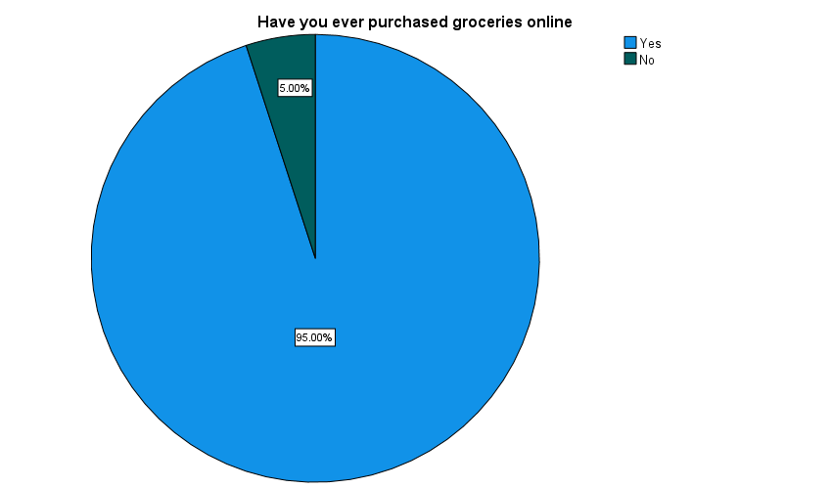**Table 1**

|  |  |  |  |  |  |  |
| --- | --- | --- | --- | --- | --- | --- |
|  | **Have you ever purchased groceries online** | | | | | |
|  |  | | Frequency | Percent | Valid Percent | Cumulative Percent |
|  | Valid | Yes | 95 | 95 | 95 | 95 |
|  | No | 5 | 5 | 5 | 100 |
|  | Total | 100 | 100 | 100 |  |
|  |  |  |  |  |  |  |
|  |  |  |  |  |  |  |

Inference:

As the table and chart shows nearly 95% of the respondents were purchased groceries online.

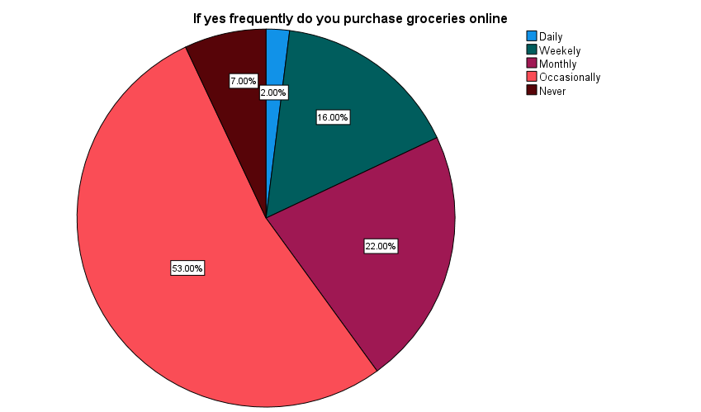**Table 2**

|  |  |  |  |  |  |
| --- | --- | --- | --- | --- | --- |
|  |  |  |  |  |  |
| **How frequently do you purchase groceries online** | | | | | |
|  | | Frequency | Percent | Valid Percent | Cumulative Percent |
| Valid | Daily | 2 | 2 | 2 | 2 |
| Weekly | 16 | 16 | 16 | 18 |
| Monthly | 22 | 22 | 22 | 40 |
| Occasionally | 53 | 53 | 53 | 93 |
| Never | 7 | 7 | 7 | 100 |
| Total | 100 | 100 | 100 |  |

Inference:

As the data shows 53% of the respondents were occasionally buying groceries in online.

**Table 3**

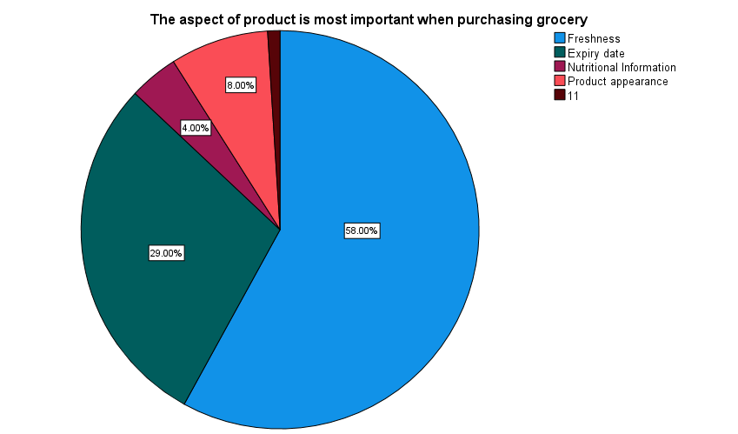

|  |  |  |  |  |  |
| --- | --- | --- | --- | --- | --- |
| **The aspect of product is most important when purchasing grocery** | | | | | |
|  | | Frequency | Percent | Valid Percent | Cumulative Percent |
|  | |  |  |  |  |
| Valid | Freshness | 58 | 58 | 58 | 58 |
| Expiry date | 29 | 29 | 29 | 87 |
| Nutritional Information | 4 | 4 | 4 | 91 |
| Product appearance | 8 | 8 | 8 | 99 |
| 11 | 1 | 1 | 1 | 100 |
| Total | 100 | 100 | 100 |  |

Inference:

As the data shows 58% of the respondents thinks freshness is the most important factor when purchasing grocery in online.

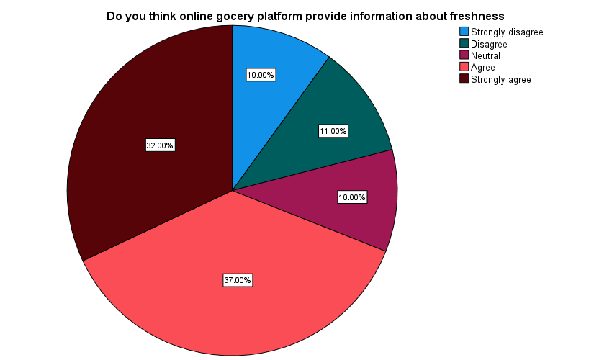**Table 4**

|  |  |  |  |  |  |
| --- | --- | --- | --- | --- | --- |
|  |  |  |  |  |  |
| **Do you think online grocery platform provide information about freshness** | | | | | |
|  | | Frequency | Percent | Valid Percent | Cumulative Percent |
| Valid | Strongly disagree | 10 | 10 | 10 | 10 |
| Disagree | 11 | 11 | 11 | 21 |
| Neutral | 10 | 10 | 10 | 31 |
| Agree | 37 | 37 | 37 | 68 |
| Strongly agree | 32 | 32 | 32 | 100 |
| Total | 100 | 100 | 100 |  |

Inference:

As the data shows 37% of the respondents were agreed that the online grocery platform provide information about freshness.

Table 5

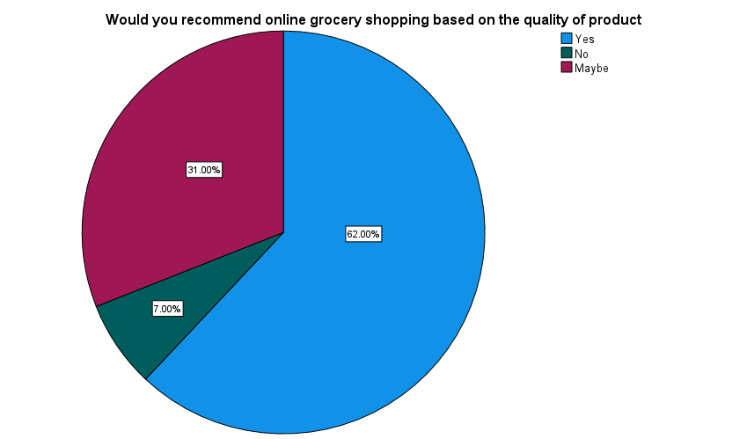

|  |  |  |  |  |  |
| --- | --- | --- | --- | --- | --- |
|  |  |  |  |  |  |
| **Would you recommend online grocery shopping based on the quality of product** | | | | | |
|  | | Frequency | Percent | Valid Percent | Cumulative Percent |
| Valid | Yes | 62 | 62 | 62 | 62 |
| No | 7 | 7 | 7 | 69 |
| Maybe | 31 | 31 | 31 | 100 |
| Total | 100 | 100 | 100 |  |
|  |  |  |  |  |  |

Inference:

As the data show 62% of respondents have agreed that they will recommend online grocery shopping based on the quality of product.

# Correlation analysis

Correlation is a statistical tool used to quantify the intensity and direction of a connection between two or more variables. It aids in comprehending how alterations in one variable correspond with changes in another. However, it's important to note that correlation does not establish a cause-and-effect relationship; it merely demonstrates the extent to which two variables tend to vary simultaneously or in opposite directions.

To find out the significance relation between Money spent monthly on online groceries shopping and factors influencing to shop grocery in online.

**Ho:** There is no significance difference between Money spent monthly on online groceries shopping and factors influencing to shop grocery in online.

**H1:** There is a significance difference between Money spent monthly on online groceries shopping and factors influencing to shop grocery in online.

Table 6

|  |  |  |  |  |
| --- | --- | --- | --- | --- |
|  | **Correlations** | | | |
|  |  | | How much do you spend monthly on online groceries shopping | What factor influence your decision to shop for groceries online |
|  | How much do you spend monthly on online groceries shopping | Pearson Correlation | 1 | 0.036 |
|  | Sig. (2-tailed) |  | 0.723 |
|  | N | 100 | 100 |
|  | What factor influence your decision to shop for groceries online | Pearson Correlation | 0.036 | 1 |
|  | Sig. (2-tailed) | 0.723 |  |
|  | N | 100 | 100 |

Inference:

From the above table, we find that the significant value is 0.723, which is greater than table value 0.05, so the Null hypothesis is accepted and Alternative hypothesis is rejected.

Therefore, there is no significance difference between Money spent monthly on online groceries shopping and factors influencing to shop grocery in online

**Chi-square analysis**

# Chi-square is a statistical test used to examine the differences between categorical variables from a random sample in order to judge the goodness of fit between expected and observed results.

To find out the association between the recommendation of online grocery shopping and major challenges faced.

**Ho:** There is no significance difference between the recommendation of online grocery shopping and major challenges faced.

**H1:** There is a significance difference between the recommendation of online grocery shopping and major challenges faced.

|  |  |  |  |
| --- | --- | --- | --- |
|  |  | Would you recommend online grocery shopping based on the quality of product | What are the major challenge you face while shopping for groceries online |
|  | Chi-Square | 45.620a | 34.300b |
|  | Df | 2 | 4 |
|  | Asymp. Sig. | .000 | .000 |
|  | a. 0 cells (.0%) have expected frequencies less than 5. The minimum expected cell frequency is 33.3. |  |  |
|  | b. 0 cells (.0%) have expected frequencies less than 5. The minimum expected cell frequency is 20.0. |  |  |

# Inference:

From the above table, we find that the significant value is .000, which is less than table value 0.05, so the Null hypothesis is rejected and Alternative hypothesis is accepted.

Therefore, there is a significance difference between frequency of brand remembrance and products seen through the past month.

**Anova**

ANOVA, or Analysis of Variance, is a statistical method employed to determine if there are significant differences among the means of three or more groups. It helps to assess whether variations observed in the data are the result of genuine differences between the groups or if they could be attributed to random fluctuations. ANOVA is particularly useful when comparing means across multiple groups, and it aids in identifying which groups, if any, exhibit statistically significant distinctions in their average values. This method allows for a more comprehensive understanding of data by examining variance both within and between groups.

To find out the association between the income and willingness for extra payment.

**Ho:** There is no association between income and willingness for extra payment.

**H1:** There is an association between the income and willingness for extra payment.

|  |  |  |  |  |  |
| --- | --- | --- | --- | --- | --- |
| Are you willing to pay extra guaranteed freshness and quality of product | | | | | |
|  | Sum of Squares | df | Mean Square | F | Sig. |
| Between Groups | 2.878 | 4 | .720 | 1.161 | .334 |
| Within Groups | 52.065 | 84 | .620 |  |  |
| Total | 54.944 | 88 |  |  |  |

Inference:

From the above table, we find that the significant value is .334, which is Greater than table value 0.05, so the Null hypothesis is accepted and Alternative hypothesis is rejected.

Therefore, there is no association between income and willingness for extra payment.

# Findings

# According to the data presented in the table, the majority of respondents were male, constituting 60% of the total. The accompanying pie chart illustrates that most respondents, 51%, fell within the age range of 18 to 25 years. The educational background analysis reveals that 53% of respondents held a master's degree. Examining the pie chart, it becomes apparent that students accounted for 51% of the respondent population. Similarly, 51% of respondents reported an income of less than 25000. Furthermore, nearly 95% of the participants indicated that they had purchased groceries online. Turning to purchasing behavior, the data from the table shows that 53% of respondents made occasional online grocery purchases. Convenience was acknowledged by 36% of respondents as a significant factor in favor of online grocery shopping. Challenges encountered included product quality issues and limited product availability, with 34% of respondents reporting these challenges. The data also indicates that 39% of participants chose Zepto as their preferred platform for purchasing groceries. Notably, freshness held importance for 58% of respondents when considering online grocery options. Regarding preferences, 41% of participants highlighted the importance of long shelf life products. A significant proportion, 37%, agreed that online grocery platforms provided valuable information about freshness. Moreover, 40% of respondents were willing to pay extra for guaranteed freshness and product quality. The survey findings demonstrated that 62% of participants would recommend online grocery shopping based on product quality. When groceries were not fresh, 78% of respondents sought assistance from customer support for refunds or replacements. Respondents' perception of online grocery pricing was notable, with 51% finding online grocery prices comparable to those in retail stores. Additionally, 58% of participants expressed a preference for online shopping due to its perceived ease in comparison to traditional offline shopping. We find that the significant value is .334, which is Greater than table value 0.05, so the Null hypothesis is accepted and Alternative hypothesis is rejected. Therefore, there is no association between income and willingness for extra payment. We find that the significant value is .000, which is less than table value 0.05, so the Null hypothesis is rejected and Alternative hypothesis is accepted. Therefore, there is a significance difference between frequency of brand remembrance and products seen through the past month. We find that the significant value is 0.723, which is greater than table value 0.05, so the Null hypothesis is accepted and Alternative hypothesis is rejected. Therefore, there is no significance difference between Money spent monthly on online groceries shopping and factors influencing to shop grocery in online.

# Suggestions

Create awareness & manage home delivery services properly. Advertise the product to reach mostly female customer’s age above 30. People are finding difficult to search/order their product which are needed. So it is suggested that, the website should provide some more facilities like expressing the freshness of the product and time of delivery to attract more customers. It is found that the main barrier in the process of online shopping is the fear of damaged products and related issues and steps need to be taken to overcome the same. 24/7 shopping facility can be given more priority by the online grocery platforms for sophisticated purchase by the customers. It is suggested to the online grocery stores that the consumers should be allowed to place their orders also through telephone and mobile applications. The online grocery store should develop the quality of packaging and assure prompt delivery. People are suggesting that the variety of products should be increased. Consumer also suggest that more variety of products needs to be displayed in the platforms.

**CONCLUSION**

In conclusion, the study underscores the transformative nature of online grocery shopping and its potential to reshape consumer behaviors and preferences. As e-commerce continues to evolve, businesses in the grocery industry need to address the identified factors influencing consumer perceptions in order to provide a seamless and satisfactory online shopping experience. By enhancing convenience, trust, and the overall user experience, online grocery retailers can tap into the growing demand and secure a competitive edge in the market. However, it's important to acknowledge that the landscape is dynamic, and ongoing research will be crucial to monitor shifting consumer attitudes and adapt strategies accordingly.

# Reference

1. Srinivasan, R., Services Marketing: Indian Context, PHI Learning, 2012.

2. e-Service: New Directions in Theory and Practice Edited by: Roland T. Rust; P.K. Kannan ISBN: 978-0-7656-0807-9

3. Bateman, J.E. and Hoffman, D., Services Marketing, 4thEdition, Cengage Learning, 2011.

4. Gronoos, C., Service Management and Marketing: Customer Management in Service Competition, 3rdEdition, Wiley India, 2011.

5. Zeithaml, V., Bitner, M.J., Gremler, D. and Pandit, A., Services Marketing, 5thEdition, Tata McGraw-Hill Education, 2010.