**India’s Journey towards Moon: From Chandrayaan-1 to Chandrayaan-3**

**Ashutosh Kumar1 & Mehnaz Mehfuza2**

1 MBA (ABM) International Agri-Business Management Institute, AAU, Anand.

2 M.Sc. (Agricultural Extension & Communication) B.A. College of Agriculture, AAU, Anand.

Corresponding Author: Ashutosh Kumar

Email Id: [kr.ashutosh4u@gmail.com](mailto:kr.ashutosh4u@gmail.com)

**ABSTRACT**

With successful landing on the unexplored South Pole region of the moon, India became the first country to do so. But the Journey to achieve this milestone started way back in 2008 when India launched its first lunar mission named chandrayaan-1 with 11 payloads. The main focus of that mission was south pole of the moon and mission was designed to find mineral composition, water-ice of lunar poles, chemical composition of lunar rocks and to gain knowledge about evolution of moon. After its success, India launched second lunar mission, Chandrayaan-2 with 8 payloads, a lander and a rover to extend the research of chandrayaan-1 and to demonstrate soft landing on lunar surface. The lander however due to technical glitch lost contact from ground station just 2.1 km above lunar surface but the orbiter is functional till date. After that India launched its third lunar mission, Chandrayaan-3 to finish the unfinished task of demonstrating the soft landing on lunar surface. On 23rd August 2023, India became the first nation to land on South Pole of moon and overall fourth nation to demonstrate soft landing on moon.

**Keywords-** Chandrayaan-1, Chandrayaan-2, Chandrayaan-3, Payloads, Vikram lander, Pragyan rover

1. **INTRODUCTION**

“We have done it, India is on moon”, these were the words of ISRO chief S. Somnath when India finally achieved soft landing on south pole of moon. This all started on 22nd October 2008 when India launched its first moon mission Chandrayaan-1. This was the major boost to India’s space program. This mission was mainly designed to find mineral composition, water-ice of lunar poles, chemical composition of lunar rocks and to gain knowledge about evolution of moon. It entered lunar orbit on 8th November 2008. It remained operational till 29th August 2009. During that mission the satellite made more than 3400 orbits around the moon. After the success of Chandrayaan-1 mission, Indian Space Research Organization (ISRO) launched their 2nd lunar mission Chandrayaan-2 to demonstrate the soft landing on undiscovered South Pole of the moon. It was launched on 22nd July 2019 and successfully entered lunar orbit on 20th August 2019. The landing of Vikram lander was expected to happen on 6th September 2019 but unfortunately just 2.1 km above the lunar surface, the lander lost its contact from ground station. Satellite with 8 payloads is functioning till date and is giving data about lunar surface and atmosphere.

As we know that true character comes only after failure and ISRO is storehouse of people with such characters. The failure of soft landing did not disappoint them rather that gave them courage to once again stand up, learn from failure and succeed. ISRO launched third lunar mission Chandrayaan-3 on 14th July 2023 with Vikram lander and Pragyan rover to finish their unfinished task. The chandrayaan-3 entered lunar orbit on 5th August 2023 and after series of obiter reduction manoeuvre the lander was finally released for soft landing on lunar surface. On 23rd August 2023, India became the first nation to land on South Pole of moon and overall fourth nation to demonstrate soft landing on moon.

1. **BEGINNING OF THE MISSION: CHANDRAYAAN-1**

Chandrayaan-1 was the first moon mission of India and was launched on 22nd October 2023 from Satish Dhawan Space Centre SHAR, Sriharikota using PSLV-XL rocket. This mission carried an orbiter and moon impact probe. The main aim of this mission was to find mineral composition, water-ice of lunar poles, chemical composition of lunar rocks and to gain knowledge about evolution of moon. The mission was also designed to find possibility of future soft landing on lunar surface. The orbiter along with MIP entered lunar orbit on 8th November 2008. The probe separated from orbiter on 14th November 2008 and hit crater Shackleton on 14th November 2008. The point of impact was called Jawahar Point. The total cost of project was approximately rupees 386 crore. The chandrayaan-1remained functional till 28th August 2009 before the mission was called off by ISRO.

The table below shows the payloads of Chandrayaan-1 along with their functions:

|  |  |
| --- | --- |
| **Payloads** | **Functions** |
| Chandrayaan-1 X-ray Spectrometer (C1XS) | To carry out high resolution X-ray spectroscopy of lunar surface to find abundance of Mg, Al, Si, Ca, Fe & Ti minerals over lunar surface. |
| Near IR Spectrometer (SIR-2) | To study surface related aspects of moon and find vertical distribution of crustal material, investigate the process of basin, maria & crater formation on moon. |
| Miniature Synthetic Aperture Radar (Mini SAR) | For viewing permanently shadowed area of moon without sunlight and proper angle. |
| Sub keV Atom Reflecting Analyzer (SARA) | For imaging moon surface including permanently shadowed area. |
| Radiation Dose Monitor Experiment (RADOM) | To quantitatively and qualitatively analyze particle flux, dose rate and deposited energy spectrum in near moon surface. |
| Moon Mineralogy Mapper (M3) | To find lunar surface mineralogy and evidence of lunar evolution. |
| Terrain Mapping Camera (TMC) | For mapping topography of both near and far side of the moon using high spatial and altitude resolution. |
| Hyper Spectral Imager (HySI) | For obtaining spectroscopic data for mineralogy mapping of lunar surface. |
| Lunar Laser Ranging Instrument (LLRI) | To prepare altimetric map of moon. |
| High Energy X-ray Spectrometer (HEX) | To carry out spectral studies on planetary surface using hard X-rays radiations. |
| Moon Impact Probe (MIP) | For designing, developing and demonstrating technologies required to impact a probe at desired location. |

**Table 1:** Payloads of Chandrayaan-1 (Source: <https://www.isro.gov.in/Chandrayaan_1.html> )

1. **THE GLORY CONTINUES: CHANDRAYAAN-2**

After the success of Chandrayaan-1, Indian Space Research Organization (ISRO) launched their 2nd moon mission named Chandrayaan-2 on 22nd July 2019 using GSLV MK III- M1 rocket from SDSC- SHAR, Sriharikota to demonstrate soft landing on moon. The mission carried a satellite with 8 payloads to extend the work of Chandrayaan-1 as well as Vikram lander and Pragyan rover. It entered lunar transfer trajectory on 14th August 2019 and successfully entered lunar orbit on 20th August 2019. The landing of Vikram lander was expected to happen on 6th September 2019 but unfortunately just 2.1 km above the lunar surface, the lander lost its contact from ground station (Kosambe, 2019). Satellite with 8 payloads is functioning till date and is giving data about lunar surface and atmosphere.

The below table shows the payloads of Chandrayaan-2 along with their functions:

|  |  |
| --- | --- |
| **Payloads** | **Functions** |
| Chandrayaan-2 Large Area Soft X-ray Spectrometer (CLASS) | To measure moon flouresence (XRF) spectra to examine presence of major elements such as Mg, Al, Si, Ca, Na, Fe & Ti. |
| Solar X-ray Monitor (XSM) | To detect X-ray emitted by sun and its corona, measures its intensity and supports CLASS payload. |
| Chandra’s Atmospheric Compositional Explorer-2 (CHAECE-2) | It is expansion of Chandrayaan-1 to carry out in-situ study of composition and distribution of lunar neutral exosphere and its variability. |
| Dual Frequency Synthetic Aperture Radar (DFSAR) | Advancement of Chandrayaan-1 S band mini SAR. It uses dual frequency (L & S) SAR. It provides better depth (About 5 metre) twice that of S band alone. |
| Imaging Infra-Red Spectrometer (IIRS) | It is hyper spectral optical imaging instrument for geomorphology and mineralogy mapping of moon. |
| Terrain Mappin Camera (TMC) | Map lunar surface at panchromatic spectral band (0.5-0.8 micron) with high spatial resolution of 5 metre and swath of 20 kilometre. It will help to know about evolution of moon and 3-D map creation. |
| Orbitor High Resolution Camera (OHRC) | To provide dual angle image of landing site to prevent lander from boulders. |
| Dual Frequency Radio Science (DFRS) Experiment | For finding temporal evolution of electron density in lunar ionosphere. It sends two signals at (X & S) band which are received by ground stations. |

**Table 2:** Payloads of Chandrayaan-2 (Source: <https://www.isro.gov.in/Chandrayaan_2.html>)

**3.1 Vikram Lander and Pragyan Rover of Chandrayaan-2**

Vikram lander carrying Pragyan rover was indigenously made by ISRO for demonstrate soft landing on moon and to explore the unexplored South Pole area of the moon. The lander was named after Vikram A. Sarabai, Father of Indian Space Program. The lander was designed for safe landing up to slope of 12 degrees. The duration of function was 1 lunar day that is 14 earth days. The landing of Vikram lander was expected to happen on 6th September 2019 but unfortunately just 2.1 km above the lunar surface, the lander lost its contact from ground station. This was totally unexpected as lander was functioning well during the trial. After few days it was found that the lander crash landed on surface of moon (Khati & Sharma, 2020). The site where lander crash-landed on moon surface was named “Tiranga Point” by prime minister of India.

1. **INDIA ON MOON: CHANDRAYAAN-3**

On 14th July 2023 ISRO launched third lunar mission Chandrayaan-3 with Vikram lander and Pragyan rover using rocket LVM III- M4 from SDSC- SHAR, Sriharikota to finish their unfinished task. The chandrayaan-3 entered lunar orbit on 5th August 2023 and after series of obiter reduction manoeuvre the lander was finally released for soft landing on lunar surface. On 23rd August 2023, India became the first nation to land on South Pole of moon and overall fourth nation to demonstrate soft landing on moon. The main purpose of this mission was to demonstrate soft landing on moon, rover roving on lunar surface and to conduct scientific experiment. The lander is designed for safe landing up to slope of 12 degrees. The duration of function is 1 lunar day that is 14 earth days. It contains Laser Altimeter (LASA), Lander Horizontal Velocity Camera (LHVC), Lander Position Detection Camera (LPDC) & Lander Hazard Detection Avoidance Camera (LHDAC). The Pragyan rover is designed with 6 wheels to cover 500 metres of lunar surface with speed of 1 cm per second. This is designed for mapping the lunar surface. The site of landing of Vikram lander was named “Shiv-Shakti Point” by prime minister of India (Chandrayaan programme, Wikipedia). As a tribute to successful landing of Vikram lander on 23rd August, he also declared that day to be celebrated as national space day.

The table below shows the Payloads of lander and rover with their functions:

|  |  |
| --- | --- |
| **Lander Payloads** | **Functions** |
| RAMBHA- LP (Langmuir Probe) | To measure near surface plasma (ions and electrons) density and its changes with time |
| Chandra’s Surface Thermo-Physical Experiment (ChaSTE) | To measure thermal properties of lunar surface near polar regions. |
| Instrument for Lunar Seismic Activity (ILSA) | To find seismicity around landing site and delineating the structure of lunar crust and mantle. |
| **Rover Payloads** | **Functions** |
| Alpha Particle X-Ray Spectrometer (APXS) | To determine chemical composition and mineralogical composition of lunar surface. |
| Laser Induced Breakdown Spectroscope (LIBS) | To find Elemental composition on lunar surface. |

**Table 3:** Payloads of lander and rover (Source: <https://www.isro.gov.in/Chandrayaan_3.html>)

1. **CONCLUSION**

The India’s journey towards moon started with launch of chandrayaan-1 with 11 payloads in year 2008. This mission was designed to find mineral composition, water-ice of lunar poles, chemical composition of lunar rocks and to gain knowledge about evolution of moon. The mission remained functional till August 2009. After the success of chandrayaan-1, India launched its 2nd moon mission named chandrayaan-2 in year 2019 with 8 payloads, a lander and a rover to continue the task of chandrayaan-1 and to demonstrate the soft landing on undiscovered South Pole of the moon. However just 2.1 km above the lunar surface, the lander lost its contact from ground station. ISRO again launched chandrayaan-3 mission with lander, rover and propulsion module. This time the landing was successful and on 23rd August 2023, India became the first nation of the world to land on South Pole of moon and overall fourth nation to demonstrate soft landing on moon.

1. 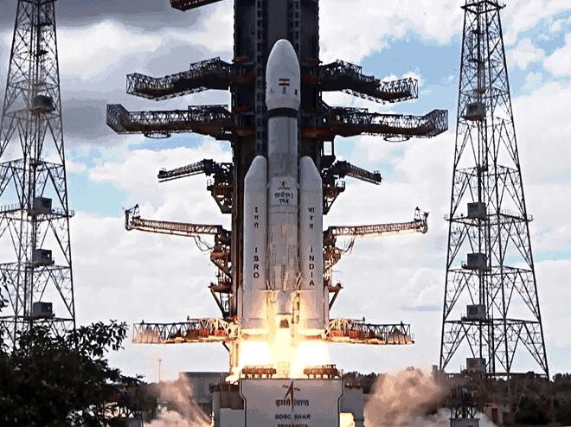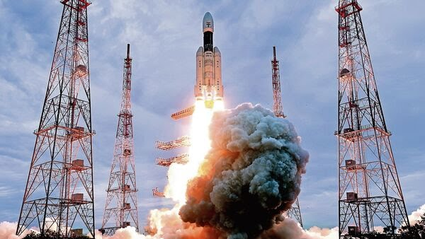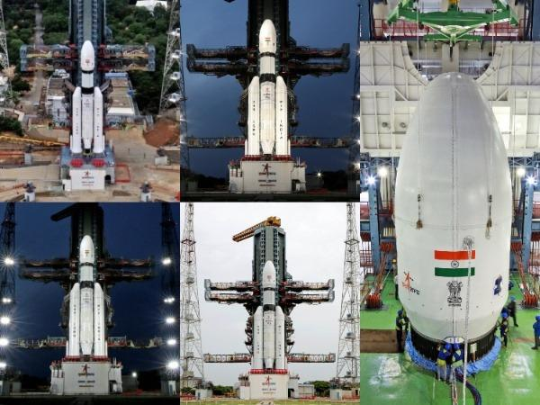**IMAGES OF LAUNCH OF LUNAR MISSION BY ISRO**

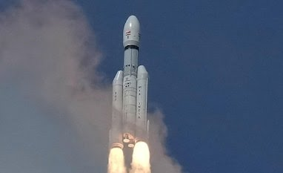

**Figure 1:** Launching of moon mission by ISRO

1. 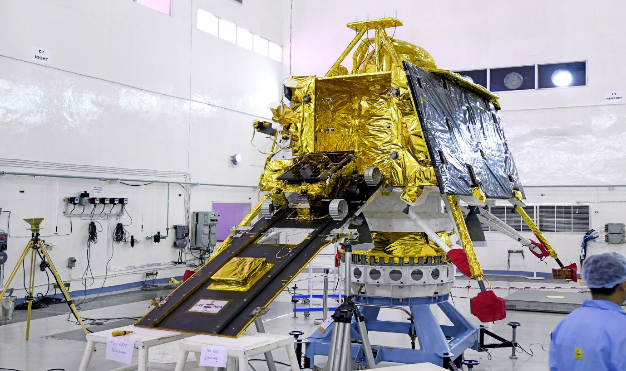**IMAGE OF VIKRAM LANDER AND PRAGYAN ROVER**

**Figure 2:** Vikram lander with Pragyan rover

1. **REFERENCES**
2. Khati, H. & Sharma, D. (2020) CHANDRAYAAN-2: India’s 2nd Lunar Exploration Mission. *International Journal of Engineering Research & Technology.* 9(7).1233-1237.
3. Kosambe, S. (2019) Chandrayaan-2: India’s Second Lunar Exploration Mission. *Journal of Aircraft and Spacecraft Technology.* Volume 3: 221-236. DOI: 10.3884/jastsp.2019.221.236
4. Chandrayaan-1. Retrieved from <https://www.isro.gov.in/Chandrayaan_1.html> , 2008.
5. Chandrayaan-2. Retrieved from <https://www.isro.gov.in/Chandrayaan_2.html> , 2021.
6. Chandrayaan-3. Retrieved from <https://www.isro.gov.in/Chandrayaan_3.html> , 2023.
7. Chandrayaan programme. Retrieved from <https://en.m.wikipedia.org/wiki/Chandrayaan_programme> , 2023.