A Physical Characteristics in Secure E- Transactions
¹Sai Srinivas Vellela, ²Khader Basha Sk, ³Venkateswara Reddy B, ⁴Roja D, ⁵Lavanya Dalavai, ⁶Sravanthi Javvadi, ⁷M Venkateswara Rao
^{1, 2, 4, 5}Asst. Professor, Dept. of CSE-Data Science, Chalapathi Institute of Technology, Guntur, AP, India
³Asst. Professor, Dept. of CSE-Cyber Security, Chalapathi Institute of Technology, Guntur, AP, India
⁶Asst. Professor, Dept. of CSE, Chalapathi Institute of Technology, Guntur, AP, India
⁷Professor, Dept. of CSE, NRI Institute of Technology, Vijayawada, AP, India

ABSTRACT
In the present day world, online shopping using WAP enabled mobile phone has widely come into use. Credit cards serve as the currency during e-business and E-Shopping. As technology has advanced in the negative side also hackers and spoofers steal misuse credit card numbers, even though the network has been made secure. So, in this paper, we have proposed a multi-biometric model (integrating voice, fingerprint and facial scanning) that can be embedded in a mobile phone, this making e-transactions more secure. The model is very cost effective as we have tried to use the hardware already present in the phone.This paper uses for image processing or facial reorganization and finger print. We have also simulated a few graphs for voice recognition and facial verification using MATLAB 6.0
Keywords- Physical Characteristics, E-Shopping, Secure E- Transactions.

1. INTRODUCTION:
Mobile phones have ceased to be exclusive status of the high class and, today has become an indispensable electronic gadget in the life of many. The main reason for their higher market penetrations in recent days is their incredible array of functions at an affordable cost. Apart from setting remainders and sending e-mails, they are also used in
- e-business
- SMS messaging
- Chatting
- Telemedicine and teleconferencing
Thus, these phones with wide roaming facility prove to be a really versatile device.

2. BIOMETRICS:
A biometric system is a recognition system, which makes a personal identification by determining the authenticity of a specific physiological or behavioral characteristic possessed by the user. This method of identification is preferred over traditional methods involving passwords and PIN numbers for various reasons:
- The person to be identified is required to be physically present at the point of identification.
- Identification based on biometric techniques eliminates the need to remember a password or carry an identity.

Depending on the context on which a biometric system works, it can be
Either classified as an identification system or a verification (authentication) system identification involves in establishing a person’s identify whereas in verification involves confirming or denying a person’s claiming identity.

3. MULTIBIOMETRICS:
A multi-biometrics system is obtained by the integration of multiple individual biometrics models. A numbers of models integrating hand geometry, keystroke dynamics, face and iris recognition system have flooded the markets in recent years.

Here we present a multimodal system that can be embedded in a mobile phone, which integrates fingerprint, voice and facial scanning. It shuts down the problem of high False Rejection Rate of facial scanners, eliminates the fooling of fingerprint scanners and overshadows the disadvantage of voice recognition models.

4. NEED FOR BIOMETRICS IN MOBILE PHONES:
Nowadays, shopping through the internet has become very popular and surely, a WAP enabled mobile phone provides the facilities to consumers to shop online. Credit cards continue to be an efficient tool for online money transactions. But, on the other hand, credit card’s number can be stolen on its way to its destination and can be misused by hackers. Thus, e-Business through a mobile phone becomes insecure.
Also, a report in www.download.com stated that much anti-fraud
Software, like those provided by ArticSoft and ISC, created a back door entry and were largely involved in data spoofing. In addition to this, many user and companies were prone to the attack of many viruses and Trojan horses.
With so much of problems faced, the service provide turned their attention towards biometrics to prevent data spoofing and to provide secure e-Transactions

5. FUTURE MOBILE PHONE:
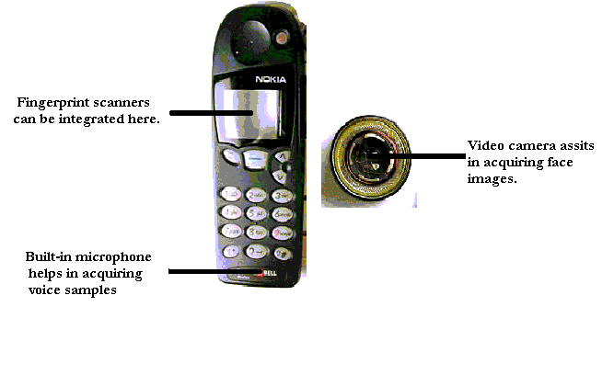

6. FACE RECOGNITION:
Facial recognition is considered to be one of the most tedious among all scans. Further, difficulty in acquisition of face and cost of equipments make it more complex.
However, some WAP enabled phones like CX 400K and LG-SD1000 manufactured by LG electronics, have built in camera that can acquire images and can be transmitted over internet. This it is sent to the credit card company to verify the face received matches with the face in their database. If it matches, the goods are sent, else the order is rejected.
protocol

Customer
Retailer
Orders with Customer id
Credit card
company
Amount request and subsequent sanction
Customer id, Amount & Biometric Data

We in our IMAGE PROCCESSING LAB took two faces with small differences (you see a small dot in the forehead of second face) and programmed MATLAB to find the difference between the two. The output is place below:



Figure 1 Figure 2

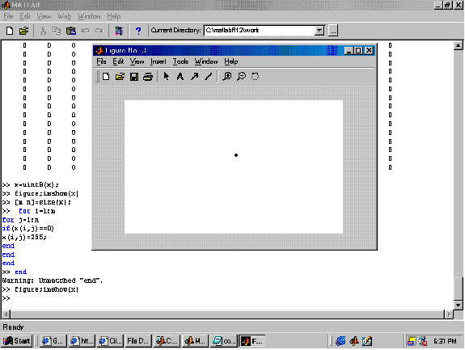
Difference between two images can be found by MATLAB.

The above simulations shows that even two persons having almost similar face with minute difference can also be differentiated.
Now, there arises a problem. A man, without bread, make as a transaction successfully .A week later he makes another transaction with some hair grown on his chin and go for acquiring images of any part of the face like forehead, nose, ear etc.
Hence, this type of facial scanning system can be used as a part of the multi-biometric system we have presented above.

7. VOICE RECOGNITION:
The speaker-specific characteristics of speech are due to difference in physiological and behavioral aspects of the speech production system in humans. The main physiological aspect of the human speech production system is the vocal tract shape. The vocal tract modifies the spectral content of an acoustic wave as it passes through it, thereby producing speech. Therefore, it is common in speaker verification systems to make use of features derived only from the vocal tract.
The microphone in the mobile phone captures the speech. Then, using cepstral analysis, an utterance may be represented as a sequence of feature vectors. Utterances, spoken by the same person but at difference times, result in similar yet a different sequence of features vectors. So, the irrespective of the mood of the consumer, his transaction is accepted or rejected. The following algorithm may be used in voice verification.
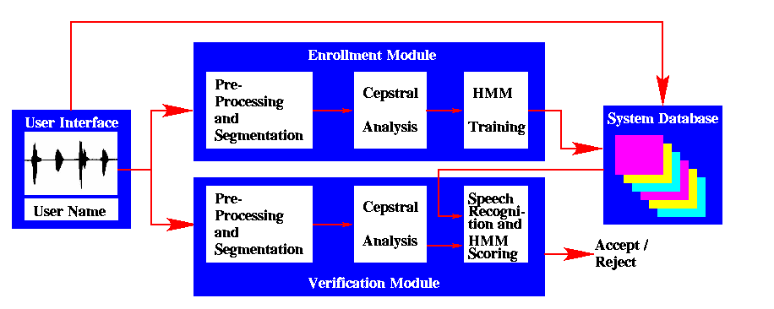
Flowchart for Voice verification

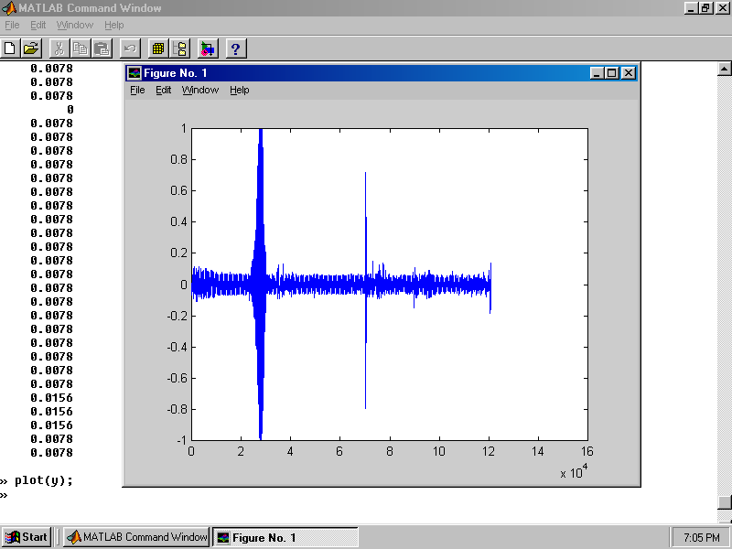

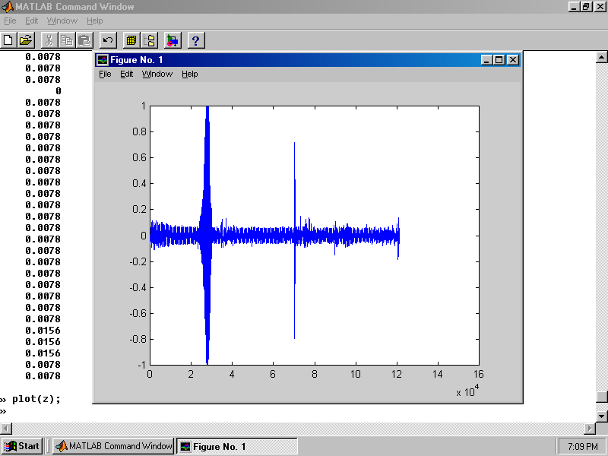

We recorded a person saying the letter ‘a’ directly into a sound recorder and plotted the graph1. This was simultaneously recorded in a tape recorder and
Graph2 was plotted. The above graph shows some minute differences which prove that this system cannot be fooled by imitation.

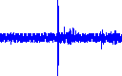
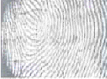
Face
Extractor

Minutiae
Extractor

Extractor
Cepstral analysis

Database browser

Template Database
Face locator
Minutiae
Extractor
Cepstral
Analyzer
Eigenspace
Comparator
Minutiae
Matching
HMM
Scoring
Decision
Fusion
Identity claim
Image acquisition
Module

Speech acquisition module
VERFICATION MODULE
Accept/
Reject

As every mobile phone have an in-built microphone and some have video camera, the need for an extra hardware for the speech and image acquisition is eliminated. A proposal for the display screen to act as a fingerprint acquisition is dealt later.

8. FINGERPRINT ACQUISITION:
Finger based scanning is one of the oldest methods used for verification. Fingerprints, unique and immunable for all are made of series of ridges and furrows on the surface of the finger. These ridges and furrows determine the uniqueness of the fingerprints. Apart from these, minute points (i.e. local ridge characteristics that occur at either a ridge bifurcation or a ridge ending also play role in fool-proofing this biometric technique.
To reduce the search time and the computational complexity, fingerprint classification is undertaken and thus fingerprints are classified as whorl, right loop, left loop, arch, and arch. Recently researchers and scientists achieved a great feat by improving the fingerprint classification to 94%.
In today’s world, fingerprint matching techniques can be placed into two categories: minutiae-based and correlation based. In minutiae based technique, the minutiae points are found and their relative placement are mapped on the finger whereas in correlation based technique, the fingerprint acquired from the person is checked for certain points previously stored in the database. If both matches, the person is given authentication, else he is denied permission.



Transaction scanner embedded above display screen

The scanner here is a transparent layer above the screen. The scanner consists of arrays of capacitors of the size of 0.03m. capacitors with such a small size can be manufactured with MEMS technology. When the consumer places his thumb on the scanner, the points at which his fingerprint touches the screen get discharged whereas others remain charged. Thus the fingerprint is scanned and is then sent for further process

9. CONCLUSION:
Thus, this mobile multi-biometrics can be embedded in mobile phone. Phone is cost effective since no special hardware in required and is highly secured. Thus, this mobile phone becomes a reality will provide more e-Business and
E-Transactions
.

10.REFERENCES:

- Sk, K. B., Roja, D., Priya, S. S., Dalavi, L., Vellela, S. S., & Reddy, V. (2023, March). Coronary Heart Disease Prediction and Classification using Hybrid Machine Learning Algorithms. In 2023 International Conference on Innovative Data Communication Technologies and Application (ICIDCA) (pp. 1-7). IEEE.
- VenkateswaraRao, M., Vellela, S., Reddy, V., Vullam, N., Sk, K. B., &Roja, D. (2023, March). Credit Investigation and Comprehensive Risk Management System based Big Data Analytics in Commercial Banking. In 2023 9th International Conference on Advanced Computing and Communication Systems (ICACCS) (Vol. 1, pp. 2387-2391). IEEE.
- Vellela, S.S., Balamanigandan, R. Optimized clustering routing framework to maintain the optimal energy status in the wsn mobile cloud environment. Multimed Tools Appl (2023). https://doi.org/10.1007/s11042- 023- 15926-5
- Vullam, N., Vellela, S. S., Reddy, V., Rao, M. V., SK, K. B., &Roja, D. (2023, May). Multi-Agent Personalized Recommendation System in E-Commerce based on User. In 2023 2nd International Conference on Applied Artificial Intelligence and Computing (ICAAIC) (pp. 1194-1199). IEEE.
- Rao, K. N., Gandhi, B. R., Rao, M. V., Javvadi, S., Vellela, S. S., & Basha, S. K. (2023, June). Prediction and Classification of Alzheimer’s Disease using Machine Learning Techniques in 3D MR Images. In 2023 International Conference on Sustainable Computing and Smart Systems (ICSCSS) (pp. 85-90). IEEE.
- Rao, D. M. V., Vellela, S. S., Sk, K. B., & Dalavai, L. (2023). Stematic Review on Software Application Under-distributed Denial of Service Attacks for Group Website. Dogo Rangsang Research Journal, UGC Care Group I Journal, 13.
- Venkateswara Reddy, B., &KhaderBashaSk, R. D. Qos-Aware Video Streaming Based Admission Control And Scheduling For Video Transcoding In Cloud Computing. In International Conference on Automation, Computing and Renewable Systems (ICACRS 2022).
- Madhuri, A., Praveen, S. P., Kumar, D. L. S., Sindhura, S., &Vellela, S. S. (2021). Challenges and issues of data analytics in emerging scenarios for big data, cloud and image mining. Annals of the Romanian Society for Cell Biology, 412-423.
- Vellela, S. S., Balamanigandan, R., & Praveen, S. P. (2022). Strategic Survey on Security and Privacy Methods of Cloud Computing Environment. Journal of Next Generation Technology (ISSN: 2583- 021X), 2(1).
- Venkateswara Reddy, B., Vellela, S. S., Sk, K. B., Roja, D., Yakubreddy, K., & Rao, M. V. Conceptual Hierarchies for Efficient Query Results Navigation. International Journal of All Research Education and Scientific Methods (IJARESM), ISSN, 2455-6211.
- Sk, K. B., Vellela, S. S., Yakubreddy, K., & Rao, M. V. (2023). Novel and Secure Protocol for Trusted Wireless Ad-hoc Network Creation. Khader Basha Sk, Venkateswara Reddy B, Sai Srinivas Vellela, Kancharakunt Yakub Reddy, M Venkateswara Rao, Novel and Secure Protocol for Trusted Wireless Ad-hoc Network Creation, 10(3).
- Sk, K. B., & Vellela, S. S. (2019). Diamond Search by Using Block Matching Algorithm. DIAMOND SEARCH BY USING BLOCK MATCHING ALGORITHM", International Journal of Emerging Technologies and Innovative Research (www. jetir. org), ISSN, 2349-5162.
- S. S. Priya, S. Srinivas Vellela, V. R. B, S. Javvadi, K. B. Sk and R. D, "Design And Implementation of An Integrated IOT Blockchain Framework for Drone Communication," 2023 3rd International Conference on Intelligent Technologies (CONIT), Hubli, India, 2023, pp. 1-5, doi: 10.1109/CONIT59222.2023.10205659.
- N. Vullam, K. Yakubreddy, S. S. Vellela, K. Basha Sk, V. R. B and S. Santhi Priya, "Prediction And Analysis Using A Hybrid Model For Stock Market," 2023 3rd International Conference on Intelligent Technologies (CONIT), Hubli, India, 2023, pp. 1-5, doi: 10.1109/CONIT59222.2023.10205638.
- Vellela, S. S., & Krishna, A. M. (2020). On Board Artificial Intelligence With Service Aggregation for Edge Computing in Industrial Applications. Journal of Critical Reviews, 7(07).
- Vellela, Sai Srinivas and B, Venkateswara Reddy and Sk, Khader Basha, Detection Of Spammers And Fake User Identification In Social Networks ( 2016). IJCRT | Volume 4, Issue 4 November 2016, Available at SSRN: https://ssrn.com/abstract=4531199
- Vellela, Sai Srinivas and Narapasetty, Suma and Somepalli, Mahendra and Merikapudi, Venkateswarlu and Pathuri, Sandeep, Fake News Articles Classifying Using Natural Language Processing to Identify in-article Attribution as a Supervised Learning Estimator (June 10, 2022). Mukt Shabd Journal, Volume XI, Issue VI, JUNE/2022, Available at SSRN: https://ssrn.com/abstract=4473702
- Vellela, Sai Srinivas and Basha Sk, Khader and B, Venkateswara Reddy and D, Roja and Javvadi, Sravanthi, MOBILE RFID APPLICATIONS IN LOCATION BASED SERVICES ZONE (June 14, 2023). International Journal of Emerging Technologies and Innovative Research, Vol.10, Issue 6, page no. ppd851-d859, June-2023, http://www.jetir.org/papers/JETIR2306410.pdf, Available at SSRN: https://ssrn.com/abstract=4478104
- Yakubreddy, K., Vellela, S. S., Sk, K. B., Reddy, V., & Roja, D. (2023). Grape CS-ML Database-Informed Methods for Contemporary Vineyard Management. International Research Journal of Modernization in Engineering Technology and Science, 5(03).
- Vellela, Sai Srinivas and Pushpalatha, D and Sarathkumar, G and Kavitha, C.H. and Harshithkumar, D, Advanced Intelligence Health Insurance Cost Prediction Using Random Forest (March 1, 2023). ZKG International, Volume VIII Issue I MARCH 2023, Available at SSRN: https://ssrn.com/abstract=4473700
- D, Roja and Dalavai, Lavanya and Javvadi, Sravanthi and Sk, Khader Basha and Vellela, Sai Srinivas and B, Venkateswara Reddy and Vullam, Nagagopiraju, Computerised Image Processing and Pattern Recognition by Using Machine Algorithms (April 10, 2023). TIJER International Research Journal, Volume 10 Issue 4, April 2023, Available at SSRN: https://ssrn.com/abstract=4428667
- Vellela, S. S., Roja, D., Reddy, V., Sk, K. B., & Rao, M. V. (2023). A New Computer-Based Brain Fingerprinting Technology.
- Vellela, S. S., Basha Sk, K., & Javvadi, S. (2023). MOBILE RFID APPLICATIONS IN LOCATION BASED SERVICES ZONE. MOBILE RFID APPLICATIONS IN LOCATION BASED SERVICES ZONE", International Journal of Emerging Technologies and Innovative Research (www. jetir. org| UGC and issn Approved), ISSN, 2349-5162.
- Sk, Khader Basha and B, Venkateswara Reddy and Vellela, Sai Srinivas, Diamond Search by Using Block Matching Algorithm (May 4, 2019). "DIAMOND SEARCH BY USING BLOCK MATCHING ALGORITHM", International Journal of Emerging Technologies and Innovative Research (www.jetir.org), ISSN:2349-5162, Vol.6, Issue 5, page no.150-154, May-2019, Available :http://www.jetir.org/papers/JETIR1905Y22.pdfDIAMOND SEARCH BY USING BLOCK MATCHING ALGORIT, Available at SSRN: https://ssrn.com/abstract=4437669
- Vellela, S. S., &Balamanigandan, R. (2022, December). Design of Hybrid Authentication Protocol for High Secure Applications in Cloud Environments. In 2022 International Conference on Automation, Computing and Renewable Systems (ICACRS) (pp. 408-414). IEEE.
- Madhuri, A., Jyothi, V. E., Praveen, S. P., Sindhura, S., Srinivas, V. S., & Kumar, D. L. S. (2022). A New Multi-Level Semi-Supervised Learning Approach for Network Intrusion Detection System Based on the ‘GOA’. Journal of Interconnection Networks, 2143047.
- Vellela, S. S., Reddy, B. V., Chaitanya, K. K., &Rao, M. V. (2023, January). An Integrated Approach to Improve E-Healthcare System using Dynamic Cloud Computing Platform. In 2023 5th International Conference on Smart Systems and Inventive Technology (ICSSIT) (pp. 776-782). IEEE.
- S Phani Praveen, RajeswariNakka, AnuradhaChokka, VenkataNagarajuThatha, SaiSrinivasVellela and UddagiriSirisha, “A Novel Classification Approach for Grape Leaf Disease Detection Based on Different Attention Deep Learning Techniques” International Journal of Advanced Computer Science and Applications(IJACSA), 14(6), 2023. http://dx.doi.org/10.14569/IJACSA.2023.01406128
- Praveen, S. P., Sarala, P., Kumar, T. K. M., Manuri, S. G., Srinivas, V. S., &Swapna, D. (2022, November). An Adaptive Load Balancing Technique for Multi SDN Controllers. In 2022 International Conference on Augmented Intelligence and Sustainable Systems (ICAISS) (pp. 1403-1409). IEEE.
- Vellela, S. S., BashaSk, K., &Yakubreddy, K. (2023). Cloud-hosted concept-hierarchy flex-based infringement checking system. International Advanced Research Journal in Science, Engineering and Technology, 10(3). Vellela, S. S., &Balamanigandan, R. (2023).

