AN INTRODUCING THE NANO CARS INTO THE ROBOTICS FOR THE REALISTIC MOVEMENTS
¹Sai Srinivas Vellela, ²Khader Basha Sk, ³Venkateswara Reddy B, ⁴Roja D, ⁵Lavanya Dalavai, ⁶Sravanthi Javvadi, ⁷M Venkateswara Rao
^{1, 2, 4, 5}Asst. Professor, Dept. of CSE-Data Science, Chalapathi Institute of Technology, Guntur, AP, India
³Asst. Professor, Dept. of CSE-Cyber Security, Chalapathi Institute of Technology, Guntur, AP, India
⁶Asst. Professor, Dept. of CSE, Chalapathi Institute of Technology, Guntur, AP, India
⁷Professor, Dept. of CSE, NRI Institute of Technology, Vijayawada, AP, India

Abstract
Material Science research is now entering a new phase where the structure and properties of materials can be investigated, characterized and controlled at the nanoscale. New and sometimes unexpected material properties appear at the nanoscale, thus bringing new excitement to this research field. In this talk, special emphasis will be given to one-dimensional nanotubes and nanowires because they exhibit unusual physical properties, due to their reduced dimensionality and their enhanced surface/volume ratio. These unusual properties have attracted interest in their potential for applications in novel electronic, optical, magnetic and thermoelectric devices.
Another feature of nanotechnology is that it is the one area of research and development that is truly multidisciplinary. Research at the nanoscale is unified by the need to share knowledge on tools and techniques, as well as information on the physics affecting atomic and molecular interactions in this new realm.
So now we are going to introduce the nano technology into the field of robotics to achieve realistic movements which is a real dream of the human for more than 5 years. By introducing this nervous system to the robot we have exactly 2 advantages that is we can pass information same time and we can also the movements at the same time the cars reached the actual part where the movement as be caused. So we need have some knowledge about nano technology and from these we are going to see what the nano cars means and then how we are going to see the introduction of the nano cars into the neuron system.
Keywords- Robotics, Nano Technology.
Introduction to nano technology:
From converting sunlight into power to clean oceans, to monitor thermal environment, and to sensors in the form of biochips built into the human body performing as lifesavers by self-monitoring and guarding, nanotechnology assures us a lot more!
Stone Age, Bronze Age, Iron Age, Silicon Age, and next what? Nevertheless to say, we are well in to the Nanotech Age, where materials are just getting smarter day by day. There would be sensors embedded in almost all walks of life. Each element would be smart enough to repair itself as and when required. All this would be possible by manipulating matter at the molecular scale.
Scientists will now like to understand how simple atoms and molecules come together and arrange themselves to form complex systems, such as living cells that make life possible on earth. This approach deals with how complex systems are built from simple atomic-level constituents which result in nanoscience and nanotechnology. In simple, it is the study of properties of a few tens of atoms in a space of less say 50nm. Manufactured products are made from atoms. The properties of those products depend on how those atoms are arranged. If we rearrange the atoms in coal we can make diamond. If we rearrange the atoms in sand we can make computer chips. If we rearrange the atoms in dirt, water and air we can make potatoes. Almost any manufactured product could be improved, often by several orders of magnitude, if we could precisely control its structure at the molecular level. We often want our products to be light and strong.

What is nanotechnology?

Nanotechnology is a molecular manufacturing or, more simply, building things the size of one atom or molecule with programmed precision. It involves working with matter at scale of one- billionth of a meter
Nanoscience is concerned with nonmaterial’s that have atleast one of three dimensions of about 1 to 10 nanometers. The word 'nano' comes from the Greek word "nanos" meaning 'dwarf'. The term nano is the factor 10⁻⁹ or one billionth. Nanotechnology is that area of science and technology where dimensions and tolerances in the range of 0.1nm to 100 nm play a critical role'. Nanotechnology can best be considered as a 'catch-all' description of activities at the level  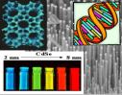 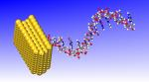

Nanotechnology is an anticipated manufacturing technology giving through, inexpensive control of the structure of matter. The term has sometimes been used to refer to any technique able to work at a submicron scale here it is used in the more usual sense of general control of the structure of matter on a nanometer scale-that is, a broad ability to control the arrangement of atoms. This ability will require development of devices termed 'assemblers'.
Nanomachines:
The idea of nanotechnology is therefore to master over the characteristics of matter in an intelligent manner to develop highly efficient systems. However, this is a big challenge to technology as to how to build material in bulk form this way. It will be easy if one can learn through bioscience how the nature does it. Proteins are molecular machines that routinely manipulate individual atoms. Synthesis of building blocks of proteins can provide us an appropriate technology for making nonmaterial’s in bulk form. Molecular nanotechnology draws on cutting-edge advances in physics, chemistry, biology and computer science to build structures measured in nanometers.
Though we haven’t reached that omnipotent stage of evolution, we still have plenty of nanotech applications, from biosensors in the human body to intelligent systems embedded in real-time cars and airplanes calculating the wear and tear on engine life, everyday stain-resistant clothes, super telecommunication systems, and not to forget ‘smart dust’.

Nanotechnology – MEMS:
Micro-electromechanical system (MEMS) combines computers with tiny mechanical devices such as sensors, valves, gears, and actuators embedded in semiconductor chips. These elements are embedded in the mainframe of the system for carrying out the bigger tasks, they are usually referred to as ‘smart matter’.
This smart matter is used as micro information seekers (MIS). Since micro information seekers are minute and are termed as ‘motes’, motes are wireless computers small enough to be integrated into anything to create robust wireless networks. Assume a room in an office building to have a hundred or even a thousand light-and temperature-sensing motes, all of which would tie into a central computer that regulates energy usage in the building.
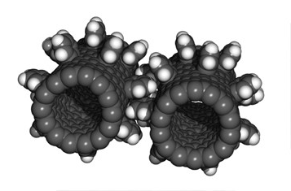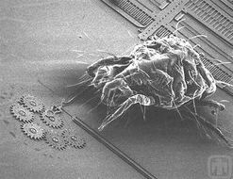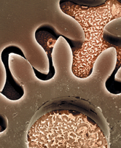
Fig: Shapes of nano gears
Taken together, motes would constitute a huge sensor network of small dust, a network that would give engineers insight into how energy is used and how it can be conserved. In such a dust- enabled environment, computers would turn on/off lights and control climate in rooms. As systems would come with an info tag on them, they can be easily located no matter where they are. So beware petty thieves stealing cars, furniture, stereos, or other valuables!
Nanotechnology-Applications

Nanotechnology - IT field, Nanotechnology - Medicine Intelligent Cars Smart furniture Airbags for Motorcyclists screening at airports Biochips for healthcare.
Nano cars in the Robotics
This paper is mainly going to discuss about the Nano cars usage in the robotics until now the robotic movements are like an artificial machine movement introducing these nano cars as the neuron system for the robots then the movements get better. Until now the robotic movements are the one which will move like a machine by introducing this new nano cars into the field of robotics the movements can be made lot better and these can be done in the following way
- By introducing these nano cars as neuron system we have the required movement and we can also have the movement that we required instance.
- How it is going to possible is by introducing nano cars as the nervous system instead of stepper motors for the movement. The nervous system will just work as just the actual neurons in the human being to make the require movement. For instance take the hand of the robot until the fingers or the wrist movement is limited to the motors used but by introducing this nano neurons we can have the required movement as a flash.
The below diagrams will demonstrate clearly show the difference between normal robotic hand and hand that having neuron system with nano cars. Fig a shows the how the normal hand will be through this the movements are so artificial but by introducing these nano cars we can overcome this disadvantage. If one way or the other way the artificial movement is removed in the hands using the normal methods we can take the real facial expressions we can make the common robot to have the smiling face or angry or and other movement which will look like lot more better than ever.
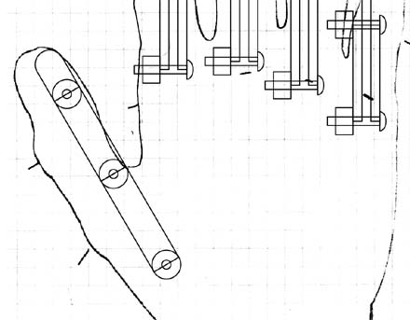
Fig a: Normal robot hand having stepper motors for the movement
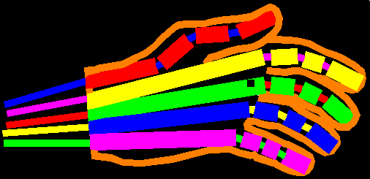
Fig b:Robot hand having Nano cars as neuron system with movement
So inorder to have this movement we are going to introduce the concept of nano cars in the robotics. What the actuall nano cars means The nano-car's molecular motor contains a pair of bonded carbon molecules that rotate in one direction if illuminated by a specific wavelength of light. After fixing the molecular engine to the car's chassis and shining a light on it, Tour's team confirmed that the engine was running by using nuclear magnetic resonance to monitor the position of the hydrogen atoms within it.
But the car was not released to drive itself along. "It's analogous to building a race car and putting it up on blocks," Tour said. "Now it's a question of getting it out on the track." The motor should function as a fifth wheel to drive the car along.
This the Hand that is designed by the NASA.

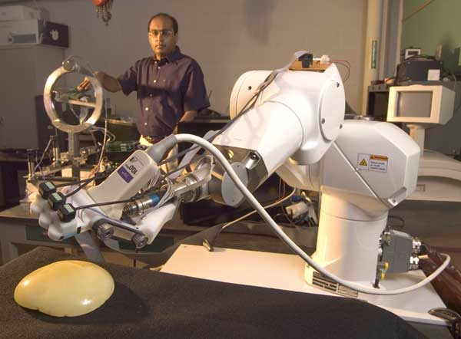

This so huge and the design can be get more simple when we use the nano cars and neuron system and by the supporter (bones so called for the humans) we can have real movement in the hand.
Below will demonstrate the supports overview in which the design is going to be
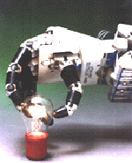
Hand Overall design

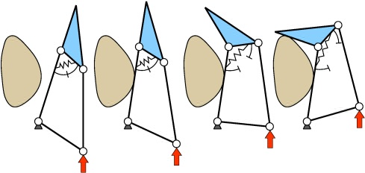
Closing of a 2-DOF finger with only one actuator.

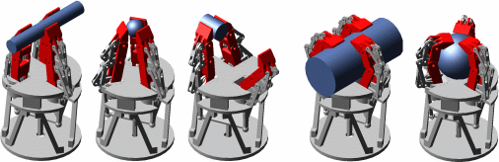
Main types of grasps.

Conclusion:
Nanoscience is emerging as the basic science providing a field which is becoming the focus of attraction of all fundamentals sciences. Physics provides possibility of maneuvering things atom by atom. Chemistry provides way of synthesizing complicated molecules provided clues for building materials on molecular level. Bioscience provides possibility of understanding how nature builds the material as proteins are molecular machines, which routinely manipulate individual atoms. To decipher it one needs mathematics and computer science for modeling and computer simulations. The ultimate aim is to achieve self assembly of devices for various applications. Of course, nanotechnology is a wonderful tool, but what would happen if this technology fell into the wrong hands? One might ask about the legal implications of nanotechnology or even the harmful effects of bioterrorism. The truth is that we simply don’t know where new technologies would lead, and we can never secure against scientific terror. Today’s advances offer tremendous possibilities as also tremendous risks-and we’re just going to learn to live with both.
Finally I would like to say that using the nano technology in the field of robotics we can achieve lot more better movements than so far.
References:
- Vellela, S. S., &Balamanigandan, R. (2022, December). Design of Hybrid Authentication Protocol for High Secure Applications in Cloud Environments. In 2022 International Conference on Automation, Computing and Renewable Systems (ICACRS) (pp. 408-414). IEEE.
- Madhuri, A., Jyothi, V. E., Praveen, S. P., Sindhura, S., Srinivas, V. S., & Kumar, D. L. S. (2022). A New Multi-Level Semi-Supervised Learning Approach for Network Intrusion Detection System Based on the ‘GOA’. Journal of Interconnection Networks, 2143047.
- Vellela, S. S., Reddy, B. V., Chaitanya, K. K., &Rao, M. V. (2023, January). An Integrated Approach to Improve E-Healthcare System using Dynamic Cloud Computing Platform. In 2023 5th International Conference on Smart Systems and Inventive Technology (ICSSIT) (pp. 776-782). IEEE.
- S Phani Praveen, RajeswariNakka, AnuradhaChokka, VenkataNagarajuThatha, SaiSrinivasVellela and UddagiriSirisha, “A Novel Classification Approach for Grape Leaf Disease Detection Based on Different Attention Deep Learning Techniques” International Journal of Advanced Computer Science and Applications(IJACSA), 14(6), 2023. http://dx.doi.org/10.14569/IJACSA.2023.01406128
- Praveen, S. P., Sarala, P., Kumar, T. K. M., Manuri, S. G., Srinivas, V. S., &Swapna, D. (2022, November). An Adaptive Load Balancing Technique for Multi SDN Controllers. In 2022 International Conference on Augmented Intelligence and Sustainable Systems (ICAISS) (pp. 1403-1409). IEEE.
- Vellela, S. S., BashaSk, K., &Yakubreddy, K. (2023). Cloud-hosted concept-hierarchy flex-based infringement checking system. International Advanced Research Journal in Science, Engineering and Technology, 10(3). Vellela, S. S., &Balamanigandan, R. (2023).
- Sk, K. B., Roja, D., Priya, S. S., Dalavi, L., Vellela, S. S., & Reddy, V. (2023, March). Coronary Heart Disease Prediction and Classification using Hybrid Machine Learning Algorithms. In 2023 International Conference on Innovative Data Communication Technologies and Application (ICIDCA) (pp. 1-7). IEEE.
- VenkateswaraRao, M., Vellela, S., Reddy, V., Vullam, N., Sk, K. B., &Roja, D. (2023, March). Credit Investigation and Comprehensive Risk Management System based Big Data Analytics in Commercial Banking. In 2023 9th International Conference on Advanced Computing and Communication Systems (ICACCS) (Vol. 1, pp. 2387-2391). IEEE.
- Vellela, S.S., Balamanigandan, R. Optimized clustering routing framework to maintain the optimal energy status in the wsn mobile cloud environment. Multimed Tools Appl (2023). https://doi.org/10.1007/s11042- 023- 15926-5
- Vullam, N., Vellela, S. S., Reddy, V., Rao, M. V., SK, K. B., &Roja, D. (2023, May). Multi-Agent Personalized Recommendation System in E-Commerce based on User. In 2023 2nd International Conference on Applied Artificial Intelligence and Computing (ICAAIC) (pp. 1194-1199). IEEE.
- Rao, K. N., Gandhi, B. R., Rao, M. V., Javvadi, S., Vellela, S. S., & Basha, S. K. (2023, June). Prediction and Classification of Alzheimer’s Disease using Machine Learning Techniques in 3D MR Images. In 2023 International Conference on Sustainable Computing and Smart Systems (ICSCSS) (pp. 85-90). IEEE.
- Rao, D. M. V., Vellela, S. S., Sk, K. B., & Dalavai, L. (2023). Stematic Review on Software Application Under-distributed Denial of Service Attacks for Group Website. Dogo Rangsang Research Journal, UGC Care Group I Journal, 13.
- Venkateswara Reddy, B., &KhaderBashaSk, R. D. Qos-Aware Video Streaming Based Admission Control And Scheduling For Video Transcoding In Cloud Computing. In International Conference on Automation, Computing and Renewable Systems (ICACRS 2022).
- Madhuri, A., Praveen, S. P., Kumar, D. L. S., Sindhura, S., &Vellela, S. S. (2021). Challenges and issues of data analytics in emerging scenarios for big data, cloud and image mining. Annals of the Romanian Society for Cell Biology, 412-423.
- Vellela, S. S., Balamanigandan, R., & Praveen, S. P. (2022). Strategic Survey on Security and Privacy Methods of Cloud Computing Environment. Journal of Next Generation Technology (ISSN: 2583- 021X), 2(1).
- Venkateswara Reddy, B., Vellela, S. S., Sk, K. B., Roja, D., Yakubreddy, K., & Rao, M. V. Conceptual Hierarchies for Efficient Query Results Navigation. International Journal of All Research Education and Scientific Methods (IJARESM), ISSN, 2455-6211.
- Sk, K. B., Vellela, S. S., Yakubreddy, K., & Rao, M. V. (2023). Novel and Secure Protocol for Trusted Wireless Ad-hoc Network Creation. Khader Basha Sk, Venkateswara Reddy B, Sai Srinivas Vellela, Kancharakunt Yakub Reddy, M Venkateswara Rao, Novel and Secure Protocol for Trusted Wireless Ad-hoc Network Creation, 10(3).
- Sk, K. B., & Vellela, S. S. (2019). Diamond Search by Using Block Matching Algorithm. DIAMOND SEARCH BY USING BLOCK MATCHING ALGORITHM", International Journal of Emerging Technologies and Innovative Research (www. jetir. org), ISSN, 2349-5162.
- S. S. Priya, S. Srinivas Vellela, V. R. B, S. Javvadi, K. B. Sk and R. D, "Design And Implementation of An Integrated IOT Blockchain Framework for Drone Communication," 2023 3rd International Conference on Intelligent Technologies (CONIT), Hubli, India, 2023, pp. 1-5, doi: 10.1109/CONIT59222.2023.10205659.
- N. Vullam, K. Yakubreddy, S. S. Vellela, K. Basha Sk, V. R. B and S. Santhi Priya, "Prediction And Analysis Using A Hybrid Model For Stock Market," 2023 3rd International Conference on Intelligent Technologies (CONIT), Hubli, India, 2023, pp. 1-5, doi: 10.1109/CONIT59222.2023.10205638.
- Vellela, S. S., & Krishna, A. M. (2020). On Board Artificial Intelligence With Service Aggregation for Edge Computing in Industrial Applications. Journal of Critical Reviews, 7(07).
- Vellela, Sai Srinivas and B, Venkateswara Reddy and Sk, Khader Basha, Detection Of Spammers And Fake User Identification In Social Networks ( 2016). IJCRT | Volume 4, Issue 4 November 2016, Available at SSRN: https://ssrn.com/abstract=4531199
- Vellela, Sai Srinivas and Narapasetty, Suma and Somepalli, Mahendra and Merikapudi, Venkateswarlu and Pathuri, Sandeep, Fake News Articles Classifying Using Natural Language Processing to Identify in-article Attribution as a Supervised Learning Estimator (June 10, 2022). Mukt Shabd Journal, Volume XI, Issue VI, JUNE/2022, Available at SSRN: https://ssrn.com/abstract=4473702
- Vellela, Sai Srinivas and Basha Sk, Khader and B, Venkateswara Reddy and D, Roja and Javvadi, Sravanthi, MOBILE RFID APPLICATIONS IN LOCATION BASED SERVICES ZONE (June 14, 2023). International Journal of Emerging Technologies and Innovative Research, Vol.10, Issue 6, page no. ppd851-d859, June-2023, http://www.jetir.org/papers/JETIR2306410.pdf, Available at SSRN: https://ssrn.com/abstract=4478104
- Yakubreddy, K., Vellela, S. S., Sk, K. B., Reddy, V., & Roja, D. (2023). Grape CS-ML Database-Informed Methods for Contemporary Vineyard Management. International Research Journal of Modernization in Engineering Technology and Science, 5(03).
- Vellela, Sai Srinivas and Pushpalatha, D and Sarathkumar, G and Kavitha, C.H. and Harshithkumar, D, Advanced Intelligence Health Insurance Cost Prediction Using Random Forest (March 1, 2023). ZKG International, Volume VIII Issue I MARCH 2023, Available at SSRN: https://ssrn.com/abstract=4473700
- D, Roja and Dalavai, Lavanya and Javvadi, Sravanthi and Sk, Khader Basha and Vellela, Sai Srinivas and B, Venkateswara Reddy and Vullam, Nagagopiraju, Computerised Image Processing and Pattern Recognition by Using Machine Algorithms (April 10, 2023). TIJER International Research Journal, Volume 10 Issue 4, April 2023, Available at SSRN: https://ssrn.com/abstract=4428667
- Vellela, S. S., Roja, D., Reddy, V., Sk, K. B., & Rao, M. V. (2023). A New Computer-Based Brain Fingerprinting Technology.
- Vellela, S. S., Basha Sk, K., & Javvadi, S. (2023). MOBILE RFID APPLICATIONS IN LOCATION BASED SERVICES ZONE. MOBILE RFID APPLICATIONS IN LOCATION BASED SERVICES ZONE", International Journal of Emerging Technologies and Innovative Research (www. jetir. org| UGC and issn Approved), ISSN, 2349-5162.
- Sk, Khader Basha and B, Venkateswara Reddy and Vellela, Sai Srinivas, Diamond Search by Using Block Matching Algorithm (May 4, 2019). "DIAMOND SEARCH BY USING BLOCK MATCHING ALGORITHM", International Journal of Emerging Technologies and Innovative Research (www.jetir.org), ISSN:2349-5162, Vol.6, Issue 5, page no.150-154, May-2019, Available :http://www.jetir.org/papers/JETIR1905Y22.pdfDIAMOND SEARCH BY USING BLOCK MATCHING ALGORIT, Available at SSRN: https://ssrn.com/abstract=4437669

