Ambika Mahorand Pankaj Shrivastava

Maharana Pratap College of Technology, Gwalior-474002, India

Design and Development of Microstrip Low Pass Filter with Wide Stopband

*Abstract*—A microstrip step impedance low pass filter (LPF) is proposed. Stop band of LPF is enhanced using a pair of open stubs connected to input and output port. LPF is fabricated on FR-4 with dielectric constant 4.3, prototype has 3dB cut off frequency (fc) of 3.16 GHz. The stop band is enhanced up to 6 GHz using two open stubs connected to input output posts and improved the selectivity.

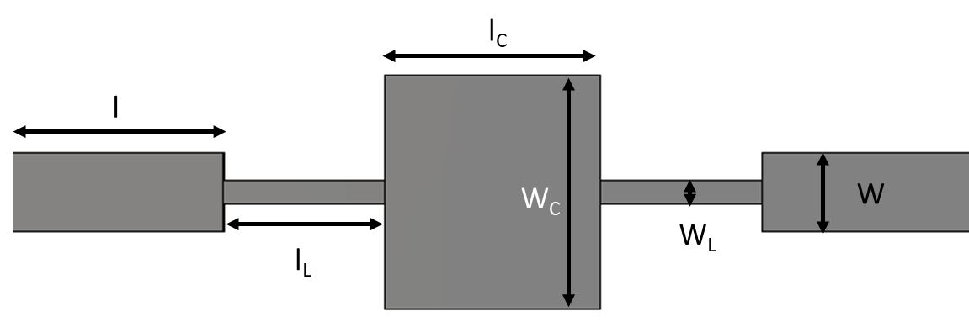

Fig. 1. Proposed Layout of low pass filter

*Index Terms*—Step impedance resonator, quarter wave open stubs, wide stopband

# INTRODUCTION

A

N efficient wireless communication system requires a compact and low profile low pass filter (LPF) to eradicate spurious and undesired higher order frequency components. To achieve this, the LPF should have good passband selectivity, sufficiently wide stopband rejection capability, low passband insertion loss and high attenuation level in stopband. Several design methodologies and techniques have been reported so far to realize such low pass filters. Mostly, planner resonator circuits and specifically in microstrip technology are utilized to perform low pass filtering operation due to its compactness, ease of fabrication and integration with other high-frequency devices and circuits. Various circuit topologies of LPFs and their detailed investigation and performance analysis in terms of roll-off factor, stopband bandwidth, out-of-band rejection and passband insertion loss (IL) have been widely reported in recent years [1]–[11]. In Proposed design [1] uses of metamaterial structures and host transmission line for the improvement of cut off frequency, insertion loss and size reduction of the filter. Here we have taken third order microstrip Lowpass filter with cut off frequency of 2 GHz, FR-4 lossy is used. In [2] a microstrip low-pass filter (LPF) using reformative stepped impedance resonator (SIR) and defected ground structure (DGS) is proposed in this paper. The proposed filter not only possesses the advantage of high frequency selectivity of SIR hairpin LPF with internal coupling, but also possesses the large stop-band (SB) bandwidth by adjusting the number and area of DGS unit. In this work, an ultra-wide stopband low-pass filter (LPF) is proposed using tapered step impedance resonators. In [3] A LPF using SIRs, open stubs and ground slots is proposed. The distributed equivalent of the proposed step impedance LPF is extracted, analyzed and legitimated with simulated and fabricated results. In [4] a comprehensive treatment of capacitively loaded transmission line resonator is described, which leads to the invention of microstrip slow-wave open-loop resonator. The utilization of microstrip slow-wave open-loop resonators allows various filter configurations including those of elliptic or quasi-elliptic function response to be realized. The filters are not only compact size due to the slow-wave effect, but also have a wider upper stop-band resulting from the dispersion effect. These attractive features make the microstrip slow-wave open-loop resonator filters good for mobile communications, superconducting and other applications. In [5] proposed an asymmetric lowpass filter in 2017. It has an extremely wide stopband and a low NCS, however, the roll off rate is inadequate. Patch resonators and open stub were reported in [6] to improve the roll off level and suppression factor. The filter achieved the desired level of suppression, but it still needs to increase roll-off and reduce losses and physical size. The compact microstrip low pass filter with flat group delay is proposed using triangle-shaped resonators in [7]. Several suppressing cells were used for the wide rejection of stopband which increases size and displays large return loss. The highly selective filter structure proposed in [8] using stepped impedance resonator and defective ground structure (DGS) were developed in Kumar, et al. (2018). The DGS model is effective for the applications associated with the requirement of low NCS. It offers lower physical size without using number of resonators. In [9] authors proposed U-shaped dual planar electromagnetic band gap microstrip low pass filter, employing the unique DP-EBG configuration. U-shaped geometry of the microstrip line aimed to achieves a wide stopband with high attenuation and a high selectivity within a small circuit area. This design demonstrates low-pass filtering functionality and can easily be applied to monolithic circuits. In [10] a stub tuned microstrip band pass filter for millimeter wave diplexer was proposed. Basically, parallel-coupled microstrip lines are utilized for bandpass response and non-uniform open-circuited stubs are added to tune the bandwidth of the passband and improve out-of-band rejection. The diplexer can be used in a phased-array transceiver system operating in millimeter wave range. In [11] Design of microstrip quadruplet filters with source–load coupling was proposed. To achieve similar skirt selectivity and/or in-band flat group delay as that of a sixth-order canonical form or an extracted pole microstrip filter. The diagnosis method of unwanted effects such as asynchronous resonant frequencies and unwanted couplings, which often occurs in the microstrip’s open environment, is described in detail. In [12] new approaches for designing microstrip filters utilizing mixed dielectric are proposed. A strategy is developed for designing capacitively loaded microstrip filters on low-temperature co-fired ceramic (LTCC) substrates with inclusion of higher permittivity dielectrics. Recently, after 2018, lowpass filters with the required 3 dB cut-off frequencies come in a variety of sizes and forms, all of which have outstanding performance characteristics. The filter topologies employed for low frequency band applications, on the other hand, were not compact. This is because vertical resonators in [13] (Hayati et al., 2018) were commonly used in lowpass filters to reject stopband frequencies by introducing transmission zeros after the cut-off frequency. Because the expanded stopband is achieved by cascading many sections, such resonators demand more space. This problem is partially handled by employing defective ground structures with the active part of the circuit is in [14]. The DGS, on the other hand, are incompatible with other circuits integrated on the same substrate. In [15], the unwanted propagation modes of frequencies were avoided by varying the width of the conductor-backed co-planar waveguide transmission line along the propagation path of electromagnetic wave. Still, the transition from passband to stopband is gradual and achieved poor roll-off level. In [16], an ultra-wide stopband low pass filter (LPF) with high selectivity is proposed using coupled stepped impedance resonators (SIRs), open shunt stubs and circular slots in the ground plane. The proposed LPF has been modeled using a lumped equivalent circuit which is extracted from the EM model.

In this article a microstrip step impedance LPF with shunt connected two open stubs is proposed to improve the selectivity and enhance the stopband bandwidth.

# **Low pass filter design and Analysis**

The design layout of proposed LPF is shown in Fig.1. The basic design of LPF consist step impedance resonator. In this LPF low width line act as an indutor and high width line act as an capacitor. The values of inductor and capacitor are calculated using equatin (1) and (2).

Li = (Zo/go) (Ωc/2πfc) g1  (1)

Ci = (go/Zo) (Ωc/2πfc) g2  (2)

Physical lengths of the high and low impedance lines (inductance and capacitance respectively) are calculated by using the equation (3) and (4).

*L*L= λgl/2π Sin-1 (ωcLi / ZOL) (3)

*l*c = λgc /2π Sin-1 (ωcCiZoc) (4)

|  |  |  |  |
| --- | --- | --- | --- |
| **Table 1: Physical Parameter** | | | |
| Characteristic Impedance (*Ω*) | Zoc= 23.5 | Zo = 50 | ZOL= 92 |
| Wavelengths (mm) | **λgC**=87 | **λg0**=53 | **λgL**=95.28 |
| Width (mm) | **wc***=* 8.7 | *w0*=2.96 | *wL*=0.85 |
| Length (mm) | *lc =9.8* | *l=8* | *lL =6* |

where ZoL and Zoc is impedances of inductance and capacitance across the low width and high width line respectively. The calculated value of the physical parameters is shown in table 1.

The layout and simulation results of LPF without open stubs is shown in figure 2 and 3 respectively. The LPF without open stubs has cutoff frequency 3.16 GHz but it has poor roll off rate with narrow stop band. To improve the stop band characteristics two quarter open stubs are connected in shunt to the LPF shown in figure 4. These two quarter-wave open stubs work as a series resonator connected in shunt to main line, that creates a transmission zero in stopband at 4.9 GHz. The simulated results of proposed LPF are shown in Figure 5. The fabricated prototype of the proposed LPF and measured results shown in figure 7 and 8 respectively.

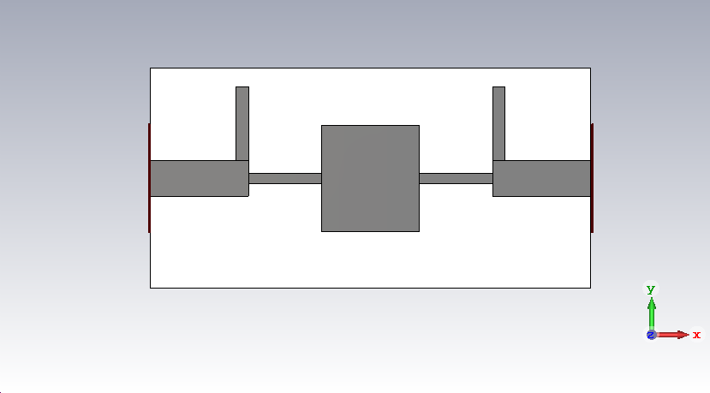

Fig.4 Layout of proposed LPF with open stubs



Fig. 2 Layout of LPF without open stubs

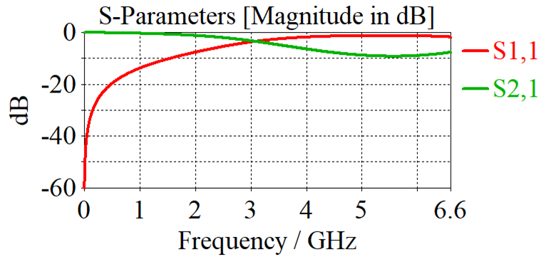Fig. 3 Simulate results of step impedance LPF without open stubs

# Result and discussion

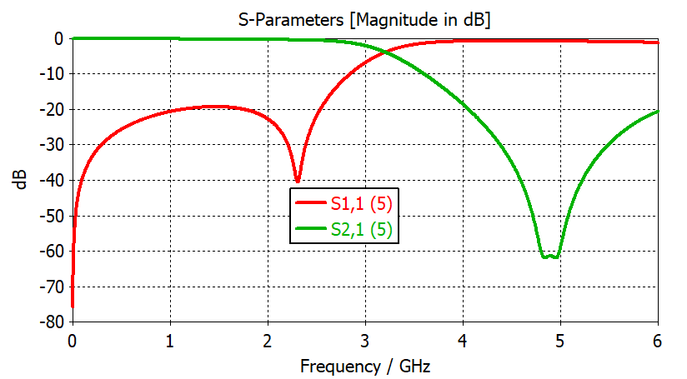

Fig. 5. Simulate results of proposed LPF with open stubs

The proposed LPF has been fabricated on FR-4 substrate with dielectric constant 4.3, loss tangent 0.025, and substrate height 1.51 mm and metal cladding thickness 1.75micron. The photograph of fabricated prototype of proposed LPF is shown in Fig.6. The measurements results (transmission and reflection coefficients) are obtained using Keysight’s Vector Network Analyzer. The measured spectral characteristics are shown in Figure 7. It could be observed that measured results are showing a fair agreement with EM model. The fabricated LPF prototype has cutoff frequency of 3.16 GHz and roll-off factor of 23 dB/GHz with a wide stopband extending upto 6.3 GHz.

# Conclusion

The fabricated LPF prototype has cutoff frequency of 3.16 GHz and roll-off factor of 23 dB/GHz with a wide stopband extending from 6.3 GHz with sharp roll off rate. The proposed filters are expected to be used in cellular mobile communication and in ISM bands where most of the household communication equipment are working.

References

1. S. S. Laharia, A. Laharia and P. S. Tomar, "Design and Analysis of Microstrip Low Pass Filter Using Metamaterial Structures and Host Transmission Line," 2016 8th International Conference on Computational Intelligence and Communication Networks (CICN), Tehri, India, 2016, pp. 183-186.
2. Zhang, Jin, Ruosong Yang, and Chen Zhang. 2019. "High-Performance Low-Pass Filter Using Stepped Impedance Resonator and Defected Ground Structure" Electronics 8, no. 4: 403.
3. P. S. Tomar and M. S. Parihar (2023): The Design and Investigation of the Low-Pass Filter with High Selectivity and Ultra-Wide Stopband, IETE Journal of Research, DOI: 10.1080/03772063.2023.2185303.
4. Jia-Sheng Hong and M. J. Lancaster, *“*Theory and Experiment of Novel Microstrip Slow-Wave Open-Loop Resonator Filters,” *IEEE Transactions on Microwave Theory and Techniques,* Vol. 45, Issue 12, Part 2, pp. 2358–2365, 1997.

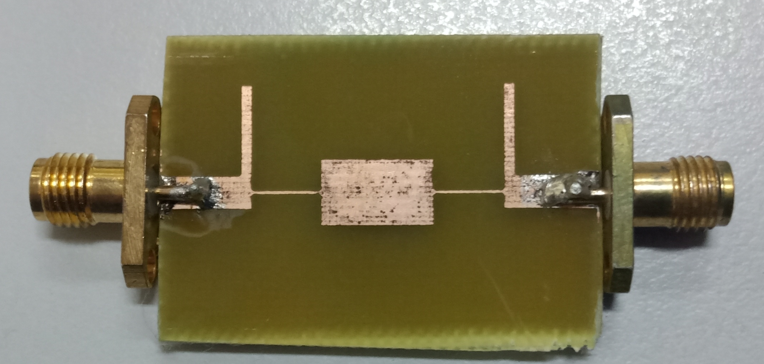

Fig. 6.: Layout of proposed LPF with open stubs



Fig. 7. Measured results of proposed LPF with open stubs

1. Hayati, M., & Shama, F. (2017). A compact lowpass filter with ultra wide stopband using stepped impedance resonator. Radio engineering, 26(1), 269- 274.
2. Rekha, T. K., Abdulla, P., Anu, A. R., Jasmine, P. M., & Raphika, P. M. (2017, August). High selectivity and ultra-wide stopband microstrip lowpass filter using high-low impedance resonators. In 2017 International Conference on Information, Communication, Instrumentation and Control (ICICIC) (pp. 1-5).
3. tKolahi, A., & Shama, F. (2018). Compact microstrip low pass filter with flat group-delay using triangle-shaped resonators. AEU-International Journal of Electronics and Communications, 83, 433-438.
4. Kumar, L., & Parihar, M. S. (2018). A wide stopband low-pass filter with high roll-off using stepped impedance resonators. IEEE Microwave and Wireless Components Letters, 28(5), 404-406.
5. Seungpyo Hong, Kai Chang, "Stub-tuned Microstrip Bandpass Filters for Millimeter-Wave Diplexer Design, "*IEEE Microwave and Wireless Components Letters,* Vol. 15, Issue 9, pp. 582–584, 2005.
6. Ching-Ku Liao and Chi-Yang Chang, "Design of Microstrip Quadruplet Filters with Source–Load Coupling,” *IEEE Transactions on Microwave Theory and Techniques*, Vol. 53, Issue 7, pp. 2302–2308, 2005.
7. Elena Semouchkina*,*Amanda Baker, George B. Semouchkin, Michael Lanagan*,* and Raj Mittra, "New Approaches for Designing Microstrip Filters Utilizing Mixed Dielectrics,” *IEEE Transactions on Microwave Theory and Techniques*, Vol. 53, Issue 2, pp. 644–652, 2005.
8. Sheng Sun*,* Lei Zhu, "Periodically Nonuniform Coupled Microstrip-Line Filters With Harmonic Suppression Using Transmission Zero Reallocation,” *IEEE Transactions on Microwave Theory and Techniques,* Vol. 53, Issue 5, pp. 1817–1822, 2005.
9. Shama, F., Hayati, M., & Ekhteraei, M. (2018). Compact microstrip lowpass filter using meandered unequal T-shaped resonator with ultra-wide rejection band. AEU-International Journal of Electronics and Communications, 85, 78-83.
10. Rekha T.K, Abdulla P, Nisamol. T.A, Ami Iqbal, Anu A.R, Sam kollannore, "Compact multilayer Microstrip Lowpass filter with ultra wide stopband for L band applications", International Symposium on Antenna and Propagation (APSYM) , CUSAT, Dec 3-5 2018.
11. Al Shamaileh, K. A., Dib, N. I., & Abushamleh, S. A. (2019). Width-varying conductor-backed coplanar waveguide-based low-pass filter with a constant signal trace to adjacent grounds separation. IET Microwaves, Antennas & Propagation, 13(3), 386-390.
12. P. S. Tomar, M. S. Parihar, “A Miniaturized Low Pass Filter with Extended Stopband and High Passband Selectivity, Radioengineering vol. 32, no. 3, sept 2023, Doi: 10.13164/re.2023.0408.