PHYSICAL AND SOCIO-ECONOMICAL IMPACT OF CYCLONE ON SUNDARBAN MANGROVE FOREST UNDER SOUTH 24 PARAGANAS , WEST BENGAL

|  |  |
| --- | --- |
| **C:\Users\Public\Pictures\Sample Pictures\WhatsApp Image 2023-05-27 at 20.25.28.jpeg** | **PROF . BIPUL CHAKRABORTY**  **PRINCIPAL**  **ST. GENIUS MODEL SCHOOL** , NADIA , WEST BENGAL  **ACADEMIC COUNSELOR** , SCHOOL OF CONTINUING EDUCATION . (RURAL DEVELOPMENT )  **INDIRA GANDHI NATIONAL OPEN UNIVERSITY** , **RISHI BANKIM CHANDRA COLLEGE FOR WOMEN**,  NORTH 24 PARGANAS , WEST BENGAL |

**ABSTRACT**

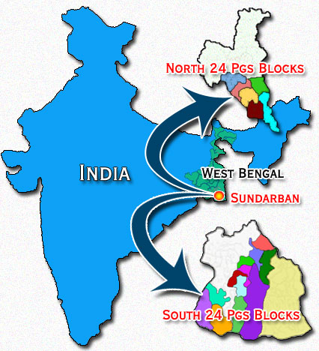The forest has immense protective and productive functions. Constituting 51% of the total [reserved forest estate](https://en.wikipedia.org/wiki/Reserve_forest) of Bangladesh, **Sahu,** **R. K. (2021)**., it contributes about 41% of total forest revenue and accounts for about 45% of all timber and fuel wood output of the country. A number of industries (e.g., newsprint mill, match factory, hardboard, boat building, furniture making) are based on raw materials obtained from the Sundarbans ecosystem.

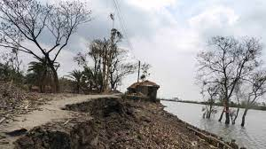**Sahu, R. K. (2021).,** [Non-timber forest products](https://en.wikipedia.org/wiki/Non-timber_forest_product) and [plantations](https://en.wikipedia.org/wiki/Plantation) help generate considerable employment and income opportunities for at least half a million poor coastal people. It provides natural protection to life and properties of the coastal population in [cyclone](https://en.wikipedia.org/wiki/Cyclone)-prone Bangladesh. The paper represent that , Cyclone and its association impact is one of the important natural disaster in costal region here the study region of this project of sundarban and surrounding region sufferings by different type of region and social econemical imbalancing for impact of cyclone in study area.Here the different objective like the causes of distortion of social economical balance and different segmentation policy formulation in study region. **Bhandari , D. C. (2013).**, The literature review of such works is highly important in this project for identify the basic importancy of fundamental growth of report and the review of analytical entry. The portion of findings related to basic causes and concequence of disaster sundarban area and also highlited of previous and contemporary situation for development of study area. Analytical portion of the work involve the block wise development and problematic overview of sundarban sarounding region of important and contemporary events like flad cyclone,soli erosion for social and economical development of region .

###### KEY WORDS

###### 1. Tropical Cyclone 2. Settlemental And Migrational Shifting 3. Sundarban Region 4. Mangrove Forest 5. Physical And Socio-Economical Impact

###### HISTORY OF TROPICAL CYCLONE

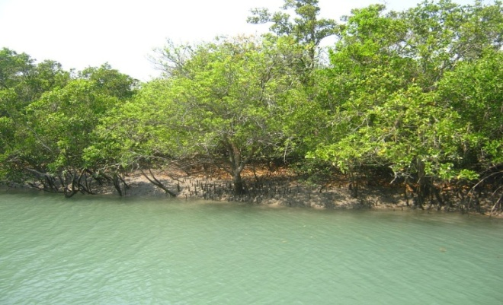**Katebi, M.N.A. and Habib, M.G. (1987).,** The practice of using names to identify tropical cyclones goes back several centuries, with storms named after places, saints or things they hit before the formal start of naming in each basin. Examples of such names are the 1928 Okeechobee hurricane (also known as the "San Felipe II" hurricane) and the 1938 New England hurricane. **J. & Hazra, S. (2020)**., The system currently in place provides identification of tropical cyclones in a brief form that is easily understood and recognized by the public. The credit for the first usage of personal names for weather systems is given to the Queensland Government Meteorologist Clement Wragge, who named tropical cyclones and anticyclones between 1887 and 1907.

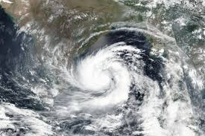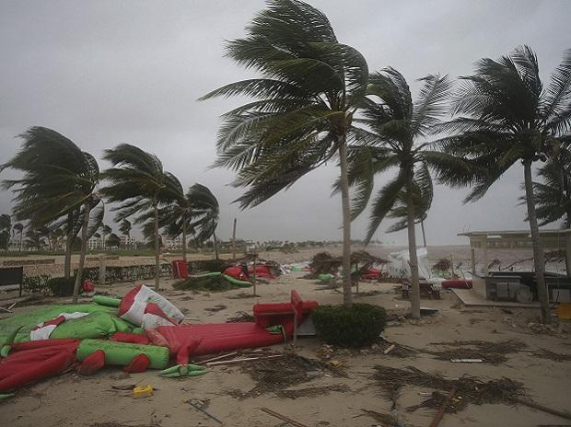**Sahu, R. K. (2021).** , This system of naming fell into disuse for several years after Wragge retired, until it was revived in the latter part of World War II for the Western Pacific. Over the following decades formal naming schemes were introduced for several tropical cyclone basins, including the North and South Atlantic, Eastern, Central, Western and Southern Pacific basins as well as the Australian region and Indian Ocean. Despite preservation commitments from both governments, the Sundarbans are under threat from both natural and human-made causes. In 2007, the landfall of [Cyclone Sidr](https://en.wikipedia.org/wiki/Cyclone_Sidr) damaged around 40% of the **Bandyopadhyay, Krishnendu (1 August 2016).**, Sundarbans. The forest is also suffering from increased [salinity](https://en.wikipedia.org/wiki/Salinity) due to [rising sea levels](https://en.wikipedia.org/wiki/Sea_level_rise) due to [climate change](https://en.wikipedia.org/wiki/Effects_of_climate_change) and reduced freshwater supply. In May 2009 [Cyclone Aila](https://en.wikipedia.org/wiki/Cyclone_Aila) devastated the Sundarbans with massive casualties. At least 100,000 people were affected by this cyclone.[[9]](https://en.wikipedia.org/wiki/Sundarbans#cite_note-9)[[10]](https://en.wikipedia.org/wiki/Sundarbans#cite_note-10) The proposed coal-fired [Rampal power station](https://en.wikipedia.org/wiki/Rampal_Power_Station_(Proposed)) situated 14 km (8.7 mi) north of the Sundarbans at Rampal Upazila of [Bagerhat District](https://en.wikipedia.org/wiki/Bagerhat_District) in Khulna, Bangladesh, is anticipated to further damage this unique mangrove forest according to a 2016 report by UNESCO

**RESEARCH OBJECTIVE**

1. TO know the basic problems and damarage and its impact on the time of cyclone in sundarban region.
2. To know the problem settlemental and migrational shifting of population by tropical cyclone in sundarban region .

**LOCATIONAL EXTENSION OF SUNDARBAN**

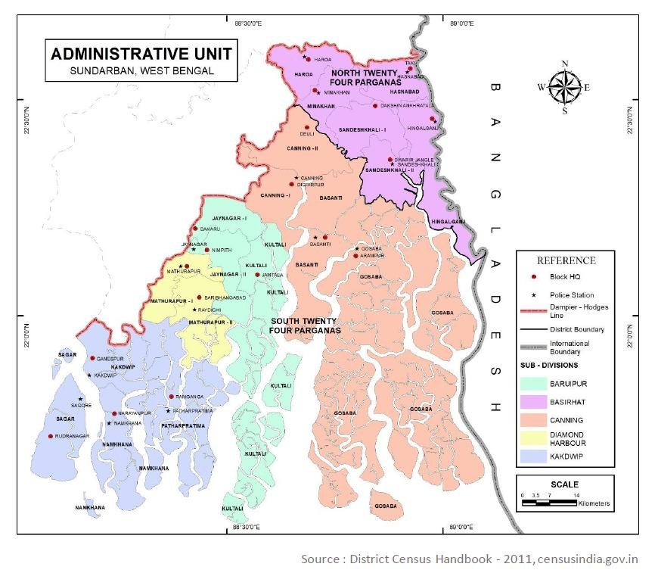**Manna, S.; Chaudhuri, K.; Bhattacharyya, S.; Bhattacharyya, M. (2010).**,  The Sundarbans, a unique biosphere reserve and of the global heritage site, are located in the extreme south of West Bengal, an eastern Indian state. Representing a cluster of islands and surrounded by one of the most beautiful arrangements of mangrove forest with rich variety of flora and fauna, the Sundarbans considered as the worlds largest river delta, represents a unique ecosystem with magnificent biodiversity. Extending between 21”32‟ north and 22”40‟ north latitude and between 88”05‟ east to 89”00‟ east longitude, it is demarcated by the river Hoogly on the west, rivers ichamati-herobhanga-Raimangal on the east. Dampier hodges on the north and the Bay of Bengal at the south. While the largest part of the region falls under the administrative boundary of Bangladesh. The Indian part of the Sundarbans covers around 9630 sq km in West Bengal, spreading across 102 islands and 19 administrative blocks of its two districts 06 nos from North 24 Parganas (Haroa, Sandeshkhali I & II, Hingalganj, Minakhan, Hasnabad) and 13 nos from South 24 Parganas (jaynagar I & II, Basanti, Gosba, Canning I & II, mathurapur I & II, Kakdwip, Sagar, Namkhana, Patharpratima).

### ECOLOGICAL SUCCESSION

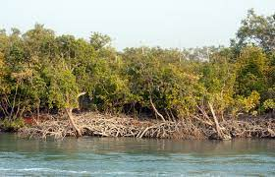**Katebi, M.N.A. and Habib, M.G. (1987).,** [Ecological succession](https://en.wikipedia.org/wiki/Ecological_succession) is generally defined as the successive occupation of a site by different plant communities. In an accreting mudflats the outer community along the sequence represents the pioneer community which is gradually replaced by the next community representing the seral stages and finally by a climax community typical of the climatic zone.  [Robert Scott Troup](https://en.wikipedia.org/wiki/Robert_Scott_Troup) suggested that succession began in the newly accreted land created by fresh deposits of eroded soil. The pioneer vegetation on these newly accreted sites is [*Sonneratia*](https://en.wikipedia.org/wiki/Sonneratia), followed by [*Avicennia*](https://en.wikipedia.org/wiki/Avicennia) and [*Nypa*](https://en.wikipedia.org/wiki/Nypa_fruticans). As the ground is elevated as a result of soil deposition, other trees make their appearance. The most prevalent, though one of the late species to appear, is [*Excoecaria*](https://en.wikipedia.org/wiki/Excoecaria). As the level of land rises through accretion and the land is only occasionally flooded by tides, [*Heritiera fomes*](https://en.wikipedia.org/wiki/Heritiera_fomes) begins to appear.

|  |  |  |  |  |  |  |
| --- | --- | --- | --- | --- | --- | --- |
| **Blocks** | **household** | **Total Persons** | **Total Male** | **Total Female** | **Total Scheduled Castes** | **Total Scheduled Tribes** |
| HAROA | 46888 | 214401 | 111080 | 103321 | 50636 | 12728 |
| MINAKHAN | 43756 | 199084 | 101827 | 97257 | 60578 | 18564 |
| SANDESHKHALI-I | 37344 | 164465 | 83925 | 80540 | 50812 | 42674 |
| SANDESHKHALI-II | 37771 | 160976 | 81921 | 79055 | 72300 | 37695 |
| HASNABAD | 47739 | 203262 | 104019 | 99243 | 51295 | 7492 |
| HINGALGANJ | 46048 | 174545 | 88937 | 85608 | 115227 | 12743 |

|  |  |  |  |  |  |  |
| --- | --- | --- | --- | --- | --- | --- |
| **Blocks** | **Total Literates** | **Male Literates** | **Female Literates** | **Total Workers** | **Cultivators** | **Agril. Labourers** |
| HAROA | 136679 | 75747 | 60932 | 73257 | 57856 | 19503 |
| MINAKHAN | 122283 | 67728 | 54555 | 68327 | 8345 | 18028 |
| SANDESHKHALI-I | 100978 | 56501 | 44477 | 61005 | 7098 | 16034 |
| SANDESHKHALI-II | 98805 | 56205 | 42600 | 61479 | 6887 | 15034 |
| HASNABAD | 127403 | 69699 | 57704 | 80077 | 8540 | 17049 |
| HINGALGANJ | 119630 | 66858 | 52772 | 74515 | 7767 | 17577 |

**ANALYSIS AND INTERPRETATION**

**Bandyopadhyay, Krishnendu (1 August 2016**).,Sundarban is a unique habitat for its rich biodiversity; above the water, mangrove canopy is home to birds, mammals, reptiles while below the water, bivalves, sponges, algae 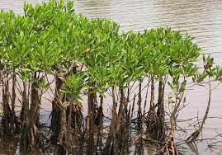overgrow its roots. In fact, Sundarbans the world's only mangrove with tiger. Spread across India and Bangladesh over 1 million ha area, Sundarban is the world's largest single contiguous mangrove swamp. The Indian part received its formal designation yesterday thus bringing the entire swamp under the ambit of Ramsar wise use framework. The Sundarbans reserve forest (SRF), located in the south-west of Bangladesh between the river Baleswar in the east and the Harinbanga in the west, adjoining to the Bay of Bengal, is the largest contiguous mangrove forest in the world. It is the only mangrove habitat in the world for Panthera Tigris Tigris species.

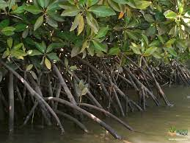**Behera, R. S.; Shaoo, C. K.; Sahu, R. K. (2021).,** Low lying coastal regionsare highly affected by salinity and its magnitude now reached beyond the tolerance limits in most of the regions. The effect of salinity on agriculture is a popular issue for scientific discussion. Land affected by salinity is always associated with less productivity or crop failure. People responses regarding salinity gave an outline of actual severity.

Majority of the respondents replied that the salinity level of their locality is under very high (44.88%) and high (33.07%) categories. Only 2.76% respondents perceived lower level of salinity. Overall result indicated salinity problem of this region (Figure 7).

**Sahu, R. K. (2021).** , Based on the survey responses Dayapur, Deulbaridebipur, Hamilton Abad, Hetalbari, Kalitala, Maipith and Samsernagar were identified as very high salinity affected areas. High perceived salinity was also identified by the villagers of Bally, Luxbagan and Sadhupur. Kumirmari and Paraghumti placed in between high to very high salinity level. Rest of the villages were identified as moderate to low salinity categories .

## ENDANGERED AND EXTINCT SPECIES

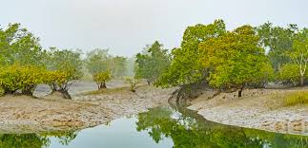Extinct [Indian Javan rhinoceros](https://en.wikipedia.org/wiki/Lesser_Indian_rhinoceros) of Sunderbans, drawing from 1877 , **Behera, R. S.; Shaoo, C. K.; Sahu, R. K. (2021).,** Forest inventories reveal a decline in standing volume of the two main commercial mangrove species – sundari ([*Heritiera*](https://en.wikipedia.org/wiki/Heritiera) spp.) and [gewa](https://en.wikipedia.org/wiki/Euphorbiaceae) (*Excoecaria agallocha*) — by 40% and 45% respectively between 1959 and 1983.  Despite a total ban on all killing or capture of wildlife other than fish and some [invertebrates](https://en.wikipedia.org/wiki/Invertebrates), it appears that there is a consistent pattern of depleted biodiversity or loss of species (notably at least six mammals and one important reptile) in the 20th century, and that the "ecological quality of the original mangrove forest is declining".

**J. & Hazra, S. (2020).,** The endangered species that live within the Sundarbans and extinct species that used to be include the Bengal tiger, [estuarine crocodile](https://en.wikipedia.org/wiki/Estuarine_crocodile), [northern river terrapin](https://en.wikipedia.org/wiki/Northern_river_terrapin) (*Batagur baska*), [olive ridley sea turtle](https://en.wikipedia.org/wiki/Olive_ridley_sea_turtle), [Gangetic dolphin](https://en.wikipedia.org/wiki/Gangetic_dolphin), ground turtles, [hawksbill sea turtles](https://en.wikipedia.org/wiki/Hawksbill_sea_turtle) and king crabs (horse shoe). The Sundarbans hold globally important numbers of the critically endangered [masked finfoot](https://en.wikipedia.org/wiki/Masked_finfoot) and are important wintering sites for the [spoon-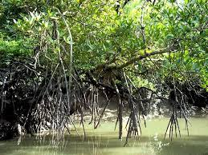billed sandpiper](https://en.wikipedia.org/wiki/Spoon-billed_sandpiper) and the [Indian skimmer](https://en.wikipedia.org/wiki/Indian_skimmer). Some species such as hog deer ([*Axis porcinus*](https://en.wikipedia.org/wiki/Axis_porcinus)), water buffalos ([*Bubalus bubalis*](https://en.wikipedia.org/wiki/Bubalus_bubalis)), [barasingha](https://en.wikipedia.org/wiki/Barasingha) or swamp deer ([*Cervus duvauceli*](https://en.wikipedia.org/wiki/Cervus_duvauceli)), Javan rhinoceros ([*Rhinoceros sondaicus*](https://en.wikipedia.org/wiki/Rhinoceros_sondaicus)), [Indian rhinoceros](https://en.wikipedia.org/wiki/Indian_rhinoceros) (*Rhinoceros unicornis*) and the [mugger crocodile](https://en.wikipedia.org/wiki/Mugger_crocodile) (*Crocodylus palustris*) started to become extinct in the Sundarbans towards the middle of the 20th century, because of extensive poaching and hunting by the British and locals.

###### EMBANKMENT BREACH AND INDIAN SUNDARBANS

###### C:\Users\USER\Desktop\images (4).jpg

Respondents were asked to inform the average duration for repairing of breached embankments. 90.94% respondents informed that it has been taken 1week to 1 month. Only 4.33% respondents have replied that it has taken 1week. Few respondents (3.54%) expressed their frustration and replied that it has been taken more than 1 year.

###### Impacts of Aila, 2009

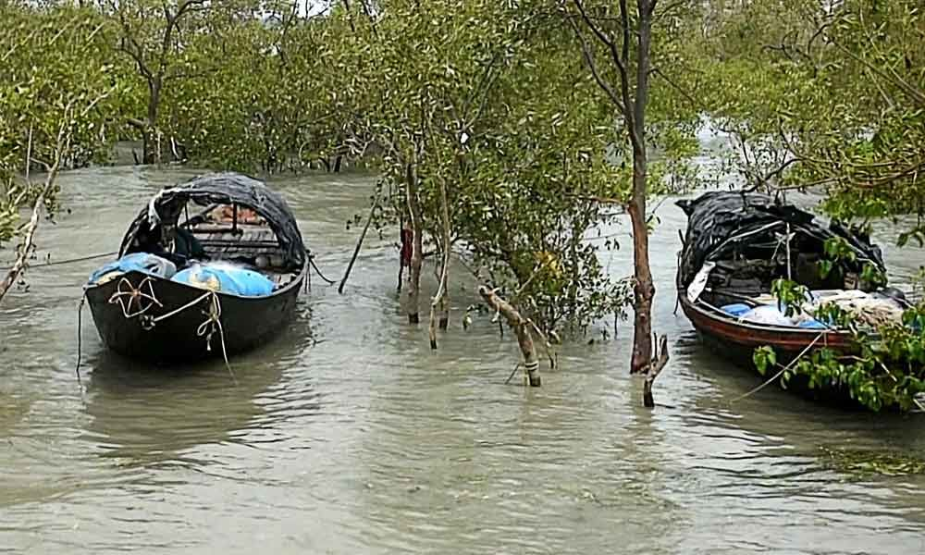**Behera, R. S.; Shaoo, C. K.; Sahu, R. K. (2021).,** Indian Sundarbans was severely affected by the Aila cyclone of 2009. People were asked to estimate their losses during Aila Cyclone. Only 4.72% respondents replied that they have lost nothing during Alia. Rest of the respondents have lost an amount range from two thousand to two lacks (Rs. 2000 to 200000). Highest no respondents (34.65%) **Bandyopadhyay, Krishnendu (1 August 2016**). , have lost an amount range from Rs20000 to 50000 .

###### HEALTH HAZARDS

Land reclamation has a closed linked with various health problems that affect most of the areas of Sundarbans. To perceived common dieses of this area we asked people to identify most common dieses affecting their locality. Malaria and Typhoid were the two dieses identified by 75.20% and . respectively. Some respondents stated about Lungs,

Nerve and Skin related dieses.

|  |  |  |  |  |  |
| --- | --- | --- | --- | --- | --- |
| Blocks | FLOOD IN % AS PER HAZARD INDEX | CYCLONE IN % AS PER HAZARD INDEX | RIVER BANK EROSION IN % AS PER HAZARD INDEX | SALINITY IN % AS PER HAZARD INDEX | WATER SCARCITY IN % AS PER HAZARD INDEX |
| HAROA | 36.32 | 45.21 | 25.36 | 39.32 | 54.21 |
| MINAKHAN | 35.21 | 45.21 | 63.21 | 54.21 | 23.24 |
| SANDESHKHALI-I | 45.32 | 56.21 | 39.32 | 45.21 | 41.21 |
| SANDESHKHALI-II | 52.21 | 32.24 | 63.21 | 55.32 | 41.21 |
| HASNABAD | 32.21 | 42.21 | 32.65 | 35.21 | 45.21 |
| HINGALGANJ | 36.45 | 34.21 | 45.21 | 39.21 | 31.98 |

|  |  |  |  |  |  |
| --- | --- | --- | --- | --- | --- |
| CORRELATION VALUE BY HAZARD INDEX | FLOOD IN % AS PER HAZARD INDEX | CYCLONE IN % AS PER HAZARD INDEX | RIVER BANK EROSION IN % AS PER HAZARD INDEX | SALINITY IN % AS PER HAZARD INDEX | WATER SCARCITY IN % AS PER HAZARD INDEX |
| FLOOD IN % AS PER HAZARD INDEX | 1 |  |  |  |  |
| CYCLONE IN % AS PER HAZARD INDEX | -0.13243 | 1 |  |  |  |
| RIVER BANK EROSION IN % AS PER HAZARD INDEX | 0.458104 | -0.39122 | 1 |  |  |
| SALINITY IN % AS PER HAZARD INDEX | 0.629946 | -0.11668 | 0.887646 | 1 |  |
| WATER SCARCITY IN % AS PER HAZARD INDEX | 0.088587 | 0.133943 | -0.75425 | -0.50522 | 1 |

|  |  |  |  |  |  |  |
| --- | --- | --- | --- | --- | --- | --- |
| Anova: Single Factor ON HAZARD INDEX | | |  |  |  |  |
|  |  |  |  |  |  |  |
| SUMMARY | |  |  |  |  |  |
| *Groups* | *Count* | *Sum* | *Average* | *Variance* |  |  |
| FLOOD IN % AS PER HAZARD INDEX | 6 | 237.72 | 39.62 | 57.25864 |  |  |
| CYCLONE IN % AS PER HAZARD INDEX | 6 | 255.29 | 42.54833 | 75.34282 |  |  |
| RIVER BANK EROSION IN % AS PER HAZARD INDEX | 6 | 268.96 | 44.82667 | 246.7173 |  |  |
| SALINITY IN % AS PER HAZARD INDEX | 6 | 268.48 | 44.74667 | 70.52323 |  |  |
| WATER SCARCITY IN % AS PER HAZARD INDEX | 6 | 237.06 | 39.51 | 115.1548 |  |  |

|  |  |  |  |  |  |  |
| --- | --- | --- | --- | --- | --- | --- |
| ANOVA |  |  |  |  |  |  |
| *Source of Variation* | *SS* | *df* | *MS* | *F* | *P-value* | *F crit* |
| Between Groups | 164.3163 | 4 | 41.07909 | 0.363534 | 0.832189 | 2.75871 |
| Within Groups | 2824.984 | 25 | 112.9994 |  |  |  |
|  |  |  |  |  |  |  |
| Total | 2989.3 | 29 |  |  |  |  |

**CONCLUSION**

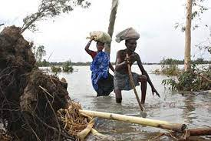The physical development processes along the coast are influenced by a multitude of factors, comprising wave motions, micro and macro-tidal cycles and long shore currents typical to the coastal tract. The shore currents vary greatly along with the [monsoon](https://en.wikipedia.org/wiki/Monsoon).

**Pani, D. R.; Sarangi, S. K.; Subudhi, H. N.; Misra, R. C.; Bhandari, D. C. (2013).**, These are also affected by [cyclonic](https://en.wikipedia.org/wiki/Cyclonic) action. Erosion and accretion through these forces maintains varying levels, as yet not properly measured, of physiographic change whilst the mangrove vegetation itself provides a remarkable stability to the entire system. During each monsoon season almost all the Bengal Delta is submerged, much of it for half a year. **Forestal (1960).,** The sediment of the lower delta plain is primarily advected inland by monsoonal coastal setup and cyclonic events. One of the greatest challenges people living on the [Ganges Delta](https://en.wikipedia.org/wiki/Ganges_Delta) may face in coming years is the threat of rising sea levels caused mostly by [subsidence](https://en.wikipedia.org/wiki/Subsidence) in the region and partly by climate change.**J. & Hazra, S. (2020).,** It has been seen that in many times, Govt. has to change or stop their project due to land conflict. Land is essential for 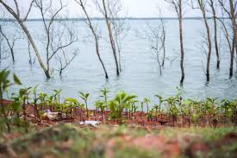any types of management either it has been using hard or soft technology. In this study majority of the respondents were go with the construction-based management options with mangrove plantation. Both of these managements required large amount of land located along the present bank. **Sarker, S.U. 1993.**, As habitation of marginal Sundarbans mostly located along the bank, to implement such scheme, Govt. has to displace lot of people living over the banks. To get information regarding the willingness of people to give land for any project related to their interest, wemade a survey on that. In this survey people were asked to state their willingness about land acquisition. The govement of India disaster management and some effort of local community awarning help the development of social and commercial grow of south 24 parganas, bakkhali , sundarban , Gosaba , Hindalganj and 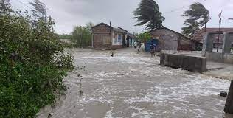some part of canning region as a morphodinamic region in particular sarvey best activity.

**J. & Hazra, S. (2020).,** The overall assessment graph and data help the basic development and disput of local region but the flash flag tendency of cyclone also create a lot of disbalancing in basic and overall assessment. According to data report national data survey 2018 more about 35.5% area as to be very constructed by local govt due to major disturbancy of agricultural practices like some block like khejuri, ramnagar.In kakdwip as a Mahishadal , Ramtanunagar in block of Namkhana as a Rajanigarh, and 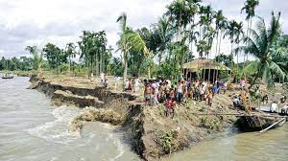specific affected block is parthpratima getting the maximum disadvantage of co-operation and subsidy policy under the disaster mitigation schame. **Bandyopadhyay, Krishnendu (1 August 2016).,** In different part due to different type of tropical cyclone the rural economy of such blocks, facing a lackness of low productive majors whole over the year . According to the planning commission of India,there are some important identification of rehabitional scheme like Indira abas yoyona food for work programe, IRDP2075 and different type of environmental scheme already activate.

**REFERENCE**

1. **Behera, R. S.; Shaoo, C. K.; Sahu, R. K. (2021).** ["Mangroves – Nature's shield against natural disasters and climate change"](https://socialdhara.com/mangroves-natures-shield-against-natural-disasters/). SocialDhara
2. **Bandyopadhyay, Krishnendu (1 August 2016).** ["Civilisation in Sunderbans traced to Mauryan era | Kolkata News - Times of India"](https://timesofindia.indiatimes.com/city/kolkata/civilisation-in-sunderbans-traced-to-mauryan-era/articleshow/53483794.cms). The Times of India. Retrieved 8 April 2022.
3. **Danda, A. A.; Ghosh, N.; Bandyopadhyay, J. & Hazra, S. (2020).** [Strategic and Managed Retreat as Adaptation: Addressing Climate Vulnerability in the Sundarbans](https://www.orfonline.org/research/strategic-and-managed-retreat-as-adaptation-addressing-climate-vulnerability-in-the-sundarbans/) (Report). New Delhi: Observer Research Foundation
4. **Forestal (1960).** Forest Inventory 1958–59 Sundarbans Forests (Report). Oregon, Canada: Forestal Forestry and Engineering International Ltd.
5. **Katebi, M.N.A. and Habib, M.G. (1987).** Sundarbans and Forestry in Coastal Area Resource Development and Management Part II, BRAC Printers, Dhaka, Bangladesh.
6. **Manna, S.; Chaudhuri, K.; Bhattacharyya, S.; Bhattacharyya, M. (2010).** ["Dynamics of Sundarban estuarine ecosystem: Eutrophication induced threat to mangroves"](https://www.ncbi.nlm.nih.gov/pmc/articles/PMC2928246). Saline Systems ,  [doi](https://en.wikipedia.org/wiki/Doi_(identifier)):[10.1186/1746-1448-6-8](https://doi.org/10.1186%2F1746-1448-6-8)
7. **Pani, D. R.; Sarangi, S. K.; Subudhi, H. N.; Misra, R. C.; Bhandari, D. C. (2013).** ["Exploration, evaluation and conservation of salt tolerant rice genetic resources from Sundarbans region of West Bengal"](https://www.researchgate.net/profile/Dilip_Kundu2/post/What_are_the_rice_varieties_that_show_salt_tolerance_naturally/attachment/59d6397779197b8077996ae6/AS%3A401904459894785%401472832898899/download/Art+9+Pani+et+al..pdf) (PDF). Journal of the Indian Society of Coastal Agricultural Research. 30 (1): 45–53
8. **Rahman, MR; Asaduzzaman, M (16 April 2013).** ["Ecology of Sundarban, Bangladesh"](https://doi.org/10.3329%2Fjsf.v8i1-2.14618). Journal of Science Foundation. 8 (1–2): 35–47. [doi](https://en.wikipedia.org/wiki/Doi_(identifier)):[10.3329/jsf.v8i1-2.14618](https://doi.org/10.3329%2Fjsf.v8i1-2.14618). [ISSN](https://en.wikipedia.org/wiki/ISSN_(identifier)) [1728-7855](https://www.worldcat.org/issn/1728-7855)
9. **Sarker, S.U. 1993.** Ecology of Wildlife UNDP/FAO/BGD/85/011. Field Document N. 50 Institute of Forestry and Environmental Sciences. Chittagong, Bangladesh.