IOT BASED AIR QUALITY INDEX MONITORING SYSTEM

Abiswetha S1, Devi Aruna A2, Vijaya Preetha S3 ,Niketha R4, ,Dr. T. Vijay Anand 5

Student at National Engineering College, Department of Electronics and Communication Engineering ,Kovilpatti-628503, Tamil Nadu,India

Assistant Professor at National Engineering College, Department of Electronics and Communication Engineering ,Kovilpatti-628503, Tamil Nadu,India

[1911002@nec.edu.in](mailto:1911002@nec.edu.in) [1911006@nec.edu.in](mailto:1911006@nec.edu.in) [1911023@nec.edu.in](mailto:1911023@nec.edu.in) [1911041@nec.edu.in](mailto:1911041@nec.edu.in)

**\*Corresponding Author: Devi Aruna A1**

Student, Department of Electronics and Communication Engineering, National Engineering College, Kovilpatti, Tamil Nadu, India.

**DOI:** 10.47750/pnr.2022.13.S10.192

# ABSTRACT

Real-time monitoring allows us to keep an eye on the deterioration of air quality, which has become a global problem in recent years. The Air Quality Index is the scale used to determine the amount of air pollution. An increased AQI indicates that the air is potentially more harmful to human health. The suggested system makes use of the MQ135, MQ7 Gas Sensor and Arduino UNO hardware and software, which helps in the accurate measurement of the amount of gases like NO2 and CO while assisting in their detection. Additionally, this research project monitors Air Quality by connecting gear to an IOT analytics platform called ThingSpeak through the Internet.

**Keywords.** Internet of Things,MQ135 sensor,MQ7 sensor , ThingSpeak, Air Quality Index

# INTRODUCTION

The majority of the yearly increase in pollution-related mortality is attributable to air pollution. Although there are many factors that affect air pollution, one of the biggest ones is pollution from vehicles. Since the air's quality is continually deteriorating, a monitoring system for it is absolutely necessary. In addition to air detection, this system should inform users of the local air quality so they are aware of it. In light of the traffic- related pollution, our research offers a real-time system that not only tracks pollution levels but also implements traffic-containment measures in extremely polluted locations. The solution is a hardware component with sensors that can be placed next to motor ways.

These devices can be mounted on lampposts and wirelessly transmit information on air quality to a remote server. The traffic can be regulated using this information. The proposed method also provides commuters with data on air quality via a mobile application, allowing them to select routes with good air quality.

The purpose of the project is to quickly assess the air quality using a Wi-Fi module and transmit the results to Thing speak. Our design seeks to rapidly inform to ThingSpeak about the air quality via a Wi-Fi module. The AQI value and pollution intensity are continuously updated by ThingSpeak. The pollution intensity and AQI rating are continuously updated by Thing speak. Based on the reported air quality, this Wi-Fi module may be utilized to perform necessary activities as well as connect to and operate other devices. As a way to judge the quality of the air, the module's (AQI) parameter is used.

This prototype is an Internet of Things-based air quality monitoring system that gathers environmental data in real-time using two sensors, the MQ135 smoke sensor and the MQ7 gas sensor. Readings from these sensors are collected and sent to the internet by a Node MCU acting as a processing unit. Hypertext Transfer Protocol (HTTP) is used to store and retrieve data on the open cloud platform Thing speak. Using the Thing Speak platform, the detected data may be graphically plotted and shown on the OLED monitor.

# EXISTING METHOD

The term "air pollution sensor" refers to a device used to identify and keep track of the presence of air pollution in the immediate vicinity. Both inside and outside use of the pollution sensor is possible. The sensors are used to track substances including lead (Pb), ozone (O3), carbon monoxide (CO), nitrogen dioxide (NO2), sulphur dioxide (SO2), and other specific substances. (PM). Due to their effects on the environment and public health, these pollutants have been classified as "criteria pollutants" by the Environmental Protection Agency (EPA). Modern sensors are getting cheaper because to technological improvements. Specific environmental problems are managed using the sensors. They are used, for instance, to compare the pollution levels that automobiles release to accepted limits in order to validate their emissions. Individuals can monitor indoor air quality levels with inexpensive sensor- mounted equipment. The Raspberry Pi, Arduino IDE, Bluetooth, wifi, and other devices are used to monitor and control sensors.

To monitor the levels of the main air pollutants, gases, air pollution monitoring system. The technology employs pricey air quality monitoring nodes that pair Wi-Fi modules with cheap semiconductor gas sensors. This system detects the concentrations of various gases, including CO, CO2, SO2, and NO2, using semiconductor sensors. The sensors will gather information from various environmental variables and transfer it to the raspberry pi, which functions as a base station, for analysis. The realization was carried out on a Raspberry Pi 3 powered Webserver.

Solutions to the issues caused by air pollution are presented. Current monitoring methods require laboratory analysis, are imprecise, and have a restricted range of sensitivity. Improvements in monitoring systems are required as a result. As a solution to the problems with the present systems, this recommends a three-phase air pollution monitoring system. An Internet of Things kit was built using gas sensor, Arduino IDE, and Wi-Fi module components. This apparatus can be set up in many cities to physically monitor air pollution. They also developed the IoT- Mob air Android app so users could obtain relevant air quality data that was saved in the cloud. The ability to forecast future air quality index levels is another benefit of air quality data.

# ALTERNATIVE METHOD

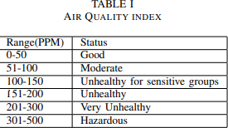

**Table 1. Air quality index assessment**

Table 1 gives an explanation of the ranges of the Air Quality Index. PPMs between 0 and 50 are initially relatively safe. Moderate levels, which are often encountered in busy areas, range from 51 to 100 PPM. 100 to 150 PPM can only be considered unhealthy for sensitive people. Above 151 PPM, the Indian capital of New Delhi, is categorically harmful or unhealthy. Recording concentrations of 300 PPM or greater, which are dangerous, are extremely rare.

This paper made a lower-cost reference to the idea stated in pushing the data. By transferring data to the cloud, an LCD and the related project costs are no longer necessary. While striving for the Internet of Things as a platform, our objective should be to convey the notion online using tools like thinger.io, thing speak, or the magnificent Cayenne website, which is capable of downloading the dataset and is exquisitely designed to present the results.

LPG and methane detectors are already utilized for home and office safety, thus they are not necessary when experimenting with air quality monitoring. Instead of employing a GSM or GPRS module, this article used WiFi to upload the data to the cloud. As stated in Table 1, the problem in the other research cited hasn't calibrated the sensor and hasn't converted the sensor output value into PPMAs in accordance with UN Data's criteria; 0-50 PPM is the SAFE value, and 51-100 PPM is moderate.

With an average PPM of 250, New Delhi, the capital of India, is the most polluted city in the world. The two sensors used in this study each have an inbuilt heater element that consumes more power (P=V*I), therefore even though both sensors are set ON, their output is. Voltage levels change and exhibit unpredictably high and low values when there is insufficient power drive. Due of the Arduino's limited power capacity, we used a 9V battery and a 7805 family LM7805 regulator for the CO sensor MQ7. The provided document is ambiguous when it comes to the components and cloud used. This article uses machine learning on a real-time dataset gathered from the Thing Speak website, but it also aims to alert the public and the government about the negative impacts on human health if the same pollution persists.

This effort also seeks to expand by incorporating three additional air quality sensors: an ozone sensor, a PM 2.5 laser dust sensor, and an MG811 (CO2 sensor), which combined create an all-in-one configuration that provides thorough monitoring of the air quality. Thequoted research made a serious error in estimation when it said that Delhi, the city with theworst levels of air pollution, measured 250PPM when the output was 997PPM. They obviously failed to calibrate the sensor and did not even convert the raw sensor data into PPM using the same derivations that we did. Because they are utilizing the limited

Local Host, they can only access the output on the laptop when it is in close proximity to the experimental setup. The goal of this study using a standard IoT platform that is highly secured and open source.

# SYSTEM OPERATION

The Node MCU receives the analogue inputs from several gas sensors, such as the MQ135, MQ7, and others, utilizing the CD4051 IC. These numbers are transformed into parts per million of the gases, and then using these ppm of gases On the OLED display, the Air Quality Index values are shown after it has been calculated. These results are sent to the ESP8266 Wi-Fi module after calculations. Real-time data is transmitted using this Wi-Fi module to thing speak.com internet server, where it may be evaluated with the use of API keys.

Figure 2 from think speak illustrates the workflow for describing and changing data. To begin with, the Arduino Uno's baud rate is set to accept inputs from the sensors. The incoming data is transformed.

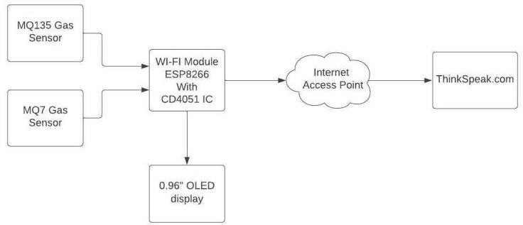

# Fig 3.1 BLOCK DIAGRAM

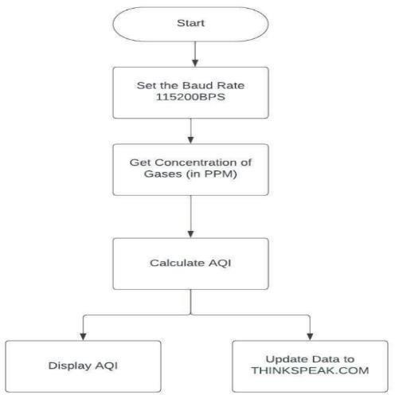

**Fig 3.2 FLOW CHART**

# HARDWARE SETUP

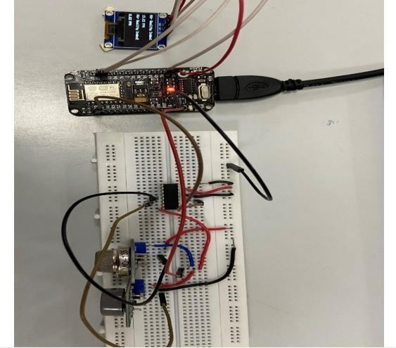

**Fig 4.1**

# RESULTS AND DISCUSSION

For the varied input data displayed in Fig.5.1, the suggested work has produced two fields. Field 1 in Fig.5.2 presents the gas concentration in ppm with respect to time in a graphical format that makes it easier to understand. Similar to Field 1, Field 2 displays the CO gas concentration over time. Both fields provide the Air Quality Index (AQI) over time.

# STEP 1: Signup with ThingSpeak.com and creating channel

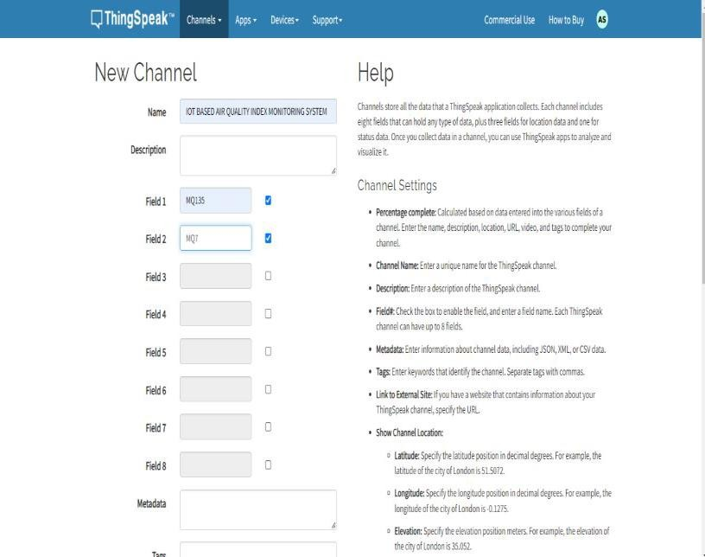

**Fig 5.1 Creation of new channel with required fields**

# STEP 2: From created channel, copy the Write API Key and used it in the code

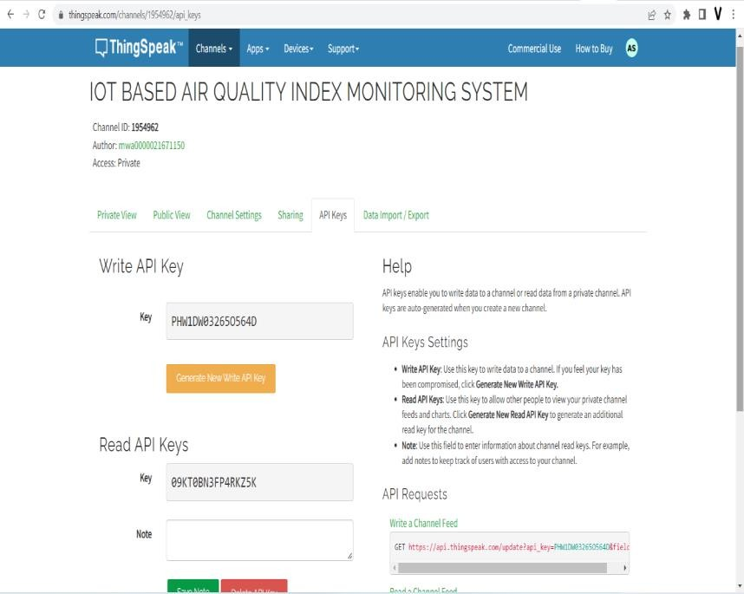

**Fig 5.2** Generation of API Key

# STEP 3: Result in ThingSpeak server

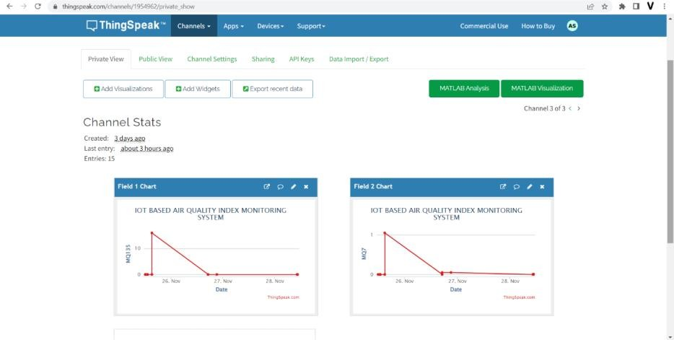

1. **CONCLUSION**

**Fig 5.3** Graph showing Air Quality Index

The proposed architecture passed testing. It was able to detect air quality, send it to a thing speak server and send it to an Android application using an API key. Given the concentration of different pollutants, the state of the air might be forecasted using historical data on air.

# REFERENCE

1. S.Muthukumar, W.Sherine Mary, S Jayanthi, R Kiruthiga, M Mahalakshmi,” IoT based air pollution monitoring and controlsystem”. International Conference on Inventive Research in Computing Applications (ICIRCA),2018.
2. Gagan Parmar, Sagar Lakhani, Manju K. Chattopadhyay,”An IoT Based Low Cost Air Pollution Monitoring System”.InternationalConference on Recent Innovations in Signal processing and Embedded Systems (RISE),2017.
3. Ch.V.Saikumar, M.Reji, P.C.Kishoreraja.,“IOT based air quality monitoring system”, International Journal of Pure & Applied Mathematics ,2017.

[4] F N Setiawan, Iwan Kustiawan,” IoT based Air Quality Monitoring”.IOP Conference Series Materials Science and Engineering,2018.

1. Swati Dhingra, Rajasekhara Babu Madda, Amir H. Gandomi,” Internet of Things Mobile

- Air Pollution Monitoring System (IoT- Mobair)”. IEEE Internet of Things Journal

,June 2019.

1. Xiaoke Yang, Lingyu Yang, Jing Zhang,” AWiFi-enabled indoor air quality monitoringand control system”. IEEE International Conference on Control & Automation (ICCA),July 2017.
2. M.F.M Firdhous, B.H Sudantha, P.M Karunaratne,” IoT enabled proactive indoor air quality monitoring system for sustainablehealth management”. International Conference on Computing and Communications Technologies (ICCCT),2017
3. R du Plessis, A Kumar, GP Hancke, BJ Silva,” A wireless system for indoor air quality monitoring”. 42nd Annual Conference of the IEEE Industrial Electronics Society,2016.
4. Sujuan Liu, Chuyu Xia, Zhenzhen Zhao,” A low-power real-time air quality monitoring system using LPWAN based on LoRa”. 13th IEEE International Conference on Solid-State andIntegrated Circuit Technology (ICSICT),October 2016.
5. Sneha Jangid, Sandeep Sharma,” An embedded system model for air quality monitoring”. 3rd International Conference on Computing for Sustainable Global Development (INDIACom),March 2016.
6. H. Ali, J. K. Soe, Steven. R. Wel,” A real-time ambient air quality monitoring wirelesssensor network for schools in smart cities”. IEEE First International Smart Cities Conference (ISC2),2015.
7. Yonggao Yang, Lin Li,” A smart sensor system for air quality monitoring and massive data collection”. International Conference on Information and Communication Technology Convergence (ICTC),2015