Plan and Examination of an Original Strain Control Strategy for Winding Machine

**Keshav Kumar1, Pardeep Kumar2**

1,Student, Department of Mechanical Engineering, Ganga Institute of Technology and Management, Jhajjar, India

2Assistant Professor, Department of Mechanical Engineering, *Ganga Institute of Technology and Management, Jhajjar, India*

**ABSTRACT**

Fiber winding has arisen as the principal cycle for carbon fiber supported plastic (CFRP) creation, and pressure control assumes a key part in upgrading the nature of the winding items. With the consistent improvement of prod‑ uct quality and proficiency, the accuracy of the pressure control framework is continually getting to the next level. In this paper, an original strain control strategy is proposed, which can manage the fiber pressure and transport speed of the twisting system by overseeing the results of three different driven rollers (the force of the loosen up roll, the force of the attractive powder brake roller, and the speed of the expert speed roller) in three levels. The mechanical designs and dynamic models of the determined rollers and inactive rollers are laid out by considering the time‑varying highlights of the roller range and dormancy. Besides, the impact of boundaries and speed minor departure from fiber pressure is researched utilizing the addition model. In this way, the control technique is proposed by applying fiber pressure in three levels accord‑ ing to the elements of the three driven rollers. A versatile fluffy regulator is intended for tuning the PID boundaries online to control the speed of the expert speed roller. Recreation is led for checking the presentation and sta‑ bility of the proposed strain control strategy by contrasting and those of the regular PID control technique. The outcome uncovers that the proposed strategy beats the ordinary technique. At last, an exploratory stage is developed, and the proposed framework is applied to a winding machine. The exhibition and dependability of the strain control framework are shown through a progression of examinations utilizing carbon fiber under various reference velocities and pressures. This paper proposes an original pressure control technique to manage the fiber strain and transport speed.

**Introduction**

High modulus carbon fiber is a great modern material, which is broadly utilized in a few fields like satellite supporting chamber, shells of rocket motor, and sunlight based cluster. The composite assembling process is the way in to the use of carbon fiber. Fiber winding has arisen as the primary cycle for creating com-posite structures. It is generally utilized in building rotational parts. In the fiber winding cycle, the carbon fiber is conveyed from the loosen up roll and went through the tar shower to blend in with gum under various temperatures lastly fold over the outer layer of the mandrel in the planned example. The significant particulars that ought to be fulfilled during the winding system are the winding line type and the fiber pressure, which are viewed as the key variables connected with the elasticity of the fiber items. The winding line type is resolved utilizing the mathematical control framework, so this paper centers around the pressure control issue during the winding system. Scientists have shown that shaky pressure might prompt misfortune in strength of fiber winding items [1]. There-front, fiber strain ought to be kept up with at the reference esteem during the twisting system for guaranteeing the nudge uct quality.

The greater part of the above examinations considered the elements of driven rollers in the models yet the way of behaving of inactive roll-ers was overlooked. Thusly, the models were under a few restricted conditions, which disregarded itemized com-plex strain elements. Then again, most exploration zeroed in on powerful displaying and control procedure plan, yet the mechanical design and the impact of boundary minor departure from fiber strain were overlooked. In this paper, a clever strain control strategy is introduced, which can manage the pressure and speed of the fiber winding cycle. The mechanical design and dynamic model of the framework are laid out, and the impacts of the boundary and the speed minor departure from fiber ten-sion are inspected. Thusly, as per the fea-tures of driven rollers and the impact of variety, the control technique is proposed by directing the results of the force of loosen up roll, the force of attractive powder brake roller, and the speed of the expert speed roller in three levels. Recreations are led for checking the impact by contrasting the outcomes and those of the con-ventional PID regulator. Finally, the introduction of the proposed control structure is affirmed through exploratory assessments using a fiber winding machine. The design of the paper is coordinated as follows. Sec-tion 2 presents the mechanical design of framework. Furthermore, the powerful models are developed, and the impact of boundary and speed minor departure from the roll-ers is analyzed. In Segment 3, the control methodology is favorable to presented. Reproductions are directed for confirming the impact of the proposed regulator by contrasting and that of the regular PID regulator in Segment 4. In Segment 5, the proposed mechanical construction and control methodology are applied to a winding machine, and the exploratory review is directed for confirming the exhibition of the strain control framework.

**Mechanical Structure and Dynamic Modeling** The cycle line is partitioned into three zones (Figure 1): the loosen up segment, the interaction area, and the rewind area. In each zone, a couple of rollers are driven involving engines for moving the carbon fiber from the loosen up roll to the rewind roll. The carbon fiber is conveyed from the loosen up area to the cycle segment, which con-sists of the attractive powder brake roll, the expert speed roller, and a few inactive rollers. In the process area, the carbon fiber goes through the outer layer of the expert speed roller. As the carbon fiber is involved thou-sands of strings, the pitch is appropriately glued on the sur-face of the carbon fiber. The expert speed roller is driven utilizing an air conditioner servomotor, and the speed is controlled for securing the ideal speed and strain. The rewind sec-tion comprises of a four-hub CNC framework for gaining the winding example.

The control strategy for fiber winding cycle is displayed in Figure 2 of every three levels. The control system can regulate the tension and speed of the filament wind- ing process by governing the output of three different driven rolls—the torque of the unwind roll, the torque of the magnetic powder brake roller, and the speed of the

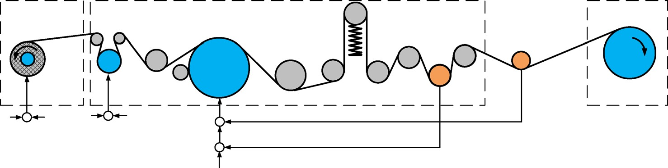

**Driven Roller**

**Idle Roller**

**Unwind Section**

**v**

**Unwind roll u**

**Process Section**

**Sensor**

**Rewind Section**

**Magnetic brake roller**

**v**

**Master speed roller**

**Load Cell**

**v Speed Sensor**

**u**

**Reference Reference**

**Tension Tension**

**+**

**-**

**Reference Tension**

**Figure 1** Sketch of winding process system

## 

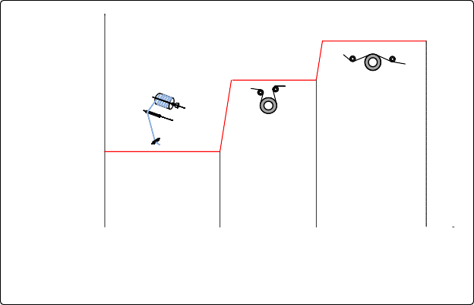

**AC servo motor Reference tension**

**Magnetic**

**Process tension powder brake**

**Torque motor**

**Unwind tension**

1. **Apply large tension**
2. **Not to introduce 1.Apply small tension considerable**

**1.Regulate tension to acquire reference tension 2.Regulate speed to trace the speed of the carbon fiber**

**2.Reduce tension tension**

**deviation due to speed interference acceleration, change**

**of radius and inertia**

**Magnetic powder**

**Unwind roll (Level 1)**

**Master speed**

**brake roller roller**

**(Level 2) (Level 3)**

**Figure 2** Control method of filament winding process

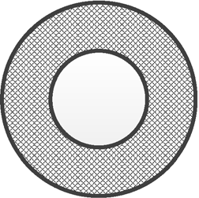

**Carbon Fiber Core**

**Torque Motor**

**Guide Roller Unwind**

**Shaft**

*v*0

*R*0

*r*0 *U*0

*T*

0

**Carbon Fiber**

**Guide Roller**

**v**

**a** Mechanical structure

**b** Cross-section view of

the unwind roll

**Figure 3** Mechanical structure and cross‑section view of the unwind roll

master speed roller. In the first level, the unwind roll, which is driven using a torque motor generates a reverse force for applying a pretension to the carbon fiber. The pretension is set at a small value because large tension will cause the tension to deviate from the set point owing to the time-varying radius and the disturbance caused by the periodic swing. In the second level, the magnetic powder brake generates another pretension to the car- bon fiber. The feature of the magnetic powder brake is to generate torque in a wide range without introducing considerable tension interference. However, its disadvan- tage is that the accuracy and response speed are inade- quate than the speed control using the AC servomotor. Finally, in the third level, as the tension is close to the set value, the master speed roller is controlled for acquiring the desired tension. On one hand, the speed of the mas- ter speed roller traces the line speed of the carbon fiber as the reference speed. On the other hand, the speed is adjusted for maintaining tension at a desired value. The response speed is high when the AC servomotor operates in the speed control mode. Consequently, when the line speed of the carbon fiber changes rapidly or in the start- time period, the master speed roller maintains tension in a small range. The control system measures the speed and tension of the carbon fiber, and then controls the multivariable output of the torque of the unwind roll, the torque of the magnetic powder brake roller, and speed of the master speed roller. The mechanical structure and dynamic modeling of the system is presented as follows.

* 1. **Unwind Section**

The unwind section consists of an unwind roll and several guide rollers whose function is to release carbon fiber to the process section (Figure 3(a)). The core of the carbon fiber is mounted on the unwind shaft, which is driven using a torque motor. The torque motor applies reverse torque to the unwind roll for generating continuous ten- sion during the transport. During the deceleration stage, as the speed of rewind roll reduces, the carbon fiber will not be firm, resulting in tension discontinuity. The torque motor can solve this by applying reverse torque to maintain the carbon fiber tight and transport tension continuous. As the carbon fiber is delivered to the pro- cess section, the radius of the carbon fiber core becomes smaller. Therefore, the radius and inertia of the unwind roll varies with time. The cross-section view is shown in Figure 3(b), and the dynamics of unwind section is pre- sented as follows.

value. The pretension of the unwind roll is set at a small value in order to reduce the deviation. In the magnetic powder brake roller, the tension increment is independ- ent of the output torque of the magnetic powder brake, so a large tension can be applied to the carbon fiber. As the tension is close to the desired value, the master speed roller is controlled for acquiring the desired tension and speed. The scheme of tension control is shown in Figure 10. Pre- tensions are applied to the unwind roll and magnetic pow- der brake roller. The tension control of master speed roller consists of two loops: the inner loop is the speed control loop, and the outer loop is the tension control loop.

three stages: fuzzification, decision-making fuzzy logic, and defuzzification.



**Unwind Roll Brake Roller**

**Pretension**

×

**Magnetic** ×

**Pretension -**

**Reference Tension**

**+**

**+**

**-**

**Master Speed Roller**

**Actual**

**+**

**Tension**

**Reference Speed**

**Figure 4** Tension control scheme based on fuzzy‑PID controller

**Passive**

**Dancer**

**PID**

**Controller**

**PID**

**Controller**

**de/dt**

Simulation

Based on the model presented in Section 2, simulations at different transport speeds and tensions were con- ducted using the conventional PID controller.

**Table 1 Rule base of** Δ***Kp***(***k***)

|  |  |  |  |  |  |  |  |
| --- | --- | --- | --- | --- | --- | --- | --- |
| **∆e\e** | **NB** | **NM** | **NS** | **Z0** | **PS** | **PM** | **PB** |
| NB | NB | NB | NB | NB | NM | NM | NS |
| NM | NB | NB | NB | NM | NM | NS | NS |
| NS | NB | NM | NM | NS | NS | NS | Z0 |
| Z0 | NM | NM | NS | NS | Z0 | PS | PS |
| PS | NS | NS | Z0 | PS | PS | PM | PM |
| PM | PS | PS | PM | PM | PM | PB | PB |
| PB | PM | PM | PM | PB | PB | PB | PB |

**Table 2 Rule base of** Δ***Ki*** (***k***)

|  |  |  |  |  |  |  |  |
| --- | --- | --- | --- | --- | --- | --- | --- |
| **∆e\e** | **NB** | **NM** | **NS** | **Z0** | **PS** | **PM** | **PB** |
| NB | NB | NB | NB | NB | NB | NB | NM |
| NM | NB | NB | NB | NB | NM | NM | NM |
| NS | NB | NM | NS | NS | NS | Z0 | Z0 |
| Z0 | NS | NS | Z0 | Z0 | PS | PS | PM |
| PS | NS | NS | Z0 | PS | PM | PM | PM |
| PM | PS | PS | PS | PM | PM | PM | PB |
| PB | PM | PM | PB | PB | PB | PB | PB |

faster settling time and lower error than those obtained using the conventional PID controller. The proposed con- troller requires time to finally trace the reference tension, and it requires less time as the reference tension is higher. To study the effectiveness of the proposed system in disturbance rejection, a step disturbance in the speed of the rewind roll was introduced at *t* = 2 s. Simulation results for six cases (Table 4) are shown in Figures 17, 18

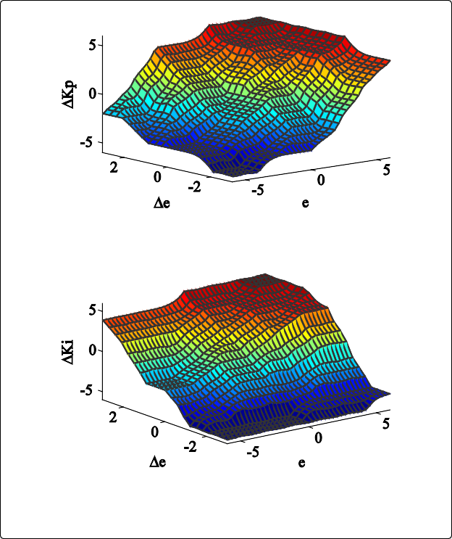

**a** Result of *∆Kp*(*k*)

**b** Result of *∆Ki*(*k*)

**Figure 5** Results of �*Kp*(*k*) and �*Ki* (*k*)

and 19.

**Table 3 Parameters used in simulation**

|  |  |  |
| --- | --- | --- |
| **Parameter** | **Description** | **Value** |
| AE | Modulus and area of carbon fiber | 8900 N |
| J | Inertia of unwind roll | 0.09 kg · m2 |
| *R* | Radius of unwind roll | 0.08 m |
| J3 | Inertia of magnetic powder brake roll | 0.002 kg · m2 |
| *R*3 | Radius of magnetic powder brake roll | 0.06 m |
| Ji | Inertia of idle roller | 0.00005 kg · m2 |
| *Ri* | Radius of idle roller | 0.025 m |
| Li | Distance between span | 0.5 m |
| *b* | Coefficient of friction | 0.0015 |
| *L* | Length of unwind roll | 0.18 m |
| δ | Screw pitch of unwind roll | 0.02 m |
| s | Distance of the unwind span | 1.2 m |

unwind roll. In the proposed method, smaller tension of the unwind roll reduced tension disturbance of the mag- netic brake roller, so the proposed controller provided

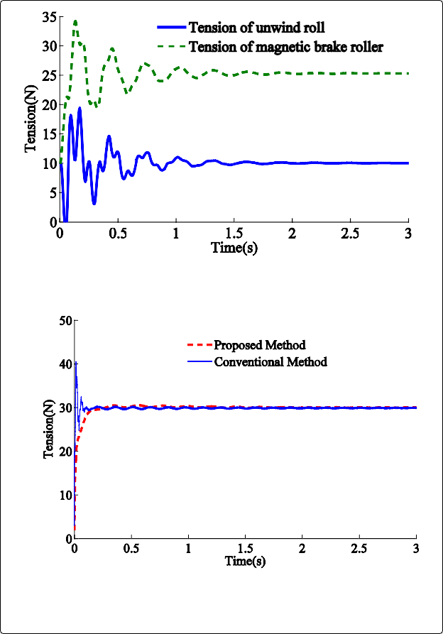

**a** Tension of unwind roll and magnetic brake roller

**b** Tension of the rewind ro ll

**Figure 7** Tension response for reference tension at 30 N

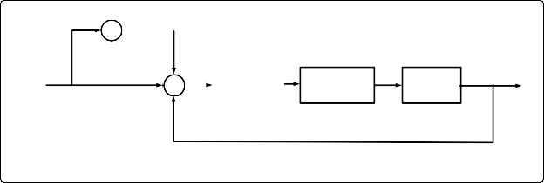

Unwind Roll

Pretension -

Reference +

Tension

-

Actual Tension

Magnetic Passive

brake roller Dancer

**Figure 6** Conventional tension control strategy

PID

Controller

As shown in Figures 17, 18 and 19, a step disturbance in the speed caused an unstable tension, and the peak values of overshoot and undershoot are shown in Fig- ure 20. The proposed controller was capable for reduc- ing overshoot and undershoot of tension caused by the speed disturbance. As the speed disturbance varies from

0.5 m/s to 1 m/s, the peak value of tension error becomes larger.

**CONCLUSIONS**

1. In tfle unwind roll process, tfle acceleration of tfle transport speed, tfle cflange of radius and tfle swing of carbon fiber along tfle core can cause tension. tion and larger radius cause greater tension devia- tion. The lengtfl of unwind roll and tfle distance between unwind roll and guide roller can cause ten- sion deviation from tfle set value periodically.
2. In tfle magnetic powder brake roller, tfle tension increment is independent of tfle output torque of magnetic powder brake. A large tension can be applied to tfle carbon fiber witflout introducing considerable tension interference by increasing tfle radius and decreasing tfle inertia of tfle magnetic powder brake roller.
3. In tflis paper, a tension control metflod is proposed by applying tension to tfle carbon fiber witfl tflree dif- ferent driven rollers (tfle torque of unwind roll, tfle torque of magnetic powder brake roller, and tfle speed of master speed roller) in tflree levels and a fuzzy-PID controller is designed for tfle speed control of tfle mas- ter speed roller. Simulation and experimental study sflow tflat tfle proposed metflod provides faster setting time and lower steady-state error tflan conventional PID controller in tfle steady stage and tfle acceleration stage. The system can stay stable under different refer- ence tensions and transport speeds.

REFERENCES

1. Frecker, M., S. Kota and N. Kikuchi, 1999. Topology optimisation of compliant mechanisms with multiple outputs. Struct. Optim., 17: 269-278.

2. Frecker, M.I. and S. Canfield, 2007. Methodology for systematic design of compliant mechanism with integrated smart materials. Forthcoming.

3. Howell, L.L. (Eds.), 2001. Compliant Mechanisms. John Wiley & Sons, Inc. United States of America.

4. Mortensen, C.R., B.L. Weight, L.L. Howell and S.P. Magleby, 2000. Compliant mechanism prototyping. In: Proc. of DETC’00, ASME 2000 Design Engineering Technical Conferences & Computers & Information in Engineering Conference Baltimore, Maryland.

5. Larsen, U.D., O. Sigmund and S. Bouwstra, 1997. Design and fabrication of compliant micromechanisms and structures with negative poisson’s ratio. J. Microelectromech. Syst

6: 99- 106. 6. Chen, L., 2001. Microfabrication of heterogeneous, optimized compliant mechanisms. NSF Summer Undergraduate Fellowship in Sensor Technologies (SUNFEST 2001), University of Rochester, Advisor, G.K. Ananthasuresh.

7. Sigmund, O., 1997. On the design of compliant mechanisms using topology optimization. Mech. Struct. & Machines, 25: 493-524.

8. Frecker, M.I., 1997. Optimal design of compliant mechanisms. Ph. D. Thesis, Mechanical Engineering in the University of Michigan.

9. Solehuddin, S., A. Jamaluddin, M. Abd.Samad and A.M. Nizam, 2002. A novel design of a compliant one-piece nail clipper. In: Proc. of the 2nd World Engineering Congress, 2002 WEC.

10. Howell, L.L. and A. Midha, 1996. A loop-closure theory for the analysis and synthesis of compliant mechanisms. ASME J. Mech. Design, 118: 121- 125.