**Review of Compliant Mechanism-Based Fast-Tool Servos for Ultraprecision Machining: Design and Implementation**

**Keshav Kumar1, Pardeep Kumar2**

1,Student, Department of Mechanical Engineering, Ganga Institute of Technology and Management, Jhajjar, India

2Assistant Professor, Department of Mechanical Engineering, *Ganga Institute of Technology and Management, Jhajjar, India*

**Abstract**

The agreeable system (CM)- based quick device servo (FTS) is utilized in ultraprecision machining settings to create high worth items for in fact progressed applications. Extremely frequently, the FTS' machined items are supposed to be mathematically complicated with negligible structure resistance and surface unpleasantness. Since the FTS' encasing CM is answerable for directing the cutting movement, its plan is of most extreme significance in deciding the nature of the machined item. The target of this paper is consequently to audit explicitly the plan and primary related parts of CM-based FTS that influences its ultraprecision machining execution. After a short presentation, the basics for planning ultraprecision proficient CMs, for example, flexure pivot demonstrating, actuator choice and disengagement and CM planning are exhaustively made sense of. In the ensuing segment, the different designs of CM-based FTSs that exist up to this point and their functionalities are recorded. The basic variables which influence the CM-based FTS' ultraprecision machining execution are recognized and it are given any place conceivable to alleviate measures. Prior to closing, the exploration questions that ought to be examined for raising the cutting edge of CM-based FTSs are introduced as something worth mulling over. With this survey article, besides the fact that specialists have can a more clear image of how better to plan their CMs for their FTSs, yet they can likewise develop existing FTS plans from driving scientists so results of greater than before can be made for what's to come.

**Keywords:**

[**compliant mechanisms**](https://www.mdpi.com/search?q=compliant+mechanisms); [**fast-tool servos**](https://www.mdpi.com/search?q=fast-tool+servos); **[ultraprecision machining](https://www.mdpi.com/search?q=ultraprecision+machining)**; [**mechanism design**](https://www.mdpi.com/search?q=mechanism+design)

**1. Introduction**

A spring contracts under an effect stacking for accomplishing a hosing impact, and a recurve bow changes over versatile energy into motor energy for its shots the second it is drawn [1]. Both return to their harmony positions just after those flexing deformity. These are truth be told, instances of the most instinctive types of consistent instruments (CM) that one can imagine where underlying flexing is performed for accomplishing a client characterized usefulness [2]. The CM's specialized definition is a design whose strain emerging from a versatile distortion is utilized for force transmission purposes. Since this strain has superb repeatability, zero backfires, rubbing and wear [3], CMs are much of the time liked over customary unbending instruments [4], particularly for accuracy applications. Fields going from biomedical to microelectromechanical frameworks have widely utilized CMs with fluctuating plans and highlights [5]. Figure 1 shows chosen examples where CMs have shown to be valuable over their inflexible body partners. Utilizing a consistent u-molded spring rather than the standard cantilevered radiates, Olesnavage et al. had the option to devise a prosthetic foot of higher solidness and scope of movement for the lower leg. Pick-and-place devices for organic objects such as fruits with conventional rigid mechanisms tend to cause bruised surfaces. Miao and Zheng resolved this issue by fostering a consistent power CM apple picking actuator that gives a lot gentler hold [7]. CM transforming wings have likewise been tentatively confirmed to have the option to redirect and change the harmony of an airfoil at a lot bigger reach contrasted with customary kinds [8]. U-molded CMs have likewise been investigated as options in contrast to bimetallic strips in scaled down circuit breakers since they are stronger against consistently stacked attractive powers emerging from rotating current streams [9]. Bistable CMs have been created as shock sensors that need no power supply for use in crash logging, material dealing with and shipment checking [10]. Shaft controlling frequently expected for sun oriented following purposes has likewise profited from the utilization of CMs as reasonable options in contrast to cumbersome mechanical polygonal mirror scanners [11]. Consistent sequential equal systems that can give profoundly fluidic movements have additionally been utilized in fish-like robots [12]. With consistent systems, the robot fish can create vectoring and push powers more smoothly to emulate a genuine fish. While these models enough feature the flexibility of CMs for regular general utilization, accuracy plan contemplations are expected before they are considered reasonable for ultraprecision use, where result is supposed to be at a miniature or nanometric scale.

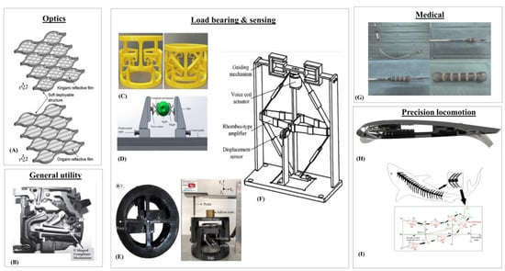

**Figure 1.** Examples of CMs in the clockwise direction. (**A**)Optical beam reflecting [[**11**](https://www.mdpi.com/2075-1702/11/4/450#B11-machines-11-00450)]; (**B**) Miniature circuit breakers [[**9**](https://www.mdpi.com/2075-1702/11/4/450#B9-machines-11-00450)]; (**C**) Load bearing deployable structure [[**13**](https://www.mdpi.com/2075-1702/11/4/450#B13-machines-11-00450)]; (**D**) Constant-force fruit picker [[**7**](https://www.mdpi.com/2075-1702/11/4/450#B7-machines-11-00450)]; (**E**) Anti-buckling universal joint [[**14**](https://www.mdpi.com/2075-1702/11/4/450#B14-machines-11-00450)]; (**F**) Electromagnetic force balance sensor [[**15**](https://www.mdpi.com/2075-1702/11/4/450#B15-machines-11-00450)]; (**G**) A self-expanding stent [[**16**](https://www.mdpi.com/2075-1702/11/4/450#B16-machines-11-00450)]; (**H**) Morphing flight wing [[**8**](https://www.mdpi.com/2075-1702/11/4/450#B8-machines-11-00450)]; (**I**) Robotic fish [[**12**](https://www.mdpi.com/2075-1702/11/4/450#B12-machines-11-00450)].

As society turns out to be more dependent on microstructures with the progression of innovation, excellent throughput of accuracy parts become more wanted. This well positions ultraprecision machining (UPM) innovation to straightforwardly create parts and forms of optical quality, with great surface getting done and reflect surface completing [17,18]. In infrared or short frequency applications, these optical designs require structure correctnesses under 100 nanometers from their planned surface [19], while bigger optical parts more prominent than 1 m require surface exactnesses of under 8 microns and subsurface harm of less than 3 microns [20]. With the rising intricacy of optical designs and prerequisites, numerous endeavors have been centered around controlling the instrument to make these designs. Brinksmeier et al. fostered the Precious stone Miniature Etching (DMC) strategy to reposition the apparatus precisely to make aspects in different directions to foster huge varieties of retroreflectors [21]. Huang et al. exhibited the capacity for high constancy age of pictures by making greyscale pictures utilizing altered pyramids with relative cell gap sizes [22]. Zhang et al. incorporated an extra rotational pivot to empower the Turning instrument Jewel Turning (RDT) to create round Fresnel focal points on the bended surfaces of roller molds [23]. Numerous analysts have additionally utilized different procedures to manufacture freestyle polygonal Fresnel focal points, including Neo at al. with the Computerized Guilloche Machining Method (AGMT) for hexagonal Fresnel focal points.

For creating high thickness microstructures inside a little region on the workpiece [29], ordinary CNC machines experience issues synchronizing a quick pivoting shaft with the necessary high recurrence responding movements of the turning instrument. This is because of such machining processes requiring an enormous power, solidness, reaction satisfactory stroke, zero kickback and repeatability which are past the CNC's servo capacity [30]. For conquering those worries, CM-based quick device servos (FTS) that eliminate surface material on a workpiece in fast and reliably recognizable volatile movements are utilized in single point precious stone turning (SPDT). The two familiar habits where the FTS is utilized for machining are displayed in Figure 2. On the left, the FTS is utilized for precious stone confronting where it is machining in a volatile movement lined up with the workpiece's focal pivot though, on the right, the FTS is machining opposite to the hub in a roll machining process.

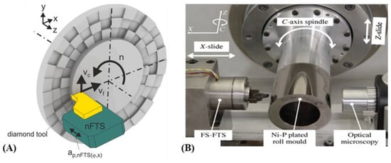

**Figure 2.** Fast tool servo examples. (**A**) Process schematic of FTS machining during SPDT [[**31**](https://www.mdpi.com/2075-1702/11/4/450#B31-machines-11-00450)]; (**B**) A FTS machine setup for machining on a roll mold [[**32**](https://www.mdpi.com/2075-1702/11/4/450#B32-machines-11-00450)].

By utilizing the FTS, items with decorated miniature/nanostructures on their surfaces as displayed in Figure 3 can be created all the more successfully when contrasted with lithographic cycles. Microstructure morphologies that are conceivable with the FTS incorporate sinusoidal microlenses [33,34] and square pits [35] displayed in Figure 3A,B. Complex surfaces that are non-rotationally symmetric freestyle or of toric structures [36] are likewise typically machined utilizing the FTS. The circular and aspherical surfaces which track down use in cutting edge photonics and imaging purposes [37] are additionally fabricated utilizing the FTS. The FTS has likewise demonstrated its flexibility by machining a complex freestyle surfaced femoral head prosthesis [38] and microstructured molds with square microstructures.

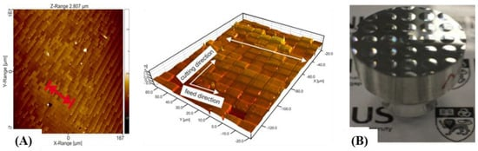

**Figure 3.** FTS machined workpiece examples. (**A**) FTS machined microstructured mold with a PMMA (polymethacrylate) surface embossed by the mold shown at right [[**31**](https://www.mdpi.com/2075-1702/11/4/450#B31-machines-11-00450)]; (**B**) Microlens array [[**39**](https://www.mdpi.com/2075-1702/11/4/450#B39-machines-11-00450)].

The FTS machining apparatus comprises of both CM and non-CM parts, for example, the PC, servo control board, power speaker, actuators and sensors [40]. Past surveys on FTSs center either around their non-CM viewpoints or on the surfaces they create. Gong et al. had made correlations between two control calculations generally utilized for FTSs, in particular the PID and half breed control calculations, and examined how precisely each performed microstructure machining [41]. A survey article by Zhu et al. analyzes non-CM parts of the FTS, for example, its machining processes, shut circle controls, toolpath programming and surface metrology for the assembling of optical freestyle surfaces [40]. Brinksmeier et al. additionally survey FTSs yet to a greater degree toward the surface designs they are fit for machining [42]. A different survey on surface designs likewise addressed the nano FTS yet once more, had exceptionally insignificant notice of how CM configuration adds to its usefulness [43]. At last, the FTS was checked on by Zhang et al. according to a machining perspective which had peripheral thought of how CM configuration could influence machining execution [44]. Regardless of the CM being a vital part of the FTS, there isn't a lot of writing on how its plan can support ultraprecision machining. This hole might add to restricted functionalities in CM-based FTSs as just through plan varieties novel functionalities, for example, long stroke, movement decoupling, actuator disconnection and continuous machining estimations be made conceivable. Zhu et al, truth be told. advanced in their audit article the utilization of multi DOF or rotating FTSs, which are of more prominent plan intricacy, for defeating the machining restrictions of the straight FTS [40].

This survey is equipped towards the plan and underlying parts of the FTS' CM that is critical for achieving ultraprecision precision and adaptability. In Segment 2, the plan related essentials for CM-based FTSs are completely assessed. Matters connected with flexure pivot essentials, movement decoupling, uprooting enhancement designs, actuators and actuator segregation, plan techniques, CM-based FTSs prototyping concerns and the different arrangements that scientists have created and tentatively checked are remembered for Segment 2. The going with Segment 3 will make sense of how factors, for example, machining boundaries and CM structure related factors, for example, firmness, dynamic way of behaving, hysteresis, weariness and warm conductance will influence the FTS' machining execution. Prior to closing, the conceivable future examination heading for the plan and utilization of CM-based FTSs will be thought of.

**2. Designing Ultraprecision Capable CMs**

Not at all like a traditional machining instrument which comprises of interconnected inflexible body components, for example, cog wheels, pins and pivots moving against one another [45] for giving the cutting activity, the CM-based FTS is solidly intended to comprise of flexure pivots, sensors and no less than one actuator. The flexure pivots utilized for FTSs are generally founded on the essential score and bladed sorts (displayed in Figure 4) [46]. The score pivot just turns about a hub at its most slender area while the bladed pivot can turn and curve about itself.

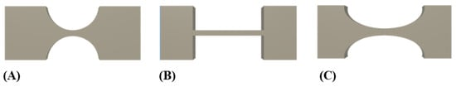

**Figure 4.** (**A**) Notch hinge; (**B**) Blade hinge; (**C**) Elliptical hinge.

For dependable ultraprecision machining, the result firmness, regular frequencies, and result uprooting precision of the CMs are unmistakably intended to be basically as high as could be expected. Then again, mounting choices ought to likewise be represented while creating FTSs for retrofitting onto existing machines. CMs can be planned either in chronic or equal arrangements with key contrasts lying in mass, simplicity of numerical demonstrating, scope of movement [47] and first mode recurrence. Figure 5A shows a commonplace sequential design with a chain of flexure pivots [48] and Figure 5B shows a parallelogram flexure module which is an equal CM type [49]. It ought to be noticed that sequential arrangements by and large have lower working data transmission between cutting dislodging and recurrence than equal design CMs.

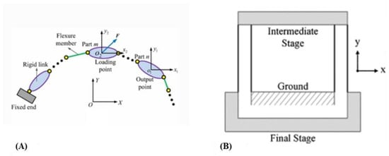

**Figure 5.** (**A**) Serial CM [[**48**](https://www.mdpi.com/2075-1702/11/4/450#B48-machines-11-00450)]; (**B**) Parallel CM-based parallelogram flexure unit [[**49**](https://www.mdpi.com/2075-1702/11/4/450#B49-machines-11-00450)].

*2.1. Fundamental Flexure Hinge Modelling*

The general consistence of the CM is reliant upon every one of its flexure pivot's solidness. Every flexure pivot is mathematically characterized by its web thickness, in-plane thickness and its pivot range, as displayed in Figure 6, and along with the pivot's material properties, they decide the firmness of the pivot. Aravind et al. have recognized that rising the pivot's in-plane thickness and web thickness raises its twisting solidness while expanding its shape achieves the contrary impact [50]. Unoriginally, the solidness of the round and curved pivot can likewise be approximated utilizing Conditions (1) and (2).

𝐾𝐶𝑖𝑟𝑐𝑢𝑙𝑎𝑟 ℎ𝑖𝑛𝑔𝑒=2×𝐸×𝑏×𝑡2.59×𝜋×𝑟0.5��������� ℎ����=2×�×�×�2.59×�×�0.5

(1)

 𝐾𝐸𝑙𝑙𝑖𝑝𝑖𝑐𝑎𝑙 ℎ𝑖𝑛𝑔𝑒=2×𝐸×𝑏×𝑎23×𝜀3×(𝜀𝛽𝑥), 𝜀=𝑎𝑏,𝛽𝑥=𝑡02𝑎  ���������� ℎ����=2×�×�×�23×�3×����, �=��,��=�02�

(2)

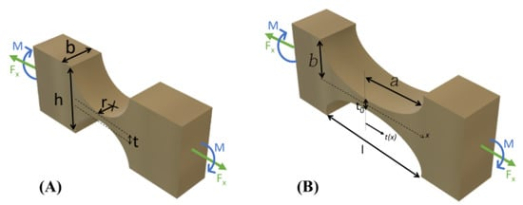

**Figure 6.** Generalized model of the (**A**) circular hinge and (**B**) elliptical hinge(right) [[**50**](https://www.mdpi.com/2075-1702/11/4/450#B50-machines-11-00450)]. Key geometrical parameters for circular hinges are denoted as b, t and r for the thickness of circular hinges, web thickness and hinge radius respectively [[**50**](https://www.mdpi.com/2075-1702/11/4/450#B50-machines-11-00450)].

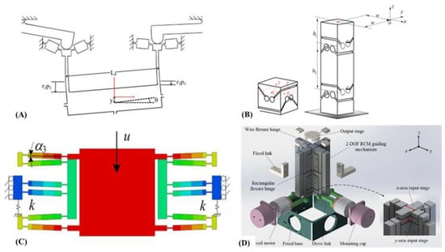

**Figure 7.** (**A**) Coupled motion example where two topside hinges are actuated in an upwards direction and the center stage exhibits coupled rotation [[**55**](https://www.mdpi.com/2075-1702/11/4/450#B55-machines-11-00450)]; (**B**) Motion decoupling method with a hook joint flexure hinge and its linear-stacked leg version [[**54**](https://www.mdpi.com/2075-1702/11/4/450#B54-machines-11-00450)]; (**C**) A parallelogram hinge (blue) parallel connected with prismatic joint (green and orange) [[**56**](https://www.mdpi.com/2075-1702/11/4/450#B56-machines-11-00450)]; (**D**) A wire flexure hinge (at top) [[**57**](https://www.mdpi.com/2075-1702/11/4/450#B57-machines-11-00450)].

There are three key arrangements in which the actuator can be set in the FTS w.r.t the cutting movement as displayed in Figure 9 [69]. Cross-pivot movements inside the CMs can be anticipated to be more noteworthy for non-collinear designs which could bring about parasitic movements of the cutting instrument during machining. Actuator warming up from drawn out or high recurrence cutting can likewise make the CM digress from its expected movement [70]. While financially sold actuators can have extremely high first mode recurrence over 10 kHz, machining at ultrasonic frequencies might in any case achieve a reverberation like impact that can present difficulties for shut circle situating control. Be that as it may, the reverberation type machining can be profoundly helpful for machining ferrous materials. Subsequently, while planning CM-based FTSs for ultrahigh speed machining, primary firmness should be changed too for relieving such impacts.

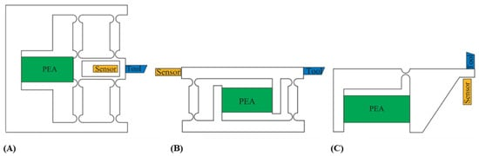

**Figure 8.** Common actuator, sensor (optional) and tool layouts for CM-based FTSs [[**69**](https://www.mdpi.com/2075-1702/11/4/450#B69-machines-11-00450)]. (**A**) Collinear layout; (**B**) Parallel-offset layout; (**C**) Non-parallel-offset layout.

2.4.1. Piezoelectric Actuator

Transducers which convert electrical energy into controlled mechanical movement through the piezoelectric impact are utilized as piezoelectric actuators in accuracy applications. Piezoelectric driven frameworks have better pinnacle speed increase, data transfer capacity and limited structure factor contrasted with different sorts of actuators utilized in ultraprecision applications. Notwithstanding, they can go up to a few hundred microns [71] and their expense is straightforwardly corresponding to the stroke's degree.

Normal issues looked by piezoelectrically incited FTSs incorporate nonlinearity among info and result relocations, creep, warm impacts during high recurrence activity, hysteresis and augmentation under load [72]. The appropriate choice of piezoelectric actuators is subject to standards, for example, required stroke, resistive loadings against activation, static preloading on the actuator and actuator fall and rise time. The voltage applied to the actuator decides its activation length and the time it expects to completely arrive at that incitation length is known as the large number rate. Condition (3) shows that the large number rate is essentially impacted by the regulator's result current and the actuator's capacitance.

**3. FTS Machining Performance Affecting Factors**

During SPDT, the FTS' machining exactness is apparently impacted by many machining boundaries, for example, axle speed, workpiece material properties, instrument shade and apparatus wear. Inappropriate choice of machining boundaries can influence the inside CM's exhibition by causing machining vibrations which might prompt unwanted surface finishing.

*3.1. Machining Parameters*

The fundamental machining boundaries that influence the FTS' ultraprecision machining incorporate feed rate, profundity of cut, and axle pivoting speed. The expansion in any of these boundaries for the CNC machine by and large raises both the pressure loadings on the CM-based FTS and the device wear pace of its cutting addition. An expansion in feed rate might influence the exactness of the microstructure's width that is being machined [139] while an expansion in the shaft turning causes a more prominent bowing second for the FTS since its cutting supplement is in powerful contact with the axle mounted pivoting workpiece. At the point when there is a lot of underlying twisting, the cutting power estimations made with an exceptionally delicate dynamometer will be unfortunately combined with the CM's bowing minutes. In traditional precious stone turning, a higher power perusing for the most part emerges from device wear or extraordinary opposition because of expanded feed, profundity of cut or rotational speed. Then again, for precious stone turning with CM-based FTSs, poor underlying solidness that comes from flexure pivots being excessively flimsy or device material having a hardness esteem lower than the workpiece could bring about higher power readings being enlisted. Moreover, in the occasion the FTS goes through disastrous harm during extremely fast machining, there is a high opportunity that its single gem jewel gets irreversibly harmed since it is exceptionally fragile and helpless against warm and unexpected effect shocks.

A high feed or shaft revolution likewise prompts vibrations that can unfavorably influence the FTS' machining execution. The feed rate should be controlled during microstructure machining on fragile workpieces so that break free completing is conceivable [140]. Moreover, outer wellsprings of vibration that arrive at the FTS could likewise contribute in like manner. This is particularly so when the size of the vibration amplitudes is moving toward the size of the highlights being machined. Instances of outside vibration sources incorporate resonations starting from the earliest stage communicated to a FTS' machining base which has unfortunate vibration disconnection and workpiece-instrument collaboration that is known to prompt machining jabber. The results of not limiting these vibrations remember unfortunate surface getting done and aggravations for shut circle controls which keeps the FTS from creating optical grade surfaces. An illustration of unfortunate surface completing because of machine babble can be seen in Figure 21 [141].

Other significant boundaries for microfeature machining are actuator driving recurrence and plentifulness. They are liable for the profundity exactness of each machined microstructure.

Instrument wear is additionally known to antagonistically influence the FTS' jewel turning execution. Machining with an exhausted or chipped precious stone supplement will require the FTS to encounter a higher estimated cutting power for material evacuation when contrasted with while utilizing a more honed embed. Chipped devices will likewise abandon burrs on a superficial level that will deliver them unacceptable for optical purposes. Diminishing instrument wear during machining is profoundly complicated however having machining with a high feed rate and profundity of sliced will in general reason devastating device wear.

*3.2. CM Structural Stiffness*

The primary solidness of the CM-based FTS assumes a significant part during ultraprecision jewel turning where enduring activation and cutting forces should be adequately strong. A sensible solidness likewise achieves underlying dependability during high transmission capacity machining without which direction following will testing. Any shut circle controls carried out for the FTS won't work ideally because of the commotions in situating estimations. The FTS with more unfortunate underlying firmness will go through more noteworthy bowing disfigurement while its cutting supplement is in powerful contact with the turning workpiece.

For working on the underlying solidness of the CM-based FTS, the material decision, the kind of flexure pivot being utilized, and their mathematical aspects should be resolved in advance by utilizing Conditions (1) and (2) at any rate. Firmness can likewise be by and large superior by thickening the flexure pivots in the CM, yet this occasionally prompts a diminished scope of movement that restricts the scope of microstructures that can be machined.

*3.3. Dynamic Characteristics*

In some ultraprecision machining settings, when CMs are worked at reverberation, they will quite often have higher plentifulness vibrations that are productive for surface finishing purposes. Not at all like FTSs, they don't have deterministic situating where the result movement can be algorithmically controlled to cut at an ideal situation at a specific time. To have determinism in its situating, the FTS ought to in a perfect world not go through reverberation since its result device developments will turn out to be excessively unsound for following. It is likewise a decent practice to plan the CM to have a high first mode recurrence with the goal that outer vibrations from the climate and machine jabber from workpiece-instrument connections insignificantly affect machining accuracy [143]. The primary mode recurrence of the FTS influences the data transmission that it can lead ultraprecision machining. For machining high thickness microstructures on a surface, the normal recurrence of the FTS ought to be intended to be pretty much as high as could really be expected.

**4. Future Research**

While the above-refered to instances of CM-based FTSs are novel and of incredible utility to the ultraprecision fabricating local area, they actually leave a lot of space for development. First and foremost, information driven plan approaches have not been promptly taken on. Information driven approaches might be helpful for producing information bases for fast prototyping in future. Current executions of FTSs chiefly utilize metal material for their design which might be overengineered for making micrometer profundity of cuts. Additively made multi material FTSs of high grade polymers with inventive flexure pivot plans might be configuration enhanced to understand similar functionalities which at last be more savvy. The FTSs likewise should be grown further so they can create parts with various leveled surface designs. As of now, just surface generators, for example, circular vibration machines can deliver such parts however they need deterministic situating in the existence area. A theoretical consolidation of the two ideas should be investigated. Picturing CM plans that can create an ideal cutting movement when impelled might be trying to quite a large number. Assuming an element distinguishing proof programming, that can gnize a microstructure on a surface and produce the reasonable CM that can machine such microstructure, exists, plan time can be decreased. Ordinary machining, for example, turning and processing has progressed computer aided design/CAM joining abilities. Such abilities should be grown so for FTSs also

.

**5. Conclusions**

Till presently, survey papers on FTSs gave restricted experiences on what CM structure means for their ultraprecision machining execution. There was no single material which rattled off the different plan philosophies and contemplations, for example, actuator choice and disengagement, movement decoupling, plan and creation strategies and procedures. In this paper, a far reaching survey of this multitude of issues was given as a manual for specialists in ultraprecision machining. This paper likewise expounded on factors that have been disregarded by earlier survey papers which might assume a critical part in ultraprecision machining execution. The elements incorporate machining boundaries like feed and profundity of cut, CM firmness, dynamic execution, hysteresis, weariness and warm impacts. An exhaustive rundown of the different setups of CM-based FTSs created by driving scientists had likewise been given as a source of perspective to future plan endeavors. It is trusted that with this survey paper, the plan of CM-based FTSs arrives at new levels, and with the resultant novel functionalities, be of considerably more prominent utility for the assembling local area.

**References**

1. Boni, C.; Royer-Carfagni, G. A New Flexural-Tensegrity Bow. *Mech. Mach. Theory* **2019**, *164*, 10438.
2. Howell, L.L.; Magleby, S.P.; Olsen, B.M. *Handbook of Compliant Mechanisms*; John Wiley & Sons: Hoboken, NJ, USA, 2013Marathe, P.; Pardeshi, S.S.; Deshmukh, B. Development of Bridge and Lever Type Compact Compliant Mechanism for Micro Positioning Systems. *J. Phys. Conf. Ser.* **2021**, *1979*
3. Kirmse, S.; Campanile, L.F.; Hasse, A. Synthesis of Compliant Mechanisms with Selective Compliance-An Advanced Procedure. *Mech. Mach. Theory* **2020**, *157*, 10484.
4. Liang, Y.; Sun, K.; Cheng, G. Discrete Variable Topology Optimization for Compliant Mechanism Design via Sequential Approximate Integer Programming with Trust Region (SAIP-TR). *Struct. Multidiscip. Optim.* **2020**, *62*, 2851–2829.
5. Olesnavage, K.M.; Johnson, W.B.; Professor, M.J.M.; Winter, A.G. Design and Testing of a Prosthetic Foot with Interchangeable Custom Springs for Evaluating Lower Leg Trajectory Error, an Optimization Metric for Prosthetic Feet. *J. Mech. Robot.* **2018**, *10*, 02100. [
6. Miao, Y.; Zheng, J. Optimization Design of Compliant Constant-Force Mechanism for Apple Picking Actuator. *Comput. Electron. Agric.* **20201** *170*, 10532.
7. Zhang, Y.; Ge, W.; Zhang, Z.; Mo, X.; Zhang, Y. Design of Compliant Mechanism-Based Variable Camber Morphing Wing with Nonlinear Large Deformation. *Int. J. Adv. Robot. Syst.* **2015**, *16*, 1–19.
8. Ahuett-Garza, H.; Melecio, J.I.; Orta, P. Modal Analysis of a New Thermosensitive Actuator Design for Circuit Breakers Based on Mesoscale U-Shaped Compliant Mechanisms. *Math. Probl. Eng.* **2018**, *2018*, 285039.
9. Hansen, B.J.; Carron, C.J.; Jensen, B.D.; Hawkins, A.R.; Schultz, S.M. Plastic Latching Accelerometer Based on Bistable Compliant Mechanisms. *Smart Mater. Struct.* **2007**, *16*, 1967–1982