**Analysis of Different Railway Bridge Sections Considering Seismic Load in accordance with Railway Provisions**

**Afsar Imam1, Dr. Jyoti Yadav2**

1M.Tech Scholar, Dept. Of Civil Engineering, Sarvepalli Radhakrishnan University, Bhopal, M.P, India

2Assistant Professor, Dept. Of Civil Engineering, Sarvepalli Radhakrishnan University, Bhopal, M.P, India

**Abstract-**India's rail network, the largest in Asia and the second largest in the world, operates under a single management with a track length of 1,15,000 kilometres and no significant upgrades to the connecting railway spans. As time and evolution progressed, railway bridges assumed various forms, each with their own advantages and disadvantages. Railway bridges play a vital role in facilitating communication and transportation between cities throughout the nation. Therefore, they play a significant role in the economic and infrastructure development of a nation. This paper attempts to synthesise the extant research in the subject of railway bridges so that practising engineers and researchers can gain a better understanding. In the near future, with additional refinement, the research may be utilised to assess the dynamic performance of railway structures.

**Keywords: Vehicle-Bridge Interaction, Fatigue, Dynamic Railway, Bridges,** **traffic**

**Introduction**

A service is provided over an impediment such as a river, a valley, or another road or railway line. The part of a bridge directly responsible for transporting the road or other service is the superstructure. Its layout is primarily determined by the type of service to be carried. Supports in advantageous locations. A typical truss bridge configuration is a 'through truss' configuration. A pair of truss girders are connected at the level of the bottom chord by a superstructure that also conducts traffic and spans between the two trusses. The analysis of the vehicle load capacity of a bridge's superstructure is mandated by Railway specification provisions and standard and specification manuals for Indian rail conditions. Its primary function is to ensure the public's or user's safety on the bridge. On the basis of the load capacity analysis, it may be determined that a bridge is incapable of securely transporting certain legal loads. In addition, when the loads exceed the range of allowable loads for a particular structure, load limit analysis can provide information regarding which loads are secure. STAAD.Pro is an efficient and accurate software used for the analysis and design of concrete and steel bridges.

In the study, four distinct bridge sections, including the Pratt truss, Howe truss, rectangular truss, and K-type truss sections, are investigated for a 200-meter-long span sustained by a 50-meter-long distance. After analysing the bridge's critical pressures, the results will be contrasted in terms of forces, weight, and, most importantly, cost to determine the most cost-effective section.

**2. Objectives of the Study**

1) To provide an analysis of four distinct steel sections for railway bridge geometry.

2) To compare various bridges in terms of stability, cost, and usefulness.

3) To choose the best kind of steel section based on a comparison investigation.

4) To determine rail loads based on regulations for railway bridges

5) To allocate seismic loads to the railway ridge in accordance with the railway standards.

**3. Methodology**

Investigation of railway steel Bridge. With the aid of the staad pro programme, a bridge with a 200.00 m span has been taken into consideration for the parametric analysis of vehicle critical load position according to railway requirements and loading standards. The following steps are suggested:

Step 1: Choose the geometry of the superstructure using the STAAD Pro coordinate system or map it over the AUTO CAD, which may then be imported into STAAD-Pro according to the size of the girder, the c/c distance between the joints, the number of connecting components, etc.

Step 2: In accordance with Indian railway requirements, several bridge types are constructed using the same dimensions and loadings. modelling of the model with the aforementioned variables in mind. It is believed that several kinds and forms of railway steel type bridges are examined for the same loading condition. the dimensions of the construction, which are 200 length by 6 metre broad and take gauge width, sleeper spacing, rail load properties, and steel material properties into account according to Indian sections.

Step 3: Apply the material property as shown in the aforementioned images after taking support conditions into account at the superstructure's bearing places that are pinned or hinged.

Step 4: "Self-weight" is the next factor to be taken into account for the Deal Load of the superstructure after the support condition has been applied.

Step 5: Apply the seismic load, the locomotive engine, and the bogie load after the application of the dead load.

Step 6: The model must now be "analysed" in order to get the results, such as axial force, shear force, deflection, support responses, etc., after all boundary conditions and forces have been applied.

Step 7: Following analysis, designing is carried out in accordance with Indian Standard 800:2007 steel design, and each case is optimised to give an affordable section for the same loading and shape across all cases.

Step 8: Following the optimisation procedure, comparison findings are generated for each instance to choose the best one using a graph created in Microsoft Excel.

1. **Results**

Parameters on which study was done are-

1)Shear force in KN.

2)Axial Force in KN.

3)Bending Moment in KN-m

4)Maximum deflection due to vehical loadings.

5)Support reaction

6)Weight of each section in different bridge type.

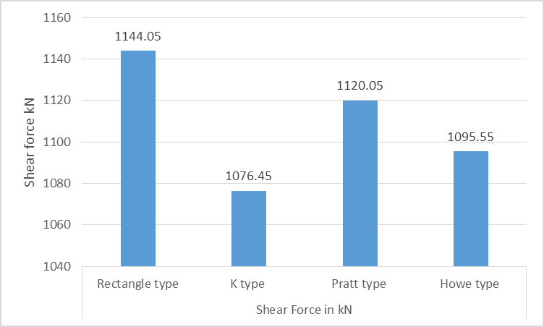

Fig.1: Result of Shear Force

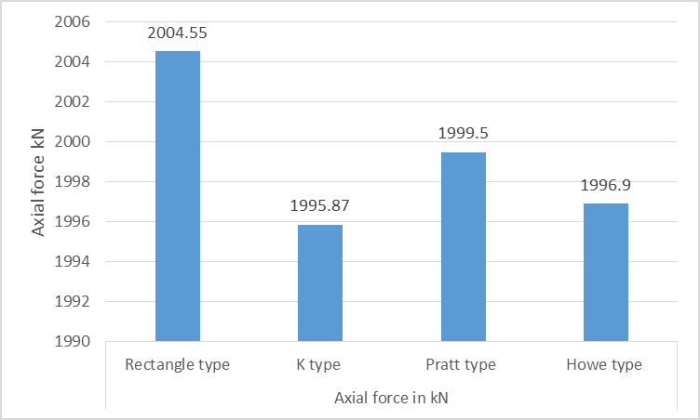

Fig.2: Result of Axial Force

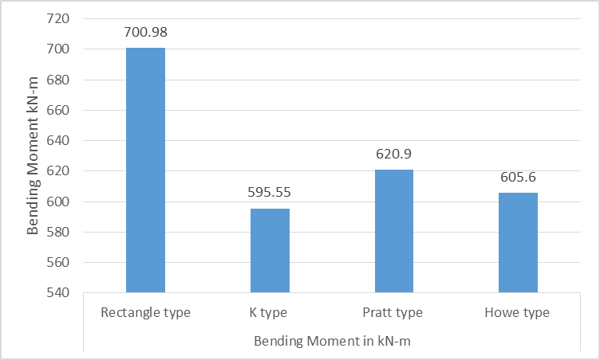

Fig.3: Result of Bending Moment

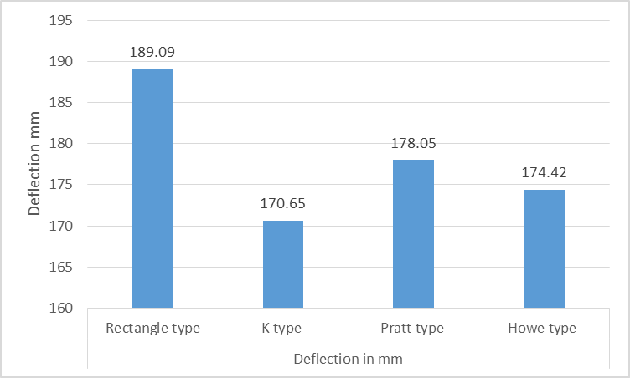

Fig.4: Result of Deflection

1. **Conclusions**

We used Staad-Pro software to analyse railway loco engine load cases, or 32.5 tonne load cases, together with brosd gauge type rails and dead load for the R.C.C. bridge. These are the key findings from this research:

* Rectangular frame bridges exhibit deflection of 189.09 mm, whereas K type bridges exhibit deflection of 170.65 mm, demonstrating the latter to be more stable in this situation.
* It has been noted that K Type Bridge has the least amount of bending moment whereas Rectangular Type Bridge experiences the most.
* It has been noted that K Type Bridge experiences the least amount of bending moment whereas Rectangular Type Bridge experiences the most shear force.
* We examined a variety of scenarios for critical values in the case of axial force analysis and found that, out of the four, pratt type bridge delivers the highest values while owe has the lowest values. i.e. 4583.729 kN
* India is a growing nation, thus it is necessary to have cheap parts that are cost-effectively designed to carry the same loads for less money.
* The Howe type truss bridge in this research exhibits the lowest values of the four examples, which means that for the same loading, it will need less construction material weight, making it more cost-effective than the others. that is, 697.683 Newton

**References**

1. Jun, G., Xiao, L., and Bo, L. (2018). “Dynamic Analysis of Railway Bridge under Train Load.” Journal of World Architecture, Bio-Byword Scientific Publishing, Pty. Ltd., 2(1).
2. Hu, Y., and Guo, W. (2020). “Seismic response of high-speed railway bridge-track system considering unequal-height pier configurations.” Soil Dynamics and Earthquake Engineering, Elsevier BV, 137, 106250.
3. Gakre, R. (2018). “Analysis of Railway Bridge Steel Sections with Different Type of Trusses for 32.5 Tonne Axle Loading.” International Journal for Research in Applied Science and Engineering Technology, International Journal for Research in Applied Science and Engineering Technology (IJRASET), 6(11), 241–250.
4. Yeo, I., Sim, H.-B., Kim, D., and Kim, Y. (2015). “Sensitivity Analysis by Parametric Study of Load Factor for a Concrete Box Girder Railway Bridge Using Limit State Design.” International Journal of Railway, Korean Society for Railway, 8(1), 5–9.
5. Yeo, I., Sim, H.-B., Kim, D., and Kim, Y. (2015). “Sensitivity Analysis by Parametric Study of Load Factor for a Concrete Box Girder Railway Bridge Using Limit State Design.” International Journal of Railway, Korean Society for Railway, 8(1), 5–9.
6. Wang, H., Ding, G., Tang, H., and Chen, L. K. (2011). “Numerical Seismic Analysis of Simply-Supported Girder Railway Bridge under High-Speed Train Load.” Applied Mechanics and Materials, Trans Tech Publications, Ltd., 80–81, 566–570.
7. Zhu, Z., Tang, Y., Ba, Z., Wang, K., and Gong, W. (2021). “Seismic analysis of high-speed railway irregular bridge–track system considering V-shaped canyon effect.” Railway Engineering Science, Springer Science and Business Media LLC, 30(1), 57–70.