FIRE ALARM CONTROL AND EVACUATION SYSTEM

Abstract— Fire safety equipment is essential in public places including workplaces, apartments, businesses, and malls. The fire sensor recognizes fire as soon as it starts. Systems for preventing fires include fire detection tools, firefighting equipment, alerting devices, and fire rescue strategies. The emphasis on implementing preventive measures should be on these safety components, such as fire detection and warning subsystems. Because of the advancement of technology, fire detection systems are currently built using tiny, portable electronics like Arduino, multiplexers, etc. However, each individual fire alerting system, comprising hooters, loudspeakers, siren lights, and manual call points, is to be erected and run in a distinct place at a large cost. To solve the aforementioned issues, it is advised that a difficult environment fire-detecting and alarming system be designed and built. Major aspects that are prioritized include adaptability, speedy functioning, and simple installation. As the equipment may be costly for regular people to buy and operate on their own, our ultimate goal is to lower the amount of equipment now used by safety firms. The security office will be notified first, and they will alert the fire department so they can rescue anyone trapped inside and provide them with the advice they need to immediately evacuate or escape

I. INTRODUCTION

With the advent of Arduino, fire protection has become a long-standing research topic in risky environments.

At this time, the bulk of wireless fire detection and alarm systems still rely on conventional sensor-based detection methods. Under this circumstance, it is challenging to detect the fire in time. Hence, a talkback fire alarm is needed. We currently have a separate fire alarm system with an alarm, loudspeaker, and manual call point. Our objective is to create a system that combines all three components. The system must contain a control panel, alarm-initiating devices, notification appliances, and any additional hardware necessary for a fully functional fire alarm system.

The principal objectives of the suggested work are as follows:

- To merge several hooters, loudspeakers, manual call points, and fire annunciating devices into a single module.

- To reduce the volume of specialized cable required for fire detection and alarms.

- To design reliable, affordable, simple-to-use, and low-maintenance fire protection equipment.

BLOCK DIAGRAM
The fire alert system&#39;s control panel was an Arduino Due R3 microcontroller. The zone that is affected by
the fire incident is chosen using the multiplexer. A zone is that specific area of the building. There are
sensors for the detection of fire and smoke in each zone&#39;s numerous numbers. Following sensor
detection, the message was transmitted by the control device using analogue and digital signals via
speaker and microphone. The talkback speaker then broadcast the information to everyone in the area.

DESCRIPTION
Technical specifications
• Arduino DUE R3 Board
• Operating Voltage: 3.3 Volts
• Input Voltage: 7 to 12 Volts
• Digital I/O Pins: 54 (of which 12 can provide PWM output)
• PWM Pins: 12
• UART: 4
• I2C: 1
• SPI: 1
• Analog Input Pins: 12
• DC Current per I/O Pin: 9 mA
• Flash Memory: 512 KB
• SRAM: 96 KB
• EEPROM: KB
• Clock Speed: 84 MHz
• Length: 101.5 mm
• Width: 53.3 mm
• Weight: 36 g
• SPI/JTAG Header: Yes
• Power Sources: DC Power Jack & USB Port

Headers
General pin functions:

VIN: The Arduino/Genuino board&#39;s input voltage when it is powered by an external source (as opposed
to 3.3 volts from the USB link or another regulated power source). This pin can be used to access voltage
or to deliver voltage when using the power jack.
5V: The regulator on the board produces a controlled 5V through this pin. The board can receive
electricity from the USB connector (5V), the DC power jack (7–12V), or the VIN pin. (7-12V). The
regulator is bypassed and the board may be harmed when power is supplied via the 5V or 3.3V pins.
3.3V: The onboard regulator produces a source of 3.3 volts. The highest power draw is 50 mA.
GND: Ground pins.
Reset: Usually applied to shields that obstruct the reset mechanism on the board.

In addition, some pins have specialized functions:
Erase Button: The Flash Memory of the microcontroller can be erased using this circuit pin. Press and
hold the Erase button for a few seconds while the device is powered up to erase.

External interrupts: The external interrupt is produced by the PINs 0,3,21,20,19, and 18 of the Arduino
device.
PWM (pulse-width modulation): the pins 3, 5, 6, 9, 10, and 11. Using the analogue Write() method, 8-bit
PWM output is possible.
SPI (Serial Peripheral Interface): This pin, known as the Serial Peripheral Interface, is used to sustain SPI
communication with the aid of the SPI library. Among the SPI ports are:
1. MISO: PIN 50 is used as a Master In Slave Out
2. MOSI: PIN 51 is used as a Master Out Slave In
3. SCK: PIN 52 is used as a Serial Clock
4. SS: PIN 53 is used as a Slave Select

TWI (two-wire interface) / I2C: The board&#39;s I2C interface uses this pin. PIN 20 is used to store data and
stands for Serial Data Line (SDA). Serial Clock Line (SCL), which is denoted by PIN 21, is used to provide
data synchronisation between the devices.

AREF(analog reference): The Arduino device has a pin for analogue reference here. From an exterior
power source, it serves as a reference voltage.

16 x1 MULTIPLEXER

A multiplexer, often known as a mux or data selector, is a device that selects one of many analogue or digital input signals and transmits it to a single output line. The selection is managed via select lines, a discrete group of digital inputs. A multiplexer with 2n inputs has n pick lines to select which input line should be transmitted to the output. One output, four selection lines, and sixteen data sources make up the 16x1 Multiplexer. There are four selection lines (s3 to s0), sixteen data sources (I15 to I0), one output (Y), a 16x1 multiplexer, and four selection lines.

In this composition, the zone selection is performed by the multiplexer. A multiplexer that has a single input and numerous outputs is used as a demultiplexer to provide a zone selector for the control system or instruction unit.

ISD 1820 MODULE

The ISD1820 is a portable Voice Recorder and Playback module that can record several segments. A high-quality recording (for 8 to 20 seconds) can be made for each programme resistor by adjusting the onboard microphone. This Voice Recorder/Playback Module has inbuilt Flash memory, which may be used to record or delete information and save data for up to 100 years. 100,000 years or more in duration.

The ISD1820 voice Recorder/playback module can reproduce natural speech and audio in high definition from audio that has been captured by a microphone or is under the direction of a microcontroller. We can easily use this according to our demands thanks to its two operating modes (Standalone and Microcontroller-driven), and with a minor adjustment to the on-board resistor, we can get flexibility in the sampling frequency of the recording time & quality.

TTP 229 KEYPAD

Based on the TTP229 Chip, the TTP229 16-Channel Capacitive Touch Sensor Module was created. Any project can benefit from incorporating capacitive touch inputs with this.

It provides up to 16 places of precise sensing. Additionally, this keypad can take the place of a mechanical keypad, with the benefit of being more durable in settings that are particularly dusty. When the 8 Key mode is in use, the output can be read using the 8 OUT wires; however, when the 16 Key mode is in use, the output can be read using the I2C Interface.
Operating Voltage: 2.4V to 5.5V
● Built In regulator
● Stand by current: &lt; 2.5 μA
● I2C Interface
● The 16 Channel Capacitive Touch Sensor Module offers
multi key or single key feature
● Sampling rate option: 8 Hz and fast sampling rate 64 Hz at
sleep mode
● Auto calibration for environment changing

8 ohms SPEAKER

An 8-ohm speaker is a speaker that transforms electrical energy into sound energy and has an 8-ohm standard input impedance. It is capable of producing sounds with mediocre clarity. It has a lengthy lifespan.

SENSORS

In this investigation, there were two different types of instruments employed. Smoke and fire sensors are what they are.

A flame sensor is one sort of detector designed specifically for detecting and reacting to the appearance of a fire or flame. The flame recognition reaction could change depending on how it is fitted. It includes a propane connection, a fire suppression system, an alarm system and a natural gas connection. They use this sensor in industrial furnaces. Checking the boiler's proper operation is its main goal. These sensors react quicker and more precisely than heat/smoke detectors due to their technique for sensing flames.

IV. EXISTING PRODUCT

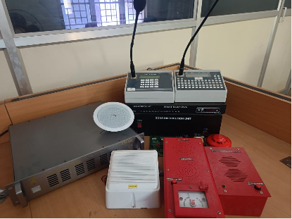

V. BLOCK DIAGRAM

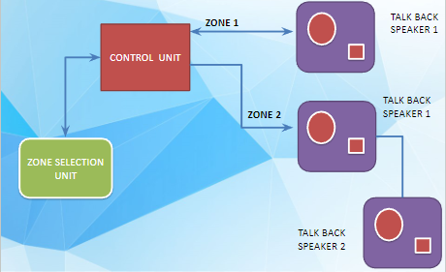

VI. CIRCUIT DIAGRAM

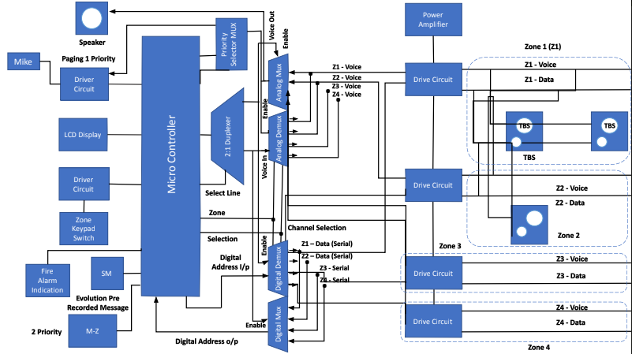

RESULT
The Arduino device is interfaced with components. Under emergency circumstances, the ISD1820
module selects zones, and statements are made through the microphone and speakers to direct people
to safety. The sensors will be able to identify a fire incident and communicate that information to the
Arduino microcontroller. When the control unit team&#39;s microcontroller learns of this, it uses the
analogue voice message module ISD1820 to transmit an evacuation message that is either live or has

already been recorded. The Arduino microcontroller will receive the analogue input and convert it to a
digital signal via the ADC port. The TTP 229 Touchpad, which connects to the Arduino Due R3
microcontroller, will be used to transmit the digitally converted signal to the area that experienced the
fire accident.

VII. CONCLUSION

We address the minor flaws in earlier fire alert system models in our work. We lower the cost of the fire alarm system, which was an important disadvantage previously. Another disadvantage of this work in comparison to earlier fire warning systems is its small size. By combining the Arduino Due R3 board with the other circuit components described above, we can reduce the size of the zone selection unit and the need for amplifier circuitry. One of the main benefits of our job is how small it is. Additionally, the price is fair. As a consequence, installation and use are simple.

VIII. REFERENCES

[1] “Automatic fire detection: A survey from wireless sensor Network perspective”, Majid Bahrepour, Nirvana Meratnia, Paul Havinga – 2008.
[2] “Survey on Various Fire Detection Methods”, Minu Sunny – 2017.
[3] “A Smart Real Time and Smoke Detection System”, Mr. Aneesh. A, Mr. Austine Cyriac, Mr. Shafeek Basheer – 2019.

[4] “Review of Recent Developments in Fire Detection Technologies”, Zhigang Liu, Andrew Kim – 2003.

