**Impact of Artificial Intelligence in Veterinary Medicine**

**Laila Elhadi Mansour1, Emhemmed Khalifa Gerish2* ,Ashraf M. Ward3**

**and Giuma Elhafi4**

1. Department of Laboratories Technology, Faculty of Sciences and Medical Technology- Tripoli, Libya

2.Department of Preventive Medicine- College of Veterinary Medicine- Misurata University- Libya

3. Department of Preventive Medicine, Faculty of Veterinary Medicine, University of Tripoli,

4. Department of Clinical Studies, Faculty of Agriculture and Veterinary Medicine, Azzaytuna University,

*Corresponding author: aqurish2001@gmail.com

**Abstract**

Artificial intelligence (AI) is a new technology that has the potential to be implemented in the field of veterinary medicine. This article discusses the potential impact of artificial intelligence (AI) on veterinary sciences and the future direction of this field, specifically in areas such as livestock production, animal health, and clinical management. Al technologies such as expert systems, physical and mechanical sensors, and machine learning algorithms can monitor animal behaviour and health patterns, allowing for early detection and prevention of diseases, personalised treatment, and genetic selection. In addition, Al can be used in clinical diagnosis and pathology, improving accuracy and reducing variability between interpretations. The use of Al in animal production can also benefit food certification and animal welfare. While there are limitations to the expansion of Al technologies, such as costs and the need for large amounts of data, companies and research laboratories are already applying Al techniques in areas such as Vaccinology and Pharmacology. Overall, the integration of Al in veterinary sciences has the potential to improve animal health, productivity, and well-being. The mention of artificial intelligence conjures images of a dystopian future worthy of a sci-fi movie: machines becoming self-aware, cyborgs battling humans for world dominance. But AI is not merely futuristic, and we should hope not dystopian. Intelligent machines are already integrated in society, from the smart phones that know our schedule to self-driving cars. And as innovation continues to evolve in every industry, researchers are also working to apply AI technology to healthcare, including veterinary medicine.

**Keywords:** Data, Artificial intelligence (AI), New Digital Technologies (NTDs), Machine learning (ML), veterinary Sciences

**Introduction**

Artificial intelligence (AI) is a specialised field within computer science that focuses on developing computational systems capable of executing activities that typically necessitate human intelligence (1). The phrase in question is a comprehensive and inclusive concept that spans various subfields and methodologies. Although most contemporary AI applications have emerged within the past decade, the foundational principles and ideas behind this field have existed for a minimum of 70 years. During the period spanning the late 1940s and early 1950s, the initial notions of artificial intelligence were introduced within the scientific community. One of the pioneering figures in the field, renowned British computer scientist Alan Turing, notably introduced the notion of computers executing intelligent operations in 1950. The phrase "artificial intelligence" was introduced by John McCarthy in 1955.

Artificial intelligence underwent extensive research during the latter half of the 20th century, yet, its limited computational capabilities could have improved its practical implementation and potential at the time. Nevertheless, due to significant advancements in computational capabilities over the last decade and the widespread digitalization and accessibility of vast quantities of data, AI has experienced a remarkable surge in development and application. Within the field of medicine, the data encompassed comprises several types of information, including but not restricted to medical imaging modalities such as radiographs, CT scans, and MRI scans. Additionally, it encompasses photomicrographs acquired through cytology and histology procedures, as well as data extracted from medical records, which encompasses free text entries and results from bloodwork analyses. One prominent use of AI in the field of medicine is the extraction of valuable insights from extensive datasets with the assistance of computer algorithms. This application aims to enhance the process of diagnosing medical conditions, refine therapeutic approaches, and ultimately enhance patient outcomes. The analysis and use of this information exhibit variability and dependency on the desired output of the artificial intelligence system, as will be demonstrated.

There are many aspects that Veterinary Sciences cover, and concomitantly, there are many areas where AI can participate, contributing positively to the development of professional activity. Inside the large areas of Veterinary Sciences, the livestock production of the different domestic species, animal health and clinical management of species company households, and the production and control of food processing intended for the human or animal population are the fundamental axes that bring together the vast majority of veterinary professionals (2). In these areas, AI that contributes to or will contribute to the best performance of these professionals will be promoted. However, it should not be forgotten that both the educational training of these professionals, such as the work of basic or applied scientific research by these actors, is of total relevance to achieving synergy between veterinary knowledge and the contribution of new digital technologies (NTDs). AI is a technology with incalculable value in the market, both in the present and in the future, but we must not only refer to monetary value; we must analyse the value it has for the optimisation of non-commercial processes, such as the education sector; AI is and will be a turning point in the changes of traditional educational paradigms. Although the pedagogical modalities at all levels of the educational system are in the process of adaptation, given the current technological tools, the modalities of virtual education are increasingly frequent in the educational policies of first world countries. AI can optimise these valuable resources since one of the biggest problems is the underutilization of technological tools or their isolated use out of context. As evidenced in the proposed schemes, AI can significantly benefit the education sector since it will help the alternatives solve significant problems currently presented by educational systems.

The automation of intensive rearing systems has been applied and evolved for some time. However, this evolution towards "intelligent" systems will allow much more precise control of all the variables, even the complete or, at least, partial autonomy of the systems. Milking robots were introduced to dairy farms years ago. However, their evolution and sophistication lead to a management level that only NTDs make possible. AI includes expert systems that integrate knowledge acquired through the repetition of data, which mathematical models and computations support. It also relies on peripheral systems, such as physical and mechanical sensors. At this point, optical recording systems have become an indispensable tool for advancing this new science in development (3).

There are currently companies that develop technologies to integrate AI into animal production. Many of these technologies are oriented towards bovine production. One of the main objectives is the exterior and interior monitoring of the animal. To implement it, it is necessary to have sensors located in collars that record external parameters of the animal or that are introduced orally so that, when swallowed, they lodge inside the reticulum, where they will remain for the rest of the animal's life. This way, it is possible to control body temperature, movement, and heartburn, among several other parameters. Externally, these sensors can establish the geolocation of the carrier, as well as detect behaviour changes in the field and determine the cardio-respiratory rhythm and the frequency of ingestion and rumination. The data download occurs when the animal approaches a wireless detector. Likewise, conventional and thermal video can be monitored by cameras, which allow individual recognition, a process carried out through digital analysis of images. The data provided by the sensors, added to those recorded in the videos, are analysed statistically through computer systems designed for this purpose (2).

All of these data can be used to find behaviour and health patterns. The constant monitoring of animals through AI allows the prevention of diseases even days before they are detected by professionals, allowing, if necessary, the isolation of the animal. In this way, the spread of the disease to the rest of the herd is avoided. It also favours early treatment and is therefore beneficial for animal welfare, as receiving personalised attention reduces the number of drugs and other inputs to be managed (4).

Constant monitoring without time restrictions generates a significant benefit. Consider combining the data from the sensors with the observation of the use of automatic feeders and drinkers. In that case, this technology can determine the conversion efficiency based on the evolution of the animal's weight, the direct milk production (or indirect through the variation of the weight of calves at the foot), among other productive indicators. Taken together, these data can also be used to establish genetic selection. By selecting the more productive animals, the environmental impact can be reduced. When it comes to genetic improvement, in particular, machine learning (ML) is a diverse collection of technologies that could impact the offspring to the extent that the genotypic information is unstructured and phenotypic to expand. Indeed, the cost for the breeder animal trade is the limitation to the expansion of genomic technologies, which generate an overwhelming amount of information. The "1000 bull genomes" project has allowed for the generation of transcendent knowledge about the genetic determinism of reproductive traits, in particular. However, the sequencing costs are still much higher than the price of the animals.

On the other hand, ML has particular limitations for its diffusion in genetic improvement, precisely the immense amount of data needed to learn in depth. In the future, it is expected that the amount of work and money needed to get the same level of accuracy in predictions from theoretical models that follow stochastic processes (such as econometrics, epidemiology, and quantitative genetics) will make the paradigm shift worth it. This could be achieved when they significantly drop the costs of "omics" technologies (phenomics, proteomics, etc.). The use of AI in animal production could favour the certification of animal welfare in food for human consumption, given the enormous amount of data possible to collect. This will allow consumers to know the living conditions of dairy or beef cows and how they were treated during production. All the data about the animals' hygiene, nutrition, and health, as well as the activities they carry out outdoors, may be available to the consumer when they require it. Intelligent weather stations can warn of changes in weather conditions. These stations, associated with monitoring the development of the forages and the personalised data of the animals, will be able to adjust accurate stocking rates (3).

Among the significant advantages of implementing AI, we could mention the early detection of mastitis in dairy cows. This health condition generates significant economic losses and affects animal welfare. In animal reproduction, machine learning algorithms could determine when to heat animals or detect the first signs of labour up to 15 hours in advance. AI could also be applied to the rest of the livestock farm animals that, although they have a much more limited productive life than that of bovines, are not for this reason less important, both in terms of their well-being, and in terms of the benefit of the food they produce for human consumption (5).

As mentioned above, AI can be implemented in the clinical practises of our pets. Thus, our country has a training model for an expert system in veterinary clinical diagnosis of mammary tumours. For the construction of this algorithm, the following were taken into account: data from the review and interrogation, morphological characteristics of the tumour, involvement of local and distant lymph nodes, and the presence of metastases in other organs. Likewise, the results of the complementary methods were consigned (laboratory and histopathology) to each patient. The data collected was collected locally, to which were added those provided by other national and international data banks. This model makes it possible to identify the existence of mammary gland tumours in companion animals based on data entered by the user.

The new data entered will make it possible to increase the initial database and the answer's precision. This algorithm is available for consultation by teachers and students. AI is also supporting traditional histopathology as a complementary technique for studying tumours. In the current conceptualization of AI, the decisions that computer systems make within the area include, but are not limited to, the interpretation of image data to define and identify structures, tissues, and abnormal changes within these images. Using deep learning, the algorithms also have the potential to unify multiple tasks in digital pathology and tissue image analysis, as they are generally good at detecting mitosis, classifying tissues, and analysing immunohistochemical staining (5). Specifically, a deep learning classifier has already been developed to automatically detect oestrogen receptor-positive breast cancer, which examines numerous fields of a large number of these tumours to measure the relationship between the number of tumour nuclei and the total number of tumour nuclei. The sample. In this way, it establishes the correlation of this relationship with the diagnostic category of oncotypes.

In the same way, other morphometric parameters can be studied, such as the nuclear perimeter and eccentricity, to arrive at the diagnosis.Several other studies show that ML algorithms work hand in hand with professional pathologists in cancer detection. These algorithms are not only accurate in detecting and classifying a cancer subtype but could also predict specific cancer or gene mutations based on imaging of pathology. Such algorithms can increase sensitivity in diagnosis while reducing sample response time, variability between clinical interpretations, pathologist workload, and total cost per diagnosis (4). A few commercial AI systems for veterinary diagnostic imaging are currently available, but they have yet to undergo rigorous peer review. Most of the peer-reviewed AI applications for veterinary imaging up to this point concentrate on proving the viability of AI's ability to precisely identify anomalies in the canine thorax (5, 6).

The utilisation of artificial intelligence in veterinary diagnostic imaging mostly centres around identifying, delineating, or categorising characteristics present within the image (7). In the context of detection, it is possible to identify anomalies within images, such as the presence of a lung nodule. In image analysis, segmentation techniques can identify and delineate distinct structures within an image. For instance, these techniques can be used to accurately define the boundaries of a nodule in the image. In classification, a category can be assigned to a characteristic or image. For instance, this can be observed when determining if a patient is positive or negative for metastasis.

Both bioinformatics and AI techniques have fueled advancements in the fields of animal health, including those in diagnosis, epidemiology, vaccineology, and pharmacology, among others. Notably, in Vaccinology and Pharmacology, AI, Machine Deep Learning, and Machine Soft Learning are not expressions of futuristic desire but, in many cases, are technological tools already being applied by companies and/or state-of-the-art research laboratories. Reverse Vaccinology (RV) has changed and accelerated the production of vaccines against different etiological agents. Unlike traditional methods that use attenuated or modified pathogens, RV uses the genetic information of these organisms and, through genomic sequencing, generates a battery of epitopes (mostly immunogenic peptides). Using bioinformatic algorithms, the proteins and epitopes most likely to be candidates for vaccine production are determined (3).

High-resolution cryoelectron microscopy, which uses bioinformatic algorithms to process and choose images, is the gold standard for predicting the secondary and tertiary (3D) structure of a protein from its genomic sequence. Using iterative learning (deep learning), it predicted protein structures with very high efficiency, similar to those obtained by X-ray crystallisation or cryoelectron microscopy. This type of technology is currently being used to develop vaccines against SARS-CoV-2. Technologies based on the production of vaccines using platforms of viral vectors, protein subunits, or mRNA, among others, use these new technologies and, in some cases, AI to analyse the impact and find new alternatives to the selection of viral variants. The rapid response to the development of vaccines for COVID-19 is an example. Developing a new algorithm for COVID-19 was optional, as companies had done for a technology of mRNA in general. Specialised agencies belonging to different countries and international organisations have developed "intelligent programmes" to predict outbreaks of infectious diseases in response to the emergency and re-emergence of human and animal diseases. These programmes are based on managing extensive data and information on emerging and re-emerging pathogens, the host response to those agents, and environmental data in real-time. Its objective is to have "early warnings" that facilitate the preparation of humanity for an eventual contingency. The COVID-19 pandemic and emergencies of Highly Pathogenic Avian Influenza (HPAI), Ebola and Marburg Fever, West Nile Fever (WNF), African Swine Fever, and others are being scrutinised permanently in order to keep the emergency risk analyses that feed the decision makers updated. By establishing such monitoring, these organisations are addressing a critical need to improve the ability of governments to forecast and model emerging threats to human and animal health, expanding collaboration through interoperability, accessibility, and a greater emphasis on supporting the decisions of policymakers and communication towards the public (4).

In the pharmacological field, around the 1980s, with the advent of the first computers, we began to model drugs and their receptors and compose the first computerised pharmacological libraries. Shortly thereafter, humans began to work on the design of new drugs. Based on defined structures, progress was made in spatial modifications adaptable to receivers known, and they were modified and selected in stages before their introduction to the laboratory. In the early 1990s, a new methodology, high-performance screening (virtual screening), was able to test several thousand compounds in a few months. It was revolutionary. Through a straightforward, fast reaction and with a clear final point, the effect exerted by various drugs on an inevitable metabolic step, binding to the receiver, etc.

High-throughput screening evolved. Since the big pharmaceutical companies have libraries of hundreds of thousands of chemical compounds, improving this methodology allowed the analysis of millions of compounds in a few days. This methodology, which develops literally at random, can be guided, in some cases, by the computerised selection of compounds, based on knowledge of the structure of the target receptors or targets. In this way, drugs are identified and considered as series heads for their subsequent transformation into candidates for clinical development, validation of targets for therapeutic use, etc. These methodologies are not revolutionary. They only represent the evolution of technologies that have been in practise for years and are becoming more potent with time. Increase in knowledge and available scientific and computational weaponry. Incorporating robotics into these screening systems transforms them into fully automated laboratories with increasing capacities. The speed and capacity of these systems have allowed not only the discovery of new drugs in a short time but have also given rise to the process of repositioning old molecules for new uses or drugs with specific indications for which new uses are discovered. The use of AI-based applications has been growing in recent years. Thus, there are currently specialised departments in these technologies and even companies that rely on intelligent computerised systems exclusively for discovering and developing new molecules with active pharmacological. The impact of innovation and evolution on the search for new drugs has and will increasingly affect the health and quality of life of human beings and animals and, ultimately, the planet's health (8). The use of AI in the orientation of activities and strategies towards animal populations who present a situation of disability or some health problem is a necessary human value, and society is indebted to policies and practises that allow the accurate insertion of unique people. AI-based assistance will support the treatments recommended by specialists and allow their insertion into society since they have exceptional abilities and skills and multiple potentials to offer society. We should not fear AI's scope and potential since, as UNESCO (2018) expressed, AI is "our service and not at our expense."

Artificial Intelligence is exerting a transformative influence on business models across several sectors, namely concerning the determination of instances necessitating human involvement or intervention and the automation of decision-making processes. The advent of big data has significantly transformed managers' decision-making processes, leading to a shift towards a more quantitative approach. This shift entails an increasing reliance on data-driven insights rather than depending solely on intuition when making business decisions. IBM is now engaged in the development of AI assistants tailored for veterinarians. These assistants can promptly identify a pet or animal type as soon as it enters the premises. Additionally, they have a comprehensive database comprising more than 800 medical diseases and cancers, which they can consult for reference.

It crosses many disciplines, including mechanistic modelling, software engineering, data science, and statistics (Figure [1](https://veterinaryresearch.biomedcentral.com/articles/10.1186/s13567-021-00902-4#Fig1)).

Figure 1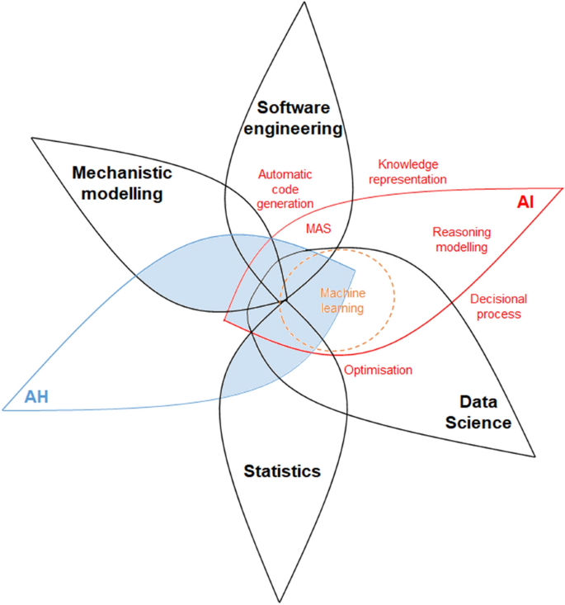

The enhancement of precision in automated veterinary diagnostic tools may be subject to alteration based on the veterinarian's direct engagement with an animal. Artificial intelligence (AI) can determine the necessity of a physical examination at a specific stage or in the presence of specific symptoms. The software, Betty,' which originates from New Zealand, aims to assist farmers in determining the urgency of their ailing cows' conditions and whether veterinary intervention is necessary. Artificial intelligence has the potential to facilitate the emergence of 'Smart Farms', wherein automated systems can diagnose illnesses in animals and dispense appropriate medicines or Combining knowledge representation (through a DSL) and such a multi-level agent-based simulation architecture (e.g., in EMULSION, Figure [2](https://veterinaryresearch.biomedcentral.com/articles/10.1186/s13567-021-00902-4#Fig2) cures through their feed, eliminating the need for human intervention.

Figure 2

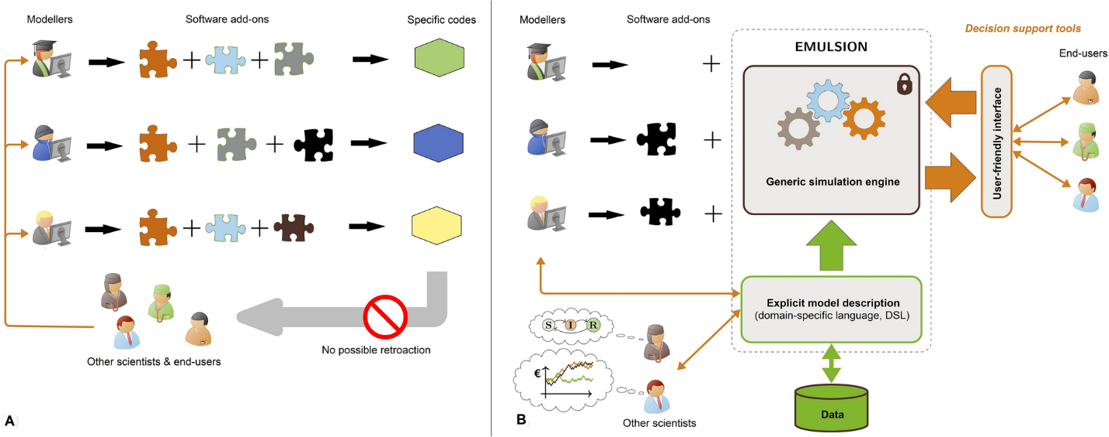

Many tasks in the veterinary sector are cognitive, such as digesting a clinical history and integrating it with an examination to develop a set of differentials or evaluating results from an imaging study or set of blood tests. There are numerous places in a veterinarian's day-to-day working life where AI could make the individual and team's job more accessible, efficient, and occasionally more effective. Finally, the power of AI is analogous to having the collective minds of some of the top professionals working for you in real time, making you, the user, better informed and more confident in your duty as a veterinarian. Integrating AI into veterinary medicine has led to a notable streamlining of medical operations.

Machine learning methods allow detecting patterns and signals in massive data, e.g., in spatial data or time-series of health syndromes and disease cases, contributing to the development of smart agriculture and telemedicine (Figure 3).

Figure 3

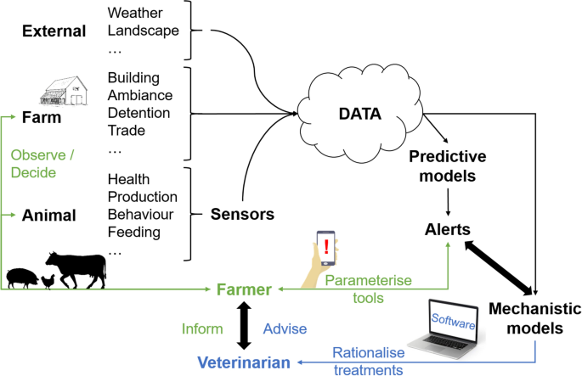

The integration of AI has facilitated the provision of several veterinary medical treatments that were previously inaccessible. Integrating artificial intelligence technology into veterinary science is progressively becoming an integral and irreplaceable element. AI has facilitated numerous advancements, such as introducing innovative technologies in veterinary medicine and improving data collection practises. Leveraging artificial intelligence (AI) approaches in animal health (AH) makes it possible to address highly complex issues such as those encountered in quantitative and predictive epidemiology, animal/human precision-based medicine, or to study host × pathogen interactions. AI may contribute (i) to diagnosis and disease case detection, (ii) to more reliable predictions and reduced errors, (iii) to representing more realistically complex biological systems and rendering computing codes more readable to non-computer scientists, (iv) to speeding-up decisions and improving accuracy in risk analyses, and (v) to better targeted interventions and anticipated negative effects.

**Conclusions**

With the advancement of computer science, the concept of AI was modified to include the ability of computers to make their own decisions with the introduction of millions of pieces of data that provide information. Once the desired level of independence from computers is reached, the concept of AI will be transferred to other objectives. AI is consistently superior to humans in performing repetitive and detailed tasks quickly and accurately. The AI will perform similarly to what the professional can do, but it is hoped that it will be a tool to help the professional, who will be challenging to replace. Various studies have shown that the performance of particular algorithms is comparable to that of an expert professional without time limitations. However, it is vital to highlight the high level of knowledge the professional provides regarding the computational advantages of AI. Thinking about the future, the ideal is to establish a mixed system that makes the advantages of computer processing compatible with professional knowledge. Even though there is a lot to think about and comprehend regarding AI, there is much potential for how AI can advance veterinary practise. We hope this article has given you some understanding of the advantages and disadvantages of AI in veterinary practise and has inspired you to learn more. We hope you like the companion article in the May 2022 American Journal of Veterinary Research issue for those interested in learning more technical elements of AI.

The Implications and usage of artificial intelligence to monitor farm animal affective state are widespread and rising technologies within human studies should be utilized and adapted to broaden the purposes of affective computing. Despite many obstacles that are yet to be overcome, it is important to recognize the problems and goals that each individual farmer might face, in order to tailor smart systems to the needs of the farm and in effect, its animals. Whereas the need for reducing disease, infection or conflict might be higher in some places and/or species, other farmers might desire to adopt even more animal-friendly and humane practices and want to focus on monitoring positive affective states to uplift animal welfare. All these factors will in turn affect the most efficient and effective technological systems and measures taken to address such goals.

Undoubtedly, technologies incorporating AI at different levels have come to stay, develop, evolve, and transform the fields of action in the veterinary sciences. The professionals in the area have the task of guiding these developments in favour of a substantial transformation to improve the nutrition of a growing world population, which demands quantity and quality, within a framework of environmental care.

**References**

1. Tran BX, Vu GT, Ha GH, et al. Global evolution of research in artificial intelligence in health and medicine: a bibliometric study. J Clin Med. 2019;8(3):360.
2. Andreas Kaplan; Michael Haenlein. (2019). Siri, Siri in my Hand, who’s the Fairest in the Land? On the Interpretations, Illustrations and Implications of Artificial Intelligence, Business Horizons, 62(1), 15-25.
3. Breiman, L. (2001). Statistical modeling: the two cultures. Stat. Sci. 16:199-231.
4. Morota,G., R.V. Ventura, F. F. Silva, M. Koyama, Samodha, C.F. (2019). Machine learning and data mining advance predictive big data analysis in precision animal agriculture. J. Anim. Sci. 96:1540-1550.
5. Banzato T, Wodzinski M, Burti S, et al. Automatic classification of canine thoracic radiographs using deep learning. Sci Rep. 2021;11(1):3964.
6. Boissady E, de La Comble A, Zhu X, Hespel AM. Artificial intelligence evaluating primary thoracic lesions has an overall lower error rate compared to veterinarians or veterinarians in conjunction with the artificial intelligence. Vet Radiol Ultrasound. 2020;61(6):619-627.
7. Tang A, Tam R, Cadrin-Chênevert A, et al. Canadian Association of Radiologists white paper on artificial intelligence in radiology. Can Assoc Radiol J. 2018;69(2):120-135.
8. Perez-Enciso, M. A. (2017). Animal breeding learning from machine learning. J. Anim. Breed. Genet. 134:85-86.
9. Hickman, S.E., Baxter, G.C. & Gilbert, F.J. Adoption of artificial intelligence in breast imaging: evaluation, ethical constraints and limitations. Br J Cancer 125, 15–22 (2021)
10. AVMA: Artificial Intelligence & Veternary Medicine https://www.avma.org/javma-news/2020-07-15/artificial-intelligence-veterinary-medicine, Accessed August 6, 2021

11.Hosny A, Parmar C, Quackenbush J, Schwartz LH, Aerts HJWL (2018) Artificial intelligence in radiology. Nat Rev Cancer 18:500–510