ARTIFICIAL INTELLIGENCE BASED MPPT TECHNIQUES
OF PHOTO VOLTAIC SYSTEM
R.GOHILA1, S.R.RITHICKUMAR2, R.VIGNESHWARAN3
1AsP, EEE, Sengunthar Engineering College, Tamil Nadu – 637 205, India.
2,3UG Student, B.E. EEE, Sengunthar Engineering College, Tamil Nadu – 637 205, India

Abstract – In this paper, Particle Swarm Optimisation (PSO) investigates the global optimal solution by taking advantage of the memory of the particle and the swarm. PSO has evolved into one of the most significant Swam Intelligence techniques and Evolutionary Computation algorithms due to its characteristics of low constraint on the continuity of goal function and joint of search space, and capacity to adapt to dynamic environments. The development of algorithms over the years is then discussed, along with applications in multi-objective optimisation, neural networks, electronics, etc. The remaining issues and potential prospects for PSO research are then examined. One of the concepts of swarm intelligence introduced in the field of computing and artificial intelligence is particle swarm optimisation (PSO). PSO is a novel collective and distributed intelligent paradigm for problem solving, primarily in the field of optimisation, without centralized control or the provision of a global model. In this work, the basic PSO, its improvements, its applications to various systems, including electric power systems, and its premature convergence as well as its combination with other intelligent algorithms to enhance search capacity and shorten the time required to exit local optimums are all thoroughly reviewed.

Key Words: Solar PV panel, Maximum Power point Tracking (MPPT), Perturb & Observe (P&O), Particle Swarm Optimization (PSO).

INTRODUCTION

Particle Swarm Optimisation (PSO) consists of a number of velocities and volume-less particles, each of which indicates a workable solution in the solution space. The algorithm moves the particles in the solution space until it finds the best answer. Researchers are paying more and more attention to PSO because of its ease of realization and great optimisation potential in a variety of problems. The majority of the pieces emphasize two aspects. The first involves enhancing PSO's performance by changing its settings, broadening its population, and combining it with other optimizing techniques. The second is the use of PSO in various fields, including multi-objective optimisation, electronics, neural network training, security, network mute selection, emergent system identification, etc.

Any photovoltaic power generation system's goal is to utilize the most power that is available at any given moment. The fact that PSO converges quickly and that efficiency is not greatly affected by the number of peaks and dimensions also makes it susceptible to other issues, such as local optimisation brought on by premature and optimal ability reliant on parameter configuration. As a result, several efforts have been made to change the parameters, broaden the algorithm, and boost diversity in order to improve PSO's ability to react worldwide and dynamically. Particle optimisation (PSO) is one of the concepts of swarm intelligence that was introduced in the field of computing and artificial intelligence as a novel, collective, and distributed intelligent paradigm for problem solving, without centralized control or the availability of a global model, optimisation is used primarily. When PSO is used to solve problems involving several variables in optimisation, the swarm adopts a predetermined size matching to the variables in the objective function(s). In the multidimensional design space, each particle is initially put at a random location with no motion. The swarm's particles, which have position and velocity, represent potential solutions in the search process. In this particle arrangement and behavior, each particle maintains a record of its positions within the search space, and its behavior will depend on the best position it has found as well as the best overall position that any member of the swarm has attained thus far. With this behavioral configuration, the design's overall impact the use of space is optimized [3] .Partial shading conditions (PSC) cause the P-V characteristic to become more complex and show several peaks, which in turn impacts the controller's performance and lowers the system's overall output power.

- EXISTING SYSTEM

`This technique alters the operating voltage to boost power. a fundamental P&O MPPT algorithm, albeit there are several more complex and well optimized variants. While ascending hills, the power converter's duty cycle is interrupted, as is the DC operating voltage between the PV array and the power converter. In the event of hill climbing, changing the voltage of the DC connection between the PV array and the power converter is necessary to disturb the duty cycle. The reference voltage and peak voltage of the module are equivalent according to the algorithm's design.

At this specific voltage level, it transports the functioning point of the module. The loss of power caused by the disorder is noticed, and under rapidly varying atmospheric circumstances, the power cannot be tracked. Yet, due to how simple it is, this approach is still fairly popular. Alternative methods, such as the partial swarm optimization (PSO) algorithm, have been developed in an effort to address these drawbacks. This methodology is adaptable and reliable and is suitable for dealing with the non-linear properties of solar panels. It can manage the effects of partial shadowing circumstances, preventing stalling at local minima and resulting in greater PV system efficiency.

PROPOSED SYSTEM

Premature convergence is one of the PSO algorithm's shortcomings while iteratively seeking out the best particles. Particle swarm optimisation relies on particle interaction to get an optimal value. The searching capacity of the algorithm will be constrained if this interaction is constrained, making it take a long time to escape local optimums. To tackle this issue, other advances have been made, including the merging of PSO with other intelligent algorithms. Elite Particle Swarm Optimisation with Mutation (EPSOM), a better Particle Swarm Optimisation (PSO) technique, was proposed by the EPSOM method speeds up convergence while enhancing the swarm's individual quality [1,2]. In the meantime, the mutation process used in this new method ensures the swarm's diversity and lowers the risk of entering a local maximum.

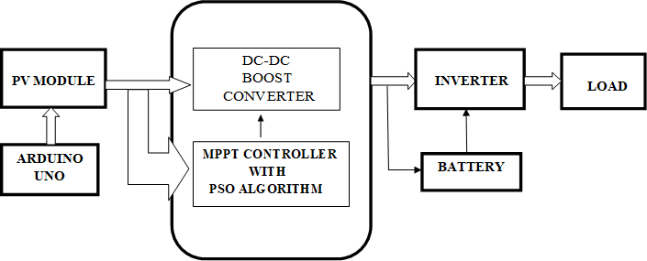
Fig- 1: Block diagram for PSO algorithm based mppt
controller
A novel particle swarm optimisation based on the equilibrium distribution of the swarm's particles was presented to address the untimely convergence problem of the PSO. To successfully prevent particle clustering inside a sub-area of the search space, a new particle that can measure the degree of the swarm equilibrium of distribution was developed. Particle swarm optimisation (PSO) algorithm is updated. Their approach combines the simulated annealing process with the particle swarm optimisation the Fig-2 shows It has improved search

efficiency because it can resolve the issue of the particle swarm optimization's local minimum and continuously narrow the search space. The approach was used to solve the problem of function optimisation, and simulation results demonstrate its efficacy.
3.1 PSO APPLIED TO ELECTRIC POWER SYSTEMS
The PSO method has genetic algorithms and evolution strategies at its foundation. As a result, it has many characteristics in common with evolutionary computing, such as random population generation at system initialization or updating generations at optimum search, but also differs from it in that it does not use evolution operators like crossover and mutation and each particle has its own memory. PSO shares many of GA's preferred qualities and is successfully applied across several sectors as a result of these commonalities. Hybrid with PSO was used to find the best mapping between unit load demand and pressure set point in a fossil fuel power unit. Based on literature[13,14], PSO has been found to be robust, flexible, and stable. The expanded PSO method for reactive power and voltage control taking voltage security assessment was proposed by Hybrid PSO, evolutionary PSO, and constriction factor [10,12]. It is suitable for solving challenging optimization issues with several parameters and is not sensitive to local optima or saddle. Similar to GA, PSO can solve nonlinear, non-differentiable multi-modal problems quickly and without the need for gradient computation.

3.2 MAXIMUM POWER POINT TRACKING

The MPPT controller determines the solar PV array's maximum power in order to operate closer to its maximum output power at the effective point [4]. Due to abrupt fluctuations in temperature and irradiance, solar PV system yield power is variable in the environment. To transfer maximum power from the PV array to the connected load, MPPT with a DC-DC converter is used [6]. As the load and source output change, the duty cycle of the DC-DC converter is continually adjusted to match the peak power point until the maximum power is reached. The Fig- 2 shows Several tracking methods for Maximum PP (Power Point) have been produced throughout the preceding ten years.

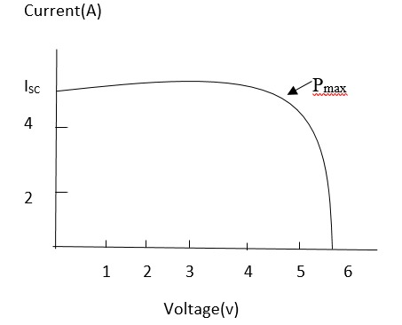
Fig-2: I-V characteristics of a solar panel

SIMULATION AND OUTPUT

4.1 Simulink for MPPT based PSO algorithm, It's flexible and robust approach fit to deal with these non direct characteristics of solar panel. It's suitable to deal with the impact of partial shading conditions therefore barring recession at original minima which restate in advanced effectiveness of PV systems.

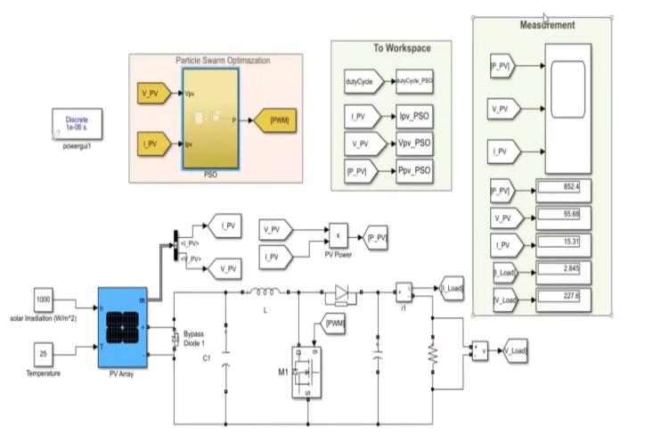 Fig - 3: Simulink model for PSO algorithm

4.2 OUTPUT
The simulation output and analysis of solar panel, converter, inverter and controlling with PSO MPPT were shown in following fig.3. The result is taken from simulation for MPPT based PSO algorithm is shown in Fig.4.

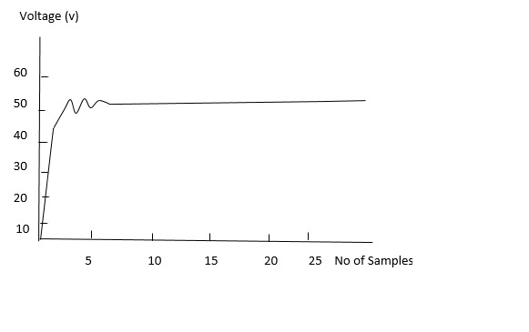
Fig - 4: Output waveforms of voltage and of PVsystem

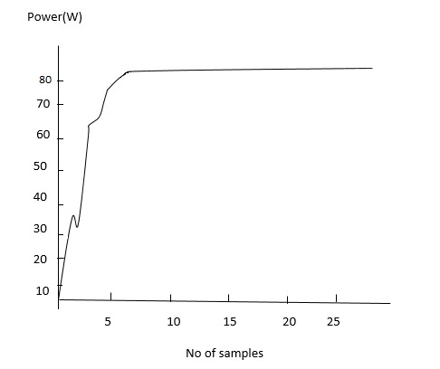
Fig-5 : Waveform of output power of PV system

4.3 DC-DC Converter
Due to its high dependability and flexibility in comparison to other converters, the boost converter is interfaced between the PV panel and the load in order to improve the efficiency of a solar PV system. It can be used to increase the voltage from a DC source [7,8]. We may adapt the voltage to the photovoltaic panels terminal using this power electronic slide, which is a continuous-continuous converter, using a control technique that enables operation at the point of greatest power[9].
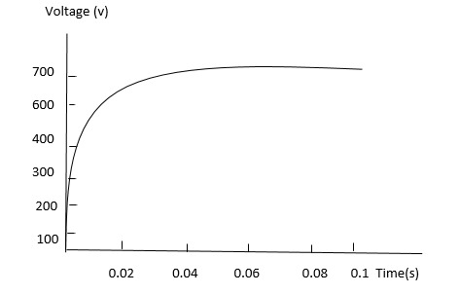
Fig- 6 : Output voltage of Dc-Dc Converter of PV system

- HARDWARE IMPLEMENTATION

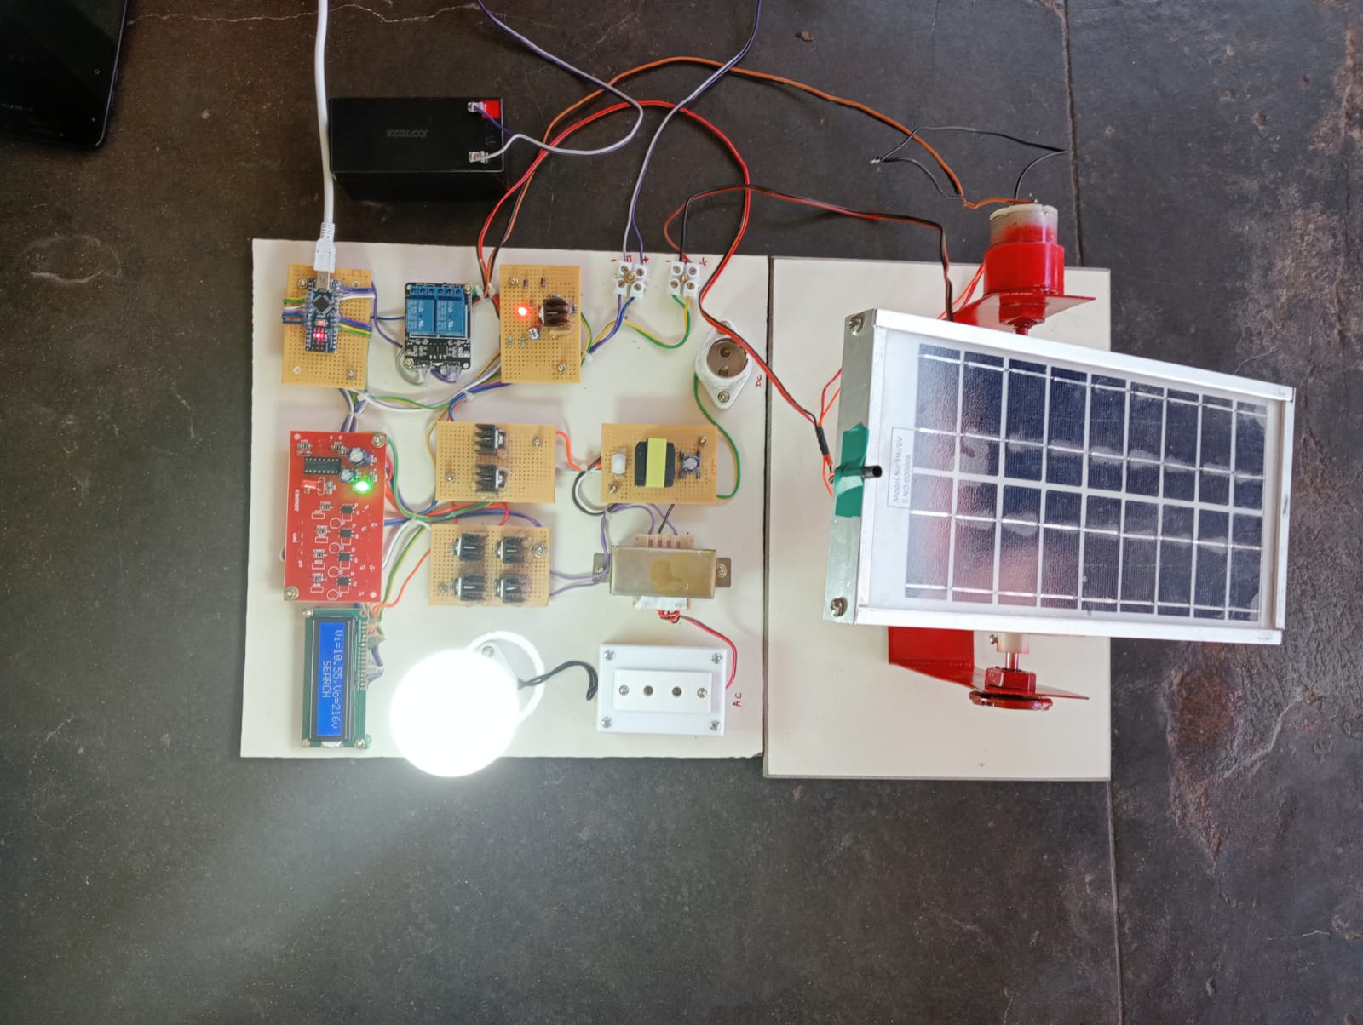

Fig – 7: Experimental Setup of Proposed system

5.1 OUTPUT

S.NO | TIME | VOLTAGE
1. | 5 | 180
2. | 10 | 200
3. | 15 | 220
4. | 20 | 220
5. | 25 | 220

6. RESULT AND DISCUSSION
In this paper, Matlab/Simulink and hardware are used to assess the convergence and effectiveness of the Particle Swarm Optimization (PSO) methods. The maximum power point tracking (MPPT) techniques PSO used to maximize the energy extraction in photovoltaic (PV) power systems. Convergence speed, efficiency and energy losses of both approaches are considered in the paper. PSO method takes longer to achieve the MPP than the other algorithm, it suffers from fewer energy losses. The PSO technique can finally ensure convergence to the maximum power. Although PSO has been accepted widely as a potential global optimizing algorithm because of its convenience of realization and low constraints on the environment and objective function, there is still a great space for the research of the algorithm itself and its application. In the application fields, it is most important to develop an effective parallel PSO to satisfy the requirement of large-scaled engineering optimization problems. The simulink and hardware output were as well as equal. So PSO algorithm obtain maximum power point tracking and give constant power as compared to other algorithm.

7. REFERENCES

[1] Ramaraju, Satish Kumar, Kaliannan,Thenmalar, Androse Joseph, Sheela, Kumaravel, Umadevi, Albert, Johny Renoald ,Natarajan, Arun Vignesh , Chellakutty, Gokul Prasad, “Design and experimental investigation on VL-MLI intended for half height (H-H) method to improve power quality using modified particle swarm optimization (MPSO) algorithm” Journal of Intelligen and Fuzzy Systems. 2021

[2] George, Sophia Jasmine Ramaraju, Satish Kumar , Venkataraman, Vanitha , Kaliannan, Thenmalar, Kumaravel, Umadevi, Veerasundaram,” Congestion management in deregulated power system by series facts device using heuristic optimization algorithms” Journal of Intelligent and FuzzySystems. 2021

[3] Marini F and Walczak B. (2015). Particle swarm optimization (PSO). A tutorial. Chemometrics and Intelligent Laboratory Systems, 149, 153–165.

[4] Saidi K, Maamoun M, Bounekhl M. Simulation and implementation of incremental conductance MPPT algorithm with indirect control method using buck converter. 2017 6thInternational Conference on Systems and Control (ICSC), Batna. 2017; 199‐204

[5] S. R. Potnuru, D. Pattabiraman, S. I. Ganesan and N.Chilakapati, "Positioning of PV panels for reduction in line losses and mismatch losses in PV array," Renewable Energy, vol. 78, , 2015, pp. 264-275.

[6] Groniewsky A. (2013). Exergoeconomic optimization of a thermal power plant using particle swarm optimization. Thermal science, 17(2), 509-524

[7] Bahgat ABG, Helwa NH, Ahmad GE, El Shenawy ET. Maximum power point tracking controller for PV systems using neural networks. Renew Energy 2005; 30:1257–68.

[8] Z. Liang, R. Guo, J. Li and A. Q. Huang, "A high- efficiency PV module integrated dc/dc converter for PV energy harvest in freedom systems”, IEEE Trans. Power Electron., vol. 26, no. 3, 2011,pp.897 -909

[9] M. Miyatake, F. Toriumi, T. Endo and N. Fujii, "A novel maximum power point tracker controlling several converters connected to photovoltaic arrays with particle swarm optimization technique," in Power Electronics and Applications, 2007 European Conference on, 2007

[10] B. N. Alajmi, K. H. Ahmed, G. P. Adam and B. W. Williams, "Single-phase single-stage transformer less grid- connected PV system," IEEE Transactions on Power Electronics, vol. 28, 2013, pp. 2664-2676.

[11] B. N. Alajmi, K. H. Ahmed, G. P. Adam and B. W. Williams, "Single-phase single-stage transformer less gridconnected PV system," IEEE Transactions on Power Electronics, vol. 28, 2013, pp. 2664-2676.

[12] S. Hadji, J. Gaubert and F. Krim, "Maximum power point tracking (MPPT) for photovoltaic systems using open circuit voltage and short circuit current," in 3rd International Conference on Systems and Control, 2013, pp.87-92.

[13] Junliang Li and Xinping Xiao. (2008). Multi- Swarm and Multi- Best particle swarm optimization algorithm. 7th World Congress on Intelligent Control and Automation.

[14] Junjun Li and Xihuai Wang. (2004). A modified particle swarm optimization algorithm. Fifth World Congress on Intelligent Control and Automation (IEEE Cat. No.04EX788).

[15] Yoshida H, Kawata K, Fukuyama Y, Takayama S and Nakanishi Y. (2000). A particle swarm optimization for reactive power and voltage control considering voltage security assessment, IEEE Transactions on Power Systems, 15(2), 1232–1239.

