FPGA IMPLEMENTATION FOR EFFICIENT LIFT CONTROL SYSTEM

AuthorAffiliations

|  |  |  |
| --- | --- | --- |
| Nayana Devi S B.E, ECE  National Engineering College, Kovilpatti [1911032@nec.edu.in](mailto:1911032@nec.edu.in) | Shirlin Jeno Wincy J B.E, ECE  National Engineering College, Kovilpatti [1911103@nec.edu.in](mailto:1911103@nec.edu.in) | Vinitha Selvi A B.E, ECE  National Engineering College, Kovilpatti [1911113@nec.edu.in](mailto:1911113@nec.edu.in) |
|  | Dr.A.Shenbagavalli (Professor) B.E, Head of the ECE Department  National Engineering College, Kovilpatti  [hodeceug@nec.edu.in](mailto:hodeceug@nec.edu.in) |  |

***Abstract*** *- The lift control framework is one of the most crucial elements of the hardware control modules used in automotive applications. Most of the time, elevators are designed with a certain building in mind. With predetermined information inputs and outputs, the FPGA may run across any number of floors while controlling utilisation. By simply altering a control variable in the HDL code, this controller can be utilised for a lift with the needed number of floors. To achieve a good response time without including any additional logic circuits, a simple plan is adopted in the design. A revolutionary FPGA-based elevator controller addresses the drawbacks of conventional single-chip microcomputer-based elevators.*

1. INTRODUCTION

Global demand for Very Large Scale Integration has increased as a result of the semiconductor industry's tremendous growth over the past 20 years. The fundamental ideas of digital logic theory and methodologies may be easily understood using VLSI- based designs. the fundamental ideas behind complex, fast digital circuitry. Every day, technology continues to advance. It follows that the designs must be made simpler in order to gain the benefits. The goal of an integrated

circuit is to create an eight-floor elevator controller that can work as a part of an elevator controller. The elevator determines where to take passengers by comparing the current floor with the desired floor and providing instructions. subject to the conditions that the weight be less than 4500 lbs. and the door close in three minutes. If the weight goes over that limit, the elevator will alert you right away. When the door has been open for more than three minutes, the Door Alert signal, which is typically quiet, becomes louder. If the elevator has passed the current floor is determined by a sensor on each floor.

The sensor's signal contains an encoding for the floor that was previously traversed. This paper offers a novel approach for enhancing the reliability of a reconfigurable FPGA-based elevator controller with predetermined inputs and outputs. Any elevator, regardless of how many floors it has, can use this controller.

Historically, steam and water hydraulic pistons or human labour were used to power the driving systems for elevators. In a "traction" elevator, vehicles are raised by rolling steel ropes over a sheave, or pulley, having a deep groove. The car's weight is balanced by a counterweight. There are times when two elevators are built to move simultaneously in opposite directions and balance one another. This

particular kind of elevator gets its name from the traction produced by the friction between the ropes and the pulley. By exerting pressure on an above- or below-ground piston using the principles of hydraulics (as in hydraulic power), hydraulic elevators raise and lower the car. Recent innovations include gearless machines mounted on tracks without needing a machine room, permanent magnet motors, microprocessor controllers, and more. The technology used in new installations is impacted by a number of factors. Although it is impractical to construct cylinders longer than a certain length for very high lift hoist systems, hydraulic elevators are less expensive. For structures taller than seven stories, traction elevators are required. Hydraulic elevators often move more slowly than traction elevators. Elevators could be mass-customized. Cost savings can be achieved by mass producing the components, however each construction has unique requirements, such as different floor counts, well diameters, and so on.

ELEVATOR CONTROLLER

Elevators were originally created as a convenience, but they have since developed into a necessary part of modern urban life. "A machine that takes people or products up and down to different levels in a building or mine" is the definition of an elevator. One master controller can control and coordinate the activities of several separate elevator units that make up an elevator system. Each elevator unit is a straightforward electromechanical machine. The apparatus uses the floor level as an input and produces control signals to manage lift activity.

1. LITERATURE SURVEY

*Survey I-*

Dumbwaiters and workplace elevators both operate in essentially the same ways. One such application is studied and simulated in this piece of work using a five- story elevator controller as an example. Because it can be reused, can be reprogrammed, and allows for quicker and less expensive prototyping, a Field Programmable Gate

Array (FPGA) was selected for this study. To move the elevator from its present state to the intended next state, the elevator control system uses a Finite State Machine (FSM), which gathers floor inputs from inside the elevator as well as up and down calls from outside.

*Survey II-*

To sustain 23 buildings at the dawn of an era of highly varied new technology. The elevator in a high-rise structure enables residents to move vertically between floors. This study includes a four-phase lift controller that uses finite state machines and Verilog HDL code (FSM)

*Survey III-*

An essential component of the hardware control modules utilised in automotive applications is the lift control framework. Often, when designing a lift, a particular building is taken into account. Use is managed by the FPGA, which has predetermined information inputs and outputs and may function across any number of levels. Just changing a control variable in the HDL code will enable this controller to work with a lift that has the necessary number of floors.

1. PROPOSED WORK

Throughout the coding phase, we used a variety of techniques to keep the programme running.To avoid using the same variable name for both the input current floor and the output current floor, we first gave them different names. Additionally, we add two new input pins to the code called Over time and Over weight. These signals will be delivered to the controller by the mechanical device. When the controller receives a signal from a weight alert or door alert, the elevator won't move while it's on the Out Current Floor.

Then, everything will come together as one. Lastly, create the Out Current Floor, Direction, Complete, Door Alert, and Weight Alert regs and assign equal values to the output. The variables will so serve as an output and register. The variables Complete, Door Alert, and Weight Alert are initialised to zero when the Reset switch is not

depressed. The variable In Current Floor is similarly only once set to equal Out Current Floor when the Request Floor is enabled.

Even when the Out Current Floor equals the Request Floor, it still updates and compares with it. Mention three if statements pertaining to elevators as a final point.

When an elevator is working properly, it compares the Request Floor and Out Current Floor to determine which way to move; however, it activates the Door Alert if a door is left open for longer than three minutes, and it activates the Weight Alert if it is transporting obese passengers.

1. BLOCK DIAGRAM

The inputs and outputs of the elevator controller are shown in the block diagram below.

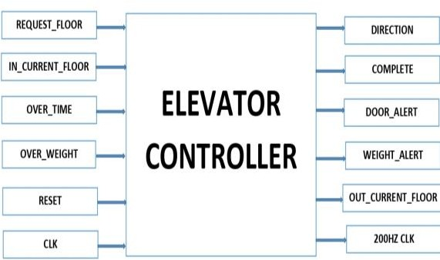

**Fig.3.1.**Block diagram of lift controller INPUTS

Define Request Floor as an input variable of type 8-bit. The numbers from 00000001 to 10000000 correspond to the first through eighth floors. (The second storey has the designation 00000010, while the third floor has the number 00000100. For In Current _Floor, add a definition for an 8- bit input variable. Instead, the Out Current _Floor that has reached the target floor may be used to specify the top floor and every floor below it. It will be helpful to define clk as an input variable. clocks with low frequency are made. To create a reset. Make Over Time an input variable. The number "1" in the tz Verilog code denotes that the waiting duration exceeds three minutes. The signal from the timer

will be Input Over Time (machinery part). Over Weight should be used as the definition of the input variable. In Verilog code, the number "1" denotes an elevator overload. A signal from the weight detector will be input over weight (machinery part).

OUTPUTS

Provide the name Direction to the output variable. The numbers "1" and "0" in Verilog code represent upward and downward motion, respectively. Provide the value Complete to the output variable. The elevator that enters the designated floor is represented by the number "1" in the Verilog code. In cases when the Over Time or Weight Warning is enabled, it can also be used in place of stopping (remain stationary at the Out Current Floor). It is necessary to set a Door Alert output variable. Output Door Alert will also be functional. Choose Weight Alert as the desired output parameter. The number "1" represents a busy elevator. When Over Weight is active, Input Weight Alert also becomes active. Define the output variable Out Current _Floor as an 8-bit value. This specific variable will be utilised.

1. THREE CASES OF ELEVATOR

*Case I-* An example of how the elevator usually operates. The elevator will move up if the Request Floor is higher than the R Out Current Floor. If the Request Floor is below the R Out Current Floor, the elevator will depressurize. If the Request Floor equals the R Out Current Floor (it reaches the Request Floor), the R Complete is on, and the elevator stops travelling. The "1" and ">>1" represent shift registers. By one, the desired orientation is introduced into the data. In this case, "1" will transform "00000001" into "00000010."

*Case II-* About three minutes had passed since I last shut the door. Both the R Door Alert and R Complete are set to ON when the Reset is disabled but Over Time is enabled. Off is an option for both the R Weight Alert and R Direction. Information is maintained there by the R Out Current Floor.

The elevator will halt (or pause) and the door alarm will cease to operate once the countdown has ended.

*Case III-* Almost 4500 pounds of weight may be supported by the elevator. The R Weight Alert and R Complete are set to be ON if Over Weight is enabled but Reset is disabled. R Door Alert and R Direction are ineffective. To R Out Current Floor, the R Out Current Floor keeps its data. As a result, if an elevator is too full, the weight alert ring will ring and it will stop (or pause) moving.

VI.IMPLEMENTATION USING FPGA

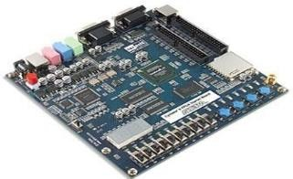The term "FPGA" refers to field-programmable gate array. An FPGA is essentially a collection of interconnected digital subcircuits that can be extremely flexible while carrying out a number of related activities. An FPGA does not consist just of a Boolean gate array. This would be a far inferior method of enabling adjustable logic because it would not benefit from the fact that common operations can be carried out much more successfully as fixed modules. The same principle underlies discrete digital integrated circuits. Hence, an FPGA is considerably more than just a gate array. It is composed of numerous well constructed and interconnected digital subcircuits that cooperate to carry out essential tasks while also enabling a great deal of flexibility. Customizable logic blocks (CLBs), which are digital sub-circuits, are used to build programmable logic by the FPGA..

**Fig.6.1.** FPGA board(EP2C35F67236) SOFTWARE USED

Previously known as Altera Quartus II, Intel Quartus II is a programme used to design programmable logic devices. Quartus Prime enables developers to compile, run timing analyses, view RTL diagrams, simulate a design's response

to various stimuli, and analyse and synthesise HDL designs. Quartus Prime also enables developers and programmers to collaborate on setting up the target device. Quartus Prime offers a VHDL and Verilog implementation for hardware description, visual logic circuit editing, and vector waveform simulation.

* 1. RESULTS MODELSIM RESULTS

*Simulation Result I-****Request floor = 00000001; In_Current_floor = 10000000***

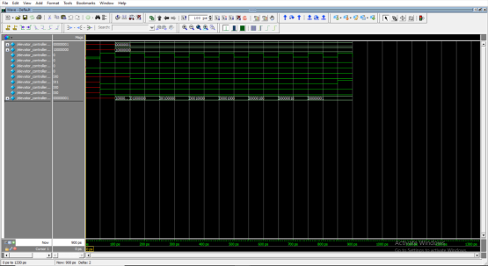

**Fig.7.1.** Simulation Result 1

**Request floor = 00001000; In Current floor = 10000000,**

according to Simulation Outcome II.

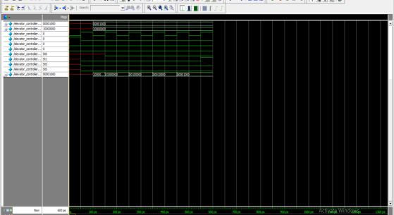

**Fig 7.2.**Simulation Result 2 QUARTUS TOOL SIMULATION RESULTS

RTL VIEW

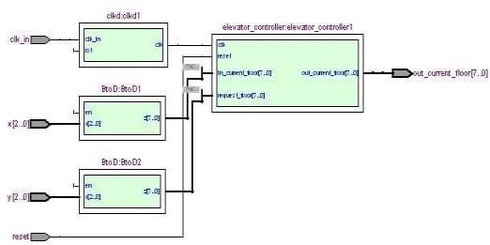

**Fig.7.3.**RTL view

CLOCK IN

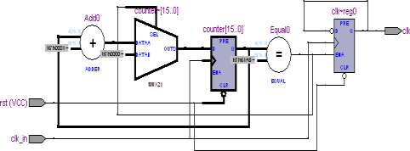

**Fig.7.4.**clock in

BINARY TO DECIMAL DECODER

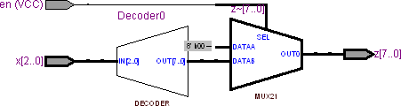

**Fig.7.5.**Binary to decimal converter CONTROLLER BLOCK

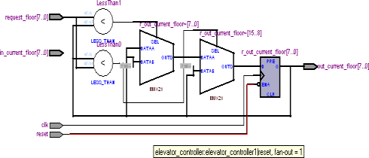

**Fig.7.6.**Controllerblock SYNTHESIZED REPORT

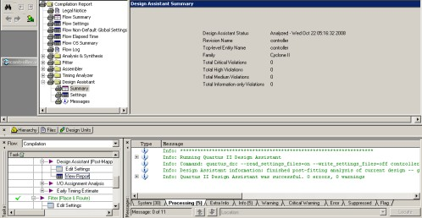

**Fig.7.7.**Synthesized report

Implementing Verilog code in EP2C35F6723

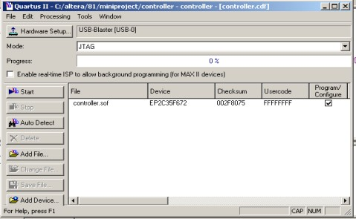

**Fig.7.8.**Implementation

* 1. CONCLUSION-

An efficient lift control system is designed and implemented in an FPGA using VHDL. The elevator controller inputs the required floor, and then outputs what the user has asked for. The modelsim tool simulates this lift movement from the current floor to the desired floor, and the results are generated as a waveform. The Verilog code is then implemented using the FPGA Cyclone 2 (ep2c35f67236). In Register Transfer Level view, the implemented verilog code is reviewed, reported on, and shown.

REFERNCES

1. M. D. Ciletti, “Advanced Digital Design with the VERILOG HDL,” Prentice Hall of India.]
2. C. Carmichael, “Triple Module Redundancy Design Techniques for Virtex FPGAs,”Application Note: XAPP197 (v1.0.1), 2006.
3. FPGA Compiler II/FPGA Express Verilog HDL Reference Manual Version 1999.05,1999.
4. M. A. Ullah, and M. A. Saeed, “Design and Implementation of EfficientnElevator Control System using FPGA,” International Journal of Innovation and

Applied Studies, vol. 9, pp. 1541-1546, 2014.

1. M. S. Siddiqui, and K. Hasan, “Synthesis and simulation model of parallel lift controller using verilog,” International Journal of Engineering Development and Research, vol. 3, pp.1-3, 2015.[6] H.P.A.P. Jayawardana, et al., “Design and Implementation of a state chart based reconfigurable elevator controller,” IEEE International Conference on

Industrial andInformation System, Kandy, pp. 352- 357, 2011.

1. P. K. Babu, and H. R. Rao, “A VLSI implementation of three-lift controller based on verilog,” International Journal of Engineering Trends and Technology, vol.6, pp. 43-48,2013.
2. H. Soni, A. Purani , and V. Dabhi, “Design and simulation of dual elevator controller using FPGA,” International Journal of Advance Research in Engineering, Science and Technology, vol. 2, pp. 1-3, 2015
3. SithuminiEkanayake,RuwanEkanayake,So masundaram Sanjayan, Sunil G.Abeyratne, S.D.Dewasurendra“FPGA Based Elevator Controller with Improved Reliability” 2013 UKSim 15th International Conference on Computer Modelling and Simulation IEEE.
4. PatchalaKiranBabu, H. RaghunathRao “A VLSI Implementation of Three- Lift Controller Based on Verilog” International Journal of Engineering Trends.and Technology (IJETT) – Volume 6 Number 1-

Dec 2013

1. D. Harel, “Statecharts : A Visual Formalism for Complex Systems”,Science of Computer Programming, Vol.8,(3), pp.231- 274, 1987
2. Y – S. Huang, S – L. Chung, and M – D. Jeng, Modelling and Control of elevators by Statecharts”, Asian Journal of Control, Vol. 6,

No. 2, pp. 242-252, June 2004

1. Brian Pratt, Michael Caffrey, Paul Graham, Keith Morgan, and Michael Wirthlin,

"Improving FPGA Design Robustness with Partial TMR", Reliability Physics Symposium Proceedings, 2006 IEEE

1. Karl Schabas,Stephen D. Brown, “Using Logic Duplication to Improve Performance in FPGAs”, University of Toronto, Toronto,

Canada

1. ZHAO Yuhang, MA Muyan, “Implementation of six – layer automatic elevator controller based on FPGA”, Wireless Communications Networking and Mobile Computing(WiCOM), 2010 IEEE
2. XILINX Triple Module Redundancy Design Techniques for Virtex FPGAs”,

Application Note

1. Monzurul Islam Dewan, Md. Arafat Mahmud, Md. Tashfiq Bin Kashem, MushfikaBaishakhiUpama, “A Simulation Study of Elevator Control of a Building using Digital Logic Circuit” IOSR Journal of Engineering Vol. 3, Issue 12 (December. 2013)