**A Bridgeless Isolated Half-Bridge Converter-Based EV Charger With Power Factor Preregulation**

**Abstract:** Conventional full and half-bridge (HB) converters are widely used in the front-end power factor (PFP) of electric vehicle (EV) battery chargers. High power discontinuous transmission mode (DCM) operation causes increased electrical noise. The oscillations increase with the addition of interference to the circuit. The oscillations are large and have been shown to increase the harmonic content at the current input when performing deep DCM. This article presents a PFP-based EV charger without an isolation HB converter to reduce LC oscillation in DCM. To reduce LC oscillations, the two diodes are connected in series with as few magnetic components as possible, which describes the concept of charger architecture in DCM for the same batteries during constant current/voltage charging.

**Keywords**: Renewable energy, Battery charger, bridgeless (BL) half-bridge (HB) converter, constant current/constant voltage (CC-CV) charging, electric vehicle (EV), PF preregulation, power quality (PQ)

1. **INTRODUCTION**

While facing many problems in today's world, many greenhouse gases are released that are not good for our environment. Non-renewable energy sources are one of the biggest contributors to greenhouse gas emissions. In addition, these power plants are the main source of many diseases for the people living in the power plants. Also, these power plants don't last forever because their energy resources are depleted quickly. Wind uses more electronics (like gearless or gearless equipment) to increase the voltage produced.In addition, inverters are used to adjust the output voltage so that it exceeds the value of the grid. Since its stage is ahead of the bus stage, it can integrate wind energy into the bus grid. The combination is easy to achieve due to the lack of shared buses. Major issues with air conditioning solutions include changes in power output or efficiency. In a renewable energy scheme, wind and solar power are combined to increase the reliability of an electrical system.Conservatively, the wind turbine's AC output power is rectified or then interacted with the solar cell's output voltage to charge the battery or power load.d.

# ENERGY RESOURCES

Since the invention of the first electric machine in the 17th century, the use of electricity has been a subject of interest for many reasons such as politics, economy, world population, the need to use new technologies. The growth of electrical applications has led to the worldwide search for new energy sources. Other new energy sources are also used to reduce energy consumption. Global energy production/consumption details. In terms of quantitative change, energy can be divided into two groups as non-renewable resources and renewable resources.

**Renewable Energy Resources** Renewable energy is a resource that can be used and recycled over time. Industrialization and increasing world population support the use of renewable energy. Know solar energy, wind energy, biomass energy, tidal energy, wave energy, geothermal energy

**STATEMENTOF THE PROBLEM**

In recent years, the search for new and improved solutions for batteries for electric vehicles (EVs) has opened up a wider platform, as today's transportation will rely on batteries as electrical power [1]. The battery charger is an essential part of the electric vehicle and its characteristics affect the life of the battery and the performance of the connected electronic equipment [2]. Therefore, a reliable EV charger must provide unified power factor (UPF) performance and low current distortion (THD) of the mainstream system, as defined by standards such as IEC 61000-3-2 [3]. However, the integration of the diode bridge rectifier into the EV power supply results in a reduction in main current of about 56.1%, as shown in Figure 2.

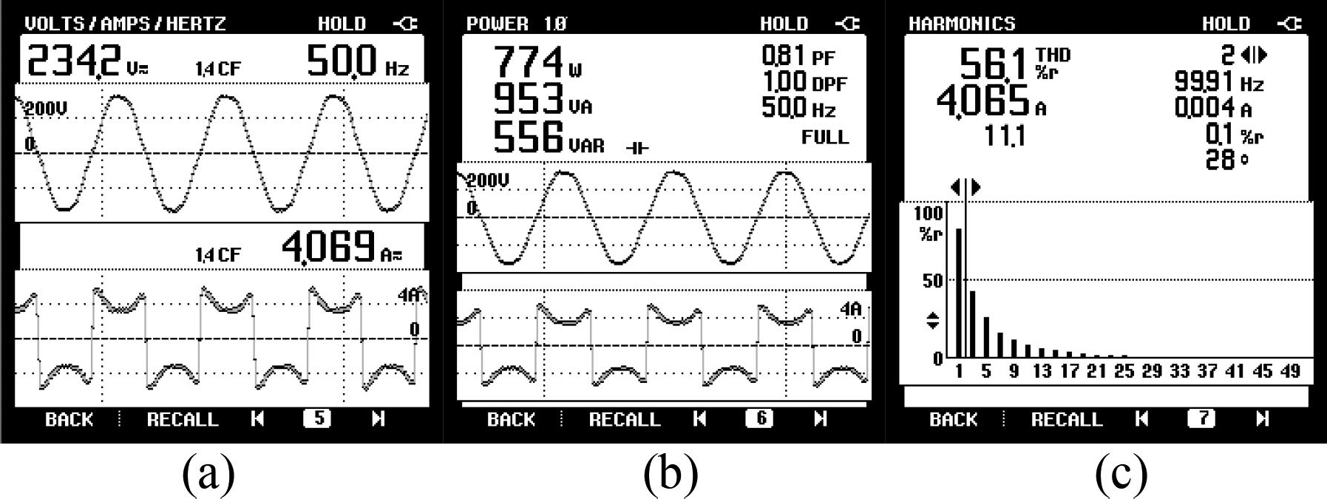

**Figure 1.2. Conventional Electric Charging System**

This exceeds the limit approved by international regulations. In addition, the presence of input diodes in the rectifier greatly contributes to higher conduction losses due to the increase in the number of places. The power factor pre-regulation (PFP) converter in bridgeless (BL) configuration provides the most reliable solution to these problems in modern EV chargers. These converters reshape the existing product, reducing the input current harmonic content to the limits recommended by the regulators. Traditional BL buck [4] and boost [5] rectifiers are considered the most popular solutions for PF correction in unidirectional battery chargers.

On the other hand, boost converters [6] provide the best solution for UPF operation in EV chargers as the duty cycle can be varied in many ways The power supply voltage changes immediately. The transmission loss in the PFC device of these BL converters is very low. Several Phase 1 battery chargers for EVs have been reported in the literature [7] based on advanced topologies such as full bridge (FB) [8]–[9], half bridge (HB) [10] and LLC converters [11]. Previous work [12], [13] discussed other EV charger configurations based on interleaving and zero voltage switched power factor correction (PFC) converters. There are both.

The converter magnetic volume reduced less high switching current and less ripple current, but added more components to the circuit. Two-stage EV chargers have major advantages such as reliability, tight DC-link voltage control, and small DC-link capacitor size, but ultimately require more equipment. Extensive research has shown that single-phase split chargers can overcome high voltage limitations and provide higher performance than two-phase chargers. To reduce LC oscillations, two diodes are used in series with minimal magnetic properties. The design of the charger in the DCM is explained to facilitate balancing of the battery current during charging / continuous.

* 1. **AIM OF THE WORK:**

**This** paper aims to develop a PFP bridgeless isolated HB converter based EV charger with reduced LC oscillation in DCM is presented in this article. To reduce LC oscillation, two diodes are used in series with minimum number of magnetic components. The design of proposed charger in DCM is illustrated to facilitate uniform battery current during constant current/constant voltage charging. The inherent advantage of reduced conduction loss with bridgeless topology is achieved. The performance of this isolated HB converter based charger is shown for improved oscillation characteristics and power quality operation at steady state and over a range of varying input voltages. These oscillations increase with parasitic components of cir- cuit. During deep DCM operation, these oscillations are seen to be signThis article is designed to design a PFP-based EV charger without an isolated HB converter to reduce LC oscillation in DCM. To reduce LC oscillations, two diodes are used in series with minimal magnetic properties. The design of the charger in DCM is explained to facilitate charging the battery as it is nowadays during current/continuous charging. The advantage of reduced transmission is achieved by the absence of a connecting link. The performance of this discrete HB converter as a charger increases oscillation characteristics and power efficiency in steady state and a wide variety of power sources.

The oscillations increase with the interference of the circuit. These oscillations are significant during deep DCM operation and increase the harmonic content at the current input. FB and HB PFC topologies are very popular for PF regulation in battery chargers. However, the electrical design and control of four-port drives is very difficult and increases the size of the converter. In addition, similar frequency oscillation problems were observed in these converters [18], [19].

In the literature, a number of suitable protection measures have been proposed to reduce the interference current, but at the expense of additional power conversion [20], active damping [21 ] or additional switches [22]. Because only two converters are used, the HB PFC converter provides a better alternative to high-speed power-based solutions. Several such HB configurations have been proposed in the literature, including switching [23] and resonant converters [24], [25]. A new battery charger with series parallel HB resonant converter is proposed in [26] to reduce the effect of low frequency and high frequency current ripple (oscillation). A new oscillation suppression technique to support the PFCconverter using only series diodes is discussed in [27].

Used in conjunction with HB PFC converters, this technique reduces LC oscillations in DCM powered converters [28] and maintains the improved efficiency and energy density of EV chargers. First, the advantages and disadvantages of the LC oscillation frequency in the HB PFC converter are examined. Table II compares the isolated HB converter by the number of switching points with the current state-of-the-art converters. Therefore, this article presents an extension-based PFP BL isolated HB converter for EV charger that reduces LC oscillations. The contribution of this work is to provide low emission, low noise and higher performance by using the least equipment.ificant and contribute to harmonic content in the input current. The FB and HB PFC topology is quite popular for PF preregulation in battery charger. However, the circuit design and control of four individual gate drivers are complex and it adds to the size of the converter as well. Moreover, similar problem of high-frequency oscillation is observed in these converters [18], [19]. Several appropriate suppressing countermeasures are suggested in the literature to reduce these current distortion, but at the cost of an extra soft-switched circuit [20], active damping [21], or additional switches [22]. The HB PFC converter gives better alternative for high power density based solutions due to use of only two switches. Several such HB configurations are presented in the literature with soft switching [23] and resonant converter [24], [25]. A new battery charger with series parallel HB resonant converter is presented in [26] to reduce the effect of low and high frequency current ripple (oscillations). A novel oscillation suppression technique for boost PFC

converter is discussed in [27] by using only a series diode. This technique is used with HB PFC converter to provide the mitigation of these LC oscillations in DCM operated converter [28] and to retain the characteristics of improved efficiency and power density of EV charger. The merits and demerits of high-frequency LC oscillations in HB PFC converter are presented with preliminary results. A comparison of proposed isolated HB converter with prior state-of-the-art converters is given in Table II based on number of circuit components. Therefore, an extended version based on PFP BL isolated HB converter fed EV charger with reduced LC oscillation is presented in this article. The contribution of this work is seen in terms of minimal component count used to provide low oscillation, lower circuit loss, and improved efficiency.