Advanced Analysis and Optimization of Coated Carbide and Ceramic Inserts for CNC Turning of Monel K-500

**Sathrak yobu S1, , Dr. N. Nandakumar 2 Dr. S. Periyasamy 3**

1PG Student , Engineering design , Government college of technology, Coimbatore, Tamilnadu, India

2 professor, Government college of technology, Coimbatore, Tamilnadu, India

3 Associate Professor, Government college of technology, Coimbatore, Tamilnadu, India

**ABSTRACT (Font-Times New Roman, Bold, Font Size -12)**

This experimental investigation aims to analyse into the vibrational characteristics and machinability performance of hard turning on Monel K-500 using different coated inserts. Three different machining inserts were taken and the cutting parameters, such as cutting speed, feed, and depth of cut, as significant aspects were considered for this work. Ceramic and coated carbide inserts (TiCN-Al2O3-TiN and TiCN-Al2O3) have been taken as categorical factors in the experiment work. An L18 mixed type orthogonal array based on Box-Behnken Design was considered to undergo various test performance. During experimental measurements, the study evaluates the cutting force components (Fx, Fy, and Fz), surface roughness (Ra), and tool vibrations in all directions in displacement, velocity and acceleration (d, v and a) were measured. Considering the data acquired, optimisation based on Response Surface Methodology (RSM) was used to reduce tool vibration and enhance machinability properties. Using 3D surface and contour plots, the impact of process parameters on machining characteristics is examined. For hard turning on Monel K-500, the study determines the optimum ideal machining parameter values, which are then confirmed through confirmatory experiments, which results in minimum tool vibration and improved machinability properties.

**Keywords:** Monel K-500,vibration characterstics,machinability

1. **INTRODUCTION (Font-Times New Roman, Bold, Font Size -12)**

The metalworking industry faces a continuous challenge in catering to the diverse demands of customers seeking qualitative, reliable, and sophisticated parts and products in our modern technological world. As a result, manufacturers worldwide are diligently searching for cost-effective solutions to maintain their competitive edge when producing machined components and goods. A pivotal aspect in achieving this lies in the effective use of cutting tools mounted on machine tools during the manufacturing process. The rapid advancements in technology have played a significant role in shaping the metalworking industry, creating new possibilities for cost reduction and improved product quality. To capitalize on these opportunities, the selection of appropriate materials, cutting tools, and combinations is of utmost importance in the production process. . Once the right cutting tool is chosen for a specific work material, the subsequent crucial step involves selecting the most suitable manufacturing or production process. Among the primary metal removal operations, turning stands as a fundamental technique that involves a lathe and a single-point cutting tool. This study is dedicated to investigating the vibrational characteristics and machinability performances associated with hard turning on Monel K-500, considering various cutting parameters. Understanding these critical factors holds the key to optimizing production schedules and ensuring cost-effective manufacturing of high-quality components.

**2. METHODOLOGY**

The present investigation uses the following technique, which begins with the choice of a turning process parameter and optimizes the output parameters. The experimental study has been carried out using an experiment design and response value measurements.

**2.1 RESPONSE SURFACE METHODOLOGY**

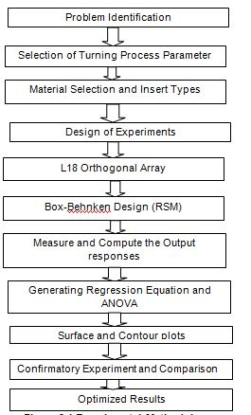

**Figure 2.1 Experimental Methodology**

**2.2BOX-BEHNKEN DESIGN**

Box Behnken designs have several advantages, but its main use is in resolving the problem of where the trial borders should be, especially to avoid treatment combinations that are harsh. Taking into account the corner and star points, which may b the most extreme places in the area where our experiment was conducted.

**2.3 KISTLER 3D DYNAMOMETER**

During the experiment, cutting forces are measured using a Kistler3-D Dynamometer. The piezoelectricity concept underpins how the Kistler dynamometer functions. The property of some materials known as piezoelectricity, most notably crystals and specific ceramics, to produce an electrical potential in response to applied mechanical stress.

Vibro Scout data acquisition software was utilized to collect the data, and the recorded observations have been organized and presented in Table 2.1 .After conducting the experiments, the obtained data underwent additional analysis using the Response Surface Methodology.

**2.4 EXPERIMENTAL WORK**

**Table 2.1 Experimental Results Of Vibration Amplitude**

|  |  |  |  |  |  |  |
| --- | --- | --- | --- | --- | --- | --- |
| **Speed** | **Feed** | **Depth of cut** | **Coating Type** | **Displacement (mm)** | **Velocity (mm/s)** | **Acceleration (m/s2)** |
| 600 | 40 | 0.30 | 1 | 0.289108 | 0.522 | 239.808 |
| 800 | 60 | 0.50 | 1 | 0.00812082 | 0.06 | 63.1097 |
| 1000 | 80 | 0.70 | 1 | 0.0170401 | 0.115 | 160.682 |
| 600 | 60 | 0.70 | 2 | 0.020585 | 0.358 | 103.363 |
| 800 | 80 | 0.30 | 2 | 0.0316881 | 0.013 | 82.5776 |
| 1000 | 40 | 0.50 | 2 | 0.0261167 | 0.013 | 41.6584 |
| 600 | 80 | 0.50 | 3 | 0.00882253 | 0.018 | 51.9806 |
| 800 | 40 | 0.70 | 3 | 0.378619 | 0.536 | 283.169 |
| 1000 | 60 | 0.30 | 3 | 0.0410116 | 0.184 | 157.866 |
| 600 | 60 | 0.50 | 1 | 0.0173622 | 0.0512 | 31.7625 |
| 800 | 80 | 0.70 | 1 | 0.361484 | 0.87 | 298.7 |
| 1000 | 40 | 0.30 | 1 | 0.0227664 | 0.536 | 101.402 |
| 600 | 40 | 0.70 | 2 | 0.0156122 | 0.358 | 51.4505 |
| 800 | 60 | 0.30 | 2 | 0.0254098 | 0.061 | 85.8926 |
| 1000 | 80 | 0.50 | 2 | 0.0191371 | 0.124 | 170.321 |
| 600 | 80 | 0.30 | 3 | 0.0123667 | 0.178 | 85.7382 |
| 800 | 40 | 0.50 | 3 | 0.0137551 | 0.013 | 122.112 |
| 1000 | 60 | 0.70 | 3 | 0.238362 | 0.358 | 209.951 |

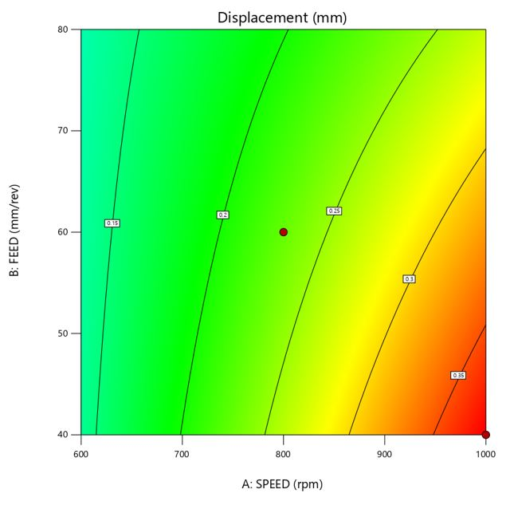

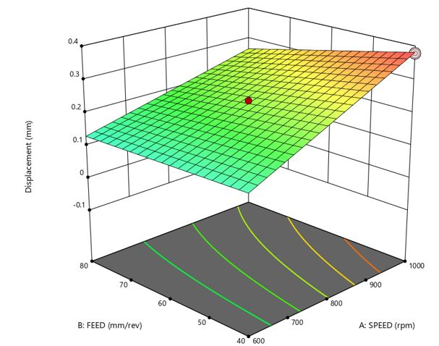

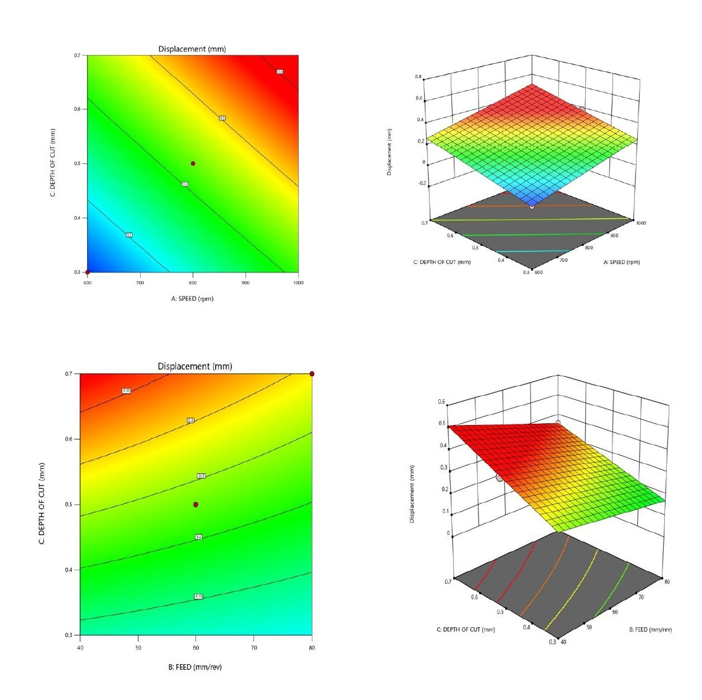

**Figure 2.2 Effect Of Cutting Parameters On Displacement**

**3.CONCLUSION**

The present work has been investigating the improvement of machinability characteristics and tool vibration of the Monel K-500 and influencing the machining parameters towards output responses.

The experimental work was carried out on Monel K-500 according to L18 orthogonal array. In turning process, the cutting speed varied from 600 to 1000 rpm, feed rate varied from 40 to 80 mm/rev and depth of cut varied from 0.30 to 0.70 mm.The optimization has been done with Box Behnken Design based Response Surface Methodology for optimizing turning parameters such as cutting speed, depth of cut, feed rate and types of inserts (TiCN- Al2O3-TiN and TiCN- Al2O3) and Ceramic inserts.

From the Analysis of Variance, the regression coefficients for displacement, velocity, acceleration, , are 98.38%, 98.10%, 92.12%, respectively

The confirmation test has been performed to get the better results and from that optimization, the best optimal values have been predicted out of eighteen experiments using RSM in Box Bekhnen Method.

**REFERENCES**

1. Hari Singh and Pradeep Kumar, 2006, Optimizing feed force for turned parts through the Taguchi technique, Sadhana Vol. 31, Part 6, December 2006, pp. 671–681.
2. Anil Gupta, Hari Singh, Aman Aggarwal, 2011, Taguchi-fuzzy multi output optimization (MOO) in high speed CNC turning of AISI P-20 tool steel, Expert Systems with Applications. 38: 6822-6828.
3. Zahia Hessainia, Ahmed Belbah, 2013, On the prediction of surface roughness in hard turning based on cutting parameters and tool vibrations, Measurement, vol. 46, pp. 1671-1681.
4. Jayakumar S, Marimuthu K & Ramachandran T 2012, Prediction of vibration amplitude and surface roughness in machining of Al6061 metal matrix composites by response surface methodology, International journal Mechanical and Materials Engineering, vol. 7, pp. 222-231.
5. Asilturk, I., Neşeli, S., & Ince, M. A. (2016), Optimisation of parameters affecting surface roughness of Co28Cr6Mo medical material during CNC lathe machining by using the Taguchi and RSM methods. Measurement, 78, 120-128.
6. Mahesh, G, Muthu, S & Devadasan, SR 2015, Prediction of surface roughness of end milling operation using genetic algorithm, International Journal of Advanced Manufacturing Technology, vol. 77, no. 1-4, pp.369-381.
7. Ashvin J Makadia & Nanavati, JI 2013, Optimization of machining parameters for turning operations based on response surface methodology, Measurement, vol. 46, pp. 1521-1529.
8. Subramanian, A. V. M., Nachimuthu, M. D. G., & Cinnasamy, V, (2017), Assessment of cutting force and surface roughness in LM6/SiCp using response surface methodology. Journal of applied research and technology, 15(3), 283-296.