**EFFECT OF ACCELERATED CURING ON COMPRESSIVE STRENGTH OF CONCRETE**

**Govind1*, Kapil Bhutani2**

1student, 2HOD

NNSS’ Samalkha Group of Institutions, Samalkha

**\*Corresponding Author**

**E-mail Id:-atrigovind2@gmail.com**

**ABSTRACT**

Concrete in various form is an age old construction material. The ease in molding to any shape and size makes concrete a versatile construction material. Not only it has the ability to get molded in any shape and size, but its strength can also be designed in accordance with the users requirement. However, its strength depends upon various factors like bonding material, types of aggregate, water/cement ratio and its curing method etc. Curing of concrete is the process of maintaining the optimum temperature and humidity during the hydration of concrete by means of either preventing loss and/or by addition of moisture and maintaining temperature so that the desired design strength of concrete can be achieved.

The traditional methods of curing of concrete not only takes more time i.e at least 28 days to get required strength but also causes delay in construction. Now a days it has been observed that the cost of the concrete specimen after one day of accelerated curing can give the design strength required without waiting for 28days. It can reduce amount of potential rework. In such circumstances it has become necessary to adopt such methods of curing which gives equivalent 28 days strength in lesser time. In the present study some of the major accelerated curing methods like warm water, boiling water and steam curing have been discussed and strength of concrete achieved through these methods have been observed.

Keywords:- curing of concrete, temperature, hydration, mitigated, compaction

INTRODUCTION

Concrete is one of the mostly used construction material, it has been prepared by mixing cement, sand, aggregate and water. The strength of concrete is mainly achieved through hydration process of cement. The hydration of cement takes place only in the presence of moisture. The term "curing" is defined as the process by which the loss of moisture from freshly placed concrete is controlled so that any adverse effect on hydration of concrete is mitigated. The concrete matures and develop optimum compressive strength over time during curing as a result of the continued hydration of the cement in the presence of sufficient water and heat. The curing period is defined as the period beginning at placing, through compaction and finishing, and extends until the desired concrete properties have developed.

The strength of concrete mainly depends upon the hydration process, which takes place after adding the water into concrete mixture. This hydration process can be expedited by increasing the temperature during curing of concrete. This process of increasing the temperature of water used for curing causes the formation of calcium silicate hydrate crystals and gel more rapidly and rate of diffusion of gel is also increased. Because of this more rapid reaction, the hydration process required lesser time. This type of curing is called accelerated curing of concrete.

The accelerated curing has many applications in manufacturing of precast concrete production. Quality control of concrete is the one of the most important purpose of accelerated curing methods. Conventional structural concrete design is based upon the compressive strength at 28 days determined by casting and curing standard specimens under controlled conditions.

CONTENT

INVESTIGATION OF MATERIALS

It is necessary to properly perform investigation of constituent materials of concrete to produce a standard mix. The first part of investigation of materials is visual inspection to ascertain that the aggregate, sand and water are free from any organic material. The materials for concrete mix were tested as per procedure laid in various IS codes before casting of specimen. Before casting of specimen tests were performed on the ingredients of concrete (i.e. Cement, sand, aggregates and water) to know the various properties of material.

CEMENT

Ordinary Portland cement of 43 grade was used for the experimental investigation which Conformed to IS: 81122013 The cement was tested according to IS: 40311988 The various physical properties observed in laboratory are given in Table1

Table 1: Physical properties of content (OPC-43 grade)

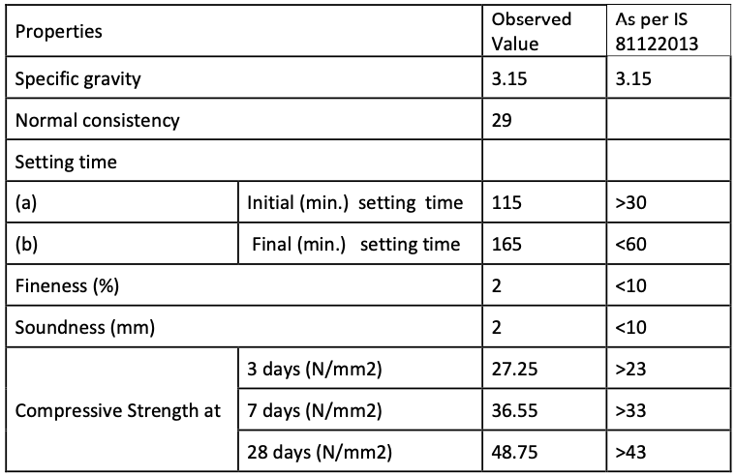

FINE AGGREGATES

The natural river sand was used in the present experimental investigation. It was sieved through 4.75 mm sieve. To sieve analysis and various properties conform to IS 383-1970 are given in Tables 2 and 3, respectively.

Table 2: Sieve Analysis of the fine aggregates.

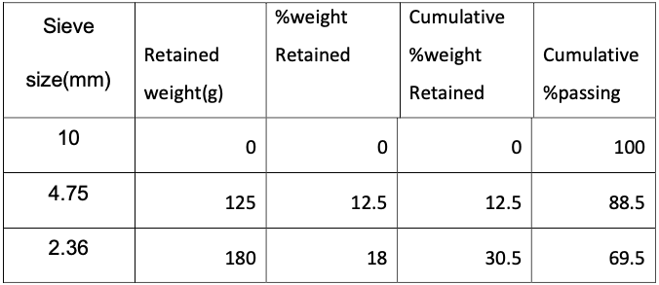

COARSE AGGREGATES

The material which is retained on 4.75mm sieve is known as coarse aggregate. Locally available 10mm & 20mm coarse aggregates were used in this work conforming to IS: 3831970 with properties as given in Table 5 respectively. Sieve analysis of 10mm and 20mm coarse aggregate are discussed respectively.

Table 3 Physical Properties of fine aggregates.

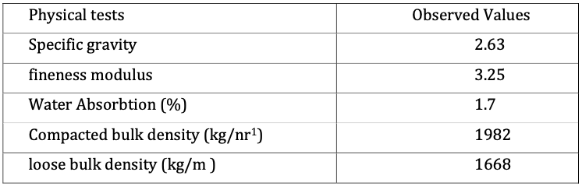

COARSE AGGREGATES

The material which is retained on 4.75mm sieve is known as coarse aggregate. Locally available 10mm & 20mm coarse aggregates were used in this work conforming to IS: 3831970 with properties as given in Table 5 respectively. Sieve analysis of 10mm and 20mm coarse aggregate are given in table 4 respectively.

Table 4. Steve analysis of Coarse Aggregate

|  |  |  |  |  |  |
| --- | --- | --- | --- | --- | --- |
| Sieve size (mm) | Retained weight(g) | %weight Retained | Cumulative %Retained | Cumulativ % Passing | Remark |
| Sieve analysis of 10 mm coarse aggregates | | | | | |
| 20 | 0 | 0 | 0 | 100 | Single Size Aggrgate |
| 16 | 0 | 0 | 0 | 100 |
| 12.5 | 20 | 1 | 1 | 99 |
| 10 | 236 | 11.8 | 12.8 | 87.2 |
| 1.75 | 1456 | 72.8 | 85.6 | 14.4 |
| 2.36 | 269 | 13.45 | 99.05 | 0.95 |
| Sieve analysis of 20 mm coarse aggregates | | | | | |
| 40 | 0 | 0 | 0 | 100 | Single Size Aggrgate |
| 20 | 0.23 | 0.23 | 4.6 | 95.4 |
| 16 | 1.73 | 1.96 | 39.2 | 60.8 |
| |I2.5 | 2.63 | 4.59 | 91.8 | 8.2 |
| 10 | 0.297 | 4.887 | 97.74 | 2.26 |
| 4.75 | 0.113 | 5 | 100 | 0 |

Table 5: Physical Properties of 10 mm and 20 mm coarse aggregates

|  |  |  |
| --- | --- | --- |
| Physical tests | Observed Values (10 mm Aggregate) | Observed Values (20 mm Aggregate) |
| Specific gravity | 2.6 | 2.64 |
| Water Absorption (%) | 1.2 | 7.02 |
| Bulk density (compactcd)(kg/m3) | 1453 | 1734 |
| Bulk density (Ioose)(kg/m3) | 1649 | 1463 |
|  |  |  |

WATER

Normal drinking water available in the lab was used. It was free from suspended solid and organic materials, which might have affected the properties of fresh and hardened concrete. The pH value was 7.6 for water used.

CONCRETE MIX DESIGN

Concrete mix design was prepared as per the IS 102622009 of M-25 grade of concrete by using 43 grade OPC. The proportion for the concrete as determined were 1:1:47:2.8 with the water cement ratio of 0.47 by weight. All in one aggregate has been prepared by mixing 10 mm and 20 mm aggregate in equal percentage of 50% each. Ordinary Portland cement supplied by Jaypee Cement. Mix proportion was constant for all methods of accelerated curing and normal curing. Mix proportion is given in Table 6.

Table 6: Mix design proportion

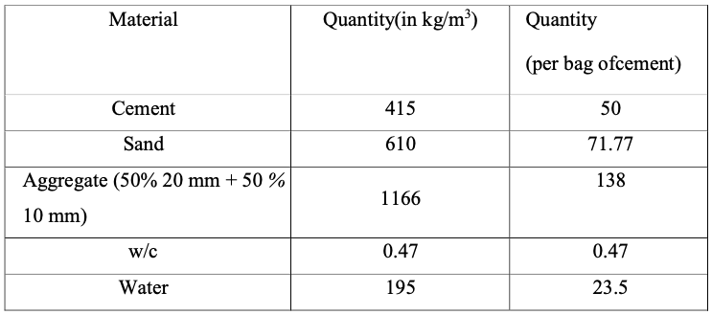

CASTING OF SPECIMEN

Standard cubes of size 150x150x150 mm were used to prepare the concrete specimens for the determination of compressive strength of concrete. All the specimen were prepared in accordance with Indian Standard Specification 1S; 5161959 All the moulds were cleaned and oiled properly. Care was taken that there are no gaps left to avoid leakage.  
A careful procedure was adopted in the batching, mixing and casting operations. The coarse aggregates and fine aggregates were weighed first with an accuracy of +5.0 grams. The concrete mixture was prepared by hand mixing on a water tight platform. On the water tight platform the course and fine aggregates were mixed thoroughly. To this mixture the cement was added. These were mixed to uniform colour. Then water was added carefully so that no water was lost during mixing. In experimental program 72 test specimens of standard cubes of size 150-150 x 150 mm were casted. 24 cubes were casted for each method (12 cubes for day accelerated curing and 12 cubes for 28 days curing under normal curing condition)

CURING OF SPECIMEN

Cast iron moulds were put on the vibrating table for casting the test specimen Having workability 50-60 mm. The casting was done in the concrete laboratory of Delhi where temperature was kept at 25°C. The specimens were then subjected to various types of curing (i.e. boiling water, warm water, steam curing and normal curing). The specimens after curing were tested on 300 ton compressive testing machine according to IS: 5161959 It may be mentioned that heat treated specimens were cooled slowly and were tested under room temperature conditions. The maximum load carried by each specimen at failure was recorded.

• Chemical admixtures for accelerating curing

a) Calcium chloride  
b) Sodium silicate  
c) Sodium hydroxide

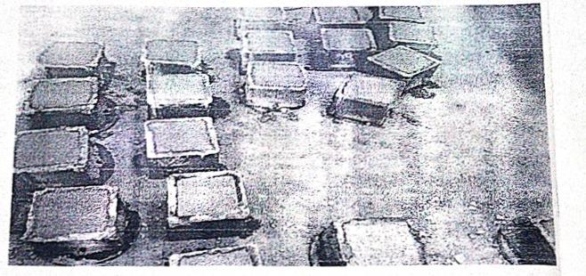

Fig.1 Casting of cube specimen

CONCLUSION

1. The difference in the one day compressive strength for accelerated curing by boiling water method and 28 days compressive strength for normal curing is about 0.73 % for boiling water method of accelerated curing. Thus, it can be concluded that the boiling water method curing provides best way of early prediction of design strength of a concrete specimen by one day accelerated curing. This helps the design engineer ascertain the probable design strength well in advance and helps in saving time and money, the most critical resources in present world of construction.  
2. The difference in one day compressive strength for accelerated steam curing and 28 days compressive strength for normal curing is 11.63% and 5.32% for warm water method. Thus it can be concluded that the warm water method curing provides more accurate results as compare to steam curing method.

From the study it has been concluded that boiling water method curing predict the strength of concrete more accurately in comparison to other methods (i.e. warm water method and steam curing method).

REFERENCES

1. IS: 90132004 “Methods of Making, Curing and Determining Compressive strength of Accelerated-Cured Concrete Test Specimens", Bureau of Indian Standards," New Delhi.
2. IS: 516-1959, "Methods of Tests for Strength of Concrete," Bureau of Indian Standards, New Delhi.
3. Yazdani, N. Filsaime, M., Islam, S. (2008). "Accelerated Curing of Silica-Fume Concrete," DOI: 10.1061/ASCE 0899-1561-(2008)20:8(521),
4. Shelke N.L. & Gadve Sangeeta (2013), "Prediction Of Compressive Strength ofConcrete Using Accelerated Curing, "international journal of pure and applied research in engineering and technology, IJPRET, 2013; Volume 1(8): 90-99.
5. Ozkul, M. Hulusi (2001), " Efficiency of accelerated curing in concrete”,Cement and Concrete Research 31 (2001) 1351-1357.
6. Jayadevan, V., Valsalakumary, V.R. and Sufeera (2014), O.B., "Reliability of accelerated curing techniques for speedy design of concrete mixes - An appraisal of IS 9013:1978 code." The Indian Concrete Journal February 2014.
7. Al-Rawi, R. S. (1976), "choice of curing temperature for accelerated cured concrete”,cement and concrete research. vol. 6, pp. 6036121976 pergamon press, incPrinted in the United States.
8. Meyer, Denny,(1997), "A Statistical Comparison Of Accelerated Concrete Testing Methods",Journal of Applied Mathematics & Decision Sciences, 1289100 (1997)Reprints available directly from the Editor. Printed in New Zealand.