**TIME HISTORY ANALYSIS OF RESIDENTIAL BUILDING WITH AND WITHOUT EXPANSION JOINTS**

**Akbar Jamal1*, Kapil Bhutani2**

1student, 2HOD

NNSS’ Samalkha Group of Institutions, Samalkha

**\*Corresponding Author**

**E-mail Id:-akbar.jamal2@gmail.com**

**ABSTRACT**

Expansion joints are often required between adjacent buildings and are often introduced to separate two or more parts of the same building. This dissertation reviews the design, selection, testing and recent developments in expansion joint and expansion joint performance from first principles (assumptions). A comparison was made with current standards and codes of practice. Joint locations, their specifications, and other significant architectural and fire issues with respect to expansion joints were also discussed.

Expansion joints affect the execution of works, construction sequence and facade design and also act as a source of monsoon leaks throughout the life of the building. To avoid all these complications, architects nowadays prefer buildings without expansion joints. A limit of 45 m length of structure has been prescribed by IS 456 (plain and reinforced concrete code) for RCC structures to be followed. Otherwise, it is necessary to design structural elements for additional stresses due to temperature changes. This case study deals with a G+5 residential building with an approximate covered area of 2700 m2 with 6 expansion joints, dividing the building into six different towers. The main objective of this dissertation is to study the response of the tower acting individually as in the case of expansion joints and the response of the tower when acting as a whole (without expansion joints). The main monitored parameters are floor displacement, maximum floor displacement and time period. Six models were created and time history analysis was used to analyze these models. The parameters of each individual tower and the tower as a whole were analyzed using time history analysis using data from past earthquakes. Time history analysis was performed using ETABS2013 software.

***Keywords:-*** *aerospace, automotive, sustainable structure, polymer composite, fibre reinforced plastic composite*

**INTRODUCTION**

Expansion joints naturally occur when one building is built next to another, regardless of whether the buildings are functionally connected. Expansion joints are also often introduced in separate wings or other parts of a single building. An expansion joint usually creates a separation between adjacent buildings or parts of buildings that include separation of walls, floors, and roofs. In the case of joints within the same building, it may also include separation or accommodation for the movement of pipes and other elements that have a functional need to cross the joints. Joint design is complex and involves the efforts of all members of the design team to ensure that the joint is properly dimensioned, adequately weather-sealed, and safe for walking, as well as ensuring sufficient movement of other systems passing through the joint and assets. maintain the fire resistance of floor, roof and wall systems. Joints are expensive and architecturally undesirable, so they should be incorporated with care.

An expansion or movement joint is an assembly designed to safely absorb heat-induced expansion and contraction of structural materials, absorb vibration, hold parts together, or allow movement due to ground settlement or earthquakes. They are commonly found between sections of buildings, bridges, sidewalks, railway tracks and other structures (Zdenek P 1996).

As per IS 456, normally structures longer than 45 m are designed with one or more expansion joints. In the event that the client does not wish to incorporate an expansion joint due to the aesthetic value of the structure, a thermal analysis must be performed to ensure the protection of the design.

Expansion joint Limit for various structures:-

* RCC structures-45m (IS 456)
* Load bearing structures - 30m (SP-62)
* Sunshades, Balconies and Parapets - 6m to 23m (SP-62)

**CONTENT**

According to IS 456, structures longer than 45 m are normally designed with one or more expansion joints. Due to the large number of factors involved in deciding the location, spacing and nature of expansion joints, the execution of expansion joints in RCC structures must be left to the discretion of the designer. Codal provisions indicate that expansion joints are desirable for spans above 45 m. However, if attempting to build without an expansion joint, thermal effects should be considered in the design and minimum reinforcement requirements for RCC members should be increased. Additional thermal movements of structural elements (beams and columns) 22.5 m from the center (length). must be taken into account through additional moments in the frame elements. The end columns and their frame beams will be most affected.

"One RCC (G+3) grade building of more than 110 m length with two staircases in Sathyabama University Chennai constructed 8 years ago without any cracks in the expansion joints even today. Wonder how this building was constructed without any expansion joints?" (V.M.RAJAN. 2015). The code (IS 456-2000) clearly states the thermal effects to be taken care of but does not state the difference in the structural behavior of a building with an expansion joint (length less than 45 m) and without an expansion joint (length more than 45 m) under seismic loading . To study the behavior of the structure under seismic loading, a G+5 residential building plan with an approximate covered area of 2700 m2 with 6 expansion joints, the division of the building into six different towers and a time history analysis (Elcentro earthquake data) were used. performed using ETABS 2013 software. Six structural models were created in ETABS, four different stand-alone towers with expansion joints (length less than 45 m) and two assumed towers without expansion joints (length greater than 45 m). The results of the analysis in terms of floor rocking and floor drift were compared for different models (the average response is taken for models whose length is less than 45 m).

Details of Models

To study the seismic response of the structure with and without expansion joints, an existing G+5 residential building plan was used, which has 6 expansion joints that divide the building into seven towers, as shown in Fig.1 The highlighted areas in Fig.1 below show the location of the expansion joints , which divide the building into seven towers.

-Four residential towers -Two towers in the lobby - One stair tower

Columns with dimensions of 300mm, 700mm, 700mm, 300mm and 500mm and 800mm were modeled, a beam with dimensions of 300mm*500mm according to the plan layout, the height of the ground column and another typical floor is maintained at 3.2m.

Fig.1 Plan of residential G+5 building with expansion joints

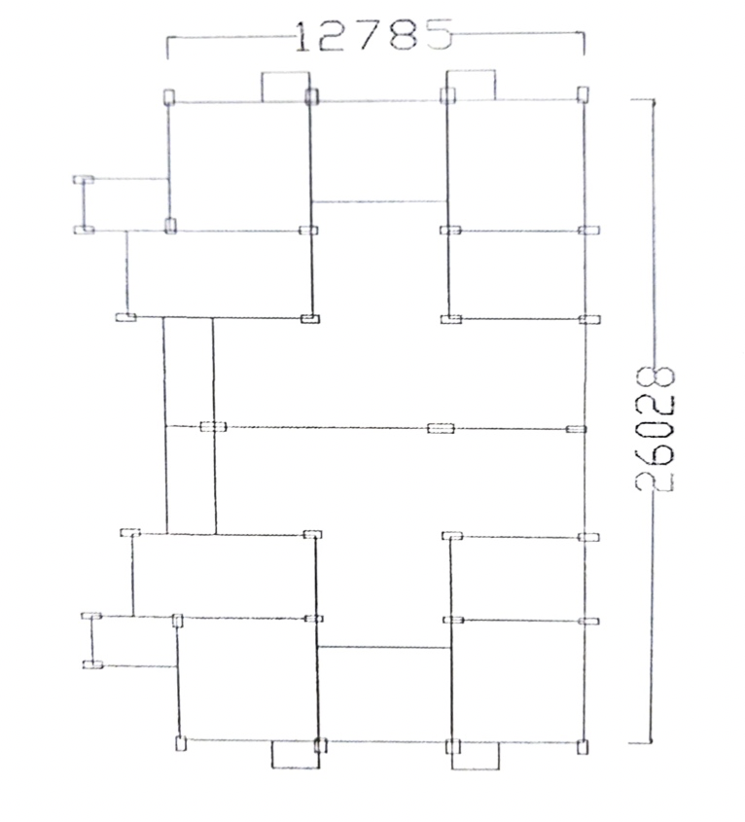

The effect of external and the internal partition has been neglected. The building model is located in zone III with medium soil condition. The Importance Factor (1) is taken to be equal to 1. All the slabs are assumed to be of thickness of 150mm. The slabs are assumed have rigid diaphragm action so that all points on the slab move by the same amount in horizontal direction. All the slabs except roof slab have floor finish and live load of 1 KN/m2 and 3 KN/m respectively. The intensity of live load and roof treatment (water proofing) on the roof slab is equal to1.5KN/m2. The load from the slab is distributed on the beam in the form of trapezoidal loads as per yield line theory.

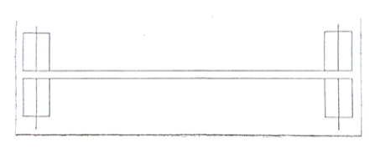

Fig 2 Expansion joint shown in plan

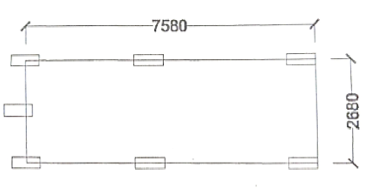

Fig 3 plan of Lobby Tower (isolated)

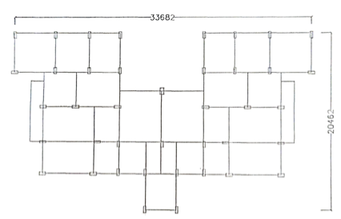

Fig. 4 Plan of Residential tower (isolated)

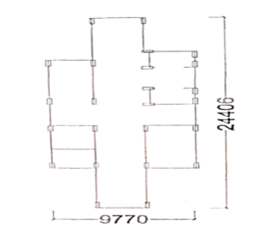

Fig. 5 Plan of Staircase Tower (Isolated)

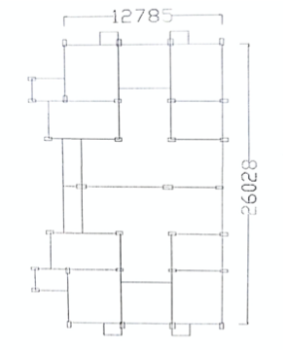

Fig. 6 Plan of Residential Tower (b) ( Isolated)

ASSUMED MODELS (Without Expansion Joints)

The highlighted areas indicate the presence of expansion joint in fig 2 by removing those expansion joints two towers have been modeled and analyzed under the time history of Elcentro earthquake data. The length of the two assumed towers is 51.3 m and 67,8 m respectively (which is more than 45 m). While modeling the two towers all the factors such as column size, beam size, dead load, live load, rigid diaphragm etc are kept same as per plan layout .The plan of two assumed models are shown below.

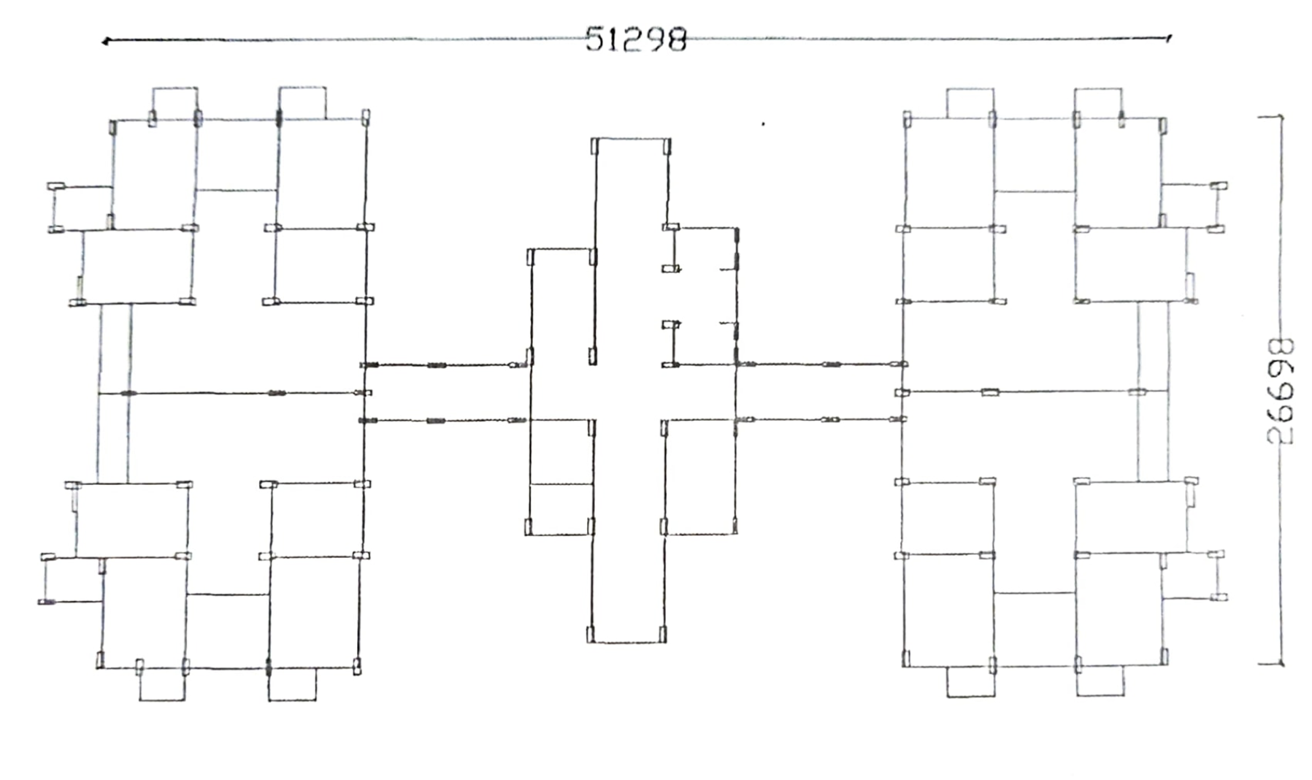

Fig. 7 Assumed tower (a) with length 51.3 m approx. (without wxpansion joints)

MATERIAL PROPERTIES

The concrete grade for all the models is taken as M25. The steel grade used is fe415 with material type rebar. The elastic properties of the material are taken as per IS 456:2000. The modulus of elasticity of concrete is taken as per clause 6.3.2.1 of IS 456:2000

Where f ck is the characteristic compressive strength of the concrete in N / mm2  
at 28 days. For the present study the value of fa is equal to 25N / m * m ^ 2 For the reinforcement, the yield strength (fy) is taken as per IS 456:2000.

CONCLUSION

1. Floor displacement for models with and without expansion joints under seismic load was maximum in the second floor, but with the increasing length of the building, the difference in floor displacement is insignificant. Likewise, variations in floor displacement are also insignificant with regard to length.
2. From the linear time history analysis, it was observed that for various models, the value of the time period decreases as the length of the building increases.
3. It has been observed that the seismic response of a building with a span greater than 45 m is almost similar to that of a building with a span less than 45 m, but in accordance with the provisions of the code, thermal effects must be included during the analysis to make the result satisfactory.
4. When the model is subjected to lateral loads, the mass of each floor acts independently, resulting in displacement of each floor relative to adjacent floors. With increasing length of construction. the relative displacement between adjacent floors is not affected.

REFERENCES

[1] Berkeley, Computers and Structures, Inc. 2005, CSI analysis reference manual. Computers and Structures, Inc., Calif

[2] Berkeley, Computers and Structures, Inc. 2005. SAP2000 advanced [computer program).Version 10.0.1. Computers and Structures, Inc., Calif.

[3] Berkeley, Computers and Structures, Inc. 2005. Section Designer (computer program]. Version 10.0.0.Computers and Structures, Inc., Calif.

[4] Berkeley, Computers and Structures, Inc. 2008. ETABS nonlinear [computer

[5] Berkeley, ETABS 2013 Integrated software for structural analysis and design. Computers and structure Inc, California

[6] Bilig, K. 1960,"Expansion joints In structural concrete", Macmillan, London [7] "BS 8110-Part 2," British Standard Code of Practice. 1985

[8] "Expansion joints in Buildings," Technical Report No. 65, National Academy of Sciences, Washington D.C., 1974, 43pp