**OPNET MODELER-BASED VLAN IMPLEMENTATION VIA WIRELESS NETWORKS**

Kirti and Upasana

M.tech Scholar, Department of Computer Engineering, Gitam Kablana Haryana

Assistant Professor, Department of Computer Engineering, Gitam Kablana Haryana

***ABSTRACT***

*A virtual local area network (VLAN) is a logical connection, as opposed to a physical one, that enables grouping hosts into a single broadcast domain so that packets are only sent to ports that are joined to the same VLAN. We can increase wireless network efficiency and conserve bandwidth by using a typical VLAN network. Additionally, by reducing the number of hosts that get copies of frames broadcast by switches, VLAN implementation dramatically enhances wireless network security because hosts containing crucial data are kept on a different VLAN. In this paper, a wireless network without VLAN deployment is contrasted with a wireless network. The proposed network is assessed using file transfer in high traffic and web browsing applications for average throughput and latency. The simulation was run using the OPNET 14.5 modeller simulation, and the findings indicate that using VLAN across a wireless network increased performance by reducing traffic and minimising delay time. Additionally, because traffic received and routed has a positive relationship with throughput, adopting VLAN decreases network throughput. Additionally, we looked into employing adhoc routing technologies to increase throughput in a wireless VLAN network. To demonstrate the impact of the proposed VLAN on performance outcomes like throughput and delay, evaluation and comparison of broad adhoc routing protocols such AODV, DSR, OLSR, TORA, and GPR are undertaken.*

## INTRODUCTION

Wireless Local Area Networks (WLANs) give devices the freedom to move about the network and connect to the LAN wirelessly using radio transmission. Users can share data, applications, and other resources through wireless technology without being reliant on connections. [1][2]. Technically speaking, WLAN's communications standard is Wi-Fi (Wireless Fidelity). The IEEE 802.11 standard is currently one of the most widely used wireless technologies for data transfer. This is because there is a demand for high-speed data rates and numerous standards have been created to address this requirement. [3][4]. Show the most used protocol in the current environment in Table 1 [5].

Table 1. Summary of Various WLAN Standards.

|  |  |  |  |
| --- | --- | --- | --- |
| **Standards** | **RF Band** | **Max. Data Rate** | **Range** |
| IEEE 802.11 | 2.4GHz | 2Mbs | 50 – 100m |
| IEEE 802.11b | 2.4GHz | 11Mbps | 50 – 100m |
| IEEE 802.11a | 5GHz | 54Mbps | 50 – 100m |
| IEEE 802.11g | 2.4GHz | 54Mbps | 50 – 100m |

The infrastructure WLAN in Figure 1 is made up of wireless stations and access points (AP), and it can accommodate a large number of wireless stations depending on the AP's specifications. UTP cable can be used to connect a wireless network to an Ethernet network up to 100 metres from the access point to the hub or switch. There are various access points with various locations and a limited communication range [6]. The mobile stations can move around while communicating, and they will automatically search for and connect to the access point device using the SSID (Service Set Identifier), which is a specific name for a wireless network matching the AP is defined in the programme. The SSID keeps the packets within the right WLAN. [1].

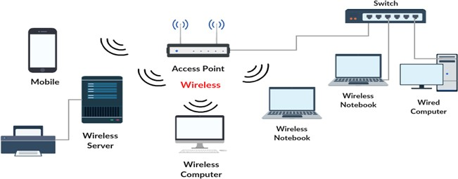

Figure 1. Wireless infrastructure diagram

When evaluating a wireless 802.11 WLAN solution, there are a number of important performance metrics to take into account. In this paper, we focused on throughput and delay. Throughput measures the rate at which data is successfully received by the wireless LAN destination, whereas delay measures the time it takes for data to be successfully delivered from the source up to the destination node. [6][7][8].

The typical definition of a Local Area Network (LAN) is a broadcast domain, meaning that all connected devices within the same physical LAN can communicate with one another without the use of a router [7]. Virtual LANs (VLANs) are typically described as a collection of devices on several physical LAN segments that are able to communicate as though they are on the same LAN segment. Switches can partition the network into distinct broadcast zones using VLANs without experiencing latency issues [8]. Trunks of VLAN are utilised when switches that support different VLANs are connected to each other via the same Ethernet lines, as shown in Figure 2. The switches tag each frame sent between switches to identify which VLAN the frame is a part of. The IEEE 802.1Q standard, which stipulates the frame format for tagging, is the foundation of VLANs [7].[9].

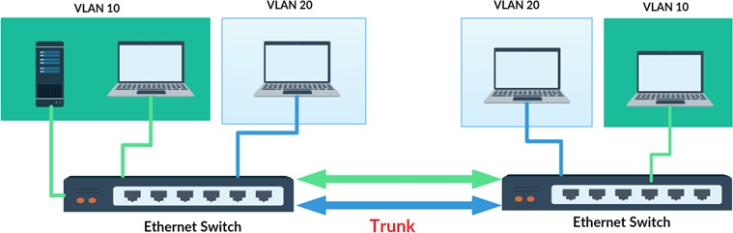

Figure 2. Network with Two VLANs

connection created for a specific purpose where hosts are enabled to send data directly to other hosts rather than going through an access point [13]. VLANs provide several Benefits, such as ease of administration, reduced broadcast traffic, and enforcement of security policies [8][9].

The Main Benefits of VLAN are listed below:

* - Performance: Broadcast traffic dominates the network traffic. By delivering packets only between ports that are joined to the same VLAN, which reduces overhead and latency in addition to saving bandwidth, VLAN segments the big broadcast domain into the small broadcast domain, reducing needless traffic in the network.
* Organization: VLANs can be very useful to group the hosts logically according to their departments or jobs which are easy to handle as compared to a bigger broadcast domain.
* Security: In the same network, sensitive data can be broadcast which can be accessed by the outsider, but by creating VLAN, greatly enhance network security by reducing the number of hosts that receive copies of frames which the switches are broadcast and keep hosts that hold sensitive data on a separate VLAN.
* Cost reduction: VLANs can be used to create broadcast domains which less cost than expensive routers.

The 802.11 communications standard defines two operating modes [10]:

Ad hoc and infrastructure modes. In infrastructure mode, which is typically the default option [6], wireless hosts can connect with one another via access point. This is illustrated in Figure 3. Adhoc mode, as depicted in Figure 4, allows wireless hosts to connect with one another directly without an access point. In this peer-to-peer network structure, each host simultaneously serves as both a client and an access point. A transitory network is an adhoc network.

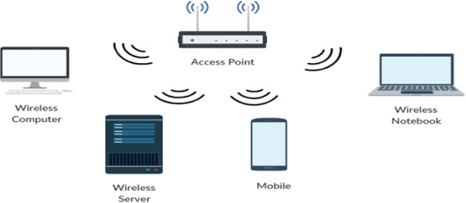

Figure 3. The 802.11 network Infrastructure operating modes

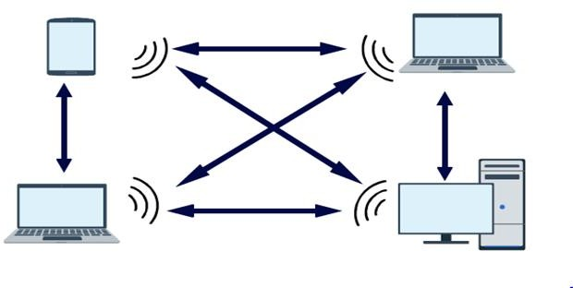

Figure 4. The 802.11 network adhoc operating modes

This article offers tremendous possibilities for enhancing the wireless network's performance. The rest of the paper is structured as follows, with this section serving as a quick introduction to wireless networks and virtual local area networks (VLANs): Section 3 of the paper gives a brief review of related work in wireless networks and VLAN networks in addition to the most pertinent prior studies concerning adhoc routing performance; Section 2 of the paper provides insight into adhoc routing protocols with a focus on flat routing protocol classifications (reactive, proactive, and hybrid); Following that, a simulation model that presents three types of networks—wireless networks, wireless networks with VLANs, and wireless VLAN networks with ad hoc routing protocols—will be implemented. Section 4 of the simulation model provides details on the simulation tool, simulation performance metrics, simulation setup, and simulation scenarios. The simulation results of a comparison between all the simulations performed to display the evaluated performance metrics are shown in section 5. Utilising OPNET, the situations are designed through simulation. Finally, Section 6 provides a conclusion based on all of the work completed and reviewed outcomes.

## ADHOC ROUTING PROTOCOLS OVERVIEW

The routing protocols that have been developed for adhoc networks are playing an important function in influencing data transmission and network performance. Each routing protocol has its own routing strategy to choose the optimum way between the nodes because all network nodes act as routers and participate in the discovery and maintenance of routes to other nodes in the network. Proactive, Reactive, and Hybrid routing protocols are the three basic categories into which routing protocols for adhoc networks can be divided [13] [17].

Because each node in the network always has one or more routes to every destination in its own routing table, proactive routing is also known as table-driven routing protocols [14]. The source node only creates routes when it has data to send, making reactive routing systems also known as on-demand routing protocols. If a route does not already exist, the protocol starts the route discovery process to find a way to the destination [17]. Every node in hybrid routing protocols acts receptively in the vicinity of it and pro-actively elsewhere [14] [13].

This section provides a quick summary of the routing procedures carried out by the well-known protocols OLSR, GRP, DSR, AODV, and TORA. Figure 5 depicts the routing protocols that were taken into consideration for this article.

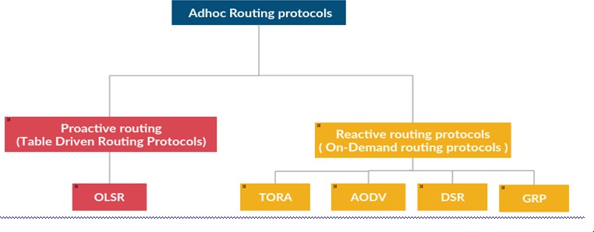

Figure 5. The adhoc routing protocols

The proactive protocol known as Optimised Link State Routing (OLSR) is based on the link state algorithm [18]. The protocol's fundamental idea is to alter network changes without adding extra overhead to control messages. Thus, only a specific set of nodes in the network known as Multi point Relays are in charge of disseminating control messages and producing link state data. Every MPR decides to broadcast link state data only among itself and the nodes that have chosen it.

Since nodes that are not on a chosen path do not maintain routing information or take part in routing table exchanges, Adhoc On-Demand Distance Vector Routing (AODV) lessens the quantity of broadcasts by establishing routes to the target only when necessary [14]. A path discovery process is started by a source node to locate the destination node when it has data to convey but no viable route to that location [15] [19].

Route discovery and route maintenance are the two techniques that make up the straightforward and effective routing protocol known as Dynamic Source Routing (DSR) [14]. When a request comes in, the source node performs route discovery to find a route and adds the found routes to the packet header. With the exception of participating in path route discovery and maintenance, intermediate nodes are not required to keep current routing information [18]. [15]. An on-demand routing protocol is Temporally Ordered Routing Algorithm (TORA) [16]. Limiting control messages in the highly dynamic mobile environment is TORA's primary goal. When a node needs to communicate information to the destination, it must first launch a query. Basically, TORA carries out three tasks: building a route from a source to a destination, maintaining the route, and erasing the route when it is no longer valid. GRP (Geographic Routing Protocol): GRP is a proactive routing protocol [17]. In GRP, a source node uses the Global Positioning System (GPS) to gather network data with little control overhead. Even if the current route is disconnected, the source node can still find routes and send data.

## RELATED WORKS

VLAN can be used to create logical groups of hosts inside the same domain, lessen broadcast traffic, and improve network security. As a result, it provides advantages in terms of performance, security, and bandwidth efficiency. Many people have written studies on wireless and VLAN networks. With the use of OPNET Modeller and the use of key performance measures including throughput, average delay, and load statistics, the authors in [4], [10], [11], and [12] analysed and evaluated the impact of the quantity of traffic in a wireless network. The writers came to the conclusion that the length of the delay depends on the volume of traffic. The longer the delay, the bigger the load.

important performance measures. The findings indicate that adding more VLANs will quickly cut traffic.

Each node works together to maintain the network structure and packet transmission in a wireless adhoc network. We summarise the most pertinent prior research on the effectiveness of adhoc routing.

The authors [13] [17] contrast the effectiveness of AODV and DSR, two on-demand routing methods for ad hoc networks. According to the simulation results, DSR is more successful in networks with fewer nodes, whereas AODV is more effective in networks with more nodes.

Another study [14] [15] employs the NS-2 simulator to examine the throughput, average delay, and packet delivery ratio of the proactive and reactive protocols DSDV, DSR, and AODV. The authors get to the conclusion that DSR performs better since it has reduced routing overhead when taking into account the aforementioned three criteria. Four ad hoc routing protocols—AODV, DSR, TORA, and OLSR—were examined by the authors [18]. Performance measurements were throughput and delay. Results from the simulation show that different scenarios involving HTTP traffic are assessed. The overall findings demonstrate that for a moderate number of network nodes, the OLSR outperforms the reactive routing protocols DSR, AODV, and TORA in terms of throughput and delay.

The most pertinent prior studies pertaining to the performance of wireless LAN, VLAN, and adhoc routing independently are shown in this section. Our work differs from previous research in that we suggested using a Virtual Local Area Network (VLAN) over a wireless LAN network, which can efficiently restrict broadcast traffic and prevent bandwidth wastage as well as enforce security policies, which is a limitation of the conventional switched used in wireless networks. Since both short latency and high throughput are desired in wireless networks, the main disadvantage of utilising VLAN is reduced throughput. As a result, we examine ways to address this issue and enhance the wireless VLAN network throughput performance using the most widely used protocols for adhoc networks.

1. **SIMULATION MODEL DESCRIPTION**

# Simulation Tool:

On the OPNET (Optimised Network Engineering Tools) 14.5 simulator, which offers a genuine network scenario creation, implementation, and results collection using various metrics, simulation design and analysis are carried out. In order to increase the wireless VLAN network throughput performance, this article evaluates the use of VLAN over wireless networks and considers the effects of employing five adhoc routing protocols: AODV, OLSR, DSR, TORA, and GRP.

# Simulation performance metrics:

The following two important performance metrics are considered for evaluation the network in this paper:

* Throughput: Also known as packet delivery ratio, it is the average rate of data packets transmitted and received successfully by every node in the network. It is measured in bits per second. In wireless networks, a better performance is indicated by a higher value of throughput.
* Delay: It is the time takes for a packet to be transmitted from the source node to the destination. It is measured in seconds; lower value delay reflects better performance.

# Simulation setup:

Setup for the simulation To analyse the effectiveness of including VLAN in the wireless network, one first compares the performance of the WLAN model with and without VLAN. The configuration is predicated on the presence of two servers and two switches linking two parts. The 20 nodes used in the simulation models are distributed at random over a square of 1000 m 1000 m, and each node has five nodes that are each wirelessly connected to an access point using a different BSS. IEEE 802.11b, which supports wireless communication at a speed of up to 11Mbps [19], used to be the MAC protocol. According to Figure 6, nodes (PC1–PC5) linked wirelessly to Access Point 1, (PC11–PC15) connected wirelessly to Access Point 4, (PC6–PC10) connected wirelessly to Access Point 2, and (PC16–PC20) connected wirelessly to Access Point 3.

The switch 1 is connected to the access points 1 and 3 by 100Base-T, while the switch 2 is connected to the access points 2 and 4 via 100Base-T. Ethernet Server_1 and Ethernet Server_2 are connected to Switches 1 and 2, respectively, through 100Base-T cables.

The network experienced increased application traffic flow, which each node will process from its own application's two Ethernet servers. File Transfer Protocol (FTP) and Hyper Text Transfer Protocol (HTTP) apps generated the majority of the application traffic. Additionally, we must define apps and profiles by including a node for each, after which we must link the workstation to the profiles.

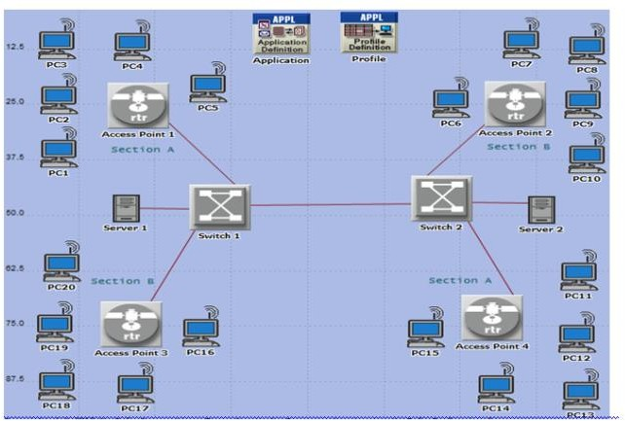

Figure 6. The Proposed wireless LAN network with 20 workstations

# Simulation Scenarios:

For the purposes of this simulation study, a square area measuring 1000m by 1000m has been taken into consideration. Three scenarios have been developed:

The first case (a wireless network devoid of VLAN): A wireless network, as depicted in Figure 6, took this issue into account. We installed an Access Point (AP) to transmit wireless signals in each sector. In this scenario, there is one broadcasting domain in the network, so any workstations can communicate with the two servers, increasing the throughput of the wireless network. All APs are connected by two Ethernet switches, and there are two Ethernet servers that provide applications used by the workstations. To track performance, wireless LAN delay and throughput are studied..

A second scenario (Wireless network with VLAN): In this scenario, implemented VLAN to the wireless network so the network is divided into two VLANs (VLAN10, VLAN20) as shown in Figure7. VLAN 10 consists of 10 workstations (PC1-PC5) connected wirelessly to Access Point 1 and (PC11-PC15) connected wirelessly to Access Point 4 in addition to Ethernet server_1

while VLAN 20 consists of 10 workstations (PC6-PC10) connected wirelessly to Access Point 2 and (PC16-PC20) connected wirelessly to Access Point 3 in addition to Ethernet server_2. Trunk of VLAN used when connected switches because they support multiple VLANs together crossing the 100base-T Ethernet links. Wireless LAN delay and throughput are analyzed to monitor the performance.

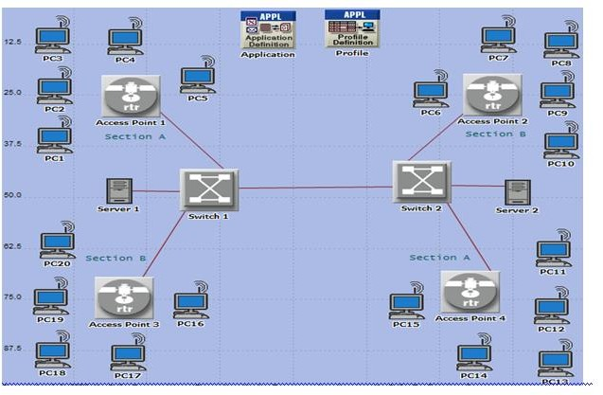

Figure7. The Proposed wireless LAN network with two VLANs

The third case (improving the performance of a wireless VLAN network by using routing protocols): The goal of this scenario was to determine how employing the ad hoc routing protocols AODV, OLSR, DSR, TORA, and GRP would affect the performance of the wireless VLAN network in terms of throughput. There are three different network scenario designs: Increased workstation density has an impact on the performance of wireless networks using VLAN in high, medium, and low density networks. In a low-density network, there are 10 workstations per VLAN; in a medium-density network, there are 20 workstations per VLAN; and in a high-density network, there are 30 workstations per VLAN. To track performance, wireless LAN delay and throughput are studied.

## SIMULATION RESULTS AND DISCUSSIONS

Both wireless networks and wireless networks with VLANs have been used to run the network. Throughput and average latency are the simulation factors that were taken into account when comparing the performance of the two scenarios. OPNET 14.5 Modeller is used to produce the simulation results.

Figure 8 illustrates the performance levels of a wireless network with a VLAN in comparison to a wireless network without a VLAN in terms of wireless latency. After the initial setup phase, the performance of these two networks remains quite stable over the whole simulation duration. However, the network broadcasting domain has been partitioned, which lessens the stress on the network and significantly reduces traffic when VLAN technology is used. In fact, VLAN over WLAN enhanced performance by demonstrating decreased wireless delay time.

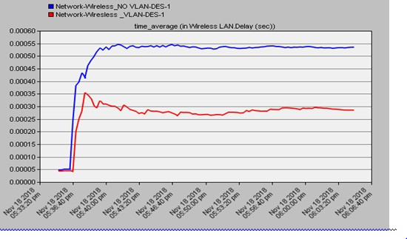

Figure 8. The wireless LAN delay in the scenario 1 and scenario 2

As indicated in Figure 9, it was discovered that VLAN through wireless has worse throughput compared to a WLAN situation. Due to a single broadcast domain, the wireless network without VLAN scenario has more traffic than the VLAN via wireless scenario. After the network has converged, the performance of these two networks nearly remains constant during the whole simulation period band. The amount of traffic that is received and forwarded and throughput are positively correlated.

**CONCLUSIONS**

We used the OPNET 14.5 simulator to demonstrate the use of a Virtual Local Area Network (VLAN) over a wireless LAN network with traffic from File Transfer Protocol (FTP) and Hyper Text Transfer Protocol (HTTP) applications. Throughput and delay were both reduced when VLAN was implemented over a wireless network, according to comparisons of performance. While minimising delay is a desirable goal, wireless networks suffer from a significant throughput problem. We used a number of adhoc routing protocols, including AODV, OLSR, DSR, TORA, and GRP, to increase the wireless VLAN network's throughput performance. Since OLSR is a proactive routing protocol and doesn't need to find routes to the destination, the overall findings revealed that OLSR performed better in terms of delay than other protocols regardless of network size. The reactive routing protocol AODV performs better in low-density networks, whereas performance suffers as node density increases, indicating that low-density networks are a better fit for the protocol. While OLSR and DSR are doing well in terms of throughput, AODV still reigns supreme. Considering that routing is necessary for the proper operation of a network, a network designer should choose the a routing protocol that is adequate for the network's needs. As a result, choosing the right routing protocol type is crucial in determining whether throughput or delay can be increased.

**REFERENCES**

1. Tambe, S. S., (2016) “Wireless technology in networks”, International Journal of Scientific and Research Publications, Vol. 5, No. 7, pp1-13.
2. Mittalh, I., & Anand mani, A., (2014) “WLan Architecture. International Journal of Computer Trends and Technology”, Vol. 8, No. 3, pp. 1428-1531.
3. Aliimi, I. A., & Mufutfgau, A. O., (2016) “Enhancement of network performance of an enterprises network with VLAN”, American Journal of Mobile Systems, Applications and Services, Vol. 1, No. 2, pp 822-913.
4. Elechi Oneeyekachi O., (2015) “Design and Simulation of Wireless Local Area Network for Administrative Office using OPNET Network Simulator: A Practical Approach”, Information and Knowledge Management, Vol.4, No.10, pp. 27-44.
5. Krupanek, B., & Bogacez, R., (2016) “OPNET Modeler simulations of performance for multi nodes wireless systems”, International Journal of Metrology and Quality Engineering, Vol. 7, No. 1, pp 105.
6. H.S.Mewara , Mukesh Kumar Saini, (2016) “ Performance Analysis of Access Point for IEEE802.11g Wireless LAN Using Opnet Simulator” , International Journal of Advanced Engineering Research and Science (IJAEERS), Vol.1, Issue.1, pp. 14-22.
7. Sarah Ali Abdullah, (2017) “Simulation of Virtual LANs (VLANs) Using OPNET”, IOSR Journal of Electronics and Communication Engineering (IOSR-JECE), Vol .11, Issue. 6, Ver. II, pp. 67-70.
8. AL-Khaffaf, D. A. J., (2019) “Improving LAN Performance Based on IEEE802. 1Q VLAN Switching Techniques”, Journal of University of Babylon, Vol. 26, No. 1, pp 286-300.
9. Chokshi, R., & Yu, C, (2017) “Study on VLAN in Wireless Networks”, Technical Report.
10. Ali, A. H., Abbas, A. N., & Hassan, M. H., (2013) “Performance Evaluation of IEEERR802. 11g WLANs Using OPNET Modeler”, American Journal of Engineering Research (AJER), Vol. 2, Issue. 12, pp. 9-28.
11. Meenakshi, Parneek Kaur, (2015) “Performance Metrics of WLAN for Different Applications using OPNET”, International Journal of P2P Network Trends and Technology (IJPTT), Vol. 4 Issue. 8.
12. Alisa, Z. T.L.., (2013) “Evaluating the performance of wireless network using OPNET modeler”, International Journal of Computer Applications, Vol. 62, No. 12.