**Analysing the Influence of Tool Pin on Mechanical Properties of Friction Stir Welded Dissimilar Aluminium Alloys AA6082 & AA5052**

Dr. M. S. Aezhisai Vallavia, K Madhavanb*

a Assist. Professor, Government College of Technology, Coimbatore, TamilNadu-641013.

b PG Scholar, Government College of Technology, Coimbatore, TamilNadu-641013.

* Corresponding Author

**Abstract**

Friction Stir Welding (FSW) has emerged as a promising solid-state joining technique for dissimilar aluminium alloys. This study investigates the influence of the tool pin on the mechanical properties of friction stir welded dissimilar aluminium alloys AA6082 and AA5052. The welding process was systematically conducted with varying tool pin designs to evaluate their effects on mechanical properties. The welding speed of 1200 rpm, feed of 60mm /min were used for the welding. Tensile strength, and hardness analyses were employed to assess the weld quality. The results demonstrate that the selection of the tool pin significantly affects the mechanical characteristics of the weld joint. This study offers insightful information on choosing tool pins to produce high-performance connections between dissimilar aluminium alloys in a variety of industrial applications.

**Introduction**

Friction stir welding (FSW) is a solid-state joining technique, has rapidly gained acceptance and found employment in a variety of industries, including the aviation, automotive, rail, and maritime ones, since its invention in 1991. The FSW process differs from other welding procedures in a number of compelling ways, the most prominent of which is possibly its capacity to weld alloys that are difficult or impossible to do so using fusion welding techniques. The FSW process doesn't face solidification-related issues such the production of second phases, porosity, embrittlement, and cracking because it occurs in the solid phase at temperatures below the material's melting point. Additionally, the method' lower temperature enables joining with less deformation and residual stress. FSW is a low-energy technique that often does not require the use of a shielding gas and does not require the use of filler material. The procedure also doesn't produce the gases, arc flash, spatter, or pollution that are common to most fusion welding methods. FSW has emerged as a desirable connecting method for many manufacturers for these and numerous more causes.

One of the most crucial aspects to take into account when developing an FSW joining process is tool design. In addition to generating heat, promoting mixing, breaking up the joint line, dispersing oxide layers, and creating forging pressure, the tool must also contain material within the joint to prevent surface weld flash and to prevent the occurrence of (or at least lessen the impact of) defects like wormholes, sheet-thinning defects, and hooking defects. Furthermore, tool geometry frequently needs to support a steady force or torque control scheme and work with a variety of plunge depths.

The objective of this was to determine the mechanical properties of friction stir welded using square, threaded cylindrical and cylindrical tool pin profiles. The mechanical properties such as tensile strength and hardness were determined.

**Methodology and Material**

The following methodology was obtained to do the current research work. The figure 1 shows the methodology flow chart of the research work. The material AA5052 and AA6082 was selected for the following research work. The table 1 shows the chemical composition of aluminium alloys.

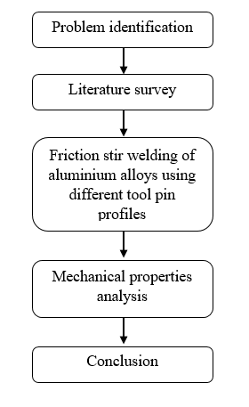

Figure 1 Methodology Flow Chart

Table 1 Chemical composition of aluminium alloy

|  |  |  |
| --- | --- | --- |
| **Element** | **AA6082-T6 (%)** | **AA5052-H32 (%)** |
| Al | 95.95 | 96.40 |
| Si | 0.9 | 0.20 |
| Mg | 1.0 | 2.5 |
| Mn | 1.10 | - |
| Cu | 0.1 | 0.10 |
| Cr | - | 0.30 |
| Fe | 0.45 | 0.30 |
| Zn | 0.20 | - |

**Experimental work**

The weld parameters for the weld are selected using the literature that has been studied. The weld parameters that have to be noted were spindle speed, transverse feed and the direction of rotation. Chemical compositions of the two base metals were determined to check if specifications are met. Friction stir welding of 5052 plates have been performed at speeds ranging from 300 to 2000rpm and good results have been obtained at speeds above 1000rpm. Another study researched friction stir welding of 5052-H32 using Taguchi Analysis. In this three levels of welding speed 30, 40 and 50mm/min were used and three levels of rotation of tool, namely 1300, 1400 and 1500 rpm were used. The Figure 2 shows the three different tool pin profiles. Results of the dissimilar welds gave tensile strengths close to the base metal. Similarly, friction stir welding of 6082-T6 was done with speeds of rotation varying between 200 rpm and 900 rpm and weld feed varying between 100 and 300mm/minute It was found that tensile properties varied with welding parameters. Therefore, the welding speed was 1200 rpm, and feed was 60 mm/min was selected.

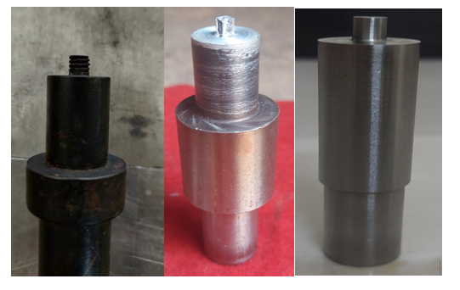

Figure 2 Threaded Cylindrical, Square, and Clindrical tool pin profiles

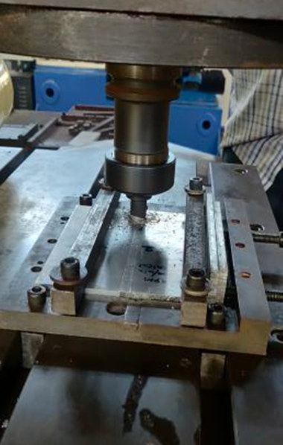

Figure 3 Friction stir welding of aluminium plate

The Figure 3 shows the friction stir welding of the aluminium plates. According to the ASTM, the standard thickness of the base metal should be 10mm or 6mm. So, we choose our weld specimen’s thickness as 6mm. Similarly, the standards for tensile testing, the standard length for a 6mm thick plate is 100mm. So, we decided to weld two 60mm plates to obtain a length of 120mm excluding the allowances. The length of the plate is selected as 150mm because 120mm is the maximum weldable length in the machine we got. The final individual dimensions of the AA6082-T6 plate and the AA5052-H32 plate is 150mm x 60mm x 6mm. After the weld, based on the ASTM-E8 standards, the tensile test was done, hardness profile has been reported and an analysis of the hardness profile was carried out. Optical micrographs of the base metal, weld, HAZ were analyzed and the results are discussed. The figure 4 shows the dimensions of tensile test specimen. The Vickers hardness test was performed using a Vickers hardness machine to assess the resistance of a test specimen measuring 10 x 10 x 6 mm³ to indentation. Prior to the test, the specimen's surface was meticulously polished to ensure accurate results.

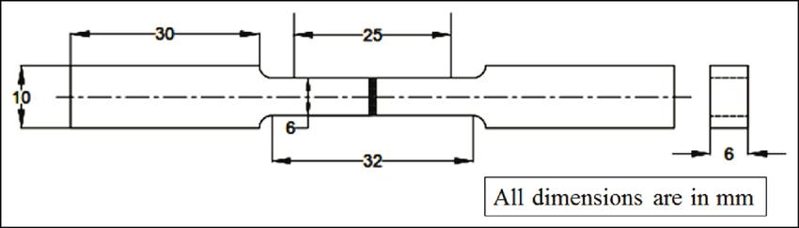

Figure 4 Tensile test specimen dimension

**Results and Discussion**

The tensile test results of the three different types of the tool pin profiles of dissimilar aluminium alloy were shown in the table 2.

Table 2 Tensile strength and joint efficiency

|  |  |  |
| --- | --- | --- |
| **Sample** | **Tensile Strength (MPa)** | **Joint Efficiency, %** |
| AA5052-H32 | 192 | - |
| AA6082-T6 | 255 | - |
| Threaded Cylindrical | 170 | 88.5 |
| Square | 185 | 96.35 |
| Cylindrical | 165 | 85.9 |

The table 2 shows the tensile strength (185 MPa) of square tool pin was high compared to the other tool pin profiles. The joint efficiency of the square was 96.35%. The threaded cylindrical and cylindrical tool pin profile shows tensile strength of 170 MPa and 165 MPa respectively. The table 3 shows the hardness value of the base material as well as the tool pin profiles.

Table 3 Hardness value of welded specimen

|  |  |  |  |  |
| --- | --- | --- | --- | --- |
| **Sample** | **Hardness 1 (HV)** | **Hardness 2 (HV)** | **Hardness 3 (HV)** | **Mean Hardness (HV)** |
| AA5052-H32 | 140 | 145 | 150 | 145 |
| AA6082-T6 | 155 | 162 | 157 | 158 |
| Threaded Cylindrical | 124 | 135 | 145 | 134.667 |
| Square | 132 | 150 | 148 | 143.33 |
| Cylindrical | 115 | 125 | 116 | 118.667 |

Therefore, the hardness as well as the tensile strength shows that the square tool pin profile yielded good results compared to other tool pin profiles. So, the further optimization of the square tool pin profile can be performed to get best welding parameter for defect free weld.

**Conclusion**

In summary, Friction Stir Welding (FSW) has rapidly gained traction across industries including aviation, automotive, rail, and maritime sectors. A pivotal factor in FSW success lies in tool design, enabling heat generation, effective mixing, and pressure application, all while preventing defects. The welding parameters of the following was kept constant at welding speed = 1200 rpm and feed = 60mm/min. This study focused on mechanical properties using different tool profiles: square, threaded cylindrical, and cylindrical. The square profile exhibited superior outcomes in both tensile strength (185 MPa) and hardness (143 HV) compared to the other profiles. This suggests a pathway for further optimization.

References

[1] W.M. Thomas, E.D. Nicholas, J.C. Needham, M.G. Murch, P. Temple-Smith, C.J. Dawes, Friction stir butt welding (The Welding Institute TWI), UK patent, 1993, 9125978.8.

[2] H.M. Anil Kumar, V. Venkata Ramana, Mayur Pawar, Experimental study on dissimilar friction stir welding of aluminium alloys (5083–H111 and 6082–T6) to investigate the mechanical properties, Mater. Sci. Eng. (2018) 330.

[3] S. Gopi, K. Manonmani, Influence of shoulder profile and shoulder penetration on joint strength of friction stir welded AA6082 in conventional milling machine, Eur. J. Scientific Res. 73 (1) (2012) 20–32.

[4] V. RajKumar, M. Venkatesh Kannan, P. Sadeesh, N. Arivazhagan, K. Devendranath Ramkumar, Studies on effect of tool design and welding parameters on the friction stir welding of dissimilar aluminium alloys AA 5052 – AA 6061, Proc. Eng. 75 (2014) 93–97.

[5] S. Gopi, K. Manonmani, Study of friction stir welding parameters in conventional milling machine for 6082–T6 aluminium alloy, Aust. J. Mech. Eng. 10 (2012) 129–140.

[6] M.I.I. Mahamud, M. Ishak, A.M. Halil, Study of dissimilar welding AA6061 aluminium alloy and AZ31B magnesium alloy with ER5356 filler using friction stir welding, Mater. Sci. Eng. 238 (2017) 1–8.

[7] Huihong Liu, Jeong-Won Choi, Ushioda Kohsaku, Hidetoshi Fujii, Effect of an Al filler material on interfacial microstructure and mechanical properties of dissimilar friction stir welded Ti/Mg joint, Mater. Charact. 155 (2019) 109801.

[8] R.K. Kesharwani, S.K. Panda, S.K. Pal, Multi objective optimization of frictio stir welding parameters for joining of two dissimilar thin aluminium sheets, Proc. Mater. Sci. 6 (2014) 178–187.

[9] Arun Kumar Kadian, Pankaj Biswas, Effect of tool pin profile on the material flow characteristics of AA6061, J. Manuf. Processes 26 (2017) 382–392.

[10] A. Farzadi, M. Bahmani, D.F. Haghshenas, Optimization of operational parameters in friction stir welding of AA7075-T6 aluminum alloy usin response surface method, Arab. J. Sci. Eng. 42 (11) (2017) 4905–4916.