PERFORMANCE COMPARISON OF PLANAR AND COAXIAL CARBON NANOTUBE FIELD EFFECT TRANSISTOR

Ida Hope. P1, Jayasri. M2, Muthu Lakshmi. P3 ,Dr. Arun Samuel T.S4

1Bachelor of Engineering, Department of ECE, National Engineering College, Kovilpatti, India. 2 Bachelor of Engineering, Department of ECE, National Engineering College, Kovilpatti, India. 3Bachelor of Engineering, Department of ECE, National Engineering College, Kovilpatti,India 4Professor, Department of ECE, National Engineering College, Kovilpatti, India.

1[1911066@nec.edu.in](mailto:1911066@nec.edu.in), 2[1911068@nec.edu.in](mailto:1911068@nec.edu.in), 3[1911089@nec.edu.in](mailto:1911089@nec.edu.in), 4arunsamuelece@nec.edu.in

***Abstract— The two CNTFET orientations that are being compared in this paper are planar and coaxial in order to evaluate their performance. Modelling various performance parameters, such as IV characteristics, density of state (DOS) vs. energy, potential vs. distance, transmission coefficient vs. energy, and density vs. distance, has been used in studies and research the data demonstrate that both orientations display distinct performance patterns for a number of variables. The highest drain current is calculated for the same chirality and tube length (L = 5 nm and 20 nm) for planner orientation and coaxial orientation. The density vs. distance map for different chirality’s is used to calculate the maximum charge carrier density in coaxial and planner systems. In this project, comparative analysis of planar and coaxial orientation of carbon field effect transistors are analyzed.***

# I. INTRODUCTION

During the past forty years, silicon-based devices have dominated the electronics device sectors. Performance and scaling of silicon-based devices are essential for their survival in the industries. Yet scientists have discovered that silicon-based gadgets have a scalability limit. As silicon MOSFET scaling down approaches its maximum, numerous materials are successfully being researched in order to preserve the scaling trend. Carbon nanotubes (CNTs), one of the most investigated materials among them, exhibit remarkable performance characteristics such reduced short channel effects, high mobility, and high normalised driving currents. Carbon nanotube field effect transistors (CNTs) are the cornerstone of the most promising alternative to silicon transistors.

1. Nowadays, carbon nanotubes (CNTs) are seen as one of the most promising materials for nano-electronics. The constraints of the silicon-based device can be overcome by CNTFETs that use CNT as a channel. Carbon mesh with a hexagonal structure is present in CNTs of various radii. It can be replaced with silicon due to the superior electronics structure and nanometre size of CNT.

Graphene sheets that have been rolled into cylinder forms are known as CNTs. They include carbon molecules arranged in a two-dimensional honeycomb pattern. Single walled - CNTs typically have a diameter of a few nanometres and have the

shape of a tube created by rolling and up such graphene sheets. Chiral properties allow a carbon nanotube to exhibit semiconducting or metallic behaviour. Two of the hexagons in a graphene lattice would need to be overlapped in order to create a seamless tube. The chiral vector, which defines the structure of a single walled CNT, is a vector that connects the centres of the two hexagons.

A carbon nanotube field effect transistor (CNTFET) is a nanoscale component that can be used to build integrated circuits that function well while using little power. CNTFETs use carbon nanotubes (CNTs) sandwiched between the source and drain of a MOSFET structure (MOSFETs), in contrast to traditional metal-oxide semiconductor field-effect transistors, which use bulk silicon as the channel material. CNTFETs offer great mobility, a high cut-off frequency, a high current density, a tiny size, and ballistic transport. The zigzag CNT (m, 0) is simulated in this work for both planar and coaxial geometry types. It presents the current-voltage-density graphs, the DOS-energy graph, the transmission-energy graph, and the density-distance graph for a variety of input parameters, including chirality (n), nanotube length (L), and insulator dielectric constant (K). The Nano hub CNTFET LAB tool is used to run the simulation.

# Carbon Nanotube Field Effect Transistor (CNTFET):

Carbon Nanotube Field Effect Transistor is referred to as CNTFET. A FET called a CNTFET employs

a carbon nanotube channel. CNTFET is a three- terminal device made up of a semiconducting nanotube that connects to the source and drain contacts and functions as a carrier channel. The third contact is used to electrically turn on or off the device (gate).

# STRUCTURE OF CNTFET:

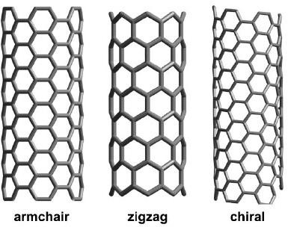CNTFET geometries may be grouped in two major categories:

electrical structure can either take on a semiconducting or metallic nature.

Depending on chirality, carbon nanotubes can be produced in three different ways:

1. A CNT with chiral zigzags (n, 0)

2. Chiral CNT with chirality (n, m)

3. Armchair CNT with chirality (n, n)

* + - Planar
    - Coaxial

Since they are easier to produce and work with current technology, planar CNTFET devices are more common. Coaxial geometry helps induce more channel charge than other designs at a given voltage by improving the capacitive coupling between the nanotube's surface and the gate

To decrease the effects of short channels, which are a key issue in technologies like CMOS and MOSFET, modified coupling is encouraged.

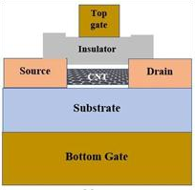

**Fig PLANAR CNTFET**

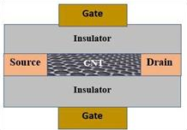

**Fig COAXIAL CNTFET**

# Chirality of Carbon Nanotube (CNT):

Different properties can be obtained depending on the diameter and length of the cylinder-shaped carbon nanotube. Any carbon nanotube's chirality can be used to define it quickly. A chiral vector, where c = na1+ma2, serves as a representation for the chirality.

The chiral index, also known as chirality, is a pair of integers (n, m) that the graphene lattice's a1 and a2 numbers correspond to. A simple vector that joins the centres of the two hexagons is known as a chiral vector, and it determines the construction of single-walled carbon nanotubes. The most intriguing feature of single-walled carbon nanotubes is that, depending on the chirality, them

**Fig 3.11 Lattice structure of different types of CNTFET**

The simulation in this paper makes use of zigzag CNT. The zigzag CNT will behave like a metallic material in this scenario if n is a number divisible by 3. Zigzag CNT will function as a semiconducting material if n is not divisible by 3. Field-effect transistors employ CNT. Without carbon nanotubes, it is unable to function as a semiconducting material.

# Density of state (DOS):

With a one-dimensional structure, the carbon nanotube nanowire used in CNTFET is essentially flat. There is an energy level for every material below which all other energy levels, or the quantum level, must contain exactly one electron at absolute zero K. Any levels of energy above that are completely empty.

Density of states is the measure of how many energy levels there are in each unit energy range (DOS). The value is E1/2 below Fermi level, and 0 above Fermi level. The energy-based DOS function varies with the spatial complexity (dimension) of the system.

# ANALYSIS OF SIMULATION

The CNTFET LAB Nano Hub tool enables simulation by allowing the gate insulator's chirality to be changed while keeping all other operational parameters constant.

# Default Input Values:

* Body Doping is 0. e8
* the top gate length is 8 nm
* the top gate thickness is 5 nm
* the top gate width is 20 nm
* the gate insulator thickness is 10 nm
* the external source/drain contact length is 0 nm
* C-C bonds have a length of 0.144 nm
* Length of the Source/Drain Doping Region is 2.5 nm
* Doping Source/Drain is 1. e8
* Source/Drain Width is 15 nm
* Source/Drain Thickness is 7 nm
* Substrate-to-Nanotube Gap is 0.144 nm.
* Substrate thickness of 9 nm
* device width of 20 nm
* substrate dielectric constant of 3.9
* ambient temperature of 300 k
* source voltage of 0 v
* drain voltage of 0 v
* top gate voltage of 0.4 v
* maximum applied voltage of 0.7 v
* applied voltage step of 1.0 v
* Substrate Thickness is 9 nm

1. **RESULTS AND OUTPUTS Current Vs Voltage:**

Varying Terminal: Drain

Varying Terminal: Source

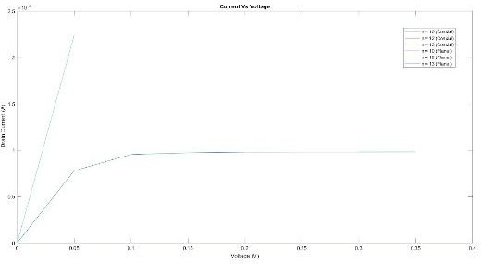

Varying Terminal: Gate

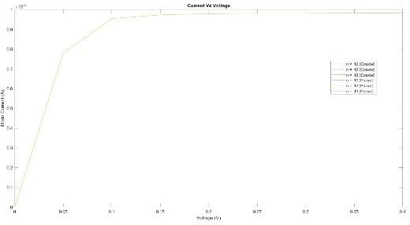

For different levels of chirality (n = 10, 12, and 13), the drain current versus drain voltage is represented on the graph. They found that an increase in carry density causes higher leakage current while studying the impact of chirality on the CNTFET's I- V curve. Moreover, coaxial offers a drain current that is more than twice as great as planar. For a given value of chirality, coaxial outperforms planar in terms of drain current.

# Density Vs Distance:

Varying Terminal: Drain

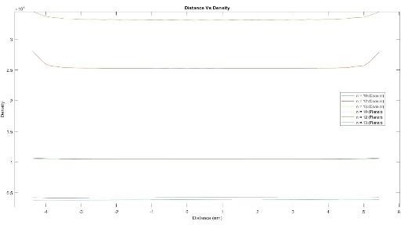

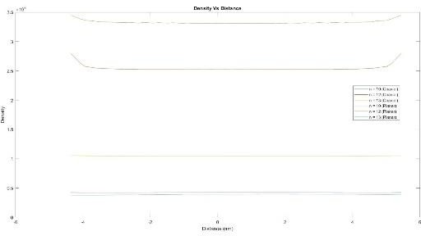Varying Terminal: Source

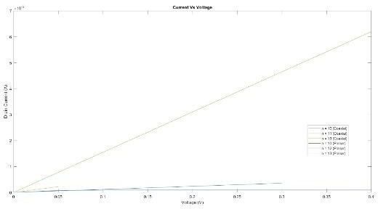

Varying Terminal: Gate

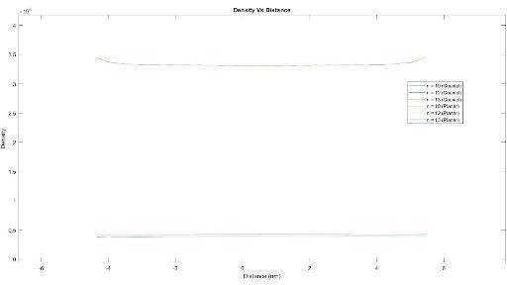

The graph shows the relationship between distance and density for various chirality values (n = 10, 12, and 13). With increasing chirality, density across the tube drops in both planner and coaxial CNTFET. Coaxial CNTFETs have higher densities than planner CNTFETs because they have more coaxial effective capacitive coupling.

# DOS Vs Energy:

Varying Terminal: Drain

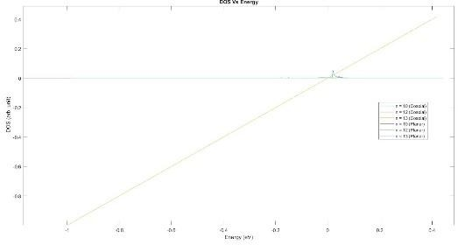

Varying Terminal: Source

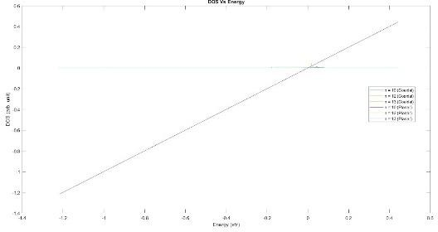

Varying Terminal: Gate

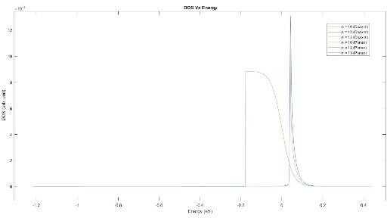

The graph shows the Energy Vs DOS for different chirality levels (n = 10, 12, and 13) while holding all other variables constant. The square root of energy and DOS shows an inverse relationship.

# Potential Vs Distance:

Varying Terminal: Drain

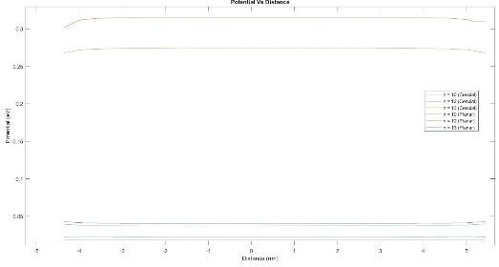

Varying Terminal: Source

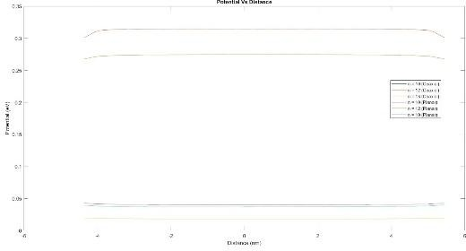

Varying Terminal: Gate

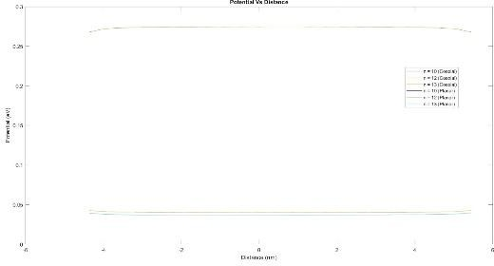

The potential vs. distance graph is shown for various chirality values (n = 10, 12, and 13). The graph displays the potential difference between the ends of the nanotube. With increasing chirality, potential is diminishing.

# Transmission Vs Energy:

Varying Terminal: Drain

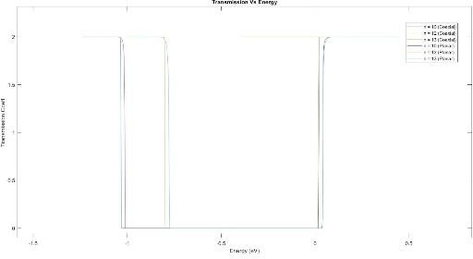

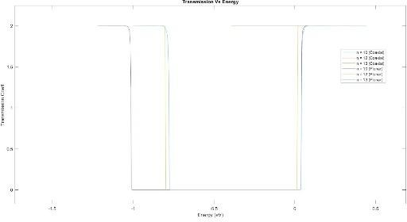Varying Terminal: Source

Varying Terminal: Gate

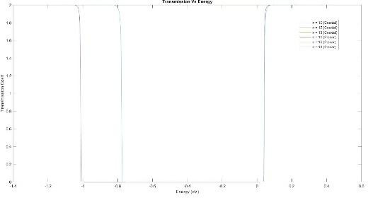

For coaxial and planar CNTFETs with different chirality values (n = 10, 12, and 13), the transmission vs. energy graph is displayed. When chirality decreases for negative energy, the transmission coefficient for coaxial materials rather than planar materials decreases more quickly.

# CONCLUSION

The performance of coaxial and planner CNTFETs is examined in this study for several factors. The findings show that both orientations perform differently for several distinct criteria. The density of state vs. energy curve for different chirality (n = 10, 12, and 13) indicates that coaxial orientation performs better than planar orientation specifically at variable chirality. The DOS for a planner is 30 arc units, whereas the DOS for coaxial is approximately 60 arc units. The highest density of charge carriers in coaxial is roughly 550M m-1 in the middle of the channel, according to the density vs. distance plot for different chirality. For a planner, it is around 200M m-1.

REFERENCES

1. M. Riordan, Michael, L. Hoddesdon, and C. Herring. "The invention of the transistor." More Things in Heaven and Earth, 563-578, 1999.
2. S. Chopra and S. Subramaniam. "A review on challenges for MOSFET scaling." Int. J. Innovative Science 2, no. 4, 2015.
3. W. Robert. "The impact of Moore's Law." IEEE solid-state circuits society newsletter vol.11, no. 3, pp. 25-27, 2006.
4. R. Saito, M. Fujita, G. Dresselhaus, and M. S. Dresselhaus, "Carbon nanotubes: synthesis, structure properties, and applications," Appl. Phys., vol. 60, 1992, pp. 2204.
5. N. Neophytou, S. Ahmed, P. ERIC, G. Klimeck, L. Mark, "CNTFET Lab," https://nanohub.org/resources/cntfet. (DOI: 10.21981/WBMS- PX40), 2019.
6. R. Martel, T. Schmidt, H. R. Shea, T. Hertel, and Ph. Avouris. "Single- and multi-wall carbon nanotube field-effect transistors." Applied physics letters 73, no. 17, pp. 2447-2449, 1998.
7. G. K. Pandey, U. N. Tripathi, and M. Mishra. "Top Gate Planner Carbon Nanotube Field Effect Transistor using Nanohub." International Journal of Applied Engineering Research 13, no. 7, pp. 4960-4965, 2018.
8. A. Singh, M. Khosla, and B. Raj. "Comparative analysis of carbon nanotube field effect transistors." In 2015 IEEE 4th Global Conference on Consumer Electronics (GCCE), pp. 552-555. IEEE, 2015.
9. A. Sarkar, B. S. Pusuluri, C. Aswini, and M. Kundu. "Analysis of dielectric and temperature impact on co-axial CNTFET characteristics using NEGF." Materials Today: Proceedings 43, pp. 3725-3728, 2021.
10. M. L. Spasova, D. N. Nikolov, G. V. Angelov, R.I. Radonov, and M.H. Hristov. "Analysis of the impact of CNTFET model parameters on its transfer and output characteristics." In 2016 XXV International Scientific Conference Electronics (ET), pp. 1-4. IEEE, 2016.
11. A. Laribi and A. G. Bouazza. "Effect of chirality and Oxide Thickness on the Performance of a Ballistic CNTFET." International Journal of Electrical and Computer Engineering 8, no. 6, pp. 4941, 2018.
12. M. Kumar and J. S. Ubhi. "Design and analysis of CNTFET based 10T SRAM for high performance at nanoscale." International Journal of Circuit Theory and Applications 47, no. 11, pp. 1775-1785, 2019.
13. G. Gelao, R. Marani, and A. Gina Perri. "A Comparison of Temperature Dependence of IV Characteristics in CNTFETs Models." Current Nanomaterials 1, no. 1, pp. 61-68, 2016.
14. P. A. G. Sankar, and K. U. Kumar. "Investigating the effect of chirality on coaxial Carbon Nanotube Field Effect Transistors." In 2012 International Conference on Computing, Electronics and Electrical Technologies (ICCEET), pp. 663-671. IEEE, 2012.
15. H. hosseinzadegan, H. Aghababa, M. Zangeneh, A. Afzali-kusha, and B. Forouzandeh. "A small current-voltage model for the field effect transistor based on carbon nanotubes”.In 2008 International Semiconductor Conference, vol. 2, pp. 359-362. IEEE, 2008.
16. A. jorio,G. Dresselhaus, M. S. Dresselhaus, Carbon nanotubes: advanced topics in the synthesis, structure, properties and applications. Edited by Ado Jorio, and Mildred S. Dresselhaus. Vol. 111. Berlin: springer, 2008.
17. B. Singh, B. Prasad and D. Kumar. "DFT based estimation of CNT parameters and simulation-study of GAA CNTFET for nano scale applications." Materials Research Express 7, no. 1, pp. 015916, 2020.
18. A. R. Aswatha, "Impact of temperature variation and oxide thickness variation on the performance of CNTFET based inverters in nanometer regime." In 2015 International Conference on Emerging Research in Electronics, Computer Science and Technology (ICERECT), pp. 408-412. IEEE, 2015.
19. K. Natori, Y. Kimura, and T. Shimizu. "Characteristics of a carbon nanotube field-effect transistor analyzed as a ballistic nanowire field- effect transistor." Journal of Applied Physics 97, no. 3, pp. 034306, 2005.
20. I. O'connor, J. Liu, and F. Gaffiot. "CNTFET-based logic circuit design." In International Conference on Design and Test of Integrated Systems in Nanoscale Technology, 2006. DTIS 2006., pp. 46-51. IEEE, 2006.
21. T. Dang, L. Anghel, and R.Leveugle. "Cntfet basics and simulation." In International Conference on Design and Test of Integrated Systems in Nanoscale Technology, 2006. DTIS 2006., pp. 28-33. IEEE, 2006.
22. I. O'Connor,J. Liu, F. Gaffiot, F. Prégaldiny, C. Lallement, C. Maneux,J. Goguet et al. "CNTFET modeling and reconfigurable logic- circuit design." IEEE Transactions on Circuits and Systems I: Regular Papers 54, no. 11, pp. 2365- 2379, 2007.
23. R. Sahoo and R. R. Mishra. "Simulations of carbon nanotube field effect transistors." International Journal of Electronic Engineering Research 1, no. 2, pp. 117-125, 2009.
24. N. Neophytou, S. Ahmed, and G. Klimeck. "Influence of vacancies on metallic nanotube transport properties." Applied physics letters 90, no. 18, pp. 182119, 2007.
25. N. Neophytou, J. Guo, and M. S. Lundstrom. "Three-dimensional electrostatic effects of carbon nanotube transistors." IEEE transactions on nanotechnology 5, no. 4, pp. 385-392, 2006.
26. S. Bala and M. Khosla. "Design and analysis of electrostatic doped tunnel CNTFET for various

process parameters variation." Superlattices and Microstructures 124, pp. 160-167, 2018.