**“HARMONIC MITIGATION USING SINGLE PHASE ACTIVE POWER FILTER CONTROLLED BY HYSTERESIS CURRENT CONTROLLER”**

**Sunny Raj, Shweta Chourasiya**

1 M.Tech. Student, EX Department, Bhopal Institute of Technology and Science,Bhopal, India.

2 Faculty, HoD EX Department, Bhopal Institute of Technology and Science,Bhopal, India.

**Abstract**— This paper illustrates the a non-linear demand is applied to a single-phase grid using an active power filter. When a non-linear load is connected to the PCC, harmonics are produced. The single-phase active power filter reduces these harmonics. In order to protect the source from damage caused by harmonic injection, the active power filter is used to divert harmonics produced by the non-linear load. This unique active power filter for a single phase uses a half bridge with shared capacitors. To compensate for harmonics in the source current, the active power filter uses parabolic pulse width modulation (PWM) to regulate the two power electronic components. Source current harmonics are reduced by using the hysteresis controller as opposed to the parabolic PWM. Both controllers' circuits, including the active power filter and the single-phase grid, are modeled in MATLAB Simulink, and time-dependent graphs are produced.

***KEYWORDS:****Power factor enhancement; harmonics suppression; shunt active power filter; parabolic pulse width modulation.*

## INTRODUCTION

Filters are networks with the ability to selectively pass signals of a desired frequency while rejecting or dampening those of other frequencies.

Pass bands refer to the frequencies that make it past the filters, whereas stop bands refer to the frequencies that are completely blocked or muted. The cut-off frequency is the dividing frequency between the pass band and the stop band.

Working properties, area of application, connection between arm impedances, frequency characteristics, etc. are only few of the criteria used to categorize filters.

These filters are broken down according to their respective fields of use:

* Passive filters
* Active filters
* Hybrid filters

These may either be passive/active shunt filters or series filters.

Power quality might vary in the following ways since it is difficult to obtain a perfect power source in the actual world:

1. **Voltage**

* Voltage sag and swell, or fluctuations in peak and RMS values
* Flickering: sudden, obviously occurring shifts in brightness that result in intermittent or cyclical voltage fluctuations.
* Voltage spikes, impulses, or surges: momentary, extreme increases
* When the nominal voltage dips below 90% for more than 1 minute, this is known as "under voltage."
* When the nominal voltage stays at or above 110% for more than a minute, an overvoltage condition has occurred.

1. **Frequency**

* frequency variations
* Non zero low-frequency impedance
* Nonzero high-frequency impedance
* Harmonics at lower frequencies
* Inter harmonics at higher frequencies

1. **Waveform**

* Voltage and current fluctuations typically take on the shape of a sine or cosine function. However, flaws in generators or loads may cause these patterns to deviate from the norm.
* Harmonics are voltage and current aberrations that are faster than the normal frequency and are often caused by generators and loads, respectively.
* Total harmonic distortion (THD) refers to the degree to which harmonics cause a waveform to deviate from its ideal form.
* Vibrations, buzzing, losses, and overheating may all result from these distorted waveforms.

All of the aforementioned power quality variations are associated with system-wide effects, such as when difficulties arise as a consequence of the usage of common facilities. Some clients may see a decrease in service due to a network problem. The severity of the outage determines how many customers are impacted. As with harmonics, a malfunction at one consumer point might cause a transient that affects everyone on the same subsystem and could even spread across the network.

### POWER CONDITIONING

Power conditioning refers to the process of modifying power in order to enhance its quality.

An uninterruptible power supply may be used to turn off the mains power if there are transients in the system. To produce AC power of greater quality than the AC power they were initially given, high-quality UPS devices utilize a twofold conversion architecture that converts incoming AC power into DC, charges the batteries, and then remanufactures an AC sine wave. Harmonics may be eliminated via electronic filters.

A Dynamic Voltage Regulator (DVR) and a Static Synchronous Series Compensator (SSSC) are used for series voltage sag correction.

A lightning arrester is utilized in the event of very high voltage surges, however a surge protector, simple capacitor, or varistor may be used in most other cases.

## POWER CIRCUIT OF SINGLE-PHASE SHUNT ACTIVE POWER FILTER:

The single-phase shunt active power filter Matlab model. Power electronic converters and efficient switch controllers are the two main components. A voltage source inverter makes up the SAPF power section, while a DC bus voltage regulator, a Reference current generating block, a current controller, and a gate signal generator make up the SAPF control section. The DC bus voltage regulator's PI controller keeps the capacitor at a steady voltage. The reference current generation block calculates the harmonic component of the load current and provides the harmonic generator with the corresponding reference current. The inverter that injects current is switched on and off by the current controller, which works in tandem with a gate signal generator.

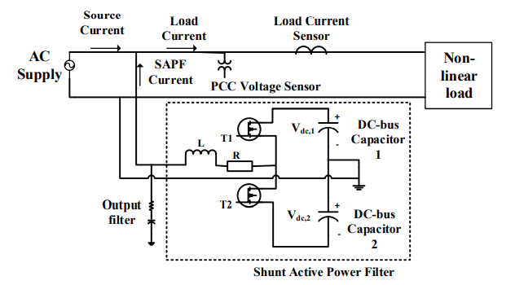

Figure 1: Power circuit of single-phase SAPF

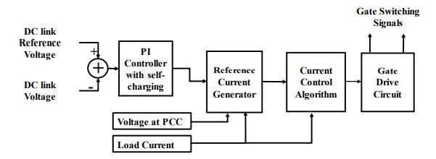

Figure 2: Controller section of single-phase SAPF

1. **THE PI CONTROLLER**

Implementing a discrete PI controller requires a discrete sample period and the discrete PI equation form necessary to approximating the integral of error, both of which are common in digital electronics. It is often used to non-integrating processes, or those where the same result is achieved regardless of the inputs or disturbances applied.



Figure 3 : PI Controller

The PI controller uses both proportional and integral modes to effectively cancel out any innate offsets. Its mathematical representation is as follows:-

$$\text{P=K}\text{p}\text{e}\text{p}\text{(t) +K}\text{p}\text{K}\text{i}\int{ep(T)dT +Pi(0)}$$

Where

* P =PI controller output
* Ki = Integral gain
* Kp= Proportional gain
* Pi(0)= Initial value of integral term
* ep(t) = Controlled variable's desired value - measured value

If the error is zero, the controlled variable will fluctuate sporadically around the target value, and the integral will eventually get it there by canceling out the error.

The controller shortens the rise time to attain maximum output under the current load circumstances if the error is greater than zero. The key benefit of using a PI controller in this situation is that it can be readily applied to fast-response processes and significant and frequent load fluctuations, and that it eliminates steady-state errors.

## 5. CURRENT CONTROL ALGORITHM:

### 1. HYSTERESIS BAND TECHNIQUE: -

Limits for the upper and lower hysteresis bands must be established before this kind of control can be used. If the load is fluctuating, the output DC voltage will fluctuate when using an open loop control technique, while a tight loop strategy will provide a consistent output. In closed-loop control, the current signal at the output is compared to a known reference current signal. Which one reduces output errors while still producing the required results? PI controllers can regulate the gate pulses that are produced. For power switching devices, these signals are generated when the upper and lower hysteresis bands are surpassed. If a critical fault occurs, this method will prevent the power switching devices from being activated. For PID controller tuning, the Ziegler-Nichols approach may be used. This technique involves contrasting the load current with the specified band limit. Switches are closed when the current reaches the upper band limit and opened when it reaches the lower band limit.

## 2.HYSTERESIS PWM FOR CURRENT CONTROL

The output current generated by the filter can be made to mimic the waveform of the reference current with the help of hysteresis current control, which involves generating the necessary triggering pulses by comparing the error signal to that of the hysteresis band.

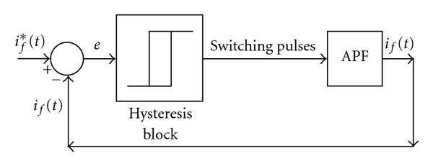Figure 4: Hysteresis Control

This technique employs an asynchronous control of the switches in the voltage source inverter to ramp the current through the inductor in order to track the reference current. In practice, the most fundamental kind of control is hysteresis current control. Hysteresis band voltage controllers are quick, have good dynamics, and need little hardware, making them an attractive option.

To minimize the current ripple at the output side, the suggested method uses a hysteresis band with a constant value (H) in the open loop and a variable value (H') in the closed loop. It will lead to high switching frequency and significant power loss during switching. It also necessitated sophisticated controls for optimal performance in.

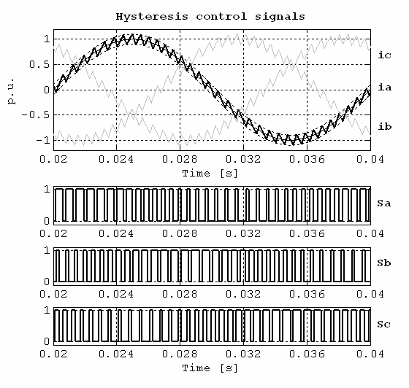

Figure 5: control signals of Hysteresis-Band PWM

Hysteresis current controllers are beneficial because to their speed and precision, as well as their ease of use. However, there may be significant variation in the switching frequency throughout the fundamental period, leading to inverter irregularities.

**6.SIMULATON RESULT AND DISCUSSION**

MATLAB (R2016) is used to put the suggested technique into action. The signal processing toolbox allows us to apply the many Windows, shifting, scaling, and other MATLAB Library operations to our work.

## 1 SIMULATION SOFTWARE

**MATLAB** (**mat**rix **lab**oratory) is a high-level language designed specifically for numerical computation. Matrix operations, graphing of functions and data, algorithm development, user interface design, and interfacing with programs written in other languages like C, C++, Java, and Fortran are all possible with MATLAB, a tool developed by Math Works.

Although MATLAB is mainly designed for numerical computation, it does provide access to symbolic computing via the usage of the MuPAD symbolic engine inside an optional toolbox. Simulink is a supplementary software that provides Model-Based Design and graphical multi-domain simulation for real-time and embedded systems.

Around one million people in business and education used MATLAB in 2004. Users of MATLAB come from a wide variety of disciplines, including engineering, science, and economics. The application of MATLAB extends well beyond the realm of industry, into the realms of academia and research.

To every engineering grad, the name "MATLAB" is instantly recognizable. Since its beginnings in the early 1990s, MATLAB has been extensively used as a scientific computing tool. Originally confined to the realm of academia, it has now become a staple of Electrical and Electronics Engineering curriculums.

The MATLAB software package combines numerical and graphical analysis with a visual programming environment. There are several built-in functions, and other toolboxes are available (e.g., for signal processing) to do even more complex tasks.

## 2 SYSTEM PARAMETER

**Table 1: Parameter used in simulation**

|  |  |
| --- | --- |
| **Parameter** | **Value** |
| AC Voltage | 220V |
| Branch inductance L | 1mH |
| Branch Capacitance C | 300 µF |
| Resistance | 100 Ω |
| Phase Locked Loop (PLL) Minimum Frequency | 37.5 Hz |
| Voltage (Vdc) | 300 V |
| Proportional (Kp) | 0.005 |
| Integral gain (ki) | 0.00023 |

## 

## 7.RESULT ANALYSIS & DISCUSSION

**Description 1 *:***The suggested concept of a single-phase grid-connected shunt active power filter and half bridge voltage source inverter with two MOSFET switches T1 and T2 . C1 and C2 on the opposite leg serve as a DC bus and aid in current compensation. Parabolic pulse width modulation (PWM) controller with source voltage feedback coupled to phase lock loop (PLL) for synchronization of pulses to grid voltage . It has a quick reaction time and a stable output current. We see SAPF's Hysteresis PWM controller in action. The MOSFET switches are alternately driven by a NOT gate, making this controller simpler to build and more responsive than a parabolic PWM controller.

The DC voltage read from the diode bridge rectifier at the load end (nonlinear load). It can withstand 325V with a 15% ripple.

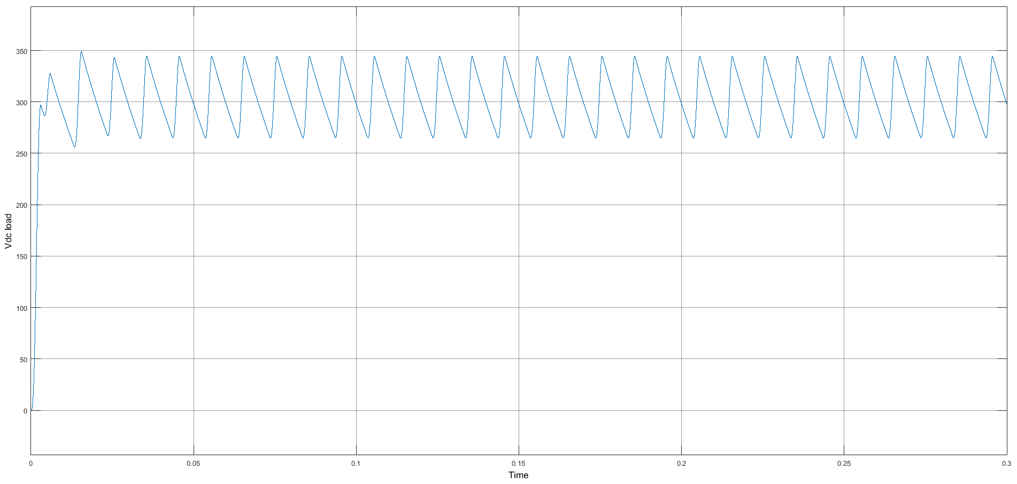

Figure 6: DC side load voltage

***Description 3):***The total harmonic distortion (THD) is calculated during the FFT analysis of the source current. The THD without SAPF, which is around 140.46%. When a SAPF is included with a parabolic PWM controller, the THD is about 6.24%. The THD for the same values for a hysteresis PWM operated SAPF, and it is about 3.98%.

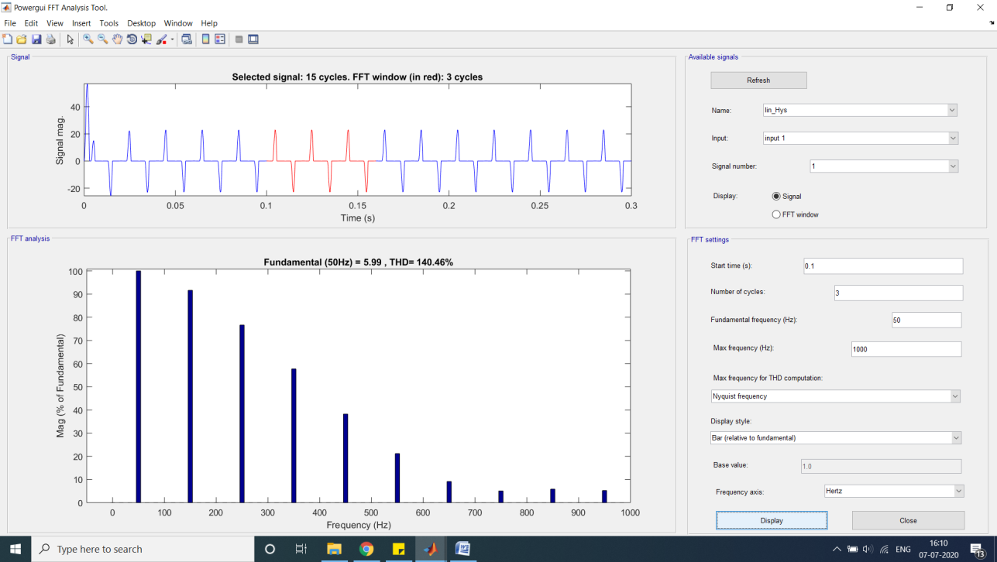

Figure 7: FFT analysis of source current before connecting active power filter

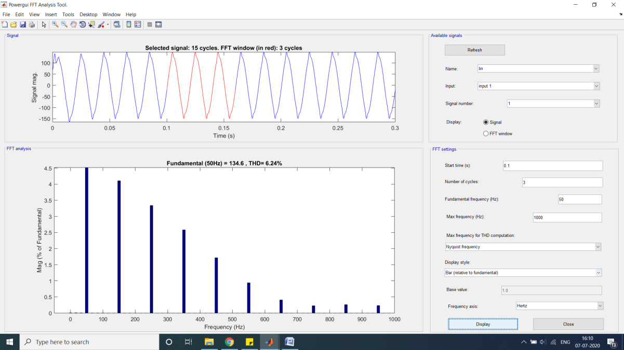

Figure 8: FFT analysis of source current with parabolic PWM active power filter

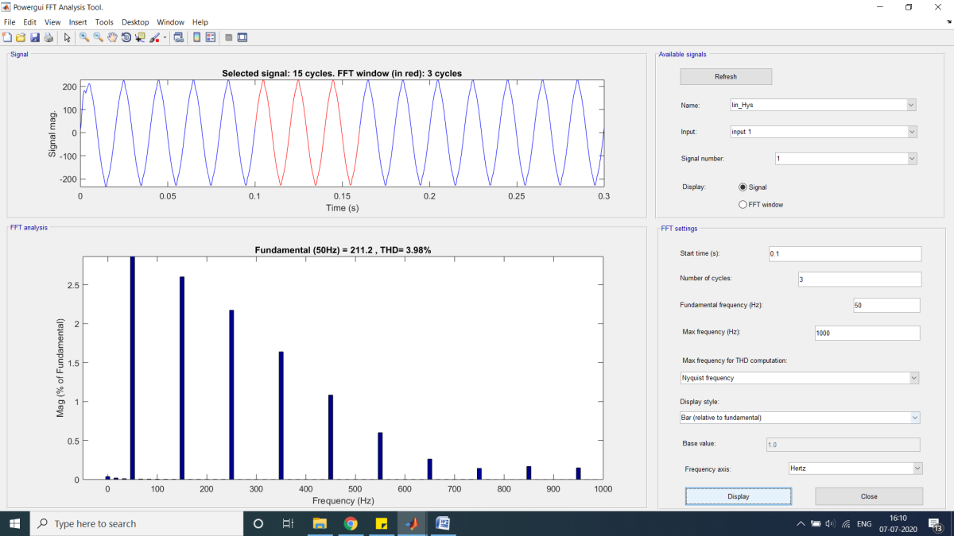

**Figure 9:** **Hysteresis PWM active power filter FFT study of source current**

**Parabolic Pulse Width Modulation Active Power Filter vs. Hysteresis Pulse Width Modulation Active Filter**

|  |  |  |
| --- | --- | --- |
| **S.N.** | **Controller** | **Harmonics Percentage** |
| **1** | Before Connecting active filter | **140.46%** |
| **2** | Parabolic pwmActive Filter | **6.24%** |
| **3** | Hysteresis PWM Active Filter | **3.98%** |

## CONCLUSION

The preceding FFT analysis findings and comparisons indicate that the source current THD is around 140% when SAPF is not present. The similar THD reduction occurs when a parabolic PWM operated SAPF is fitted. If a PWM controller with hysteresis is added to the SAPF, the value drops to roughly 3.98%. The non-linear loads' harmonics are reduced by the SAPF linked at the PCC, safeguarding the whole system from disruption. In MATLAB, the 'Power GUI' block of the Simulink environment is where you'll find yourself using the FFT analysis tool.

## FUTURE SCOPE

In order to further reduce harmonics in the grid, adaptive controllers or fuzzy logic controllers may replace the presently utilized PI controller for the DC bus voltage regulation, which is used to calculate the current magnitude. Hybrid active power filters combine the advantages of active and passive filters to reduce harmonic distortion to levels below 1%. Using parabolic pulse width modulation (PWM) and hysteresis pulse width modulation (HPWM), the same single-phase active power filter may be converted into a three-phase active power filter with two levels of VSI linked to the three-phase grid.

## REFERENCES:

[1] B. Singh, K. Al-Haddad and A. Chandra, "A review of active filters for power quality improvement," in IEEE Transactions on Industrial Electronics, vol. 46, no. 5, pp. 960-971, Oct. 1999.

[2] T. C. Green and J. H. Marks, "Control techniques for active power filters," in IEE Proceedings - Electric Power Applications, vol. 152, no. 2, pp. 369-381, 4 March 2005

[3] Zhaoyang Yan and Guiping Zhu, "Voltage ripple across the capacitor in DC side of shunt APF," 2012 IEEE International Conference on Power System Technology (POWERCON), Auckland, 2012, pp. 1-6.

[4] T. Thomas, K. Haddad, G. Joos and A. Jaafari, "Design and performance of active power filters," in IEEE Industry Applications Magazine, vol. 4, no. 5, pp. 38-46, Sept.-Oct. 1998.

[5] H. -. Kuo, S. -. Yeh and J. -. Hwang, "Novel analytical model for design and implementation of three-phase active power filter controller," in IEE Proceedings - Electric Power Applications, vol. 148, no. 4, pp. 369-383, July 2001.

[6] N. Mendalek, K. Al-Haddad, F. Fnaiech and L. A. Dessaint, "Nonlinear control technique to enhance dynamic performance of a shunt active power filter," in IEE Proceedings - Electric Power Applications, vol. 150, no. 4, pp. 373-379, 8 July 2003.

[7] Hoon, Y., Mohd Radzi, M.A., Hassan, M.K., Mailah, N.F., “Control Algorithms of Shunt Active Power Filter for Harmonics Mitigation: A Review”, Energies, 10, 2038, 2017.

[8] H. -. Jou, J. -. Wu and H. -. Chu, "New single-phase active power filter," in IEE Proceedings - Electric Power Applications, vol. 141, no. 3, pp. 129-134, May 1994.

[9] Wang, G., and Li, Y.W., “Parabolic PWM for Current Control of Voltage-Source Converters (VSCs)”, IEEE Trans. Ind. Appl., vol. 57, no. 10, pp. 3491-3496, 2010.

[10] Y. Singh, I. Hussain, B. Singh, and S. Mishra “Single-Phase Single-Stage Grid Tied Solar PV System with Active Power Filtering Using Power Balance Theory” Received: 9 March 2017 / Accepted: 7 March 2018 the Institution of Engineers (India) 2018.

[11] A. A. Imam, R. Sreerama Kumar, and Y. A. Al-Turki, “Modeling and simulation of a pi controlled shunt active power filter for power quality enhancement based on p-q theory,” Electron., vol. 9, no. 4, 2020, doi: 10.3390/electronics9040637.

[12] R. Kanagavel, I. Vairavasundaram, and S. Padmanaban, “Design and prototyping of single-phase shunt active power filter for harmonics elimination using model predictive current control,” Int. Trans. Electr. Energy Syst., vol. 30, no. 2, pp. 1–21, 2020, doi: 10.1002/2050-7038.12231.

[13] P. Swarnkar, S. K. Jain, and R. K. Nema, “Advanced controlling schemes for active power filter: A review,” Int. J. Emerg. Technol., vol. 10, no. 1, pp. 114–120, 2019.

[14] W. I. S. Qutaina and M. Thesis, “Modeling and Control of Shunt Active Power Filter in Medium Voltage applications,” 2019.

[15] S. S. Managule, S. Dabhole, and S. Gupta, “The shunt active power filter to compensate reactive power and harmonics with optimized PI controller in a 3 phase 3 wire distribution network,” Int. J. Innov. Technol. Explor. Eng., vol. 7, no. 4, pp. 1–7, 2018.

[16] P. K. Ray, “Power Quality Improvement Using VLLMS Based Adaptive Shunt Active Filter,” CPSS Trans. Power Electron. Appl., vol. 3, no. 2, pp. 154–162, 2018, doi: 10.24295/cpsstpea.2018.00015.

[17] Y. Hoon, M. A. M. Radzi, M. K. Hassan, and N. F. Mailah, “Control algorithms of shunt active power filter for harmonics mitigation: A review,” Energies, vol. 10, no. 12, 2017, doi: 10.3390/en10122038.

[18] P. S. Magdum and U. T. Patil, “Development of single phase shunt active power filter,” Proc. Int. Conf. Inven. Commun. Comput. Technol. ICICCT 2017, no. Icicct, pp. 351–355, 2017, doi: 10.1109/ICICCT.2017.7975218.

[19] M. A. A. M. Zainuri, M. A. M. Radzi, A. C. Soh, N. Mariun, and N. A. Rahim, “DC-link capacitor voltage control for single-phase shunt active power filter with step size error cancellation in self-charging algorithm,” IET Power Electron., vol. 9, no. 2, pp. 323–335, 2016, doi: 10.1049/iet-pel.2015.0188.

[20] T. Rajesh, S. Aravindhan, M. Sowmiya, S. Thenmozhi, and U. Scholar, “Design of Shunt Active Filter for Reduction of Harmonics,” Int. J. Eng. Sci., vol. 3317, no. 4, pp. 3317–3321, 2016, doi: 10.4010/2016.770.