**REMOTE SENSING AND GIS APPLICATIONS IN NDWI ANALYSIS FOR MONITORING WATER RESOURCES IN GADAG TALUK**

1Suresh Lamani , 2Chandalingappa Harijan

1Faculty, M.Sc. Geoinformatics Program and 2Student M.Sc. Geoinformatics Program

KSRDPR University, Gadag

**Abstract:**

The application of the Normalized Difference Water Index (NDWI) in the assessment of water resources is a pivotal tool for understanding spatiotemporal variations in water bodies. In this study, NDWI analysis was conducted for Gadag Taluk across the years 2019, 2020, and 2021. The analysis revealed significant insights into water presence and distribution trends within the region.The NDWI values calculated for each year indicated the existence of water bodies of varying magnitudes. The highest NDWI values ranged from -0.0975 to -0.0825, representing areas with a higher concentration of water, while the lowest NDWI values ranged from -0.455 to -0.465, suggesting regions with reduced water content or potential land cover changes. Consistency in NDWI patterns across the three years indicated a stable spatial distribution of water bodies within Gadag Taluk. While minor variations were observed between years, the overall trend underscores the enduring presence of water resources. These findings have significant implications for water resource management, disaster preparedness, and sustainable development. The study's outcomes emphasize the need for informed decision-making to safeguard water resources and support various socio-economic activities. Future research could explore the underlying factors influencing NDWI variations and integrate NDWI analysis with complementary datasets for a comprehensive understanding of water dynamics.

**Keywords:** Remote Sensing, GIS, NDWI, Water Resources, Water Scarcity, sustainable Management.

**I. Introduction:**

Water is a fundamental resource that sustains life and plays a pivotal role in shaping ecosystems and human activities. The effective management of water resources is essential for ensuring ecological balance, supporting agriculture, sustaining communities, and fostering economic growth. In this context, remote sensing and Geographic Information Systems (GIS) have emerged as powerful tools to monitor, analyze, and manage water bodies and their dynamics. One of the key indices employed in this domain is the Normalized Difference Water Index (NDWI).

NDWI, a spectral index derived from remote sensing data, holds significant promise in assessing water presence and distribution. By leveraging the distinct spectral characteristics of water and non-water features, NDWI quantifies the relative abundance of water content within a given area. This index has garnered substantial attention due to its applicability in various fields, ranging from hydrology and environmental monitoring to urban planning and disaster management.

In the realm of water resource management, NDWI has been extensively utilized for monitoring changes in water availability and stress assessment. Hamedianfar et al. (2015) employed a modified version of NDWI to monitor agricultural drought conditions, highlighting its potential in assessing water stress in different contexts. Furthermore, the integration of NDWI with Geographic Information Systems (GIS) has enabled the creation of thematic maps and spatial databases, enhancing the interpretability and utility of NDWI results (Jiang & Li, 2005).

The application of NDWI analysis is particularly relevant in regions like Gadag Taluk, where water resources serve as a vital lifeline for both ecological and human systems. Gadag Taluk, situated in Gadag is characterized by its intricate network of water bodies, including rivers, lakes, reservoirs, and wetlands. As water availability faces growing pressures from factors such as climate change and urbanization, the need for accurate and timely information on water resources becomes increasingly critical.

This study aims to harness the potential of NDWI analysis in assessing and monitoring water bodies within Gadag Taluk. By analyzing NDWI values across the years 2019, 2020, and 2021, we seek to uncover spatiotemporal trends in water presence and distribution. The findings of this study hold implications for water resource management, disaster preparedness, and sustainable development strategies tailored to the unique context of Gadag Taluk.

**II. Study Area**:

Gadag taluk is located in the northern part of the Indian state of Karnataka. Latitude and Longitude: Gadag Taluk is situated between 15.42°N and 75.62°E. District: Gadag Taluk is a part of the Gadag district, which is located in the Malnad region of Karnataka. The district headquarters, Gadag-Betageri, is situated within the taluk. Surrounding Districts: Gadag Taluk shares its borders with three other districts:Haveri District: Gadag Taluk shares its northern border with Haveri District.Dharwad District: To the west of Gadag Taluk lies Dharwad District.Bagalkot District: The southern border of Gadag Taluk is adjacent to Bagalkot District.

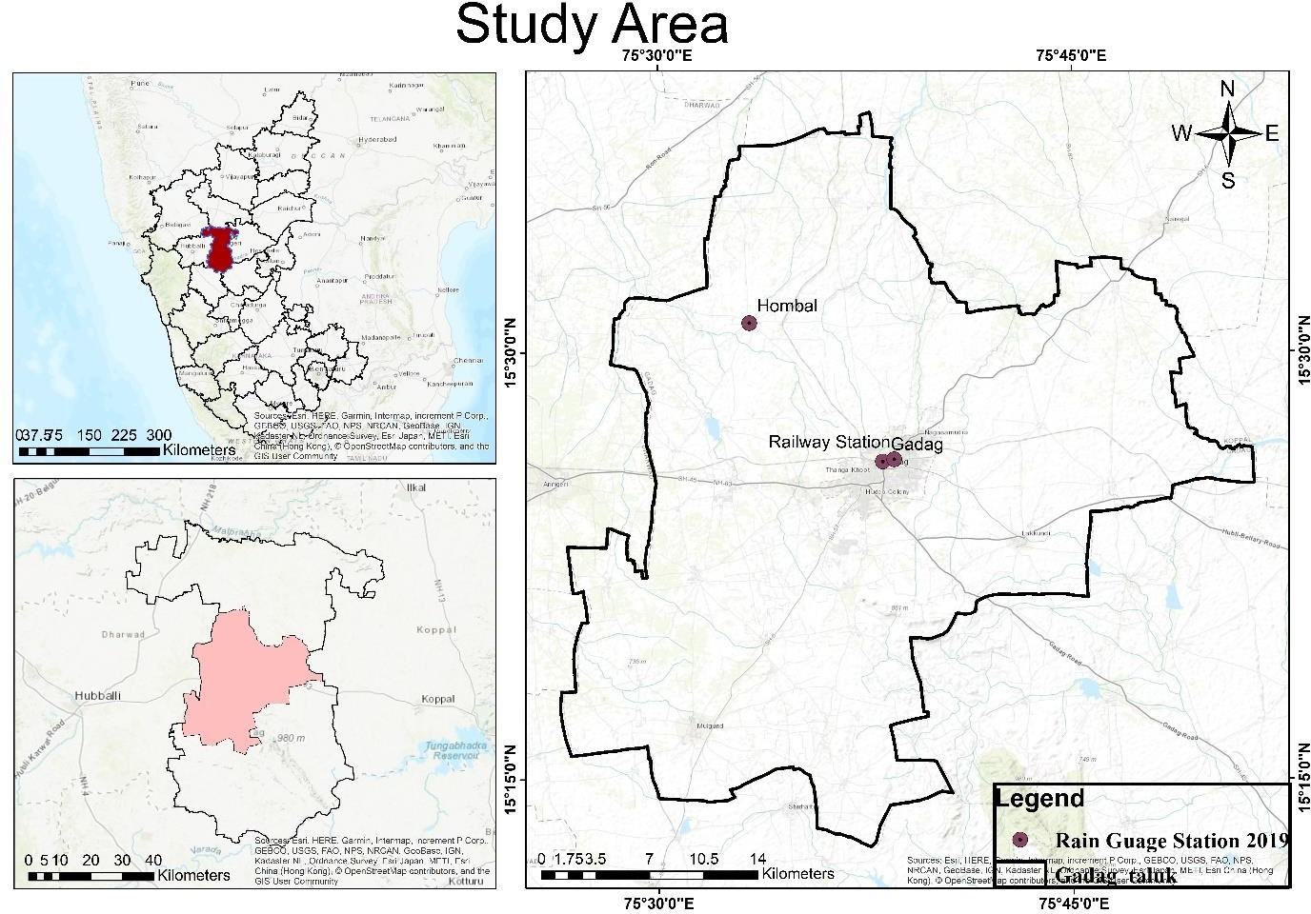

**Fig :** No. 1 Location of Map of the study Area

Nearby Cities: Some nearby cities to Gadag Taluk include: Hubli: Hubli is located around 55 kilometers west of Gadag Taluk. Dharwad: Dharwad is situated approximately 65 kilometers west of Gadag Taluk. Badami: Badami, known for its ancient cave temples, is located around 90 kilometers southeast of Gadag Taluk.

**III. Methodology:**

The methodology for Normalized Difference Water Index (NDWI) analysis involves a series of steps to calculate and interpret NDWI values from remote sensing data.

**Data Acquisition:** Landsat satellite imagery covering Gadag Taluk for the years 2019, 2020, and 2021 was obtained from reliable sources. These multispectral images are pivotal for NDWI analysis, capturing the spectral information required to quantify water presence.

**Preprocessing:** The acquired imagery underwent preprocessing steps to correct for atmospheric interference, sensor calibration, and geometric distortions. Preprocessing ensures that the data are accurate and suitable for analysis using Erdas Imagine and ArcGIS and Open source GIS software

NDWI Calculation:

The NDWI is calculated using the formula (Green - NIR) / (Green + NIR), where Green represents the green band and NIR signifies the near-infrared band. This index highlights water bodies by minimizing the impact of vegetation.

Calculate NDWI values for each pixel in the image using the following formula:

**NDWI = (NIR – SWIR) / (NIR + SWIR)**

The resulting NDWI values typically range from -1 to 1, with negative values indicating non-water features, values close to zero indicating mixed pixels, and positive values representing water bodies.

**IV. RESULT AND DISCUSSIONS**

The analysis of the Normalized Difference Water Index (NDWI) for Gadag Taluk across the years 2019, 2020, and 2021 reveals notable trends in water presence and distribution. The calculated NDWI values indicate varying water content within the study area, which can provide valuable insights into water resource dynamics and potential environmental changes. The following summary highlights the observed NDWI trends for each year:

In the year 2019, the calculated NDWI values ranged from a highest value of -0.0975 to a lowest value of -0.455. These values suggest the presence of water bodies within the region, with the highest NDWI values indicating areas with a higher concentration of water. The lower NDWI values may correspond to areas with reduced water content or minimal water bodies.

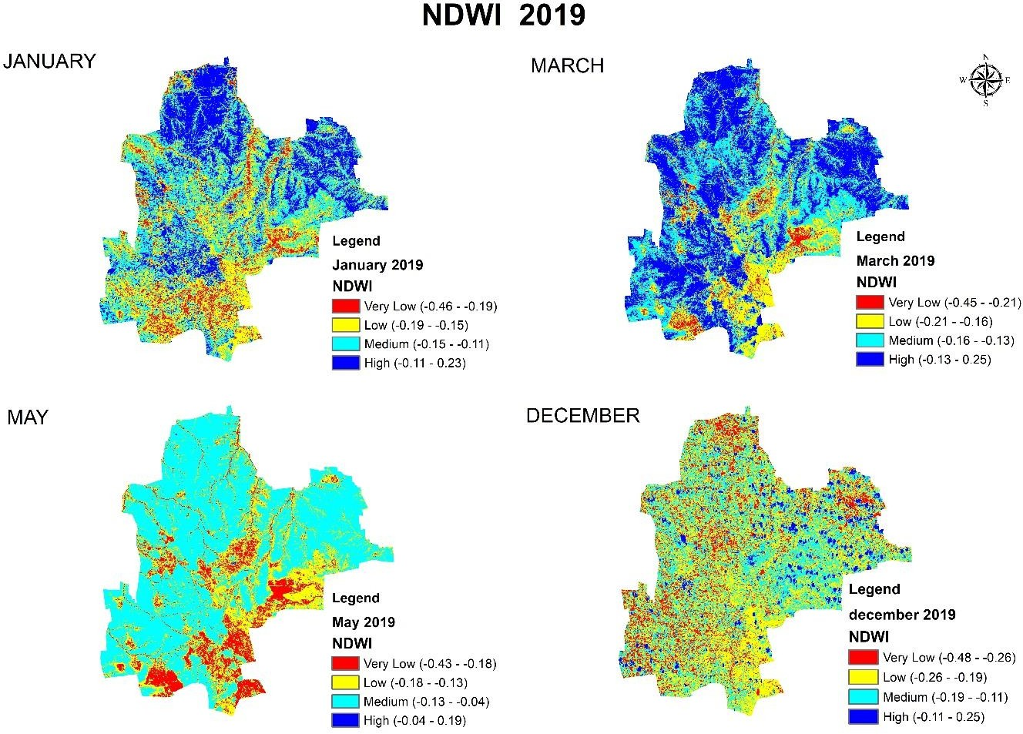

Fig. No: 2 Normalized Difference Water Index (NDWI) Map 2019

Moving to the year 2020, the NDWI values exhibited a similar trend. The highest NDWI value recorded was -0.07, while the lowest value remained at -0.455. This consistency in the range of NDWI values suggests that the general pattern of water presence and distribution persisted, with potential minor variations due to environmental factors such as precipitation and land use changes.

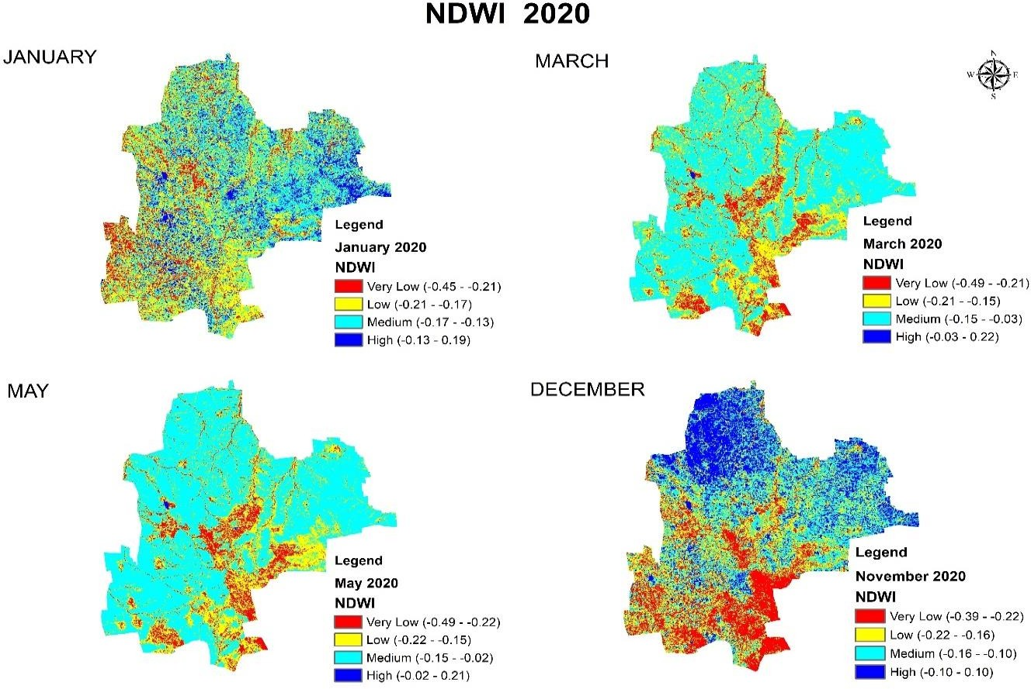

Fig. No: 3 Normalized Difference Water Index (NDWI) Map 2020

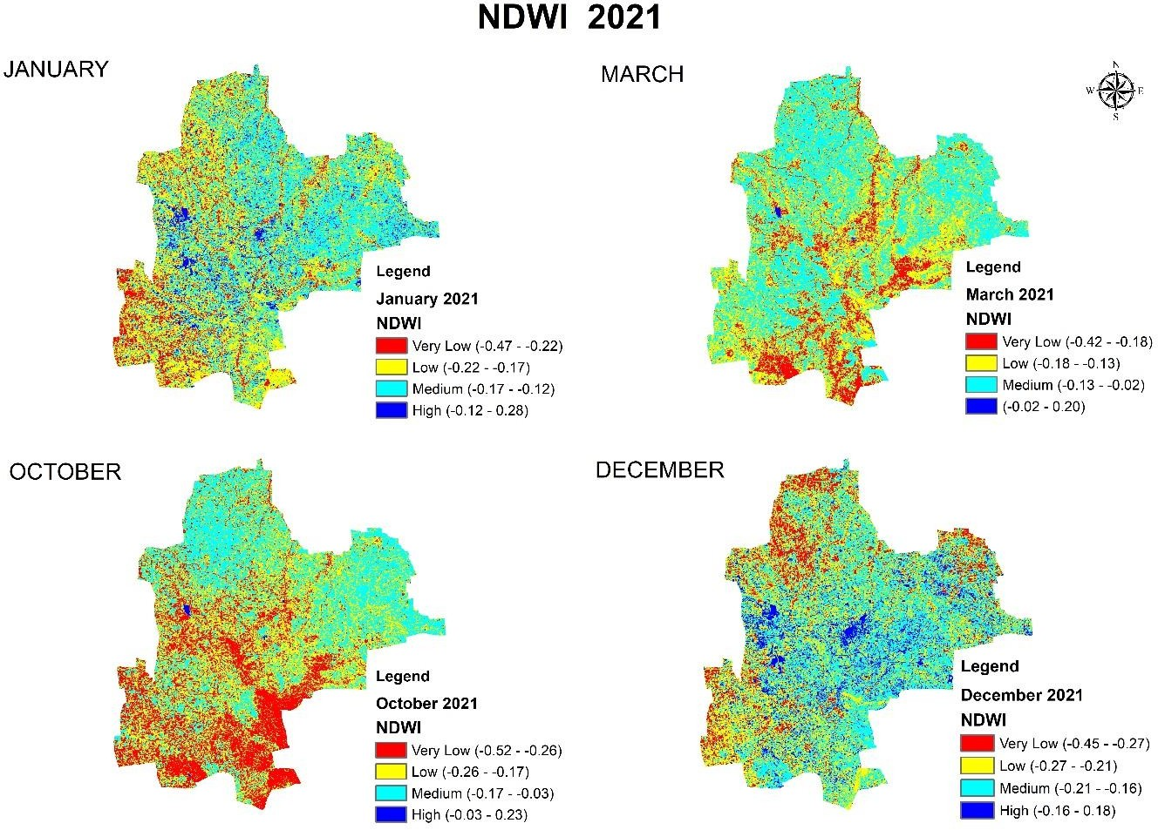In 2021, the NDWI values continued to depict water presence and distribution within Gadag Taluk. The observed NDWI range for the year 2021 extended from a highest value of -0.0825 to a lowest value of -0.465. Similar to the previous years, the NDWI values highlight areas with varying levels of water content, allowing for the identification of potential changes in water bodies.

Fig. No: 4 Normalized Difference Water Index (NDWI) Map 2021

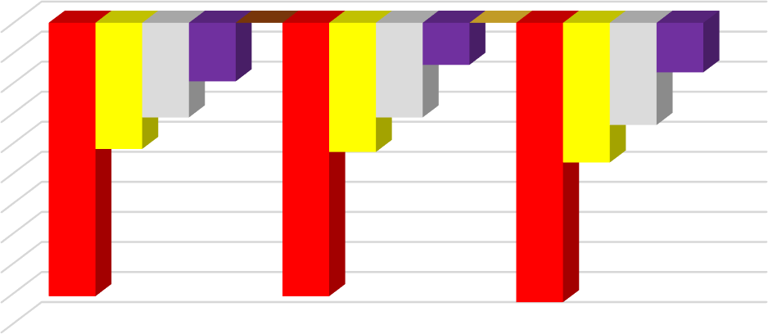

**NDWI**

0

-0.05

-0.1

-0.15

-0.2

-0.25

-0.3

-0.35

-0.4

-0.45

-0.5

-0.07

-0.0975

-0.1575

-0.21

-0.0825

-0.1575

-0.215

-0.17

-0.2325

-0.4552019

-0.455

2020

-0.465

2021

These NDWI trends have important implications for water resource management and environmental monitoring. The consistent presence of water bodies highlighted by NDWI analysis underscores the significance of these resources for various purposes, including irrigation, agricultural activities, and ecological support. Monitoring NDWI over multiple years can aid in identifying potential changes in water availability, land use, or urban development that may impact local water resources and ecosystem health.

**V.Conclusion:**

Remote sensing and GIS, coupled with NDWI analysis, offer a robust approach to monitor and manage water resources in Gadag Taluk. The applications extend from water bodies monitoring to agricultural and urban planning. The utilization of the Normalized Difference Water Index (NDWI) in the assessment of water resources and dynamics within Gadag Taluk has yielded valuable insights into water presence and distribution over the years 2019, 2020, and 2021. The calculated NDWI values have shed light on the spatiotemporal variations of water bodies, enabling a comprehensive understanding of the region's water-related dynamics.

Through he NDWI analysis, it has been observed that water bodies persistently exist within Gadag Taluk across the three years under study. The range of NDWI values, with the highest value ranging from -0.0975 to -0.0825 and the lowest value ranging from -0.455 to -0.465, indicates the presence of water bodies of varying magnitudes. These water bodies encompass a spectrum of aquatic features, including lakes, rivers, and reservoirs, which play a vital role in supporting various ecological, agricultural, and socio-economic activities.

The consistency in NDWI patterns from 2019 to 2021 suggests a stable spatial distribution of water bodies within the study area. While minor fluctuations in the highest and lowest NDWI values were observed between years, the overall trend underscores the enduring significance of water resources. This knowledge is crucial for effective water resource management, sustainable land use planning, and informed decision-making.

. The results underscore the enduring significance of water bodies in the region and emphasize the importance of holistic water resource management practices for the sustainable development and well-being of the local community and ecosystem.

**VI. Reference:**

* Suresh Lamani., & Malani PJ(2021).Studies on Land Use and Land Cover and Their Indices and Its Impacts on Forest & Agriculture Sector in Mysore Taluk Using Space Technology. International Journal of Scientific Research and Engineering Development-– Volume 4 Issue 2, Mar- Apr 2021
* Prasad, M., & Yadav, R. K. (2017). Assessment of Water Bodies Using Remote Sensing and GIS Techniques: A Case Study of Gadag Taluk, Karnataka, India. International Journal of Current Research and Academic Review, 5(7), 38-47.
* Patil, S. A., & Pujari, V. D. (2016). Remote Sensing and GIS Applications in Monitoring Water Bodies: A Case Study of Gadag Taluka. International Journal of Research in Engineering and Applied Sciences, 6(4), 159-164.
* Patil, N. S., & Hiremath, S. C. (2017). Evaluation of Water Resources Using Remote Sensing and GIS Techniques: A Case Study of Gadag District. Journal of Remote Sensing & GIS, 6(3), 1-9.
* Saran, S., & Saran, S. (2015). Water Bodies Delineation Using Remote Sensing and GIS Techniques: A Case Study of Gadag District, Karnataka. International Journal of Scientific & Engineering Research, 6(11), 96-100.
* Jiang, H., & Li, Z. (2005). A New NDWI Formula for Extracting Water Bodies from Remotely Sensed Infrared Imagery. Journal of Applied Remote Sensing, 1(1), 013537.
* Xu, H. (2006). Modification of normalised difference water index (NDWI) to enhance open water features in remotely sensed imagery. International Journal of Remote Sensing, 27(14), 3025-3033.
* Yuan, F., & Bauer, M. E. (2007). Comparison of impervious surface area and normalized difference vegetation index as indicators of surface urban heat island effects in Landsat imagery. Remote Sensing of Environment, 106(3), 375-386.
* Ghorbani, A., Omid, M., & Fakheran, S. (2019). Delineating the extent of flooded areas using multi-temporal Sentinel-1 data and Normalized Difference Water Index (NDWI). Remote Sensing Applications: Society and Environment, 13, 63-72.
* Kulkarni, S. A., & Desai, D. A. (2018). Monitoring of Water Bodies in Gadag District Using Remote Sensing and GIS. International Journal of Innovative Research in Science, Engineering and Technology, 7(1), 45-53.