SMART FISH FARMING SYSTEM

Mohamed Anas. M1, Naveenraj .B.M2, Anand. L3, Kalieswari. C4

1Student, Bachelor of Engineering, Department of ECE, National Engineering College, Kovilpatti, India.

2Student, Bachelor of Engineering, Department of ECE, National Engineering College, Kovilpatti, India.

3Student, Bachelor of Engineering, Department of ECE, National Engineering College, Kovilpatti, India.

4Assistant Professor, Department of ECE, National Engineering College, Kovilpatti, India.

[11911009@nec.edu.in, 21911033@nec.edu.in,](mailto:1911009@nec.edu.in) [31911036@nec.edu.in, 4kalieswari_ece@nec.edu.in](mailto:1911036@nec.edu.in)

***Abstract -* In order to bring a fish farming pond as close to its natural state as feasible with the least amount of human intervention, the proposed work intends to create a smart IoT system that is utilized to automate the monitoring and maintenance of a fish farming pond in remote places. We concluded that most smart fishponds employ temperature sensors to gauge the water's temperature based on the results of several studies we reviewed. In this situation, a DSP18B20 sensor is being used to measure the temperature, and we have offered a clever solution for keeping the fish tank's temperature within the permitted temperature range. We are using a water heater and a water chiller to maintain our fishpond's temperature within the appropriate range. MATLAB's Thingspeak IOT platform receives the temperature measurement after the DSP18B20 initially determines the tank's temperature. After that, based on the temperature reading, the water heater and water cooler will start operating. The goal of this inventive technique is to lessen environmental stress on the pond's fish population. An automated Internet of Things system for fish farming uses a Wi-Fi remote link to measure crucial variables like water temperature and water level.**

***Keywords*** *– IoT system, Wi-Fi module, Sensors, temperature, water level.*

1. INTRODUCTION

These days, as there is occasionally a need for fish, the entrepreneurial sector of fish farming is growing in popularity. For instance, Abiodun Enola, a guy from Nigeria, has additional money and is able to break his own records in the fisheries (catfish) industry. He began the firm with N200,000, and now he is the owner of 15 ponds. However, company owners in this industry need to understand how crucial it is to keep an eye on the fish farming environment in order to remain profitable. This is so that the ecology won't go out of balance as a result of fish farming's chemicals, which are produced and then dissolve in the water and impair its quality. Ammonia is one of the byproducts of protein metabolism that fish expel via their gills. Since Vietnam is one of the major exporters of fish to the rest of the globe, the water quality in ponds and tanks is highly regulated. This demonstrates how significantly the aquaculture environment is impacted by water quality. Fish produce less often or have shorter lives as a result of poor water quality. Nevertheless, the presence of pollutants in the water is a serious issue since it might lead to chemicals leaking into the water, therefore this system was proposed to provide a self-regulating mechanism for managing water quality.

The sensor's data can be used to identify problems in the fish farming sector and discover solutions, such as improving fish health. IoT integration in the sector hence has many benefits. It provides comprehensive coverage of data from various sources, enabling effective monitoring and the quick implementation of corrective action. The scalability and data red Cloud systems' scalability and data redundancy hem with IoT. For accurate decision-making, process automation, and timely alerts, sophisticated prediction models may be created using artificial intelligence (AI) and machine learning (ML) technology. The Internet of Things is being used in aquaculture to give its systems more artificial intelligence (IoT). Aquaculture supports the population recovery of aquatic species that are threatened by providing sustainable food and economic items. Fish growth has increased in open oceans and coastal marine areas as a result of the rising demand for seafood.

Aquaculture systems based on the Internet of Things (IoT) allow for the control of the wheels, motors, feed machines, and other equipment as well as the monitoring of purity and the microclimate, the provision of warning functions, and the enhancement of early warnings and reaction times. Furthermore, by utilizing sensors and feed data, the information gathered by such an IoT system can help aquaculture become more precise and intelligent. In addition to consistent water quality, energy savings, and precise feeding, there will be labor savings as a result. This can improve the output of aquaculture and maximize its advantages in addition to lowering catastrophe and damage risks. In addition, because of their hectic daily schedules, those who keep fish as pets are more prone to abandon their aquariums. An automated system called the "Fish Pond Monitoring System" monitors the environment in fish ponds. Several crucial factors are being checked and maintained to ensure that fish ponds are in the best possible environment and are profitable for business owners.

This study's smart fish farm system prototype, which is built on the internet of things and artificial intelligence, aims to address current aquaculture problems. The suggested maximization has a number of sensors that can be controlled by an Arduino Mega2560, which also has sensors, a motor, and an inbuilt Wi-Fi module.

These are the goals of this investigation:

1. To make real-time data gathering possible, enabling easy remote monitoring, change, and evaluation of system characteristics such as fishpond water quality; 2) By linking the various feeding system parameters, a model is developed to forecast the growth of California bass fish; 3) To make it possible to assess the water's temperature, the depth of oxygen, and the feed's usage of a sediment sensor; 4) To ascertain the input and output factors that have the most effects on the model's ability to maximize efficacy, a correlation analysis was performed.
2. A mobile application has been created to remotely monitor and manage the system. This will increase fish productivity while lowering production expenses. The outcome might be the emergence of the most elite and competitive aquaculture sector. Financial advantages may have an impact on improvements in fish farming.
3. RELATED WORKS

Using an IoT-based automation system, the pH, temperature, and dissolved oxygen levels of a fish pond may be continually monitored. Profit maximization and improved resource management may result from using the data the system gathers. culminating in exhaustive investigation and prudent decisions. A wireless sensor network (WSN) was used by the researcher to create and install an aquaculture real-time monitoring platform that recorded data on water quality, dissolved oxygen concentration, pH, and water level. The authors proposed

wireless sensor network-based energy-saving aquaculture approaches (WSN).

They created and put into use a real-time fish farming monitoring system that connected sensor devices to the server side using the GPRS and ZigBee technologies, resulting in an increase in transmission reliability. Ida Chaba and associates created a pond controller that employs suitable sensors to monitor the pond's water quality and can be operated remotely by CCTV. Cairo and coworkers developed a trustworthy method for long-term environmental monitoring in fish farming.. Deep learning computer vision was utilized by Wu-Chih Hu and others to build a fish-feeding system. The amount of feed is calculated by calculating the waves that the feed that feeds fish produces.

1. METHODOLOGY

The quantity of fish needed to maintain an aquaculture environment may be considerably reduced with the application of automation technologies such as intelligent fish management systems and systems for monitoring and controlling water quality. In this project, the ultrasonic sensor and DS18B20 are used to secure the fish tank. Here, the temperature is determined by a DS18B20, and the water level in the fish tank is monitored by an ultrasonic sensor. A decrease from the water's normal temperature shows that the water heater is being used to maintain the water at room temperature if the temperature is calculated by estimating the water's wavelength for fish-eating feed. Node MCU makes use of both a microcontroller and a Wi-Fi module. The flow chart of the working principle is shown in Fig.3.2.

The gadget uses data from the sensors to continually monitor the environment. The data is then transferred to the IoT website ThingSpeak across our network using the Wi-Fi module. After MATLAB integration, our data is shown as the gauge's present value. It will be possible to write that data using API keys. As a result, the fish keeper will receive information about the fish tank using ThingSpeak. This system monitors the water quality by taking measurements of pH, turbidity, conductivity, and temperature using a number of sensors. The sensor data will be available to the Arduino controller in use. IoT is utilized to analyze the collected data, and a rigorous process may be applied to check into water contamination. A smart water quality monitoring system can help achieve LEED certification by lowering water use, and monitoring water temperature and humidity, oxidation-reduction potential, and other data.API keys will be used to write that data. As a result, the fish keeper will receive information about the fish tank via ThingSpeak. Figure 3.1 depicts the deployment of a smart fish farming system.

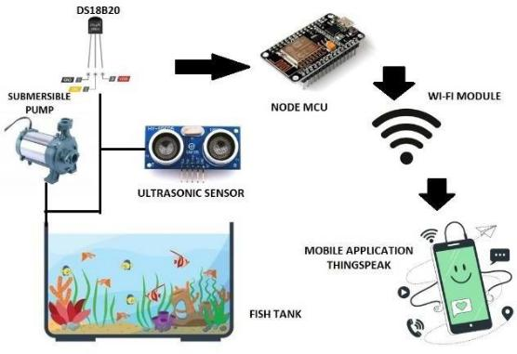

Fig. 3.1 Smart Fish Farming System

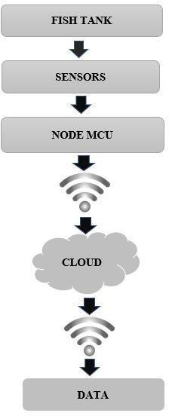

Fig 3.2 Flow chart of smart fish farming system

1. HARDWARE DESCRIPTION

The Connection of Hardware components with Node MCU is shown in Fig.4.1

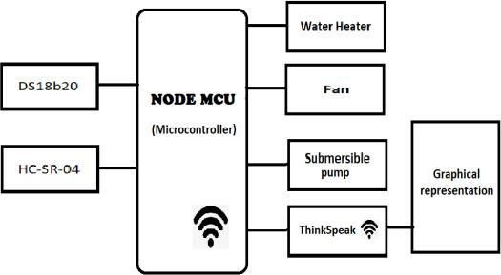

Fig. 4.1 Block diagram of smart fish farming system

1. NODE MCU

The Node MCU (Node Micro Controller Unit), an open-source software and hardware development environment for software and hardware development, is based on the inexpensive ESP8266 System-on-a-Chip (SoC). The ESP8266 was created and produced by Express if Systems and has all of the necessary components of a computer, such as a CPU, RAM, networking (Wi-Fi), and even a contemporary operating system and SDK. This makes it a fantastic alternative for all types of Internet of Things (IoT) projects, making it a fantastic option for all types of Internet of Things (IoT) projects.

However, using the ESP8266 as a chip is difficult. Even the simplest operations, like turning it on or sending a keystroke to the "computer" on the chip, require the proper cable connections to its pins. Low-level machine commands that the chip hardware can understand must also be used when programming it. Using the ESP8266 as an embedded controller in surplus items is not challenging at this degree of integration. For newcomers, hackers, or students who want to test it out in their own IoT projects, it is a significant hardship.

1. ULTRASONIC SENSOR

When measuring the distance to a target object using ultrasonic sound waves, an ultrasonic sensor turns the audio that is reflected back into an electrical signal. Ultrasonic waves move more slowly than audible sounds and travel more swiftly than the latter (i.e., the sound that humans can hear). The transmitter (which generates a signal using piezoelectric crystals) and receiver make up the majority of an ultrasonic sensor (which encounters the sound after it has traveled to and from the target). By maintaining a record of the amount of time between sound emission from the transmitter and its interaction with the receiver, the sensor may determine how far away an item is from it. D = 12 T x, where D is the length, T is the time, and C is the sound speed of 343 m/s, is used to calculate the answer. For instance, if a researcher placed an ultrasonic sensor inside a container and waited 0.025 seconds for the noise to return, the distance between the two items would be as follows:

= 0.5 0.025 343 4.2875 .

1. DS18B20 TEMPERATURE SENSOR

A specific kind of temperature sensor, the DS18B20, produces temperature data in the 9–12 bit range. These numbers display the device's temperature. This sensor is able to connect with an internal CPU thanks to the one-wire bus protocol, which only requires a single data line.

Additionally, since this sensor receives its power straight from the data line, it does not need an additional power source. The DS18B20 temperature sensor can be used in thermosensitive industrial systems, consumer goods, thermostatic controls, and thermometers. The DS18B20 temperature sensor monitors temperature in a manner similar to a temperature sensor. The power-up resolution of this sensor, which has a sensitivity range of 9 bits to 12 bits, is tuned to the 12-bit standard. Temperature measurements can be saved in the sensor's 2-byte register before it returns to its inactive state. The master can add scan time slots adjacent to the Convert T instruction if the sensor is powered by an external source. The sensor will respond by providing and delivering 1 in response to changes in temperature.

1. WATER HEATER

The aquarium heater's temperature may be adjusted automatically. Setting the heater to the preferred temperature, which varies from 68°F to 93°F (20°C to 34°C), is quite easy. The majority of fish thrive in the 76°F to 80°F (25–27°C) temperature range. Mount the light on the fish tank heater, which is submersible and has moveable suction cups and is equipped with two suction cups as well.. Anywhere along the cylinder wall may be used to mount the aquarium heater. Thicker, never-aging materials are used in the suction cups of the device, substantially extending their lifespan.

1. WATER COOLER

Blower Cooling Fan constructed from high and unique materials. It is incredibly robust and resistant to high temperatures. A great choice for cooling heat sinks on hot ends, printing, or other cooling requirements. For tremendous air throw, this blower fan incorporates a projector blower centrifugal fan. Its construction with premium PBT+30% glass line+VO and high-precision bearings ensure a long lifespan and little noise. It may be used to manage a temperature drop to 75 degrees. It can operate continuously for 24 hours at a temperature of 40.

f. SUBMERSIBLE PUMP

A centrifugal pump that runs in water and is driven by an electric motor is known as a submersible pump. An array of impellers are rotated by the sealed electric motor. Each rotor in the series pushes water into the rotor above it through a diffuser. A typical 4-inch submersible pump impeller raises the pressure by roughly 9 psi. For instance, a normal 10-stage pump will provide an exit pressure of around 90 psi (i.e.10 impellers x 9 psi).

The breadth of the impeller and the number of impellers, respectively, define the pump's volume and pressure. In contrast to a 1/2 horsepower 14-stage pump, which will generate less water but at a higher pressure, a 1/2 horsepower 7-stage pump has the capacity to produce a significant volume of water at low pressure. Similar to other centrifugal pumps, the throughput will decline as the descent depth or output pressure rises.

1. WORKING PRINCIPLE

The DS18B20 sensor value will be read by the smart fish farming system to determine the temperature, and three conditions will be applied to the process based on the reading. Temperatures in the aquarium should range from 23 to 27 degrees Celsius. If the temperature in the initial scenario is below 23 degrees, the water heater will turn on and run until the number reaches the ideal range. The second requirement will be met if the reading exceeds 27 degrees. When the temperature rises to the proper level, the heater will activate and start working. The value will first measure the temperature before reading the water level with an ultrasonic sensor. The submersible pump will operate according to the water level.

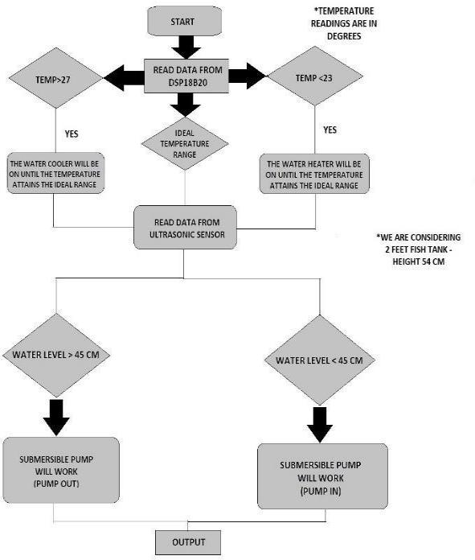

1. RESULT

Figures 6.1 and 6.2, illustrate the results of the thingspeak's measurements of the water's temperature and level, respectively.

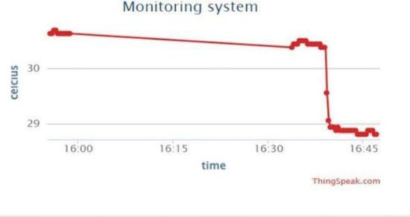

Fig. 6.1 Water temperature of the fish tank

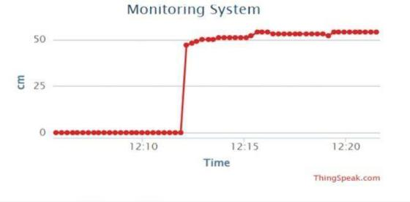

Fig. .2 Water Level of the fish tank

7. HARDWARE SETUP

The Node MCU is connected to the Thingspeak in the example working model, and the Sensors are connected to the Node MCU. Figure 7.1 depicts the hardware configuration of the smart fish farming system.

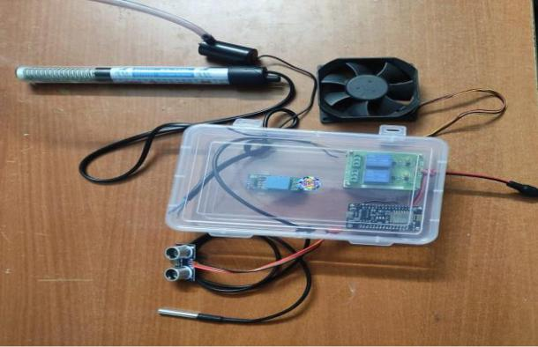

|  |  |  |
| --- | --- | --- |
| Fig. 5.1 Flow chat of Working principle | Fig.7.1 Hardware setup of Smart fish tank |  |
|  |  |

1. CONCLUSION

This project involved designing and implementing an autonomous fish farming system that gauges the water's level and temperature. The system also automatically turns on the motor if the water level is low, the heater if the temperature is low, and the fan if the temperature is excessive. It also notifies the user of the various characteristics of the water in the tank via the Thingspeak website. It is intended to construct an automated feeding system in the future.

REFERENCE

1. M. Abdulrahman, A. G. Putrada, and M. M. Deris, "A Robust Internet of Things-Based Aquarium Control System Using Decision Tree Regression Algorithm," in IEEE Access, vol. 10, pp. 56937-56951, 2022, doi: 10.1109/ACCESS.2022.3177225.
2. L. -B. Chen, Y. -H. Liu, X. -R. Huang, W. -H. Chen and W. -C. Wang, "Design and Implementation of a Smart Seawater Aquarium System Based on Artificial Intelligence of Things Technology," in IEEE Sensors Journal, vol. 22, no. 20, pp. 19908-19918, 15 Oct.15, 2022, doi: 10.1109/JSEN.2022.3200958.

[3] Y. -C. Wu, C. -H. Chen, S. -E. Kao and J. -J. Chen, "FishFarm Management System Based on IoT," 2021 International Symposium on Intelligent Signal Processing and Communication Systems (ISPACS), Hualien City, Taiwan, 2021, pp. 1-2, doi: 10.1109/ISPACS51563.2021.9651086.

1. G. A. Chelaru and F. C. Braescu, "FreeRTOS Based Aquarium Monitoring and Maintenance Embedded System," 2021 25th International Conference on System Theory, Control and Computing (ICSTCC), Iasi, Romania, 2021, pp. 144-149, doi: 10.1109/ICSTCC52150.2021.9607142.
2. A. Petkovski, J. Ajdari and X. Zenuni, "IoT -based Solutions in Aquaculture: A Systematic Literature Review," 2021 44th International Convention on Information, Communication and Electronic Technology (MIPRO), Opatija, Croatia, 2021, pp. 1358-1363, doi: 10.23919/MIPRO52101.2021.9597005.
3. J. Lee, A. Angani, T. Thalluri and K. j. Shin, "Realization of Water Process Control for Smart Fish Farm," 2020 International Conference on Electronics, Information, and Communication

(ICEIC), Barcelona, Spain, 2020, pp. 1-5, doi: 10.1109/ICEIC49074.2020.9051285.

1. A. K. Pasha Mohd Daud, N. A. Sulaiman, Y. W. Mohamad Yusof and M. Kassim, "An IoT-Based Smart Aquarium Monitoring System," 2020 IEEE 10th Symposium on Computer Applications & Industrial

Electronics (ISCAIE), Malaysia,2020, doi:10.1109/ISCAIE47305.2020.9108823.

1. A. K. Muhammad Masum, M. Shahin, M. K. Amzad Chy, S. Islam Khan, A. Shan-A-Alahi and M. G. Rabiul Alam, "Design and Implementation of IoT based Ideal Fish Farm in the Context of Bangladesh Aquaculture System," 2019 1st International Conference on Advances in Science, Engineering and Robotics Technology (ICASERT), Dhaka, Bangladesh, 2019, pp. 1-6, doi: 10.1109/ICASERT.2019.8934736.
2. Y. -B. Lin and H. -C. Tseng, "Fish Talk: An IoT-Based Mini Aquarium System," in IEEE Access, vol. 7, pp. 35457-35469, 2019, doi: 10.1109/ACCESS.2019.2905017.
3. M. Abinaya., S. Survenya., R. Shalini., P. Sharmila and J. Baskaran, "Design And Implementation Of Aquaculture Monitoring And Controlling System," 2019 International Conference on Computation of Power, Energy, Information and Communication (ICCPEIC), Melmaruvathur, India, 2019, pp. 232-235, doi: 10.1109/ICCPEIC45300.2019.9082359.
4. S. Meshram, et al., "Fish feede using internet of thing," International Research Journal Of Engineering And Technology, vol. 6, pp. 1680-1682, 2019.
5. S. Saha, R. Hasan Rajib and S. Kabir, "IoT Based Automated Fish Farm Aquaculture Monitoring System," 2018 International Conference on Innovations in Science, Engineering and technology ,

Chittagong, Bangladesh, 2018, pp. 201-206, doi: 10.1109/ICISET.2018.8745543.

1. Y. Kim, N. Lee, B. Kim and K. Shin, "Realization of IoT Based Fish Farm Control Using Mobile App," 2018 International Symposium on Computer, Consumer and Control (IS3C), Taichung, Taiwan, 2018, pp. 189-192, doi: 10.1109/IS3C.2018.00055.
2. PHILMINAQ (Mitigating impact from aquaculture in the Phillippines), 2018. Water Quality Criteria and Standards for Freshwater and Marine Aquaculture, Marine Science Institute, IOP Conf. Series: Materials Science and Engineering 340 (2018) 01201doi:10.1088/1757-899X/340/1/012014.
   1. C. Dupont, P. Cousin, and S. Dupont, "IoT for Aquaculture 4.0 Smart and easy-to-deploy real-time water monitoring with IoT," 2018 Global Internet of Things Summit (GIoTS), Bilbao, Spain, 2018, pp. 1-5, doi: 10.1109/GIOTS.2018.8534581.
   2. F. Lopes, H. Silva, J. M. Almeida, C. Pinho, and E. Silva, "Fish farming autonomous calibration system," OCEANS 2017 - Aberdeen,

Aberdeen, UK, 2017, pp. 1-6, doi: 10.1109/OCEANSE.2017.8084565.

* 1. Harun Z., Reda, E. and Zulkifli, R. (2017). Buoyancy effect on atmospheric surface layer: measurements from the East Coast of Malaysia, IOP Conference Series. 33
  2. S. -P. Tseng, Y. -R. Li and M. -C. Wang, "An application of internet of things on sustainable aquaculture system," 2016 International Conference on Orange Technologies (ICOT),

Melbourne, VIC, Australia, 2016, pp. 17-19, doi: 10.1109/ICOT.2016.8278969.

1. Yusof M., Presentation, Program National Key Economic Areas (NKEA) on Agriculture, Fisheries Department of Malaysia, Downloaded on 15 Feb. 2017.
2. Kutty, M. N. (2017). Site selection for aquaculture: physical features of water, Nigerian Institute for Oceanography and Marine Research, Food and Agriculture Organization of The United Nations. Downloaded on 21 Feb. 2017