**WEB CONTROLLED SMART NOTICE**

**BOARD USING NODEMCU**

*Mathan Abishek.R1, Mohamad Asif Hameed.K2, Ajay Raja Pandiyan.R3, NavaneethaKrishnan.P4, Mrs.C.Asha Beaula5”*

1Bachelor of Engineering, Department of ECE, National Engineering College, Kovilpatti, India.

2Bachelor of Engineering, Department of ECE, National Engineering College, Kovilpatti, India.

3Bachelor of Engineering, Department of ECE, National Engineering College, Kovilpatti, India.

4Bachelor of Engineering, Department of ECE, National Engineering College, Kovilpatti, India.

5Professor, Department of ECE, National Engineering College, Kovilpatti, India.

[“](mailto:\“11911085@nec.edu.in,)[1](mailto:\“11911085@nec.edu.in,)[1911085@nec.edu.in,](mailto:\“11911085@nec.edu.in,) [2](mailto:21911086@nec.edu.in,)[1911086@nec.edu.in,](mailto:21911086@nec.edu.in,) [3](mailto:31911053@nec.edu.in,)[1911053@nec.edu.in,](mailto:31911053@nec.edu.in,) [4](mailto:41911116@nec.edu.in,)[1911116@nec.edu.in,](mailto:41911116@nec.edu.in,) [5](mailto:5cabece@nec.edu.in)[Ashajulus.nec@gmail.com](mailto:5cabece@nec.edu.in) ”

**Abstract**

The fundamental idea of a web-controlled smart notice board with a rolling display is to show scrolling messages and control them with a smartphone or tablet. On his or her smartphone or tablet, the user must navigate to a particular IP address. The text message must then be entered on the website. The NodeMCU receives these directives from the internet after which they are transmitted wirelessly. It means that the user can make changes to the scrolling message without having to physically interact with the electronic notice board. Wi-Fi technology is the wireless communication method employed in this project. With the aid of a Wi-Fi receiver and decoder, the NodeMCU receives these commands. These instructions are then sent to the Rolling display, which is composed of Matrix LED's.

1. **INTRODUCTION**

Elementary schools, shopping centers, and other public areas frequently use notice boards to post messages for everyone to see. A paper is frequently used, and just this wastes. This greatly increases the likelihood of deforestation. signals the occurrence of hazardous weather changes. The average person can use a little creativity. When it comes to the difficulties of the land, the benefit has a good impact. The development of a remote notification system that can display any message is the main objective of the study. relates to the interface used by Wi-Fi remote devices to send and receive data between two devices. This system's main objective is to use less paper while enabling users to view and amend notices at any time and from any location. The NodeMCU is configured to take in and show the message sent by the web server. The parts are all put together such that they may function as a smart board when the code is run on them.

1. **LITERATURE SURVEY**

This approach is described as entrusting numerous employees with the duty of delivering the notice system, which is determining in contrast to the single centralized heading system. A difficult process is adhering to several notices every day. In order to keep away from a large portion of these disadvantages of this regular strategy, a great deal of ways to deal with digitize the techniques have just been proposed and actualized such as Liquid Crystal Displays (LCD) and Light Emitting Diode (LED) screens spreading over a specific area. A couple of the preexisting techniques incorporate the utilization of Global system for Mobile Communication (GSM) network systems with smaller scale micro-controllers for example ATmega32, GSM modem with Short Messaging Service (SMS) for notice information and micro-controllers for example ARM-LPC2148 attached with visual representations.

The architecture suggested by Yash Teckchandani et al. and Darshankumar C. Dalwadi et al. is either only suitable for text-only views with a 160-character limit imposed by the Short Messaging Service (SMS) technique used for notice generation, or it is designed to display a single notification message at a time. The approach employed by Nivetha S.R. et al. in Yash Teckchandani et al., uses a 16x2-character LCD, which has a perceivability disadvantage because viewers must get close to the screen in order to read the notification information displayed there. All of the aforementioned methods that have been proposed and implemented have some significant drawbacks or are not entirely practicable in terms of actual execution. In that scenario, the implementation of this project has the potential to significantly improve by using technology and modify the environment. A web page and a NodeMCU must be connected to one another via a web server in order to implement this project.

Notices are posted on a variety of notice boards that are manually controlled in different institutions. The notice board takes time to post announcements. There is a lot of resource loss involved in this process, including the use of paper, printer ink, labour, and lost time. Examples of these message boards are those found on the LCD panels in malls and buses. The notices cannot be changed simply and take a lot of time because they have already been stored in the memory of the displaying device.

1. **HARDWARE DESCRIPTION**
2. **NODEMCU ESP8266**

For the open-source firmware NodeMCU, there are free prototype board designs available. The name "NodeMCU" is created by combining the words "node" and "MCU" (micro controller unit). Firmware is strictly speaking referred to in this context as "NodeMCU" rather than the associated development kits. Both the firmware and the prototype board designs are open-source. These days, over half of all Internet of Things (IoT) applications employ the Nodemcu ESP8266 or Nodemcu ESP32, which are both growing in popularity.

The firmware uses scripting written in Lua. Built using the Espressif Non-OS SDK for ESP8266, eLua is the project on which the firmware is based. SPIFFS and lua-cjson are only two examples of the open source projects it uses. Users must select the modules needed for their project and develop a firmware specifically for them due to the limited resources available. Additionally, support for 32-bit ESP32 is now possible.

1. **P10 LED DISPLAY**

Excellent technical specs are present in the P10 LED display panel. The P10 LED display can generate between 3500 and 4500 nits of brightness with a maximum power demand of 20 watts and a 5-volt direct current voltage input. The P10 is especially helpful for usage as floor or wall tiles because it can be seen clearly from a high angle, has an impressive contrast between its LEDs of different colours, and is waterproof according to IP65 standards. The P10 full colour LED display provides an even wider spectrum of colours using more base colours for a more immersive experience, whereas the normal P10 LED display generates colours utilising red, green, and blue lights.

The P10 LED display is a very adaptable tool that can be applied in a wide range of disciplines and industries and is suitable for use in severe industrial applications. For instance, in mining operations, a P10 LED panel can be utilised to illuminate pathways, offer brilliant focused light, or reflect sensor data on air quality or other crucial safety rules.

1. **JUMPER WIRES**

Small metal connectors known as jumpers are typically employed to open or close circuit components. They control a circuit board for an electrical system using two or more connecting points. They set up the settings for hardware components like the motherboard and other computer peripherals. If your motherboard had intrusion detection, it would be great. You can configure a jumper to make it active or inactive. Jumper wires are electrical cables having connector pins on either end. Without the need for soldering, they are utilised to link two points in a circuit. Jumper wires are useful for both circuit modification and circuit troubleshooting. Additionally, it is ideal to employ them to bypass a suspected-faulty section of the circuit that lacks a resistor. A wire or switch falls within this category.

Find the circuit switch in the event that all the fuses are functioning properly but the component is still not receiving power. Use the jumper wire to then bypass the switch.

1. **BLOCK DIAGRAM**

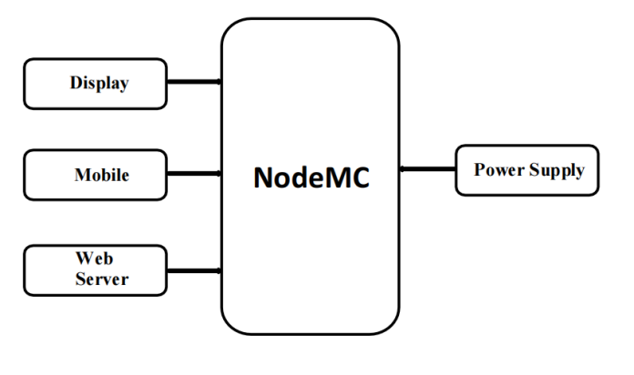

1. **DESIGN AND IMPLEMENTATION**

The entire model is based on the NodeMCU with each component placed meticulously on the breadboard. NodeMCU is chosen because of its main properties ideal for this project - simple, low cost and programmable. Its work similar to Arduino and also is Wi-Fi enabled which is best for IoT application process. 5V adapter is required to connect NodeMCU with the LED display. NodeMCU uses 4 pins to connect with display. We are using P10 LED MODULE to display the notice. This LED is sufficient to display. But we can connect more LED MODULES together to make a JUMBO LED display also.

Firstly, initializing the NodeMCU as well as web server and web page by supplying power the display will show an unset IP address. By creating a personal hot spot, the NodeMCU will receive the established connection and showing a default message on the display. However, often using multiple access from different persons from different connection of phones, laptops and other devices this must be connected to same personal hot spot to show the convey message. After doing this, there is also a web page that is used for making the connection between a NodeMCU and a phone. After connecting the phone with the following IP address, phone will be directly connected to the NodeMCU. By using this web page, we can write a notice and it will directly go to the NodeMCU. Whenever NodeMCU receive a notice, the message will be shown in the display. If there is a problem between connecting the mobile and following IP address, the message will not be shown in the display.

1. **HARDWARE SETUP**

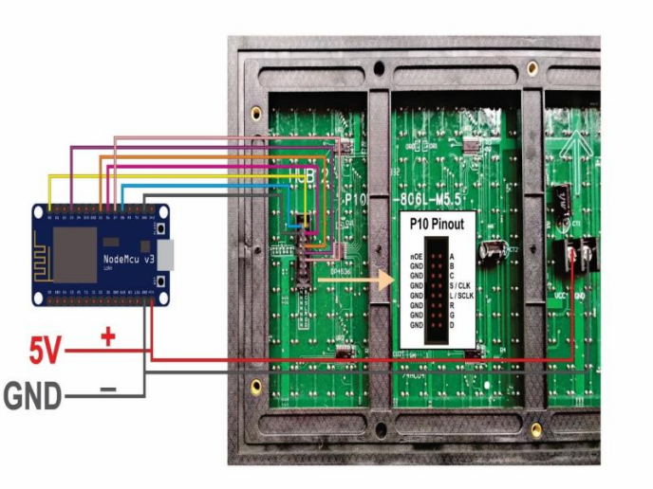

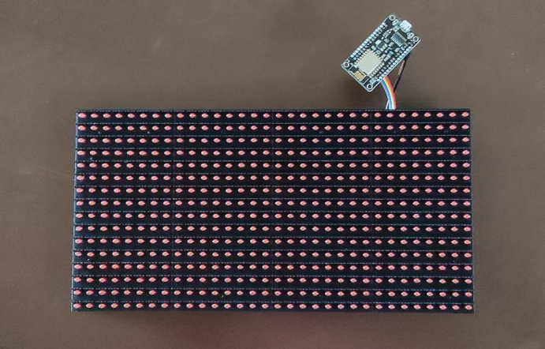

1. **OUTPUT**

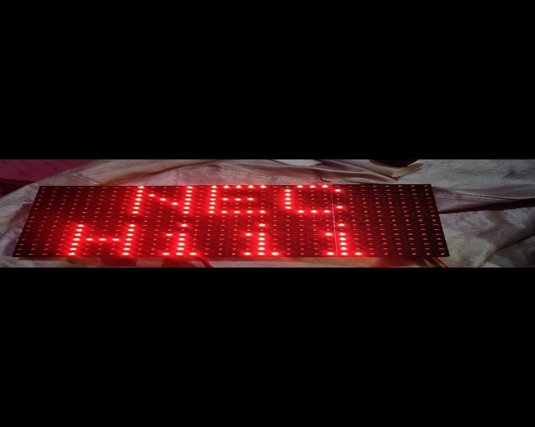

1. **CONCLUSION**

In this modern era of technology is helping us to reduce human work. The planned initiative could lessen the need for human labour and reduce workload. Designing a display toolkit that may be accessed from a trusted website is suggested. One of the most crucial media for spreading information to as many end users as possible is the display boards. The transition from traditional handwritten to digital presentation is being made via display board systems due to technological advancements. From any location on earth, a user can send a message. This system's key features include user friendliness, a long range, and a quick means of information transmission.

REFERENCES

1. Bento, A. C. (2018). IoT: NodeMCU 12e X Arduino Uno, Results of an experimental and comparative survey. International Journal.

2. Ilha, P., Schiesari, L., Yanagawa, F. I., Jankowski, K., & Navas, C. A. (2018). Deforestation and stream warming affect body size of Amazonian fishes. PloS one.

3. Kashyap, M., Sharma, V., & Gupta, N. (2018). Taking MQTT and NodeMcu to IOT: Communication in Internet of Things. Procedia computer science, 132, 1611- 1618.

4. Dalwadi, D. C., Trivedi, N., & Kasundra, A. (2011, May). Wireless notice board our realtime solution. In National Conference on Recent Trends in Engineering & Technology.

5. Ling, Z., Zhang, Z., Shi, G., Fang, X., Wang, L., Gao, X., ... & Liu, X. (2014). Review on thermal management systems using phase change materials for electroniccomponents, Li-ion batteries and photovoltaic modules. Renewable and Sustainable Energy Reviews, 31, 427-438.

6. Looseley, D., & Mével, P. A. (2009). Notice Board. French Cultural Studies, 20(4), 419- 426.

7. Meenachi, A., Kowsalya, S., & Kumar, P. P. (2016). Wireless E-Notice board using wi-fi and bluetooth technology. Journal of Network Communications and EmergingTechnologies (JNCET).

8. Merai, B., Jain, R., & Mishra, R. (2015). Smart Notice Board. International Journal of Advanced Research in Computer and Communication Engineering, 4(4), 105-

107.

9. Teckchandani, Y., Perumal, G. S., Mujumdar, R., & Lokanathan, S. (2015, December). Large screen wireless notice display system. In 2015 IEEEInternational Conference on Computational Intelligence and Computing Research (ICCIC) (pp. 1-5). IEEE.

10.REDDY, G. G. (2018). IoT Based Real Time Digital Led Notification Display Board using Node MCU via Telegram Messenger App.

11.Nivetha, S. R., Pujitha, R., Preethi, S., & Yashvanthini, S. M. (2013). SMSbased wireless notice board with monitoring system. International Journal of Advanced Electrical and Electronics Engineering,(IJAEEE).