**DETERMINATION OF GEOID IN PART OF ADO EKITI USING GEOMETRIC METHOD**

Oyinkolade S.P, Aleem K.F & Abdulkadir I.F

Department of Surveying and Geoinformatics, Abubakar Tafawa Balewa University Bauchi

E-mail:-oyinkolade_sp@fedpolyado.edu.ng

Abstract

The use of geoidal undulations from a geoid model is necessary to translate theoretical and geometric heights into actual heights. For the purpose of computing orthometric heights and comparing three geometric geoid surfaces with the *Global Geoid Model* (GGM). This paper established the geoid of Federal Polytechnic Ado Ekiti. *Geoid has not been determined in the Federal Polytechnic and it’s environs. It is required to convert ellipsoidal heights to orthometric height.* Users of height naturally prefer a precise orthometric height system. *This paper established the geoid* using Unistrong differential GPS in static mode and spirit level in closed loop for the observations, respectively, GPS and spirit levelling *observations with application of orthometric corrections* on the same thirty stations' EGM 2020 and 2021 data were downloaded. Geoidal undulation was computed using the processed data, and a geoidal map was created. The ellipsoidal heights, equivalent orthometric heights, and geoidal heights of the stations are the findings of this investigation. The descriptive statistics analysis describes geoid heights from three sources using the mean, median, skewness, kurtosis, standard deviation, variance. It was observed, that the results from EGM 2020 and 2021 have similar means at 95% confidence interval of 25.6147, 25.6214 and 25.5190 ,25.5250 at lower and upper bound respectively, while the Results from Geoidal Height has a mean of 20.2153 and 20.7991 at lower and upper bound. The skewness values point to the normality of the datasets, while kurtosis explains their peakedness. The standard deviations and variances describe the variations or dispersions in the data points. This research suggests using it to make important choices about the geophysical and infrastructure development of the region.

Keywords: Height, Geoid, Orthometric, Ellipsoidal, Geoidal height

1. INTRODUCTION

An essential element in determining the position of any point is its height. Depending on the reference surface and the process used to determine it, various height systems have been employed. Because of their geocentric and physical significance, orthometric heights, that are measured above mean sea level, are extremely significant practically. Orthometric heights are often calculated using gravity measurements and spirit leveling. (Moka, 2011, Tata & Ono, 2018). The geoid, which ignores oceanographic influences like salinity, pressure, and temperature fluctuations, is the equipotential surface of the Earth's gravity field that most nearly coincides with MSL in the open waters. (Vanicek & Christou, 1994). Geoid determination is one of the challenging tasks in geodesy study. Geoid has not been determined in the Federal Polytechnic and it’s environs. Orthometric height must be created by converting ellipsoidal heights. Despite the earth's overall undulations, the geoid surface is significantly smoother than the earth's natural *surface.*  (Aleem et al. 2016). Orthometric height determination plays a vital part in geodesy and has several applications in a variety of industries. Users of the GPS, who must convert GPS-derived ellipsoidal heights to orthometric heights, have primarily pushed the need for improved geoid models (Engelis, 1985) in order to make them comparable with the current orthometric heights on the vertical datum. The majority of benchmarks in Ado Ekiti and its surroundings are ellipsoidal in height, which is not desirable because such height is known as inappropriate height because it has no relationship with ocean (water Body) Before GPS, it was laborious to estimate an ellipsoid height using transit: Ellipsoidal height is the straightline distances produced away from (or into) the ellipsoid to the point of interest that are normal to a reference ellipsoid. Now, geodetic latitude, longitude, and ellipsoid height may be determined using three-dimensional baselines created by GPS receivers. Ellipsoid heights are now frequently used as a result. Since ellipsoids generally aren't good replacements for the geoid, they can never be used to replace orthometric heights. Therefore, if the geoid undulation is known, ellipsoidal heights can be utilized to calculate orthometric heights.

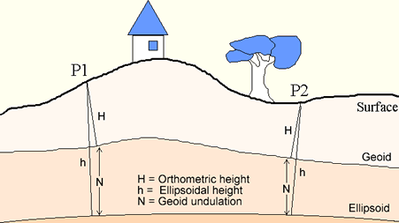

Figure 1: The Three Reference Surfaces ( Knippers, 2009)

2.0 LITERATURE REVIEW

Now that the Global Positioning System (GPS) and other global navigation satellite systems have been developed, it is possible to directly calculate ellipsoidal heights of points from their GPS X, Y, and Z Cartesian coordinates by solving the inverse problem for geodetic latitude, geodetic longitude, and height above the ellipsoid (Moka, 2011). The Geodetic Levelling technique is now advocated as an interim measure to solve the age-long problem of insufficient gravity data and less accurate astrogeodetic approach for orthometric height determination. To convert geodetic heights h (ellipsoidal heights) to orthometric heights (H), the geoid undulations N (geoid separation) must be known (Ghilani & Wolf, 2008). Depending on the technology and approach employed, the GPS positioning system is intended to locate a point at any time and in any location with an accuracy that could reach a few millimeters. Permanent GPS stations were employed in this situation to find the displacement of a few millimeters per year along the Alps. (Caporali.& Matin, 2000). The application of GPS technology has advanced quickly, particularly in the geodetic sciences and surveying engineering disciplines. In terms of placement, space technology is currently undergoing a significant revolution. GPS technology is used to create all geodetic networks since it is a dependable and effective method for increasing the density of geodetic networks. Global Positioning System (GPS) has the capability of delivering high accuracy level of three-dimensional coordinates of points for various applications. Geodetic heights referred to the ellipsoid are obtained by inverse solutions using the 3-dimensional Cartesian coordinates of the points (Moka, 2011).

Requirements for Obtaining Orthometric Heights from GPS-Delivered Ellipsoid Heights

As earlier mentioned, applying the formula relating geodetic (ellipsoidal) height, h to orthometric height, H and geoid height N, it looks very straight forward to derive orthometric height given the current capability of GPS in positioning. An important issue to be considered, however, is how can we get “acceptable‟ orthometric height values from ellipsoidal heights obtained from GPS?

It has been found that the height component of the GPS delivered coordinates is the poorest in accuracy when compared with the latitude φ and longitude λ. Recognizing this, the National Geodetic Survey (NGS), in partnership with other organizations in the US, has drawn up guidelines for establishing GPS-derived ellipsoid heights (NOAA Technical Memorandum NOS NGS-58). These guidelines are meant for establishing geometric vertical control networks.

Two important requirements are noted in the guidelines, if the necessary accuracy will be attained. These are observations and vector processing.

**ii. Observations**

Choice of GPS receiver. Dual frequency, full-wavelength GPS receivers are recommended, regardless of baseline distance. Geodetic-quality antennas with ground planes are also required. Secondly, the survey should be referenced to existing high order reference stations. Thirdly, the observation session is also important as well as the epoch intervals for data collection. For control stations, meteorological data are also required. Focusing on simplicity, GNSS Solution helps through planning, processing, quality control, reporting, and data exporting. It will be used to process all of the GPS observations. It is a comprehensive office software with all the capabilities necessary to properly handle GPS and GLONASS survey data.

**iii. Vector Processing**

In processing the observation for the vectors, the use of precise ephemeris is recommended and the fixing of all integers, among other requirements. A model should also be used to account for tropospheric effects for each vector for all sessions. The Quality of data should be determined from residuals. Final coordinates are to be determined from least-squares adjustment. A Several software vendors have incorporated all these processing requirements in their products. A good example is GNSS Solution, a complete office suite that includes all the tools needed to correctly process GPS and GLONASS survey data. Through planning, processing, quality control, reporting, and data exporting, GNSS Solution focuses on simplicity. The processing of all the GPS observations involved its utilization

Opaluwa and Adejare (2010) investigated the geometric method of obtaining orthometric height from a GPS survey along a profile and the usage of the EGM 96 geoid model for doing so (using GNSS solution software). The primary goal of the research was to identify the most effective methodology as a replacement for traditional differential leveling by closely evaluating the potentials of these technologies. The EGM 96 model's respective standard errors from the results were 1.450m and 1.453m, respectively. The two curves abruptly turned sinusoidal from a station, as seen in the graphical representation of the residuals from the two approaches. This similarity pattern of the residuals makes it difficult to draw a conclusive judgment between the two methods examined; it was concluded from the standard errors, that it could be inferred that the geometrical technique gave a better result over EGM 96 model.

Aleem et al. (2016) used a single frequency Global Positioning System and Geodetic Level (Wild N3) instruments to obtain ellipsoidal and orthometric heights of the areas before adjusting the orthometric heights obtained from geodetic levelling and the ellipsoidal heights which is part of the geodetic coordinates obtained from GNSS. The result was a geoidal map of a portion of Mubi North Local Government Area Adamawa state, Nigeria.

Oluyori et al. (2018) explored the "Comparison of Two Polynomial Geoid Models of GNSS/Levelling Geoid Development for Orthometric Heights in FCT, Abuja" Nine coefficients were utilized to represent the FCT surface for geoid interpolation and orthometric height modeling.

To establish the local geoid model for Kampala in Uganda, Kyamulesire et al. (2020) conducted research titled "Comparative Analysis of three plane geometric geoid surfaces for orthometric height modeling in kampala, Uganda." Three planar geometric geoid surfaces were compared after the orthometric heights computation. The study employed 19 points altogether. The model parameters were calculated using the least squares adjustment method. Programs for Microsoft Excel were created to apply the models. The accuracy of the models was calculated using the Root Mean Square Index. The accuracy of the three geometric geoid models that can be used in the study area was examined in order to identify which is most suited for use there. The comparison results show that the three models can be applied in the study area.

Eteje and Oduyebo's (2018) study, "Local Geometric Geoid Models Parameters and Accuracy Determination Using Least Square Technique," Local geoid models have been established in diverse regions of some countries as a result of the national local geoid model's absence. When utilizing the geometric method, fitting an interpolation surface to known geoidal undulation points necessitates figuring out the geometric geoid model's parameters and determining how accurate it is using the least square method. The geoid height of new points inside the area can be interpolated using geometric geoid models, which are surfaces that fit to the geoidal undulations of an area. The geoid height can be extrapolated inside the application area because the Root Mean Square Error is less than 0.017 m.

A local geometric geoid spanning Nairobi County and its surroundings was established via a geometric technique in Odera et al. (2014). In the research region, 19 points were levelled using both accurate leveling methods and the Global Positioning System (GPS). In order to describe the local geoid height as a function of position, seven triangulation points were employed to calculate the transformation parameters between World Geodetic System 1984 (WGS84) and ArcDatum 1960 coordinates. Using 14 GPS/leveling locations, a biquadratic surface polynomial was used to represent the geoid height as a function of the local plane coordinates. The results were tested using five points. The outcome demonstrates that the geometric geoid experience with Nairobi County and its surroundings suggests that interpolation of geoid heights in

1. EQUIPMENT AND METHOD

The instruments that were used for this research Paper can be grouped into three:

**Surveying instrument which includes:**

1. Two Unistrong GNSS Receivers (Differential GPS) and their accessories
2. Sokkia Automatic Level and its accessories

**Computer Hardware**

The computer hardware that was used are:

1. Zinox 64 bit Laptop computer (Intel core (TM) i5 CPU, M700 @ 1.70 GHz and 2.4GHz, 8.0 GB (RAM).
2. HP office jet 7000 E809a series A3 Printer

**Computer software/programmes**

The following software and applications were used:

i GNSS solution

ii Generic Mapping Tools

iii Microsoft Office (MS Word, MS Excel, MS Power Point).

Quantitatively data were acquired using instruments. It typically involves obtaining data and transforming it into numerical form in order to do statistical computations and draw conclusions. In order to meet the goal and objectives of the research activity, methodologies and mode of operation were chosen to carry out the geoid determination of the study region. These steps entail GPS tracking, geodetic levelling, and GGM download. The GGM of the thirty stations was downloaded via the International Center for Global Earth Model, and a total of thirty (30) stations were observed for GPS and Levelling observation. Program creation to enable the computation of geoidal height and orthometric height, together with the processing of GPS observed data using the suitable GNSS Processor, are all parts of the processing technique that was chosen. On the website of the International Centre for Global Earth Model, the GGM 2020 and GGM 2021 of the 30 stations was downloaded.

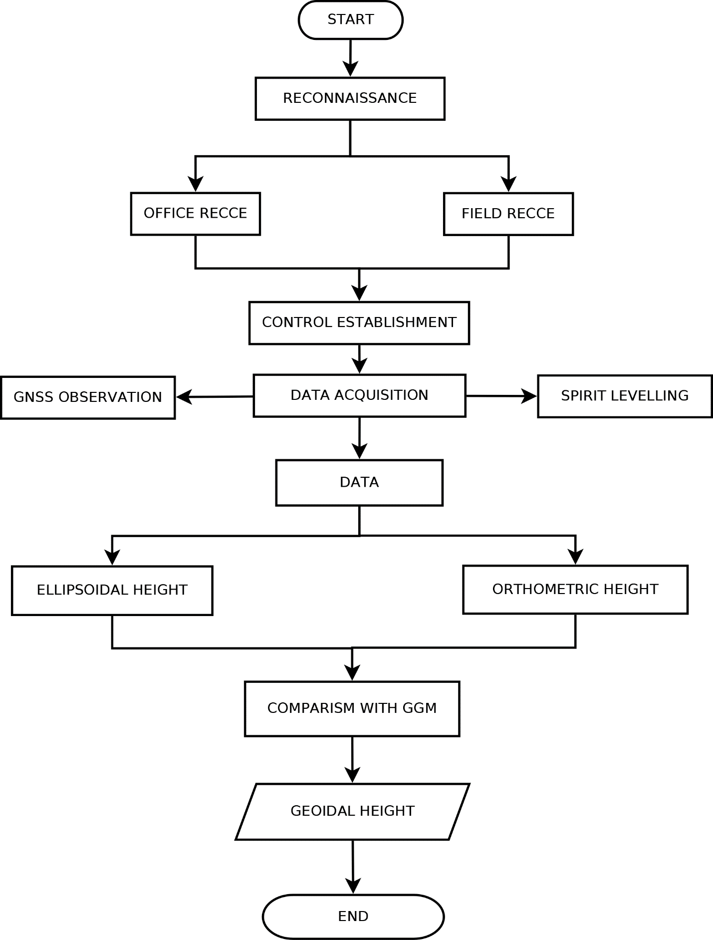

Figure 2. Frame work of Methodology

**2.1 GNSS Observation**

Two Unistrong GNSS Receivers were used for the observation of 3D coordinates of the existing GPS control points located within the vicinity of the study area were used as controls. The instrument was first mounted on a known existing point and performed the temporary adjustment. The important settings of the parameters required for the observation were imputed on the base and the rover for effective streaming of data, such as the station ID, antenna height, epoch for streaming of data, mask angle, mode of observation. After the setting operation, the instrument was allowed to track not less than 4 satellites for data streaming. The observations were done in static mode with the base station at the Known point and the rover moving round from station-to-station. During the observation, the PDOP (Positional Dilution of Precision) was ensured to be consistently less than 2.0

**2.2 Levelling Observation**

The approach is based on the linear sum of height variations between two points. This operation was carried out in the closed loop. The height discrepancies were measured using a leveling device that was perfectly horizontally positioned between two leveling rods. The difference of the two observations on the rods is the height difference between the two points. A two-peg test was done prior to the operation to ascertain whether the instrument's precision and quality actually met the requirements for the task. The instrument was determined to have a collimation error of 0.004mm, indicating that it is in good working order and can be used to undertake observations. In this study, the operation was conducted in the closed loop levelling nets in order to obtain the height differences between the points. Spirit level instrument was set-up at a convenient point and the elevation of the control point AGST. In determining the height discrepancies between the sites in this investigation, the operation was carried out in closed-loop leveling nets. With the help of a leveling staff held vertically over the control point AGST 001, which is of second order accuracy as back sight and another leveling staff held vertically over the next chainage point as foresight reading, using the spirit level instrument. The leveling instrument was then moved to the next middle point and the initial fore sight chainage was sighted as back sight and the next chaanage pont was sighted as fore sight.

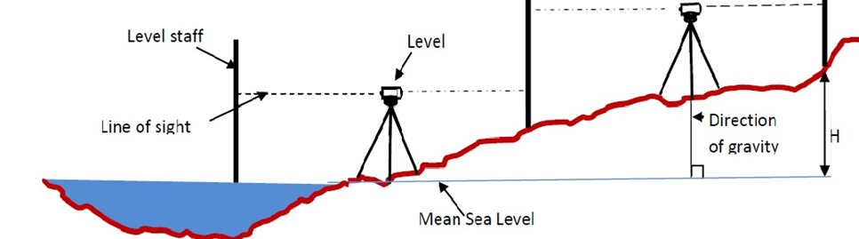

Figure 3. Levelling procedure to determine difference in height. (Source: Badejo, et al. 2016 as cited in Tata and Ono, 2018)

**2.3 International Centre for Global Earth Model Operation**

International Centre for Global Earth Models (ICGEM) is one of the five services coordinated by the International Gravity Field Service (IGFS) of the International Association of Geodesy (IAG). The primary objective of the ICGEM service is to collect and archive all existing static and temporal global gravity field models and provide an online interactive calculation service for the computation of gravity field functional freely available to the general public.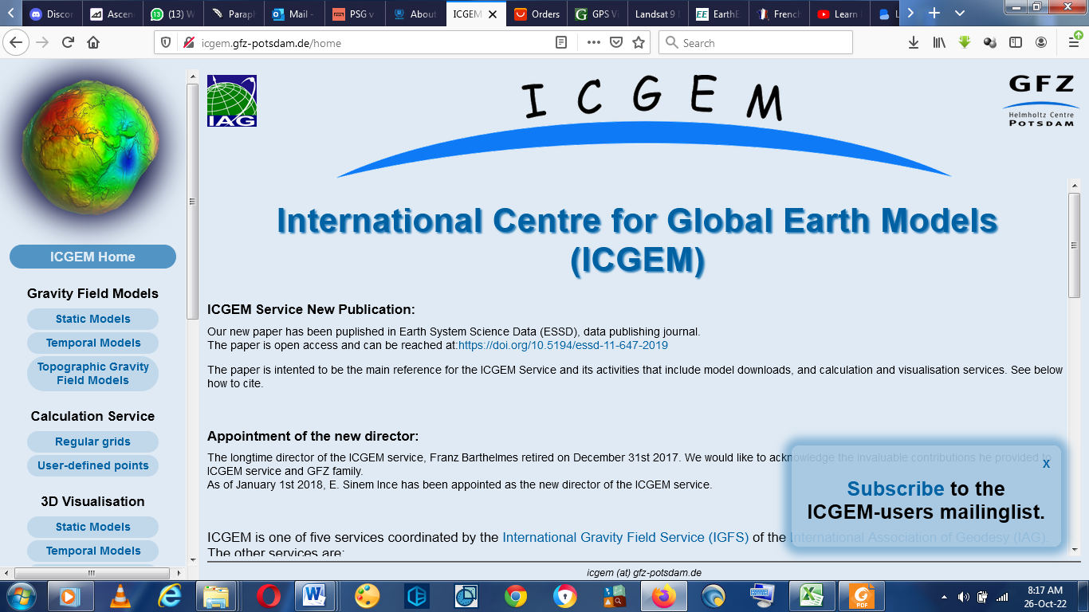

Figure 4. International Centre for Global Earth Models Website (ICGEM)

1. RESULTS AND DISCUSSIONS

3.1 Results

The ellipsoidal heights, corresponding orthometric heights, and geoidal undulation of thirty (30) places were estimated using geodetic leveling and DGPS measurements as the study's findings. The change in the ellipsoidal height differences and equivalent orthometric height differences were compared, the height difference between the points was separately determined, and the accuracy of the results was estimated using the root mean square error (RMSE) in order to analyze the results. the results of the DGPS and Geodetic leveling observations that have been analyzed, including the change in the height difference between the points and statistical analysis of the data.

Table 1. Results obtained from GPS observation

|  |  |  |  |
| --- | --- | --- | --- |
| Stations | Easting (m) | Northing (m) | Ellipsoidal Height (h)m |
| PT01 | 753722.572 | 840788.326 | 358.826 |
| PT02 | 753910.089 | 840719.847 | 359.292 |
| PT03 | 753160.741 | 841004.419 | 360.075 |
| PT04 | 753535.242 | 840859.016 | 361.337 |
| PT05 | 752973.075 | 841076.030 | 362.146 |
| PT06 | 753268.090 | 840818.010 | 363.087 |
| PT07 | 753349.025 | 840931.620 | 364.266 |
| PT08 | 753390.622 | 840639.767 | 365.805 |
| PT09 | 754210.987 | 840619.381 | 366.568 |
| PT10 | 752711.650 | 841019.250 | 367.876 |
| PT11 | 752787.902 | 841145.768 | 368.053 |
| PT12 | 753712.260 | 840461.420 | 369.494 |
| PT13 | 753975.883 | 840296.026 | 370.814 |
| PT14 | 753758.484 | 840027.320 | 371.703 |
| PT15 | 752889.655 | 840381.183 | 372.223 |
| PT16 | 752953.470 | 840735.460 | 372.475 |
| PT17 | 752804.249 | 840549.923 | 372.693 |
| PT18 | 753614.768 | 840070.306 | 372.771 |
| PT19 | 752481.835 | 840999.644 | 373.092 |
| PT20 | 753470.975 | 840113.278 | 374.027 |
| PT21 | 753607.250 | 840338.280 | 374.722 |
| PT22 | 753083.489 | 840332.769 | 374.987 |
| PT23 | 753265.120 | 840208.708 | 375.172 |
| PT24 | 753011.490 | 840827.500 | 375.432 |
| PT25 | 753401.970 | 840454.310 | 375.632 |
| PT26 | 753151.325 | 840555.165 | 375.811 |
| PT27 | 752567.137 | 840855.009 | 375.839 |
| PT28 | 752694.868 | 840713.791 | 376.092 |
| PT29 | 752601.615 | 841216.515 | 376.319 |
| PT30 | 752804.931 | 840841.971 | 375.933 |

: Table 2. Results obtained from Geodetic levelling observation

|  |  |
| --- | --- |
| Stations | Orthometric Height (H)m |
| PT01 | 340.209 |
| PT02 | 340.568 |
| PT03 | 340.855 |
| PT04 | 340.787 |
| PT05 | 341.035 |
| PT06 | 342.240 |
| PT07 | 343.803 |
| PT08 | 344.999 |
| PT09 | 345.886 |
| PT10 | 346.665 |
| PT11 | 345.283 |
| PT12 | 349.353 |
| PT13 | 350.119 |
| PT14 | 351.011 |
| PT15 | 351.549 |
| PT16 | 352.399 |
| PT17 | 352.544 |
| PT18 | 352.382 |
| PT19 | 353.177 |
| PT20 | 353.337 |
| PT21 | 353.502 |
| PT22 | 354.301 |
| PT23 | 354.493 |
| PT24 | 353.975 |
| PT25 | 354.642 |
| PT26 | 355.278 |
| PT27 | 355.862 |
| PT28 | 355.962 |
| PT29 | 355.673 |
| PT30 | 355.458 |

Table 3. Results obtained from GPS and Geodetic levelling observation

|  |  |  |  |  |  |
| --- | --- | --- | --- | --- | --- |
| Stations | Easting (m) | Northing (m) | Ellipsoidal Height (h)m | Orthometric Height (H)m | Geoid height (N)m |
| PT01 | 753722.572 | 840788.326 | 358.826 | 340.209 | 18.617 |
| PT02 | 753910.089 | 840719.847 | 359.292 | 340.568 | 18.724 |
| PT03 | 753160.741 | 841004.419 | 360.075 | 340.855 | 19.220 |
| PT04 | 753535.242 | 840859.016 | 361.337 | 340.787 | 20.550 |
| PT05 | 752973.075 | 841076.030 | 362.146 | 341.035 | 21.111 |
| PT06 | 753268.090 | 840818.010 | 363.087 | 342.240 | 20.847 |
| PT07 | 753349.025 | 840931.620 | 364.266 | 343.803 | 20.463 |
| PT08 | 753390.622 | 840639.767 | 365.805 | 344.999 | 20.806 |
| PT09 | 754210.987 | 840619.381 | 366.568 | 345.886 | 20.682 |
| PT10 | 752711.650 | 841019.250 | 367.876 | 346.665 | 21.211 |
| PT11 | 752787.902 | 841145.768 | 368.053 | 345.283 | 22.770 |
| PT12 | 753712.260 | 840461.420 | 369.494 | 349.353 | 20.141 |
| PT13 | 753975.883 | 840296.026 | 370.814 | 350.119 | 20.695 |
| PT14 | 753758.484 | 840027.320 | 371.703 | 351.011 | 20.692 |
| PT15 | 752889.655 | 840381.183 | 372.223 | 351.549 | 20.674 |
| PT16 | 752953.470 | 840735.460 | 372.475 | 352.399 | 20.076 |
| PT17 | 752804.249 | 840549.923 | 372.693 | 352.544 | 20.149 |
| PT18 | 753614.768 | 840070.306 | 372.771 | 352.382 | 20.389 |
| PT19 | 752481.835 | 840999.644 | 373.092 | 353.177 | 19.915 |
| PT20 | 753470.975 | 840113.278 | 374.027 | 353.337 | 20.690 |
| PT21 | 753607.250 | 840338.280 | 374.722 | 353.502 | 21.220 |
| PT22 | 753083.489 | 840332.769 | 374.987 | 354.301 | 20.686 |
| PT23 | 753265.120 | 840208.708 | 375.172 | 354.493 | 20.679 |
| PT24 | 753011.490 | 840827.500 | 375.432 | 353.975 | 21.457 |
| PT25 | 753401.970 | 840454.310 | 375.632 | 354.642 | 20.990 |
| PT26 | 753151.325 | 840555.165 | 375.811 | 355.278 | 20.533 |
| PT27 | 752567.137 | 840855.009 | 375.839 | 355.862 | 19.977 |
| PT28 | 752694.868 | 840713.791 | 376.092 | 355.962 | 20.130 |
| PT29 | 752601.615 | 841216.515 | 376.319 | 355.673 | 20.646 |
| PT30 | 752804.931 | 840841.971 | 375.933 | 355.458 | 20.475 |
|  |  | **Mean =** | **370.085** | **349.578** | **20.507** |
|  |  | **Standard deviation =** | **5.765** | **5.550** | **0.782** |

Figure 5. Chart Showing Comparison of Ellipsoidal, Orthometric, and Geoidal heights of the Study Area

Figure 6. Chart Showing Geoidal Height Profile of the Study Area

Figure 7. Contour Map of the Geoid Undulation of the Study Area

Figure 8. 3D Geoidal Model of the Study Area

**Hypothesis Testing**

**Table 4. Statistical Analysis on Geoid Heights from various sources**

|  |  |  |  |  |  |  |  |  |  |  |  |  |
| --- | --- | --- | --- | --- | --- | --- | --- | --- | --- | --- | --- | --- |
| **Descriptives** | | | | | | | | | | | | |
|  | Geoid height source | | | | | | | | Statistic | | Std. Error | |
| Geoid height | Geoid height space (2020) | | Mean | | | | | | 25.6181 | | .00165 | |
| 95% Confidence Interval for Mean | | | | Lower Bound | | 25.6147 | |  | |
| Upper Bound | | 25.6214 | |  | |
| 5% Trimmed Mean | | | | | | 25.6181 | |  | |
| Median | | | | | | 25.6178 | |  | |
| Variance | | | | | | .000 | |  | |
| Std. Deviation | | | | | | .00904 | |  | |
| Minimum | | | | | | 25.60 | |  | |
| Maximum | | | | | | 25.63 | |  | |
| Range | | | | | | .03 | |  | |
| Interquartile Range | | | | | | .02 | |  | |
| Skewness | | | | | | -.048 | | .427 | |
| Kurtosis | | | | | | -.986 | | .833 | |
| Geoid height space (2021) | | Mean | | | | | | 25.5220 | | .00147 | |
| 95% Confidence Interval for Mean | | | | Lower Bound | | 25.5190 | |  | |
| Upper Bound | | 25.5250 | |  | |
| 5% Trimmed Mean | | | | | | 25.5220 | |  | |
| Median | | | | | | 25.5219 | |  | |
| Variance | | | | | | .000 | |  | |
| Std. Deviation | | | | | | .00807 | |  | |
| Minimum | | | | | | 25.51 | |  | |
| Maximum | | | | | | 25.54 | |  | |
| Range | | | | | | .03 | |  | |
| Interquartile Range | | | | | | .01 | |  | |
| Skewness | | | | | | -.062 | | .427 | |
| Kurtosis | | | | | | -.962 | | .833 | |
| Geoidal height | | Mean | | | | | | 20.5072 | | .14272 | |
| 95% Confidence Interval for Mean | | | | Lower Bound | | 20.2153 | |  | |
| Upper Bound | | 20.7991 | |  | |
| 5% Trimmed Mean | | | | | | 20.5088 | |  | |
| Median | | | | | | 20.6600 | |  | |
| Variance | | | | | | .611 | |  | |
| Std. Deviation | | | | | | .78172 | |  | |
| Minimum | | | | | | 18.62 | |  | |
| Maximum | | | | | | 22.77 | |  | |
| Range | | | | | | 4.15 | |  | |
| Interquartile Range | | | | | | .68 | |  | |
| Skewness | | | | | | -.120 | | .427 | |
| Kurtosis | | | | | | 2.759 | | .833 | |
| **Table 5. Tests of Normality** | | | | | | | | | | | |
|  | | Geoid height source | | Kolmogorov-Smirnov | | | | Shapiro-Wilk | | | |
| Statistic | Df | p-value | | Statistic | | df | |
| Geoid height | | Geoid height space (2020) | | .081 | 30 | .200* | | .973 | | 30 | |
| Geoid height space (2021) | | .078 | 30 | .200* | | .973 | | 30 | |
| Geoidal height | | .144 | 30 | .113 | | .903 | | 30 | |

|  |  |  |
| --- | --- | --- |
|  | | |
|  | Geoid height source | Shapiro-Wilk |
| p-value |
| Geoid height | Geoid height space (2020) | .627 |
| Geoid height space (2021) | .636 |
| Geoid height GPS | .010 |

**Comment**

The results of test of normality (Kolmogorov-Smirnovand Shapiro-Wilk tests) show that the data is normally distributed except that of Geoidal Height This means other inferential analysis can be carried out without violation of the underlying assumptions.

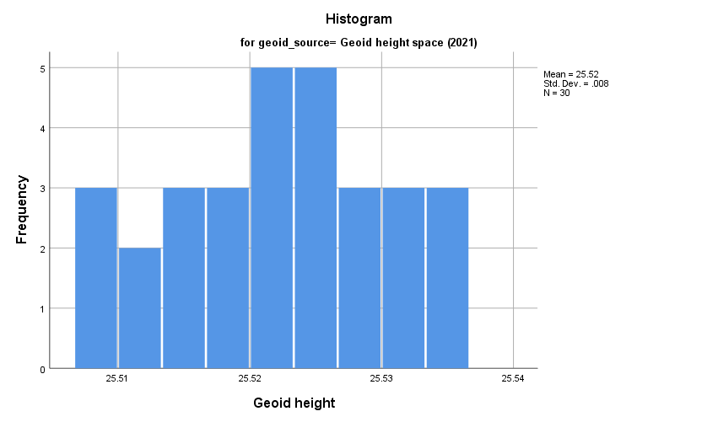

**Figure 9. Histogram for geoid space 2021** 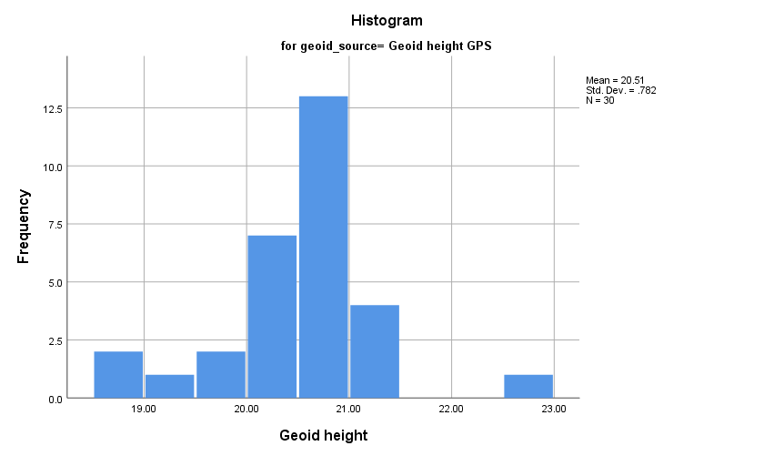

**Figure 10. Histogram for geoid Geoidal Height**

**Normal Q-Q Plots**

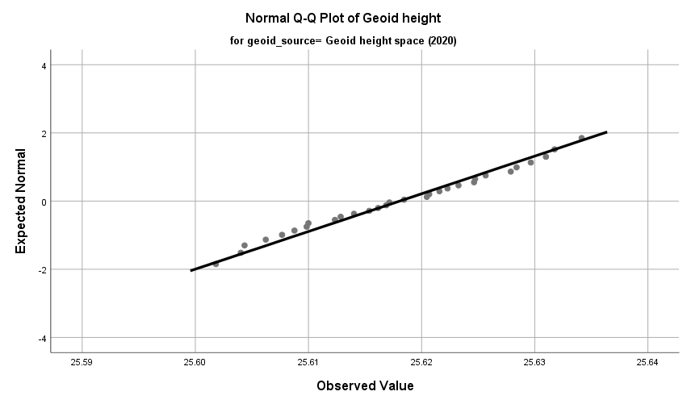

**Figure 11. Normal Q-Q plot for 2020 space Height**

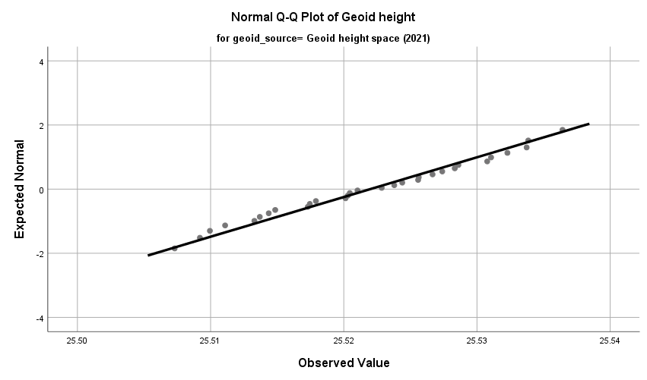

**Figure 12. Normal Q-Q plot for 2021 space Height**

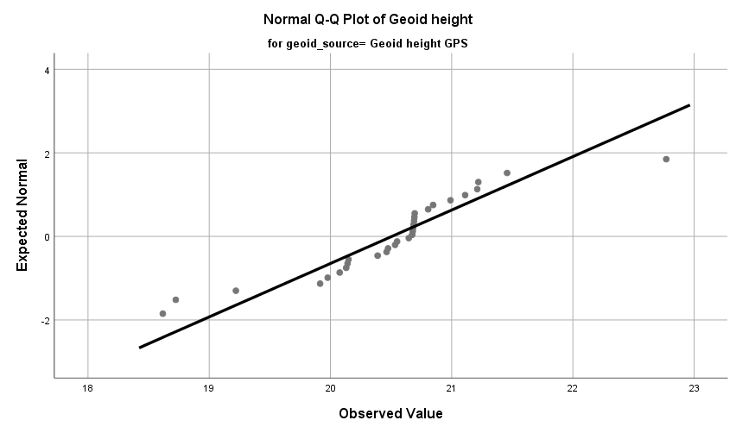

|  |  |  |  |  |  |
| --- | --- | --- | --- | --- | --- |
| **Figure 13. Normal Q-Q plot for Geoidal Height**  **Table 6. ANALYSIS ON GEOID HEIGHTS USING ANOVA** | | | | | |
| Geoid height | | | | | |
|  | Sum of Squares | df | Mean Square | F | P-value |
| Between Groups | 512.789 | 2 | 256.395 | 1258.405 | .000 |
| Within Groups | 17.726 | 87 | .204 |  |  |
| Total | 530.515 | 89 |  |  |  |

The analysis of variance (ANOVA) results show that the null hypothesis, which states that the means from the three sources are equal, is rejected at the 5% level, indicating that there is a substantial difference in the means and that further tests will reveal where the difference is.

**Means Plots**

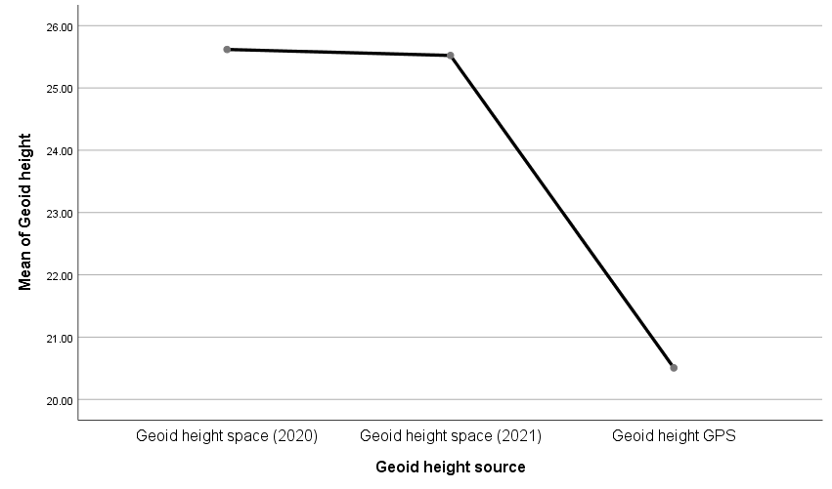

**Figure 14. Mean plot for all the Height**

**Comment**

This means plot shows that the geoid heights downloaded from the space for 2020 and 2021 are almost the same in their means, while geoid height measured using the GPS differs in means.

**Table 7. ANALYSIS ON h AND H DATA USING INDEPENDENT T-TEST**

|  |  |  |  |  |  |
| --- | --- | --- | --- | --- | --- |
| **Group Statistics** | | | | | |
|  | levels | N | Mean | Std. Deviation | Std. Error Mean |
| h and H data | h(m) | 29 | .5899 | .49716 | .09232 |
| H(m) | 29 | .5258 | .90343 | .16776 |

The means of h(m) and H(m) are 0.5899 and 0.5258 respectively. The mean difference here may not be different

|  |  |  |  |  |  |
| --- | --- | --- | --- | --- | --- |
| **Table 8. Independent Samples Test (Equality of variance test)** | | | | | |
|  | | Levene's Test for Equality of Variances | | t-test for Equality of Means | |
| F | P-value | t | df |
|
| h and H data | Equal variances assumed | 1.193 | .279 | .335 | 56 |
| Equal variances not assumed |  |  | .335 | 43.534 |

The results in the table above shows that the variances are equal. This is good for the test, if the variances are not equal, the use of t-test may be unacceptable because it will lead to violation of assumptions

|  |  |  |  |  |
| --- | --- | --- | --- | --- |
| **Table 9. Independent Samples Test (Equality of means test)** | | | | |
|  | | t-test for Equality of Means | | |
| P-value | Mean Difference | Std. Error Difference |
|
| h and H data | Equal variances assumed | .739 | .06407 | .19149 |
| Equal variances not assumed | .740 | .06407 | .19149 |

The p-value 0.739 (greater than 0.05) shows that the mean difference between the two variables is not significant. This means they are not different.

**Means Plots**

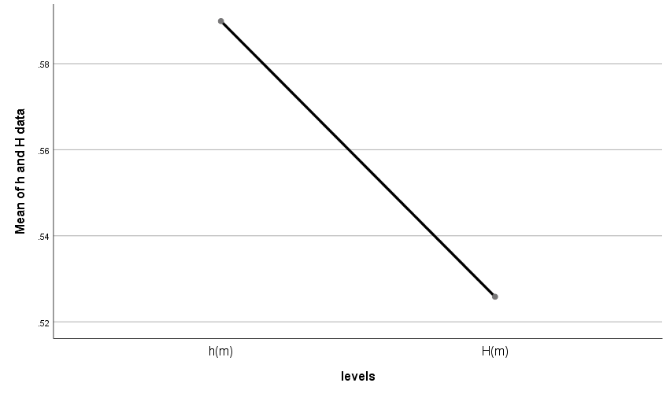

**Figure 15. Mean plot for Orthometric and Ellipsoidal Height**

Despite the fact that the means of h(m) and H(m) do not significantly differ from one another according to inferential statistical analysis using the t-test, there is a little discrepancy in the means.

1. CONCLUSION

This study was able to identify the Geoid by using geometry. The geoidal height has a mean of 20.507m with 95% confidence interval for lower bound at 20.215 and upper bound at 20.799. the 5% Trimmed mean is 20.509 while the median is 20.660. the variance is 0.611 while the standard deviation is 0.78172. The skewness is -0.120 while the kurtosis is 2.759.

The table of descriptive statistics describe geoid heights from three sources using the mean, median, skewness, kurtosis, standard deviation, variance, etc. It can be observed from that the first two sources have similar means while the third has a different one. The skewness values point to the normality of the datasets, while kurtosis explains their peakedness. The standard deviations and variances describe the variations or dispersions in the data points.

The results of test of normality (Kolmogorov-Smirnov and Shapiro-Wilk tests) show that the data is normally distributed except that of Geoidal Height. This means other inferential analysis can be carried out without violation of the underlying assumptions.

From the results of the analysis of variance (ANOVA), it can be seen that the null hypothesis that says the means from the three sources are equal is rejected at 5% level. This means that the difference in their means is significant. Further test will show where the differences are located.

The means plot shows that the geoid heights downloaded from the internet for 2020 and 2021 are almost the same in their means, while geoid height measured using the GPS and Spirit levelling differs in means.

The means of h(m) and H(m) are 0.5899 and 0.5258 respectively. The mean difference here may not be different. The results in the table of independence Sample Test (Equality of variance Test) shows that the variances are equal. This is good for the test, if the variances are not equal, the use of t-test may be unacceptable because it will lead to violation of assumptions. The p-value 0.739 (greater than 0.05) shows that the mean difference between the two variables is not significant in the equality of mean test, this means they are not different. Although the inferential statistical analysis using t-test shows that there is no significant mean difference between h(m) and H(m) but the means shows a little difference.

**Recommendation**

Based on the study's findings, it is advised that:

i All upcoming geodetic and engineering projects in the region should refer to one of the thirty (30) stations for the correct height

ii The values discovered for the geoidal height are a fundamental component of the land, so additional research should be done in other areas within or outside the Institution.

REFERENCES

Aleem, K.F., Adesoye, A.A., & Bankole, A.L. (2016). Practical Determination of Geoidal Undulation and Geoidal Map of Part of Mubi, Adamawa State, Nigeria. *International* *Journal of Engineering Research and Technology* (IJERT). ISSN: 2278-0181 *(5)* 4

Engelis, T. (1985). Measuring orthometric height differences with GPS and gravity data. *Manuscripta Geodaetica*, *10*(3), 187-194.

Knippers, R. (2009). Geometric aspects of mapping. International Institute for Geo-Information

Science and Earth Observation, Enschede, Nederland. Accessed from http://

kartoweb.itc.nl/geometricson

Kyamulesire, B., Oluyori, P. D., & Eteje, S. O. (2020) “Comparative Analysis of three plane geometric geoid surfaces for orthometric height modelling in kampala, Uganda” FUDMA Journal of Science vol. 4 No. 3, September, 2020.PP 48-51

Moka E.C. (2011). Requiements for the Determination of Orthometric Heights From GPS- Determined Heights. *Contemporary issues in surveying and geoinformatics.* Published by BPrint Ikeja, Lagos, Nigeria

Oluyori, P. D., Ono, M. N., & Eteje, S. O. (2018) “Comparison of Two Polynomial Geoid Models of GNSS/Leveling Geoid Development for Orthometric Heights in FCT, Abuja” International Journal of Engineering Research and Advanced Technology (IJERAT) vol. 4, issue 10, October 2018

Opaluwa, Y. D., & Adejare, Q. A. (2010). Derivation of orthometric heights from GPS measured heights using geometric technique and EGM96 model. *FUTY Journal of the Environment*, *5*(1), 80-93.

Vaníček, P., & Santos, M. (2019). Earth & Environmental Sciences.