**Comparative Performance Evaluation of Optical Amplifiers for Multi-Channel WDM Systems**

**Naveen Kumar Yadav a, Shiksha Jain b, Abhishek Srivastava c, Shri Om Mishra d**

Department of Electronics and Communication, Institute of Engineering & Technology

Dr Rammanohar Lohia Avadh University, Ayodhya, Uttar Pradesh

a [naveenu137379324021@gmail.com](mailto:naveenu137379324021@gmail.com),b [shiksha98jain@gmail.com](mailto:shiksha98jain@gmail.com),

c [abhishek200959@gmail.com](mailto:abhishek200959@gmail.com),d [shriom18m@gmail.com](mailto:shriom18m@gmail.com)

**Abstract**

This research investigates the performance of optical amplifiers in multi-channel Wavelength Division Multiplexing (WDM) systems operating at various data rates (16 × 10). The study focuses on three types of amplifiers, namely Erbium-Doped Fiber Amplifiers (EDFAs), Raman amplifiers, and Semiconductor Optical Amplifiers (SOAs), and compares their effectiveness in terms of transmission distance and dispersion, considering the presence of nonlinearities.

When operating with a dispersion of 2 ps/nm/km and a lower number of channels, the SOA exhibits superior performance due to its reduced gain saturation issues. However, as the number of channels increases, the SOA experiences challenges arising from cross gain modulation, cross phase modulation, and four-wave mixing.

**Introduction**

With the ever-increasing demand for high-speed and reliable data transmission, optical communication systems utilizing Wavelength Division Multiplexing (WDM) have emerged as a promising solution. In these systems, the use of multiple optical channels operating at different wavelengths enables simultaneous data transmission, significantly increasing the overall data capacity. However, to ensure efficient and robust signal transmission over extended distances, optical amplifiers play a pivotal role.

This research presents a comprehensive investigation into the performance of optical amplifiers in multi-channel WDM systems operating at varying data rates of 16 × 10 Gbps [1]. The study aims to assess and compare the effectiveness of three commonly used amplification technologies: Erbium-Doped Fiber Amplifiers (EDFAs), Raman amplifiers, and Semiconductor Optical Amplifiers (SOAs).

The performance evaluation encompasses critical aspects such as transmission distance, dispersion effects, and the presence of nonlinearities, which are essential factors in determining the overall efficiency and reliability of these optical amplifiers in modern communication networks. Understanding the strengths and limitations of each amplifier type under different data rate and dispersion conditions is crucial for designing optimal WDM systems that meet the demands of high-capacity, long-distance data transmission.

The subsequent sections of this paper delve into the experimental setup, methodologies employed, and a detailed analysis of the obtained results. The insights gained from this research will aid network designers, engineers, and researchers in making informed decisions when selecting the appropriate optical amplifier technology for specific WDM system configurations, ultimately contributing to the advancement and optimization of modern optical communication networks. In the context of long-haul optical communication systems, the conventional approach of using optoelectronic repeaters for signal regeneration has proven complex and costly, particularly in wavelength-division multiplexed (WDM) Lightwave systems. To address this limitation, modern optical amplifiers have emerged as a more efficient solution for directly amplifying the optical signals without converting them to electrical forms. These in-line amplifiers simultaneously amplify multiple signals, thereby reducing signal attenuation over long distances.

The primary cause of signal power depletion during transmission is fiber attenuation, while fiber non-linearities also contribute to power level degradation. In the 1990s, the advent of the fourth generation of optical systems brought about significant progress, largely due to the development of optical fiber amplifiers. Among these, Erbium-Doped Fiber Amplifiers (EDFAs) have played a crucial role as booster and inline amplifiers, facilitating the transmission of optical signals over thousands of kilometers. EDFAs are known for their low noise figures, wide gain bandwidth, and the ability to amplify multichannel signals on different wavelengths, making them ideal for WDM systems. It has been reported that under deeper saturation or with steeper saturation characteristics, EDFA exhibits less Bit Error Rate (BER) impairment.

Another notable option for amplification is the Fiber Raman Amplifier (FRA), which proves beneficial in long-distance transmission lines by reducing noise accumulation, improving the noise figure, and mitigating the nonlinear penalties of fiber systems. As a result, Raman amplifiers enhance overall system performance, enabling longer amplifier spans, higher bit rates, and closer channel spacing.

The Semiconductor Optical Amplifier (SOA) presents an attractive alternative with its ultra-wideband spectrum, low power consumption, and cost-effectiveness.

Researchers like Yeh et al. [6] have explored advancements in EDFA technology, demonstrating a new S-plus C-bands EDFA module with a significant gain bandwidth of 96 nm (1480–1576 nm) and gain levels exceeding 10 dB when the input signal power level exceeds 5 dBm. This proposed amplifier also provides broadband ASE (Amplified Spontaneous Emission) light sources from 1480 to 1578 nm at optical output levels above −40 dBm.

In conclusion, modern optical amplifiers, such as EDFAs, Raman amplifiers, and SOAs, have revolutionized long-haul optical communication systems by enabling efficient signal amplification, reduced noise, and improved overall system performance. These advancements have paved the way for higher data rates, longer transmission distances, and more reliable WDM systems, opening new possibilities for future optical communication networks. In the study conducted by Kim et al. [7], successful transmission of 10-Gb/s optical signals over a distance of 80 km through Standard Single Mode Fiber (SSMF) was achieved using Semiconductor Optical Amplifiers (SOAs) as booster amplifiers. The researchers further identified key parameters, including extinction ratio, rising/falling time, and chirp parameter of the input signals for the SOAs, optimizing the output dynamic range and available maximum output power.

In separate research by Singh et al. [8], a ten-channel 100 Gb/s Dense Wavelength Division Multiplexing (DWDM) system was simulated using cascaded SOAs with Differential Phase-Shift Keying (DPSK) modulation at a channel spacing of 20 GHz. Through careful optimization of the SOA model, they achieved a low saturation power of 21.36 mW, reduced crosstalk of 14.1 dB, and a high optical gain of 36.5 dB. With these optimized parameters, they observed an improvement in output signal power using the SOA inline amplifier, enabling 70 km transmission without the need for additional inline amplifiers. By implementing an optimal span scheme, they demonstrated the transmission of 100 Gb/s RZ-DPSK signals up to an impressive distance of 17,227 km with a power penalty of only 2.1 dB, while maintaining good signal quality.

In a different study by Singh et al. [9], the post-power compensation method was investigated and found to exhibit superior performance in terms of bit error rate, eye closure penalty, and received power compared to pre- and symmetrical power compensation methods. However, it was observed that the bit error rate and eye closure penalty increased with higher signal input power. These research findings collectively contribute valuable insights into the optimization and performance enhancement of SOAs as booster amplifiers in optical communication systems. The knowledge gained from these studies could significantly impact the design and implementation of high-speed, long-distance optical networks, leading to improved signal quality, increased transmission distances, and enhanced overall system efficiency.

**Optical Amplifiers**

* EDFA is one of the most widely used optical amplifiers in modern communication networks. It operates based on the principle of optical amplification using erbium-doped optical fibers. When an optical signal interacts with the erbium ions in the fiber, it stimulates the emission of photons, leading to signal amplification. EDFAs offer a broad gain bandwidth, typically around 1530-1565 nm in the C-band and 1570-1610 nm in the L-band. They are characterized by low noise figures, high gain, and compatibility with multiple wavelengths. EDFAs are commonly used in long-haul communication systems and Wavelength Division Multiplexing (WDM) applications.
* Raman amplifiers are based on the Raman scattering effect in optical fibers. When an optical signal propagates through the fiber, it interacts with the fiber material, leading to the generation of new optical frequencies and resulting in signal amplification. Raman amplifiers are particularly effective in compensating for fiber loss and extending the reach of communication systems. They offer advantages like low noise figure, low polarization-dependent gain, and minimal nonlinear effects. Raman amplifiers are often used incombination with other opticalamplifiers to improve overall system performance.
* SOAs are based on semiconductor materials and work on the principle of stimulated emission. When an optical signal is injected into the SOA, it interacts with the semiconductor material, leading to signal amplification. SOAs have a wide gain spectrum and can provide high gain in a short length of fiber. They are compact, fast, and cost-effective, making them suitable for various applications, such as optical signal processing, wavelength conversion, and optical switching. However, SOAs have higher noise figures and are more susceptible to nonlinear effects compared to other optical amplifiers.
* Distributed Raman Amplifiers are a specific type of Raman amplifiers that utilize distributed Raman scattering along the entire length of the optical fiber. Instead of using discrete Raman pump sources, DRA employs the backward and forward Raman scattering from the signals themselves for amplification. DRA offers advantages like high output power, low noise, and reduced polarization-dependent gain.
* Hybrid optical amplifiers combine multiple amplifier technologies to leverage their individual strengths and compensate for their limitations. For example, a combination of EDFAs and Raman amplifiers can provide enhanced performance in long-haul optical communication systems. Hybrid amplifiers aim to optimize signal amplification, minimize noise, and extend transmission distances.

**Comparison Analysis**

In this paper 16 channels are transmitted at 10 GB/s data rate with 100 GHz channel spacing. We have used NRZ data format (electrical driver) which converts the logical signal to corresponding electrical signal. The logical signal is fed into the external Mach-Zehnder modulator (sin2 MZ for all configurations), where the input signals from data source is modulated through a carrier (optical signal from the laser source). The amplitude modulator is a sine square with an excess loss of 3 dB.

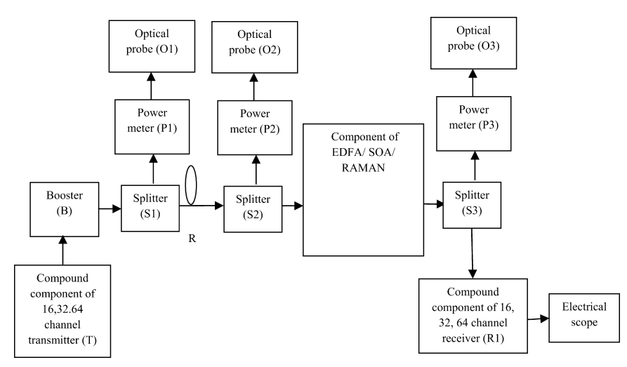

Figure 1: Block Diagram for analysis [10]

The optical signal is transmitted and measured over different distances for 40, 80, 120, 160 and 200 km (R) at 2 ps/nm/km dispersion individually. In the case of different dispersion (2, 4, 6, 8, 10 ps/nm/km) the transmission distance is set at 50 km.

**Results and Discussions**

The different optical amplifiers (RAMAN, EDFA, SOA) have been compared for 16 × 10 Gbps WDM system in the term of received maximum Q factor (dB), minimum eye closure (dB), minimum BER and maximum output power (dBm). To analyze the system, the results of the first channel have been taken. Output power, BER and Q factor for all cases can be seen for existing optical amplifiers that as the line is varied from 40 km to 200 km and dispersion varied from 2 to 10 ps/nm/km. Fig. 2 shows the graphical representation of output power as a function of length in the presence of nonlinearities. The output power decreases due to the fiber non-linearities and fiber attenuation. The better output power is provided by the EDFA amplifier (12.040 dBm) and also for the worst case (at 200 km) it becomes 9.710 dBm. The variation in output power for RAMAN, EDFA and SOA is 3.464 to −27.969 dBm, 12.040 to 9.710 dBm and 10.627 to −11.079 dBm, respectively. If we have not considered the nonlinearities, better output power is provided by the EDFA amplifier (12.043 dBm) and also for the worst case (at 200 km) it becomes 9.689 dBm as compared to other amplifiers as shown in Fig. 3. The variation in output power for RAMAN, EDFA and SOA is 3.465 to −27.945 dBm, 12.043 to 9.689 dBm and 10.628 to −11.076 dBm, respectively. Fig. 4 depicts the graphical representation of Q factor as a function of length in the presence of non-linearities. The better Q factor is provided by the RAMAN amplifier (26.19 dB) and also for the worst case (at 200 km) it becomes 15.54 dB. In the distance range 40 to 120 km, RAMAN and EDFA amplifiers have comparable Q factor. Also, at 120 km EDFA, RAMAN and SOA have almost the same Q factor. The variation in Q factor for RAMAN, EDFA and SOA is 26.19–15.54 dB, 26.308–11.52 dB and 18.059–19.73 dB, respectively [10]. When we compare these optical amplifiers, RAMAN provides the better result as compared to other amplifiers up to 160 km and at 200 km SOA has highest Q factor. If nonlinearities are not considered, better Q factor is provided by the RAMAN amplifier up to 120 km and at 160 onwards SOA has highest Q factor as shown in Fig. 5. The variation in Q factor for RAMAN, EDFA and SOA is 33.57–16.23 dB, 32.76–13.64 dB and 18.66–19.82 dB, respectively. At 120 km EDFA, SOA and RAMAN have comparable Q factor.

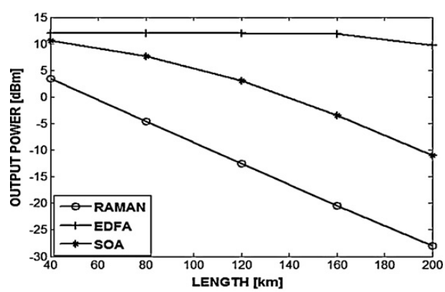

Figure 2: Output power vs. length for 16 channels in the presence of nonlinearities [10]

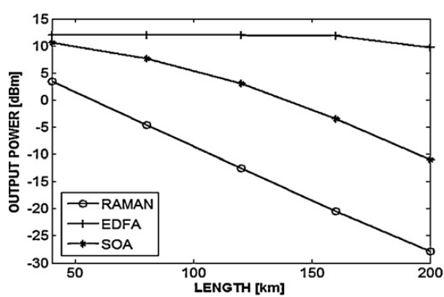

Figure 3: Output power vs. length for 16 channels in the absence of nonlinearities [10]

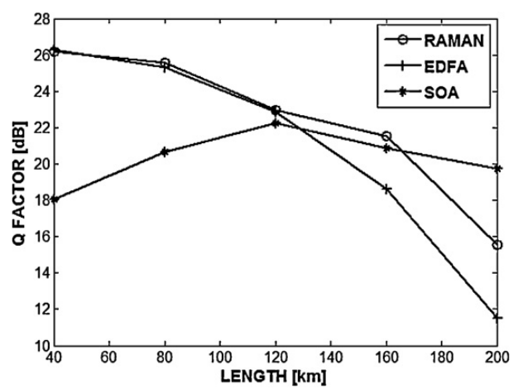

Figure 4: Q factor vs. length for 16 channels in the presence of nonlinearities [10]

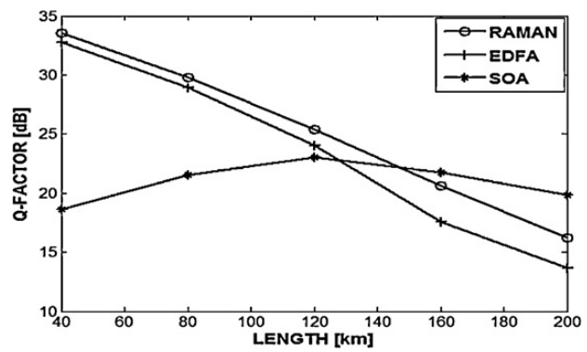

Figure 5: Q factor vs. length for 16 channels in the absence of nonlinearities [10]

**ConclusionTop of Form**

In this study, we have examined a WDM Lightwave system operating at data rates of 16 × 10 Gbps. The system uses optical amplifiers (RAMAN, EDFA, and SOA) and is analyzed both with and without nonlinearities. The aim is to compare the performance of these optical amplifiers under different conditions, including varying transmission distance (40–200 km) and dispersion (2–10 ps/nm/km). Key performance metrics such as output power, BER, Q factor, and eye closure are evaluated.

The results indicate that when the dispersion is 2 ps/nm/km, the SOA amplifier demonstrates better performance. However, as the number of channels increases, the performance of SOA degrades due to the problem of gain saturation. On the other hand, if we increase the dispersion and the number of channels, the EDFA amplifier outperforms SOA.

Furthermore, the study reveals that the RAMAN amplifier provides lower output power compared to other existing amplifiers. However, it shows promise for higher wavelengths, suggesting potential benefits in certain wavelength ranges.

In summary, the research findings indicate that the choice of the appropriate optical amplifier depends on factors such as dispersion, the number of channels, and the desired wavelength range to achieve optimal performance in WDM Lightwave systems.

**References**

[1] S. Singh, R.S. Kaler, Transmission performance of 20 × 10 Gb/s WDM signals using cascaded optimized SOAs with OOK and DPSK modulation formats, Opt. Commun. 266 (1) (2006) 100–110.

[2] N. Kikuchi, S. Sasaki, Analytical evaluation technique of self-phase modulation effect on the performance of cascaded optical amplifier systems, IEEE J. Lightwave Technol. 13 (5) (1995) 868–878.

[3] R.S. Kaler, A.K. Sharma, T.S. Kamal, Comparison of pre-, post- and symmetricaldispersion compensation schemes for 10 Gb/s NRZ links using standard and dispersion compensated fibers, Opt. Commun. 209 (1–3) (2002) 107–123.

[4] M.N. Islam, Raman Amplifiers for Telecommunications – 2 Subsystems and Systems, Springer, 2004.

[5] M.L. Nielsen, K. Tsuruoka, T. Kato, T. Morimoto, S. Sudo, T. Okamoto, K. Mizutani, H. Sakuma, K. Sato, Koji Kudo, SOA-booster integrated Mach–Zehnder modulator: investigation of SOA position, IEEE J. Lightwave Technol. 28 (5) (2010) 837–846.

[6] C.-H. Yeh, C.-C. Lee, S. Chi, S-plus C-band erbium-doped fiber amplifier in parallel structure, J. Opt. Commun. 241 (2004) 443–447.

[7] Y. Kim, H. Jang, Y. Kim, J. Lee, D. Jang, J. Jeong, Transmission performance of 10- Gb/s 1550-nm transmitters using semiconductor optical amplifiers as booster amplifiers, IEEE J. Lightwave Technol. 21 (2) (2003) 476–481.

[8] S. Singh, R.S. Kaler, Simulation of DWDM signals using optimum span scheme with cascaded optimized semiconductor optical amplifiers, Optik 118 (2007) 74–82.

[9] S. Singh, R.S. Kaler, Placement of optimized semiconductor optical amplifier in fiber optical communication systems, Optik 119 (2008) 296–302.

[10] Kaur, R., Randhawa, R., & Kaler, R. S. (2013). Performance evaluation of optical amplifier for 16× 10, 32× 10 and 64× 10 Gbps WDM system. *Optik-International Journal for Light and Electron Optics*, *124*(8), 693-700.