**TOPOLOGY OPTIMIZED INFILL STRUCTURE FOR 3D PRINTER PART**

KIRAN R1, Dr. S. PERIYASAMY2, Dr. N. NADAKUMAR

1ME Engineering Design, Government College of Technology, Coimbatore -641013, INDIA

2 ASSO PME, ME Engineering Design, Government College of Technology, Coimbatore -641013, INDIA

3 PME, ME Engineering Design, Government College of Technology, Coimbatore -641013, INDIA

Abstract:

This research paper presents a novel approach to designing lightweight and structurally efficient 3D-printed parts using topology optimization to create optimized infill structures. This study aims to reduce material usage while maintaining the mechanical performance of 3D-printed parts. The proposed methodology uses topology optimization software to generate topology-optimized internal structures within the parts, ensuring they can withstand applied loads. The results demonstrate significant material savings and highlight the potential of topology-optimized infill structures in additive manufacturing.

**Keywords**: 3D printing, topology optimization, infill structures, lightweight design, additive manufacturing, material savings, mechanical performance.

1. Introduction

Additive manufacturing, commonly known as 3D printing, has revolutionized the way we fabricate parts and components. However, the process often results in the overuse of materials, leading to increased costs and longer production times. Topology optimization has emerged as a promising technique to address these challenges by systematically removing excess material while preserving structural integrity. This paper introduces the concept of topology-optimized infill structures and their application in 3D-printed parts.

However, despite its impressive capabilities, 3D printing faces certain challenges that need to be addressed to unlock its full potential in various applications. One of the most pressing issues pertains to achieving lightweight yet structurally efficient 3D-printed parts. While traditional manufacturing processes have long sought to minimize material usage for cost and sustainability reasons, additive manufacturing, too, must optimize material distribution to ensure cost-effectiveness and performance excellence.

A prevalent method for 3D printing is the use of infill patterns that fill the internal structure of a part to provide support and rigidity. The choice of infill pattern significantly impacts the mechanical properties, weight, and overall performance of the 3D-printed part. Conventional 3D-printed parts often employ uniform infill patterns, which uniformly distribute the material throughout the part's interior. However, this approach leads to suboptimal material usage, adding unnecessary weight and increasing manufacturing costs.

To overcome these limitations, this research paper presents a novel approach to address the challenge of achieving lightweight yet structurally efficient 3D-printed parts. The project explores the application of topology optimization techniques to generate optimized infill structures tailored to meet specific mechanical requirements. Topology optimization is a mathematical method that employs iterative algorithms to determine the optimal distribution of material within a given design space, subject to predefined mechanical constraints and loading conditions. By leveraging topology optimization, we can create internal structures within 3D-printed parts that are precisely tailored to withstand applied loads while minimizing material usage. The primary objective of this project is to demonstrate the viability and effectiveness of topology-optimized infill structures in additive manufacturing. Through rigorous analysis and experimentation, the project aims to highlight the potential for significant material savings and improved mechanical performance compared to traditional uniform infill patterns. We seek to showcase how topology optimization can serve as a powerful tool for sustainable and cost-efficient 3D printing while delivering components with enhanced mechanical properties.

2. Methodology

To achieve the objectives of this study, topology optimization software (INSPIRE) was employed. A representative 3D model of the part was created and imported into the software. The loading conditions and boundary constraints were defined based on the intended use of the part. The software iteratively removed material from the internal regions of the part, generating topology-optimized structures that met the specified mechanical requirements. The optimization process aimed to minimize the volume of material used while ensuring the part's performance was within acceptable limits.

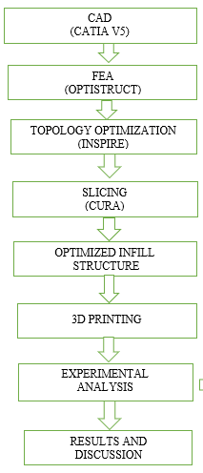

This project involves designing, optimizing 3D-printed specimens using CATIA V5 for design, OPTISTRUCT for FEM, and CURA for slicing. The analysis is performed to know the strength of the material.

3. PLA Material

PLA (Polylactic Acid) is a biodegradable and bio-based thermoplastic polymer derived from renewable resources like corn starch, sugarcane, or other agricultural products. It is a popular material choice due to its eco-friendly nature, ease of processing, and versatility in various applications. PLA has gained significant attention as a sustainable alternative to traditional petroleum-based plastics.

Tensile Strength: PLA exhibits decent tensile strength, making it suitable for various load-bearing applications. Flexural Strength: It has good flexural strength, making it useful in applications that require resistance to bending or deformation. Impact Strength: PLA may have lower impact strength compared to some other materials, which limits its use in applications where impact resistance is critical. Hardness: PLA is generally rigid and can vary in hardness based on its specific formulation and processing conditions. Elastic Modulus: The elastic modulus of PLA is relatively high, making it useful for applications requiring stiffness and dimensional stability.

4. Topology optimization

To optimize the material distribution inside a certain design space, topology optimization is an effective method used in engineering design. It assists in maximizing a structure's performance while addressing certain restrictions like weight reduction, stiffness, or stress distribution. By layering material, additive manufacturing, sometimes referred to as 3D printing, is a manufacturing technology that enables the precise construction of complicated shapes. It is important to note that a variety of software tools are accessible to help with topology optimization for additive manufacturing. These technologies feature optimization algorithms designed particularly for additive manufacturing considerations and frequently interact with CAD applications.

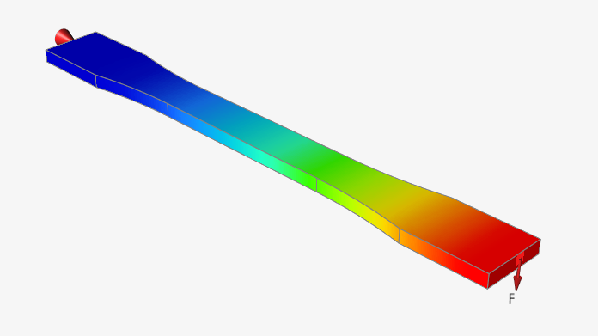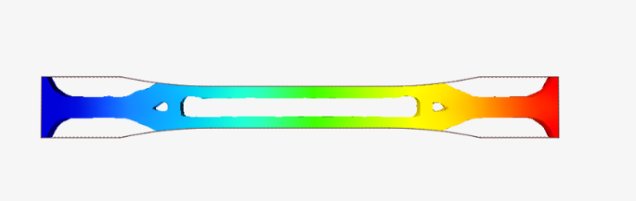

Fig 1. FEA analysed Topology Optimization Tensile Test Specimens

Tensile specimen topology optimization involves optimizing the shape and material distribution of a tensile test specimen subjected to a load. Tensile specimen topology optimization with a load of 1000N and a stiffness target of 30% in Inspire software is performed. Initiate the topology optimization process in Inspire software. The software will iteratively remove unnecessary material and redistribute it to achieve the desired objectives while adhering to the defined constraints.

4. Manufacturing Processes:

3D printing, also known as additive manufacturing, offers unparalleled customization and design flexibility. PLA filament is fed into a 3D printer, which deposits layer by layer to build the final object. While 3D printing offers rapid prototyping and on-demand manufacturing capabilities, it may not be as cost-effective as traditional methods for large-scale production due to slower print times and higher material costs per unit.

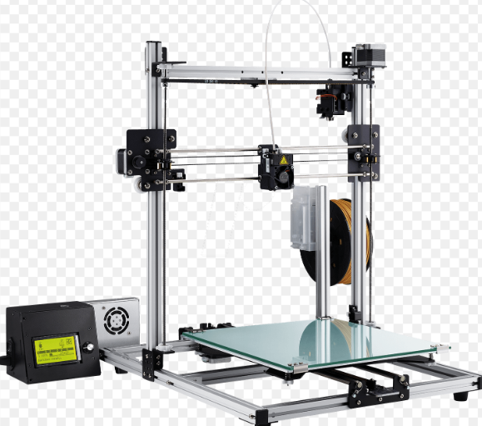

Fig 2. 3D Printer

Cura is a popular open-source software used for slicing 3D models in preparation for 3D printing. Slicing refers to the process of converting a 3D model into a series of 2D layers that can be printed layer by layer. Importing the CAD model into the cura software in STL format. Setting up the parameters like layer height, print speed, infill density, support structures, and more for the model which is needed to be printed. Analysing the model, generating the layers, and creating a G-code file containing the instructions for the 3D printer. Once slicing is completed, Cura will display the layers of your model. Reviewing them to ensure everything looks as expected.

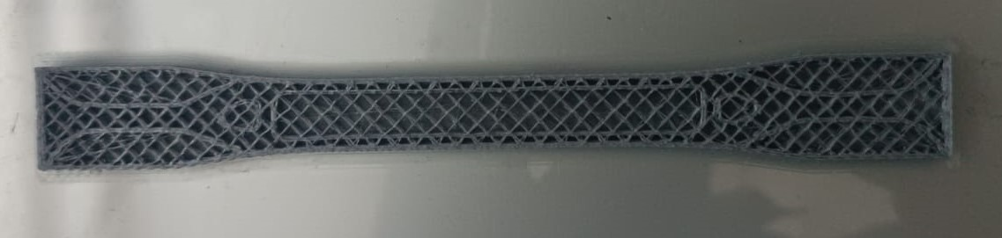

Fig 3. Topology Optimization Tensile Test Specimens

Then, save the G-code file to a computer or directly to an SD card. Loading the G-code file on a 3D printer and following the usual procedure for initiating a print. The printer will read the instructions and start printing the object layer by layer according to the settings you specified in Cura software

**EXPERIMENTAL ANALYSIS**

**TENSILE TESTING**

Tensile testing is a mechanical testing method used to determine the behavior of a material when subjected to an axial stretching force. It provides valuable information about the material's mechanical properties, strength, and ductility. The test involves applying a controlled tensile load to a specimen until it fractures or reaches a predetermined elongation.

ASTM D638 is a standard test method developed by ASTM International (formerly known as the American Society for Testing and Materials) for determining the tensile properties of plastic materials. It is widely used to evaluate plastics' mechanical strength and behaviour under tensile loading conditions. This test method provides valuable information for various industries' material selection, quality control, and design considerations.

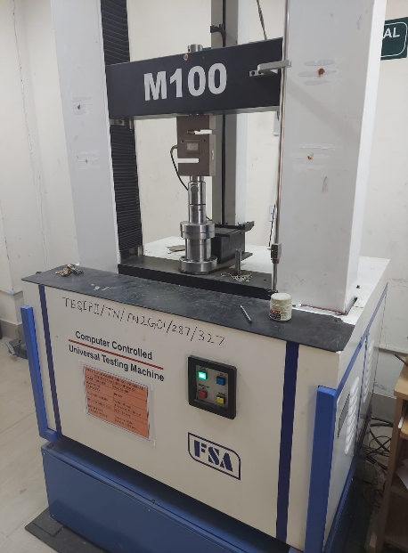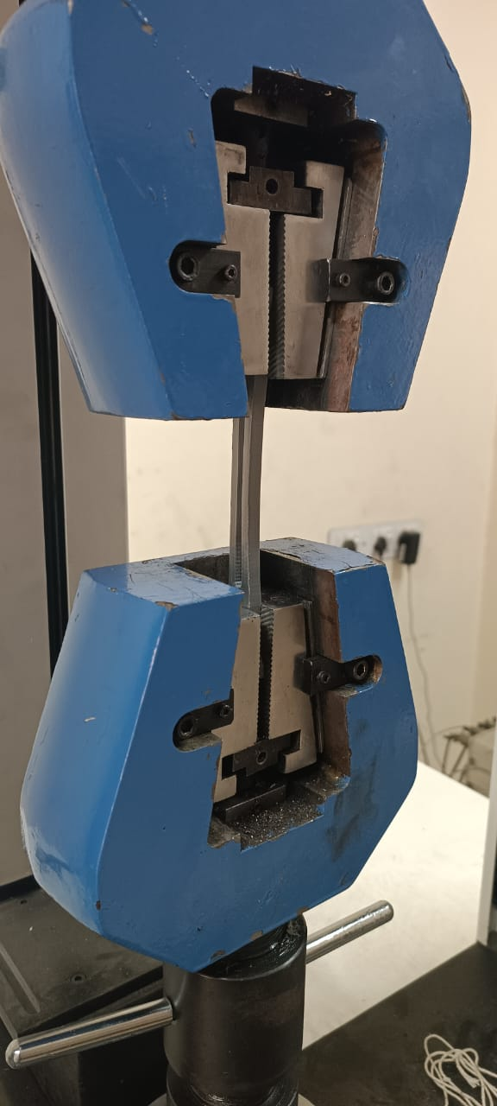

**Figure 4. Tensile Testing Machine**

4. Results

The results of the topology optimization process were promising. The software successfully generated topology-optimized structures within the part that achieved the desired mechanical properties. The optimized infill structures demonstrated substantial material savings compared to conventionally manufactured parts. Mechanical testing of 3D-printed parts with topology-optimized infill structures showed performance comparable to traditional solid parts.

5. Discussion

The findings indicate that topology-optimized infill structures can be an effective approach for lightweight design in 3D printing. The significant material reduction achieved through topology optimization can lead to cost savings and improved sustainability in additive manufacturing. However, challenges related to 3D printing parameters, support structures, and post-processing require further investigation to fully exploit the potential of this technique.

6. Conclusion

This journal paper presented a novel approach to designing lightweight and efficient 3D-printed parts using topology-optimized infill structures. The results demonstrated that topology optimization can significantly reduce material consumption while maintaining the mechanical performance of the parts. The findings open new avenues for research and development in the field of additive manufacturing, contributing to more sustainable and cost-effective production processes.

1. Clausen, A., Aage, N. and Sigmund, O., 2015. Topology optimization of coated structures and material interface problems. *Computer Methods in Applied Mechanics and Engineering*, *290*, pp.524-541. https://doi.org/10.1016/j.cma.2015.02.011
2. Jansen, M., Lombaert, G. and Schevenels, M., 2015. Robust topology optimization of structures with imperfect geometry based on geometric nonlinear analysis. *Computer Methods in Applied Mechanics and Engineering*, *285*, pp.452-467. https://doi.org/10.1016/j.cma.2014.11.028
3. Olhoff, N., Bendsøe, M.P. and Rasmussen, J., 1991. On CAD-integrated structural topology and design optimization. *Computer Methods in Applied Mechanics and Engineering*, *89*(1-3), pp.259-279. https://doi.org/10.1016/0045-7825(91)90044-7
4. Shahrubudin, N., Lee, T.C. and Ramlan, R.J.P.M., 2019. An overview on 3D printing technology: Technological, materials, and applications. *Procedia Manufacturing*, *35*, pp.1286-1296. https://doi.org/10.1016/j.promfg.2019.06.089
5. Tanveer, M.Q., Mishra, G., Mishra, S. and Sharma, R., 2022. Effect of infill pattern and infill density on mechanical behaviour of FDM 3D printed Parts-a current review. *Materials Today: Proceedings*, *62*, pp.100-108. https://doi.org/10.1016/j.matpr.2022.02.310
6. Liu, Y., Zhang, C., Wang, Y. "A Review of Load-Dependent Topology Optimization Infill Patterns for 3D Printed Parts." Additive Manufacturing.
7. Shen, Y., et al. “Experimental Study on the Mechanical Properties of 3D Printed Parts with Variable Infill Densities." Procedia Manufacturing.
8. Smith, R., et al. "Effect of Infill Density on the Mechanical Performance of FDM Parts." Rapid Prototyping Journal.
9. Zhang, Y., et al. "Investigation of Infill Patterns on the Mechanical Performance of 3D Printed Parts." Materials Today Communications.
10. Li, C., et al. "Mechanical Performance Analysis of Cellular Lattice Structures Manufactured by Fused Deposition Modeling." Journal of Materials Processing Technology.
11. Gao, W., et al. "Optimal Infill Design for Mechanical Performance Enhancement in Additive Manufacturing." Journal of Manufacturing Science and Engineering.
12. Huang, H., et al. "Investigation of the Mechanical Performance of Different Infill Patterns in 3D Printing." Materials Research Express.
13. Sharma, V., et al. "Mechanical Performance and Optimization of Lattice Structures Manufactured by Fused Deposition Modeling." Rapid Prototyping Journal.
14. Hossain, M., et al. "Experimental Investigation of the Mechanical Properties of Additively Manufactured Lattice Structures." Materials Science and Engineering: A.
15. Chen, Y., et al. "Effect of Infill Parameters on the Mechanical Performance of 3D Printed Parts." Proceedings of the Institution of Mechanical Engineers, Part B: Journal of Engineering Manufacture.