AUTOMATION SYSTEM FOR ELECTRIC CHARGING STATION USING IOT

Sathya harikara Sankar. S1, Azik Jamal Ghouse M2, Arjun D3

1Bachelor of Engineering, ECE department, National Engineering College, Kovilpatti, India.

2 Bachelor of Engineering, ECE department, National Engineering College, Kovilpatti, India.

3Bachelor of Engineering, ECE department, National Engineering College, Kovilpatti, India.

1 sathyasamson85@gmail.com, 2 azikjamalghouse2201@gmail.com, 3arjunsathya750@gmail.com

**ABSTRACT-** The IoT module is deployed on-site to watch and signal the availability of each individual Electric Vehicle Charging station space in the proposed Smart Electric Vehicle Charging station system. It allows the user to locate the closest area with an electric vehicle charging station and provides information on the number of available slots in that location. The search for a free electric vehicle charging station area can be sped up significantly.Each slot has an infrared sensor to determine whether a specific plot is empty or not. By providing information on available Electric Vehicle Charging station slots, smart Electric Vehicle Charging system assists people in their hunt for these spaces with ease through IOT automation*.*Its primary goal is to shorten the time needed to locate available Electric Vehicle Charging station slots and to prevent needless travel through fully utilised Electric Vehicle Charging station lots in an Electric Vehicle Charging station area. As a result, it cuts down on gasoline usage, which in turn lowers the amount of carbon dioxide in the air.

**INTRODUCTION:** The popularity of smart city concepts has substantially grown recently. The development of the Internet of Things and the idea of the modern city seem to be realisable at this time.  (IOT) makes it feasible to link non-internet things to the network and access them from anywhere. Inevitably, people will stay current with technology. IoT is used to handle issues like snarled traffic, a lack of parking spaces, and road safety. . Things with identification communication devices were the foundation for the Internet of Things (IoT) idea. Using distant computers linked via the Internet, the devices could be tracked, managed, or watched over. By extending the use of the Internet for communication, the Internet of Things (IoT) creates an interconnected network of things, including electronic and physical items. Internet refers to a vast, interconnected worldwide network of servers, computers, tablets, and mobile devices that communicate via widely accepted protocols and connecting systems. Information can be sent, received, or communicated via the internet. The word "thing" can indicate a variety of things in English. When we don't want to be precise, we can refer to a thing as a material object, a deed, an act, an idea, a circumstance, or an event. IoT, in general, comprises of a network of connected hardware and real-world objects. A few of these items have the capacity to gather information from far-off places and communicate with other units in charge of gathering, organising, controlling, as well as analysing information used in the procedure and amenities become intelligent and exhibit lifelike behaviours through embedded tiny devices that sense, compute, and communicate and engage with distant objects via connectivity. The cloud's scalable and stable features have made it possible for developers to create and store their apps there. The cloud is the perfect IoT partner since it acts as a portal where all sensor information is stored and accessible from remote locations. The IOT's objects (nodes) can be viewed, followed, and managed remotely through the cloud. Any number of nodes might be added to or withdrawn from the IOT in real time because to the cloud's great degree of flexibility. The idea of creating a metropolis is increasingly taking shape.

**HARDWARE DESCRIPTION**

1. Arduino UNO

At the heart of the Arduino UNO is the ATmega328P microcontroller. Besides with digital and analogue I/O pins, the board also has shield and extra hardware. The Arduino UNO contains an ICSP header, a USB port, six analogue input pins, six digital input pins, and six power pins. It is created with an IDE.

1. Wi-Fi Module

With the Wi-fi Module, any microcontroller may connect to your Wi-Fi network because it is a self-contained SOC with an integrated TCP/IP protocol stack. All Wi-Fi traffic can be offloaded or a software can be hosted on the Wi-Fi module.

1. Lcd Display

A flat panel monitor known as an LCD runs mostly on liquid crystals. LCDs have many uses for both consumers and businesses because they are often used in smartphones, televisions, sytem monitors, instrument cluster, and other items.

1. IR sensor

The area of the electromagnetic spectrum between 0.75 m and 1000 m is known as the infrared region. Infrared radiation has wavelengths that are longer than those of visible light but smaller than those of microwaves.

1. Relay

A piece of electrical machinery is known as a relay. A group of functional contact terminals plus a group of input terminals for one or more control signals make up this component. Many contacts, including combinations of these two types of contacts as well as make-and-break contacts, could be present on the switch.

1. **PROPOSED WORK**

Based on IoT Slot Prediction and Online EVs, a Framework and Design for the Next-Generation Communication System Booking a Space for Charging at a Station. To locate the open slot, a fake EV IOT device was created. Stochastic Queueing Model for Charging Spot Prediction

1. **BLOCK DIAGRAM**

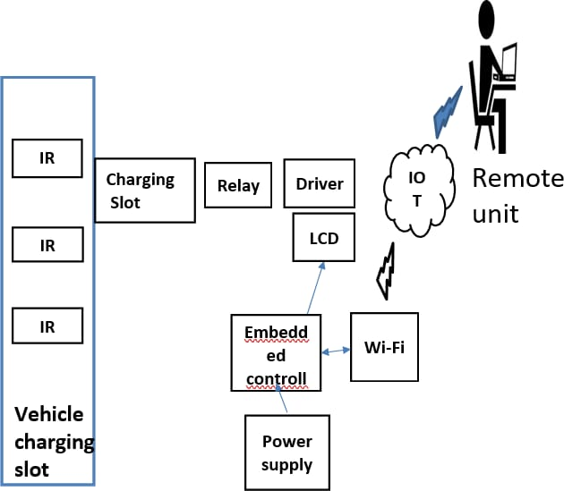

1. OUTPUT

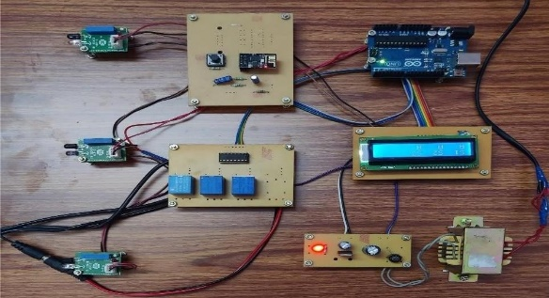 Fig. 3.1 Hardware prototype

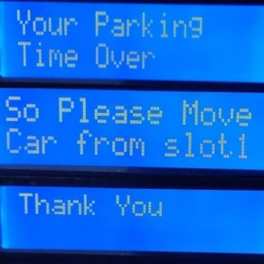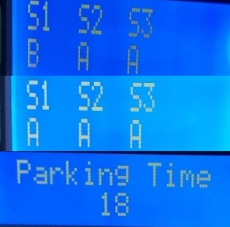

Fig. 3.2 Result in LCD display

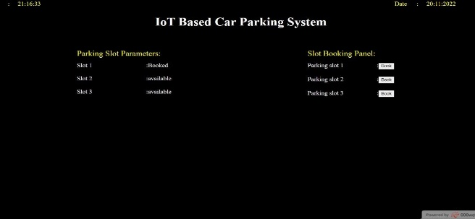

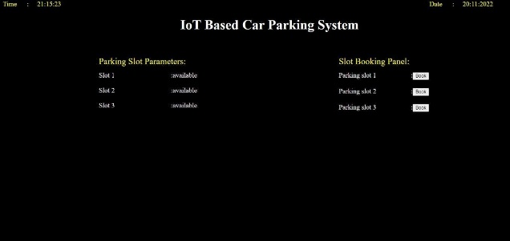

Fig 3.3 Web Application

1. **WORKING**

All components receive power from the power source. It transforms AC electricity into DC voltage. Converter for changing 230V to 12V AC. The LED receives 12V AC. When converting AC power to DC voltage, the diode range is 1N4007.Using an AC capacitor, AC components are charged and then released on the earth. The next capacitor receives the signal after the LM 7805 voltage regulator keeps the voltage steady and filters out the unwanted AC component. LEDs and resistors will be the load. 1.75V is the LED power. We employed Arduino microcontrollers. The controller pins 23, 24, and 25 and pin 26 are linked to the IR sensor. link between controller and ULN2003 and LCD. D10, D11, D12, and D13 are used to link to the ULN2003 Port. Bar code is scanned and tagged by RFID. The information about obstacles is detected by the IR camera and sent to the controller. The data and processor output provided to the relay are accessed. The controller is a ULN2003A IC. . This activates the repeater. Send information via IOT to Wi-Fi if there is room available. It has been reserved to use the web programme. If we reserve slot 1, we will then be enabled. Slot 1 is available for car charging. Similarly, if we reserve slot 2 and activate it It will instantly disconnect once the gas charging limit entered in the web application has been reached.

**V. CONCLUSION**

This automatic smart charging slot scheduling system for electric vehicles is easy to use, reasonably priced, and offers a useful way to lessen the atmosphere's chemical imprint. From any distance, a web browser can be used to map out the location and availability of parking spaces. It lessens the possibility that parking lots will be discovered in any parking area and prevents cars from needlessly travelling past occupied parking spaces and charging stations in a city. Both money and time are saved.

**VI. REFERENCES**

[1]M. Brenna, G. C. Lazaroiu, M. Roscia, and S. Saadatmandi, Dynamic model for the EV's charging infrastructure planning through finite element method," IEEE Access, vol. 8, pp. 102399 102408, 2020.

[2]G. Trencher, Strategies to accelerate the production and diffusion of fuel cell electric vehicles: Experiences from California,"Energy Rep., vol. 6, pp. 2503-2519, Nov. 2020.

[3]X. N. Penisa, M. T. Castro, J. D. A. Pascasio, E. A. Esparcia, O. Schmidt, and J. D. Ocon, Projecting the price of lithium-ion NMC battery packs using a multifactor learning curve model," Energies, vol. 13, no. 20, p. 5276, Oct. 2020.

[4]S. Zhou, Y. Qiu, F. Zou, D. He, P. Yu, J. Du, X. Luo, C. Wang, Z. Wu, and W. Gu, ``Dynamic EV charging pricing methodology for facilitating renewable energy with consideration of highway traffic flow," IEEE Access, vol. 8, pp. 13161-13178, 2019.

[5]H.-M. Chung, W.-T. Li, C. Yuen, C.-K. Wen, and N. Crespi,``Electric vehicle charge scheduling mechanism to maximize cost efficiency and user convenience," IEEE Trans. Smart Grid, vol. 10, no. 3, pp. 30203030, May 2019

[6]R. Bruno and M. Conti, Throughput and fairness analysis of 802.11- based vehicle-to-infrastructure data transfers, in Proc. IEEE 8th Int. Conf. Mobile Ad-Hoc Sensor Syst., Oct. 2011, pp. 232241, doi: 10.1109/MASS.2011.30.

[7]S. Bayram and I. Papapanagiotou, A survey on communication technologies and requirements for Internet of electric vehicles, EURASIP J. Wireless Commun. Netw., vol. 2014, no. 1, p. 223, Dec. 2014.

[8]L. Cai, J. Pan, L. Zhao, and X. Shen, Networked electric vehicles for greenintelligent transportation, IEEE Commun. Standards Mag., vol. 1, no. 2, pp. 7783, Jul. 2017.

[9]C. E. Hatton, S. K. Beella, J. C. Brezet, and Y. C. Wijnia, Charging stations for urban settings the design of a product platform for electric vehicle infrastructure in dutch cities, World Electr. Vehicle J., vol. 3, no. 1, pp. 134146, Mar. 2009.

[10] V. del Razo and H.-A. Jacobsen, Smart charging schedules for highway travel with electric vehicles, IEEE Trans. Transp. Electrific., vol. 2, no. 2, pp. 160173, Jun. 2016.