**“Evaluation and Assessment of Properties of Concrete by Mixing Virgin Shredded Plastic”**

**Sumit Kumar Singh , Manoj Sharma, Piyush Kumar**

M. Tech. Students, IPS College Of Technology & Management Gwalior M.P., India.

Professor, IPS College Of Technology & Management Gwalior M.P., India.

Assistant professor IPS College Of Technology & Management Gwalior M.P. India.

**ABSTRACT**

The polythene bags have become an important part of human beings all over the world. Due to such heavy usage, it has become an environmental problem to dispose these polythene bags thus creating pollution in the environment in recent years. Since, these bags are not bio-degradable; it has to be utilized in construction industry so as to reduce its effect on environment.

This study examines mechanical an durability properties of concrete using polythene waste as a partial replacement of fine aggregate at replacement levels of 0%, 5%, 10%, 15% and 20% by weight of the fine aggregate. Total 110 concrete specimens were cast in this study. The specimens were prepared of the concrete mix of M30 grade and 0.45water to cement ratio was maintained. The effects on different properties of concrete with polythene waste were evaluated in this study. The specimens of concrete mixes were tested for workability, compressive strength, split tensile strength, flexural strength, carbonation depth, freeze-thaw resistance and load deflection behavior.

**KEYWORDS –** polythene, flexural strength, tensile strength, compressive strength, concrete, fine aggregate

**INTRODUCTION-** Concrete is most commonly used composite material in the construction industry made up of cement, aggregates, water and admixture. The cementitious materials required for concrete has very high demand in the market of construction materials due to their mechanical strength and durability dominance. The growth of construction industry is so rapid that it requires huge amount of these cementing materials and thus it leads to reduction in availability of these natural resources. For this purpose man y researchers are required to find the suitable alternative material. These materials could possibly be wastes producing from many industries which could be hazardous for the environment. The use of waste materials has two major impacts, one that it solves environmental problems and secondly it makes concreting more economical as it is available in large quantities and has very low value secondly it makes concreting more economical as it is available in large quantities and has very low value.

Concreting is not possible without the use of sand, for that purpose shredded plastic waste can be used as partial replacement of sand. These plastics are available in large quantities depleting the environment plus they are of low cost.

Plastic belongs to hydrocarbon monomers family and is used in day to day life in the form of water bottles, containers, electrical appliances, furniture, polythene bags, food packaging materials, cutting boards, vehicles etc. But the benefits of plastic use are suppressed by its harmful impacts on the environment. This daily usage of plastic leads to the production of a huge quantity of waste in the world.

**PLASTIC SCENARIO -** Plastic can by synthetic of semi-synthetic organic polymer which can be transformed into many shapes. The first ever plastic was discovered in 1855 by the Alexander Parkes and it was named plastic celluloid. Leo Hendrik Baekeland invented the fist purely synthetic plastic material in 1907 and it was named Bakelite. Bakelite plastic was strong, durable, and cheap and it could be molded into thousand of shapes. As of today, the plastic is use in large quantities all over the world. The major characteristics of plastic material is flexible, strong and cheap which leads to its utilization for various purposes like packing ingredients, plastic bucket, plastic glass, plastic furniture, transporting goods, accumulating household waste, shopping bag, wrapping fabric, fluid container, industrial product, building fabric and so on.

**TYPES OF PLASTICS -**Plastics can be divided into two major categories

**(i) Thermoset of Thermosetting Plastics** Once cooled and hardened, these plastics retain their shapes and cannot return to their original form. They are hard and durable. Thermosets can be used for auto parts, aircrafts parts and tires.

**(ii) Thermoplastics** Less rigid than thermosets, thermoplastics can soften upon heating and return of their original form. They are easily molded and extruded into films, fibers and packaging. Examples include polyethylene (PE), polypropylene (PP) and polyvinyl chloride (PVC). These plastics comprises of around 80% of the total postconsumer plastic waste generated.

**RESEARCH AIM AND OBJECTIVES** The aim of his research is to find out the properties of concrete after partial replacement of the fine aggregate with shredded plastic waste. The following objectives will be determined for the concrete prepared with plastic waste as fine aggregate’s replacement.

* To determine the mechanical properties of concrete containing plastic waste.
* To determine durability properties of concrete containing plastic waste.
* To determine load deflection behavior of concrete containing plastic waste.
* To determine toughness of concrete containing plastic waste.

**LITERATURE REVIEW**

**Frigione (2010)** studied about the use of waste polyethylene terephthalate (PET) as partial replacement of fine aggregate in concrete at replacement level of 8% by the weight of fine aggregate. The size of PET waste used was in the range of 0.1 mm to 5 mm. Tests were performed to determine the mechanical properties of concrete at the age of 28 days curing and 365 days curing. The workability results showed that PET replaced concrete had same workability as that of control mix concrete. The compressive and tensile strength of PET replaced concrete reduced by 0.4% to 1.9% as compared to control mix but it showed higher ductility. Thus it was concluded that the use of PET waste in concrete was economical but up to certain percentages and without any special treatment.

**Kandasamy and Murugesan (2011)** studied about the use of domestic waste plastic bags as a replacement in concrete at replacement level of 0.5% by the weight of cement. Mechanical properties of concrete were determined to check the performance of M20 grade of concrete. For this purpose compressive and tensile strength test was carried out at the end of 7 days curing and 28 days curing. Compressive strength was calculated for cubes and cylinder and tensile strength was calculated for the cylinders. The results showed that the addition of waste plastic bags at 0.5% replacement level increased the compressive strength for cubes and cylinders and also increased the tensile strength for 28 days curing by 5.12%, 3.84% and 1.63% respectively. Therefore from the study it was concluded that he mechanical properties of concrete incorporating waste plastic bags increases up to certain replacement level.

**Raghatate (2012)** studied about the use of plastic bag pieces in the form of fibers in concrete. Plastic fibers were used at replacement levels of 0%, 0.2%, 0.4%, 0.6% and 1%. The concrete made with plastic fibers was tested for compressive strength and tensile strength tests to determine its mechanical properties. The results of compressive strength test after 28 days curing showed that on addition of plastic fibers the strength reduces as compared to the control mix, on addition of 1% plastic fibers the strength reduced by 20%. The results of split tensile strength test showed that the strength increased up to 0.8% addition of plastic fibers, and after that the strength started to decrease. Hence, it was concluded that certain properties of concrete increases and some properties decreased on addition of plastic fibers.

**Bhogayata et al. (2013)** studied about the strength properties of concrete by adding polythene waste at replacement levels of 0%, 0.5%, 1% and 1.5% by the volume of concrete. Along with plastic waste, fly ash was also added to concrete at the levels of 0% to 30%. The polythene waste was used in the form of macro pallets by shredding it to the size of 1 mm x 2 mm. Various tests like compressive strength, split tensile strength and pull off test were performed to determine the properties of concrete. The results showed that addition of polythene waste up to 1.5% reduced the split tensile strength, surface tensile strength, and compressive strength of concrete by 43%, 56% and 56% respectively.

**Kumar et al. (2014**) studied the use of plastic waste in the form of fibers as partial replacement of cement at the replacement level of 0%, 0.5%, 0.75% and 1% along with 0.4% super plasticizer as replacement of cement. The workability and compressive strength test were carried out for 7, 28 and 56 days curing. The results of workability test showed decrease in workability with increasing replacement levels. Compressive strength results showed an increase in strength up to 0.75% replacement level and after that strength started to reduce but the compressive strength of concrete at 1% replacement level was more than the control mix. Therefore it was concluded that the concrete can be made with plastic waste in fiber form.

**Patil et al. (2014)** used plastic aggregate as coarse aggregate’s partial replacement at replacement levels of 0%, 10%, 20%, 30%, 40% and 50% for the production of concrete. Various tests such as density of concrete, compressive test and flexural test were carried out to determine the properties of concrete. The results of density and compressive strength of concrete showed that it reduced with increasing percentage of replacement. The results of flexure strength showed that the strength increased up to a replacement level of 10% and after that the strength started to reduce. So, it was concluded that the replacement of coarse aggregate up to 10% could be beneficial but after higher replacements cannot be used.

**Usman (2015)** used the plastic waste as coarse aggregate replacement at the replacement levels of 0%, 2% and 7% to produce a concrete of M25 grade. Various tests such as workability, compressive strength and tensile strength tests were performed to determine the properties of concrete mix. The results of compressive strength showed a reduction in strength with the increasing replacement levels of plastic waste. The workability of the concrete decreased as the amount of the polythene waste increase but the workability of the concrete can be adjusted by varying the amount of water. The results of the study concluded that the concrete with 5% replacement level can be used effectively as the results of the rests are approximately same as that of control mix.

**Zerdi et al. (2016)** used waste high density polyethylene (HDPE) granules as partial replacement of coarse aggregate to study the characteristic of concrete. These were replaced at replacement levels of 0%, 10%, 20% and 30% and the compressive strength of concrete was calculated. The results of compressive strength decreased with increasing amount of HDPE waste in concrete, but the optimum compressive strength was obtained at 10% HDPE replacement. From the study it was also determined that the unit weight of concrete decreased due to addition of HDPE granules, thus produced light weight concrete.

**Bhogayata et al. (2017)** used metalized plastic waste (MPW) obtained from discarded food packaging articles to prepare the concrete. Unlike the packaging articles like polypropylene terephthalate (PET) waste bottles and plastic carry bags; MPW is relatively unfit for effective recycling and contributes to the littering and expanding landfill areas causing environmental hazards. The concrete was tested for split tensile strength, compressive strength, slump, and flexure strength. MPW was mixed in concrete from 0% to 2% by the volume of concrete in the form of 5mm, 10mm and 20 mm long fibers.

**Jain et al. (2018)** used waste plastic bags at replacement levels of 0, 0.5, 1, 2, 3 and 5% by weight of concrete and checked for workability, density, compressive and flexural strength, and water permeability, static and dynamic modulus of elasticity and abrasion resistance properties. The results showed decrement in workability and mechanical properties of concrete and an increment in water permeability and abrasion resistance as compared with control mix. Microstructure study revealed the poor interface of concrete-plastic bag matrix. So based on the study it was suggested that waste plastic bag concrete can be used for non-structural works such as park benches, stone curb, driveways, walkways etc. and it would be very environment friendly.

**MATERIALS &METHODOLOGY** In this systematic study cement, fine aggregate, coarse aggregates, water and polythene bags were used to produce concrete mixes.

**CEMENT-** For casting the specimen of all the concrete mixes ordinary Portland cement (OPC) of 43-grade was used. The source from where the cement was bought was same throughout the research work. There were no hard lumps in cement and it was free from moisture. The cement was of uniform grey color.

Cement’s physical properties

|  |  |  |  |
| --- | --- | --- | --- |
| **S.No.** | **Properties** | **IS 4031-1988 Specification** | **Test results** |
| 1 | Soundness | 0-10 mm | 2.4 mm |
| 2 | Initial setting time  Final setting time | 30 minutes (min)  600 minutes (max) | 118 minutes  311 minutes |
| 3 | Consistency | 24-34% | 33% |

**FINE AGGREGATE -**Fine aggregates are the one which passes through 4.75 mm sieve and retains on 75 um sieve. For this study IS:383-2016 was used to procure the fine aggregates from local fine aggregate suppliers.

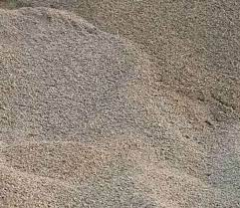

**Fig. 1 fine aggregate**

The quality of fine aggregate depends on certain parameters such as it should be free from organic matter, loam, slit, salt and clay. It should be hard, strong and durable. It stiffens the binder and fills the voids in the coarse aggregate.

**COARSE AGGREGATES-** The aggregate which passes through 80 mm sieve and retains on 4.75 mm sieve is termed as coarse aggregate. For this study IS:383-2016 was used to procure the fine aggregates from local fine aggregate suppliers.

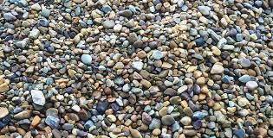

Fig. 2coarse aggregates

Coarse aggregate should have certain properties such as it should be free from dust, vegetation, organic matters, and clay. It should be angular in shape which shows good interlocking properties.

**WATER-** Water is an important factor in the production of concrete. The water should be free from impurities, salt and other toxic substances otherwise it might affect the properties of



Fig. 3water

concrete such as setting time of cement and its strength, other than that it might lead to stains on the surface and the worst is corrosion of reinforcement in the concrete

**POLYTHENE-** Polyethylene or polythene (abbreviated PE; [IUPAC](https://en.wikipedia.org/wiki/IUPAC) name polyethene or poly(methylene)) is the most commonly produced [plastic](https://en.wikipedia.org/wiki/Plastic). It is a [polymer](https://en.wikipedia.org/wiki/Polymer), primarily used for [packaging](https://en.wikipedia.org/wiki/Packaging) ,[plastic bags](https://en.wikipedia.org/wiki/Plastic_bag), [plastic films](https://en.wikipedia.org/wiki/Plastic_film), [geomembranes](https://en.wikipedia.org/wiki/Geomembranes" \o "Geomembranes) and containers including [bottles](https://en.wikipedia.org/wiki/Bottle), etc.). As of 2017, over 100 million [tonnes](https://en.wikipedia.org/wiki/Tonne" \o "Tonne) of polyethylene [resins](https://en.wikipedia.org/wiki/Resin) are being produced annually, accounting for 34% of the total plastics market. Many kinds of polyethylene are known, with most having the [chemical formula](https://en.wikipedia.org/wiki/Chemical_formula) (C2H4)n.

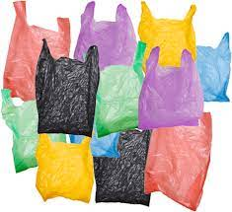

Fig . 4Polyethylene

PE is usually a mixture of similar [polymers](https://en.wikipedia.org/wiki/Polymer) of [ethylene](https://en.wikipedia.org/wiki/Ethylene), with various values of n. It can be low-density or high-density: [low-density polyethylene](https://en.wikipedia.org/wiki/Low-density_polyethylene) is extruded[[verification needed](https://en.wikipedia.org/wiki/Wikipedia:Verifiability)] using high pressure (1,000–5,000 [atm](https://en.wikipedia.org/wiki/Atmosphere_(unit)" \o "Atmosphere (unit)) (100–510 MPa)) and high temperature (520 [K](https://en.wikipedia.org/wiki/Kelvin) (247 °C; 476 °F)), while [high-density polyethylene](https://en.wikipedia.org/wiki/High-density_polyethylene) is extruded[[verification needed](https://en.wikipedia.org/wiki/Wikipedia:Verifiability)] using low pressure (6–7 atm (610–710 kPa)) and low temperature (333–343 K (60–70 °C; 140–158 °F)).

**METHODOLOGY-** Certain steps were followed to accomplish the objective of this experimental study and these are as follows:

**Mix design and casting of concrete-** Concrete mix design was done to determine the mix proportion for the preparation of concrete. The mix design was done according to M30 grade of concrete and a water cement ration of 0.45 was adopted. The concrete mix designing was done according to the Indian standard namely IS:10262-2009 and IS: 456-2000.

**PREPARATION OF MATERIAL**

All the material to be used in the experiments were brought to room temperature before commencing the experiment. The cement and shredded polythene were stored in a dry place and the aggregates were kept at air dried condition. The aggregates were separated for fine and coarse with the help of 4.75 mm sieve.

**MIXING-** Mixing of all the materials for preparing the concrete has to be done with utmost care as the performance of concrete depends upon the mixing. Thus mixing becomes an important part of this experimental study. For this a pan mixture was used as shown in Fig. 3.2.

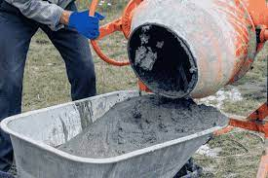

fig.5mixing

For best mix all the dry materials like cement, sand, coarse aggregates, and polythene bags were poured in the pan and then it is mixed without adding the water so that all the materials gets mixed properly. After that the water is added and pan is rotated for not less than 2 minutes till a homogeneous concrete is prepared.

**Compaction**-Compaction is the process in which the air voids from the freshly placed concrete is eliminated with the help of vibrating machine. The compaction needs to be done for each specimen so that the aggregate gets interlocked properly and thus making the concrete sound.

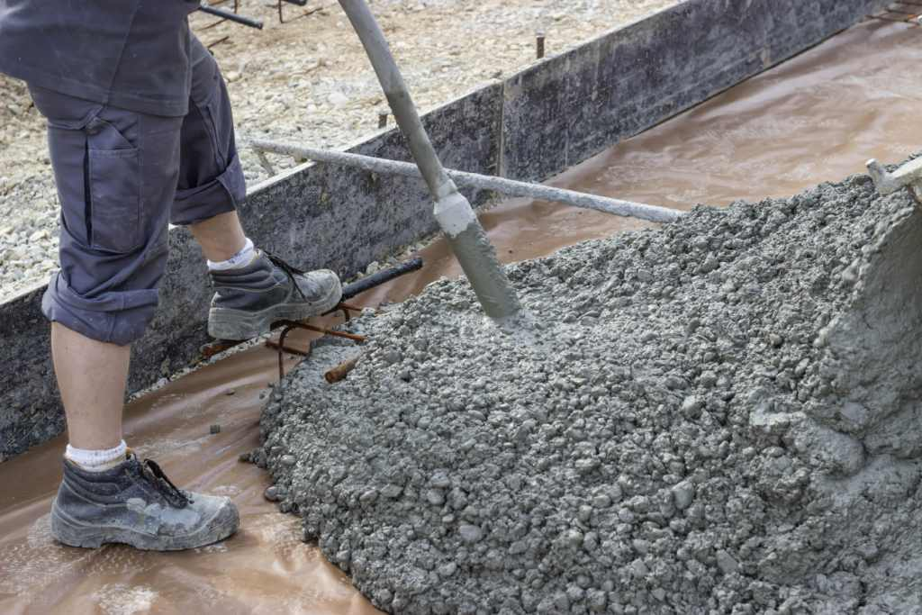

Fig. 6 Compaction

For compaction process the concrete is poured in moulds in three layers with each layer being temped 25 times with the help of temping rod.

**RESULTS-** The main focus of this chapter is to show the results of the tests which determine the behavior of the concrete made by replacing fine aggregate with shredded plastic waste. The tests such as compaction factor, compressive strength, split tensile strength, flexure strength, carbonation and freeze-thaw were carried out to know the mechanical properties, durability properties, load deflection behavior and toughness of the concrete made with shredded plastic waste.

**WORKABILITY-** Workability of concrete is the property of freshly mixed concrete which determines the ease and homogeneity with which it can be mixed, placed, consolidated and finished as defined by ACI Standard 116R-90 (ACI 1990b). In this study the workability of concrete was carried out using the compaction factor test. This test is considered suitable for the concrete with low workability as the slump test fails to give the accurate results.

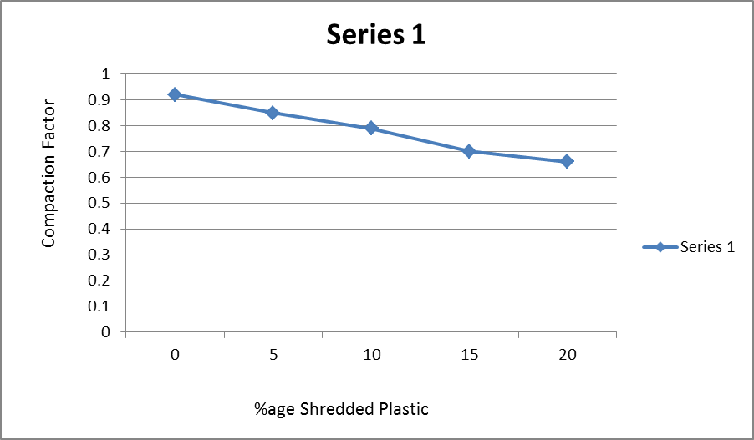

Fig. 7 workability test

The workability of the concrete made using 5% replacement of fine aggregate with shredded plastic waste was 0.85, for 10% replacement it was 0.79, for 15 and 20% it was 0.70 and 0.66 respectively. As it is evident from the results that the workability of concrete has reduced as the percentage of replacement has increased. The workability for 5% replacement reduced by 7.60% as compared to control mix, and for 20% replacement level it reduced by 28.26%.

**COMPRESSIVE STRENGTH-** The characteristic compressive strength of concrete of control mix and the concrete having shredded plastic waste at the end of 7 and 28 days curing was determined using compressive strength test.

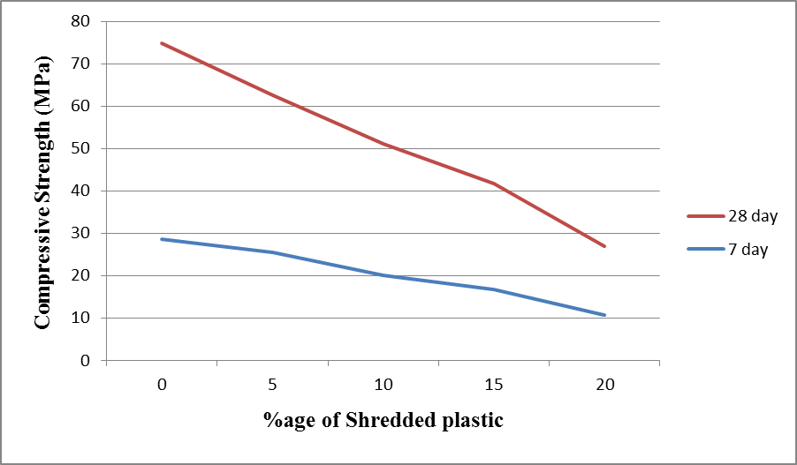

Fig . 8 Compressive strength test

The results of compressive strength are shown in Fig. 4.2. The compressive strength of concrete at the end of the 7 days curing of control mix (0%), 5%, 10%, 15% and 20% replacement level were 28.57 MPa, 25.56 MPa, 20.09 MPa, 16.76 MPa, and 10.67 MPa respectively. The results of compressive strength of 28 days curing were 42.67 MPa, 36.92 MPa, 31.04 MPa, 24.87 MPa, and 16.34 MPa. The results showed decrement in the compressive strength for both 7 and 28 days with the increment in the percentage of shredded plastic waste.

**SPLIT TENSILE STRENGTH-** The results of the split tensile strength of this study is represented in Fig. 4.3 for both control concrete and concrete having shredded plastic waste **Fig. 4.3** shows that the tensile strength of concrete decreased with increasing percentage of plastic waste.

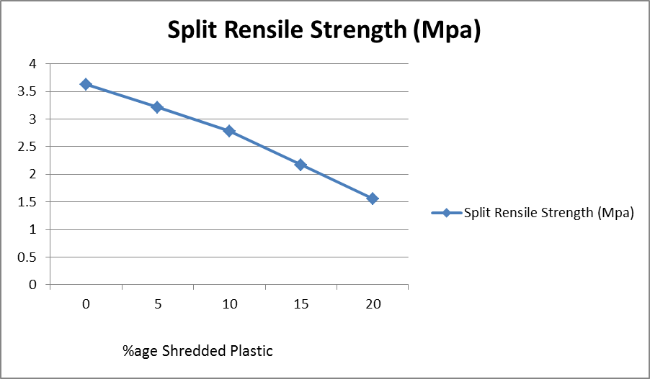

Fig. 9 split tensile strength test

The tensile strength of control mix (0%), 5%, 10%, 15% and 20% was 3.63 MPa, 3.21 MPa, 2.78 MPa, 2.17 MPa, and 1.56 MPa respectively. The reduction in strength for 5% replacement was 11.57% and that for 20% replacement was 57.02%.

**CONCLUSIONS-** This study was carried out to determine the performance of concrete containing shredded plastic waste material. For this purpose various tests such as workability, compressive strength, split tensile strength, flexural strength, carbonation, freeze-thaw test and load deflection behavior of plastic waste concrete were carried out. After using polythene waste as concrete ingredient (fine aggregate replacement and addition), the following conclusion can be drawn:

The workability and the mechanical properties like flexural strength; split tensile strength, and compressive strength of concrete containing polythene waste decreased with increase in the percentage of waste polythene. The workability and compressive strength up to 5% replacement level were in permissible limit.

The carbonation depth of plastic waste concrete increased with the increasing replacement levels. Therefore concrete containing plastic waste can be used for the construction of nonstructural members such as paver blocks, concrete blocks etc.

The load deflection behavior showed that the peak load decreased with increase in plastic content but the deflection values increased. The control mix had brittle behavior whereas due to the addition of plastic waste all other specimen showed ductile behavior. Energy absorption capacity and toughness factor of the concrete increased with increasing amount of plastic waste replacement.

Therefore it can be concluded that the concrete with 5% replacement level of waste plastic can be used satisfactorily without compromising the workability and compressive strength. IT can also be used for the construction of members where strength is not a major factor. Such type of concrete can also be used in cold region as well for application which required high energy absorption capacity.

**REFERENCES**

1. Subramanian, M.P. 2000. Plastics recycling and waste management in the US. Resources, Conservation and Recycling 28: 253-263.
2. Trossarelli, L., and Brunella, V. 2003. Polyethylene: discovery and growth. In UHMWPE meeting 5-18.
3. Hassani, A., Ganjidoust, H., Maghanaki, A.A. 2005. Use of plastic waste (poly-ethylene terephthalate) in asphalt concrete mixture as aggregate replacement. Waste Management & Research 23: 322-327.
4. Dullius, J., Ruecker, C., Oliveira, V., Ligabue, R., Einlof, S. 2006. Chemical recycling of post-consumer PET: Alkyd resins synthesis. Progress in Organic Coating 57: 123-127.
5. Ismail, Z.Z., and Al-HAshmi, E.A. 2008. Use of waste plastic in concrete mixture as aggregate replacement. Waste Management 28: 2041-2047.
6. Siddique, R., KHatib, J., and Kaur, I. 2008. Use of recycled plastic in concrete: a review. Waste management 28: 1835-1852.
7. ASTM C597, 2009: Standard test method for pulse for pulse velocity through concrete.
8. Kan, A., Demirboga, R. 2009. A novel material for lightweight concete production. Cement and Concrete Composites 31: 489-495.
9. Kou, S.C., and Poon, C.S. 2009. Properties of self-compacing concrete prepared with recycled glass aggregate. Cement and Concrete Composites 31: 107-113.
10. Akcaozoglu, S., Atis, C.D., Akcaozoglu, K. 2010. An investigation on the use of shredded waste PET bottles as aggregate in lightweight concrete. Waste Management 30: 285-290.
11. Hannawi, K., Kamali-Bernard, S., Prince, W. 2010. Physical and mechanical properties of mortar containing PET and PC waste aggregates. Waste Management 30:2312-2320.
12. Frigione, M. 2010. Recycling of PET bottles as fine aggregate in concrete. Waste Management 30: 1101-1106.
13. Ghernouti, Y., Rabehi, B., Safi, B., Chaid, R. 2011. Use of recycld plastic bag waste in the concrete. Journal of International Scientific Publications: Materials, Methods and Technologies 8: 480-487.
14. Karahan, O., Atis, C.D. 2011. The durability properties of polypropylene fiber reinforced fly ash concrete. Materials and Design 32: 1044-1049.
15. Badia, J.D., Stromberg, E., Karlssonb, S., Ribes-Greus, A. 2012. The role of crystalline, mobile amorphous and rigid amorphous fractions in the performance of recycled poly (Ethylene terephthalate) (PET). Polymer Degradation and Stability 97: 98-107.
16. Gawande, A., Zamare, G., Renge, V.C., Tayde, S., and BHarsakale, G. 2012. An overview on waste plastic utilization in asphalting of roads. Journal of Engineering Research and Studies 3: 1-5.
17. Saikia, N., and Brito, J. 2012. Use of plastic waste as aggregate in cement mortar and concrete preparation: A review. Construction and Building Materials 34: 385-401.
18. Bhogayata, A., Shah, K.D., and Arora, N.K.. 2013. Srength properties of concrete containing post-consumer metalized plastic wastes. International Journal of Engineering Research and Technology (IJERT) 2: 1-4.
19. Othman, S.N., Noor, Z.Z., Abba, A.H., Yusuf, R.O., Hasan, M.A.B. 2013. Review on life cycle assessment of integrated solid waste management in some Asian countries. Journal of Cleaner Production 41: 251-262.
20. Silva, R.V., Brito, J. de, Saikia, N. 2013. Influence of curing condition on the durability related performance of concrete made with selected plastic waste aggregate. Cement and Concrete Composites 35: 23-31.
21. Garg, C., and Jain, A. 2014. Green concrete: efficient and eco-friendly construction materials. Internatioanl Journal of Research in Engineering and Technology 2: 259-264.
22. Kumar, A., Srivastava, V., and Kumar , R. 2014.Effect of waste polythene on compressive strength of concrete. Journal of Academia and Industrial Research (JAIR), 3(3): 152.
23. Malak, K.R., 2015. Use of waste plastic in concrete mixture as aggregate replacement International Journal of Engineering, Education and Technology (ARDIJEET) 3.
24. Marthong, C., and Sarma, D.K. 2015. Influence of PET fiber geometry on the mechanical properties of concrete: an experimental investigation. European Journal of Environemental and Civil Engineering 20: 771-784.
25. Sharma R., Bansal, PP. 2015. Use of Different Forms of Waste Plastic in Concrete – A Review, Journal of Cleaner Production, doi: 10.1016/j.jclepro.2015.08.042.
26. Al-HAdithi, A.I., and Hilal, N.N. 2016. The possibiitry of enhancing some properties of sel-compacting concrete by adding waste plastic fibers. Journal of Building Engineering. 8: 20-28.
27. Alqahtani, F.K., GHataora, G., Khan, M.I., Dirar, S. 2017. Novel lightweight concrete containing manufactured plastic aggregate. Construction and Building Materials 148: 386-397.
28. Bhogayata, A., and Arora, N.K. 2017. Feasibilitry study on usage on metalized plastic wase in Concrete. Contemporary Issues in Geoenvironmental Engineering 2: 328-337.
29. Al-Hadithi, A.I., Alani, M.F. 2018. Importance of adding waste plastic to high-performance concrete. Waste and Resource Management 171: 36-51.
30. Saxena, R., Siddique, S., Gupta, T., Sharma, R.K., Chaudhary, S. 2018. Impact resistance and energy absorption capacity of concrete containing plastic waste. Construciton and Building Materials 176: 415-421.
31. Jain, A., Siddique, S., Gupta, T., Jain, S., Sharma, R.K., Chaudhary, S. 2018. Fresh, strength durability and microstructural properties of shredded waste plastic concrete. Iranian Journal of Science and Technology 1-11.
32. Thorneycroft, J., Orr, J., Savoikar,P., Ball R.J. 2018. Performance of structural concrete with recycled plastic waste as a partial replacement for sand. Construction and Building Materials 161: 63-69.
33. Alani, A.H., Bunnori, N.M., Noaman, A.T., Majid, T.A. 2019. Durability performance of a novel ultra-high-performance PET green concrete (UHPPGC). Construction and Building Materials 209: 395-405.
34. Shreyas, A.V. and Venkateswaran, S. 2019 Experimental investigation on the strength of concrete by partial replacement of fine aggregates by low-density shredded polyethylene. Sustainable Construction and Building Materials 25: 619-626.
35. Colangelo, F., Farina, I. 2019. Use of recycled plastics in eco-friendly concrete. Woodhead Publishing Series in Civil Structural Engineering. 8: 167-187.
36. IS 383-2016: Specification for coarse and fine aggregates from natural source for concrete.
37. IS 10262-2009: Guidelines for concrete mix proportioning.
38. IS 456-2000: Code of practice-plain and reinforced concrete.
39. IS 1199-1959: Methods of sampling and analysis of concrete.
40. IS 516, 1959: Methods of tests for strength of concrete.
41. IS 5816-1970: Method of test splitting tensile strength.
42. JSCE-SF4: method of tests for flexural strength and flexural toughness of steel fiber reinforced concrete.
43. RILEM Committee TC56, 1988: Measurement of hardened concete carbonation depth.