**Estimation of Renewable Energy Based Micro Grid Power Management System**

Samarjeet Singh1, Sabreen Khan2*

1 M. Tech Research Scholar, Department of Energy Technology, Aditya College of technology & Science, Satna

2 *Asst. Professor, Department of Mechanical Engineering, Aditya College of technology & Science, Satna

**Abstract:** Microgrid power systems, which use storage batteries and diesel engines to generate electricity, are gaining popularity due to the consistently decreasing cost of renewable energy. But, more power can't be added if the system's storage capacity is limited. Multiple inductance (RL) circuits feeding three-phase resistors that simulate open circuits may be reliably backed up by a combination of photovoltaics (PV), wind power, and a battery energy storage system (BESS). location where power is produced This device's vulnerability to power outages is proportional to the load fluctuation. Power fluctuations on the grid are growing more regular as demand increases, but distributed generators provide a solution. To get around the intermittent nature of power provided from renewable sources inside a microgrid, the deployment of a diesel generator will need an update to current protective mechanisms. In order to validate the simulation's predictions for the Micro Grid Power system, measurements and testing were conducted utilising the system developed for this thesis. The results of the MATLAB simulation were compared to real-world data to see how close they came. Seeing as how the wind turbines hooked up to the PMSG are producing power, we can safely assume that this subsystem is operating as planned. Permanent magnet synchronous generators (PMSGs) are crucial for transforming mechanical energy from a turbine into electrical power. The results demonstrate that wind power production is accounted for in the model and that the whole process is based on Energy-Based Micro Grid Power.

**Keywords: - *Renewable Energy, microgrid power system, diesel engines. wind power***

1. **INTRODUCTION**

There are several advantages to using a small "hybrid" electric system that combines home wind electric with house solar electric (photovoltaic or PV) technologies, according to experts in the area of renewable energy. During the summer, when the sun is at its highest and longest, the breezes are often calm over the bulk of the United States. Less sunlight in the winter means stronger winds. As wind and solar systems have different peak operation hours throughout the day and year, hybrid systems are better able to provide power when it is required.

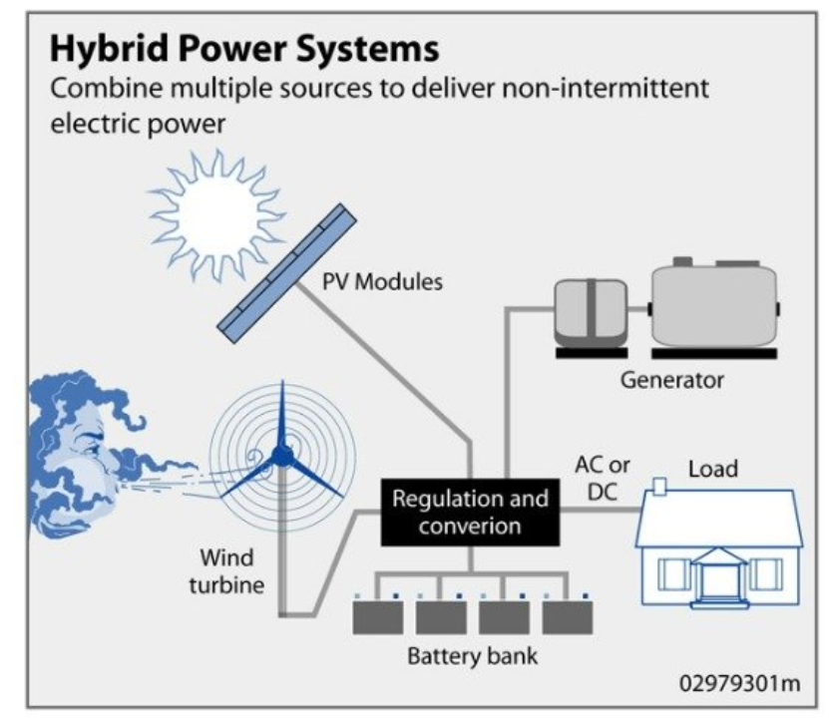

**Fig. 1: Hybrid Power System**

Many current hybrid installations are "off-grid" systems that are not connected to the main power supply. When the wind and sun aren't blowing and shining, most hybrid systems use batteries and/or a conventional fuel generator to keep the lights on. It's possible that the engine generator will kick in if the batteries start to fail, keeping everything operational until the batteries can be recharged.

While the addition of a generator engine increases the complexity of the system, modern electronic controllers allow for fully automated operation. If an engine generator is used, the system's other components might be made smaller. Keep in mind that even when the system is not charging, the storage capacity must be adequate to satisfy electrical needs. The number of days' worth of energy storage is the standard by which a battery bank's size is measured.

Yet, many outlying locations don't have the utilities or means to hook up to the grid. To provide their homes with power, these communities often rely on standalone, modest diesel generators. The decreased pricing of fossil fuels, together with difficulties in fuel supply and generator maintenance, may result in unnecessarily high operating expenses connected with these diesel generators. Hybrid energy systems, which use a variety of energy sources, have been found to significantly reduce the total life cycle cost of standalone power supplies in many off-grid situations while still providing a reliable electrical supply. The rapidly expanding renewable energy industry has led to the development of highly reliable and cost-effective hybrid systems, which have since been implemented in many parts of the world.

According to a study, India's total renewable energy capacity might reach 220 GW by 2032.

The analysis found that despite India's 14.8 GW of renewable energy potential, the country has just scratched the surface of an enormous possibility (i.e., 9.7 percent of the total installed generating capabilities of 150 GW as of 30 June 2009). Renewable energy's share of total installed capacity has increased dramatically in recent years, from 5% to 9.7%.

Based on current renewable energy technologies, this might equal to hundreds of gigawatts (GW) of energy output potential. Many of areas still lack access to electricity, and it would be prohibitively costly to provide power to them via expanding networks or diesel generators alone. Because of the government's current resource problems, extending the grid to these communities is not a top priority. Solar PV-wind hybrid energy systems may be used to provide reliable and cheap electricity for these kinds of localised applications. With their inexhaustibility, independence from fossil fuels, and lack of toxic consequences, solar and wind power are two of the most promising renewable energy sources currently available. Wind and PV systems are being considered by a growing number of countries as a method of decreasing their use of fossil fuels and other nonrenewable energy sources. The current state of technology notwithstanding, there is still a significant portion of the year that power cannot be collected from self-sufficient wind turbines. This is mostly due to the prevalence of wind speeds between 3.5 and 4.5 metres per second (the range at which a wind turbine starts generating usable power). It is suggested that a hybrid system consisting of solar photovoltaics (PV) and wind turbines be used to circumvent this blackout. In order to deal with peak loads during the short periods when there is inadequate energy supply to meet the demand, diesel generators are often utilised in these systems. While diesel generator sets are inexpensive to acquire, they may be expensive to operate and maintain, especially during times of low system demand.

In general, the timing of energy use does not match up with the ebb and flow of renewable sources like solar and wind. The main issue with wind and solar power is their reliance on favourable weather and climatic conditions. Perfect dependability requires both components, which would have to be massive if employed alone.

This configuration has been shown to potentially reduce the overall cost of the autonomous renewable system. Combining photovoltaic (PV) and wind systems with battery storage and a diesel backup system makes electrifying remote locations economically viable. Wind and solar are scalable, so more capacity may be added as needed. The future of power generation with hybrid energy systems seems promising. Using hybrid energy systems reduces emissions of carbon dioxide, the main contributor to the greenhouse effect/global warming caused by the combustion of fossil fuels. The most critical environmental issue affecting energy policies worldwide is climate change. As a result of this crisis and as part of the response, renewable sources of energy like solar and wind are expected to get substantial support. To mitigate current issues in the power industry such pollution from traditional power generation, system losses, and unreliable energy in rural areas, it is best to be ready for a smart grid.

It would be prohibitively expensive to extend the standard utility infrastructure to reach more remote places in order to provide electricity to the surrounding settlements. The advantages of using a hybrid energy system are only fully realised if the system is constructed and operated in an optimal manner. There is a close relationship between system sizing, control parameters, and operational methods in such structures. In addition, there is odd behaviour coming from several of the system's components. As a consequence, assessing feasible hybrid system designs in advance of a specific location is not a simple procedure.

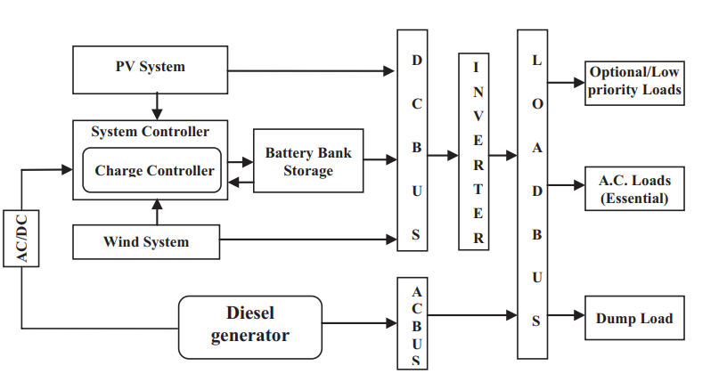

**Fig. 2: Block diagram of a typical PV–wind hybrid system is depicted.**

1. **Background**

**Qadir, et.al. (2021),** In comparison to traditional fossil fuel-based resources, renewable energy sources may play a crucial role in sustaining a country's economy and boosting the quality of life there. This research has the potential to enhance the precision of weather forecasts in smart grids, which is crucial in light of the present environmental crisis. A machine learning model with high potential for precise prediction of energy and power consumption was classified in this study. Both adjusted and unadjusted historic hourly data are processed. In the words of Charrouf et al (2020), In this research, we look at the feasibility of using an Artificial Neural Network (ANN) to control the output of a reverse osmosis desalination system that draws its electricity from a mix of solar photovoltaics (PV), wind turbines, and a battery bank. The primary objective of the ANN power management system is to enable the seamless transfer of the power generated by these sources throughout a 24-hour workday despite the intermittent nature of wind speed and solar radiation, taking into account the limitations of the RO unit and the required water profile. We thank Anoune and co. (2018), This investigation provides a current literature analysis of the best technique and methodologies used in sizing and optimising a photovoltaic-wind based hybrid system (PWHS) for a remote place. Finding a happy medium between power supply reliability and hybrid system cost is the focus of this research. In addition to contrasting the most popular PWHS implementation topologies, this research delves further into the software tools and analytical technique utilised in size optimization and pays special attention on power reliability and system cost. What Ma et al (2019), This study introduces a mathematical model for analysing the impact of saturation on battery bank size, SOC, power supply loss, surplus energy, net present cost, levelized cost of energy (COE), and investment payback time. Varying saturation is defined as an increase in the saturation of one resource and a decrease in the saturation ratio of another resource. A saturation factor is also provided, with values from 0 to 1 and a step size of 0.02. If the value is 0, then the system is entirely powered by the wind; if it is 1, then the system is entirely powered by the sun. The study examined three systems, each with a unique configuration of wind generators (for a total of 150 permutations). According to the results, the cheapest option for the proposed off-grid island is a system with a 2-kilowatt (kW) wind turbine, which harnessed 90% of the available wind energy. The collective Das et al (2018), They provide a method for controlling the flow of electricity in a hybrid renewable energy system that combines solar panels, wind turbines, and batteries for use in remote locations (HRES). A fuzzy logic controller is used to stabilise the power supply while maintaining the battery's state of charge (SOC) within acceptable ranges. The various components are modelled and simulated using MATLAB/Simulink. The results show that the proposed fuzzy logic-based controller is able to keep the supply and demand for electricity in equilibrium, even when there are sudden changes in both load and power generation (FLC). Power fluctuations are reduced and high-quality energy is provided while keeping SOC within secure limits. Authors Chang et al (2015), The purpose of this research is to investigate the viability of using Monte Carlo simulation in tandem with simulation optimization methodologies to identify the optimal design for HRES in dynamic environments when uncertainty is high. The suggested model accounts for power production, allocation, and transmission within the HRES in order to satisfy power needs at the lowest feasible cost. This includes the installation of equipment like PV, wind, and diesel power generators and energy storage devices in each power station. Comprehensive computational study confirms the solveability of the proposed model at actual size, opening the way for the production of high-quality judgements in practise.

1. **ESTIMATION ANALYSIS OF RENEWABLE ENERGY BASED MICRO GRID POWER MANAGEMENT SYSTEM**

Modeling anything allows you to get insight into its characteristics and performance without subjecting it to rigorous testing in the actual world. As it is difficult to design a system or apply exact conditions in actual operation testing, it is vital to use a software computer programme for modelling in a simulation environment.

**Modeling of Photovoltaic Panels**

If the solar array is aimed at the right angle with regard to the sun, it may generate direct current with no environmental costs. Solar energy systems rely on individual sun cells. Solar photovoltaic (PV) systems use PN junctions in semiconductors to convert sun energy into electricity. The quantity of sunlight striking a solar cell has an effect on its output voltage and other attributes. Figure 3 depicts a circuit with similar functionality for a PV array.

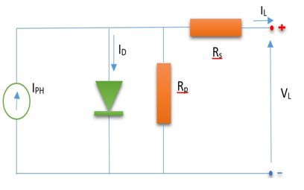

**Fig. 3:** Basic components of PV

The open circuit voltage (Voc) of the cell is measured when there is no current flowing through it (zero amperes).

$V^{OC}=V+{IR}^{sh}$ (3.1)

Typically, the photocurrent is represented by a diode with parallel and series resistance connections. A shunt resistor stands in for the leakage current, while a series resistor represents the current's internal resistance in a standard photovoltaic model circuit.

Equation (3.2) [28] gives the current-voltage characteristic equation of a solar cell.

$IPV=IPH-Is×\left[\frac{\left(q\left(VPV+IPV\right)RS\right)}{K×TC×A}\right]-\frac{\left(VPN+IPV\right)RS}{RP}$ (3.2)

The influence that temperature and solar irradiation have on the photocurrent of cells is essentially described by the equation.

$IPH=\frac{\left[Isc+K1(Tc-Tref)\right]λ}{1000}$ (3.3)

The cell temperature due to varying of the saturation current that is expressed in equation (3.4).

$Is=Irs×{\left(\frac{Tc}{Tref}\right)}^{3}{l }^{\frac{\left(\frac{1}{Tref}-\frac{1}{Tc}\right)}{K×4}}$ (3.4)

Shunt leakage current (Is) is inversely proportional to shunt resistance (Rp). The parallel leakage resistance is assumed to approach infinity in the absence of ground leakage, and as a result, PV array efficiency is insensitive to variations in Rp. Alternatively, the output power of PV cells is sensitive to even modest variations in the series resistance Rs.

Equation (3.2) can be modified to be .

$IPV=IPH-Is×\left[l\frac{\left(q\left(VPV+IPV\right)Rs)\right)}{K×Tc×A}\right]$ (3.5)

The series loss and leakage to ground are not taken into account in an ideal photovoltaic cell.

Then, Rs=0 and Rp = ∞.

So, the equation (1.5) can be written in another form as:

$IPV=IPH-Is×\left[l\frac{\left(q×VVP\right)}{K×Tc×A}-1\right]$ (3.6)

In order to create a voltage and current, the array cells may be connected as either a parallel or series circuit, and the Np parallel modules can be represented as either: [28]

$IPV=NP×IPH-NP×IS×\left[l\frac{\left(q×VVP\right)}{K×Tc×A}-1\right]$ (3.7)

When the parallel resistance in the solar cell system changes, the efficiency is not sensitive but sensitive to changes in series resistance.

This model is able to represent mathematics when parallel and series resistances are taken into consideration. The equation (3.7) can be simplified as: [28]

$IPV=NP×IPH-NP×IS×\left[l\frac{q\left(\frac{vpv}{NS}+\frac{IPV}{NP}×RS\right)}{K×Tc×A}-1\right]$ (3.8)

$IPV=NP×IPH-NP×IS×\left[l\frac{q\left(\frac{vpn}{NS}+\frac{IPV}{NP}×RS\right)}{Ns×K×Tc×A}-1\right]$ (3.9)

To measure the battery's electrical performance, the open (Voc) and short (Isc) circuit voltages and currents are the most crucial metrics. In a typical setup, Iph>> allows us to disregard the effects of ground leakage at zero-terminal voltage and modest diode current, making the short circuit current almost equal to the photocurrent.

Then,

$IPH=ISC$ (3.10)

When the output current is assumed to be zero, the parameter for the voltage in the output circuit may be calculated. To achieve the reverse saturation current, the following open circuit voltage and reference temperature conditions must be met.

Additionally, the maximum power can be stated as:

$Irs=\frac{Isc}{\left[l\left(\frac{q×Voc}{Ns×K×Tc×A}\right) -1\right]}$ (3.11)

$P^{MAX}=V^{MAX}xI^{MAX}XV^{oc}xI^{sc}$ (3.12)

**Maximum Power Point Tracking**

One example of a technology that might be used in a PV array solar system is a more efficient DC-DC converter, which can be used to offset the effect of changes in irradiance and temperature on the solar panel's maximum power point. It is often disregarded as irrelevant. If you want to get the most juice out of your solar panels, you might try using the maximum power point tracking (MPPT) technique. In this study, the maximum power point tracking (MPPT) was calculated using the perturbation observation technique for the PV system model. It requires less machinery, is easier to install, and may be used more quickly than rival products. The maximum Power point tracker in the camp can currently extract the greatest energy possible from a solar panel. As opposed to using a mechanical mechanism, this technique employs a purely electrical manner of directing cells towards the light source. With this adjustment, the module can collect as much solar energy as possible from where it is. The MPPT is limited in its ability to maintain a constant voltage output because to the variability in photovoltaic output caused by variables like as radiation, temperature, and load characteristics.

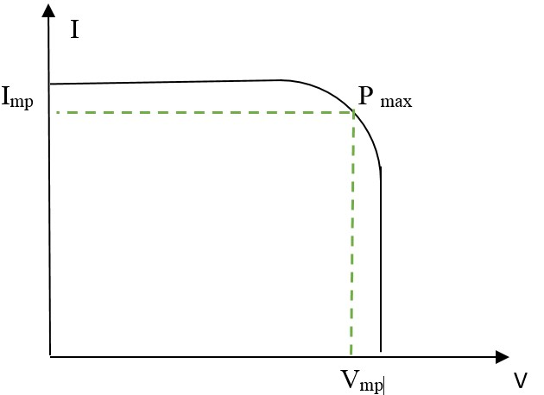

**Fig. 4: maximum power point characteristic**

A PV module's peak power varies with the voltage and current supplied to it, however this power can never exceed a fixed value. Optimizing the efficiency with which energy is transferred from solar panels to the load is essential for maximising the output of a photovoltaic system. Bringing the load impedance into phase with the source at the maximum power transfer point is achieved by altering the duty cycle.

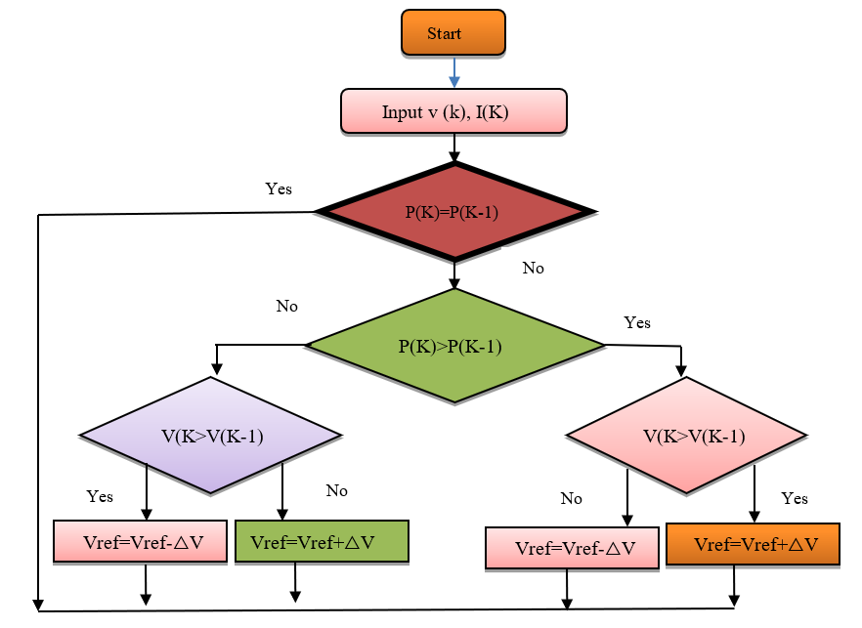

**Fig. 5:** PV applied to MPPT

**Current Development**

Increasing the amount of ground area exposed to sunlight improves the efficiency of photovoltaic (PV) systems. The solar tracker is able to adjust the angle of the solar panel, allowing it to face the sun more efficiently. Expansion rates of 20% in the winter and 50% in the summer are to be expected. The trajectory of the sun may be studied to improve the efficiency of static installation methods. Whilst the panel's performance is often best when set at latitude, adjusting it for summer or winter may improve it. Overheating a solar cell might cause it to lose efficiency in the same manner as other semiconductors lose efficiency when heated.

When the zenith distance from the sun is more than zero, several solar panels may be put vertically inside one another in the tower, the tower can be turned horizontally as a whole, and each panel is further rotated along the horizontal axis to get maximum exposure to the sun. Solar panels mounted on this kind of tower can follow the sun in any direction. It's a rung-based system on a revolving disc that allows access to several tiers. By standing the ladders on end, a rectangular solar panel is formed. When the sun is at its lowest zenith distance, you may prevent the bottom solar panel from being shadowed by rotating the Ladder to the north or the south. A tower that is not completely vertical but whose axis is aligned with a pole star and so perpendicular to Earth's rotational axis is another option. This means that there will never be an axis-sun angle less than 67 degrees. Tracking the sun's movement throughout the day is as easy as turning the panel on its axis. The gadget may be mounted on the ceiling or wall of a building, or it can be buried in the dirt (often used in agricultural or grazing contexts) (building integrated solar power).

Solar cells are another another technological breakthrough of the contemporary era. Perovskite is a far more cost-effective alternative to the more expensive crystalline silicon that is still utilised in conventional solar cell production. As a result, we believe that future efficiency will be far higher than the present peak of 18%. A persuasive case, considering that most organisations operate at a 20% efficiency rate. The price of solar panels' components has increased.

1. **SIMULATION & RESULT**

But, if the supply is depleted, no more energy may be added. To that end, when open circuits are represented by opening and closing multiple inductance (RL) circuits feeding three-phase resistors, a combination of photovoltaics (PV), wind energy (WES), and a battery energy storage system (BESS) is an alternative support suitable for this type of power generation system. Generation of Power The device acts as a variable load and is thus susceptible to fluctuations in the supply of electrical power. Decentralized generators may aid in smoothing out power fluctuations when they occur near to load. Due to the weather-dependent nature of renewable energy-based microgrid power, the addition of a diesel generator will need adjustments to existing safeguards but will still fall short of meeting the needs of power regulation.

The hybrid PV/Wind/Diesel Generator system integration and simulation is shown in Figure 6 using MATLAB Simulink block diagrams.

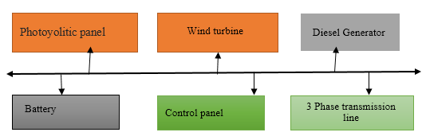

**Fig. 6:** Block Diagram of Energy Based Micro Grid Power

**PV-Wind System Model**

Many solar cells in a panel array use the combined voltage and current outputs of individual sun cells to generate power. The link between the amount of sunlight entering the battery and the consequent amount of power generated is shown in Figure 4.2.

**Description:** Microgrid hybrid systems, such as the one seen in Figure 4.2, often use solar panel installations of 100 kilowatts (kW) or more to balance the grid's load.

This setup consists of:

Using two sets of parallel solar panels, this array generates enough electricity to run eleven series DC power supply at a steady 9.464 kWh each day. In order to change the induced voltage in a solar energy system in a matter of days even without previous solar planning, the photovoltaic array, which is made of MPPT controllers, is used.

The photovoltaic system's direct current (DC) is changed into alternating current (AC) via a pulse width modulation (PWM) inverter.

When the inverter's external power supply is disconnected, it will immediately begin operating on its own power.

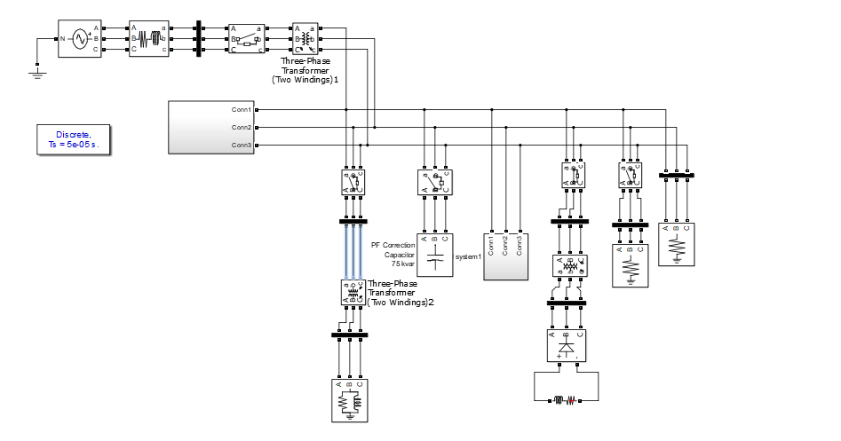

**Fig. 7:** Top level Model

If you look at Figure 7, you'll find that the wind turbine and the synchronous generator are the two mainstays of the concept. Wind turbines are able to convert the kinetic energy of the wind into usable electricity by translating the rotation of the turbine's blades into mechanical torque. Figure 8 is a graphical representation of wind power and rotational speed.

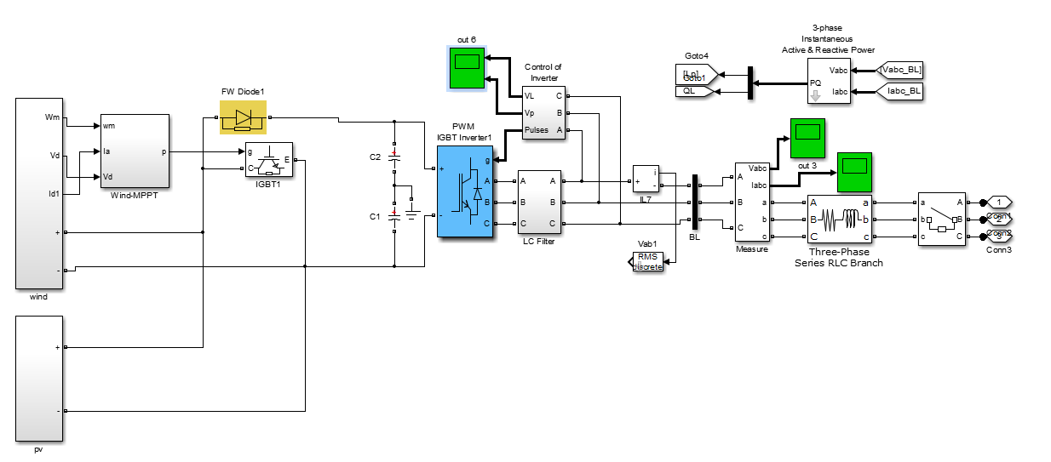

**Fig. 8:** PV Wind Subsystem

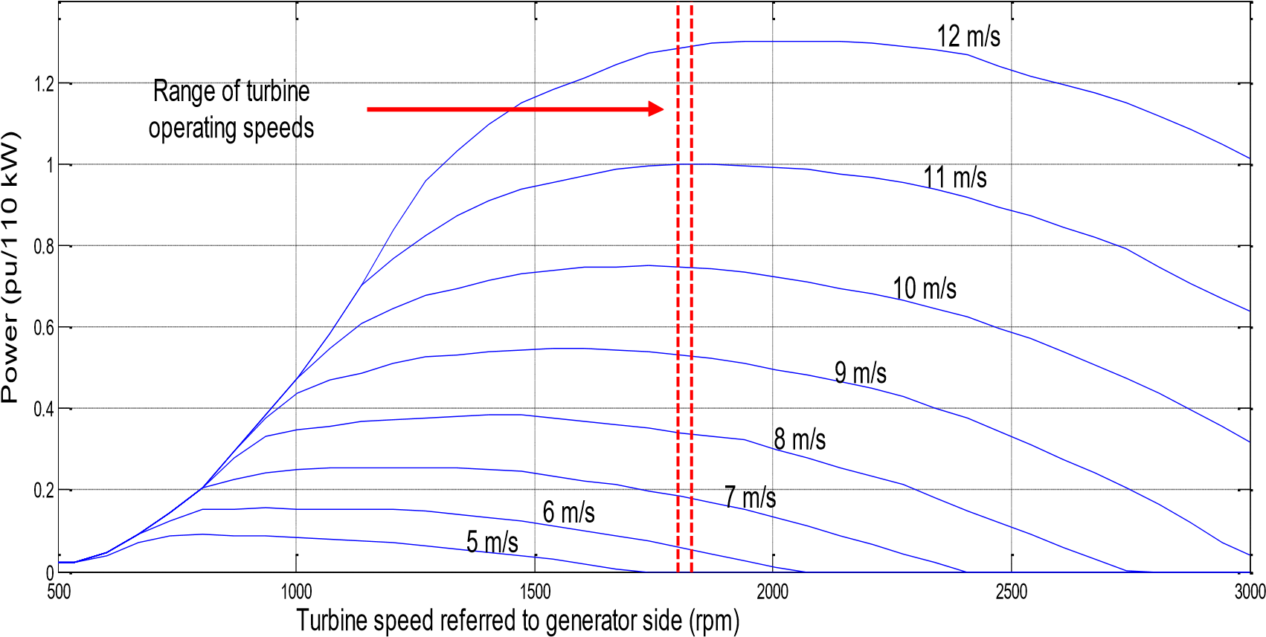

**Fig. 9:** Characteristic of Wind Turbine Power with Respect to the Wind Speed

**Results and Discussion**

Here, we put the built simulation system to the test by collecting data and conducting experiments to determine whether the predicted power production from the Micro Grid holds up under actual conditions. The results of a MATLAB simulation were compared to those of a real-world implementation.

## The Simulation Results of Energy Based Micro Grid Power

Our team uses SIMULINK, a component of the MATLAB software package, version 2013a, to model and simulate operational systems. The following images show the voltage and frequency output configurations of the autonomous hybrid system, which adapt to external changes.

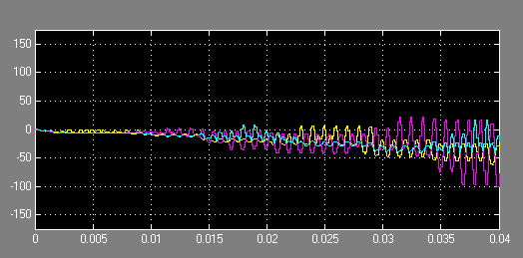

**Fig. 10: 5output current of Micro Grid Power**

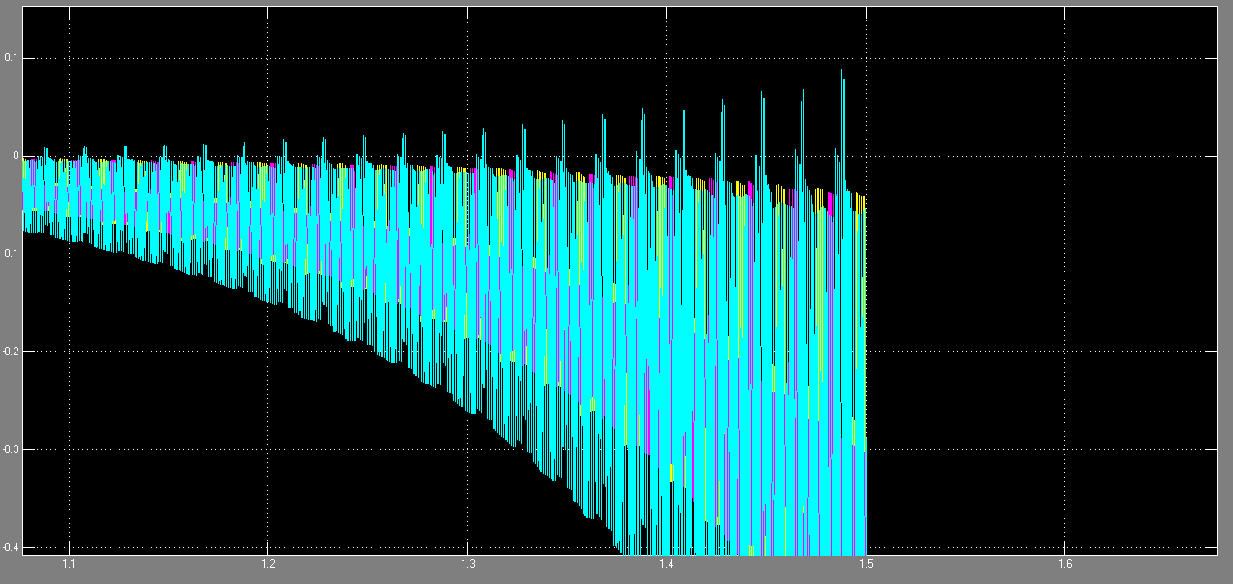

**Fig. 11: 6output voltage of Energy Based Micro Grid Power**

MPPT subsystem track the maximum power point as shown in fig. below.

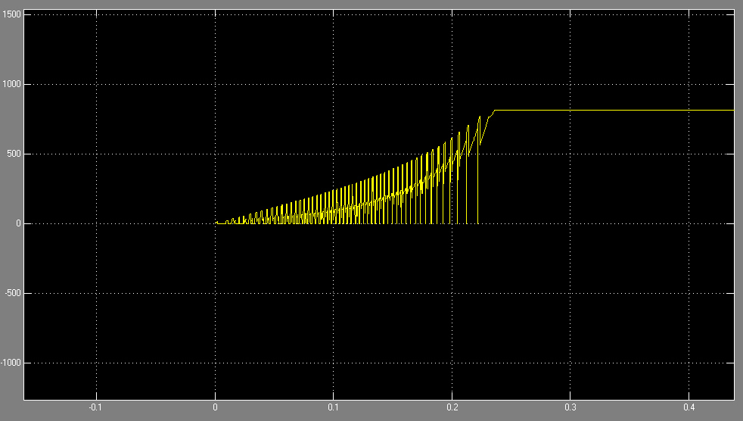

**Fig. 12: output current of MPPT system**

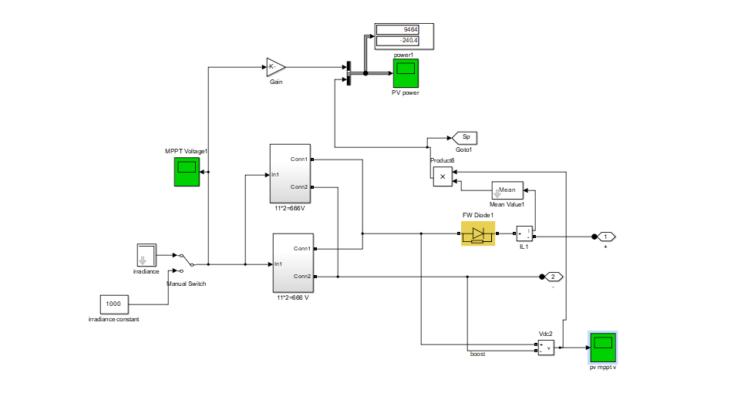

**Fig. 13: PV Micro Subsystem**

To further understand how the wind turbine subsystem works, consider the diagram below, which shows how the turbines are connected to the power management and storage grid (PMSG). The mechanical energy produced by the turbine is converted into electrical energy by a permanent magnet synchronous generator (PMSG). A diagram of a wind farm is shown in Fig.

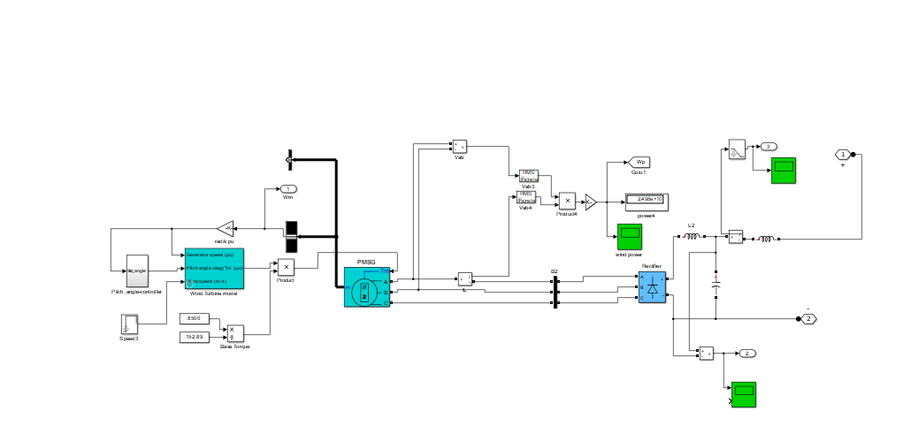

**Fig. 14: Wind Micro subsystem**

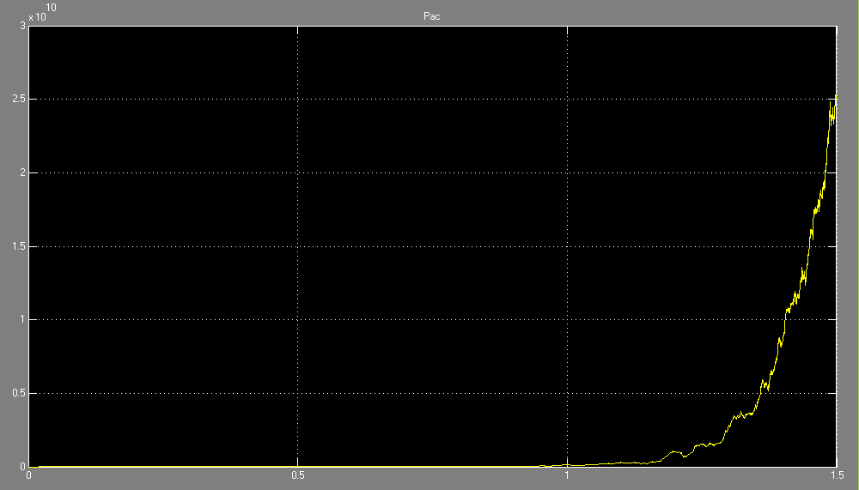

**Fig. 15: Wind Micro view for delivered power**

1. **CONCLUSION & FUTURE SCOPE**

The low annual cost of renewable energy is making microgrid power systems, which combine storage batteries and diesel generators, a practical choice. But if there isn't enough space to store the energy, then injecting it won't be feasible. Combining photovoltaics (PV), wind energy, and a battery energy storage system (BESS) is an effective backbone for a power generating system in which multiple inductance (RL) circuits feeding three-phase resistors stand in for open circuits. a source of energy A variable load is particularly vulnerable to power outages and surges because of its high reliance on electricity. Alternating current (AC) electricity from many sources may smooth out voltage swings produced by surging use. Due to the weather-dependent nature of micro grid power supplied from renewable energy sources, using a diesel generator will need an update to current protection mechanisms. To guarantee the accuracy of the Micro Grid Power predictions, extensive measurements and testing were performed utilising the simulated system built for this thesis. The results of a MATLAB simulation were compared to those of a real-world implementation. As a result of the wind turbine subsystem, PMSG is demonstrated to be connected to power-generating wind turbines. The mechanical energy produced by the turbine is converted into electrical energy by a permanent magnet synchronous generator (PMSG). This shows that the model and mechanism successfully incorporate wind power production into microgrid power generation.

# **References**

1. Abbassi, A., Dami, M. A., &Jemli, M. (2017). A statistical approach for hybrid energy storage system sizing based on capacity distributions in an autonomous PV/Wind power generation system. *Renewable Energy*, *103*, 81-93.
2. Agrawal, S., Chorsiya, S., &Palwalia, D. K. (2018). Hybrid energy management system design with renewable energy sources (fuel cells pv cells and wind energy): a review. *IJSET*, *6*(3), 174-177.
3. Ahadi, A., Kang, S. K., & Lee, J. H. (2016). A novel approach for optimal combinations of wind, PV, and energy storage system in diesel-free isolated communities. *Applied Energy*, *170*, 101-115.
4. Al Busaidi, A. S., Kazem, H. A., Al-Badi, A. H., & Khan, M. F. (2016). A review of optimum sizing of hybrid PV–Wind renewable energy systems in oman. *Renewable and Sustainable Energy Reviews*, *53*, 185-193.
5. Al-Ghussain, L., Samu, R., Taylan, O., &Fahrioglu, M. (2020). Sizing renewable energy systems with energy storage systems in microgrids for maximum cost-efficient utilization of renewable energy resources. *Sustainable Cities and Society*, *55*, 102059.
6. Al-Ghussain, L., Samu, R., Taylan, O., &Fahrioglu, M. (2020). Techno-economic comparative analysis of renewable energy systems: Case study in Zimbabwe. *Inventions*, *5*(3), 27.
7. Ali, I. B., Turki, M., Belhadj, J., &Roboam, X. (2018). Optimized fuzzy rule-based energy management for a battery-less PV/wind-BWRO desalination system. *Energy*, *159*, 216-228.
8. Almashakbeh, A. S., Arfoa, A. A., &Hrayshat, E. S. (2019). Techno-economic evaluation of an off-grid hybrid PV-wind-diesel-battery system with various scenarios of system’s renewable energy fraction. *Energy Sources, Part A: Recovery, Utilization, and Environmental Effects*, 1-24.
9. Amir, M., & Srivastava, S. K. (2019). Analysis of harmonic distortion in PV–wind-battery based hybrid renewable energy system for microgrid development. In *Applications of Computing, Automation and Wireless Systems in Electrical Engineering* (pp. 1223-1231). Springer, Singapore.
10. Anoune, K., Bouya, M., Astito, A., &Abdellah, A. B. (2018). Sizing methods and optimization techniques for PV-wind based hybrid renewable energy system: A review. *Renewable and Sustainable Energy Reviews*, *93*, 652-673.
11. Anoune, Kamal, AzzeddineLaknizi, MohsineBouya, AbdelaliAstito, and Abdellatif Ben Abdellah. "Sizing a PV-Wind based hybrid system using deterministic approach." *Energy Conversion and Management* 169 (2018): 137-148.
12. Aziz, A. S., Tajuddin, M. F. N., &Adzman, M. R. (2018). feasibility analysis of PV/wind/battery hybrid power generation: a case study. *International journal of renewable energy research*, *8*(2), 661-671.
13. Badwawi, R. A., Abusara, M., & Mallick, T. (2015). A review of hybrid solar PV and wind energy system. *Smart Science*, *3*(3), 127-138.
14. Baghdadi, F., Mohammedi, K., Diaf, S., & Behar, O. (2015). Feasibility study and energy conversion analysis of stand-alone hybrid renewable energy system. *Energy Conversion and Management*, *105*, 471-479.
15. Baghdadi, F., Mohammedi, K., Diaf, S., & Behar, O. (2015). Feasibility study and energy conversion analysis of stand-alone hybrid renewable energy system. *Energy Conversion and Management*, *105*, 471-479.
16. Bagheri, M., Delbari, S. H., Pakzadmanesh, M., & Kennedy, C. A. (2019). City-integrated renewable energy design for low-carbon and climate-resilient communities. *Applied energy*, *239*, 1212-1225.