Authors research impact on the world countries: A Bibilometric analysis from wos data
A Smitha Kranthi#, Anil Kumar Matta* , Dhanvi Matta*
#Department of BES-I, Koneru Lakshmaiah education foundation, Green fields, Guntur, A.P-522302, India.
asmithakranthi@kluniversity.in
*Data Scientist, TI, NC, NH, Vijayawada, A.P-520011, India.
anilkumarmatta7@gmail.com
*Nalanda Vidyaniketan, Gayatri Nagar, A.P-520010, India.
dhanvi.m@nalanda.edu.in

Abstract—In this paper, referred articles for the authors publications on Rapid Prototyping are taken from wos data base (2015-2023). Referred articles are the articles which are published by citing the author publications. Results enhanced from 47 sums of times cite. “Rapid Prototyping” is the research area for the 47 cites and impact on the world countries. Finally the paper showed the authors research impact on the exact world countries.

Keywords— Rapid Prototyping, WOS Data Base, Bibliometrics
- Introduction

Cited articles on rapid prototyping takes a lot of time, patience & effort to identify their impact on research and outgoing research in a country. A study of outdated research must be modified with the advances along with the world countries. Article citation rate helps in referral speed of a data scientist or researcher, huge citations on an article needs to be analysed especially web of science citations with science citation indexing. The citations of a paper do reflect, huge scientific impact and society [1-27].

Most cited article of a paper give a holistic progress on construction of scientific research society. The main purpose of this data analysis is to do bibliometrics & to find out the exact country citing the article for scientific progress on rapid prototyping.

- METHODOLOGY

Bibilometric analysis for web of science data is obtained from ‘WOS’, the key word is ‘WOS’ in search Google page. Wos menu bar of author with Published Names: Matta, Anil Kumar, Anil K Matta (Matta, A.K) , Web of science researcher ID: T-2997-2018, Published Organizations: Koneru Lakshmaiah Education Foundation (KL Deemed to be University), SRKR Engineering College, GMR Institute of Technology [28-33]. Research Areas: 3D Printing, Rapid Prototyping, Magnesium Alloys, Automobile Components [34-45]. Web of science core collections metrics and Publications in Web of science core collection are shown in Table1a & 1b.

TABLE 1a
Web of science core collections metrics
Authors Impact Beam Plot
Researcher | Documents
Publications in web of science | 4
Sum of times cited | 47
H-Index | 2

TABLE 1b
Publications in Web of science core collection
Publications in Web of science core collection
Publications of the web of science core collection | Times cited | Publisher
Metal Prototyping the future of automobile industry: A review | 12 | Materials Today: Proceedings, 2018
3D Support and software compensation for rapid virtual prototyping of tractor rockshaft arm | 0 | Advances in civil, architectural , structural and constructional engineering, 2016
Addressing Object Heterogeneity through edge cluster in multimode networks | 0 | Smart innovations, Systems and Technologies, 2015
The integration of cad/cam and rapid prototyping in product development: A review | 35 | Materials Today: Proceedings, 2015

A citation percentile measures the number of citations for an article against a benchmark set of similar papers (in terms of field, publication year, document type). An article with no citations has a percentile 0 and the article with most citations has a percentile score of 100.
Citation counts are from Web of Science Core Collection; citation percentile data are from In Cites
Author Impact Beam plot data is built on a researcher's articles and review documents over their career, back to max 1980.
The citation map shows the distribution of the researcher's citations across the globe:
- For each article in the Web of Science Core Collection that cited the researcher's work, a city with a contributing author's institution represents a data point [46-48].
- A publication may appear under multiple locations if the contributing authors are affiliated with different institutions
- The number of data points on the map may be higher than the sum of times cited in the Web of Science Core Collection. Times cited and Publications over time & Geographic Citation Map are shown in Fig.1 and Fig.2.

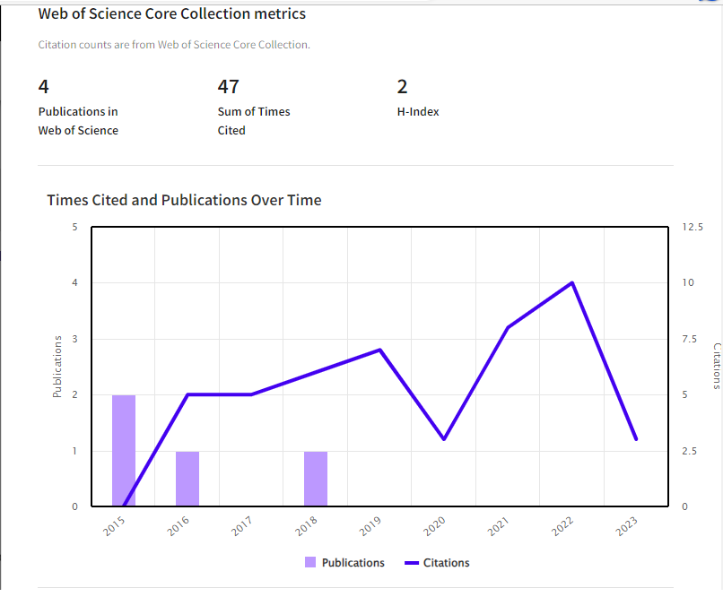

Fig.1: Times cited and Publications over time

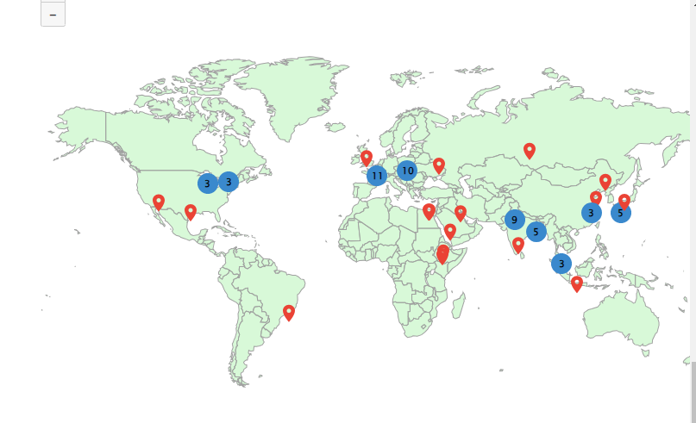

Fig.2: Geographic citation map

- RESULTS AND DISCUSSION
From the authors publications from Wos published from 2015 to 2018 which were visualized in land scape and repetitions in blue and red dots are analysed to view the impact of research in the exact institute of respective country in the world. Blue circles can be clicked to zoom in and see more precise locations; red pins can be clicked to see the details of papers citing the researcher's work from a particular city. Land scape and Bibliometrics is performed to check the city and country for red pin as shown in Fig.2and also for Blue pin article, author, respective institute, citations from the exact city and country were analysis and tabled in 3.1 & 3.2.

TABLE 3.1
Details of papers citing the researcher's work from a particular city.
Red Pin | City & Country
1 | Prescott, Unites States
2 | Houston, United States
3 | Rio de Janeiro, Brazil
4 | Huddersfield, United Kingdom
5 | Belgorod, Russia
6 | Cairo, Egypt
7 | Egaila, Kuwait
8 | Bisha, Saudi Arabia
9 | Awassa, Ethiopia
10 | Addis Ababa, Ethiopia
11 | Tomsk, Russia
12 | Vellore, India
13 | Changchun, China
14 | Quindao, China
15 | Suita, Japan
16 | Yogyakarta, Indonesia

TABLE 3.2
Blue circles analysis to see more precise locations.
Blue Pin | Article | Author | Institute | Citations from the City & Country
3 | Quantitative detection method for defects of curved metal materials based on 4 axis platform and flexible array electromagnetic sensor | Ma, Hoo | National University of Defense Technology, China | Maplewood, Unites States
3 | 3D Printing of a Biocompatible Nanoink derived from waste animal bones | Peter Samora | State College, United States | State College, United States
3 | A review of CAD CAM system applications in the production of transtibial prosthetic socket in developing countries | Nur, Razak | Universiti Malaya | Kuala Lampur, Malaysia
3 | A review of patient specific facial and cranial implant design using AI techniques | Memon | Shanghai Jiao Tong University | Shanghai, China
5 | 3D Printing of a Biocompatible Nanoink derived from waste animal bones | Das Manojit | IIT, Kharagpur | Kharagpur, India
5 | A dynamic physical model based on a 3D digital model for architectural rapid prototyping | Fukuda | Osaka University | Suita, Japan
9 | An experimental study on carbon fibre thickness and layer thickness of depositing material in fused deposition modeling | Sharma | Swami Keshvanand Inst Technol Management a nd Gramot | Jaipur, India
10 | Performance of thermal insulation fabricated by rapid prototyping technology | Tychanicz kwiecien | Rzeszow University of Technology | Rzeszow, Poland
11 | 4D Printing of shape memory polymers, blends and composites and their advanced applications: A comprehensive literature review | Kouka Mohamed Ali | Institute National Polytechnique de Toulouse | Tarbes, Frances

Tab.3.1 showed 16 red pins where the city and country in the world and identified and tabulated, it is clear that red pin 1 is Prescott city in United States and last red pin 16 is Yogyakarta, Indonesia. But a thorough analysis is done to check the institute and citations from the city; it is need not necessary that citations are from the same institute city, it may be base on funding and respective author citation city. So Landscape analysis is done to check the details of author, institute, citations from city and country. Blue pin numbering were not as per ascending order but as number of 3s, 5s, 9, 10, 11. One of the Blue pins 5 & 9 are from authors respective country India but very distant impart located at Leading institute IIT Kharagpur and Jaipur.

- Conclusions

From the publications of author from his wos data in the research fields of Rapid prototyping it is evident and clear that the author’s research has an huge impact along side with advanced countries like National University of defense technology china cited from Maplewood, United States, Institute National Polytechnique de Toulouse, Tarbes, Frances. So the analysis have found out the exact country citing the article for scientific progress on rapid prototyping which paves the way for future research on rapid prototyping.

References

A.K.Matta. Metallic Product Prototyping, testing and web visibility for manufacturers: Reference module in materials science and materials Engineering, Oxford: Elsevier 2018, pp 1-10.
- A.K.Matta. Metal Prototyping the future of Automobile Industry: A review: elseiver, procedia material science, materials today proceedings 5(9),17597-17601,2018.
- A.K.Matta. C based design Methodology and topological change for an Indian Agricultural tractor component: journal of the Institution of Engineers(India): Series A., Springer, vol.04, issue.13, pp.375-378, 2017.
- A.K.Matta. Development and Impact Testing of a pultruded composite material highway guardrail: Research Journal of engineering and Technology,Volume 4, Issue 3 July-Sept, 2013, pp 132-135.
- A.K.Matta. Experimental analysis of Erosive behavior on Al-Sicp based MMC using micro particle (Al₂O₃) as Erodent: IOP Conference Series: Material science and engineering, 455(1), pages 012094, 2017.
- A.K.Matta. Computer-aided Engineering for four wheeler accelerator pedal:IJPAM, vol.18, issue 24, 2018. PP.1-10.
- A.K.Matta. Problems and Challenges in MMC contributing to RP, IJMTST: vol.04, issue 1, 2017.
- A.K.Matta. Modeling of micro turbine for Rapid prototyping : vol.no.2,issue 7,IJMTST, july 2016, pp 19- 22.
- A.K.Matta. Modeling and optimization of Rapid prototyping for an Agricultural Tractor component: Discovery Engineering, 2016. vol.04, issue.13, pp.375-378.
- A.K.Matta. 3D Design support and software compensation for Rapid Virtual prototyping of Tractor Rockshaft arm: Taylor and Francis, CRC PRESS, Balkema publication, 2015, PP.91-94.
- A.K.Matta. Optimization of Brake rotor by using Taguchi method and 3D Finite Elements:IJAER, Volume 10, Number 13, pp 33175-33177 (2015).
- A.K.Matta. Optimization of operation parameters on a Novel internally ventilated cross drilled disc brake by using Taguchi Method : IJESTA,Volume 1, Number 5 (2015), pp. 8-14.
- A.K.Matta. The integration of CAD/CAM and RapidPrototyping in Product Development A review: elseiver, procedia material science pp.3438- 3445,vol.2,2015.
- A.K.Matta. Brake Rotor Design and Finite Element Analysis: IJMER,Volume 4, Number 1 (2014), pp. 29-33.
- A.K.Matta. Construction of a Test Bench for bike rim and Brake Rotor: IOSR Journal of engineering Volume 2, Issue 8 (August 2012), PP 40-44.
- A.K.Matta. Design and Analysis of Steam Turbine Blades using FEM: International Journal of Mechanical Engineering Research,Volume 2, Number 2 (2012), pp. 67-73,2012.
- A.K.Matta. Analysis of Gas Turbine blades with materials N155 and INCONEL 718: International Journal of Advances in Science and Technology, Vol.4,No.1, pp 46-50, 2012.
- A.K.Matta. Convective Heat Transfer Analysis of Gas Turbine Blades Using Finite Element Method: IJMER , Vol1,no.3, pp 391-397 , 2011.
- A.K.Matta. An approach to predict loads on Tractor rockshaft arm: ICAI, Space society of mechanical engineers,Gujarat, 5th to 6thapril, PP.290-293, 2016.
- A.K.Matta. Sparse Social Dimension Based Collective Behavior Learning in Social Networks: Springer, ICCIDM-2014 20-21st Dec 2014.
- A.K.Matta. Analysis of Novel Brake Rotor using FEM: AIMTDR-2014 IIT Guwahati,12-14 ^{th}Dec 2014.
- A.K.Matta. Experimental Heat Transfer And Transient State Stress Analysis Of a Brake Rotor: APM-2013,CIPET,Lucknow,1-3 March 2013,PP 17.10-17.20.
- A.K.Matta. Scallable learning of collective behaviour. 978-3-330-35098-4.
- A.K.Matta. How to develop a component and file a patent. 978-620-2-30228-9. https://www.amazon.com/How-develop-component-file-patent/dp/6202302283, 2017.
- A.K.Matta. Allaying of Tractor Wing. 978-613-8-95950-2. https://www.morebooks.de/store/fr/book/allaying-of-tractor-wing/isbn/978-613-8-95950-2, 2021.
- https://rapid-prototyping-consultancy.business.site
- A.K.Matta. MATLAB to Scallable learning, Notion Press, 2022.
- A.K.Matta. Making of AZ91E series, Notion Press, 2022.
- A.K.Matta. Examination of AZ91E with Ni0.21 Ca0.03, Notion Press, 2022.
- A.K.Matta. AZ91E towards GCI, Notion Press, 2022.
- A.K.Matta. Relevance of AZ series to humanity, Notion Press, 2022.
- A.K.Matta. Modified RS Arm, Indian Patents, 2021.
- Anil Kumar Matta. Recent studies on particulate reinforcement AZ91 Magnesium composites fabricated by stir casting- A Review: JMEE, 2020, pp.115-126.
- A.K Matta. Preparation and toughness studies of Acetol (POM) & PTFE blend: IJMTST, 2016, pp.63-67.
- A.K Matta. Fabrication of six legged robot with crank and slotted lever mechanism using RF communication: IJAER, 2015.
- A.K Matta. Preparation and characterization of biodegradable PLA/PCL polymeric blends: Procedia material science, 2014.
- A.K Matta. The six sigma approach to reduce specific roll consumption in medium merchant and structural mill: IOSRJEN, 2013.
- A.K Matta. Construction of a test bench for bike rim and brake rotor: IOSRJEN, 2012.
- A.K Matta. 3D Design support and software compensation for rapid virtual prototyping of tractor rockshaft arm: ICCASCE, 2015.
- A.K Matta. Construction of a test bench for bike rim and brake rotor: IOSRJEN, 2012.
- A.K Matta. Preparation and characterization of ternary blends composed of polylactide and MWCNT: ICEMAP, 2013.
- A.K Matta. Convective heat transfer analysis of gas turbine blades using fem: ICCMM, 2011.
- M Anil Kumar. T24 Experimental Investigation of Neem Oil as a fuel in CI engine: ACME, 2010.
- KVS Hari Prasad. Scientometric analysis of endocrinology research from India: JSCIRES, 2013.
- Xiaohong He. Self healing concrete: A scientometric analysis based review of the research development and scientific mapping, Case studies in construction materials, 2022.
- Anil Kumar Matta. Top Journals on metals and alloys: Scientometric based review analysis with scientific mapping, Scope, vol 13, issue 1, 2023.
- Anil Kumar Matta. Bibilometric analysis with top cited articles in magnesium alloys/ az91e mg alloy from dimensions, IJSET, 2023.
- Anil Kumar Matta. Theoretical Prediction of 3D Printed accelerator pedal using machine learning regressions, Notion Press, 2023.
- Anil Kumar Matta. Machine learning : Bibilometric analysis for most cited article, vol.4, no.6, pp. 3221-3224, IJRPR, 2023.

