**Gram Panchayat Wise Analysis of Level of Development in Goalpokhar-I Block of Uttar Dinajpur District, West Bengal**

Jiyaul Hoque*

Syed Najmul Islam Hashmi**

jiyaulhoque429@gmail.com

Research Scholar* and Professor** Department of Geography

Aligarh Muslim University, Aligarh, 202002 (India)

**Abstract**

Development is a multifaceted phenomenon that affects both the qualitative and quantitative aspects of society. It has been correctly conceptualized as a process that enhances people’s quality of life. A balanced regional development process is essential to advancing society’s growth in a sustainable way. The main objectives of the present study are to evaluate the spatial pattern of the level of development and to assess the inter-gram panchayat disparity in the level of socio-economic development in Goalpokhar-I block. In the present study, Z-Score and Composite Z-Score methods have been used to analyze the development level, MS Office 2010 and SPSS software have been used to analyze data and Arc GIS 10.2 has been used to prepare maps. The analysis reveals that the four gram panchayat, i.e., Dharampur-I, Lodhan, Goalpokher, and Sahapur-II falls under the high level of socio-economic development in the study area and five-gram panchayat such as Jaingaon, Mohua, Goagoan-I, Sahapur-I and Dharampur-II comes under the medium level of socio-economic development in the block. Whereas, five-gram panchayats i.e., Khagore, Pokheria, Goti, Goagoan-II and Panjipara are least socio-economic developed gram panchayat in the block.

**Keywords:** Disparity, Socio-Economic, Development, Composite Z-score.

**Introduction:**

Development is a multifaceted phenomenon that affects both the qualitative and quantitative aspects of society. It has been correctly conceptualized as a process that enhances people’s quality of life. A balanced regional development process is essential to advancing society’s growth in a sustainable way. There are significant inter- and intra-regional disparities throughout the regions as a result of the unequal distribution of physical, human, and socio-economic resources, which is of major concern to both developed and developing nations of the world. Government planning is always evolving with the intention of eliminating regional disparities by taking into account regional priorities and resources.

Regional disparity is a universal phenomenon. It is observed at the macro level and it also found at the meso and micro levels (**Hoque and Hashmi, 2023**). **Ahmad, Islam and Bano (2019)** have focused on a micro-level analysis of regional variation in socio-economic conditions for Hathras district. They have used two different methodological principles, i.e., Development Index prepared by UNDP and PCA (Principle Component Analysis), to identify the position of each block in terms of socio-economic development. **Hoque and Hashmi (2020)** have analyzed the regional disparity in the level of educational development in Uttar Dinajpur. They used Z-score and Composite Z- score techniques to measure the level of educational development. Their study shows a wide range of variations in the level of educational development in terms of the number of educational facilities. It also shows that the number of educational facilities and the level of educational development are positively related. **Majumder (2002)** discussed multidimensional face of development to be reflected through composite indices of development. He dealt with the development trends exhibited at the National and Regional level during the period 1971-1995 with special focus on regional disparity in development levels. Considerable variation in the levels of development both across states and also within each state was perceived. **Kurian (2000)** concluded that inter-state economic and social disparities in India have been increasing in spite of various governmental measures to develop backward areas. To prove this he chose the indicators viz. demographic indicators, female literacy, state domestic product and poverty, development and non-development expenditure by state government, shares in plan outlay, investments, banking activities and infrastructural development. **Tiwari (1985)** based on the technique of composite index, attempted to assess the existing scenario of inter-state disparities in the levels of development in India in temporal perspective and suggested to assign top priority for infrastructural development to remove it. **Chandra (2015)** identifies the pattern of level of development and factors behind disparity regarding development in different blocks of Malda district. In this paper, index of development in respect of socio-economic status has been worked out after Kendall’s method. The district depicts a poor condition regarding the level of development. It is seen that there exists a disparity in the level of development as well as socio-economic conditions among the blocks. To minimize this disparity, he suggests balanced growth in each and every sphere is required. However, it is very difficult to identify all sorts of developmental strategies to take into account, and he also says that to achieve overall development of the district. It is possible only when each and every aspect of every block is equally developed.

**Study Area:** Goalpokhar-I block is an administrative division of the Islampur sub-division of Uttar Dinajpur district in the Indian state of West Bengal. It is 60 kilometres north of Raiganj, the district headquarters. Goalpokhar-I block is bordered on the north by Islampur Block, on the east by Baliadangi, Ranisankail, and Haripur Upazilas in Bangladesh’s Thakurgaon district, on the south by Karandighi block, and on the west by Goalpokhar II block and Kishanganj Block in Bihar’s Kishanganj district. Geographically Goalpokhar-I block is located at 26°05′ north latitudes and 88°08′ east longitudes. The Nagar Nadi (river) flows north to south along the eastern border of the Goalpokhar-I block, serving as a natural border between India and Bangladesh. It has one panchayat samiti and 14-gram panchayat, as well as 145 inhabited settlements (Fig.1), including one census town.

**Objectives:**

The main objectives of the present study are-

1. To evaluate the spatial pattern of the level of development.
2. To assess the inter-gram panchayat disparity of level of socio-economic development in Goalpokhar-I block.

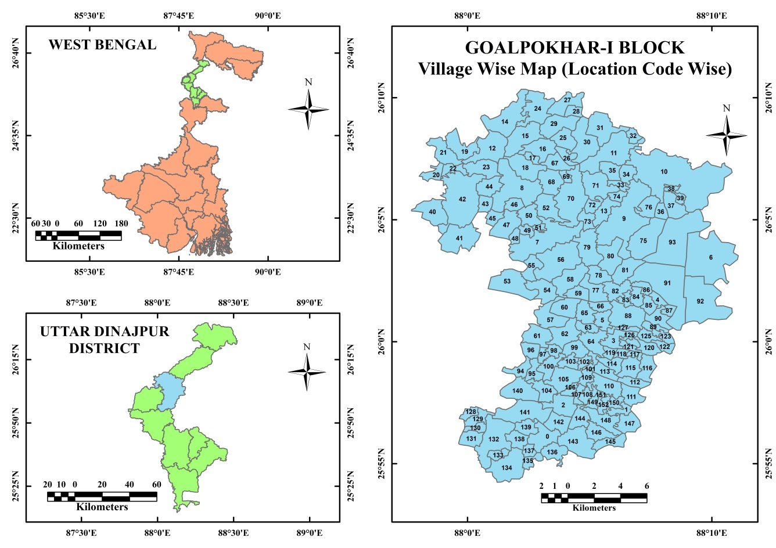

**Fig.1 Location Map of Study Area**

**Database and Methodology:**

Both the primary and secondary sources of data have been used. Primary data collected through empirical field observation for the year 2021. Secondary data collected from Census of India, District Census Handbook, 2011. The method used in the present study are- Z-Score and Composite Z-Score. The Z-score method has been used to analyze the levels of socio-economic development at the Gram Panchayat level. Each variable’s raw data has been standardized using this method. The model is as follows;

$$zi=\frac{X-\overline{X}}{σ}$$

Where, zi = Standard score or Z-score of the ith variable.

Xi = Individual observation, and

$\overline{X}$ = Mean of the variable and σ indicates standard deviation.

The indicators of development of each block have been estimated using the composite Z-score (C.S) of all the variables in the appropriate category. They are divided into three tiers of development; high, medium and low. The model is as follows:

$$C.S=\frac{\sum{Zij}}{N}$$

Where, C.S = Composite Z-Score,

Zij = Z-score of an indicator j in the area (Gram panchayat) i, and

N = Number of variables.

**Table 1: List of Selected Variables and Indicators**

|  |  |  |
| --- | --- | --- |
| **Indicators** | **Variables** | **Description of the Variables** |
| Education | X1 | Number of Primary School Per 1,000 Persons |
| X2 | Number of Middle School Per 1,000 Persons |
| X3 | Number of Secondary School Per 1,000 Persons |
| X4 | Number of Higher Secondary School Per 1,000 Persons |
| Health | X5 | Number of Primary Health Centre Per 1,000 Persons |
| X6 | Number of Primary Health Sub-Centre Per 1,000 Persons |
| X7 | Number of Maternity and Child Welfare Centre per 1,000 Persons |
| X8 | Number of Dispensary Per 1,000 Persons |
| Transportation and Communication | X9 | Number of Bus Stand Per 100 Sq. Km. Area |
| X10 | Number of Settlements with Pucca Road Facility to total Inhabited Settlements |
| X11 | Number of Post Office Per 1,000 Persons |
| Drinking Water and Market | X12 | Number of Settlement having Tape Water Facility to total Inhabited Settlements |
| X13 | Number of Settlement having Tube Well Water Facility to total Inhabited Settlements |
| X14 | Number of Weekly Market Per 1,000 Persons |
| X15 | Number of Daily Market Per 1,000 Persons |
| Agro-economy and Veterinary | X16 | Number of Settlement with Electricity For Agriculture to total Inhabited Settlements |
| X17 | Number of Agricultural Credit Societies Per 100 Inhabited Settlements |
| X18 | Number of Commercial and Cooperative Bank Per 1,000 Persons |
| X19 | Number of Veterinary Hospital Per 1,000 Persons |

**Source:** Prepared by authors.

**Analysis and Discussion:**

The level of socio-economic development has been analysed and discussed in a sequent manner. Each indicator has been discussed explicitly, e.g., education, health, transportation and communication, drinking water and market, as well as agro-economy and veterinary.

**Table 2: Indices of Socio-Economic Development in Goalpokhar-I Block, 2021**

|  |  |  |  |  |  |  |  |  |  |  |  |  |  |  |  |  |  |  |  |  |  |  |  |  |  |
| --- | --- | --- | --- | --- | --- | --- | --- | --- | --- | --- | --- | --- | --- | --- | --- | --- | --- | --- | --- | --- | --- | --- | --- | --- | --- |
| Name of the GP | Educational Development | | | | | Health Development | | | | | Transportation and Communication Development | | | | Drinking Water and Market Development | | | | | Agriculture and Veterinary Development | | | | | Composite Index |
| X1 | X2 | X3 | X4 | CE | X5 | X6 | X7 | X8 | CH | X9 | X10 | X11 | CTC | X12 | X13 | X14 | X15 | CDM | X16 | X17 | X18 | X19 | CAV |
| DHARAMPUR-I | -0.53 | 0.23 | 0.34 | 0.34 | 0.10 | -0.48 | 0.83 | 1.71 | 2.95 | 1.25 | 0.62 | 0.42 | -0.15 | 0.71 | 1.33 | 1.05 | -0.14 | -0.73 | 0.38 | -0.75 | -0.70 | 0.99 | -0.56 | -0.26 | 0.36 |
| DHARAMPUR-II | -0.18 | 1.39 | -0.09 | -0.09 | 0.26 | -0.48 | 1.20 | -1.14 | -0.87 | -0.32 | -1.46 | 0.91 | -0.49 | -0.45 | 1.99 | 1.05 | -1.22 | -0.97 | 0.22 | 0.26 | 1.05 | 2.11 | -0.56 | 0.72 | 0.13 |
| GOAGOAN-I | -0.62 | 1.34 | -0.12 | -0.12 | 0.12 | 1.95 | 0.35 | -0.04 | -0.45 | 0.45 | -0.91 | 0.98 | 0.71 | 0.41 | -0.65 | 0.60 | -0.39 | -0.98 | -0.36 | 0.88 | -0.70 | -0.97 | -0.56 | -0.34 | 0.01 |
| GOAGOAN-II | -0.03 | 0.05 | 0.17 | 0.17 | 0.09 | -0.48 | 0.64 | -1.14 | 0.12 | -0.21 | 0.06 | 0.08 | -0.29 | -0.12 | -0.04 | -0.08 | 0.74 | -0.82 | -0.05 | -0.98 | -0.70 | -0.97 | -0.56 | -0.81 | -0.21 |
| GOALPOKHER | -0.77 | -0.39 | -0.27 | -0.27 | -0.42 | -0.48 | -1.27 | 0.84 | 0.64 | -0.07 | -0.54 | 1.05 | 2.67 | 1.04 | 1.61 | -1.05 | 0.28 | -0.29 | 0.14 | 2.10 | 0.85 | 0.39 | -0.56 | 0.70 | 0.24 |
| GOTI | -0.14 | -1.20 | -0.49 | -0.49 | -0.58 | -0.48 | -0.03 | 0.54 | -0.55 | -0.13 | 1.36 | -1.04 | 0.14 | 0.11 | -0.65 | -0.63 | -1.22 | 0.14 | -0.59 | -0.32 | -0.70 | 0.19 | 0.94 | 0.03 | -0.24 |
| JAINGAON | -0.93 | -0.66 | -1.68 | -1.68 | -1.24 | -0.48 | -1.27 | 0.46 | 0.96 | -0.08 | 0.17 | 1.88 | -1.73 | 0.08 | -0.65 | 0.07 | -0.01 | 1.92 | 0.33 | 1.87 | 1.80 | -0.97 | -0.56 | 0.53 | -0.08 |
| KHAGORE | -0.30 | -0.85 | 0.21 | 0.21 | -0.18 | -0.48 | -0.29 | -1.14 | -0.36 | -0.57 | -0.78 | -0.07 | -0.25 | -0.55 | -0.65 | -0.91 | 1.80 | 1.30 | 0.38 | -0.28 | -0.70 | -0.97 | -0.56 | -0.63 | -0.27 |
| LODHAN | -0.35 | 0.98 | 0.16 | 0.16 | 0.24 | 2.39 | 0.64 | -1.14 | 0.12 | 0.50 | 1.74 | -1.84 | -0.29 | 0.04 | -0.65 | -0.02 | 0.74 | 1.22 | 0.32 | -0.03 | -0.70 | 0.82 | 1.75 | 0.46 | 0.30 |
| MOHUA | -0.86 | 0.00 | 0.11 | 0.11 | -0.16 | -0.48 | -1.27 | -1.14 | -0.39 | -0.82 | 0.40 | -1.04 | -0.33 | -0.60 | -0.65 | 1.05 | 0.68 | 0.14 | 0.31 | -0.14 | 1.28 | 0.77 | -0.56 | 0.33 | -0.12 |
| PANJIPARA | 0.06 | -0.40 | -0.75 | -0.75 | -0.46 | 0.97 | -1.27 | 0.82 | -0.62 | -0.03 | -1.46 | -0.46 | -1.00 | -0.98 | 0.94 | 1.05 | -0.23 | -1.33 | 0.11 | -0.87 | 1.35 | -0.07 | 0.60 | 0.25 | -0.18 |
| POKHERIA | 0.27 | -1.23 | -0.53 | -0.53 | -0.50 | -0.48 | -0.68 | -0.33 | -0.87 | -0.59 | -0.61 | 0.08 | 0.06 | -0.35 | -0.65 | -1.21 | -1.22 | 0.06 | -0.75 | 0.14 | -0.70 | -0.97 | -0.56 | -0.53 | -0.52 |
| SAHAPUR-I | 1.88 | -0.97 | -0.03 | -0.03 | 0.21 | -0.48 | 1.29 | 1.18 | -0.43 | 0.39 | 1.03 | -0.21 | 0.85 | 0.69 | -0.65 | -1.89 | 1.41 | 0.90 | -0.06 | -1.01 | -0.70 | 0.63 | -0.56 | -0.41 | 0.12 |
| SAHAPUR-II | 2.50 | 1.70 | 2.96 | 2.96 | 2.53 | -0.48 | 1.13 | 0.49 | -0.25 | 0.22 | 0.39 | -0.75 | 0.08 | -0.02 | -0.65 | 0.91 | -1.22 | -0.56 | -0.38 | -0.87 | -0.70 | -0.97 | 2.35 | -0.05 | 0.47 |

**Source:** Calculated by Researchers.

**Note:** GP= Gram Panchayat, CE= Composite Score of Education, CH= Composite Score of Health, CTC= Composite Score of Transportation and Communication, CDM= Composite Score of Drinking Water and Market, CAV= Composite Score of Agro-Economy and Veterinary.

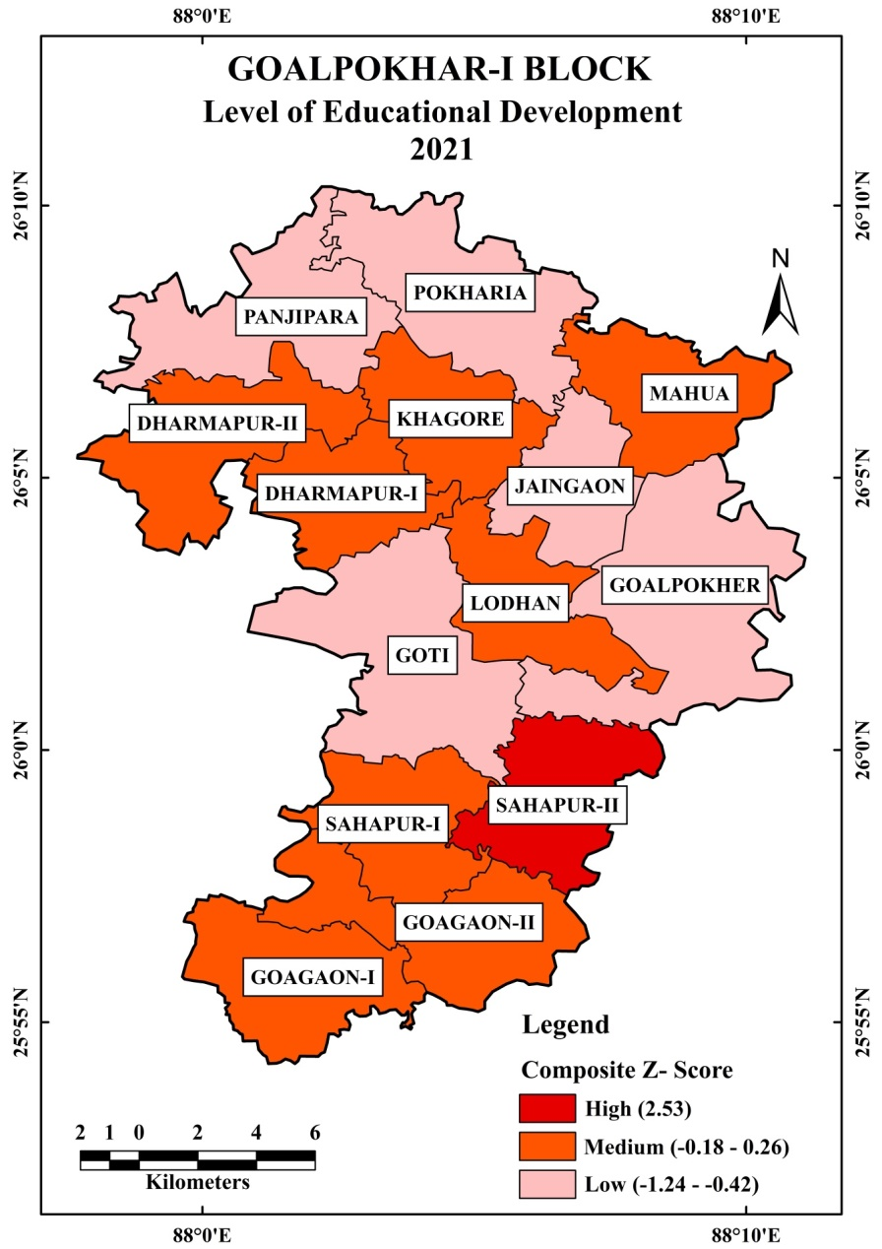

Fig.2

**Level of Educational Development:**

Educational is one of the most important aspect of human life. Table 2 and Fig.2 clearly show the level of educationl development in Goalpokhar-I block. The high level of educational development (Z-Score Value 2.53) only found in Sahapur-II gram panchayat, due to the well accecibility in educational facilities, proper allocation of facility as well as good transport and communication facility. The medium level of educational development (Z-Score Value -0.18 to 0.26) found in eight gram panchayat namely Goagaon-I, Goagaon-II, Sahapur-I, Lodhan, Dharmapur-I, Dharmapur-II, Khagore and Mahua. Whereas the least educational developed (Z-Score Value – 1.24 to -0.42) gram panchayat are Goti, Goalpokhaer, Jaingaon, Pokharia and Panjipara. Because of the lowest number of educational institution and inappropriate location of facilities.

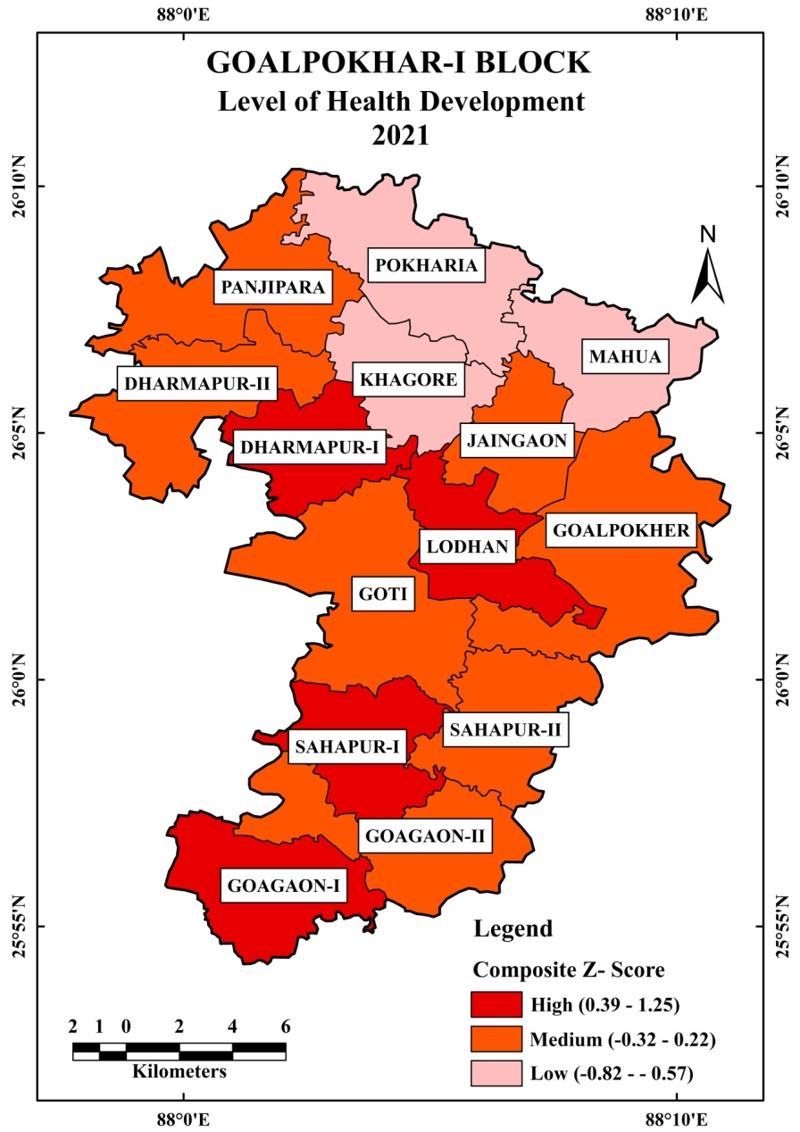

Fig.3

**Level of Health Development:**

Table 2 and Fig.3 clearly reveal the level of health development in Goalpokhar-I block. The highest health development observed in four gram panchayat (Z-Score Value 0.39 to 1.25) such as; Goagaon-I, Sahapur-I, Lodhan and Dharmapur-I. The medium development (Z-Score Value – 0.32 to 0.22) recorded in seven gram panchayat, they are- Goagaon-II, Sahapur-II, Goti, Goalpokher, Jaingaon, Dharmapur-II and Panjipara. While least development (Z-Score Value – 0.82 to – 0.57) found in three gram panchayat i.e., Pokharia, Khagore and Mahua, these are located in northern part of the block.

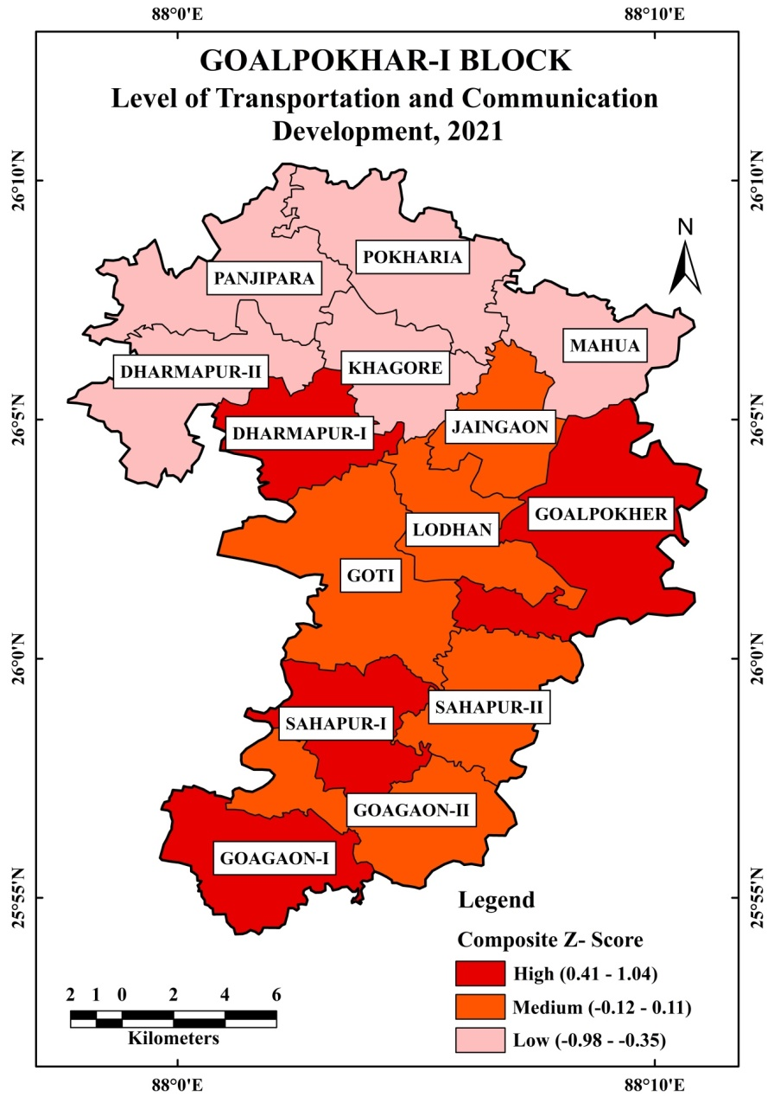

Fig.4

**Level of Transportation and Communication Development:**

Transportation and Communication are one of the important aspect of level of development in any region. Table 2 and Fig.4 clearly show the level of transportation and communication development in Goalpokhar-I block. The highest composite Z-score value of transportation and communication development has been recorded in Goagaon-I, Sahapur-I, Goalpokher and Dharmapur-I. While medium development found in Goagaon-II, Sahapur-II, Goti, Lodhan and Jaingaon. The least development in northern part of the block i.e., Dharmapur-II, Khagore, Panjipara, Pokharia and Mahua. Lack of facilities as well as uneven distribution of facilities and poor road connectivity are major resason behind these least developed gram panchayat.

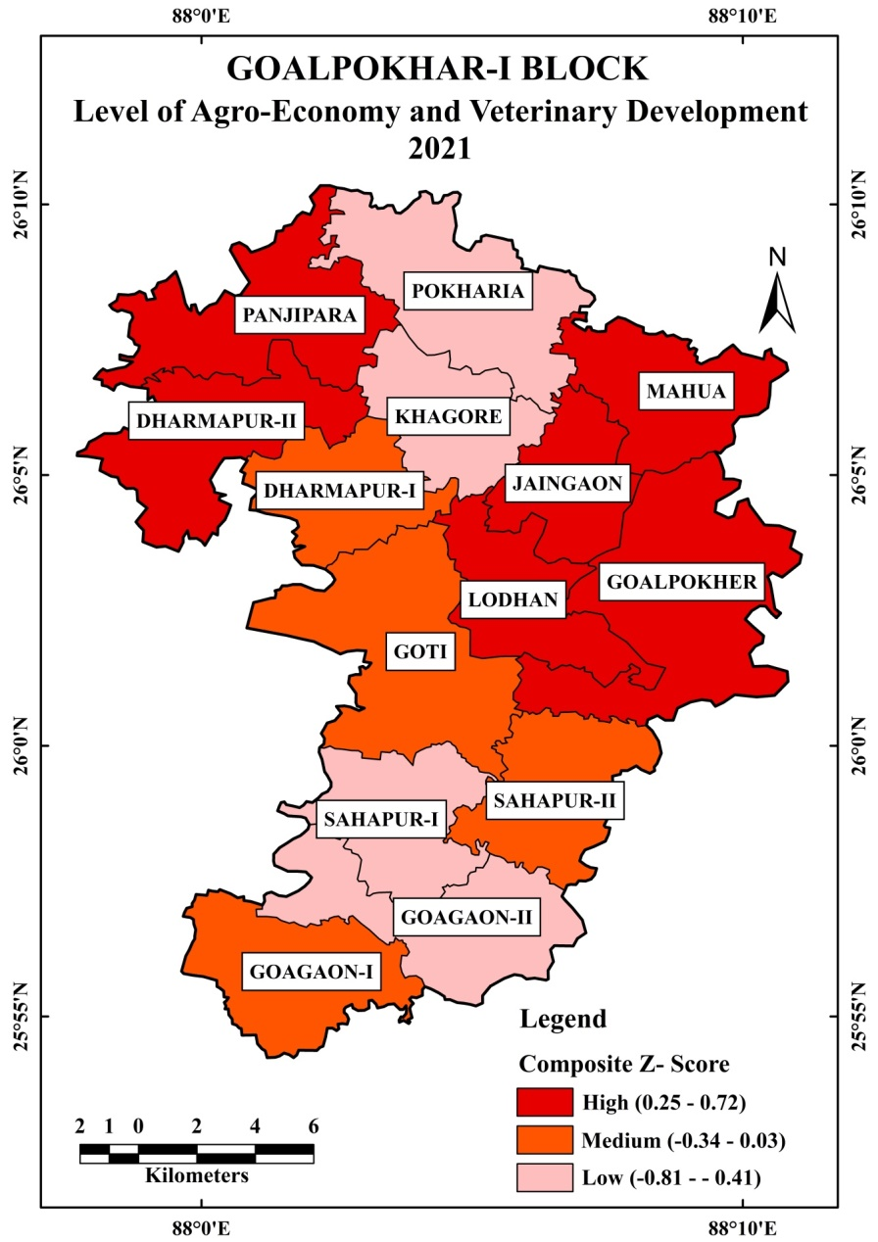

Fig.5

**Level of Agro-Economy and Veterinary Development:**

Table 2 and Fig.5 show the level of agro-economy and veterinary development in Goalpokhar-I block. The highest development found in Dharmapur-II, Panjipara, Jaingaon, Mahua, Lodhan and Goalpokher gram panchayat due to the fertile soil, well connectivity and proper allocation of agro-economy and veterinary facilities. The moderate development observed in Dharmapur-I, Goti, Sahapur-II and Goagaon-I gram panchyat. Whereas, least developed gram panchayat are- Pokharia, Khagore, Sahapur-I and Goagaon-II, because of the poor connctivity, less fertile soil and imprper allocation of agro-economic facilities.

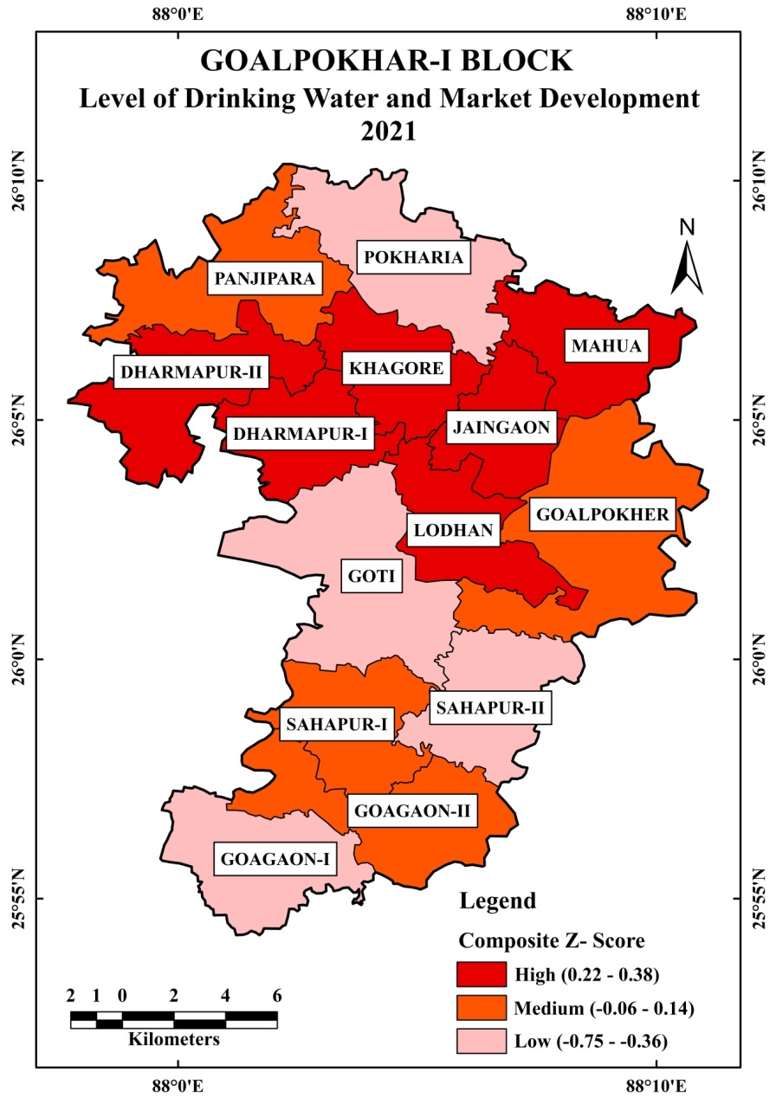

Fig.6

**Level of Drinking water and Market Development:**

Table 2 and Fig.6 show the drinking water and market facilities development in Goalpokar-I block. The high development found in the central or middle part of the block i.e., Dharmapur-I, Dharmapur-II, Khagor, Jaingaon, Lodhan and Mahua gram panchayat. The moderate development has been recorded in Sahapur-I, Goagaon-II, Goalpokher and Panjipara. While, the least developed gram panchayat are-Goagaon-I, Sahapur-II, Goti and Pokharia, due to high density of population, less fertile soil as well as poor transportation and communication facilities.

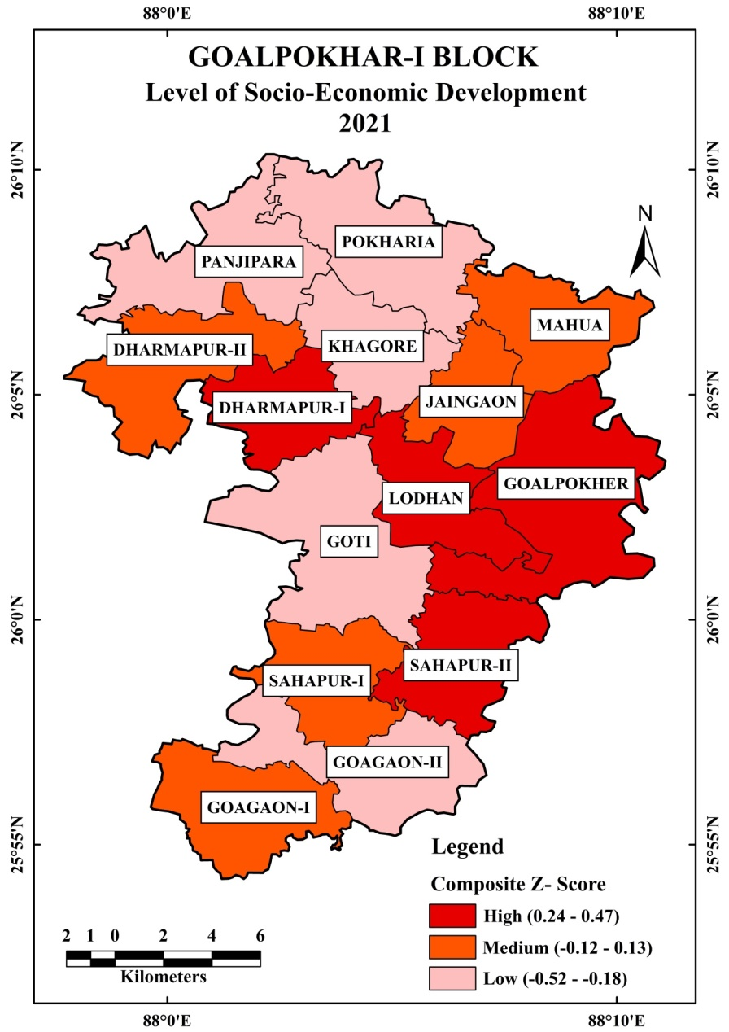

Fig.7

**Level of Socio-Economic Development:**

Table 2 and Fig.7 show the level of socio-economic development in Goalpohar-I block and these are categorised into three categories i.e., High, Medium and Low.

**High Level of Socio-Economic Development (**0.24 to 0.47**)**

Table 2 and Fig.7 reveal that the four gram panchayat, i.e., Dharampur-I (0.36), Lodhan (0.30), Goalpokher (0.24), and Sahapur-II (0.47) falls under the high level of socio-economic development in the study area. It accounts for 31.72 percent of settlements, 29.14 percent area, and accommodates 24.45 percent population of the block. Among the highly developed four-gram panchayat Sahapur-II gram panchayat stands in first position in terms of the level of socio-economic development in the block. The high level of socio-economic development in these gram panchayats is due to the ample quantity of educational facility, transportation and communication, health facility and market facility compared to the other gram panchayat of the block.

**Medium Level of Socio-Economic Development (**-0.12 to 0.13**)**

It is clear from Tables 2 and Fig.7 that there are five-gram panchayat such as Jaingaon (-0.08), Mohua (-0.12), Goagoan-I (0.01), Sahapur-I (0.12) and Dharampur-II (0.13) comes under the medium level of socio-economic development in the block. These gram panchayat accounts for 27.59 percent of settlements, occupying 30.56 percent area and accommodating 32.28 percent population of the block. These gram panchayats recorded moderate level of development.

**Low Level of Socio-Economic Development (**- 0.52 to - 0.18**)**

Table 2 and Fig.7 reveal that there are five-gram panchayats, i.e., Khagore (-0.27), Pokheria (-0.52), Goti (-0.24), Goagoan-II (-0.21) and Panjipara (-0.18)are least socio-economic developed gram panchayat in the block. It shares 40.69 percent of settlements, covering an area of 40.30 percent, and accommodates 43.27 percent population of the block. As the data clearly indicates that the area and population served by these gram panchayats are almost equal. The important factors which are responsible for the low level of development are political biases in the allocation of facilities, deficient educational facility, health facility, inaccessibility of transportation and communication, and lack of market facilities, etc. The population of these gram panchayats travels long distances to avail the socio-economic facilities. Despite the fact that it is not economically, socially, or environmentally viable or sustainable, it requires special consideration in order to examine the situation for balanced regional development.

**Conclusion:**

From the above appraisal, it has been found that there is a wide regional disparity in the level of socio-economic development at the gram panchayat level. Among the gram panchayat, Pokharia gram panchayat is the least developed in the block, which requires much more attention for the allocation of socio-economic amenities and facilities. Whereas, Sahapur-II gram panchayat stands in first position in terms of the level of socio-economic development in the block. So, this analysis well helps in allocation as well as identification of least developed region. It also helps in planning purpose for the government and non-government agencies, which are willing to eradicate the regional disparity at the micro level.

**References:**

1. Hoque, Jiyaul & Hashmi, S.N.I. (2020). Regional Disparity in the Levels of Educational Development in Uttar Dinajpur District of West Bengal, India. *International Journal for Scientific Research & Development. Vol. 8*, Issue 1, pp.77-81. https://www.ijsrd.com/Article.php?manuscript=IJSRDV8I10312
2. Hoque, Jiyaul. (2020). Micro-Level Analysis of Human Settlements in Uttar Dinajpur District: A Quantitative Approach. *International Journal of Trend in Scientific Research and Development Vol.5*, Issue.1, pp.1530-1540. <https://www.ijtsrd.com/papers/ijtsrd38257.pdf>
3. Hoque, Jiyaul., & Hashmi, S.N.I. (2023). Regional Variation in the Level of Socio-Economic Development in Uttar Dinajpur District, West Bengal. *International Journal of Research Publication and Reviews, 4*(3), 2782–2795. <https://ijrpr.com/uploads/V4ISSUE3/IJRPR10730.pdf>
4. Jawaid, S., Hoque, Jiyaul., Aaquib, Md., & Mahjabeen. (2023). Regional Disparities in the Health Infrastructure and Facilities of Bareilly District, Uttar Pradesh: An Analysis. *International Journal of Trend in Scientific Research and Development,Vol.7*,Issue.2,pp.528-537, <https://www.ijtsrd.com/papers/ijtsrd55055.pdf>
5. Ahmad, M., Islam, P., & Bano, E. (2019). An inter-block analysis of regional disparities in socio-economic conditions of Hathras district, Uttar Pradesh. *ZENITH International Journal of Multidisciplinary Research*, *9*(5), 265-277.
6. Majumder, R. (2002). India’s Development experience – A Regional Analysis: An eassy in honour of Prof. Ashok Mathur, Published in Industrialization, Economic Reforms and Regional Development: Eassays in honour of Ashok Mathur (eds.) Prof. S.K. Thorat et al, Shipra Publication, New Delhi (2005).
7. Kurian, N. J. (2000). Widening regional disparities in India: Some indicators. *Economic and Political Weekly*, 538-550.
8. Chandra, B. (2015). An Analysis of Disparity in Level of Development as well as Socio-Economic Environment among the Blocks of Maldha District, West Bengal. *Scholarly Research Journal for Interdisciplinary Studies*, *4*(27), 3199-3208.
9. Tiwari, R.T. (1985). Inter-Regional Disparities in Levels of Development, in Misra, G.P. (Ed.). *Regional Structure of Development and Growth in India, Vol. 1*, New Delhi, pp. 102-120.